
INDIVIDUAL BLOG

Ivelina Georgieva-Draganova

Student ID: 2235428
Module: Marketing Fundamentals

Lecturer: Dr. Piyumika Kithulgoda Gamage

INTRODUCTION 3
MAIN BODY 4
Overview of Burberry 4
Segmentation strategies 5
Targeting and positioning strategies 6
Marketing Mix strategies 8
CONCLUSION 10
References 11

INTRODUCTION

A company's marketing process involves engaging customers, building strong customer relationships, and creating value for customers so that they can provide value in return (Kotler, et al., 2019).Organisations must implement effective segmentation, targeting, positioning, and marketing mix strategies if they want to survive and thrive in today's rapidly evolving, fiercely competitive business environment (Study Smarter, 2022).With the help of these techniques, businesses may identify their ideal customers, discover how to effectively position their products in the market, and adjust their product lines to meet the needs of their target market (Kotler, et al., 2019). One business that has successfully implemented these strategies is the well-known luxury clothing brand Burberry. Burberry, a British fashion house established in 1856, is recognised for its timelessly beautiful designs. Due to the brand's recognisable trench coats, distinctive check patterns, and other superbly crafted items, the word Burberry has come to be associated with wealth and style. The business has grown through time, adapting to the market while holding true to its fundamental principles (Burberry, 2023). Due to its commitment to fusing tradition with innovation, Burberry remains at the forefront of high fashion. Due to the company's use of segmentation, targeting, positioning, and marketing mix strategies, Burberry has become the go-to brand for wealthy customers who value class and sophistication. Burberry targets certain customer groups based on their demographics, psychographics, and location through thorough market segmentation. Additionally, Burberry's approach of exclusive targeting is intended to win the patronage and loyalty of affluent customers who value privacy and individuality (Galstian, 2023). The company deliberately collaborates with well-known figures in the media to increase its reputation and appeal to its target audience. This tactic enhances Burberry's standing as a fashionable, aspirational brand (Kemp, 2021). We will go through Burberry's success in the luxury apparel market in more detail in the sections that follow, paying particular attention to the brand's segmentation, targeting, positioning, and marketing mix strategies.

MAIN BODY

Overview of Burberry
Burberry is a widely recognised and esteemed luxury fashion brand with a longstanding presence in the industry. The establishment of the business can be attributed to Thomas Burberry in the year 1856, which promptly garnered attention due to its fashionable and superior garments, with the trench coat being particularly noteworthy. The fundamental tenets of Burberry, namely, its commitment to excellence, craftsmanship, and the preservation of British heritage, have remained steadfast throughout its history (BURBERRY 2023). One of the contributing factors to Burberry's longevity is its dedication to blending historical elements with contemporary innovations. The company has effectively amalgamated a commitment to tradition with a penchant for contemporary aesthetics. Burberry's continued success can be attributed to its adeptness in seamlessly integrating traditional and contemporary fashion trends (Burberry, 2022).
Burberry is a high-end fashion brand that targets affluent customers. Its name alone suggests a certain aura of elegant beauty. Because of its commitment to expert craftsmanship and meticulous attention to detail, the brand has become a symbol of excellence and luxury. An iconic piece that Burberry has gained fame for is the trench coat. The trench coat is a timeless piece of outerwear that has endured the test of time for both its fashion and usefulness. It was first worn in the early 20th century. In order to cater to the many tastes of its customer base, Burberry currently offers a huge selection of apparel, accessories, luggage, and cosmetics (Burberry, 2023).
Burberry shop
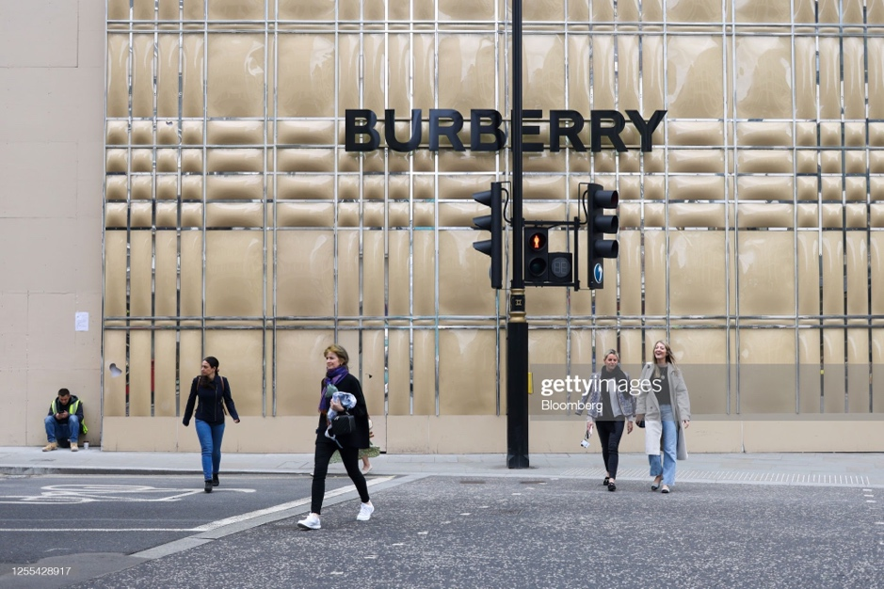
Source: (Getty Images, 2023)

Burberry recently incorporated digital innovation, enhancing customer interactions with the brand through technology. Burberry was one of the first high-end brands to broadcast its fashion shows online to a global audience. Burberry has been able to attract more people, expand its business, and prosper in the digital era because to this creative strategy. Burberry is sought after by fashion-conscious people all around the world due to its well-known talent for skilfully fusing heritage and innovation. Burberry's lengthy history, commitment to quality, and ability to keep up with the rapidly changing world of high fashion have made the firm synonymous with sophistication and elegance.

Segmentation strategies
Market segmentation is the deliberate division of a big market into more manageable groups of consumers with comparable characteristics, requirements, and preferences
Source: (BURBERRY,2023)
(Bian, Song and Bai, 2019). This makes it easier for companies like Burberry to identify their ideal customers and better target them with marketing. Burberry understands that in order to properly serve its wide range of customers, the premium fashion market must be segmented.
- Demographic segmentation
Burberry divides their clientele into many segments based on demographic factors including age, income, gender, and profession. For instance, Burberry has collections designed especially for children, teenagers, and adults. By considering each customer's unique preferences and the price range they are ready to pay for clothing, Burberry caters to customers of all ages (Burberry, 2022).
- Psychographic segmentation
Because it is aware that customers' values, priorities, and aspirations greatly influence their purchasing decisions, Burberry uses psychographic segmentation. Burberry focuses on customers that have similar tastes in high style, innovation, and refinement using psychographics. The target market for this brand, for instance, consists of people who place a premium on characteristics like exclusivity, elegance, and status when buying goods (Burberry, 2022).
- Geographic segmentation
As a worldwide premium brand, Burberry uses regional segmentation to specifically target markets and areas throughout the world with its products They consider factors like regional taste, culture, and weather while designing a product or service. Burberry, for instance, creates distinct collections for each country in order to cater for regional variations in fashion preferences. Burberry uses a variety of marketing strategies, not just for their products. They customise their marketing strategies and channels for particular consumer demographics. Examples include targeting certain markets by utilising models, celebrities, and influencers from various backgrounds. This facilitates communication between Burberry and those who hold the same values and interests as the featured individuals (Li and et. Al., 2021)..

Targeting and positioning strategies

Burberry employs a focused approach, focusing on affluent individuals who have a strong affinity for high fashion. By connecting the brand with other pricey and prominent industry emblems, this strategy aids the business in raising the brand's profile. Burberry is able to connect with wealthy customers who value the brand's commitment to excellence in design and construction by specialising in luxury items. Burberry carefully chooses celebrity collaborations and endorsements to boost sales and brand recognition (Zhang and et. Al., 2020). Collaboration with well-known celebrities and influencers can increase the connection between the business and inspirational individuals. By engaging the aid of these popular individuals, Burberry is able to connect with its target audience and communicate its brand of elegance, sophistication, and exclusivity. For instance, Burberry has collaborated with famous people like Cara Delevingne, Romeo Beckham, and Emma Watson because they exemplify the brand's beliefs and aesthetic.
Additionally, Burberry collaborates with a variety of individuals. The business has created limited-edition collections and one-of-a-kind pieces in collaboration with other labels, studios, and designers (Schlegelmilch, 2022). These collaborations not only raise Burberry's visibility among fashion-conscious customers, but they also strengthen the brand's position as a pioneer in the fashion sector. Burberry can expand its customer base and increase sales through these kinds of alliances without losing the distinctiveness of its brand (Burberry, 2022).
Burberry positions itself as a forward-thinking, aspirational brand because it is always one step ahead of the fashion curve. The brand displays its most recent collections during its runway shows and rebels against tradition with distinctive, avant-garde designs. By skilfully fusing its illustrious past with the most recent fashion trends, Burberry has effectively established itself as a brand that offers both timeless elegance and cutting-edge flair. Thanks to its significant retail presence, Burberry has been able to successfully portray itself as an exclusive, high-end brand. The company locates its boutiques in upscale shopping areas to provide its customers with the best luxury shopping experience (Uggla and Verick, 2023). This physical presence boosts the brand's reputation and enhances the buying experience. Burberry's marketing initiatives are crucial in positioning the business as a pioneer in the fashion sector (Romagnoli, 2022).

Burberry’s positioning map
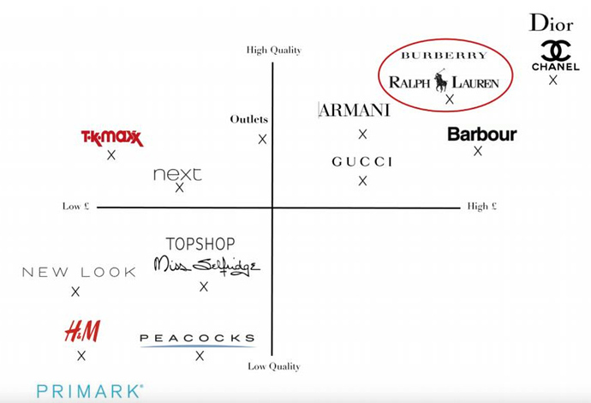
Source: (Freetrade, 2020)

The brand's advertisements are visually appealing and emotionally compelling; they usually use well-known imagery and seek to arouse feelings of Britishness. Burberry promotes itself as the pinnacle of refinement, elegance, and aspiration by touching its target market on an emotional level through powerful brand storytelling and eye-catching imagery (Ramos and et. Al., 2019).
In conclusion, Burberry's positioning and targeting strategies focus on a selective approach, placing a major emphasis on affluent individuals who enjoy high fashion. Through a combination of celebrity endorsements, innovative collaborations, and thoughtful brand positioning (Singh, Rajput and Kanvah, 2022). Burberry keeps its reputation as a forward-thinking, aspirational fashion firm. These strategies assist. Burberry in standing out in the congested luxury clothing market and sustaining its market dominance (Romagnoli, 2022).

Marketing Mix strategies
Burberry's approaches to them are a representation of the four pillars of a successful marketing mix: product, pricing, promotion, and venue. By combining superior product quality, a high asking price, captivating promotions, and tactical placement, Burberry creates an engaging brand experience for its target customers (Lahtinen, Dietrich and Rundle-Thiele, 2020).
- Product
Burberry, a British firm, sells a wide range of merchandise. Burberry is renowned for its unusual trench coats, distinct check patterns and avant-garde fashions. Burberry prioritises product excellence and craftsmanship, ensuring that each product faithfully reflects the brand's values . The range offers goods that successfully combine traditional British design with cutting-edge technology for both young and old (Burberry, 2023).
- Price
Burberry is a high-end fashion brand; hence its goods are pricey. The costs must reflect the brand's intended meanings of luxury, exclusivity, and high quality. Burberry's price strategy aligns with the company's core principles. Burberry maintains the image of its products as being luxurious and aspirational by charging high costs (Kucuk, 2023). Diving into Retviews real-time data and looking into leading brands` pricing strategies for leather such as bags and small leatcher goods within the UK market, showcases that Burberry`s leather goods pricing currently sits close to high-end luxury brands, although still on the lower end of the pricing spectrum, as both its maximum and most frequent prices are much lower than of leading Luxury brands Gucci, Prada and Louis Viuitton. However, the luxury brands stand at a similar entry-level price (Lectra, 2022).
- Promotion
Burberry draws in and draws in their target audience with interesting promotional strategies. To reach customers worldwide, the company markets its products using both conventional and online channels. Burberry commonly uses vintage photographs in their advertising campaigns, which are both visually stunning and emotionally stirring (Avallone, 2021). The "Burberry Her" fragrance line, presented by Cara Delevingne, emphasises women's independence and individuality, while the "Burberry Festive" holiday advertisements convey extravagance and joy. Burberry also collaborates with well-known public figures in order to further enhance its profile and grow its consumer base. Through its partnerships with well-known individuals who exemplify the brand's guiding principles, Burberry is able to further solidify its association with flair and grandeur. For instance, the Burberry x Vivienne Westwood collection featured collaborations with Emma Watson and Romeo Beckham and merged the history of Burberry with Westwood's punk-inspired creations (Burberry, 2023).
- Place
Burberry carefully chooses the locations for its stores as part of a strategic placement technique. The company offers its products for sale online as well as in physical stores. Burberry stores are often found in upscale retail districts, giving customers a luxurious and energising environment in which to connect with the brand. Burberry's physical stores emphasise providing excellent customer service and are aesthetically consistent with the brand. Additionally, Burberry's e-commerce platform, which provides accessibility and convenience for customers everywhere, expands the brand's global reach (Ahmed and et. Al., 2023). Burberry supports its marketing mix ambitions through a variety of advertising campaigns, partnerships, and distribution strategies. By livestreaming runway events, the "Burberry World Live" campaign, for instance, allowed customers from all around the world to engage with the fashion house. Burberry's collaborations with platforms like Apple Music and Snapchat, among others, show the company's commitment to technological advancement and the brand's capacity to appeal to a younger audience.
Burberry employs a variety of distribution methods. In addition to its own retail sites, Burberry also has a small number of department stores, specialty stores and airport duty-free outlets where its products are sold (Tong, Luo and Xu, 2020). The business caters to the growing popularity of online shopping through its e-commerce platform, which also allows it to contact customers all over the world. In summary, Burberry's marketing mix strategies emphasise offering luxury goods at competitive costs, running eye-catching promotions, and positioning their goods in favourable locations. Burberry successfully develops its brand image and connects with its customer base by highlighting these elements. Burberry's marketing initiatives, alliances, and distribution methods all contribute to this strategy, enhancing the brand's position as a leader in high-end fashion that can give wearers access to a desirable way of life, sophistication, and creativity (Burberry, 2022).

CONCLUSION

Finally, Burberry's success in the high-end fashion industry may be attributed to the company's carefully considered use of segmentation, targeting, positioning, and other marketing mix components. Burberry has succeeded in establishing a connection with its target market by getting to know its customers on a deep level and providing them with goods and services that are especially suited to them. Based on demographic, psychographic, and geographic variables, Burberry uses market segmentation to target different segments of its intended audience with specific products and advertising. Burberry emphasises its commitment to quality, craftsmanship, and remarkable design by concentrating on rich customers who value high fashion. Burberry has been able to raise its profile and broaden its client base thanks to celebrity sponsorships and partnerships. Through its alliances with well-known celebrities and influencers, Burberry is able to effectively communicate its brand of style, elegance, and exclusivity by forging close bonds with aspirational people.

References

Ahmed and et. Al., 2023. Effect of green marketing mix, green customer value, and attitude on green purchase intention: Evidence from the USA. Environmental Science and Pollution Research, 30(5), pp.11473-11495.
Avallone, L., 2021. Digital transformation in the luxury fashion industry.
Bian, Y., Song, K. and Bai, J., 2019. Market segmentation, resource misallocation and environmental pollution. Journal of Cleaner Production, 228, pp.376-387.
Burberry, 2022. Srategic Report. [Online]
Available at: https://www.burberryplc.com/content/dam/burberry/corporate/oar/2022/pdfs/Burberry_2021-22_Strategic_Report.pdf
[Accessed 20 07 2023].
Burberry, 2023. Our history. [Online]
Available at: https://uk.burberry.com/c/our-history/
[Accessed 20 07 2023].
Burberry, 2023. Our products. [Online]
Available at: https://uk.burberry.com/our-products/
[Accessed 21 07 2023].
Burberry, 2023. Vivienne Westwood & Burberry. [Online]
Available at: https://uk.burberry.com/c/vivienne-westwood-burberry/
[Accessed 20 07 2023].
Caliskan, A., Özkan Özen, Y.D. and Ozturkoglu, Y., 2021. Digital transformation of traditional marketing business model in new industry era. Journal of Enterprise Information Management, 34(4), pp.1252-1273.
Freetrade, 2020. Burberry: An iconic british luxury brand. [Online]
Available at: https://community.freetrade.io/t/burberry-an-iconic-british-luxury-brand-my-bear-market-pick-1/17558
[Accessed 20 07 2023].
Galstian, K., 2023. Market Segmentation of Burberry. [Online]
Available at: https://thesocialgrabber.com/market-segmentation-of-burberry/
[Accessed 20 07 2023].
Getty Images, 2023. Burberry Group Plc Stores Ahead Of Earnings. [Online]
Available at: https://www.gettyimages.co.uk/detail/news-photo/shoppers-pass-renovation-works-at-the-burberry-group-plc-news-photo/1255428917?adppopup=true
[Accessed 20 07 2023].
Kemp, K., 2021. Burberry luxury brand reaps rewards of Vivienne Westwood collaboration. [Online]
Available at: https://www.insider.co.uk/news/burberry-shares-vivienne-westwood-fashion-13895096
[Accessed 20 07 2023].
Kotler, P. T., Armstrong, G., Harris, L. C. & He, H., 2019. Principles of Marketing. 8 ed. s.l.:Pearson Education Limited.
Kucuk, S.U., 2023. Marketing and Marketing Mix. In Visualizing Marketing: From Abstract to Intuitive (pp. 7-13). Cham: Springer International Publishing.
Lahtinen, V., Dietrich, T. and Rundle-Thiele, S., 2020. Long live the marketing mix. Testing the effectiveness of the commercial marketing mix in a social marketing context. Journal of Social Marketing, 10(3), pp.357-375.
Lectra, 2022. Burberry : elevating british luxury. [Online]
Available at: https://www.lectra.com/en/library/burberry-elevating-british-luxury
[Accessed 25 07 2023].
Li and et. Al., 2021. Learning deep semantic segmentation network under multiple weakly-supervised constraints for cross-domain remote sensing image semantic segmentation. ISPRS Journal of Photogrammetry and Remote Sensing, 175, pp.20-33.
Ramos and et. Al., 2019. Natural products targeting strategies involving molecular networking: Different manners, one goal. Natural product reports, 36(7), pp.960-980.
Romagnoli, R., 2022. Discover three pioneers of luxury fashion in the metaverse. [Online]
Available at: https://www.thedrum.com/opinion/2022/03/02/discover-three-pioneers-luxury-fashion-the-metaverse
[Accessed 20 07 2023].
Schlegelmilch, B.B., 2022. Segmenting targeting and positioning in global markets. In Global Marketing Strategy: An Executive Digest (pp. 129-159). Cham: Springer International Publishing.
Singh, D., Rajput, D. and Kanvah, S., 2022. Fluorescent probes for targeting endoplasmic reticulum: design strategies and their applications. Chemical Communications, 58(15), pp.2413-2429.
Study Smarter, 2022. Market Segmentation Targeting and Positioning. [Online]
Available at: https://www.studysmarter.co.uk/explanations/marketing/customer-driven-marketing-strategy/market-segmentation-targeting-and-positioning/
[Accessed 17 07 2023].
Tong, S., Luo, X. and Xu, B., 2020. Personalized mobile marketing strategies. Journal of the Academy of Marketing Science, 48, pp.64-78
Uggla, H. and Verick, H., 2023. Five Challenges for Digital Luxury Branding in Practice and Theory Development. IUP Journal of Brand Management, 20(1), pp.28-31.
Zhang and et. Al., 2020. State-of-the-art robotic grippers, grasping and control strategies, as well as their applications in agricultural robots: A review. Computers and Electronics in Agriculture, 177, p.105694.

