

Module: Organisational Behaviour and Management - Level 5
Component 1

Critical Evaluation of Organizational Culture and Its Impact on Structure,
Decision-Making, and Performance: A Case Study of British Airways

Student Name :NAMITA YADAV
Student ID :2313042

Table of Contents
1. Introduction ........................................ 3
2. Organisational Culture and Its Influence on Structure and Decision-Making ........................................ 4
2.1 Defining Organisational Culture ........................................ 4
2.2 The Impact of Culture on Organisational Structure ........................................ 5
2.3 Decision-Making Processes and Cultural Influences ........................................ 6
3. Identifying Organisational Culture Types ........................................ 7
3.1 Application of Hofstede’s Cultural Dimensions ........................................ 7
3.2 Handy’s Cultural Types and British Airways ........................................ 8
3.3 Prevailing Organisational Culture ........................................ 9
4. Organisational Culture and Adaptation to External Environment ........................................ 10
4.1 Environmental Influences on British Airways ........................................ 10
4.2 Leveraging Culture for Strategic Flexibility ........................................ 11
5. Organisational Culture as Barrier or Enabler ........................................ 12
5.1 Culture as an Enabler ........................................ 12
5.2 Culture as a Barrier ........................................ 13
6. Impact of Organisational Culture on Performance ........................................ 13
6.1 Operational Performance ........................................ 13
6.2 Financial and Strategic Performance ........................................ 14
7. Recommendations for Improvement ........................................ 14
8. Conclusion ........................................ 15
9. References ........................................ 15

Component 1: Organisational Culture: Individual Report

1. Introduction
The organisational culture has been defined as the values, beliefs, and behaviours that outline the manner in which work is undertaken in an organisation (Mullins and Christy, 2016). It is a decisive factor of organisational procedures such as decision-making, structural design, employee motivation and performance results. The international operation, the competitiveness in the market and the socio-economic pressures have ensnared the management of various workforce cultures in global organisations further. As one of the major international airlines, British Airways (BA) has been performing its activities in highly dynamic environment where demand and regulative and technological interference change. To assess the impact of the organisational culture on the internal processes and decision making and the general organisational performance, it is crucial to understand the organisational culture of BA.

Within the frames of this report, the organisational culture of British Airways is paid special attention and analysed with the help of the theoretical framework of the model of organisational culture created by Schein forming the Cultural Dimensions framework by Hofstede, typologies and types of cultures developed by Handy concept. The paper reviews the role of culture in the way BA has responded to the pressures in the external environmental forces and how culture based attributes are either facilitating or inhibiting elements to operational effectiveness. In combining the out, academic body, and industry reports and specific data of the company are utilized in order to provide a sound critique reflection. The focus is to offer practical solutions that improve the performance, adaptability, and functioning of the organisations in an intricate global environment.
2. Organisational Culture and Its Influence on Structure and Decision-Making
2.1 Defining Organisational Culture
The organisational culture may be considered the broad patterns of behaviours, values, beliefs, and assumptions, which identify how the work is done, and how people in an organisation interact with each other (Malagas et al., 2022). It can be formal in the form of policy, hierarchy, and channels of communication, and informal in the form of normative behaviours and interactions between the leadership and the subordinates (Denham and Bratten, 2020). In reality, culture determines the structural form of the organisation, a centralised or devolved decision making process, allocation distribution of power and amount of flexibility or inflexibility in operations processes (Mullins and Christy, 2016).
Traditionally, British Airways is hierarchical, bureaucratic, and has a culture that is based on operational control, safety compliance, and efficiency (Cozmuta, 2024). It is an established reporting and centralised the decision making process more so where there is a necessity to impose regulations such as security and safety. The other one that BA would have to conquer however is, but the establishment of a more innovative and responsive biosphere in an airline that is competitive. This incompatibility of operational control and dynamic adaptability defies the focus achieved in defining organisational decision-making to be an emphasis of culture (Obeidat, 2020).
2.2 The Impact of Culture on Organisational Structure
The BA culture is the combination of incorporating the adaptive norms and the traditional hierarchic norms. According to the typology by Handy, BA possesses the characteristics of a role culture, with formalised rules and responsibilities being the overarching features of their culture, and the peculiarities of task culture, namely the specialised teams working towards operational efficiency, customer service, and IT innovations (Mullins and Christy, 2016; Sewsankar and Loewenberger, 2024). This duality allows BA to find a balance between stability and targeted flexibility simultaneously as it introduces the possible conflict between the inflexible bureaucratic demands and the need to bring an innovation in the form of a team.
Table 1: British Airways Organisational Structure and Cultural Influence
Level | Role | Decision-Making Approach | Cultural Influence
Executive Board | CEO, CFO, COO | Strategic and centralised | Emphasis on formal authority and accountability
Divisional Heads | Operations, IT, Marketing | Semi-centralised | Task-focused culture enabling specialised decision-making
Middle Management | Department Managers | Delegated but monitored | Role culture ensuring compliance and consistency
Operational Staff | Cabin Crew, Ground Staff | Decentralised in daily tasks | Task culture encouraging initiative within formal boundaries

Such a systematic solution will guarantee compliance with laws and safety in operations as well as enable BA to respond to customer demands through team efforts. However, simultaneously, the inappropriateness between hierarchy and responsiveness, which has been described by Rahman (2024), can default even the speed of decision-making at the top because the culture turns out to be in this instance.
2.3 Decision-Making Processes and Cultural Influences
Cultural norms at BA are manifested in the way of decision making. The senior management has centralised authority, meaning high-risk activities such as route planning, fleet management and safety protocols are highly monitored by the senior management (Joseph and Gaba, 2020). This centralisation goes in line with the role culture of airlines and risk-averse attitude. At the same time, the customer facing functions like the cabin crew and service teams encourage decentralised decision-making, which allows them to respond in real-time, according to the needs of the passengers (TING, 2023).
The Model offered by Schein offers a convenient guideline in interpreting these layers of culture. At the artefact level, the behaviours such as safety briefings, customer service procedures and homogenous standards are the manifestations of the cultures as formality. The Announced values are safety, reliability, and service excellence, and the underlying assumptions set are quite deep-rooted in prioritising safety and operational efficiency as the highest value (Malagas et al., 2022; Raškaj, 2023). These assumptions impact the standard of decision making across the organisation in such a way that strategic purpose and operational performance fit.
Figure 1 below summarises Schein’s three cultural layers in the context of BA:
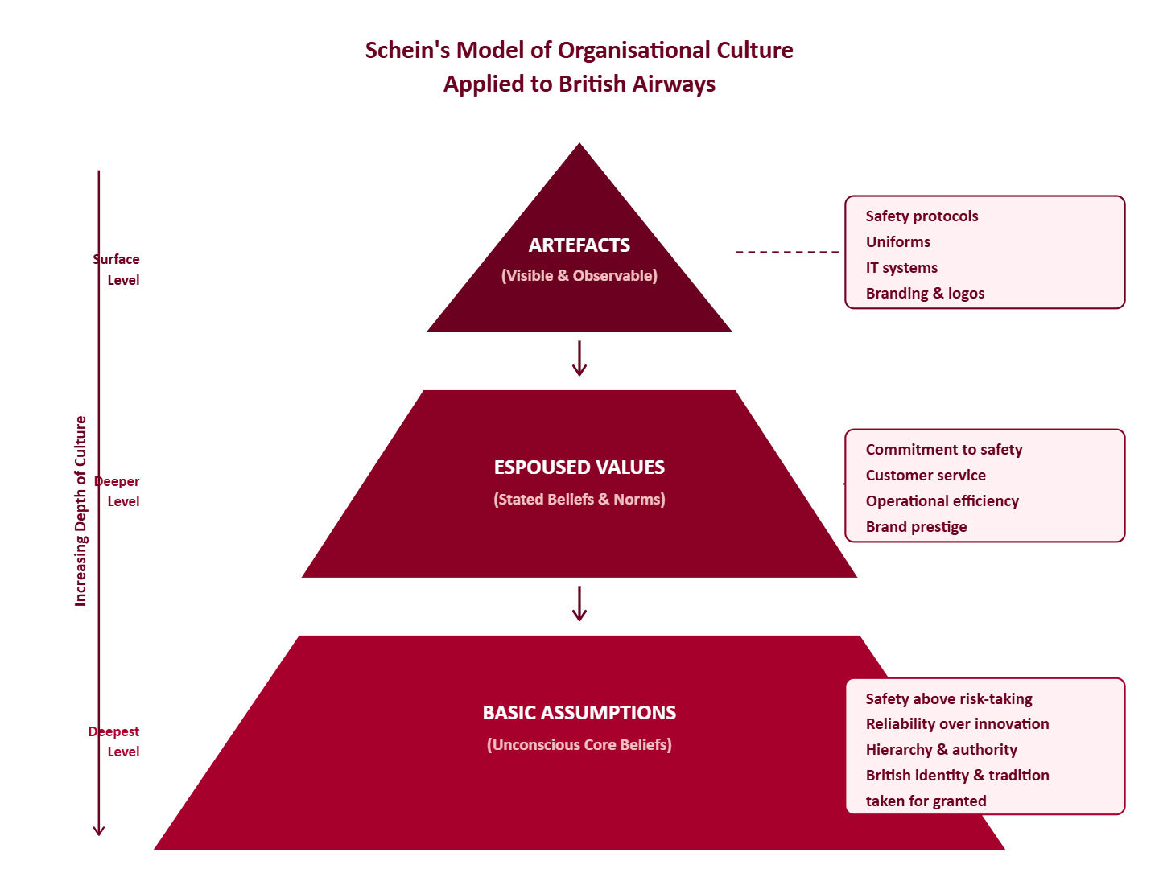
Figure 1: Schein’s Model of Organisational Culture Applied to British Airways (self-created)
The value point is that since BA has long prioritized safety and reliability in a unit culture, it has acted beneficially on its performance in operations, but it may also hamper innovation and flexibility on how the company deals with rapidly changing market conditions as shown by Alotaibi and Campbell (2022) and Cozmuta (2024).
3. Identifying Organisational Culture Types
3.1 Application of Hofstede’s Cultural Dimensions
The Cultural Dimensions are models by Hofstede that are quantitative in nature and which enable examination of cultural orientations in both a country and in an organisation (Hofstede et al., 2010). BA is based in a UK environment which has a low power distance, moderate individualism, high uncertainty avoidance, and high long-term orientation. The organisational culture of BA reflects these cultural peculiarities of countries too and influences leadership styles, decision-making and interaction within the team (Obeidat, 2020; Denham and Bratten, 2020).
To illustrate, high uncertainty avoidance will be defined as the presence of stricter safety regulations and formalised operations procedures, compliance with the demands of regulations and reduction of operations risk (Ul Haq and Faizan, 2022). In contrast, Medios individualism allows the initiative of the team members in a customer service case because it allows taking advantage of tasks in the process of making a decision without rotting hierarchical control (Tariq et al., 2021).
3.2 Handy’s Cultural Types and British Airways
The model by handy divides culture into the places of power, role, task, and person. Similar to forms of rules, job description, and hierarchical organisation, the organisational culture of BA is primarily described as role type of culture (Mullins and Christy, 2016; Sewsankar and Loewenberger, 2024). This can be seen specially in compliance-comprised fields including flight operations, maintenance, and regulatory reporting. The elements of task orientation also can be observed in the projects-specific teams such as the digital transformation and operational efficiency initiatives wherein there is the promotion of autonomy and problem-solving within a framework.
The model developed by Handy helps us to debate the aspect of cultural hybridisation in BA. A dominant culture guaranteeing stability, compliance and task culture elements that should enable the adaptation, innovation, and responsiveness to the emerging challenges provide the answer to the dual demand of both the airline in terms of safety and competitiveness on the market (Bastola, 2022; Durak and Sengur, 2024).
3.3 Prevailing Organisational Culture
The dominating culture of BA can be summarised with a safety-oriented, hierarchical role culture comprising of adaptive task-based aspects. This dynamic solution helps the airline to be reliable in terms of operations and flexibility to operate on team level to serve customers and innovate. Importantly, this cultural construct has enabled BA to overcome the cultural crises, such as the COVID-19 pandemic, changing fuel prices, and changes in regulations, retaining the fundamental operational integrity (Kankaew et al., 2021; Ul Haq and Faizan, 2022).
A visual representation of BA’s prevailing culture is provided in Figure 2:
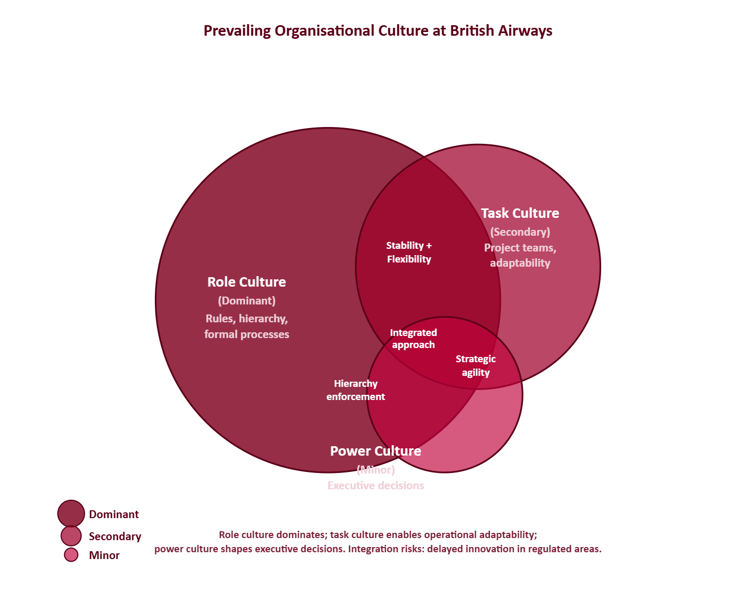
Figure 2: Prevailing Organisational Culture at British Airways (self-created)
As shown in the diagram, the role culture is most pre-eminent where as the task culture allows flexibility in the working of an organization and the power culture impacts the executive decision making process. This integrated culture approach will allow the stability and maneuverability, and also bring out potential conflicts, such as the postponement of innovation within the context of operations with stringent regulations (Cherian et al., 2021; Rahman, 2024).
4. Organisational Culture and Adaptation to External Environment
4.1 Environmental Influences on British Airways
The external environment of British Airways is overly unpredictable and subject to world economic cycles, laws, technological upset, and socio-cultural demands (Bastola, 2022; Durak and Sengur, 2024). The outbreak of the COVID-19 pandemic showed just how fragile airlines are to abrupt demand shocks, travel limitations, and operational constraints. Moreover, the environmental factors like carbon emission reduction requirements, consumer demands to service providers to be digital, and low cost airline competition require BA to be both resilient and flexible (Ul Haq and Faizan, 2022).
Of paramount importance also is organisation culture insofar as BA is reviving in response to such outside forces. The culture of safety, order, and excellence in operations makes the stability to fulfil the regulatory standard and ensures passenger safety (Mullins and Christy, 2016; Cozmuta, 2024). Meanwhile, dynamic task-related cultural assets foster innovation to enable BA to use digital means, enhance the customer experience, and address operational crises (Tariq et al., 2021).
4.2 Leveraging Culture for Strategic Flexibility
Strategic flexibility is the ability of an organisation to change its resources allocation, how operations are executed and how decisions are made to deal with the external situation (Durak and Sengur, 2024). Open to the need of customers and market, BA applies to its hybrid configuration (role and task) as a way of establishing control in operations as well as allowing teams to make decisions. One example is how cabin crew and operation teams should exercise discretion, subject to set limits, to respond to real-time disturbances, such as flight delays, passenger complaints, technical-related incidents (TING, 2023).
This adaptability is imposed in the adoption of the cultural layers proposed by Schein. The artefacts used by BA, including the digital reporting and feedback systems, help in the real-time problem-solving. Adaptive behaviour is driven by its professed values, such as safety, reliability, and service excellence, whereas the prioritisation of operational continuity and compliance across all levels is inculcated by basic assumptions (Raškaj, 2023; Malagas et al., 2022). Figure 3 below is a visual map of how BA has been cultural coping with external pressures:
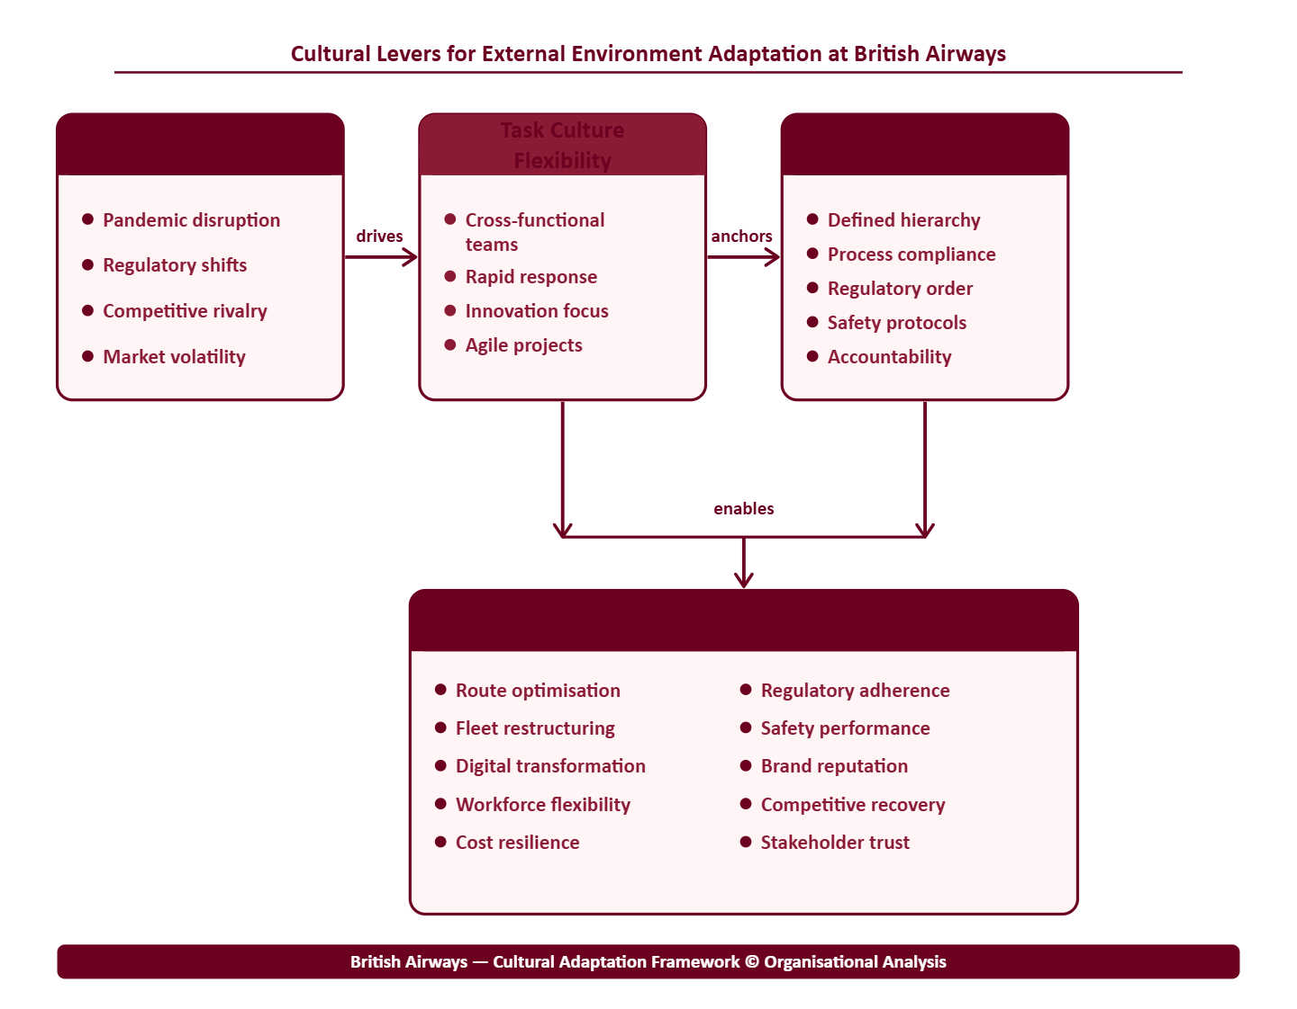
Figure 3: Cultural Levers for External Environment Adaptation at British Airways (self-created)
This structure highlights the duality of culture as stabilising and adapting process that enables BA to adapt to the unpredictability of the environment and maintain the basic principles of operation.
5. Organisational Culture as Barrier or Enabler
5.1 Culture as an Enabler
Organisational culture is a great performance facilitator at BA. A safety and compliance-oriented decrease the risk of the business, offer sustainable work, and promote brand awareness (Ahsan, 2024; Cozmuta, 2024). Novelty of customer services, digitalisation, operational efficiency are the characteristics of tasks that help BA to stand out in the highly competitive global context (Cherian et al., 2021).
The studies by Alotaibi and Campbell (2022), and by Bastola (2022) demonstrate that an appropriate fit between culture and strategic purpose might help organisations to be more agile, but study by Rahman (2024) shows that culture based on values motivates workers to be more motivated and pleased with their job. At BA, the employee engagement surveys show that culturally ingrained recognition of performance and compliance with safety measures results in a sense of loyalty, accountability, and consistency of operations (Joseph and Gaba, 2020; Sewsankar and Loewenberger, 2024).
5.2 Culture as a Barrier
Despite these benefits, the culture of BA can also be a hindrance to effective operations at least when the aspect of innovation and quick decision-making are involved. Hierarchical decision-making procedures promoted by the dominant role culture can slow down the reaction to the new opportunities arising in the market or changes in technology (Obeidat, 2020; Bennett IV and Soylu, 2021). Furthermore, cultural change, established practices and procedures might drown out the practice of agile working or cross-functional cooperation (Serfontein and Govender, 2021; Tariq et al., 2021).
All this was proven through the COVID-19 pandemic: continuity of operations was ensured, delays of strategic shifts, such as digitalization and new approaches to customer engagement, were reported, which suggests the constraints of a traditional hierarchical culture (Ul Haq and Faizan, 2022; Durak and Sengur, 2024). As such, the culture of BA both facilitates operational excellence and limits the ability of the top level to be strategic.
6. Impact of Organisational Culture on Performance
6.1 Operational Performance
The BA culture has a direct impact on how the operation will perform with regards to safety, reliability and provision of services. The systematic approach of culture that can be traced in the performance indicators of the past and academic research shows that the airline is equivalent to the international safety standards, operational accidents, and customer satisfaction (Cozmuta, 2024; Ul Haq and Faizan, 2022).
Table 2: Cultural Influence on Operational Performance at British Airways
Cultural Element | Performance Impact | Evidence
Role Culture (hierarchy, compliance) | High operational reliability, safety | Cozmuta, 2024; Mullins and Christy, 2016
Task Culture (team-based problem solving) | Enhanced customer service, operational flexibility | Sewsankar and Loewenberger, 2024; Tariq et al., 2021
Safety as Core Value | Reduced incidents, brand reputation | Alotaibi and Campbell, 2022; Raškaj, 2023

Since it is demonstrated in the table, owing to its cultural integration, BA has not just the consistency and quality in all its operations, but has the opportunity to respond to a team level.
6.2 Financial and Strategic Performance
Culture also impacts BA’s financial and strategic performance. Aman and Altass (2023) emphasise that alignment between values and strategic objectives in an organisation is conducive to the long-term profitability and competitiveness in a market. Efforts to recover revenue post-pandemic have been enabled by innovation on digital platforms, flexibility in pricing and efficiency in operations among other practices aimed at tasks (Bastola, 2022; Durak and Sengur, 2024).
Conversely, excessively using hierarchy and norms might slow down the decision making process, and this may affect time sensitive strategic projects such as alliance negotiations, or short-term changes to routes. TING (2023) notes that cultural barriers could act against operational costs and reduce being responsive to the activities of the competitors. In this regard, despite the BA culture being a support system to the basic operational and safety performance, strategic and financial agility might require tailor-made cultural adjustment.
7. Recommendations for Improvement
Based on the above critical analysis, it is recommended that the evidence based recommendations given below be implemented to enhance organisational culture and performance of BA;
- Promote Agile Leadership Practices: The top leaders should embrace the agile concepts so as to accommodate the hierarchical decision-making. This can involve decentralised making of decisions where there is a cross-functional project and digital innovation team (Bennett IV and Soylu, 2021; Sewsankar and Loewenberger, 2024).
- Enhance Change Management Programmes: There should be systematized change management programs on how culture can be reversed in digital transformation and innovation in processes. The model proposed by Kotter (1996) is culturally sensitive and its eight steps can be used to facilitate change implementation (Asikhia, 2021).
- Strengthen Task Culture in Strategic Functions: Incorporation of task-based operations in such strategic areas as marketing, IT, and customer experience can lead to increased responsiveness and innovativeness without impacting the stabilization of the operation (Durak and Sengur, 2024; Tariq et al., 2021).
- Cultural Integration for Global Workforce: If BA implies international work, it means that there are cultural integration programs that may be utilized to establish coherence within multi-diverse teams, reduce conflict and create collaboration in the regions (Malagas et al., 2022; Rahman, 2024).
- Continuous Performance Monitoring Linked to Culture: Adding indicators that identify a relationship between cultural behaviour and performance outcomes can reinforce targeted behaviours and identify barriers and improvements in continuous improvement (Ul Haq and Faizan, 2022; Hassan et al., 2021).
Figure 4 below illustrates the recommended framework linking cultural adaptation to performance outcomes:
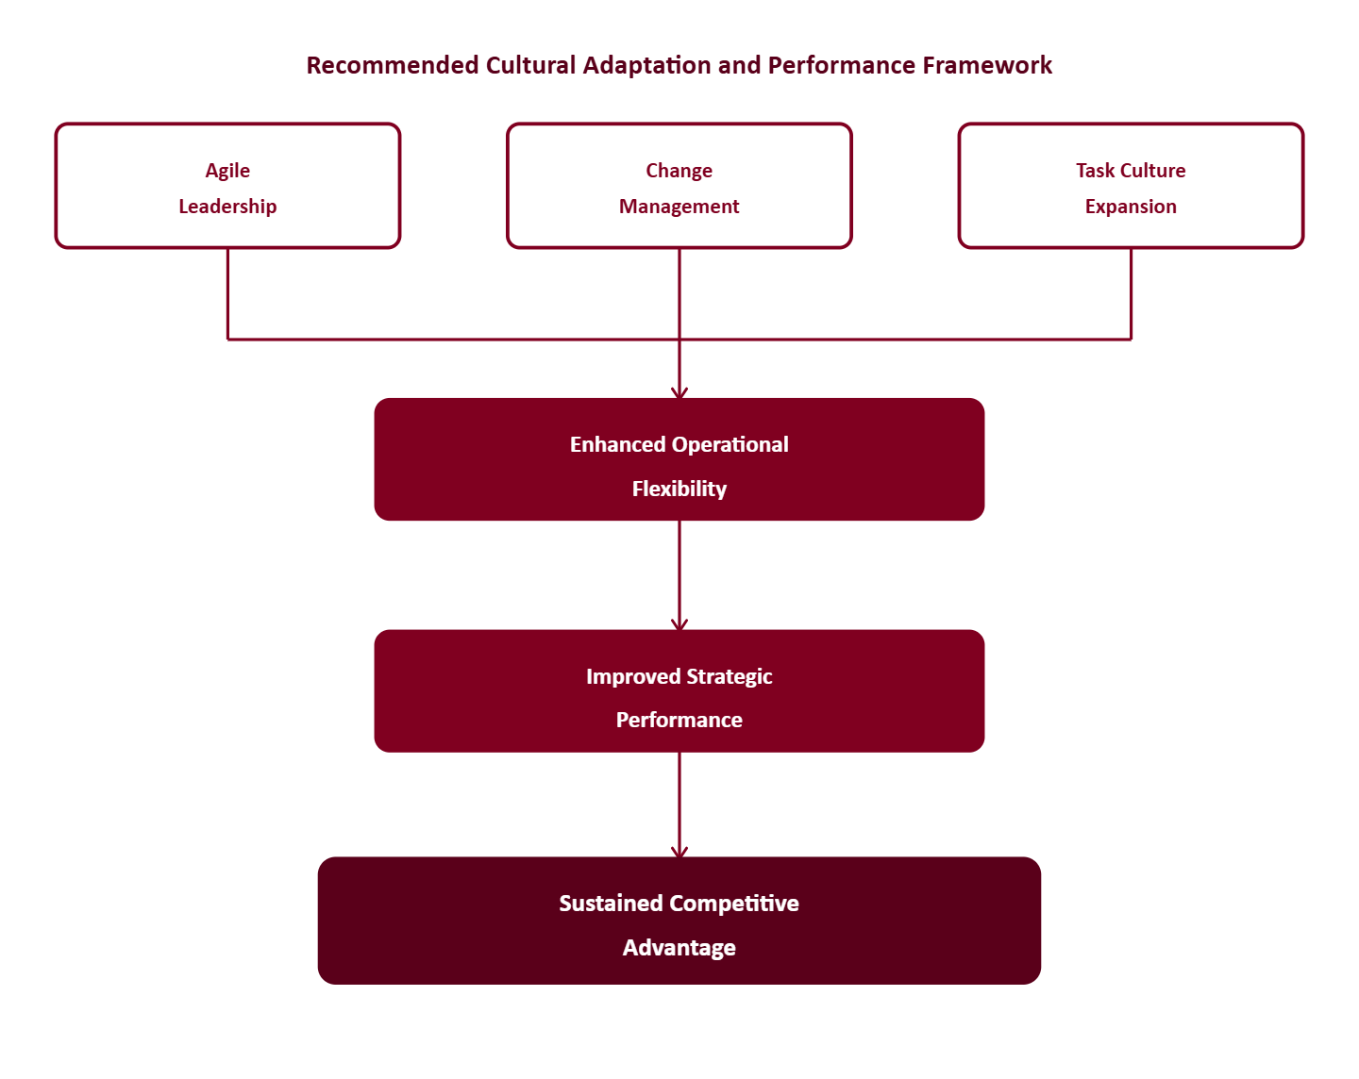
Figure 4: Recommended Cultural Adaptation and Performance Framework (self-created)
8. Conclusion
This report has critically evaluated the organisational culture of the British Airways, the impacts of the organisational culture to the organisational structure, decision making, flexibility and overall organisational performance. The culture of BA is a hybrid one (role with supplementing task-based practices). This integration helps in achieving operational reliability, safety, and compliance and offers flexibility at the team level in service provision and problem-solving.
However, the problem of quick strategic decision making can also be ascribed to hierarchical rigidity and both the potential of culture as a facilitator and barrier are apparent. Cultural benefits, focusing on the practice of tasks, and the implementation of the agile leadership and change management strategy will enable BA to enhance operational performance, the adaptation of the strategy, as well as long-term competitiveness.
The discussion shows the organisational culture is not merely a liability but a competitive advantage that has an effect on the ability of BA to respond to pressure within the environment, galvanize employees and sustain the performance. The problem of constraint of culture can be addressed with evidence-based solutions to enable the desirable behavior to be reinforced and an airline to flourish in a complex international environment.

References
Alotaibi, H.S. and Campbell, N., 2022. Organizational culture towards Saudi Arabia’s vision 2030: Evidence from national water company. Businesses, 2(4), pp.562-577.
Aman, Q. and Altass, S., 2023. The impact of debt and equity decisions on business performance: Evidence from International Airline Corporation. Amazonia Investiga, 12(63), pp.10-20.
Asikhia, O., 2021. Change management and organisational performance: a review of literature. International Journal of Advances in Engineering and Management.
Bastola, D., 2022. Strategic factors for organizational performance: A study of Aviation Industry. International Journal of Advanced Research and Publications, 5(1), pp.5-13.
Bennett IV, E.R. and Soylu, A., 2021. Overcoming the obstacles in corporate change management. Journal of Business and Social Science Review, 2(2), pp.23-29.
Cherian, J., Gaikar, V., Paul, R. and Pech, R., 2021. Corporate culture and its impact on employees’ attitude, performance, productivity, and behavior: An investigative analysis from selected organizations of the United Arab Emirates (UAE). Journal of Open Innovation: Technology, Market, and Complexity, 7(1), p.45.
Cozmuta, A., 2024. Selling ‘The World’s Favourite Airline’: British Airways’ privatisation and the motives behind it. Business History, 66(1), pp.181-200.
Durak, M.S. and Sengur, P., 2024. Managing uncertainty in the airline industry: The interaction of strategic flexibility, organizational learning, and dynamic capabilities. International Journal of Aviation, Aeronautics, and Aerospace, 11(3), p.8.
Hassan, A., Nordin, N. and Azamin, A., 2021. The influence of organizational culture and the external and internal factors on performance measurement system adoption: A conceptual framework. Asian Journal of Interdisciplinary Research, pp.101-110.
Kankaew, K., Kangwol, K., Guzikova, L.A., Kungwol, S., Sitikarn, B. and Suksutdhi, T., 2021. Organizational structure enhancing airlines efficiency amid the pandemic: Low-cost carriers in Thailand as a case. Geo Journal of Tourism and Geosites, 38(4), pp.1189-1194.
Mullins, L. and Christy, G., 2016. Management and Organisational Behaviour. 11th ed. Pearson Education Limited.
Obiedat, B., 2020. A critical conceptualisation of leadership and organisational change: The case of Royal Jordanian Airline. Doctoral dissertation, Cardiff Metropolitan University.
Rahman, M.M., 2024. Assessing the relationship between organisational culture and employees' performance: A study on private banking sector in Bangladesh. International Journal of Business Excellence, 32(2), pp.247-271.
Sewsankar, G. and Loewenberger, P., 2024. A comparative analysis of leadership styles on organisational performance in the airline industry. International Journal of Innovative Science and Research Technology (IJISRT), pp.2724-2743.
TING, H., 2023. An assessment of how to achieve competitive advantage and alleviate organizational weaknesses: Insight from British Airways. Doctoral dissertation, SIAM University.
Tariq, E., Muhammad, A., Iman, A. and Sulieman, A.H., 2021. The effect of digital marketing capabilities on organizational ambidexterity of the information technology sector. International Journal of Data and Network Science, 6(2), pp.401-408.
Ul Haq, I. and Faizan, R., 2022. Role and effectiveness of five-performance indicators in attaining competitive edge in the aviation industry. International Journal of Applied Business and Management Studies, 7(2), pp.11-51.

