- 34% of children on the autism spectrum say that the worst thing about being at school is being picked on (Reid, 2011).  - 63% of children on the autism spectrum are not in the kind of school their parents believe would best support them (Reid, 2011). | Characteristics to look out for:  - Presence of restricted interests and activities  - Impaired social interaction  - Impaired communication  - Repetitiveness of activities  - Resistance to change in surroundings  - Behaviour such as biting, pinching, kicking etc | “A persuasive developmental disorder marked by extreme unresponsiveness to others, poor communication skills, and highly repetitive and rigid behaviour”  (corner, 2007) | “SO, your child has autism ” (ASD)  INFORMATION LEAFLET
- 17% of autistic children have been suspended from school; 48% of these had been suspended three or more times; 4% had been expelled from one or more schools (Reid, 2011).  - Seventy per cent of autistic adults say that they are not getting the help they need from social services. Seventy per cent of autistic adults also told us that with more support they would feel less isolated (Bancroft et al,2012).  - At least one in three autistic adults are experiencing severe mental health difficulties due to a lack of support (Rosenblatt, 2008).  - Only 15% of autistic adults in the UK are in full-time paid employment (Redman, et al, 2009). | Possible Causes of ASD:  - Recent research found a sensitivity to Gluten but has no relationships to Celiac’s Disease  - Abnormalities in brain development  - Genetic – odds increase if parent or sibling has ASD  Geas ASD | 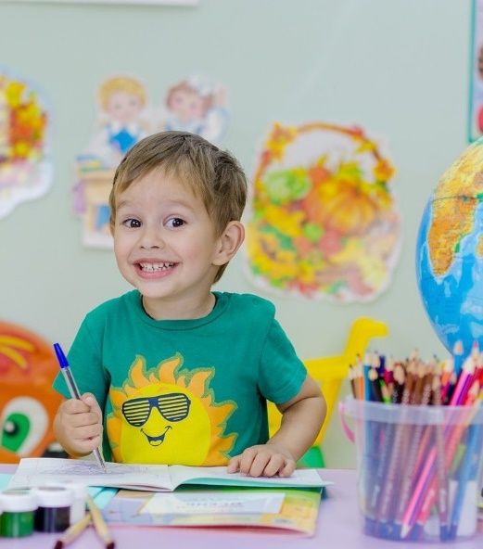 | 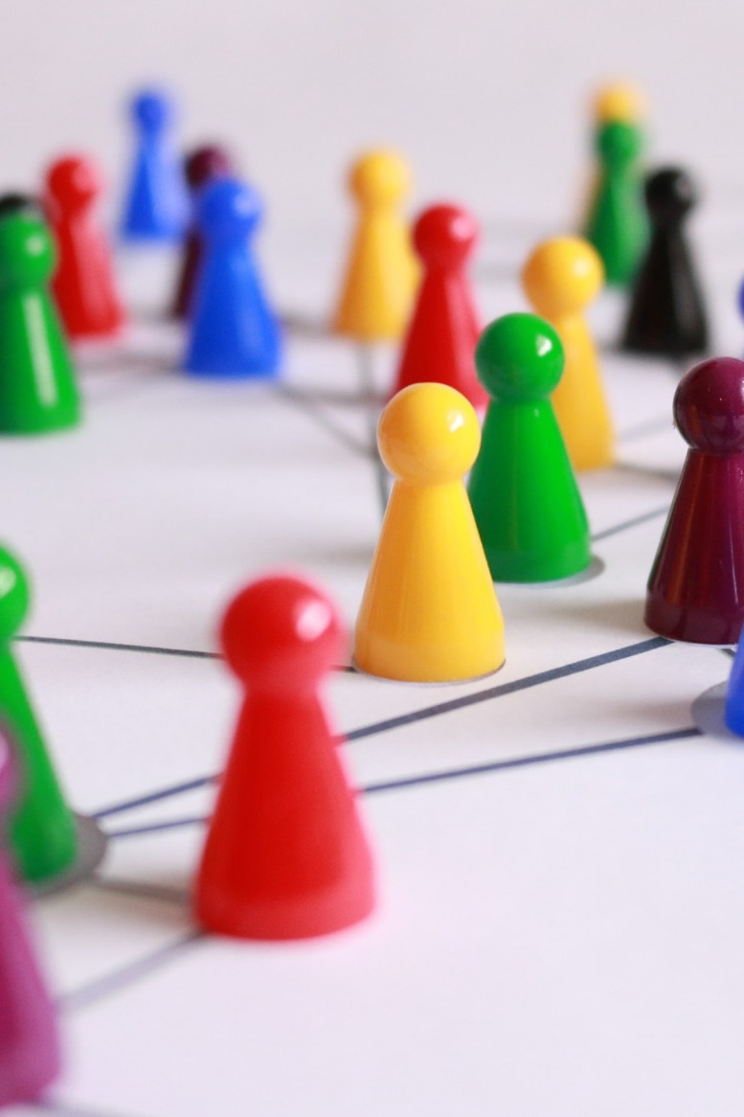
 | 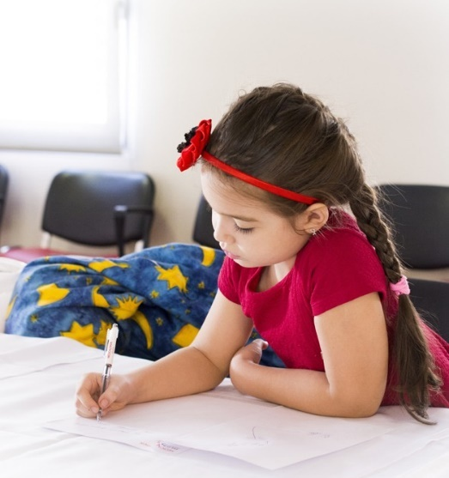 | Mothers and fathers of children with ASD report higher levels of parenting stress and poorer psychological well-being as compared to parents of children without disabilities, as well as parents of children with other types of disabilities (e.g. Ekas & Whitman, 2010; Hartley, Seltzer, Head, & Abbeduto, 2012)

“Autism is also marked by limited imaginative or abstract play and by very repetitive and rigid behaviour. Children with the disorder maybe unable to play in a very, spontaneous way. Unlike other individuals of the same age, the children may fail to include others in their play or to represent social experiences when they are playing; in fact, they often they fail to see themselves as others see them and have no desire to imitate or be like the others.  (Siegel and Ficcaglia, 2006).” | Ways in which children are affected by Autism: -  - Autistic people and their families are at risk of being isolated  - Roughly half of all sufferers fail to speak or develop language skills (Dawson and Castelloe, 1992).  - They have difficulty reading other people – recognising or understanding their emotions | Impact on children’s well being, school life and home: -  - Because of the risk of being isolated, children and families can develop mental health problems  - The family and the child will need extra support in both education and at home helping the child communicate and socialise with others  - As autistic children have difficulty reading other people, they find it hard to navigate the social world e.g. appear to be insensitive, seek out time alone, not seek comfort from others etc |  | Additional Resources  - https://gov.wales/sites/default/files/publications/2019-01/ways-of-supporting-learners-with-autistic-spectrum-disorder-asd.pdf  - https://www.autism.org.uk/about/what-is/myths-facts-stats.aspx  - 0808 8004104 Autism Helpline  - 0208 4583259 – Resources for Autism
Autistic Disorder – DSM Checklist  A total of at least six items from the following groups of symptoms:  1. A. Impairment in social interaction as manifested by at least two of the following: - a) A marked impairment in the use of non verbal behaviours such as eye to eye gaze, facial expression etc. b) A failure to develop peer relationships appropriately. c) A lack of spontaneous seeking to share enjoyment, interests or achievements with other people. d) A lack of social or emotional reciprocity.  B. Impairment in communication, as manifested by at least one of the following: a) Delay in, or total lack of, the development of spoken language. b) In individuals with adequate speech, with marked impairment in the ability to start or sustain a conversation with others. c) Sterotyped and repetitive use of language. d) A Lack of varied, spontaneous make-believe play or social imitative play. | When can Autism be diagnosed:  - It can be diagnosed as early as 1 years of age  - No babbling by 12 months old  - No words by 16 months old  - Any loss of speech, babbling or social skills at any age  - No big smiles or other warm, joyful expressions by 6 months or thereafter | 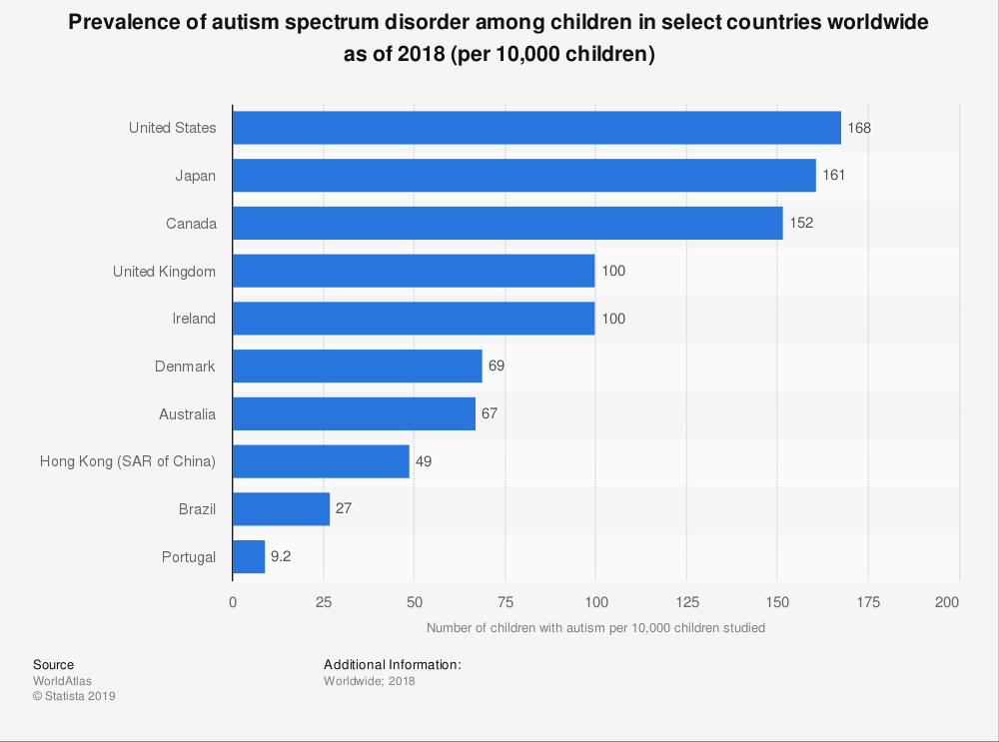 |  | Further information Enquiries about this document should be directed to:  Additional Learning Needs Branch Support for Learners Division The Education Directorate Welsh Government Cathays Park Cardiff CF10 3NQ  e-mail: additionallearningneedsbranch@gov.wales
 | C. Restricted repetitive and sterotyped patterns of behaviour, interests, and activities, as manifested by, at least one of the following: a) An Abnormal preoccupation with one or more sterotyped and restricted patterns of interest. b) Inflexible adherance to specific non functional routines or rituals. c) Stereotyped and repetitive motor mannerisms e.g hand or finger flapping or twisting. d) Persistant pre occupation with parts of objects.  2. Prior to 3 years of age, delay or abnormal functioning in either social interaction, language, or symbolic or imaginative play.  (Based on APA, 2000, 1994) |  | Additional difficulties might indicate speaking out of turn, eating, drinking and sleeping irregularities, anxiety, difficulty with managing time, finishing work, handing in or completing homework or getting to lessons on time, also, lack of appropriate eye contact and over compliance – the individual can be easily led | Medications and Alternative Treatments:  - Stimulants  - SSRI’s  - Atypical antipsychotics  - Melatonin  - Seizure medication  - Diet  - Vitamins  - Yeast Treaments  - Manipulation

