Material Science and Building Services

Construction Materials

Author – Matthew Berry
Student ID – 2320401
Date – 21/11/2023



Contents
Cover Page 3
Introduction 4
1 Salk Institute - Original Design Planning and Construction Method 5
1.1 Salk Institute – Materials Used 6
1.2 Environment Affects and Sustainability 9
2 Framing Material Analysis 11
Conclusion 14
References 15

Cover Page

The Salk Institute
Research centre created by Jonas Salk and designed by Louis Kahn in 1965.

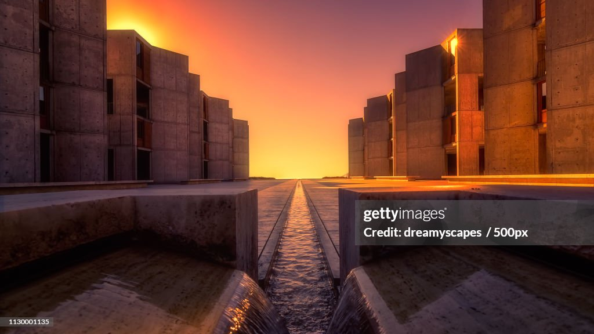
Figure 1: Salk Institute Research Centre, California (Getty Images, n.d.).

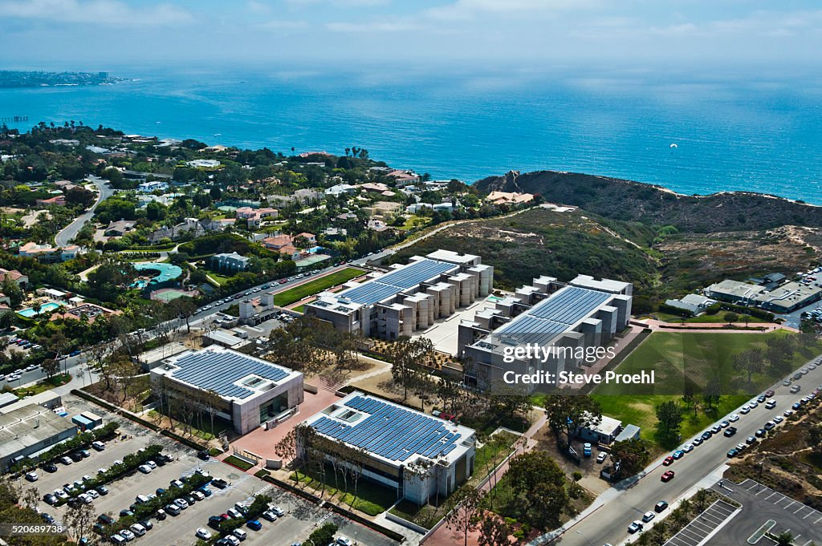
Figure 2: Bird-eye view of Salk Institute with surroundings (Getty Images, n.d.).

Introduction

The Salk Institute is a building created by Jonas Salk and designed by leading Architect Louis Khan in 1965. Jonas Salk wanted to create a research centre, an environment where collaborations may take place, the idea was different people would work to produce/discover to better the future for humanity. This case study will look at the concrete building process, where it started, and how it was created. The report will include the concrete frame, original design planning, and original construction method, with any environmental impacts causing future sustainability issues. The chosen framing materials will be analyzed, supplying information on any factors of the materials over time, due to building surroundings or potential conditions. The building process started in the year of 1959 and was completed sometime in 1965.

1 Salk Institute - Original Design Planning and Construction Method

The Salk Institute building went through three phases to create the building Salk and Kahn envisioned from the get-go, these two respected in their own professions discussed and planned to design a building made of concrete, steel, lead and glass with preservations put in place for the buildings concrete and structure to not only last over a period of time but also put in place a plan for the building to last with potential environmental factors affecting the longevity of the building.
First Phase – The first phase of the project was to work out the layout of the building, there were four buildings laid out during the plans, and a tower was designed to be in the labs. They then designed another part which would be known as the meeting house, Furthermore, this included a cafeteria and other services. The third part of the building included a recreation room, where relaxation would take place for workers, this was placed at the top of the cliff. Finally, a housing was placed at the bottom of the cliff. These four buildings were separated from each other creating the layout design (https://en.wikiarquitectura.com/, n.d.).
Second Phase – In this phase Khan reduced the height of these, achieving more area and dividing into three pavilions. The laboratories, the meeting room, and other rooms, as mentioned during the first phase, have been designed differently with different dimensions to the formal workspace. The studies had carpeting and wood while the Laboratories had glass and metal, these rooms are consistent with all phases of the project.
Third Phase – This was the final phase; the laboratories were to be divided up into two blocks which would be separated by the plaza. At this design stage, there are three floors for laboratories and three mezzanines. These floors are made higher than those designed in the second phase, the purpose is that they could walk upright, but the use is still the same regardless.

These phases show how original planning would have changed through different stages/phases of the build, to most suit what it was being used for. The same as a lot of buildings a design could come into a stage where it would need to be altered to perfectly operate, the way the building was intended. Also, the change would have been to suit the surroundings to be more effective.

1.1 Salk Institute – Materials Used

The building used materials such as concrete, teak, glass, and steel. These materials were used for different purposes. The text below will discuss materials used to build the Salk Institute buildings advantages and disadvantages.
Materials are substances used to create different kinds of products or objects. These can all have their advantages such as being strong, lightweight, and durable to a building. Furthermore, they also have disadvantages, such as being too expensive, especially when a project is limited financially. They can also be difficult to work with. Materials will be labeled and explained relative to the Salk Institute building. The Architect Kahn used materials that would be strong and durable while only requiring minimal maintenance over time. The two main components of strength and durability and the long-lasting time of the building Kahn wanted to achieve are listed below…

Materials | Advantages | Disadvantages
Concrete (LGW Group, n.d.) | - Concrete is incredibly durable – Concrete is used for main roads and walking spaces around the world, it takes heavy traffic constantly, so it’s proven to be incredibly durable over time. Concrete can cope with the most extreme weather conditions, meaning it wouldn’t break down easily in a badly weathered part of the climate. It produces unrivaled stability for structures around the world. Considering Kahn wanted to make the building durable his choice of concrete was a choice proven to this day to be a good one.  - Concrete is extremely long-lasting – Concrete strength speaks for itself over time, with buildings still standing today, built by the Romans. For example, the Ancient Romans used their concrete to build the Pantheon Dome, including the roof which is made up of concrete and still standing to this day, believed to be around 126 – 128 A.D. Today the monument is used as a tourist attraction.  - Concrete can be used for a variety of purposes: Kahn used concrete masterfully. Kahn would examine the sand under a microscope, looking for the perfect hue, he didn’t want it too green or too blue but like most concrete it had to have warmth. “The concrete has an enormous warmth to it and changes in beautiful ways as the sun moves around or the fog rolls in,” says Nathaniel Kahn, son of Louis Kahn and creator of the Oscar-nominated 2003 documentary My Architect.” (Kahn, 2003) | - Concrete often needs to be reinforced – While concrete is a durably proven product it can also need reinforcing with steel rods, for example any building with an open area like a window/door will need a concrete linter or steel depending on the span. Concrete lintels are reinforced with steel rods given the pressure weight from above.  - Concrete can crack if not installed professionally – Concrete needs to be mixed and installed professionally, if the mix isn’t correct before it's been poured this could lead to cracks, which in turn leads to questions over its integrity and strength. This incredible design and proven longevity has proven Kahn and his professional constructors have got this one right.
Steel (Anon., n.d.) | - Reliability – Steel structures are more than reliable. Reliability is generated through steel's incredible elasticity and ductility. Steel is yield tested in laboratories to determine ultimate strength and elongations, the results show that the variations are much lesser than other materials like concrete and wood.  - Lesser construction time/Greater erection speed - Whilst working to a budget before any build, financials are always a factor, steel can be cheaper in both materials and labor costs. This makes the progress of work faster also making the structures economical.  - Elasticity – Thanks to Hook’s Law, it is proven that steel stress produced remains proportional to the strain applied to the stress-strain diagram and remains a straight line. This is perfect for harsh conditions around the world like in California where the Salk Institute is built, due to California being vulnerable to earthquakes. | - Corrosion -Corrosion would occur if exposed to water/air and oxygen causing steel to weaken and needing treatment regularly. Considering the Salk Institute is close to the Arctic Ocean there could have been issues with steel corrosion, although, the steel was preserved and put in place to withstand these environmental issues. The time spent has proven this.  - Higher Initial Cost/Less Availability – Steel isn’t available in abundance in certain countries due to its high cost. This is a factor in the decline of steel structures in these countries.

1.2 Environment Affects and Sustainability

Salk and Kahn created a monument to science and innovation for years. The building is located in California near the Pacific Ocean, this in a lot of cases may lead to environmental effects on the building such as exposure to water, wind, and air, therefore, causing defects for any building over a period of time. Furthermore, California potential risk for frequent earthquakes, this part of report will show what precautions were taken for the Salk Institute building to be environmentally sustainable across decades to date.
Kahn chose materials to endure materials like concrete, steel, and teak. Equally important to Salk’s durability is what Salk called “an investment in flexibility (Salk. Inside Salk., 2019).”
Energy – Kahn had installed several photovoltaic (PV) panels exceeding 2000. These (PV) panels were spread across the roofs of the institute’s buildings. The panel's purpose is to naturally capture the sun’s energy and convert it into electricity, by adding such panels, renewable energy can be generated continuously with the correct amount of heat. For Kahn to achieve this during that time was nothing short of incredible. During the sunniest times of day, these panels generated almost half a megawatt of energy, this is the equivalent of powering 400 homes.
Water – Salk and Kahn added a collective of Californian Native plants locally, along with other drought-tolerant vegetation this in turn reduces the amount of water needed for future landscaping. Furthermore, recycling of tree trimming was used as chippings and compost to create and retain precious moisture in the ground. A 250,000-gallon tank was also installed underground, the purpose was to collect valuable rainwater to achieve replenishment of the “river of life” running through the centre, as well as the fountain at its west end side building.
Green Roofs – A green roof’s purpose is to reduce the flow of stormwater from a roof by up to 65%, delaying the flow rate by up to three hours. Green roofs reduce the interior energy of the building, using cooling roofs, thermal mass, and insulation. A green roof contributes to helping the environment. Carbon Dioxide is one of the key components of Global Warming, green roofs are positive for the building decreasing CO2 emissions from the building, this is because green roofs reduce the need for air conditioning, also reducing heat needed for the winter, both air-con and generation of heat create CO2 (Green Roofers, 2016).
Light – During Kahn’s design he purposely added large windows and lightwells, the purpose was to capture the natural sunlight, which is good for the environment. Today, they have additionally fitted motion-sensing LED lighting, being made efficient so that electricity isn’t wasted, whilst lighting up empty space during the day or night.
Green products and partners – To this day, seven decades on, the institute still looking at purchasing ‘green’ products as a first choice, to keep the memory alive from the masterful design that was created by Louis Kahn. For example, any necessary products used inside the building such as cleaning products and hand soap, they make sure what they order is certified ‘green’ this in turn ensures no pollution is caused in the waste stream. During the landscaping and maintenance process at the building, the management are only permitted to use quiet, non-polluting, electric mowers and blowers to maintain the site and keeping the phenomenon build immaculate.
Recycling is a major part in the building to keep the site ‘green’ by correctly recycling paper, plastic, and batteries, etc…

2 Framing Material Analysis

The chosen materials were chosen based on lasting weather conditions and potential hurricanes on the edge of the Pacific Ocean. The beams had holes to make them more flexible to withstand the effects of any potential hurricanes. The concrete was chosen as mentioned the proven pure strength and durability of this product over time. Teak wood was used, being so close to the see with wind and rainy conditions a potential to cause rotting. These are all materials that have withstood a length of time. Furthermore, the argument would be against having to maintain these materials over time, towards the end of the project, the money was running out which caused cheaper materials options like sealants, and the omission of weather seal strip. This over time with tricky weather conditions has shown the sealants not adhering to concrete and teak, this being a knock-on effect causing moisture to infiltrate through the window walls. The growth of a biofilm on the surface of the wood caused the teak to show a black shading, varying significantly by exposure. Several cleaning attempts have been made to remove the film, although none have been long-lasting.
Cement is proven to be one of the main producers of carbon monoxide and greenhouse gases. It is believed that concrete causes damage to the most fertile layer of the earth, the topsoil. This is a harmful bi-product to the Salk Institute building, although this can be said for most things around the world that use cement e.g., roads, buildings, and walkways. Today there are alternatives, but contrasts can always be made between materials, always coming up with advantages and disadvantages in comparison.
The Salk building is mostly made up mainly of concrete, and the surroundings being near the Pacific Ocean, weather conditions can become harsh, also being in California where earthquakes can be common, with a lot of wind and water effects during harsh weather. This could impact the social and ecological environment with Air pollution from the concrete dust from the building or whilst used during the original construction process. Concrete is made up of additives, these additives are very useful to its strength and finished compaction although harmful, some being toxic, due to its surroundings the dust from the concrete can cause toxicity if breathed in by people living close by causing pollution in the air. Furthermore, this toxicity contributes to harming the environment. This is an example of concrete effects before, during, and after the social and ecological environment (Science Museum, 2021).
The concrete manufacturing process would chemically use Calcium, Silicone, Aluminum, and Iron amongst other ingredients, chemically controlled to be added with water, sand, and rock to form finished concrete. Water is added to sand and cement to create this tough finished concrete material to withstand heavy loads and last over a long period of time, the mix needs to be done correctly to avoid any lose, non-filled areas, these discrepancies can cause the concrete to become weak over time instead of strengthening. The process of making the concrete needs to be poured with any potential air pockets in the base to make sure every square inch of the pour has no voids (PCA AMERICAS CEMENT MANAFACTURERS , n.d.)
This building was built seven decades ago, a time where the earth wasn’t as in such a state as it is today, with concrete being the most damaging to the earths most fertile area (top soil). There are ways where concrete can be recycled and reused and recycled today, this needs to be promoted more to mitigate concrete being so damaging to the earth. The recycling of concrete means reusing old stuff by turning it into aggregate, this drops the demand for new material to create new. This option is a great start, reusing old material that has already influenced the environment instead of using new to second and third the process over again, can be a step forward in protecting the environment.

Kahn used Pozzolanic concrete to construct the building, which was first formulated by the ancient Romans, this cement was used to create several buildings years before, way before its time should not have been possible, and this still baffles leading Architects and scientists in the 21st Century as to how they were able to create such monuments, during a time less advanced as today. These buildings were so famous by the Romans as the time we live in now, without the advanced machinery and technology we have, it is hard to answer how they were able to achieve these unbelievable masterpieces with concrete created by themselves.
This Concrete produced and used by the Romans gives great water resistance due to the volcanic pumice aggregate and cement mixture.
Khan’s idea of spreading out the massive buildings makes it harder for harsh weather conditions to break down numerous buildings as opposed to an individual concrete frame.
Concrete frames can be built in different shapes and sizes, shaping of a building can add or take away strength. For example, a triangle-shaped building is seen as the strongest structure of a building, the theory is that it has three corners to support its load, The Salk Institute was built standard and most common rectangular configuration, this isn’t the strongest but considering the building had open spaces and had a load of steel built inside also the strength of the building will become enhanced. The shape of a building can be affected and breakdown easier, especially given the conditions the Salk Institute is exposed to. Given the building is still standing 70 years on, the addition of steels with holes drilled into them to enhance flexibility in case of heavy winds, earthquakes, the fact is it has barely been maintained or nothing has been construction ally changed on the building, shows how well built this was years before its time should have been (Phoenix Reinforcing, 2021).

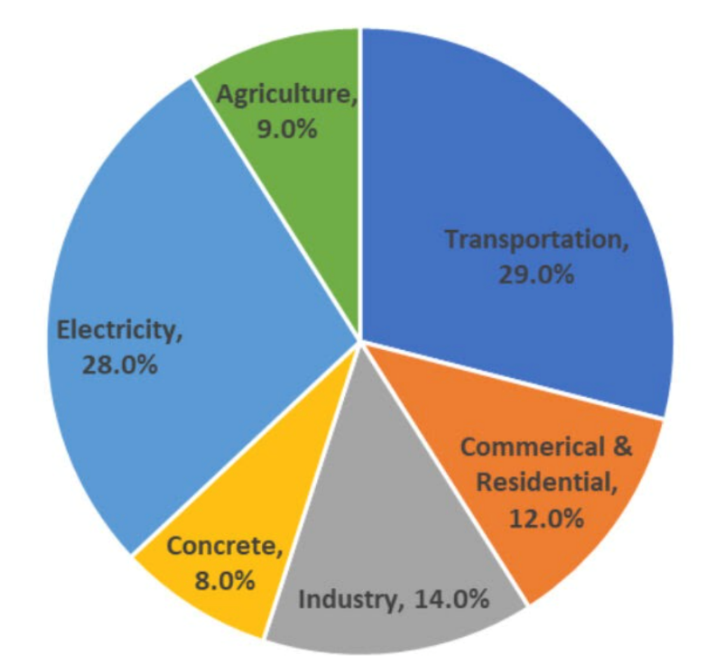
Figure 5: This shows concrete making up 8% of overall global carbon emissions, chart showing concrete as a harmful bi-product (Ramsden, 2020).

Conclusion

In conclusion, this build was a masterpiece all in all, considering the time frame it was built, well ahead of its time through materials of science. The fact Salk and Kahn were able to produce a concrete building using only minimal materials with the idea of it lasting a length of time, considering the fact apart from some minor maintenance on the building to this day, no serious defects or flaws in the build, the choice of materials have been an overall success. The use of steel with the great advantages steel possesses over a long period, one of the reasons using this material was to repel future earthquakes, the concrete is today still in the same shape with the same strength as it was when built seven decades ago, the teak, although the most repairs being on the teak wood around the windows, the conclusion is this is a minimal repair considering 77% of the original teak has been kept, which shows only minor repairs being made around the original.
Overall, a monumental building, built for a good cause to enhance humanity studies, has proven to have withstood the test of time in conditions and surroundings even now would take major planning and preparations.
When comparing materials, the two mains used for this building that come to mind are concrete and steel. Concrete and steel complement each other brilliantly and only add to the strength of a building, this has been proven time and time again, when you look at how many times concrete and steel are used together to create the stronger and most durable outcome, its common. These have similar strength abilities and both very durable. The opinion is these have their own important characteristics, advantages, and disadvantages during the process of building projects. Concrete, if prepared and fitted correctly becomes stronger and stronger over time which gives the impression becoming weak isn’t an option, again, if prepared and poured correctly. Concrete is strong and durable, if you look at the amount of highways and bridges made out of concrete, it shows the shear strength of this product, physically and mentally.

References

Anon., n.d. Advantages & Disadvantages of Steel Construction. [Online]
Available at: https://structural.community/articles/advantages-of-steel-construction/
[Accessed 27 11 2023].
Getty Images, n.d. Salk Institute - gettyimages. [Online]
Available at: https://www.gettyimages.co.uk/detail/photo/salk-institute-royalty-free-image/520689742?adppopup=true
[Accessed 28 11 2023].
Getty Images, n.d. Salk Institute At Sunset. [Online]
Available at: https://www.gettyimages.co.uk/detail/photo/salk-institute-at-sunset-royalty-free-image/1130001135?adppopup=true
[Accessed 22 11 2023].
Green Roofers, 2016. ADVANTAGES AND DISADVANTAGES OF GREEN ROOFS. [Online]
Available at: https://www.greenroofers.co.uk/green-roofing-guides/advantages-disadvantages-green-roofs/
[Accessed 27 11 2023].
https://en.wikiarquitectura.com/, n.d. Salk Institute for Biological Studies. [Online]
Available at: https://en.wikiarquitectura.com/building/salk-institute-for-biological-studies/#
[Accessed 26 11 2023].
Kahn, N., 2003. A Masterful Design. [Online]
Available at: https://inside.salk.edu/spring-2017/intersection-masterful-design/
[Accessed 27 11 2023].
LGW Group, n.d. Pros and Cons of Concrete Construction. [Online]
Available at: https://www.lgwgroup.co.uk/news/the-pros-and-cons-of-concrete-construction#cookieagree
[Accessed 27 11 2023].
PCA AMERICAS CEMENT MANAFACTURERS , n.d. How Cement is made. [Online]
Available at: https://www.cement.org/cement-concrete/how-cement-is-made#:~:text=Concrete%20is%20formed%20when%20portland,aluminum%2C%20iron%20and%20other%20ingredients.
[Accessed 28 11 2023].
Phoenix Reinforcing, 2021. Steel and Concrete: The Perfect Combination for Construction. [Online]
Available at: https://phoenixreinforcing.com.au/uncategorized/steel-and-concrete-the-perfect-combination-for-construction/
[Accessed 28 11 2023].
Ramsden, K., 2020. CEMENT AND CONCRETE: THE ENVIRONMENTAL IMPACT. [Online]
Available at: https://psci.princeton.edu/tips/2020/11/3/cement-and-concrete-the-environmental-impact
[Accessed 27 11 2023].
Salk. Inside Salk., 2019. Substainability Salk Style. [Online]
Available at: https://inside.salk.edu/spring-2019/analysis/
[Accessed 27 11 2023].
Science Museum, 2021. BUILDING THE MODERN WORLD: CONCRETE AND OUR ENVIRONMENT. [Online]
Available at: https://www.sciencemuseum.org.uk/objects-and-stories/everyday-wonders/building-modern-world-concrete-and-our-environment
[Accessed 28 11 2023].

