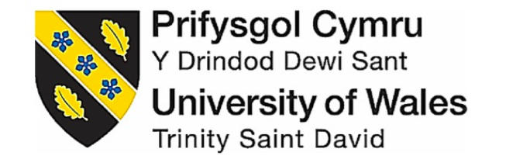

To critically explore the demand for FaceBook to integrate Corporate Social Responsibility to improve brand perception
By Emily Miller
1706535

Dissertation submitted as part of the requirements for the award BA (HONS) Business Management
UWTSD SWANSEA
May 2020

Declaration

This work has not previously been accepted in substance for any degree and is not being concurrently submitted in candidature for any degree.
Signed……………………………..
Date…29/05/2020……………………………

STATEMENT 1
This dissertation is being submitted in partial fulfilment of the requirements for the degree of BA.
Signed………………………………
Date…29/05/2020…………………………….

STATEMENT 2
This dissertation is the result of my own independent work/investigation, except where otherwise stated. Other sources are acknowledged by footnotes giving explicit references. A bibliography is appended.
Signed……………………………….
Date…29/05/2020…………………………….
STATEMENT 3
I hereby give consent for my dissertation, if accepted, to be available for photocopying and for interlibrary loan, and for the title and summary to be made available to outside organisations.
Signed…………………………………
Date…29/05/2020……………………………….

STATEMENT 4
I hereby give consent for my dissertation, if accepted, to be available on the university’s IT system to those who have consent to use the system.
Signed…………………………………
Date…29/05/2020……………………………….

Acknowledgements

I would like to thank my dissertation supervisor Julie Thomas for all the guidance she has provided throughout this process. I would also like to thank the lecturers, Caroline Jawad, Gareth Hughes, and Julie Hayward who over the past three years have helped me to achieve my best.
I am greatly thankful to all my friends and family who shared my questionnaire and all those who took time out of their day to be a participant.
I am particularly thankful to Daniel Hengstenberg for taking the time to proof-read numerous reports and essays, which has helped me improve the standard of my work.
Lastly, I would like to thank my mum, dad and sister who have provided me with constant support and guidance throughout my whole time at University and have believed in me every step of the way.

Abstract

The aim of this dissertation aim was to critically explore the demand for FaceBook to integrate corporate social responsibility to improve brand perception. A set of objectives were created to achieve this aim, they are as follows:
- Examine previous academic literature surrounding CSR and brand perception and analyse the impact integrating methods of CSR have had on similar organisations.
- Conduct primary research in the form of an online questionnaire which will evaluate FB current brand perception and determine the CSR responsibilities most effective in improving FB brand perception.
- Synthesise previous academic literature and collected primary research to draw a conclusion on FB’s current brand perception and make recommendations on how they can improve their brand perception.
The aim of the dissertation and objectives were fulfilled by analysing a substantial amount of existing literature concerning CSR and brand perception. Articles and journals relating to how people view FB was also examined which assisted in identifying whether there is a need for FB to integrate CSR. The findings from chapter two were used to generate questions for the questionnaire.
An online questionnaire was produced and distributed via WhatsApp and Instagram. In total there was 141 respondents. The primary research supported much of the findings in chapter two. The first theme to be established was that FB is associated with being a “older generation” platform. Secondly the FB-CA scandal caused participants to have a lack of trust in FB. Lastly it was established the most influential responsibility for improving FB brand perception was a legal responsibility. An ethical responsibility was the second most chosen responsibility which suggests that there is a need for FB to integrate CSR to improve brand perception.
Contents
Declaration 2
Acknowledgements 4
Abstract 5
List of Tables 10
List of Figures 1
Abbreviations 1
Coronavirus Statement 1
1.0 Chapter One – Introduction 1
1.1 Problem orientation 1
1.2 Background of the research problem 1
1.3 Rationale 4
1.4 Aims and Objectives 5
1.5 Research 5
2.0 Chapter two – Literature Review 6
2.1 Corporate Social Responsibility 6
2.1.1 Shareholder vs Stakeholder theory 7
2.1.2 Ethical CSR 9
2.1.3 Legal CSR 11
2.1.4 Economic Corporate Social Responsibility 12
2.2 Brand equity 14
2.2.1 Perceived quality 14
2.2.2 Brand Awareness 15
2.2.3 Brand Association 15
2.2.4 Brand loyalty 16
3.0 Chapter 3 – Methodology 18
3.1 Research onion 18
3.1.1 Research Philosophy 19
3.1.3 Research Approach 19
3.1.4 Research strategies 20
3.1.5 Research choice 20
3.1.6 Time horizons 20
3.1.7 Techniques and Procedures 21
3.2 Reliability and Validity 25
3.3 Limitations 25
3.4 Ethical considerations 26
3.5 Conclusion 27
4.0 Chapter4 -Data Analysis 28
4.1 Introduction 28
4.2 Data Analysis 28
4.3 Methods 29
4.4 Demographics 30
4.4.1 Question 2 30
4.5 Question 3 31
4.6 Question 4 34
4.7 Question 5 38
4.8 Question 6 39
4.9 Question 7 42
4.10 Question 8 42
4.11 Question 9 43
4.12 Question 10 46
4.13 Question 11 48
4.14 Question 12 50
4.15 Question 13 52
4.16 Triangulation of findings 52
4.17 Conclusion 53
5.0 Chapter 5 – Conclusion 54
5.1 Introduction 54
5.2 Conclusion 54
5.3 Recommendations 56
5.4 Limitations 56
5.5 Recommendations for future research 57
5.6 Self-reflection 57
Bibliography 58
Appendices 74

List of Tables

Table 1 FB stakeholder matrix 9
Table 2 Age demographic 29
Table 3 Familiarity frequency table 30
Table 4 Age and Familiarity crosstabulation 31
Table 5 Age and Familiarity collapsed crosstabulation 32
Table 6 Age and Familiarity Chi-Square Test 32
Table 7 Favourable Frequency table 33
Table 8 Age and Favourability crosstabulation 34
Table 9 Age and Favourability Chi-Square test 35
Table 10 Favourable and Familiar crosstabulation 36
Table 11 Favourable and Familiar Chi-square test 36
Table 12 Nodes table 37
Table 13 Age and perception ranks 40
Table 14 Age and perception Mann Whitney U test 40
Table 15 FB-CA bar graph 41
Table 16 Independent sample T test 44
Table 17 Responsibility frequency bar graph 45
Table 18 Responsibility and Age crosstabulation 46
Table 19 Responsibility and Age Fishers Exact test 47
Table 20 Response bar graph 48
Table 21 Q12 Responses 49
Table 22 Q11 and Q12 Crosstabulation 50
Table 23 Q11 and Q12 Chi-Square test 50

List of Figures

Figure 1 Conceptual framework for research 4
Figure 2 Interaction of stakeholders with a firm (Polonsky, 1995) 8
Figure 3 The pyramid of CSR, (Carroll, 1991) 12
Figure 4 The Research Onion, (Saunders et al, 2007) 18
Figure 5 Nodes Concept map 38
Figure 6 Q8 Word cloud 42
Figure 7 Q13 Text search query 51

Abbreviations

FB – FaceBook
CA – Cambridge Analytica
H1 – Alternative hypothesis
H0 - Null hypothesis

Coronavirus Statement
After the UK implemented a 24-hour curfew in March 2020, UWTSD took steps to support the research student and research during the curfew and University building closures.
Formal supervision meetings continued as much as possible and arranged via suitable meeting software and documents shared electronically.
Some research was at greater risk to delays, for example within this dissertation the researcher was no longer able to undertake interviews in person. Supervisors and research students urgently reviewed their research plans. UWTSD understands that some students’ projects and dissertations such as this one was planned to require in-person research and data collection that is not possible in this period of remote learning. Digital research activities that advance the studies, were prioritised. If it was no longer possible to continue with the existing plan then consideration to changes to the project plan should be considered to offset, wherever possible, undue future delays to the project/dissertation submission. All fieldwork conducted by students occurred remotely using electronic means wherever possible.

1.0 Chapter One – Introduction
The fundamental aim of this dissertation is to examine if there is a need for FaceBook (FB) to integrate Corporate Social Responsibility (CSR) strategies to improve their brand perception. Previous studies have focused on why social media platforms such as FB are important to CSR, (Dutot et al., 2016; Golob et al., 2013) but very little research has been carried out on whether there is a need for social media platforms such as FB, to integrate CSR strategies into their business plan to assist in improving brand perception: an area which this dissertation hopes to contribute in fulfilling.

1.1 Problem orientation
A brand is a set of perceptions which consumers believe a service represents not what the company claims to be, (Yaniv and Farkas, 2005; Kervyn et al, 2012). Brand perception is often known to be, “the added value given by current and potential consumers to the brand name”, (Foroudi et al., 2018, pg2.). Many studies have found that having a good brand perception can generate positive outcomes for an organisation as it strengthens business-consumer relationships, (Hess et al.,2011; Veloutsou, 2007). Coinciding with brand perception is consumer trust. Improving consumer trust affects the attractiveness of an organisation and improve brand perception, (Kim et al.,2015). The topic of consumer trust has gained a lot of press attention and has become a mainstream issue for FB over the past three years due to the FB-Cambridge Analytica (CA) scandal in 2018. This revealed over 50 million FB accounts had been harvested for CA in a major data breach, (Cadwalladr and Graham-Harrison, 2018). CSR can be used to improve brand trust and establish a positive relationship with FB overall improving brand perception, (Lai et al, 2010).

1.2 Background of the research problem
The entirety of CSR can be discerned by the three terms found in its title phrase: ‘corporate,’ ‘social,’ and ‘responsibility.’ One of the earliest contributors to CSR literature is Howard R. Bowen who raised the question “What responsibilities to society may businessmen reasonably be expected to assume?”, (Bowen, 2013. Pg17). There are numerous definitions for CSR one being, “the responsibilities corporations have to their stakeholder groups”, (Johnson et al, 2008) another by Heald (1957) declares, “an obligation to the society it serves not only for maximum economic performance but for humane and constructive social policies as well”, (Rahman, 2011). CSR has a long history which evolved to cover the obligations corporations have to the societies which they are based and operate to assist in achieving long term sustainable corporate success, (Rahman, 2011; Lee-Davies, 2005). CSR is becoming increasingly observed on the business agenda as it is connected to many other aspects in an organisation such as Consumer engagement and brand loyalty, (Grayson, 2004; He and Lai, 2014). Lego, Microsoft, Google, and Intel are all organisations which have successfully incorporated CSR practises. These companies are being perceived by consumers as the most socially responsible, (Strauss, 2017). However, existing literature covering FB in connection to CSR is very sparse and the overall perception of FB is negative. The internet is inundated with articles of instances where FB has mistreated and exploited user’s data, (Bertot et al., 2012; Doward et al., 2017).
Social media refers to websites and applications that enable its users to exchange content with other users quickly and efficiently, it has transformed the way information is shared through communities and around the world, (Mayfield, 2008). There are numerous social media sites the most popular being FB, YouTube, Instagram, Weibo, Twitter, and Reddit, (Greenwood, Perrin, Duggan, 2016). This dissertation will be analysing FB, although the company owns Instagram, WhatsApp, and Oculus, (Shead, 2019) the researcher will be only analysing FB the platform not the corporate.
The number of people using social media is rapidly rising. One report recorded 90% of young adults aged 18 to 29, 65% of adults and 35% of seniors aged 65 and above are currently using a form of social media, (Perrin, 2015). In 2019 it was recorded that 79% of the American population had a networking profile, (Statista, 2019). FB has 2.5 billion monthly active users making it the largest social networking site globally and has the vision of giving people the power to build community and bring the world closer together, (Zuckerberg, 2017; FB users worldwide 2019, Statista, 2020). There has been a major increase in the use of social media as more people and business are recognising the benefits of using platforms like FB which can be adopted and utilised as sources of income, It is reported that the type of generation choosing to use social media is altering as generation Z and millennials are spending less time using platforms such as FB but generation X and baby boomers are using FB the most frequently, (Viens, 2019). In 2010, 88% of marketers were using social media and were spending over 60 billion dollars annually on advertising, (Whiting and Williams, 2013). Social media has become the pinnacle for successful businesses. It allows businesses to communicate with customers enabling them to build relationships and target potential customers, (Lovejoy and Saxton, 2012). The creation of Virtual customer environments (VCEs) is formed from online communities which share the same interests are grouped around specific firms, brands, and products, (Scott, 2015). These environments create value for businesses by driving traffic, generating sales by advertising, create customer satisfaction through customer service and aid in product development by generating an increase in revenue, (Scott, 2015). With so many users and uses, platforms such as FB need to be conscious of the impact, they are allowing their platforms to have on society, this can be achieved by practising CSR. The development of CSR means that businesses such as FB can improve their brand image by changing user attributes towards the company, (Bertels and peloza, 2008).
CSR claims to improve brand identity if there is a long-term commitment to CSR activities and if it is incorporated into building user trust it can sustain long-term relationships; "CSR activities create and nurture consumers' trust in the company, which in turn, bring about consumers' positive or improved perceptions of the firm”, (Park et al., 2014).
There is a landscape of CSR theories and approaches that have been developed, (Carroll, 1999), for this dissertation the conceptual framework published by the Global Business and Management Research Journal which was built by incorporating Aaker's model (1991) on brand equity and Schwartz and Carroll’s model (2003) of CSR, will be used as a structure in chapter two, (Niazi et al., 2012). This framework has been chosen as it lists the constructs and key variables which influence relevant to this study. Exploring each of these headings will provide an in-depth analysis of FB current brand perception and CSR theories.
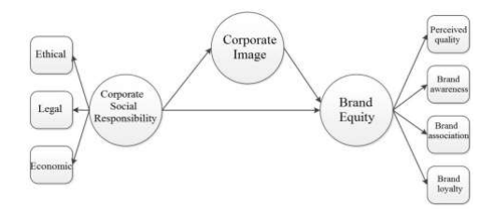
Figure 1 Conceptual framework for research

1.3 Rationale
There is research concerning the relationship of using social media platforms to communicate CSR values towards consumers which can lead to improved brand perception, (Vernuccio, 2014), but there is minimal research examining the importance of FB integrating CSR strategies to improve their brand perception. As previously identified the internet is inundated with articles discussing FB’s poor reputation, exploiting its members and their social networks by exposing them to commercialisation, (Lilley and Gumbus, 2012). This dissertation will discuss the advantages of incorporating CSR practises, analyse FB current brand perception and investigate through the means of secondary and primary research what the most valuable CSR responsibilities individuals consider to be, which if acted upon by FB would improve their perception.

1.4 Aims and Objectives
The purpose of this investigation is to critically explore if there is a demand for FB to integrate CSR strategies to improve their brand perception. The objectives are as follows.
- Examine previous academic literature surrounding CSR and brand perception and analyse the impact integrating methods of CSR has had on similar organisations.
- Conduct primary research in the form of an online questionnaire which will evaluate FB current brand perception and determine the CSR responsibilities most effective in improving FB brand perception.
- Synthesise previous academic literature and collected primary research to draw a conclusion on FB’s current brand perception and make recommendations on how they can improve their brand perception.

1.5 Research
An online questionnaire will be produced using the online survey tool Google forms. By complying with the five principles of research ethics the research carried out will cause no harm to those involved. The researcher will obtain consent for all respondents before using their data. Will minimise the risk of harm to respondents by providing anonymity and confidentiality. Will avoid using any deceptive practices and give participants the right to withdraw from the research. To remain ethical the questionnaire will not be distributed on the FB platform and will instead be delivered via WhatsApp and Instagram. These approaches allow a wide variety of people to have access to and complete the questionnaire which allows the researcher to collect a variety of responses while providing anonymity to the participants. The responses will be analysed for themes using the software NVivo and SPSS.
The next chapter discusses scholarly research on CSR and social media. This work will be used to help the dissertation to be carried out by the researcher.

2.0 Chapter two – Literature Review
The purpose of this chapter aims to fulfil the first research objective of the dissertation:
- Examine previous academic literature surrounding CSR and brand perception and analyse the impact integrating methods of CSR has had on similar organisations.
To achieve this objective, a variety of information sources will be analysed these will include academic journals, peer-reviewed journals, relevant texts books, literature, and a broad range of credible online news articles. The academic literature within this chapter will assist the researcher in the design of an appropriate data collection method for the primary research and methodology for Chapter three.
This literature review will concern FB brand perception and CSR discussing the three parts -ethical, legal, and economic while using the conceptual framework from Chapter one to create a structured literature review. The literature generated on CSR has been developed into many fields. The researcher will concentrate on literature produced on marketing as it focuses on how consumers perceive CSR activities at an individual level, (Fatma and Rahman, 2015) and in this instance will explore the effect this has on brand perception and attitudes towards FB.

2.1 Corporate Social Responsibility
Social responsibility is important to a corporation as it demonstrates to its stakeholders that the organisation is concerned and aware with wider social issues, not just profit margins, which, in effect, can lead to greater profits for a business, (Morsing and Schultz, 2006). Literature formed on CSR has developed into two main themes, marketing (Broad CSR), and management (Narrow CSR). Marketing focuses on how consumers respond to CSR and management focuses on the impact CSR activities have on their financial bottom line, (Berger et al.,2007; Fatma and Rahman, 2015). The literature developed around marketing will be explored and evaluated in-depth to gain a better understanding of consumer perception of CSR activities which will assist in developing potential strategies that could be implemented by FB. Management CSR will be briefly explored to provide the researcher with a whole and thorough understanding of the field.

2.1.1 Shareholder vs Stakeholder theory
Milton Friedman developed Shareholder theory in 1970, it takes the view that “a business needs to be run in the interests of the shareholders and relationships with other stakeholders is via legal or implied contracts" (Moore, 1999). The theory aims to maintain relationships well enough to lead to an improved return for shareholders, in the hope to obtain greater wealth for the organisation and therefore society, (Carson, 1993). Friedman opposes CSR, as it is a direct contrast with the shareholder paradigm as it diverts resources and energy away from profit maximising behaviours. This theory contrasts with Stakeholder theory which not only seeks to create profit but also aims to satisfy the interests of all the organisation's stakeholders, (Ferrero et al, 2014). Stakeholders are defined as individuals or groups who depend on an organisation to fulfil their own goals and on whom, in turn, the organisation depends (Laplume et al, 2008). Figure 2 depicts the many groups of stakeholders an organisation has within the stakeholder model. In 1984, R. Edward Freeman detailed Stakeholder Theory. This theory is a view of capitalism that reveals interconnected relationships between a business and its stakeholders, (Stieb, 2009). The principle notes that an organisation should generate value for all its stakeholders, not just its shareholders. This can be accomplished by integrating CSR into the day-to-day operations of the organisation (Freeman et al, 2010).
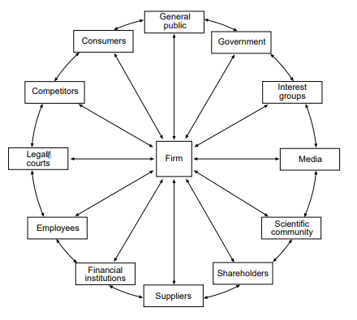
Figure 2 Interaction of stakeholders with a firm (Polonsky, 1995)
There will always be theoretical experts who will argue which theory is superior in terms of Shareholder versus Stakeholder theory, but what cannot be dismissed is the movement toward CSR that has been called for by various groups of stakeholders, (Faucher, 2015). Mendelow's matrix is a system which uses mapping to group stakeholders which have the same level of interest and power towards an organisation and its activities. It helps to establish the level of relationship an organisation has with its stakeholders and assists to recognise and understand the demands and expectations these stakeholders have, (Bryson and Patton, 2010; Kuzmin and Khilukha, 2016). Table 1 illustrates Mendelow’s matrix which has been applied to FB stakeholders.

​ |  | ​Level of Interest​
 |  | ​Low | High​
​  ​  ​  Level of Power​ | ​​  Low​  ​ | (Minimal effort) ​  Political groups  ​ | (Keep informed​)  Investors  Competitors
​  ​  ​  Level of Power​ | ​  ​  High | (Keep satisfied​)  ​ Members ​  Government and Regulatory bodies  ​  ​ | (Key players​)  ​Advertisers​  Employees​  Unions  Owners  Shareholders
Table 1 FB stakeholder matrix

2.1.2 Ethical CSR
Ethical CSR ensures consumers, that their needs are part of the organisation’s principles. Applying ethical CSR is an important means of establishing stable relationships with stakeholders and maintaining the requisite conditions for long-term sustainability and growth, (Adams and Zutshi, 2004). Ethical Corporate marketing broadens stakeholder theory by considering past, current, and potential stakeholders, an approach that has been stated to be essential for organisations as it develops an authentic ethical corporate identity, (Balmer et al.,2011). The FB-CA scandal has created concerns in the ethical principles and CSR of organisations involved within their marketing activities and has given rise to the opinion that corporations need to be more accountable for the impact they have on society, (Swift, 2001; Porter and Kramer, 2006; Baur and Schmitz,2012). Corporate marketing allows companies to understand that corporate identities can be a valuable source for the distinction which needs to be active on multi-lateral relationships regarding customers, stakeholders, and society at large. A significant characteristic of corporate marketing is that organisations should be aware of their social responsibilities and not just their economic, (Balmer and Powell, 2011). Corporate marketing provides a comprehensive insight into brand perception as a wider concept of stakeholder is considered, this includes past as well as present stakeholders and incorporates their expectations and perceptions of brand identity and corporate image, (Gregory, 2007). Ethical marketing enables organisations to market their goods and services by focusing on how their products benefit consumers and how they support socially responsible causes. A business needs to be consistent with its ethical decision-making process because its implications influence all facets of the company's system, (Ardichvili et al, 2009). Virtue ethics is an ethical marketing strategy that could be implemented by FB. This is a modern approach, based on the concepts of Aristotle’s philosophy, requiring decisions to be made in accordance with the knowledge of a person’s character and moral virtue in contrast to the approach that emphasises obligations (deontology) or consequences of actions (consequentialism), (Crisp and Slote, 1997; Hursthouse, 1999). If FB were to implement a set of ethical standards, they must question how they want their platform to be perceived based on the decisions they make. Haagen-Dazs is an example of an organisation that has successfully incorporated ethical marketing into their brand image. For the past ten years, they have put efforts into helping revive the bee population. The companies director Elizabeth Marquez stated, “There are three important ways we can help bees: bring them flowers, protect their homes and spread the word, the past 10 years, HÄAGEN-DAZS has supported each of these components, by donating over £ 1million to research and working with suppliers to grow ingredients in bee-friendly environments”, (Save the Honey Bees | Häagen-Dazs, 2020). This mission has seen such success as the organisation has incorporated it into all aspects of the business. Their webpage illustrates its efforts, the honeybee logo is printed onto the packaging of their products and also integrated into advertising campaigns.

2.1.3 Legal CSR
Society has changed in the way that accountability for actions is becoming a priority in all aspects of life including business. Legal CSR refers to a corporation that is free to enter into business, however, it wishes to do so, but as long as it is within the limits and rules of the law. Companies may voluntarily go beyond what is necessary by law to achieve social goals during their day-to-day business activities, (George, 2019; Li, 2019). FB has come under fire in recent years after breaching the Data Protection Act. The data protection act has six data protection principles (see appendix 2). Everyone responsible for using personal data has to follow these principles, FB has failed to do this and has failed to safeguard its user's information by not being transparent with what and how data was being collected, (Hern and Pegg, 2018; Waterson, 2018; Data protection, 2020). The CA scandal was a major political scandal which exposed FB of exploiting over 50 million members and their social networks by subjecting them to commercialization, (Lilley and Gumbus, 2012; Cadwalladr and Graham-Harrison, 2018). FB violated the law by allowing third parties access to user’s data as well as advertising through the use of phone numbers that were wrongly demanded as a security necessity. Lindsey Barrett, staff attorney at Georgetown communication and technology clinic deemed the actions of the platform as “putting growth and profits above designing a platform that predicated on the needs of its users”, (Wong, 2019). As a result of this FB has received negative press globally and the internet has been inundated with articles describing FB inexistent respect for its users. BBC News alone has 18 articles depicting the scandal, (BBC News, 2020). The platform has received a £4 billion fine in the US, which is the largest fine to be handed out by the Federal Trade Commission a £500,000 fine from the UK and an ongoing settlement with Australia for violation of the 300,000 citizens privacy agreement, which laws carry a maximum fine of £860,000 for every serious interference with privacy, (Davies and Rushe, 2019; Woodcock, 2019; Australia sues FB over Cambridge Analytica, 2020). The impact of not abiding by the law has had a huge negative impact on FB, it has adversely impacted their financial situation and created a stigma around their corporate image. A week after the scandal arose it was reported that trust in FB had dropped by 66%, overcoming this requires a revaluation of what the company values are, (Weisbaum, 2018).

2.1.4 Economic Corporate Social Responsibility
A credible explanation of economic CSR states, “Organisations have an economic responsibility to the society that permitted them to be created and sustained”, (Carroll, 2016, pg.3). Carroll's pyramid is one of the more popular constructs of CSR which incorporates four sections CSR those being, Economic, Legal, Ethical and Philanthropic, (Nalband and Kelabi, 2014; Carroll, 2016; Ehie, 2016). Economic is placed at the base of the pyramid as it is the basic necessity of business, observed in figure 3.
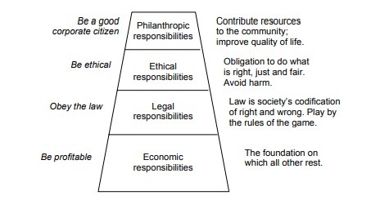
Figure 3 The pyramid of CSR, (Carroll, 1991)
The CSR-Universal model (refer to appendix 1) is based on Carroll’s pyramid but is extended to include the environment, the beliefs, values, and assumptions of an organisation and then proceeds to include the legal, economic, ethical, and philanthropic responsibilities. Legal is classed as the basic responsibility instead of economic as placing economic as the basic responsibility contradicts CSR and shows favour to Friedman’s shareholder theory, (Visser, 2006). FB has an economic responsibility is to their stakeholders. FB has a diverse range of online stakeholders as a result of the size and nature of its platform. On their community standards page, the platform identifies their stakeholders as "all organisations and individuals who are impacted by, and therefore have a stake in, FB's community standards" (Community Standards | Facebook, 2020). FB website explains that as this covers 2.7 billion active users, they focus on influential stakeholders which they list as civil society organisations, activist groups, thought leaders and academics. As of 2019 FB has claimed to be open about sharing their community standards and how they come to decide on the rules for what content is and is not permitted on their platform, this has largely been down to the 2016 Cambridge Analytica scandal, (Writing Facebook's Rulebook, 2019; Community Standards | Facebook, 2020). However, FB has been accused of not being as transparent as they claim as they have refused independent researchers to study how political disinformation flows across their advertising platform, (Siddiqui, 2019). Alongside this, FB has been criticized for failing to provide information on target advertising and user engagement which would inform researchers how much advertisers are paying the platform and how effective the adverts are, (Lomas, 2019). A lack of transparency and trust can stunt a company’s growth If FB was to allow their users access to credible environmental, ethical and social data this would enable them to make more informed decisions sustaining the future of their platform, (Corporate transparency: why honesty is the best policy, 2014). FB could strike a balance between business, environmental and philanthropic practise establishing economic responsibility.

2.2 Brand equity
Brand equity is a relatively modern concept and in its simplest terms can be defined as being, "the public valuation of a brand", (Barwise, 1993; Building Brand Equity, 2017). This concept serves as a basis for managers to understand the influence consumers emotions have concerning the position of the organisation. For this dissertation, Brand equity subcategories will be explored in relation to FB which is taken from chapter one figure 1. These subcategories are:
- Perceived quality
- Brand Awareness
- Brand Association
- Brand loyalty

2.2.1 Perceived quality
Aaker stated brand equity was made up of five elements, the main elements being perceived quality. He defines it as "The consumer's judgement about products overall excellence or superiority”, (Kirmani and Zeithaml, 1993. pg.144). This attribute impacts the way brand image is perceived through consumer attitude which can be altered depending on how the company portrays itself through its actions. FB must enhance consumer perception by leaving a positive impression on their stakeholders. Research has identified that perceived quality has a significant positive effect on brand trust and brand image, (Tsiotsou, 2006; Alhaddad, 2015; Rahmatulloh et al, 2019). Microsoft implements CSR throughout their organisation to gain consumer trust. Microsoft created "Microsoft YouthSpark" to increase employment opportunities. The programme helped over 300 million young adults who have assisted in creating a positive brand perception for Microsoft, (Microsoft.com, 2020). FB could consider a similar strategy. However, if FB is more concerned with certain stakeholder groups, they could use advertising campaigns to target specific stakeholders. Coca-cola is an example of a company whose advertising strategies are changing perceptions. The company's products are associated with being unhealthy and linked to adverse health implications such as obesity. To change this view coke changed their brand campaign by uniting all drinks and giving them all the same slogan, "taste the feeling", (Coca-Cola Slogans Through the Years, 2020). They focused on enhancing the product experience through an emotional storytelling theme.

2.2.2 Brand Awareness
Aaker defines brand awareness as “the durability of a brand that embedded in the customer memory”, (Severi and Ling, 2013, p.g.126). This is how well consumers can recognise a brand (brand recognition). This means that consumers should recall the brand name when giving the needs that the organisation aims to fulfil, (Dew and Kwon, 2010). FB is the world's largest social media platform and has over seven million active advertisers a month, (Facebook active advertisers 2019 | Statista, 2019). This research suggests that FB has very strong brand recognition and brand awareness. Brand awareness often sways a consumer in the direction of a purchase decision or FB instance a service use. If the brand has a bad reputation this could turn consumers away from particular brands and stunt brand market performance, (Huang and Sarigollu, 2014). It is important to note that the literature discussing the link between brand awareness and brand equity also incorporates brand association.

2.2.3 Brand Association
Brand association is defined as products and firms, which have specific and clear values and characteristics that are unique to them which differentiates themselves from the competition, (Yoo and Donthu, 2001; Dew and Kwon, 2010). These are not reasons to buy into a brand but provide differentiation that is not replicable by a competing brand. The brand association also is said to "act as an information collecting tool to execute brand differentiation and brand equity”, (Severi and Ling, 2013, p.g.127). A brand association should be linked to the positive attributes of a brand. While FB is widely recognised as a forum for connecting with friends and family their brand association could improve their positive brand affiliation. FB has been credited for providing a good social support system within their platform, (Janh et al., 2016). However, FB is experiencing a negative brand association in connection with mental health. The brand is associated with addiction, body image, depression, anxiety, and disordered drinking and eating conditions as well as additional mental health problems, (Frost and Rickwood, 2017). Studies have also concluded that FB users are experiencing high stress and anxiety levels in comparison to non-users, (Farahani et al, 2011). Although the company recognises this and has admitted that the material on their platform can pose a mental health risk, they also claim that the site can improve people’s wellbeing through engagement, (Levin, 2020). However, this acknowledgement is not enough to change consumers association between the brand and mental health and instead they should seek to find a way to steer themselves towards a positive association with mental health. One platform which is attempting to change their association with mental health is Instagram. Instagram has changed their platform regulations restricting users under the age of 18 from being able to view posts related to cosmetic surgery or dieting and have removed any content which is considered dangerous to users mental health, (Manavis, 2019).

2.2.4 Brand loyalty
Brand loyalty is defined by Aaker (1991) as “a constructive mindset toward a brand that leading to constant purchasing of the brand over time”, (Severi and Ling, 2013. P.g.127). It is said to be the core of a brands equity, (Aaker, 2009) a study into the detriments of brand equity for brand loyalty is considered the most influential dimension of brand equity, (Atigan et al., 2005). Brand loyalty for a social media platform can be measured by analysing the levels of community commitment, attitude and behaviour and positive word-of-mouth, (Schivinski and Dabrowski, 2015). It was reported that FB came under the brands with the greatest loyalty erosion observing a drop in consumer loyalty by 16 per cent, (Brand Keys 2019 Loyalty Leaders, 2019). Robert Passikoff founder of brand keys a system developed to measure brand equity claimed, “Trust is an engagement factor in every service category, it has become the indispensable connective tissue between brands and customer loyalty”, (Brand keys customer loyalty engagement index, 2019). For FB users trust has been a rising concern as they have failed to successfully address security, privacy and transparency measures that should have taken place following the 2016 FB-Cambridge Analytica scandal. FB needs to meet their consumer's expectations and alter the values of the organisation to improve Brand loyalty.
In conclusion, previous literature demonstrates that there is a demand for FB to integrate corporate social responsibility to improve their brand perception. Peoples association of the brand currently is overwhelmingly negative and if FB chooses to continue to acknowledge these negative associations but not act on them, they should expect to observe a continuing drop in brand loyalty. FB should be focussing on acting within the law and integrating ethical responsibilities to strengthen and improve their brand perception as well as help ensure long-term sustainability for the business. This chapter has helped in identify the hypothesis the researcher will be testing which will be Integrating CSR responsibilities will improve FB brand perception.
This dissertation, therefore, assists in fulfilling an evident gap of research concerning CSR and brand perception of FB bringing these two concepts into unison.

3.0 Chapter 3 – Methodology

This chapter will help to achieve the second research objective of this dissertation:
2. Conduct primary research in the form of an online questionnaire which will evaluate FB current brand perception and determine the CSR responsibilities most effective in improving FB brand perception

3.1 Research onion
Research has been defined as ‘enquiry and investigation (that)…is systematic and methodical…(and) increases knowledge’, (Collins and Hussey 2013, pg.1). People undertake research to find matters out in a systematic way, thereby increasing their knowledge, (Jankowicz, 1995). The Saunders, et al (2009) Research Onion diagram will be used to detail the primary research method the researcher will conduct and justify the chosen research approach, the data collection methodology and the data analysis process.
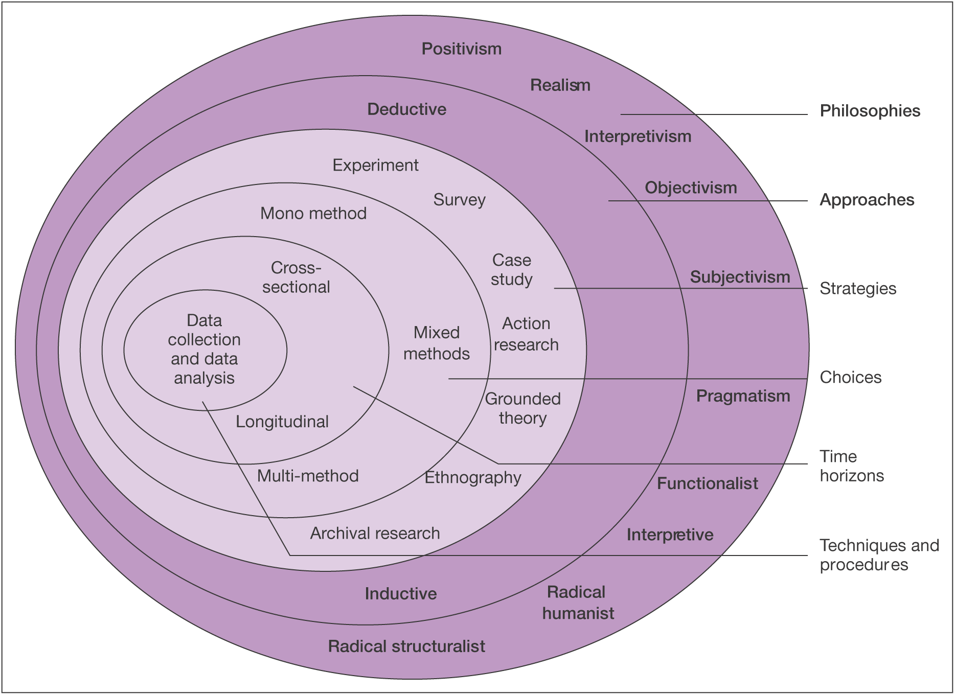
Figure 4 The Research Onion, (Saunders et al, 2007)
Figure four will be utilised by the researcher to assist in the selection of the appropriate research route beginning with the outermost layer of the diagram working towards the centre. The philosophic perspective of this dissertation will use pragmatism and apply a deductive approach. The strategy for the information collection method will be mono method in the form of an online questionnaire which will collect both quantitative and qualitative data. This will be a cross-sectional study, as the information being obtained will be gathered at only one point in time. Data collection and analysis will be addressed by the researcher through the collection of data using an online survey, which will be analysed using the programmes NVivo and SPSS.

3.1.1 Research Philosophy
Research philosophy is explained as “relating to the development of knowledge and the nature of that knowledge”, (Saunders et al., 2003. Pg.106). This dissertation research philosophy will use realism. Pragmatism research philosophy combines positivism and interpretivism philosophy. Pragmatism demonstrates how to transform a culture which is decaying within society rather than just cope with it, (Sleeper, 2001). This type of philosophy will underpin the research strategy as well as the methods chosen as part of the strategy, as the study focuses on FB user’s perceptions collecting qualitative and quantitative questions.

3.1.3 Research Approach
The research approach is the second layer of the research onion, offers the choice of two approaches. Inductive and deductive. An inductive approach is often found along-side a qualitative research model and refers to the trends and themes that can be identified when the textualized data is condensed, the researcher creates a theory from the collected data which is turned into a framework or model, (Thomas, 2003; Thomas, 2006; Jebreen., 2012; Liu, 2016). Deductive research is often used when gathering quantitative data. The collected data informs whether a prior developed hypothesis is valid or not, (Manna and Waldinger, 1980; Saunders et al., 2003). This dissertation will use a deductive approach as the primary research will pursue qualitative and quantitative data and will be testing an existing theory.

3.1.4 Research strategies
Research strategies state several data collection methods. The researcher will collect primary data using the data collection method surveys in the form of an online questionnaire. Questionnaires are commonly used as a way of collecting quantitative data, although, this questionnaire will collect quantitative and qualitative data. Questionnaires are structured in a way that the information collected is concerning two or more similar variables which result in the formation of a data grid, (De Vaus and De Vaus., 2013). The researcher has opted for the method as online questionnaires can be widely distributed to large sample size as well as provide a quick turnaround, which is desirable given that there is limited time to collect the data, (Evans and Mathur, 2005; Sue and Ritter, 2012).

3.1.5 Research choice
The researcher has chosen to undertake a mono method approach. Although a Multi-method analysis draws and combines data from various sources (Paul, 1996; Flick, 2004; Brewer and Hunter, 2006; Lauri, 2011).The researcher will include questions in their survey which will collect qualitative and quantitative data which will assist in providing more accurate results as it allows triangulation to take place. Multi-method was the original option of data collection, but due to unforeseen circumstances of the COVID-19 crisis, this prevented the possibility of interviews to take place.

3.1.6 Time horizons
Time horizon refers to the length of time which research is carried out and is independent on which research strategy the researcher chooses to use, (Saunders et al., 2007). The previous chapter highlighted that there is a gap within existing literature when attempting to identify whether there is a demand for FB to integrate CSR to improve brand perception. This research will, therefore, be a new phenomenon requiring primary research to be undertaken. Cross-sectional research is conducted within a given time frame, while longitudinal research represents events over a number of years, (Bethlehem, 1999; Levin., 2006). Given that the dissertation is time-restricted, the research carried out will be cross-sectional.

3.1.7 Techniques and Procedures
Techniques and procedures are at the core of the research onion. As identified previously, the researcher will use the mono method to gather information but will collect quantitative and qualitative responses in the form of an online questionnaire.

3.1.7.1 Questionnaire
Qualitative research can yield a large amount of data that is typically gathered through interviews and focus groups. The notes taken from these endeavours are transcribed which can be very time-consuming. The transcribes provide explanations and is the job of the researcher to find patterns and links by interpreting the data, (Pope et al., 2000). Quantitative research is described as being, “Explaining phenomena by collecting numerical data that are analysed using mathematically based methods”, (Mujis, 2010, Pg.14). Questionnaires are often a form of quantitative research and are considered to be useful for non-experimental descriptive designs that seek to describe reality by collecting information on attitudes and behaviour, (Mathers et al.,2007). Using online questionnaires, the researcher will be able to collect a vast amount of data in a standardised way allowing the data to be internally coherent for analysis within a short period, (Malhotra, 2006). The questionnaire will be created using Google Forms which is a trusted site and all participants replies can only be accessed through a Google account login which only the researcher will have access to. Unlike other survey building sites such as survey monkey, Google forms do not allow the access of third parties, (Privacy Policy | SurveyMonkey, 2020). The questionnaire will be designed to reflect the research in Chapter two and engage participants thoughts, feelings, and perceptions of FB. The number of questions which will be asked will not exceed 15, as the research into the relationship between the length of a survey and the response rate suggests the longer a survey the fewer respondents it will receive, (Kost and da Rosa., 2018). The types of responses the questionnaire will gain will be categorical, ordinal, and nominal, (Fink., 2003).

The questionnaire will be shared via email and WhatsApp and uploaded on to the researchers Instagram page which can be accessed and shared by other Instagram users to reach a larger number of participants, (see appendix three for a copy of the questionnaire). It will also be available on survey circle which is a website that has the largest community for online research, which will assist in finding respondents, (Survey Circle, 2020). Uploading the questionnaire to this number of platforms will increase the number of possible respondents. Once the questionnaire is closed and all data collected has been analysed the results will be accessible at EmilyCMiller.blogspot.com commencing the 1st of June 2020.

3.1.7.2 Question and Literature review matrix
The table below contains the questionnaire questions participants will be asked to answer and indicates where in the literature review, they were derived from.
Questionnaire questions | Relation to secondary research
Q1. Participation and all data collected as a result of taking part in this questionnaire will remain anonymous and confidential. Please state whether you give your consent for the results to be used as part of the researcher’s BA research project. | asking for consent is considered an ethical requirement but is also mandatory for the researcher to be able to process the data collected and later share the results. Article 7 of the GDPR, Conditions for Consent highlights this, ((UK Data Service, 2020; Vollmer, 2020).
Q2. How old are you? | This demographic question will assist in identifying whether FB brand perception changes depending on age and will be used as a test variable on SPSS.
Q3. How familiar are you with FB?  Q4. How would you describe your overall perception of FB?  Q5. Please briefly explain your overall perception of FB. | Q3 measures respondents brand awareness, 2.2.2 (Severi and Ling, 2013).  Q 4 and 5 identify the depth of the brand awareness and establish whether the participants identify characteristics associated with Fb 2.2.3 and measures brand loyalty 2.2.4, (Yoo and Donthu, 2001; Dew and Kwon, 2010; Severi and Ling, 2013).
Q6. Corporate Social Responsibility (CSR) has been defined as "The responsibilities corporations have to their stakeholder groups", (Johnson et al, 2008). Please state how far you agree with the following statements.  Fb does the minimum to maintain relationships with its users.  Fb goes above and beyond to satisfy their user’s needs.  Fb supports socially responsible causes which benefit society at large.  Fb complies with all consumer rights and acts in accordance with the law.  Fb is more focused on generating revenue than user satisfaction. | Definition of CSR, 1.2, (Johson et al, 2008).  Statement 1 and 2, stems from 2.1.1, Shareholder vs Stakeholder theory, (Moore, 1999; Ferrero et al, 2014).  Statement 3 derives from 2.1.2 Ethical CSR, (Swift, 2001; Adams and Zutshi, 2004; Porter and Kamerr, 2006; Baur and Schmitz, 2012).  Statement 4. 2.1.3, Legal CSR, (George, 2019; Li, 2019)  Statement 5. 2.1.4, Economic CSR, (Carroll, 2016, Siddiqui, 2019).  These statements will assist in determining whether participants agree with shareholder or stakeholder theory which will help determine if there is a need for CSR.
Q7. In 2018 it was revealed that FB allowed CA to harvest the profiles of 50 million FB users without consent. Does this affect your perception of FB?  Q8. Please state why you answered yes or no to the previous question. | Q7 and 8 derive from 2.1.3 Legal CSR, (Lilley and Gumbus, 2012; Cadwalladr and Graham-Harrison, 2018) as well as chapter 2.2.1, Perceived quality, (Kirmani and Zeithaml, 1993; Tsiotsou, 2006). It will identify if corporate scandals impact brand perception.
Q9. How far do you agree with these statements?  FB has a responsibility for improving the welfare of all of its stakeholders  FB has an obligation to do what is right, just, and fair to avoid causing harm.  FB has a duty to abide by society’s codification of what is right and what is wrong  FB has an economic responsibility  Q10. Which of the following is the most important responsibility FB has in your opinion? Please choose every option that applies.  Philanthropic (Be a good a corporate citizen)  Ethical  Legal  Economic | Figure 3. The Pyramid of Corporate Social Responsibility, (Carroll, 1991). By identifying which responsibility participants feel most strongly about will help determine if there is need for FB to integrate CSR as well as identify the responsibility respondents feel is the most important for improving brand perception.
Q11. Do you feel that FB could do more to act on the previously chosen responsibilities?  Q12. If FB acted on the responsibilities listed in question 10 would this improve your perception of FB?  Q13. Please briefly explain why you have chosen the answer to the previous question. | 2.2 Brand Equity, (Barwise, 1993; Building Brand Equity, 2017).  These questions will assist the researcher to make conclusions and recommendations for FB.

3.2 Reliability and Validity
Reliability concerns the consistency of a measure and the validity is defined as the degree to which a concept is accurately measured in quantitative analysis, (Del Greco et al., 1987; Heale and Twycross., 2015). Joppe (2000) defines reliability and validity in research as the following, "if the results of a study can be reproduced under a similar methodology, then the research instrument is considered to be reliable…Validity determines whether the research measures which is intended to measure or how truthful the results are", (Golafshani., 2003. Pg.3). Reliability and validity of the study is the duty of the researcher to generate well-designed research that reflects the main objective of the study and then to build a compelling case once the data has been analysed. Questionnaires are deemed as positivist research. Positivism in research takes the view that factual knowledge is gained through scientific evidence. This will ensure that the data being collected will be of a valid, and reliable source. For data extraction, both quantitative and qualitative data is being collected so triangulation can take place which will enhance the validity of the research. Triangulation increases validity as it uses more than one approach to researching a question, this increases the confidence in the findings by using more than one independent measure, (Heale and Forbes, 2013).

3.3 Limitations
One prominent limitation of this dissertation is the unforeseen condition of Covid-19. This has restricted access to resources. Access to computers which have the appropriate software for analysing the collected primary research is no longer available. To overcome this the researcher will download the software on to a PC available to them with the assistance of their lecture and their university IT services. Due to Covid-19, this has resulted in one to one meetings with supervisors being cancelled due to social distancing measures. To adhere to these new legal measures and to continue to have support throughout this journey, email and Microsoft Teams will be used as a form of contact.
A second limitation to consider is the restricted time provided to collect primary research and analyse the data. To assist in reducing the impact of this limitation, the researcher has created a Gantt chart which will be referred to throughout the dissertation to improve time management.
A third limitation to this research which could be not gaining enough responses. As the research is concerning FB the questionnaire will not be posted on to this platform. This could restrict the number of responses as the researcher will have to use other platforms which are not as well-known or used for sharing such documents. To overcome this limitation the questionnaire will be posted to several other platforms and shared through the researcher’s friends and family via WhatsApp.

3.4 Ethical considerations
Ethical issues must be given a great deal of consideration by the researcher to ensure no person will be harmed or offended by the nature of this research. To achieve this the design of the research, process and storage of personal data will be treated with the utmost respect. This will be achieved by providing complete confidentiality to all participants and not including questions within the questionnaire which could cause the respondent to feel uneasy or cause upset, (Kajornboon, 2005). The respondent's data will be saved to one computer which will be passcode protected to ensure it will be protected.

3.5 Conclusion
This chapter has identified and explained the research methodology which will be carried out to gain data for analysis for chapter four. It has also contributed to achieving objective two; Conduct primary research in the form of an online questionnaire which will evaluate FB current brand perception and will determine the CSR responsibilities most effective in improving FB brand perception. The chapter has helped the researcher to reduce the impact that the previously mentioned limitations could have had by planning methods to overcome them.

4.0 Chapter4 -Data Analysis

4.1 Introduction
Chapter three explained the collection methods the researcher will use to obtain primary data. Chapter four aims to contribute to fulfilling the aim of this dissertation which is to determine if there is a need for FB to incorporate Corporate Social Responsibility to improve brand perception and will fulfil objective two:
2. Conduct primary research in the form of an online questionnaire which will evaluate FB current brand perception and determine the CSR responsibilities most effective in improving FB brand perception
The total number of responses the questionnaire collected was 141. The average response rate for a survey is 20.4%, (Deutskens et al, 2004; Baruch and Holtom, 2008). The survey response rate for this questionnaire cannot be determined because the number of people who shared the questionnaire was not recorded and neither was the number of followers for each story the link was uploaded to. It can be concluded that the response rate was below average, considering that the researcher alone shared the questionnaire with 958 potential participants and that the questionnaire was uploaded to five Instagram story’s, all of which had a minimum of four hundred followers. However, 141 respondents can still be considered as a good sample size as it is large enough to be able to identify emerging patterns and themes within the research.

4.2 Data Analysis
Data analysis uses analytical and logical reasoning to extract knowledge from the data. The aim of analysing data is to find significance in the data so that the derived information can be used to make informed decisions. There are many approaches to qualitative and quantitative data analysis, which have been extensively explored in the literature on social sciences, (Welsh, 2002; Ding and Beichner, 2009; Smith and Firth, 2011).

4.3 Methods
The online questionnaire collected quantitative and qualitative data. The software programme SPSS is an effective form of analysis for quantitative data; however, it is sufficient to use NVivo to analyse the qualitative results. Analysis of the quantitative data was deemed as positivism by use of the statistical tests; the crosstabulation, Pearson’s Chi-Square test, the independent sample t-test and Mann-Whitney U Test. The SPSS independent T-test measures the variation in a mean between two groups to a given value, analysing if the difference in the mean is 0, (DeCoster and Claypool, 2004; Park, 2009). The Mann-Whitney U Test and the Chi-Square Test are non-parametric tests, this test can be applied to smaller sample sizes and the sample does not have to follow specific assumptions, (Chan, 2003; Hinton, 2014). The Mann-Whitney U test is a nonparametric version of the independent sample T-Test. The Mann-Whitney U Test deals with two unrelated samples containing ordinal data and the Chi-Square Test analyses the difference between the expected theoretical value and the observed theoretical value between two categorical variables, (Ruxton, 2006; McKnight and Najab, 2010; McHugh, 2013; MacFarland and Yates, 2016). To use SPSS, the quantitative data had to be coded from words to nominal data using both excel and SPSS. Likert scale questions where the participants stated their degree of agreement to a statement had to be coded from 1 to 5, e.g. Strongly disagree – 1, Disagree – 2, Neither Disagree or Agree – 3, etc.
NVivo was the chosen method of coding qualitative data since it can be learned within a limited time and does not require prior knowledge, (Richards, 1999). NVivo has been used to run queries regarding the data obtained. Queries such as word frequency have been used to find out how many times a word has recurred as well as text searches for particular words. The programme also allows phrases and terms to be encoded and applied to the appropriate nodes that can be used to create project and concept maps.
This chapter starts with question two, as question one asked participants for their consent to use their data within this study. All the data which has been analysed within this chapter have received consent (Raw data can be found in appendix 4).

4.4 Demographics

4.4.1 Question 2
Question two asked participants to select the age group in which they fall, with the option of selecting, “prefer not to say” for any participants who did not wish to reveal this information. This question was asked because the researcher was interested to see whether age had any effect on how FB was perceived. Here is what the population look like.
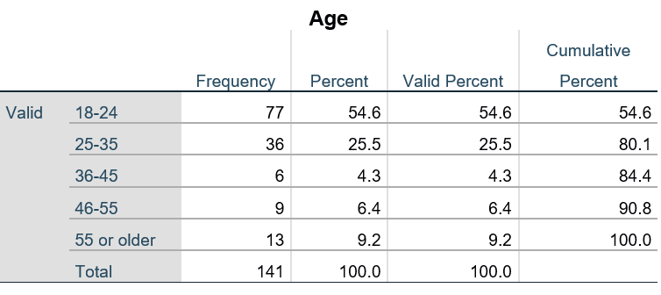
Table 2 Age demographic
The data indicates that a significant percentage of participants was between 18 and 24 years of age, this age group made up for 54% of all participants and the remaining 46% of participants were 25 years of age and older.

4.5 Question 3
Question three asked respondents how familiar they with FB. The options were, Extremely familiar, Very familiar, Somewhat familiar, Not so familiar, and Not at all familiar. 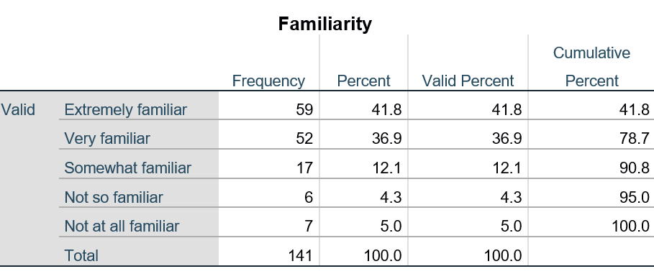
Table 3 Familiarity frequency table
The results found that 41.9% of the participants were extremely familiar, 36.9% were very familiar, 12.1% were somewhat familiar, 4.3% were not so familiar and 5% were not at all familiar. It is not a surprise to see that 95% of participants showed some familiarity to FB giving that in chapter two states FB is the world’s largest online social media platform and section 2.2 2 suggests that FB has strong brand awareness. The researcher explored the possible link between familiarity and age. The hypothesis was:
- H1 (Alternative Hypothesis). There is a difference in familiarity between age groups
- H0 (Null Hypothesis). There is no difference in familiarity between age groups.
The hypotheses were tested using a Chi-Square test to conduct a Crosstabulation on Age and Familiarity. The column headings are Extremely familiar, very familiar, somewhat familiar, not so familiar, and not at all familiar. The row headings are the age groups 18-24, 25-35, 36-45, 46-55 and 65 or older.

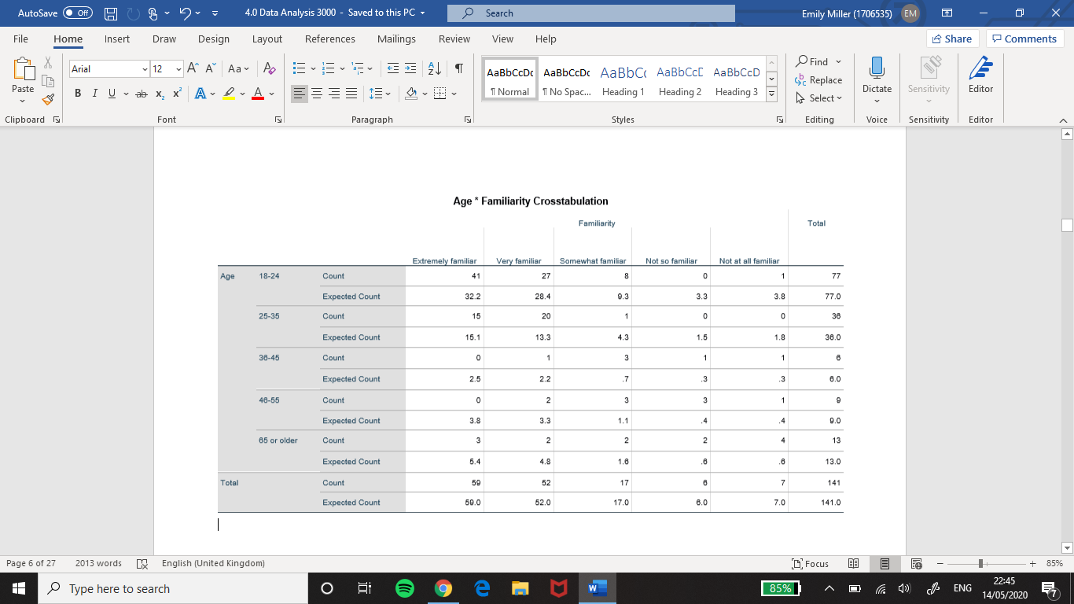
Table 4 Age and Familiarity crosstabulation

The crosstabulation of the two variables reveals the majority of the expected count (p-value) was less than 5% (0.05). This is a type-1 error that indicates a false positive null hypothesis, for this reason, H0 in this form will be rejected. This test cannot be used in its current form since there are too many values less than 5%. Collapsing the data by grouping the ages to under 35 and over 35 and Extremely familiar, very familiar to familiar, not so familiar, and not at all familiar to not familiar. Somewhat familiar will remain but be referred to as neither, this will reduce the number of groups for the categorical variables.
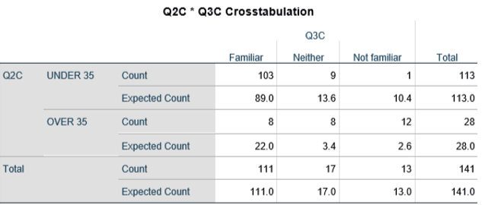
Table 5 Age and Familiarity collapsed crosstabulation
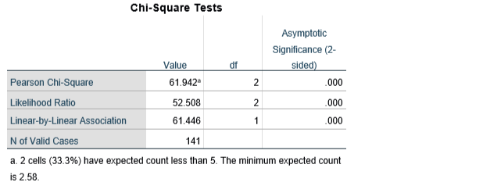
Table 6 Age and Familiarity Chi-Square Test
Chi-square tests are used to measure the p-value to determine if it is equal to or less than 0.05 (5%). If over 20% of the expected values are less than 0.05 the Chi-square test would not be valid. In this instance, 33.3% of the cells are less than 5% meaning the test is invalid, because of this the researcher must use Fisher's exact test to assess H0. This identifies if there are non-random associations between the two categorical variables, it is not an approximation of the p-value it is the exact calculation of the p-value. The result from this test was 3.25658705928824e-12 which is far less than 0.05. This proves H1, there is a difference. 103 people are familiar, and 13 said they are not familiar for under 35, whereas over 35, 8 people were familiar whereas 13 were not this does not support Veins (2019) who says FB is more frequently used with generation X and Baby Boomers.

4.6 Question 4
Question four asked participants to describe their overall perception of FB. The options were, Extremely favourable, Very Favourable, Somewhat favourable, Not so favourable, Not at all favourable.
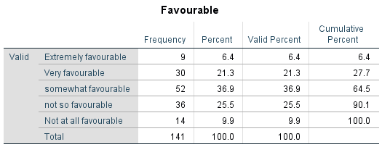
Table 7 Favourable Frequency table

The table displays the frequency and percentage for each term that was selected. The results show that Somewhat favourable was the most selected term, having been selected by 52 out of the 141 respondents and the least selected term was Extremely favourable.
A Chi-square test was run to identify whether favourability is dependent on age. The hypothesis was:
- H1. Favourability is dependent on age.
- H0. Favourability is not dependent on age.
Extremely favourable, very favourable, were collapsed grouped under favourable. Somewhat favourable was referred to as neither. Not so favourable, and not at all favourable were grouped under Not favourable.
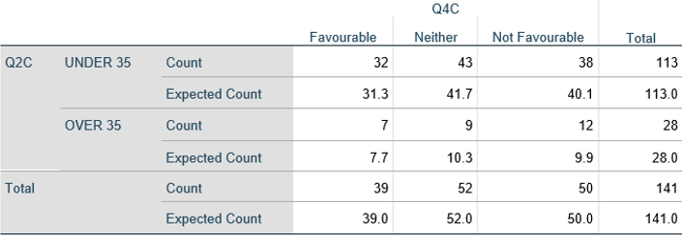
Table 8 Age and Favourability crosstabulation

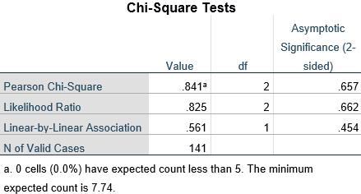
Table 9 Age and Favourability Chi-Square test
The crosstabulation of the two variables shows all of the expected counts were more than 5%. This indicates H0 was correct, there is no difference between age and favourability of FB which again goes against Veins (2019)
The second analysis was carried out to identify if there is a relationship between favourability and familiarity.
- H1. There is a relationship between favourability and familiarity.
- H0. There is no relationship between favourability and familiarity.
The headings Extremely familiar, very familiar, somewhat familiar were grouped under Familiar. Not so familiar and not at all familiar were grouped under Not familiar.
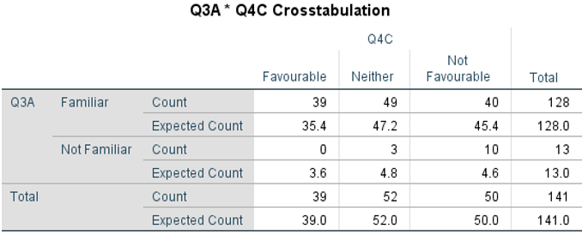
Table 10 Favourable and Familiar crosstabulation
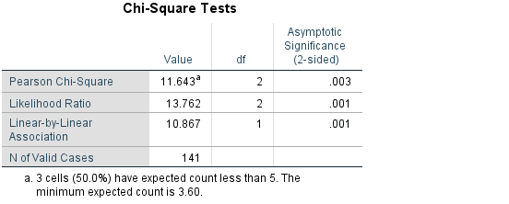
Table 11 Favourable and Familiar Chi-square test
This test is invalid. 50% of the expected count was less than 5%, because of this Fisher's exact probability test will determine H0. The result was 0.000018678427711528592. This is substantially smaller than 0.05 and therefore H1 is found to be true. In section 2.2.3 it is found that FB is experiencing negative brand association as it is being linked to causing adverse effects on the user's mental health. However, it must be noted this result lacks reliability due to the disproportionate number of participants which fall into the categories familiar and not familiar. There are 128 participants in the category familiar and only 13 participants in the unfamiliar category.

4.7 Question 5
Question five asked participants to briefly explain their overall perception of FB. Out of the 141 participants, there were 131 responses. However, 130 responses were analysed as one response was antisemitism, which the researcher felt would be unethical to add this to their research and would not add value to their results. The qualitative data collected has been coded in NVivo. Responses were formed from an Excel document into a Word document which was imported into NVivo which was used to code the data into nodes. Similar perspectives were grouped by highlighting sections of text and adding them to the appropriate nodes. Themes could be determined from the perception's participants stated they had of FB. The nodes were used to create a visual representation of the relationship between each reference in the form of a concept map (figure 5).
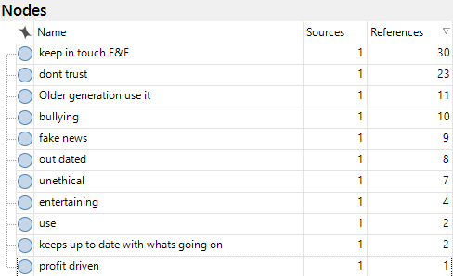
Table 12 Nodes table
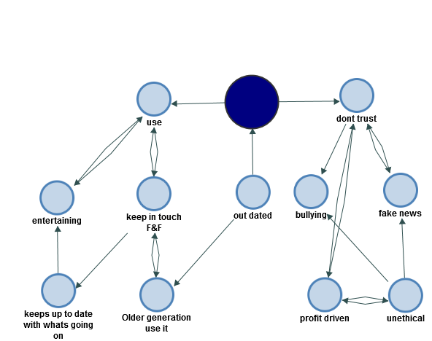
Figure 5 Nodes Concept map
The nodes table reveals how many times participants shared similar perceptions. This analysis highlighted that FB is perceived as being a platform to keep in touch with Family and Friends. In Chapter one FB mission statement is disclosed, these results suggest that FB is achieving its mission statement, (Zuckerberg, 2017). The second most common reference was statements regarding a lack of trust in FB. This supports what was found in the literature review when it was reported that trust in FB had dropped by 66%, (Weisbaum, 2018). The third most common perception was, FB is used by the older generation which fits with what was found in Chapter one, (Viens, 2019).

4.8 Question 6
Question six was a Likert scale which asked participants to state how far they agreed with the following statements:
6A. FB does the minimum to maintain relationships with its users.
6B. FB goes above and beyond to satisfy their user’s needs.
Statements
6C. FB supports socially responsible causes which benefit society at large.
6D. FB complies with all consumer rights and acts in accordance with the law.
6E. FB is more focused on generating revenue than user satisfaction.
The hypothesis for this test was:
- H1) Age has an effect on how people perceive FB.
- H0) Age does not affect how people perceive FB.

A Mann-Whitney U test is the most appropriate test because the data is ordinal.
Participants rated the statements from strongly Disagree, Disagree, Neither Disagree or Agree, Agree and Strongly Agree. The data were collapsed to increase the significance of the results. Strongly disagree and Disagree became Disagree. Neither remained and Agree and Strongly agree became Agree.
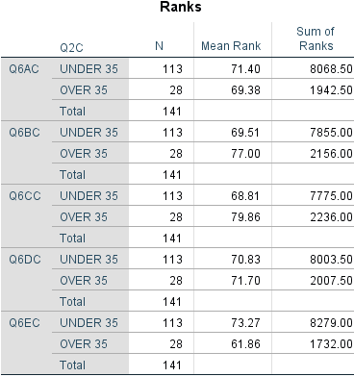
Table 13 Age and perception ranks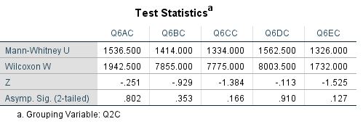
Table 14 Age and perception Mann Whitney U test

The asymptotic significances inform the researcher to retain H0 for each of the statements as each asymptotic significance is greater than 0.05. It can be concluded that age does not affect how people perceive FB.

4.9 Question 7
Question seven informed participants of the FB C-A scandal. Table 15 demonstrates 111 participants said Yes, this does affect their perception while 30 participants answered, No. This indicates that when corporations such as FB carry out unethical and illegal activities this negatively impacts the way they are perceived.
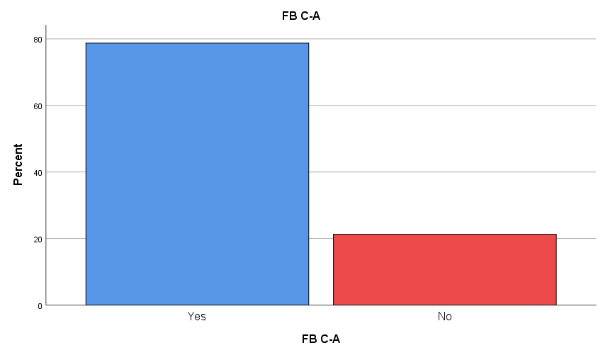
Table 15 FB-CA bar graph

To be able to thoroughly analyse the responses to this question, question eight must be analysed which explains the reason why the respondents answered yes or no.

4.10 Question 8

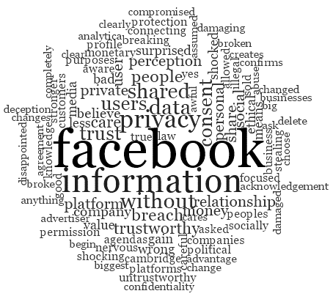
Figure 6 Q8 Word cloud
NVivo was used to create a word cloud for qualitative data. A word cloud is a visual that enables the researcher to observe what the most frequently mentioned words are. The size of the words in the cloud is dependent on the frequency. If a word is larger this indicates the word was mentioned often. Figure 6 is the 100 most frequently used words it depicts the thoughts and feelings that respondents had to the information some of which are, disappointed, shocked, untrustworthy, damaging The words in the figure, show that the respondents do not hold FB in high regard. This supports section 2.2.4 where it is reported that FB is experiencing a loyalty erosion

4.11 Question 9
Question nine was a Linkert scale which asked participants how far they agree with the following statements:
Q9A. FB has a responsibility to improving the welfare of all its stakeholders.
Q9B. FB has an obligation to do what is right, just, and fair to avoid causing harm.
Q9C. FB has a duty to abide by society’s codification of what is right and what is wrong.
Q9D. FB has an economic responsibility.
The hypothesis for this test was:
- H1. People feel that FB have economical, legal, ethical, and philanthropic responsibility.
- H0. People feel that FB does not have economical, legal, ethical, and philanthropic responsibility.
An Independent T-test was performed to analyse the data collected for this question. The p-value from the results will be calculated to identify if the values are greater than 0.05. If this is found to be true H1 would be accepted as there has been a significant statistical difference which has occurred which supports Carroll (1991).

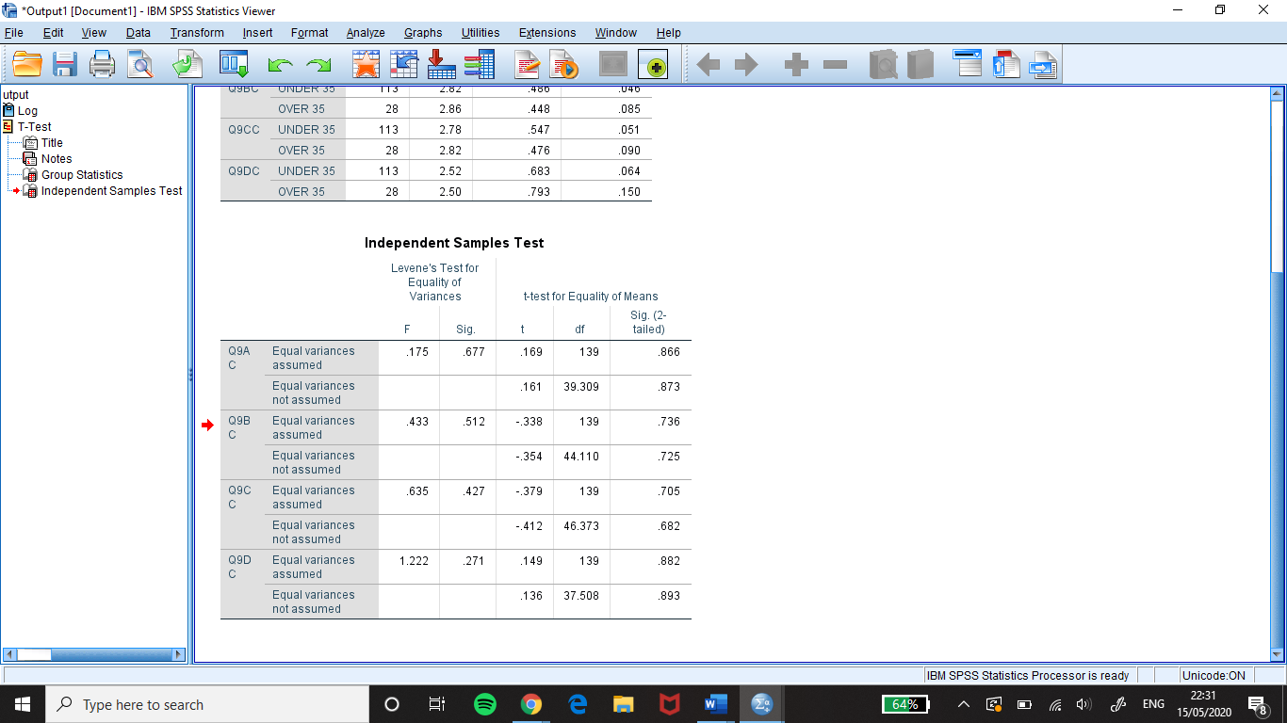

Table 16 Independent sample T-test
Table 16 show that all the results in the p-value column (Sig. (2-tailed)) are greater than 0.05, meaning there is no significant difference and therefore retain H0. The responses provided for statement 9A and 9B support Freemans view of stakeholder theory and opposes Friedman’s Shareholder theory within Chapter two. Statement 9C shows there is a want from people for FB to stop breaking the rules and regulations and to abide by society’s codification. Statement Q9D results show that economic responsibility is held in high regard supporting the theory of Carroll’s pyramid (1991) in Chapter two.

4.12 Question 10
Question ten asked participants to select the responsibilities they felt was the most important for FB to act on. The responsibilities were economic, legal, ethical, and philanthropic. Each responsibility had to be coded and counted in excel as participants had the option of selecting more than one. Therefore, economic was assigned the number 1, Legal 2, Ethical 3, and Philanthropic 4.
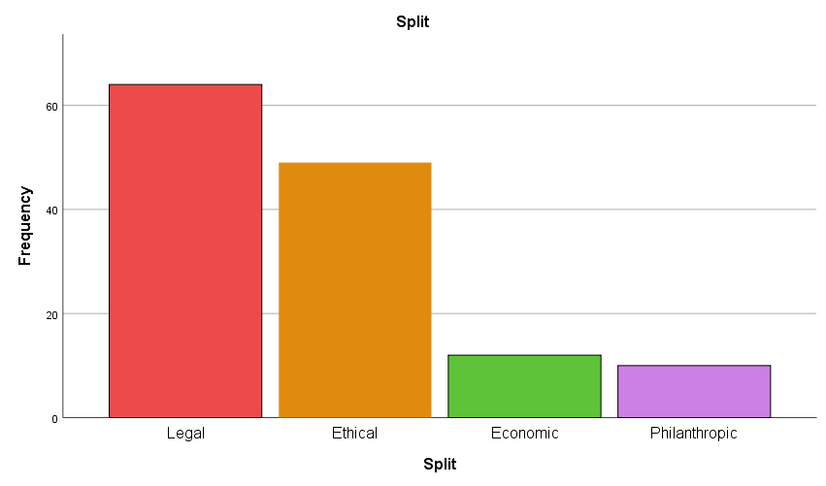
Table 17 Responsibility frequency bar graph
Table 17 was created in SPSS as a visual tool and depicts the frequency each responsibility was selected. The results show people feel FB greatest responsibility is a Legal responsibility which was selected 117 times. The next most important was an Ethical responsibility, selected 53 times, then an economic responsibility, selected 37 times and lastly a Philanthropic which was selected 31 times. It is clear that participants are not in support of Carroll’s pyramid (1991) which states economic should be a businesses bottom responsibility and instead agrees with the CSR-Universal Model, Carroll’s Pyramid remodelled, (Visser, 2016) which says a businesses bottom line responsibility should be a legal responsibility (see appendix one).

The researcher explored if there was a link between the age and the responsibilities participants choose. The hypothesis tested was:
- H1. There was a difference between the age of a participant and the responsibilities they felt FB had.
- H0. There was no difference between the age of a participant and the responsibilities they felt FB had.
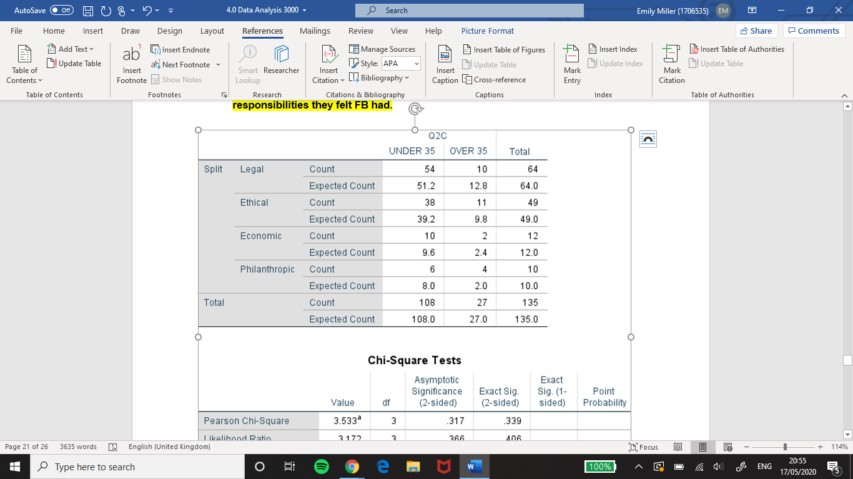
Table 18 Responsibility and Age crosstabulation
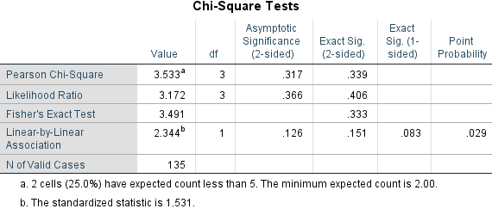
Table 19 Responsibility and Age Fishers Exact test
This Chi-square test would not be valid as 25% of the expected value are less than 5%. Fisher's exact test was calculated which gave the result .333, this greater than 0.05. This proves H0, there was no difference between the age of a participant and the responsibilities they felt FB had.

4.13 Question 11
Question 11 asked participants do they feel that FB could do more to act on the previously chosen responsibilities? 130 respondents choose Yes while 11 choose No.

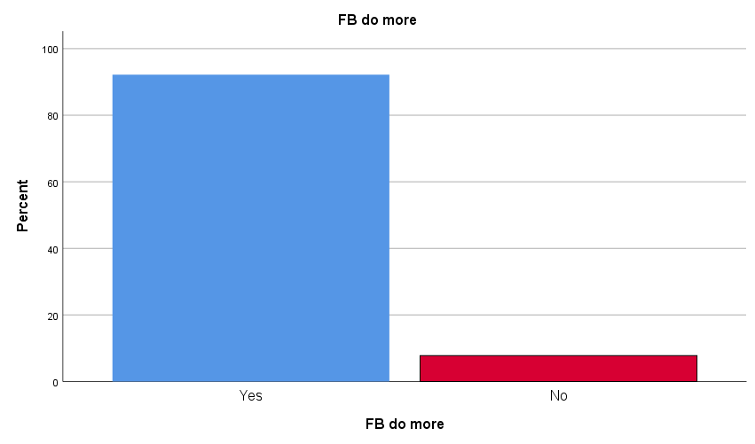
Table 20 Response bar graph
The respondents that choose No and gave a reason within Question 13 gave the reasons:
- “I like keeping connected”
- “I feel people can be a bit naive about data sharing and must understand that even though companies like FB do misuse them, it is part of society at the moment”.
- “I believe that they are not a safe site and have no privacy which is why I deleted it”
These three participants also said that their perception would not be changed if FB did more to act on their responsibilities for question 12. Responses one, two and three take very different views. Response one indicates if FB did or did not incorporate CSR this would have no effect on their perception as they like the platform service either way. Response two believes that unethical corporate actions are part of the way all organisations are run and so it is something that should be accepted. Whereas response three takes the approach that such unethical corporate actions should not go unnoticed and once FB has broken its user's trust it cannot be rebuilt.

4.14 Question 12
Question 12 asked participants if FB acted on the responsibilities listed in question 10 would this improve their overall perception of FB? Table 21 presents the findings. 93 participants selected Yes and 46 selected No.
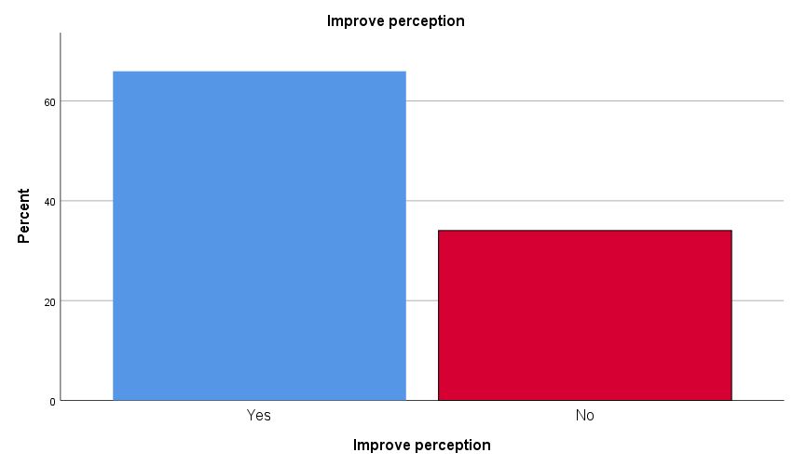
Table 21 Q12 Responses
A Chi-square test was used to find a link between the respondent’s answers to question 11 and question 12. The hypothesis was:
- H1. Participants who said that FB could do more to act on the responsibilities also said that this would improve their perception.
- H0. Participants who said that FB could do more to act on the responsibilities also said that this would not improve their perception.
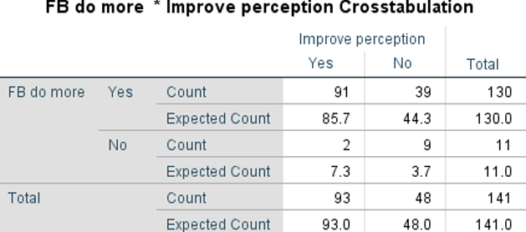
Table 22 Q11 and Q12 Crosstabulation
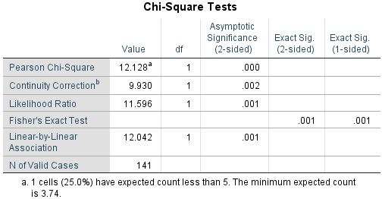
Table 23 Q11 and Q12 Chi-Square test
The Chi-square test was not valid as 25% of the p-value is less than 5%. Fisher's exact test was used to assess H0. The result was 0.001 which is lesser than 0.05, this proves H1. Table 23 presents this as 91 participants agreed that FB could do more to act on their responsibilities and this would improve their perception of FB whereas, 39 participants said that FB could do more to act on the responsibilities but this would not change their perception.

4.15 Question 13
Question 13 asked participants to explain why they had chosen Yes or No to question 10. NVivo was used to run a text search query to identify the most common response. It was discovered if FB acted lawfully this would have the greatest impact on changing perception. Figure 7 shows the responses which included the term "law". This indicates if FB continues to involve themselves in activities such as the FB-CA scandal their brand perception will decrease.
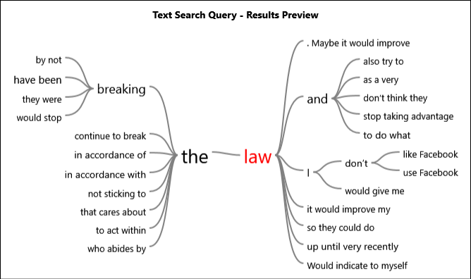
Figure 7 Q13 Text search query

4.16 Triangulation of findings
The online questionnaire collected qualitative and quantitative data. The analysis of the data revealed that there was an agreed theme within the qualitative data which was also present within the quantitative data. Therefore, triangulation can be used. The theme to emerge was a legal responsibility was considered most valuable and could be most effective for improving brand perception if acted on.

4.17 Conclusion
By carrying out primary research in the form of an online questionnaire and analysing and presenting the results objective two has been successfully fulfilled. From the study, it was found that participants perception was more unfavourable than favourable and the responsibility which participants felt FB had a duty to upkeep was a legal responsibility, this responsibility was also identified as the one which could improve perception If acted upon. Ethical responsibility was the second most chosen responsibility, but it was not expressed as being as effective for improving brand perception as a legal responsibility. Comparing the results obtained from the primary research and those from the secondary research it is clear that they in favour of each other as the primary research supports what was found in the secondary research.

5.0 Chapter 5 – Conclusion

5.1 Introduction
This chapter will discuss and evaluate the data collected in chapter three and will look to satisfy the final objective of the dissertation:
3. Synthesise previous academic literature and collected primary research to draw a conclusion on FB’s current brand perception and make recommendations on how they can improve their brand perception.

5.2 Conclusion
The first objective of the dissertation was to examine previous academic literature surrounding CSR and brand perception and analyse the impact integrating methods of CSR has had on similar organisations. This was achieved within chapter two by analysing an extensive range of literature for each of the categories within figure 1. A conceptual framework for research, (Niazi et al, 2012). This set a clear guide of what needed to be researched to obtain thorough and dense knowledge on each of the fields of research, CSR, and brand perception. The researchers Milton Friedman (1970), Edward Freeman (1984) and (Carroll (1991) provided essential literature for CSR and Severi and Ling (2013) provided key literature concerning brand perception. Chapter two provided examples of companies who are achieving a positive brand image by altering their business strategy and incorporating CSR into their business, (Haagen Dazs, Microsoft and Coca-Cola) and also uncovered how FB is harming theirs by involving themselves with illegal activity such as the FB-CA scandal which has been identified by Hern and Pegg (2018) and Waterson (2018).
Objective two was to conduct primary research in the form of an online questionnaire which will evaluate FB current brand perception and determine the CSR responsibilities most effective in improving FB brand perception. This was fulfilled within chapter three and four as the appropriate methodology was identified using the Saunders et al 2007 Research onion which facilitated in accumulating findings which were analysed within chapter four. The participant's responses analysed in chapter four supported the majority of which was identified within chapter two. One reoccurring perception of FB was that it was associated with an “older generation”, chapter two identified that baby boomers and generation X were the age groups which most frequently used FB supporting Viens (2019). Taking into consideration that 113 participants were under the age 35 it is most likely; baby boomers and generation X are considered as an “older generation” to these participants. It was also found when informed of the FB-CA scandal a significant number of participants said Yes this affected their perception of FB. It was identified that it caused participants to feel a lack of trust in FB as well as emotions of shock and disappointment, this supports chapter two which stated trust in FB decreased by 66% after the FB-CA scandal was unveiled, (Weisbaum, 2018). Out of the four CSR responsibilities participants had the option of choosing the most important to them the study revealed legal was ranked as the most important responsibility, the second was ethical, third was economical and last was philanthropic. It was found that age, favourability, or familiarity did not influence this choice. The results contradict Carroll’s CSR pyramid (1991) which states economic as the basic responsibility and instead agrees with the CSR Universal-model that legal is the basic responsibility. However, both models agreed that philanthropic was the least important responsibility which was also found to be true within this study. Overall, this study has presented the perception of FB as being unfavourable. Chapter two and four have provided evidence in support of this. What was shown within this dissertation is that there is a need for FB to improve their brand perception. However, although the findings presented that there was a want for FB to act more ethically which could be achieved by integrating CSR theories, there is a greater need for FB to make legal their basic responsibility, as this was the most commonly chosen responsibility which participants said would have the greatest impact on improving brand perception.
These findings can be used to suggest recommendations for FB to improve their brand perception.

5.3 Recommendations
The first recommendation produced by analysing the results of the study, suggests FB need to act in strict accordance with the law. This can be achieved by prioritising their legal responsibilities. If implemented correctly and throughout the organisation, it will greatly reduce the chance of being involved in a major scandal again. Also, by doing this as the researchers such as Lai et al (2010) and Kim et al (2015) suggest it will improve their brand perception as it will raise their level of brand trust.
The second recommendation is for FB to increase the number of ethical decisions they make. This can be achieved incorporating CSR theories and concepts within their organisational strategy as well as conducting a stakeholder analysis such as Mendelow’s matrix to identify the needs and wants of their stakeholders and the impact they have on the company. Researchers Moore (1999), Steib (2009) and Freeman et al (2010) propose this will assist in keeping all stakeholders satisfied Improving brand perception.

5.4 Limitations
The main limitation of this study was in connection with the development of the coronavirus. In the field of academic research, in-person group interviews were unable to be carried out due to the restrictions put in place for COVID-19. Although it was possible to carry out interviews using Microsoft teams and What’s App, unfortunately, interview participants no longer wished to be a part of this study. This stunted the depth of the answers which participants provided as it was very common with the online questionnaire for participants to not provide an answer for written answers or only to answer with one word.
The second limitation of this study was the enormous imbalance of participants under and over the age of 35. Under 35 had 113 participants whereas over 35 had 28. This made it difficult to draw reliable conclusions due to the subcategory being too small. Due to gender research becoming a complex topic because of societal changes the researcher decided to exclude this demographic question from the questionnaire, however, in hindsight, this should have been included as it could have been used for crosstabulation instead of age and could have provided more reliable conclusions.

5.5 Recommendations for future research
The study could be constructed to include the collection of brand perceptions of other social media websites which are similar to FB such as Twitter or Instagram and compare the perceptions people have of those brands to find out if one is held in higher regard than the other. The reasons for this may be revealed within the data collected. By comparing FB to a similar organisation, it can show them what they are doing right and what they could improve on. For the future study, it is also recommended to carry out interviews and increase the period in which data is collected to increase the range and number of responses collected.

5.6 Self-reflection
The inspiration for this study came from watching the documentary on Netflix, “The great hack”. The researcher was shocked at what FB had been involved with, yet it was still the largest platform in the world with the most monthly active users even after breaching major privacy laws which have impacted societies globally. The researcher found the dissertation difficult at times as the scale of information and data which was read and analysed was daunting. However, the skills which have been developed on this journey has been very rewarding. On the completion of this dissertation the researcher has gained a considerate knowledge of CSR theories and understand the importance of why a company should act on their economic, legal, ethical, and philanthropic responsibilities if they wish to improve their brand perception. Although she has realised that once a company establishes a large consumer base and is successful and effective in providing a useful service, users are willing to overlook the negative actions of a company to continue using its services.

Bibliography

Aaker, D.A., (2009). Managing brand equity. Simon and Schuster.
About Facebook. (2019). Writing Facebook's Rulebook. [online] Available at: https://about.fb.com/news/2019/04/insidefeed-community-standards-development-process [Accessed 4 April 2020].
Adams, C. and Zutshi, A., (2004). Corporate social responsibility: why a business should act responsibly and be accountable. Australian accounting review, 14(34), pp.31-39.
Alhaddad, A., (2015). Perceived quality, brand image and brand trust as determinants of brand loyalty. Journal of Research in Business and Management, 3(4), pp.01-08.
Ardichvili, A., Mitchell, J.A. and Jondle, D., (2009). Characteristics of ethical business cultures. Journal of business ethics, 85(4), pp.445-451.
Atilgan, E., Aksoy, Ş. and Akinci, S., (2005). Determinants of the brand equity. Marketing intelligence & planning.
Balmer, J.M. and Powell, S.M., (2011). Corporate marketing myopia and the inexorable rise of corporate marketing logic. European journal of marketing.
Balmer, J.M., Powell, S.M. and Greyser, S.A., (2011). Explicating ethical corporate marketing. Insights from the BP Deepwater Horizon catastrophe: The ethical brand that exploded and then imploded. Journal of business ethics, 102(1), p.1.
Baruch, Y. and Holtom, B.C., (2008). Survey response rate levels and trends in organizational research. Human relations, 61(8), pp.1139-1160.
Barwise, P., (1993). Brand equity: snark or boojum?. International Journal of Research in Marketing, 10(1), pp.93-104.
Baur, D. and Schmitz, H.P., (2012). Corporations and NGOs: When accountability leads to co-optation. Journal of Business Ethics, 106(1), pp.9-21.
BBC News. (2020). BBC News. [online] Available at: https://www.bbc.co.uk/news/topics/c81zyn0888lt/facebook-cambridge-analytica-scandal [Accessed 2 March 2020].
BBC News. (2020). Australia Sues Facebook Over Cambridge Analytica. [online] Available at: <https://www.bbc.co.uk/news/technology-51799738> [Accessed 2 April 2020].
Berger, I.E., Cunningham, P.H. and Drumwright, M.E., (2007). Mainstreaming corporate social responsibility: Developing markets for virtue. California management review, 49(4), pp.132-157.
Bertels, S. and Peloza, J., (2008). Running just to stand still? Managing CSR reputation in an era of ratcheting expectations. Corporate Reputation Review, 11(1), pp.56-72.
Bertot, J.C., Jaeger, P.T. and Hansen, D., (2012). The impact of polices on government social media usage: Issues, challenges, and recommendations. Government information quarterly, 29(1), pp.30-40.
Bethlehem, J., (1999). Cross-sectional research. Research methodology in the social, behavioural and life sciences, 110, p.142.
Bowen, H.R., (2013). Social responsibilities of the businessman. University of Iowa Press.
Brandkeys.com. (2019). Brand Keys 2019 Loyalty Leaders. [online] Available at: https://brandkeys.com/wp-content/uploads/2019/09/Press-Release-2019-Loyalty-Leaders.pdf [Accessed 9 March 2020].
Brandkeys.com. (2019). Brand Keys Customer Loyalty Engagement Index. [online] Available at: https://brandkeys.com/wp-content/uploads/2019/05/PRESS-RELEASE-2019-CLEI-Overall.pdf [Accessed 10 March 2020].
Brewer, J. and Hunter, A., (2006). Foundations of multimethod research: Synthesizing styles. Sage.
Bryson, J.M. and Patton, M.Q., (2010). Analyzing and engaging stakeholders. Handbook of practical program evaluation, 3, pp.30-54.
Cadwalladr, C. and Graham-Harrison, E. (2018). The Cambridge Analytica Files | The Guardian. [online] the Guardian. Available at: https://www.theguardian.com/news/series/cambridge-analytica-files [Accessed 23 Oct. 2019].
Cadwalladr, C. and Graham-Harrison, E. (2018). The Cambridge Analytica Files | The Guardian. [online] the Guardian. Available at: https://www.theguardian.com/news/series/cambridge-analytica-files [Accessed 23 Oct. 2019].
Carroll, A.B., (1999). Corporate social responsibility: Evolution of a definitional construct. Business & Society, 38(3), pp.268-295.
Carroll, A.B., (2016). “Managing ethically with global stakeholders: A present and future challenge,” ACAD Manage Perspect, vol. 18, no. 2, pp. 114-120.
Carroll, A.B., (2016). Carroll’s pyramid of CSR: taking another look. International journal of corporate social responsibility, 1(1), p.3.
Carson, T., (1993). Friedman’s theory of corporate social responsibility. Business and Professional Ethics Journal, 12(1), pp.3-32.
Chan, Y.H., (2003). Biostatistics 102: quantitative data–parametric & non-parametric tests. Blood Press, 140(24.08), p.79.
Coca-colacompany.com. 2020. Coca-Cola Slogans Through The Years. [online] Available at: https://www.coca-colacompany.com/au/news/coca-cola-slogans-through-the-years [Accessed 10 March 2020].
Collis, J. and Hussey, R., (2013). Business research: A practical guide for undergraduate and postgraduate students. Macmillan International Higher Education.
Crisp, R. and Slote, M.A. eds., (1997). Virtue ethics (p. 284). Oxford: Oxford University Press.
Davies, R. and Rushe, D., (2019). Facebook To Pay $5Bn Fine As Regulator Settles Cambridge Analytica Complaint. [online] the Guardian. Available at: https://www.theguardian.com/technology/2019/jul/24/facebook-to-pay-5bn-fine-as-regulator-files-cambridge-analytica-complaint [Accessed 2 March 2020].
De Vaus, D. and de Vaus, D., (2013). Surveys in social research. Routledge.
DeCoster, J. and Claypool, H., (2004). Data analysis in SPSS. Retrieved October 2, p.2015.
Del Greco, L., Walop, W. and McCarthy, R.H., (1987). Questionnaire development: 2. Validity and reliability. CMAJ: Canadian Medical Association Journal, 136(7), p.699.
Deutskens, E., De Ruyter, K., Wetzels, M. and Oosterveld, P., (2004). Response rate and response quality of internet-based surveys: An experimental study. Marketing letters, 15(1), pp.21-36.
Dew, L. and Kwon, W.S., (2010). Exploration of apparel brand knowledge: Brand awareness, brand association, and brand category structure. Clothing and Textiles Research Journal, 28(1), pp.3-18.
Ding, L. and Beichner, R., (2009). Approaches to data analysis of multiple-choice questions. Physical Review Special Topics-Physics Education Research, 5(2), p.020103.
Doward, J., Cadwalladr, C.C.C. and Gibbs, A., (2017). Watchdog to launch inquiry into misuse of data in politics. Sat, 4, pp.22-29.
Dutot, V., Galvez, E.L. and Versailles, D.W., (2016). CSR communications strategies through social media and influence on e-reputation. Management decision.
Ehie, I.C., (2016). Examining the corporate social responsibility orientation in developing countries: an empirical investigation of the Carroll's CSR pyramid. International Journal of Business Governance and Ethics, 11(1), p.42755.
Evans, J.R. and Mathur, A., (2005). The value of online surveys. Internet research.
Facebook.com. (2020). Community Standards | Facebook. [online] Available at: https://www.facebook.com/communitystandards/stakeholder_engagement [Accessed 4 April 2020].
Farahani, H.A., Kazemi, Z., Aghamohamadi, S., Bakhtiarvand, F. and Ansari, M., (2011). Examining mental health indices in students using Facebook in Iran. Procedia-Social and Behavioral Sciences, 28, pp.811-814.
Fatma, M. and Rahman, Z., (2015). Consumer perspective on CSR literature review and future research agenda. Management Research Review.
Faucher, R.C., (2015). Stakeholder Theory & Corporate Social Responsibility in Spain (Doctoral dissertation).
Ferrero, I., Michael Hoffman, W., and McNulty, R.E., (2014). Must Milton Friedman embrace stakeholder theory? Business and Society Review, 119(1), pp.37-59.
Fink, A., (2003). The survey handbook. Sage.
Flick, U., (2004). Triangulation in qualitative research. A companion to qualitative research, 3, pp.178-183.
Forbes. (2017). Building Brand Equity. [online] Available at: <https://www.forbes.com/sites/propointgraphics/2017/07/08/building-brand-equity/#f6d365d6e8f8> [Accessed 10 March 2020].
Foroudi, P., Jin, Z., Gupta, S., Foroudi, M.M. and Kitchen, P.J., (2018). Perceptional components of brand equity: Configuring the Symmetrical and Asymmetrical Paths to brand loyalty and brand purchase intention. Journal of Business Research, 89, pp.462-474.
Freeman, R.E., Harrison, J.S., Wicks, A.C., Parmar, B.L. and De Colle, S., (2010). Stakeholder theory: The state of the art. Cambridge University Press.
Frost, R.L. and Rickwood, D.J., (2017). A systematic review of the mental health outcomes associated with Facebook use. Computers in Human Behaviour, 76, pp.576-600.
George, E., (2019). Can Corporate Social Responsibility Be Legally Enforced?. [online] Forbes. Available at: <https://www.forbes.com/sites/uhenergy/2019/10/11/can-corporate-social-responsibility-be-legally-enforced/#2a8ce2503d44> [Accessed 9 March 2020].
Gibbs, G.R., (2018). Analyzing qualitative data (Vol. 6). Sage.
Golafshani, N., (2003). Understanding reliability and validity in qualitative research. The qualitative report, 8(4), pp.597-607.
Golob, U., Elving, W.J., Nielsen, A.E., Thomsen, C., Schultz, F., Podnar, K. and Colleoni, E., (2013). CSR communication strategies for organizational legitimacy in social media. Corporate Communications: an international journal.
GOV.UK. (2020). Data Protection. [online] Available at: <https://www.gov.uk/data-protection> [Accessed 4 March 2020].
Grayson, D. (2004). Corporate social opportunity!. Sheffield; Greenleaf.
Greenwood, S., Perrin, A. and Duggan, M., (2016). Social media update 2016. Pew Research Center, 11(2).
Gregory, A., (2007). Involving stakeholders in developing corporate brands: The communication dimension. Journal of Marketing Management, 23(1-2), pp.59-73.
Haagendazs.us. (2020). Save The Honey Bees | Häagen-Dazs®. [online] Available at: <https://www.haagendazs.us/save-the-honey-bees> [Accessed 31 March 2020].
He, Y. and Lai, K.K., (2014). The effect of corporate social responsibility on brand loyalty: the mediating role of brand image. Total Quality Management & Business Excellence, 25(3-4), pp.249-263.
Heale, R. and Forbes, D., 2013. Understanding triangulation in research. Evidence-Based Nursing, 16(4), pp.98-98.
Heale, R. and Twycross, A., (2015). Validity and reliability in quantitative studies. Evidence-based nursing, 18(3), pp.66-67.
Hern, A. and Pegg, D., 2018. Facebook Fined For Data Breaches In Cambridge Analytica Scandal. [online] the Guardian. Available at: <https://www.theguardian.com/technology/2018/jul/11/facebook-fined-for-data-breaches-in-cambridge-analytica-scandal> [Accessed 5 March 2020].
Hess, J., Story, J. and Danes, J., (2011). A three staged model of consumer relationship investment. Journal of Product and Brand Management.
Hinton, P.R., McMurray, I. and Brownlow, C., (2014). SPSS explained. Routledge.
Huang, R. and Sarigöllü, E., (2014). How brand awareness relates to market outcome, brand equity, and the marketing mix. In Fashion Branding and Consumer Behaviors (pp. 113-132). Springer, New York, NY.
Hursthouse, R., (1999). On virtue ethics. OUP Oxford.
Investor.fb.com. (2020). Facebook - Resources. [online] Available at: <https://investor.fb.com/resources/default.aspx> [Accessed 8 March 2020].
Jang, K., Park, N. and Song, H., (2016). Social comparison on Facebook: Its antecedents and psychological outcomes. Computers in Human Behavior, 62, pp.147-154.
Jankowicz, A.D., (1995). Business Research Projects, London.
Jebreen, I., (2012). Using inductive approach as research strategy in requirements engineering. International Journal of Computer and Information Technology, 1(2), pp.162-173.
Johnson, G., Scholes, K. & Whittington, R. (2008). Exploring Corporate Strategy. Edinburgh: Pearson Education Limited
Kajornboon, A.B., (2005). Using interviews as research instruments. E-journal for Research Teachers, 2(1), pp.1-9.
Kervyn, N., Fiske, S.T. and Malone, C., (2012). Brands as intentional agents’ framework: How perceived intentions and ability can map brand perception. Journal of Consumer Psychology, 22(2), pp.166-176.
Kim, H., Hur, W.M. and Yeo, J., (2015). Corporate brand trust as a mediator in the relationship between consumer perception of CSR, corporate hypocrisy, and corporate reputation. Sustainability, 7(4), pp.3683-3694.
Kirmani, A. and Zeithaml, V., (1993). Advertising, perceived quality, and brand image (pp. 143-62). Hillsdale, NJ: Lawrence Erlbaum Associates.
Kirmani, A. and Zeithaml, V., 1993. Advertising, perceived quality, and brand image (pp. 143-62). Hillsdale, NJ: Lawrence Erlbaum Associates.
Kost, R.G. and da Rosa, J.C., (2018). Impact of survey length and compensation on validity, reliability, and sample characteristics for Ultrashort-, Short-, and Long-Research Participant Perception Surveys. Journal of clinical and translational science, 2(1), pp.31-37.
Lai, C.S., Chiu, C.J., Yang, C.F. and Pai, D.C., (2010). The effects of corporate social responsibility on brand performance: The mediating effect of industrial brand equity and corporate reputation. Journal of business ethics, 95(3), pp.457-469.
Laplume, A.O., Sonpar, K. and Litz, R.A., (2008). Stakeholder theory: Reviewing a theory that moves us. Journal of Management, 34(6), pp.1152-1189.
Lauri, M.A., (2011). Triangulation of data analysis techniques. Papers on Social Representations, 20(2), pp.34-1.
Lee-Davies, L. (2005). Corporate social responsibility and stakeholder approach: A conceptual review. International Journal of Business Governance and Ethics, 1.
Levin, K.A., (2006). Study design III: Cross-sectional studies. Evidence-based dentistry, 7(1), pp.24-25.
Levin, S., (2020). Facebook Admits It Poses Mental Health Risk – But Says Using Site More Can Help. [online] the Guardian. Available at: <https://www.theguardian.com/technology/2017/dec/15/facebook-mental-health-psychology-social-media> [Accessed 7 March 2020].
Lilley, S., Grodzinsky, F.S. and Gumbus, A., (2012). Revealing the commercialized and compliant Facebook user. Journal of information, communication, and ethics in society.
Lin, L., (2019). Mandatory Corporate Social Responsibility? Legislative Innovation And Judicial Application In China. [online] Oxford Law Faculty. Available at: <https://www.law.ox.ac.uk/business-law-blog/blog/2019/05/mandatory-corporate-social-responsibility-legislative-innovation-and> [Accessed 2 April 2020].
Liu, L., (2016). Using Generic Inductive Approach in Qualitative Educational Research: A Case Study Analysis. Journal of Education and Learning, 5(2), pp.129-135.
Lomas, N., (2019). Techcrunch Is Now A Part Of Verizon Media. [online] Techcrunch.com. Available at: <https://techcrunch.com/2019/04/29/facebook-accused-of-blocking-wider-efforts-to-study-its-ad-platform/> [Accessed 8 March 2020].
Lovejoy, K., and Saxton, G.D., (2012). Information, community, and action: How nonprofit organizations use social media. Journal of computer-mediated communication, 17(3), pp.337-353.
MacFarland, T.W. and Yates, J.M., (2016). Mann–whitney u test. In Introduction to nonparametric statistics for the biological sciences using R (pp. 103-132). Springer, Cham.
Malhotra, N.K., (2006). Questionnaire design and scale development. The handbook of marketing research: Uses, misuses, and future advances, pp.83-94.
Manavis, S., (2019). Is Instagram Starting To Take Mental Health Seriously?. [online] Newstatesman.com. Available at: <https://www.newstatesman.com/science-tech/social-media/2019/09/instagram-starting-take-mental-health-seriously> [Accessed 10 March 2020].
Manna, Z. and Waldinger, R., (1980). A deductive approach to program synthesis. ACM Transactions on Programming Languages and Systems (TOPLAS), 2(1), pp.90-121.
Mathers, N., Fox, N. and Hunn, A., (2007). Surveys and Questionnaires. The NIHR RDS for the East Midlands/Yorkshire & the Humber.
Mayfield, A., (2008). What is social media.
McHugh, M.L., (2013). The chi-square test of independence. Biochemia medica: Biochemia medica, 23(2), pp.143-149.
McKnight, P.E. and Najab, J., (2010). Mann‐Whitney U Test. The Corsini encyclopedia of psychology, pp.1-1.
Microsoft.com. (2020). Computer Science Education & Digital Skills – Microsoft CSR. [online] Available at: <https://www.microsoft.com/en-us/corporate-responsibility/skills-employability/computer-science> [Accessed 20 May 2020].
Moore, G., (1999). Tinged shareholder theory: or what’s so special about stakeholders?. Business Ethics: A European Review, 8(2), pp.117-127.
Morsing, M. and Schultz, M., (2006). Corporate social responsibility communication: stakeholder information, response, and involvement strategies. Business ethics: A European Review, 15(4), pp.323-338.
Muijs, D., (2010). Doing quantitative research in education with SPSS. Sage.
Nalband, N.A. and Kelabi, S.A., (2014). Redesigning Carroll’s CSR pyramid model. Journal of Advanced Management Science, 2(3).
Niazi, M.S., Haider, M.I., Islam, T., and Rehman, S.U., (2012). The impact of corporate social responsibility on brand equity. European Journal of Social Sciences, 34(3), pp.520-529.
Park, H.M., (2009). Comparing group means: t-tests and one-way ANOVA using Stata, SAS, R, and SPSS.
Park, J., Lee, H. and Kim, C., (2014). Corporate social responsibilities, consumer trust and corporate reputation: South Korean consumers' perspectives. Journal of Business Research, 67(3), pp.295-302.
Paul, J., (1996). Between-method triangulation in organizational diagnosis. International Journal of Organizational Analysis, 4, pp.135-153.
Perrin, A., (2015). Social media usage. Pew research center, pp.52-68.
Polonsky, M.J., (1995). A stakeholder theory approach to designing an environmental marketing strategy. Journal of business & industrial marketing.
Pope, C., Ziebland, S. and Mays, N., (2000). Qualitative research in health care: Analysing qualitative data. BMJ: British Medical Journal, 320(7227), p.114.
Porter, M.E., and Kramer, M.R., (2006). The link between competitive advantage and corporate social responsibility. Harvard business review, 84(12), pp.78-92.
Rahman, S., (2011). Evaluation of definitions: ten dimensions of corporate social responsibility. World Review of Business Research, 1(1), pp.166-176.
Rahmatulloh, R., Yasri, Y. and Abror, A., (2019), April. The Influence of Brand Image and Perceived Quality on Brand Loyalty with Brand Trust as Mediator in PT Bank Syariah Mandiri. In 2nd Padang International Conference on Education, Economics, Business and Accounting (PICEEBA-2 2018). Atlantis Press.
Richards, L., (1999). Using NVivo in qualitative research. Sage.
Saunders, M., Lewis, P. and Thornhill, A., (2003). Research methods for business students. Essex: Prentice Hall: Financial Times.
Saunders, M., Lewis, P., and Thornhill, A., (2007). Research methods. Business Students 4th edition Pearson Education Limited, England.
Schivinski, B. and Dabrowski, D., (2015). The impact of brand communication on brand equity through Facebook. Journal of Research in Interactive Marketing.
Scott, D.M., (2015). The new rules of marketing and PR: How to use social media, online video, mobile applications, blogs, news releases, and viral marketing to reach buyers directly. John Wiley & Sons.
Severi, E. and Ling, K.C., (2013). The mediating effects of brand association, brand loyalty, brand image and perceived quality on brand equity. Asian Social Science, 9(3), p.125.
Shead, S., (2019). Facebook Dominates Most Downloaded Apps Of Decade. [online] BBC News. Available at: <https://www.bbc.co.uk/news/technology-50838013> [Accessed 27 March 2020].
Siddiqui, A., (2019). Facebook's Lack Of Transparency Is Causing Researchers To Lose Trust In The Company Once Again!. [online] Digitalinformationworld.com. Available at: <https://www.digitalinformationworld.com/2019/05/facebook-putting obstacles-research-ad-platform-misinformation.html> [Accessed 5 April 2020].
Sleeper, R.W., 2001. The necessity of pragmatism: John Dewey's conception of philosophy. University of Illinois Press.
Smith, J. and Firth, J., (2011). Qualitative data analysis: the framework approach. Nurse researcher, 18(2), pp.52-62.
Statista. (2019). Facebook Active Advertisers 2019 | Statista. [online] Available at: <https://www.statista.com/statistics/778191/active-facebook-advertisers/> [Accessed 10 March 2020].
Statista. (2019). U.S. population with a social media profile 2019 | Statista. [online] Available at: https://www.statista.com/statistics/273476/percentage-of-us-population-with-a-social-network-profile/ [Accessed 29 Jan. 2020].
Statista. (2020). Facebook Users Worldwide 2019 | Statista. [online] Available at: <https://www.statista.com/statistics/264810/number-of-monthly-active-facebook-users-worldwide/> [Accessed 27 March 2020].
Stieb, J.A., (2009). Assessing Freeman’s stakeholder theory. Journal of Business Ethics, 87(3), pp.401-414.
Strauss, K., (2017). The 10 Companies With The Best CSR Reputations In 2017. [online] Forbes. Available at: <https://www.forbes.com/sites/karstenstrauss/2017/09/13/the-10-companies-with-the-best-csr-reputations-in-2017/#1a07ae60546b> [Accessed 12 March 2020].
Sue, V.M. and Ritter, L.A., (2012). Conducting online surveys. Sage.
Survey Circle. (2020). Survey Circle. [online] Available at: <https://www.surveycircle.com/en/> [Accessed 22 April 2020].
SurveyMonkey. (2020). Privacy Policy | Surveymonkey. [online] Available at: <https://www.surveymonkey.com/mp/legal/privacy-policy/> [Accessed 22 April 2020].
Swift, T., (2001). Trust, reputation, and corporate accountability to stakeholders. Business Ethics: A European Review, 10(1), pp.16-26.
The Guardian. (2014). Corporate Transparency: Why Honesty Is The Best Policy. [online] Available at: <https://www.theguardian.com/sustainable-business/corporate-transparency-honesty-best-policy> [Accessed 5 March 2020].
Thomas, D.R., (2003). A general inductive approach for qualitative data analysis.
Thomas, D.R., (2006). A general inductive approach for analyzing qualitative evaluation data. American journal of evaluation, 27(2), pp.237-246.
Tsiotsou, R., (2006). The role of perceived product quality and overall satisfaction on purchase intentions. International journal of consumer studies, 30(2), pp.207-217.
Ukdataservice.ac.uk. 2020. UK Data Service. [online] Available at: <https://ukdataservice.ac.uk/manage-data/legal-ethical/consent-data-sharing/surveys.aspx> [Accessed 5 May 2020].
Veloutsou, C., (2007). Identifying the dimensions of the product-brand and consumer relationship. Journal of Marketing Management, 23(1-2), pp.7-26.
Vernuccio, M., (2014). Communicating corporate brands through social media: An exploratory study. International Journal of Business Communication, 51(3), pp.211-233.
Viens, A., (2019). This Graph Tells Us Who's Using Social Media the Most. [online] World Economic Forum. Available at: <https://www.weforum.org/agenda/2019/10/social-media-use-by-generation/> [Accessed 19 May 2020].
Visser, W., (2006). Revisiting Carroll’s CSR pyramid. Corporate citizenship in developing countries, pp.29-56.
Visser, W., (2006). Revisiting Carroll’s CSR pyramid. Corporate citizenship in developing countries, pp.29-56.
Vollmer, N., (2020). Article 7 EU General Data Protection Regulation (EU-GDPR). Privacy/Privazy According To Plan.. [online] Privacy-regulation.eu. Available at: <https://www.privacy-regulation.eu/en/article-7-conditions-for-consent-GDPR.htm#> [Accessed 5 May 2020].
Waterson, J., (2018). UK Fines Facebook £500,000 For Failing To Protect User Data. [online] the Guardian. Available at: <https://www.theguardian.com/technology/2018/oct/25/facebook-fined-uk-privacy-access-user-data-cambridge-analytica> [Accessed 4 March 2020].
Weisbaum, H., (2018). Zuckerberg's Apology Tour Has Not Done Much To Regain User Trust. [online] NBC News. Available at: <https://www.nbcnews.com/business/consumer/trust-facebook-has-dropped-51-percent-cambridge-analytica-scandal-n867011> [Accessed 2 March 2020].
Welsh, E., (2002), May. Dealing with data: Using NVivo in the qualitative data analysis process. In Forum qualitative sozialforschung/Forum: qualitative social research (Vol. 3, No. 2).
Whiting, A. and Williams, D., 2013. Why people use social media: a uses and gratifications approach. Qualitative Market Research: An International Journal.
Wong, J., (2019). The Cambridge Analytica Scandal Changed The World – But It Didn't Change Facebook. [online] the Guardian. Available at: <https://www.theguardian.com/technology/2019/mar/17/the-cambridge-analytica-scandal-changed-the-world-but-it-didnt-change-facebook> [Accessed 2 March 2020].
Woodcock, A., (2019). Facebook Agrees To Pay £500,000 Fine Over Cambridge Analytica Scandal, But Doesn’T Accept Liability. [online] The Independent. Available at: <https://www.independent.co.uk/news/uk/politics/facebook-fine-cambridge-analytica-user-personal-information-liability-latest-a9177471.html> [Accessed 2 March 2020].
Yaniv, E. and Farkas, F., (2005). The impact of person-organization fit on the corporate brand perception of employees and of customers. Journal of Change Management, 5(4), pp.447-461.
Yoo, B. and Donthu, N., (2001). Developing and validating a multidimensional consumer-based brand equity scale. Journal of business research, 52(1), pp.1-14.
Zuckerberg, M., (2017). Bringing The World Closer Together | Facebook. [online] Facebook.com. Available at: <https://www.facebook.com/notes/mark-zuckerberg/bringing-the-world-closer-together/10154944663901634/> [Accessed 19 May 2020].

Appendices

Appendix 1: The CSR-Universal Model, Carroll’s Pyramid remodelled, (Visser, 2016).
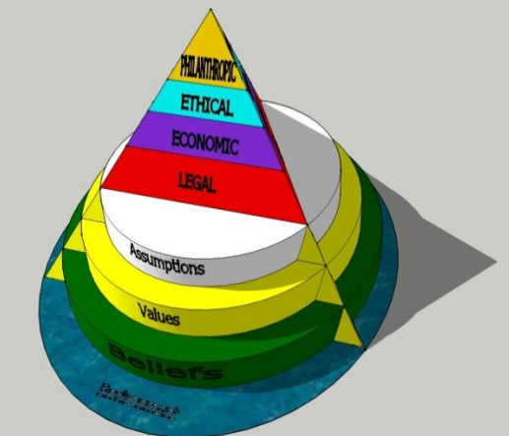

Appendix 2: Data Protection ACT 2018. The six principles
Everyone responsible for using personal data has to follow strict rules called ‘data protection principles. They must make sure the information is:
- used fairly, lawfully, and transparently
- used for specified, explicit purposes
- used in a way that is adequate, relevant, and limited to only what is necessary
- accurate and, where necessary, kept up to date
- kept for no longer than is necessary
- handled in a way that ensures appropriate security, including protection against unlawful or unauthorised processing, access, loss, destruction, or damage

Appendix 3; Copy of questionnaire

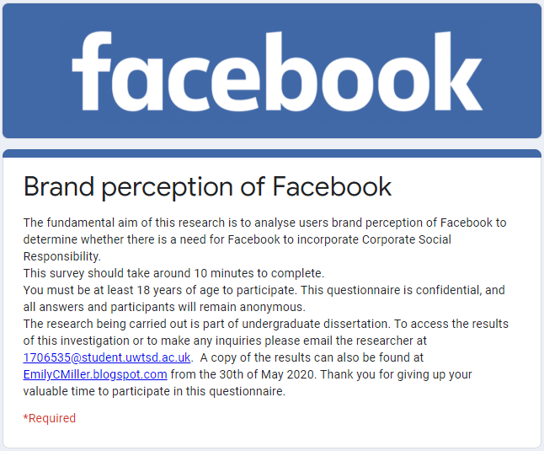
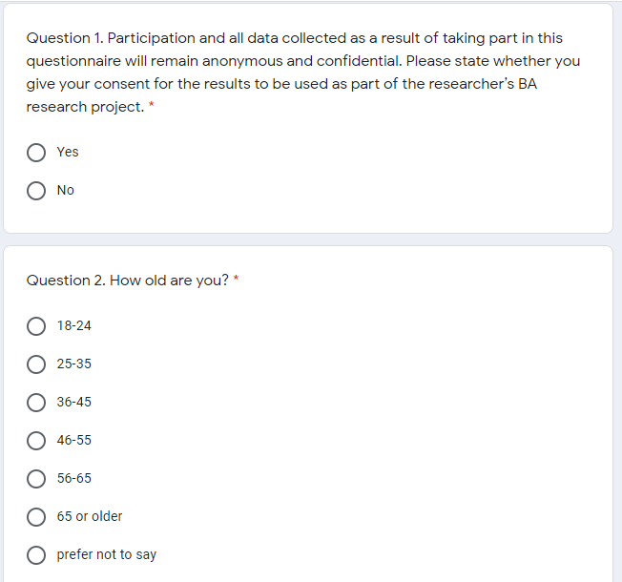
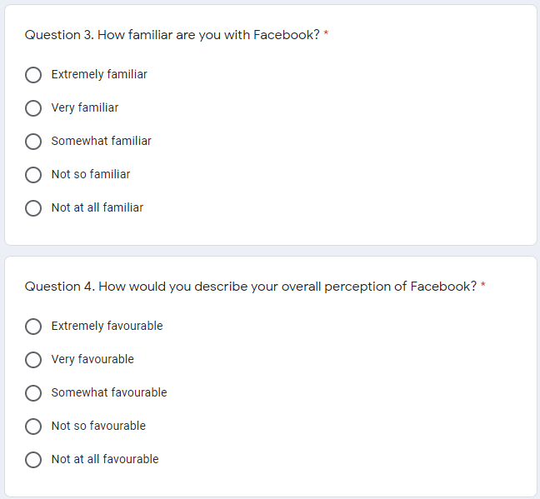
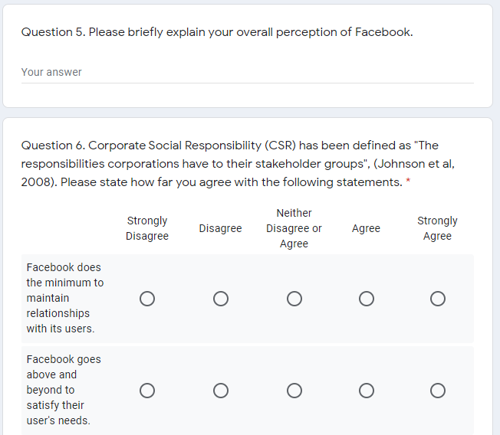
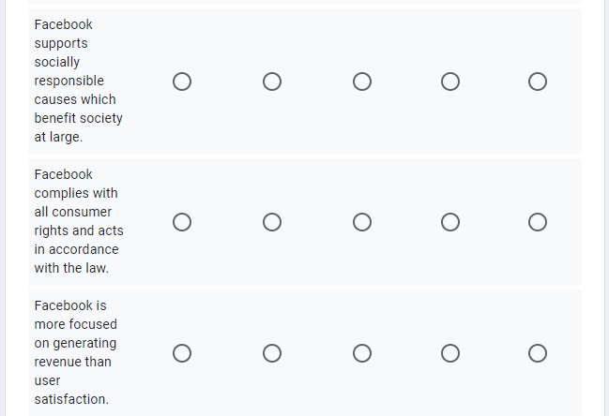
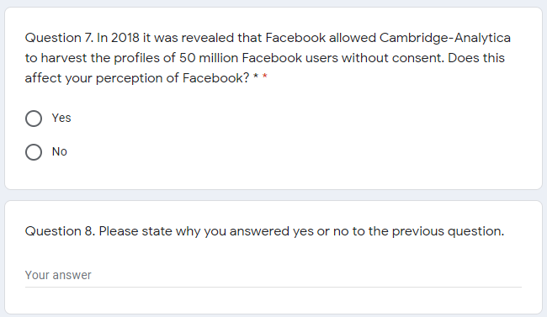
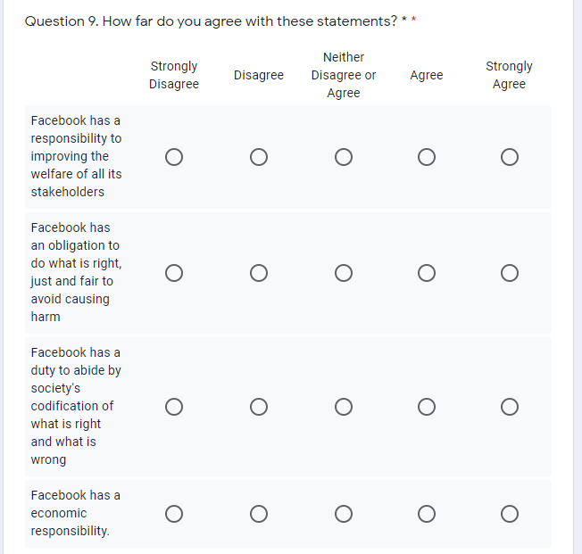
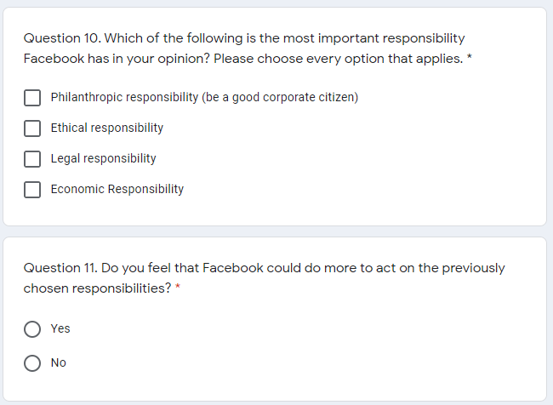
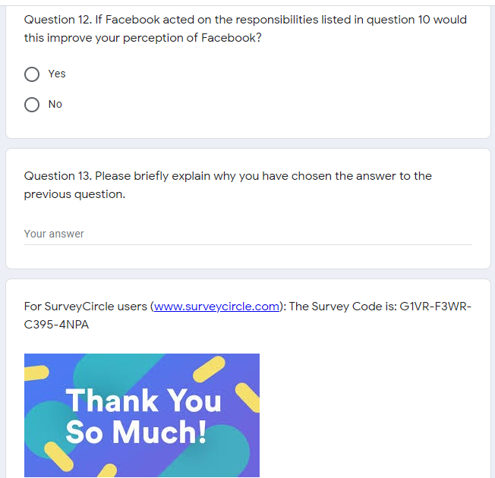

Appendix 4; Copy of raw data results.


