

SUPPORTING YOUNG CHILDREN THROUGH TRANSITIONS

Transitions in Early Years:
Supporting children into the nursery setting

A Practitioner’s Handbook



Contents

1. Introduction
2. The needs of the child
3. The role of the adult
4. Partnership
5. Interventions
6. Proposed outcomes

Introduction
This handbook is aimed at practitioners working in an early years setting, supporting children starting nursery for the first time, aiming to guide practitioners through the process of this transition providing the best possible care, and gaining the best possible outcome for the child and their family/carers. This handbook will also explore children’s rights and the National Minimum Standards in Wales, covering key points which are relevant to adhere to for best practice. Gaining insight into theories from theorists such as Maria Montessori, Urie Bronfenbrenner, and Abraham Maslow, and what they believe children need to enable a positive transition, and how these theories relate to the curriculum today.
What is a transition?
The definition of transition is “A change from one form or type to another, or the process by which this happens” (Cambridge Dictionary, 2020). Voglar et al (2008) say the term “transition” has many meanings, it should not be considered as a single definition. Voglar et al (2008) state that one generic definition would be to emphasise that a transition can be a change in appearance, roles, status, activity, or a change of social or physical space.
According to Brooker (2008), the overall long and short–term goal of a transition is for the child to feel safe, with a feeling of overall belonging and well-being. A strong group of educators said that well-being is a total condition meaning, intellectual, physical, emotional, and social – this is when a child is absorbed in their chosen activity, but also fully supported by an adult who cares.

The needs of the child
Every child should be seen as and treated as an individual. Practitioners must get to know each child to fully recognise what those needs are, and how best to adapt their own ways of communication and environment to support those needs (Dowling, 2014).
Abraham Maslow’s concept of a hierarchy of needs was first published in 1943 in his paper titled ‘A Theory of Human Motivation’ stating that basic needs need to be fulfilled before being able to meet more advanced needs, meaning that the needs at the bottom tier of the triangle called ‘basic needs’ such as food, water, oxygen are needed to enable one to move to the next tier ‘psychological needs’ such as friends, family, and accomplishment. Reaching the top tier ‘self-fulfillment’ would mean one has met their full potential (Poston, 2009).
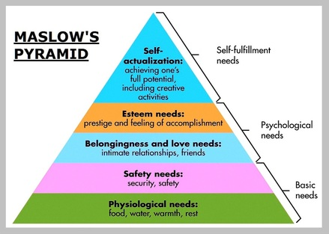

(Isaacs, n.d.)
Practitioners need to be aware of children not being able to meet those basic needs and provide them with those basic needs to enable them to flourish.

Needs of child???
It has been heavily documented that some children need access to a familiar adult or item during a transitional period, this is known as attachment, Dowling, (2014). John Bowlby’s attachment theory (1958) is based on ethology and evolutionary theory. Bowlby suggests that children are born pre-programmed to form attachments to those around them which will help them to survive any real or potential threats, there is a need to gravitate towards one significant attachment figure, known as monotropy (Fletcher and Gallichan, 2016).

- Look at more on Bowlby
- Maria Montessori
- Julie fisher

Look for context to counteract good points on each of these

The role of the adult
The role of the adult during a child’s transition is very important, this role does not only include practitioners but also the family and friends of the child. According to Early Years Matters (2022), a child going into a setting for the first time can be seen as normal by many, but this transition is a significant event that can have a significant impact on a child’s development. There can be feelings of excitement but also feelings of uncertainty. It is vital that the transitional process is positive and accommodates each child’s individual needs, along with parent’s/caregivers (Early Years Matters, 2022).

Bronfenbrenner et al., (1996), States that to enable a child to develop morally, intellectually, socially, and emotionally, participation is needed in a more complex reciprocal activity, this needs to be done regularly, extended over a long period of time with someone whom the child has formed an emotional, strong, mutual, irrational attachment and who is committed to that child’s development and wellbeing, for life. Urie translated this simply, stating “Every child needs at least one adult who is irrationally crazy about him or her” he believed that the primary caregiver should also have support from another adult, this being a grandparent or spouse (Brendtro, L.K, 2006, p.162). Urie Bronfenbrenner’s model (1976) is based on children being the centre of an ecological system that consists of four parts. Bronfenbrenner strongly believed that a child should be studied in their own environment, where they feel most comfortable surrounded by objects and people who are familiar to them. During his studies, Bronfenbrenner has highlighted that working together is crucial for a child’s development, and a child would significantly lack developmental milestones if isolated. Working together and forming strong ties between a setting and the child’s family/caregiver will positively aid a child’s development (Aubrey and Riley, 2022, p.184). The curriculum for Welsh non-maintained settings emphasises the importance of working together with families, providing a meaningful and holistic approach to learning, supervised by adults who are interested and observant, and providing engaging experiences to enable child development (Education Wales, 2022). Bronfenbrenner’s theory promotes the importance of inclusion, children who feel secure, loved, and valued have a greater potential of reaching their developmental milestones. Practitioners must support and promote this theory whilst working with children (Hayes, O’Toole and Halpenny, 2017).

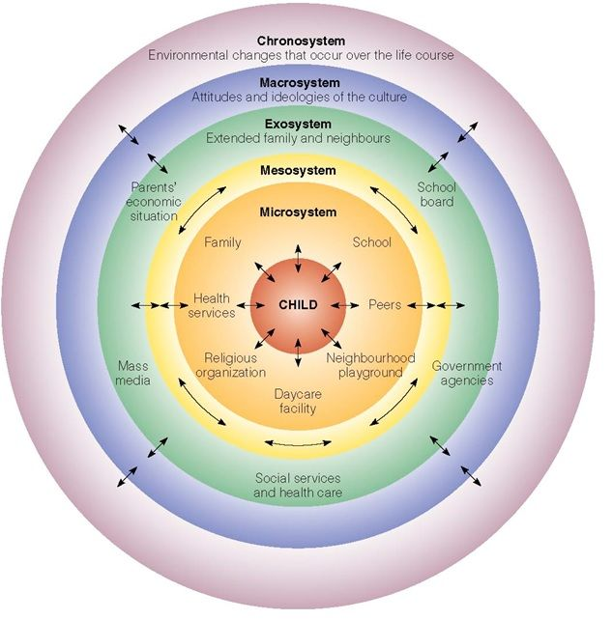

(Guy-Evans, 2020)

Practitioners in early years settings need to be aware of how important it is for a child to have a smooth positive transition when starting in a nursery. Maria Montessori believed that childcare practitioners should be highly qualified within their roles and be proficient in observing children and recognising what a child’s learning needs are, in doing that practitioners should provide children with an environment they can develop freely (Kramer, 2017). Montessori stated that her theory prepared the child for life, not just for school, teaching children to run and not sit still, to provide freedom within limits, and supporting the child as an active learner. Although Maria Montessori’s theory is more than 110 years old, it is still very relevant today, the Statutory Framework for Early Years Foundation Stage in England states that (Bradbury and Swailes, 2022, p.83):
“It promotes teaching and learning to ensure children’s ‘school readiness’ and gives children the broad range of knowledge and skills that provide the right foundation for good future progress through school and life” (Department for Education, 2021, p.5).
In September 2022 the Welsh Government introduced a new curriculum for Wales, giving teachers and practitioners in maintained settings the freedom to teach children freely, through different means, numeracy, for example, can be taught through play, thus giving children the freedom to explore and develop in a way which suits their needs (Dauncey, M, 2022). This is strongly based on Maria Montessori’s theory of every child being different and being given an environment in which they can develop freely (Kramer,2017).
Maria Montessori and Urie Bronfenbrenner place the child at the centre of their theories and believe in a holistic approach to child development. Maria stated, “The most important period of life is not the age of university studies, but the first one, the period from birth to six” (Montessori, 1966, p.22).
In Wales, there are National Minimum Standards that regulated childcare providers must follow. The setting manager is responsible for ensuring all staff are aware of and following these standards. There are points set out in the National Minimum Standards to ensure a positive transition for the child (Welsh Government, 2016) which are as follows:

Standard 3: Assessment
Providing the opportunity for the child and parent to attend the setting to make sure the needs of the child are clearly identified during these visits. Parents are to be asked about the needs, abilities, and preferences of the child, ensuring the best possible outcomes (Welsh Government, 2016).
Standard 4: Meeting individual needs
To meet the individual needs and preferences of the child. For example, if a child has additional needs, the Code of Practice for Special Educational Needs in Wales needs to be followed or if the child has a particular religion or belief, these need to be adhered to (Welsh Government, 2016).

Standard 6: Working in partnership with parents
Practitioners need to be working in partnership with parents. Parents should be kept informed of their child’s developmental milestones, activities, and achievements. It is important for practitioners to create an environment where parents feel they can speak also, this will enable practitioners to provide better care for the child (Welsh Government, 2016).

Standard 8: Nurture & Wellbeing
It is vital for children to feel comfortable around practitioners, it is a practitioner’s role to make sure children feel safe and happy within the setting and that the rights of the child are always respected (Welsh Government 2016). This section emphasises the importance of the United Nations Convention on the Rights of the Child (UNCRC) giving children the freedom to be heard with positive communication at eye level with the child with minimal distress to the child during the transition (Department for Education, 2010).

