University Of Wale Trinity Saint David

Wales Institution of Science and Art



Analysis and Simulation of a Centrifugal Clutch
Stress Analysis and Dynamics (ACMA5010)

Kenyon Dale Montana
2123458
October 2024

Table of Contents
University Of Wale Trinity Saint David 1
1.0 Task A 3
1.1 Introduction 3
1.2 Background 4
1.3 Applications 4
1.4 Advantages of Centrifugal Clutches. 5
1.5 Design and Materials. 5
1.6 Electro Magnetic Clutches 6
1.7 Advantages of Electromagnetic Clutches in Manufacturing Automation 7
1.8 Applications in Manufacturing. 7
1.9 Conclusion 7
2.0 Task B 9
3. References 15

Task A

1.1 Introduction

Centrifugal clutches (CCs) have played an incredibly important role in simplifying power transmission across various applications. The historical evolution of centrifugal clutches is examined in this technical report, particularly how they were first used as automated torque transfer systems in small engines and utility vehicles. Their development, workings, and applications such as industrial machinery and scooters will be important research topics within this report. The research also explores the materials used, including modern composites and asbestos-based friction facings, examining how improvements in material science have improved performance under various operating situations. The study also looks at the incorporation of electromagnetic clutches, which have transformed modern production by precisely and automatically controlling motion and torque in robotic systems and assembly lines. This analysis demonstrates the different functions and interdependencies of centrifugal and electromagnetic clutches in improving mechanical and automated processes by contrasting their dependability and efficiency.

1.2 Background

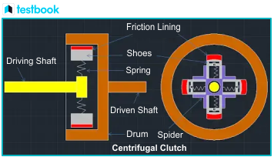
Figure 1- Construction of a Centrifugal Clutch (Testbook, 2023)

Like a conventional clutch, a CC’s purpose is to transfer power typically from an engine to a drive shaft. Distinctly, CCs allow transmission of torque controlled by rotational velocity without any external control mechanism. Figure 1 highlights the construction of a centrifugal clutch (CC). As rotational speed increases, the clutch shoes lined with the friction lining are forced outwards, when they are typically restrained at rest by springs. (Bo-Yo & Kai Chun, 2024). The shoes then contact the drum, gradually increasing the friction until both the concentric elements are locked, and slippage no longer occurs. The drum then rotates at the same rate as the driving shaft. The phenomenon in which the rotational speed drives the shoes outwards is due to the centrifugal force, which increases as the driving shaft’s rate of rotation increases.
The exact moment of conception isn’t entirely known, but earliest recording of their use was in railway locomotives pre 1858 (MechStudies, 2021). The next significant recalling is the introduction of CCs in the automotive industry, found in a vehicle called the Sapphire. The Saphire was featured in 1952 during the Earls Court Motor Show, and was invented by Armstrong Siddeley (Boddy, 2014). This came in conjunction to the also newly developed automatic transmission. Thomas Foggarty was also accredited to inventing the CC for small motor applications in the 1940’s. When encountering troubles with the transmission of his scooter, he created a CC when he was twelve years of age (Johnstone, 2021).

1.3 Applications

CCs are used in an abundance of applications, spanning many industries. Their versatility allows them to be implemented into heavy duty industries to small motor applications such as lawnmowers, and everything in between. Most known applications are in the automotive sector such as commercial vehicles, go-karts, and motorcycles, etc (Engineering Designer, 2024). Small motors in outdoor appliances also rely on CCs. Chainsaws, lawnmowers, and hedge trimmers all fall under this category. BLM, an industry leading manufacturer in CCs states how their products are used within the mining industry, specifically, coal crushers. These machines reduce bulk material into crushed, finer material for processing. Furthermore, the medical industry utilises this form of clutch for mixers, which distinctly are designed for immense loads and commanding task. BLM further state that military applications for CCs are abundant, being applied in fuel control, air control systems, and in systems controlling autopilot (BLM, 2019b).

1.4 Advantages of Centrifugal Clutches.

Firstly, CCs are automatic, negating the need for any electrical controllers. This can therefore result in a cheaper and lighter set-up as there is no battery, or other components required. CC set-ups also require minimal maintenance. Given that the starting design and production is thorough, the system is highly unlikely to have severe failures. (BLM, 2019a). The engagement method of CCs allows efficient energy transfer from the driver shaft to the driven shaft without losing power or torque. When starting the engine, since the clutch is not engaged with the drive shaft, less torque is required to initiate the first turnovers to get started. Therefore, preserving drive shaft and engine health as there is less strain throughout the system. CCs also protect the engine from any sudden increase in load. Should the driven shaft suddenly require much more torque to turn, slippage occurs between the shoes and the drum, therefore protecting the engine from being damaged (Hilton, 2022).
On the other hand, there are numerous disadvantages to using a CC. They produce more noise in comparison to other types of clutches, an undesirable feature in certain working environments (Engineer Designer, 2023). Secondly, CCs cannot be utilised for lower rpm engines as it could cause slippage. This is when manual clutch alternatives must be used (BLM, 2019a).

1.5 Design and Materials.

Different materials, component sizes, and types are used, but conditions they are placed under must be carefully considered such as: maximum load, temperature, potential debris. For the friction lining, six main classifications of materials are used, organic, heavy-duty organic, ceramic, Kevlar, and Feram Alloy (Phoenix Friction, 2022).

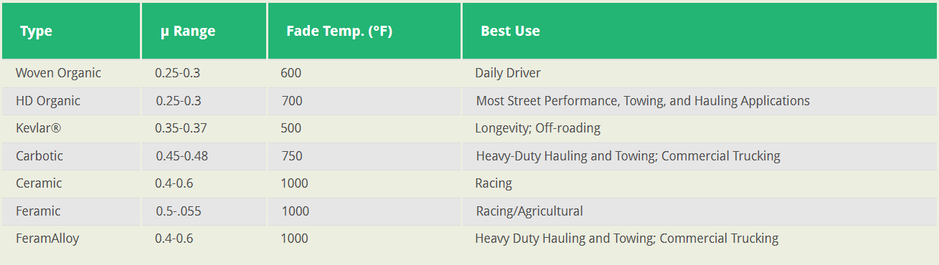
Figure 2 - Spec Table of Friction Materials (Phoenix Friction, 2022).

Figure 2 highlights the different materials and their properties indicating which applications they should be utilised for. For example, woven organic is used for standard commercial vehicles as they do not require a high coefficient of friction and do not operate under extreme temperatures with the benefit of smooth torque delivery and low noise, ideal for daily driving. Whereas ceramic linings are ideal for motorsport as they have a higher coefficient of friction, and a high ratio of dynamic and static friction which is ideal for repeated engagement and disengagement cycles. Although they are noisier, this is insignificant to their application in motorsports (Phoenix Frictions, 2022). The drums and retention materials are often made from steel as it Is stable at high temperatures and have durability.

1.6 Electro Magnetic Clutches

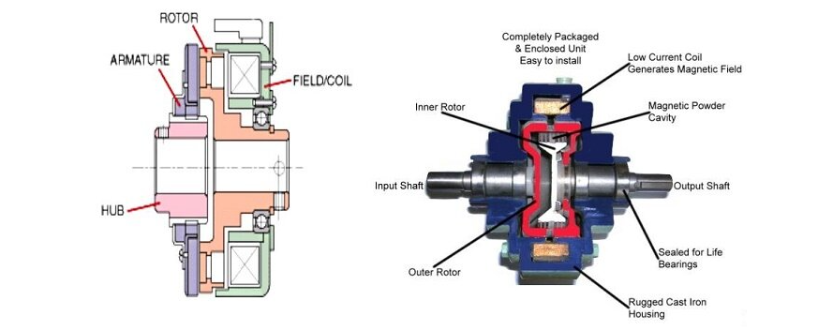
Figure 3 - Diagram of an Electromagnetic Clutch (EM Works, 2024).

Figure 3 demonstrates the workings of an electromagnetic clutch (EMC). Similarly to a CC, it transmits power from an input (in this case the rotor) to a shaft (the armature) but engages it using an electromagnet. The torque is still transferred mechanically via friction, but the engagement is done using the input of a current through the electromagnet. The field/coil in the diagram above transmits a magnetic field when a current is inputted, the armature which contains the friction lining is pulled towards the rotor, allowing the hub to be driven by the rotor. When the electromagnets are switched off, the armature is pulled back to its resting position normally by springs which provide them with a constant resistance (Jaber, 2024).

1.7 Advantages of Electromagnetic Clutches in Manufacturing Automation

Electromagnetic Clutches (EMCs) provide for highly accurate, efficient, and responsive transfer of torque, making them ideal for automation of machinery. Electromagnetic tooth clutches are a type of EMC that are commonly used in manufacturing automation. These clutches have an instant, complete lock up between the two components as soon as the electromagnet is activated, preferred in automation machinery where accuracy is crucial, and backlash must be minimised. Electromagnetic tooth clutches transmit higher torques than friction electromagnetic clutches due to the use of gear teeth and can also be packaged much smaller, being able to be housed in manufacturing machinery (MikiPulleys, n.d.). Torque transmission can be accurately controlled by altering the current supplied to the electromagnet, allowing for versatile application where the same clutch can be used in multiple machines within an assembly line (Dr. Solenoid, 2024). This can reduce overall cost of parts and simplifying maintenance and initial set-up of a line.

1.8 Applications in Manufacturing.

Due to the aforementioned advantages, EMCs are used in plentiful industries to automate production. Their accuracy, efficiency, and high torque capabilities are utilised by industrial manufacturers in the use of automating CNC, milling, and lathe machines (JBJ, n.d.). This includes controlling rotation of spindles and engagement of tools. Robotics in production lines also utilise EMCs to control movements and for transmission of power in their limbs. EMCs are an ideal application due to the accuracy they provide in power transmission (Dr. Solenoid, 2024). Gates and doors for parts of the production lines are also controlled using EMCs for accurate timing and smooth operation.

1.9 Conclusion

In conclusion, EMCs and CC have their place with their unique characteristics and are both optimal in differing applications. CCs have a wide range of application from small motors to industrial equipment and should be used in mechanically simpler equipment, which is not a disadvantage. Not requiring an external input to control the clutch engagement allows for CCs to be highly effective, simplifies entire systems, reduces maintenance, and allows for easier use and implementation. In contrast, EMCs have a significantly higher set-up cost in comparison and are much more complex, requiring more specialised staff/ training to maintain them. Furthermore, CCs are not dependent on an electrical source, leading to what can be a more reliable method of transferring torque. EMCs are susceptible to electrical failure, an additional failure mode that simply is negated in CCs.
On the other hand, CCs lack the control, response time, and capabilities that applications require where EMCs are operated. Automated production lines for example require the complexity and degree of control that EMCs offer to operate robotic arms, conveyor belts, and doors. Moreover, a complex system such as a production line requires an abundance of machinery to coordinate with each other in incredibly precise timing and in unforgiving tolerances. EMCs are ideal for this application as they are electrically controlled, being able to tightly control machine timings to each other via code.

2.0 Task B

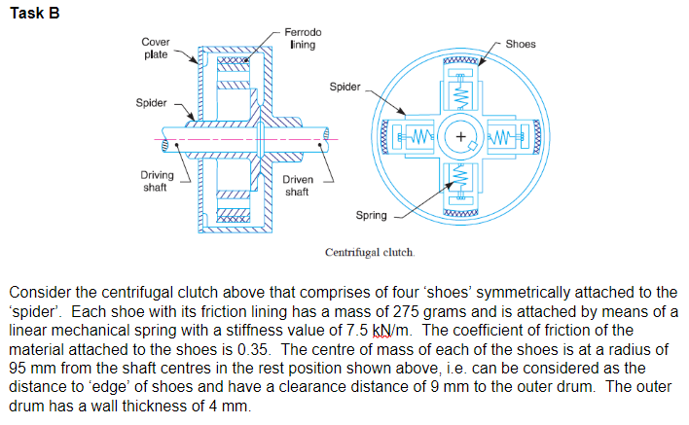
Figure 4 - Task B

- Diameter of outer drum:
$$Inner Diameter=2\left(Radius from center of mass of the shoe+Clearance of shoe from drum\right)$$
$$Inner Diameter=2 \left(95+9\right)$$
$$=208mm$$
$$=0.208 m$$
$$Outer Diameter=2\left(Radius from CoM of the shoe+Clearance of shoe from drum+Drum thickness\right)$$
$$=2(95+9+4)$$
$$=216mm$$
$$=0.216 m$$

- Engagement Speed of Clutch
$$Mass of each shoe, m=0.275kg$$
Spring Stiffness, k = 7500 N/m
Shoe and drum clearance, x = 0.009 m
Radius at contact point between shoe and drum, $r_{d}=0.104$

Centrifugal force at engagement, $F_{c}=mrω^{2}$
Spring force at engagement, $F_{s}=kx$
At Point of engagement, $F_{c}= F_{s}$
Therefore: $mrω^{2}=kx$
$$ω= \sqrt{\frac{kx}{mr_{d}} }$$
$ω= 48.58 rad/s (2d.p)$ = 464 RPM (to the closest integer).

- Radial force acting on clutch face when driving shaft is rotating at 550 RPM
$$F=mrω^{2}$$
F = Centrifugal Force (radial force)
m = 0.275kg
r = 0.104m
ω = 550 RPM
ω = 57.60 rad/s (2d.p)

$$F=0.275 ×0.104 ×{(57.60)}^{2}$$
$$F=94.89 N (2d.p)$$

- At the driving shaft speed of 550 RPM, what will be the value of torque transmitted to the driven shaft?
$$F_{f}= μF_{c}$$
$$F_{c}=94.89 N$$
$$μ=0.35$$
$$F_{f}= 0.35×94.89$$
$$F_{f}= 33.21 N \left(2 d.p\right).$$

- Using either MatLab or MS Excel, calculate and plot on a suitable graph the transmitted torque at the driven shaft against driving shaft speed, from 450 RPM to 700 RPM in increments of 25 RPM.

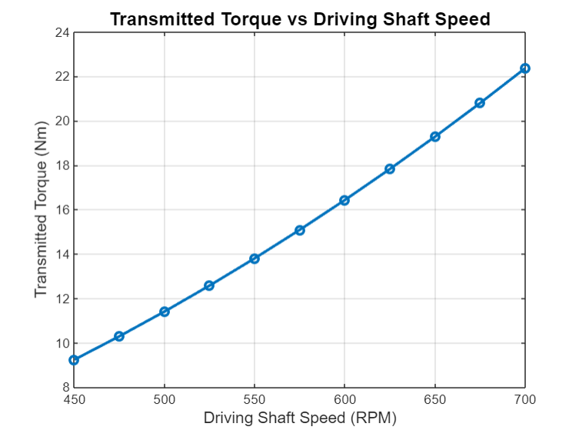
Figure 5- Graph of Transmitted Torque vs Driving Shaft Speed (Montana, 2024).

- Undertake the same analysis as in point 5 above but adopt a coefficient of friction of 0.3 and 0.4. Discuss the effect of changing the coefficient of friction of the shoe material on the torque transmitted when comparing the three values of coefficient of friction.
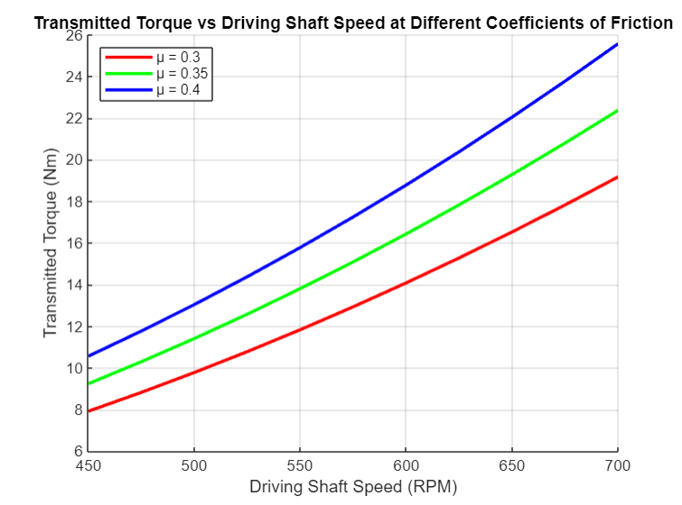
Figure 6 - Graph of Transmitted Torque vs Driving Shaft Speed at Different Coefficients of Friction (Montana, 2024)

Given that $F_{f}= μF_{c}$ , increasing the coefficient of friction ($μ$) would increase the overall friction force. Then, since torque is given as the friction force multiplied by the radius from contact point, as the friction force increase (due to the increase of $μ$) then overall torque therefore increases. The gradient of the curves appears to remain similar for all value of $μ$ due its proportional relation ship with torque, although the height of the curves with be higher as you increase the coefficient of friction. In conclusion, the graph displays that the transmitted torque increases as you increase the coefficient of friction.

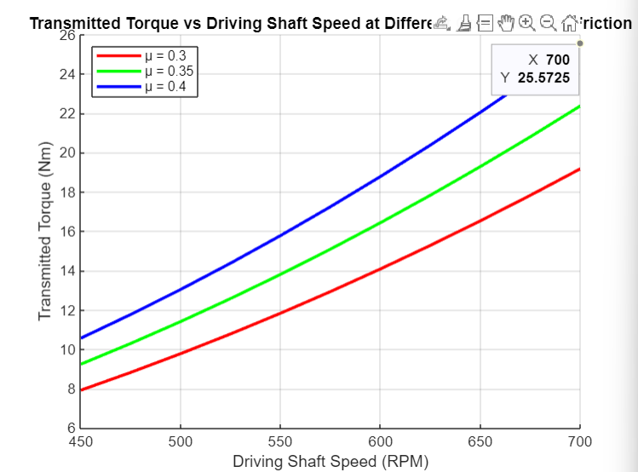
Figure 7 - Peak Transmitted Torque (Montana, 2024)
Highest transmitted torque = 25.2725 N/m
Mass of the drum, $m_{d}$ = 0.75kg
Radius of the drum, $r_{d}=$0.104m
Moment of inertia of a solid disc, $I_{d}=\frac{1}{2}m_{d}r_{d}^{2}$
$$I_{d}=\frac{1}{2}×0.75×{0.104}^{2}$$
$$I_{d}=0.004056 kgm^{2}$$

$$T= Iα$$
$$α=\frac{T}{I}$$
$$α=\frac{25.5725}{0.004056}$$
$α=$6304.86 rad/ $s^{2}$ (2 d.p.)

8.) If the driven shaft had a diameter of 17.5 mm and a constant tangential braking force of 500N was applied to the driven shaft, determine the maximum possible angular acceleration for the drum as given in point 7 above.

$$F_{b }=500N$$
$$r_{s}=0.00875 m$$
$$I=0.004056 kgm^{2}$$
$$T=500 ×0.00875$$
= 4.375 N/m
$$α=\frac{T}{I}$$
$$α=\frac{4.375}{0.004065}$$
$α=1076.260763 rad$/$s^{2}$

3. References

BLM (2019a). Advantages and Disadvantages of Centrifugal Clutches. [online] BLM Automatic Clutch. Available at: https://www.centrifugalclutches.com/blog/advantages-disadvantages-centrifugal-clutches/ [Accessed 19 Oct. 2024].
BLM (2019b). The How and Why of Centrifugal Clutches. [online] BLM Automatic Clutch. Available at: https://www.centrifugalclutches.com/blog/the-how-and-why-of-centrifugal-clutches/ [Accessed 16 Oct. 2024].
Boddy, B. (2014). A History of the Armstrong Siddeley Car. [online] Motor Sport Magazine. Available at: https://www.motorsportmagazine.com/archive/article/december-1958/30/a-history-of-the-armstrong-siddeley-car/ [Accessed 16 Oct. 2024].
Dr.Solenoid (2024). Electromagnetic Clutch / Brake: Working Principle, Advantages ,Disadvantages and Application. [online] Electromagnetic Clutch / Brake: Working Principle, Advantages ,Disadvantages and Application. Available at: https://www.drsolenoid.com/news/electromagnetic-clutch-brake-working-principle-advantages-disadvantages-and-application/ [Accessed 21 Oct. 2024].
EM Works (2024). A Guide to Designing & Simulating Electromagnetic Clutches. [online] EMWorks. Available at: https://www.emworks.com/application/a-guide-to-designing-simulating-electromagnetic-clutches [Accessed 20 Oct. 2024].
Engineering Designer (2023). How Does a Centrifugal Clutch Work? What Are the Pros and Cons? - Engineering Designer. [online] www.engineeringdesigner.co.uk. Available at: https://www.engineeringdesigner.co.uk/how-does-a-centrifugal-clutch-work-what-are-the-pros-and-cons/ [Accessed 18 Oct. 2024].
Hilton, N. (2022). Heavy-Duty Centrifugal Clutches: a BLM Case History. [online] BLM Automatic Clutch. Available at: https://www.centrifugalclutches.com/blog/heavy-duty-centrifugal-clutches-a-blm-case-history/ [Accessed 19 Oct. 2024].
Jaber, S. (2024). Electromagnetic Clutch Design: Simulate and Optimize. [online] SimScale. Available at: https://www.simscale.com/blog/electromagnetic-clutch-design-simulate-and-optimize/ [Accessed 20 Oct. 2024].
JBJ (n.d.). Electromagnetic-clutches. [online] www.jbj.co.uk. Available at: https://www.jbj.co.uk/electromagnetic-clutches.html [Accessed 22 Oct. 2024].
Johnston, B. (2021). A True Pioneer: Dr. Thomas J. Fogarty - Fogarty Innovation. [online] Fogarty Innovation. Available at: https://www.fogartyinnovation.org/a-true-pioneer-dr-thomas-j-fogarty/ [Accessed 15 Oct. 2024].
Kai Chun , L. and Bo-Yo , L. (2024). Analysis of Centrifugal Clutches in Two-Speed Automatic Transmissions with Deep Learning-Based Engagement Prediction. [online] ar5iv. Available at: https://ar5iv.labs.arxiv.org/html/2409.09755 [Accessed 9 Oct. 2024].
MechStudies (2021). Centrifugal Clutches – Definition, Parts, Types, Working, Application. [online] www.mechstudies.com. Available at: https://www.mechstudies.com/centrifugal-clutches-parts-types-working/?utm_content=cmp-true [Accessed 15 Oct. 2024].
Miki Pulleys (n.d.). Electromagnetic Clutches | EM Clutches | Electric Clutches. [online] www.mikipulley-us.com. Available at: https://www.mikipulley-us.com/em-clutches [Accessed 21 Oct. 2024].
Phoenix Friction (2022). Clutch Friction Materials Explained - Organic, Kevlar, Ceramic, etc. [online] Phoenixfriction.com. Available at: https://www.phoenixfriction.com/t-clutch-materials-explained.aspx?srsltid=AfmBOoomjJCnGFebaWkoV3cfhvCBr-3mJ33zDrgpe_qU1vCNnFEx_DWd [Accessed 20 Oct. 2024].
Testbook (2023). Centrifugal Clutch- Diagram, Working, Advantages and Applications. [online] Testbook. Available at: https://testbook.com/mechanical-engineering/centrifugal-clutch [Accessed 12 Oct. 2024].

4. Appendices

