UNIVERSITY OF WALES:  TRINITY SAINT DAVID |  |  | PRIFYSGOL CYMRU:  Y DRINDOD DEWI SANT
LOCATION: LAMPETER |  | LLEOLIAD: LLAMBED
LEVEL 5 |  | LEFEL 5
EXAMINATION PERIOD |  | CYFNOD ARHOLIADAU
January 2012 |  | IONAWR 2012

MODULE CODE: AHAC5008

Palaeoenvironmental Archaeology

TIME: 2 HOURS
answer Twenty quESTIONs out of Twenty Five in section A (worth 20% of the exam)

and

answer four questions out of Eight in section B (Worth 80% of the exam)

Equipment or materials required – None
Adnoddau neu ddefnyddiau sydd eu hangen - Dim

SECTION A - worth 20% of the exam

ANSWER TWENTY QUESTIONS OUT OF TWENTY FIVE.

Each question is worth 1 mark.

You should look to spend no more than 20 minutes on this section.

- What types of evidences are included in Bioarchaeology? (RC)

- What do you understand by the term ‘Scientific Method’ within Environmental Archaeology? (RC)

- Give two reasons why it is important that archaeologists understand ancient landscapes. (MCB)

- Give two reasons why environments in the past may change over time. (MCB)

- Under what sets of conditions would you expect molluscs to be preserved in the archaeological record? (MCB)

- Give two examples of contexts in an urban environment in which environmental archaeological material is likely to build up. (MCB)

- Name two sources of material that may end up deposited in a well from an urban environment. (MCB)

- What is the difference between a soil and a sediment? (EG-B)

- What is the natural, biological source of magnetic enhancement in topsoils? (EG-B)

- What are phytoliths? (EG-B)

- What is the difference between alluvium and colluvium? (EG-B)

- What are the main functions of bone? (RC)

- With regard the trace elements within bone (either the essential or non-essential trace elements) sate why these minute elements are so useful to archaeologists. (RC)

- Excluding radiocarbon dating, name two radiometric dating techniques? (NN)

- What is meant by the ‘half-life’ of a radioactive isotope? (NN)

- Why do radiocarbon dates need calibration? (NN)

- Name two methods of incremental dating, excluding dendrochronology. (NN)

- Apart from dating, how can dendrochronology be applied to palaeo-environmental questions?

- Give two types of environmental analysis that might be undertaken on a buried soil preserved beneath a prehistoric bank or field boundary. (AC)

- Name two kinds of biological environmental evidence that are likely to be preserved in calcareous soils and sediments on dry sites. (AC)

- Under what conditions are plant macrofossils likely to survive on a dryland archaeological site? (AC)

- What depth of soil would typically develop over a period of 1000 years on: (a) limestone and (b) unconsolidated deposits such as alluvium? (JC)

- Identify two factors, other than soil properties, that affect land use capability. (JC)

- Give two reasons why rates of soil erosion are accelerated by agriculture. (JC)

- Identify two different forms of evidence for soil erosion in the Mediterranean region during the Holocene, naming one case study location for each. (JC)

End of section A
SECTION B - worth 80% of the exam

ANSWER FOUR QUESTIONS FROM EIGHT

Each question is worth 20 marks.

You should look to spend no more than 20 minutes on each question.

- Discuss why pollen analysis is a useful technique in the reconstruction of past environments. (AC)

- Using specific archaeological examples indicate the changes to the skeleton that tell us when animals may have been manipulated by human populations in the past. (RC)

- Using an archaeological case study, outline the main arguments that propose humans as the main cause of animal extinctions in the past. (RC)

- Using the attached diagram describe and interpret the changes in molluscs through the sequence (MCB)

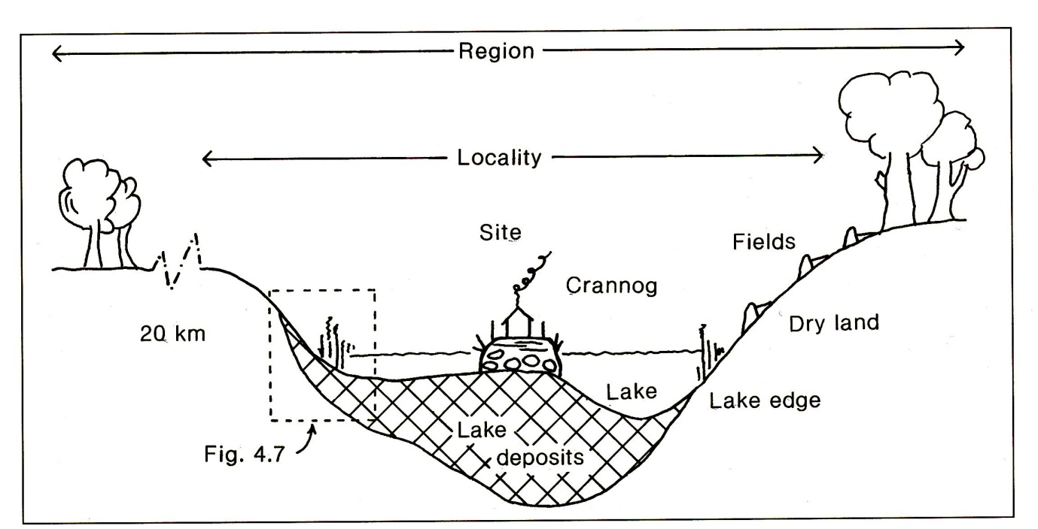

Figure 1. Small lake basin (arrow shows position of core).

- With reference to at least two sites discuss the problem of interpreting palaeoenvironmental material from sewer systems in urban contexts (MCB)
.
- Outline the reasons why the Mediterranean region is particularly vulnerable to soil erosion (JC)

- Outline the uses of soil phosphate analysis in archaeology. (EG-B)

- What are plaggen soils, and how were they created? (EG-B)

End of section A

