Nicolae Panait (2311205)

Data Warehousing & Data Mining (ACCA6026 – Component 1)

Task1:

Introduction:
Delivering acute, community, mental health, specialist, and public health services across numerous Integrated Care Systems (ICSs) and NHS Trusts, NHS England is in charge of one of the world's most complicated healthcare systems. Critical operational, clinical, workforce, and financial data is generated by every patient interaction; however, this data is stored across multiple independent systems, including financial applications, diagnostic platforms, workforce management tools, Electronic Patient Records (EPR), and Patient Administration Systems (PAS). [1]

Operational Challenges:
Hospitals, community providers, mental health services, speciality centers, and Integrated Care Systems (ICSs) make up NHS England's widely dispersed network. Digital technologies including Electronic Patient Records (EPR), Patient Administration technologies (PAS), diagnostic platforms, workforce management tools, and finance systems are used by every organization, but they are not nationally integrated and function independently. Senior leadership consequently lacks a cohesive, almost real-time perspective of operational performance throughout England.The management of bed utilisation is also challenging because occupancy data is kept locally and reported slowly, making it difficult to coordinate resources across ICS boundaries.

Data Warehouse:
Timely, accurate, and integrated data are increasingly essential to NHS England's ability to provide safe, effective, and high-quality care. Critical data is currently scattered over workforce platforms, financial applications, diagnostic systems, electronic patient records (EPR), patient administration systems (PAS), and regional reporting tools.
NHS England can more accurately identify financial risks, forecast staffing shortages, and simulate future demand by combining historical and real-time data. This guarantees that resources are distributed where they are most needed and improves national decision-making.Long-term strategic planning and evidence-based policy making are also supported by it. [2]

Architecture Data Warehouse:
Data from hundreds of operational, clinical, workforce, and financial systems from NHS Trusts and Integrated Care Systems (ICSs) must be integrated into a national data warehouse for NHS England. The architecture needs to be scalable, reliable, and able to enable analytics in almost real time.

-Data Sources Layer: Data from key NHS systems, such as Electronic Patient Records (EPR), Patient Administration Systems (PAS), diagnostic platforms, workforce management tools, financial systems, and quality reporting apps, will be ingested by the warehouse. London, the Midlands, the Northwest, the South West, and Northern England are the operational regions that provide structured data on admissions, diagnostics, personnel levels, costs, and performance metrics.
-ETL / ELT processing layer:
National coding systems including ICD-10, SNOMED CT, and RTT standards will be used for data extraction, validation, cleaning, and standardisation. This guarantees that all Trusts have the same definitions. Before data is loaded into the warehouse, the ETL process eliminates duplicates, fixes missing values, and harmonises formats.
-Storage / modelling layer: For patient activity, workforce utilisation, financial transactions, and quality measures, the warehouse will employ a dimensional model that includes fact tables. Flexible analysis across geographies and care pathways is made possible by dimension tables that include time, location, speciality, and service type.
-Analytics / reporting layer: Leadership will gain insights into patient flow, bed occupancy, elective backlogs, workforce pressures, financial performance, and quality indicators using dashboards and analytical tools. These graphic aids facilitate quick decision-making and aid in national planning. [3]

Strategic Benefits
NHS England can gain major strategic advantages in terms of personnel management, financial supervision, operational efficiency, and care quality by putting in place a single data warehouse. The organization obtains a consolidated, almost real-time view of healthcare performance across all Integrated Care Systems (ICSs) and Trusts by combining disparate data from Electronic Patient Records (EPR), Patient Administration Systems (PAS), diagnostics, workforce platforms, and finance systems.[4]

-Operational Efficiency: NHS England can monitor patient flow, spot bottlenecks, and coordinate bed capacity across regions thanks to a single data platform. This facilitates quicker discharge planning, better theatre usage, and more efficient backlog management for elective treatment.
-Workforce Optimisation: Leadership can foresee personnel shortages, minimise agency dependency, and maximise rota planning with integrated workforce data. This promotes safer staffing methods and increases the resilience of the workforce.
-Financial: Consistent reporting on treatment costs, budget adherence, and national tariff performance is made possible by a single warehouse. This promotes evidence-based investment choices and enhances financial accountability.
-Quality / Safety: NHS England can more accurately monitor readmissions, mortality indicators, patient satisfaction, and safety events thanks to standardised data. This minimises unnecessary regional variation and facilitates focused quality improvement initiatives.
-Planning: NHS England can more efficiently plan national service reform, evaluate demographic challenges, and estimate future demand with integrated historical and real-time data. This promotes long-term sustainability and improves strategic decision-making. [5]

Risks and Mitigation

To guarantee successful uptake and long-term sustainability, NHS England must carefully manage a number of strategic risks associated with the implementation of a national data warehouse. Since the warehouse will integrate sensitive health, employee, and financial data from several systems, data governance and privacy are among the main risks. Unauthorised access, breaches, and varying data standards are all possible in the absence of robust governance systems. Role-based access controls, rigorous adherence to NHS Digital standards, and ongoing auditing can all help to reduce this.
Interoperability issues constitute a second risk. Different EPR, PAS, diagnostic, and workforce systems used by NHS Trusts may differ in terms of data quality and coding procedures.
Another major risk is change management. Employees may be hesitant to switch from local systems to a national platform or inexperienced with new reporting tools.

Conclusion:
Effective national decision-making depends on timely, reliable, and integrated data in the increasingly complex and high-pressure healthcare environment in which NHS England functions. The organization's capacity to track performance, foresee operational pressures, and provide consistent, high-quality treatment is hampered by the current fragmentation across Electronic Patient Records (EPR), Patient Administration Systems (PAS), diagnostics, workforce platforms, and finance systems. Better patient outcomes, stronger long-term planning, and more flexible responses to demand are made possible by this. [6]

  - OLTP vs. Data WareHouse

NHS England already makes extensive use of Online Transaction Processing (OLTP) technologies, including financial systems, workforce management tools, diagnostic platforms, Electronic Patient Records (EPR), and Patient Administration technologies (PAS). These platforms are intended to assist with routine clinical and operational tasks. The quick and precise recording of individual transactions, such as patient registrations, appointment scheduling, diagnostic orders, staff rota changes, or financial entries, is the main goal of an OLTP system. They are tailored for operational efficiency, guaranteeing that frontline personnel can swiftly enter, update, and retrieve data while providing care.
OLTP systems, however, are not made to offer organization-wide, strategic insights. NHS England finds it difficult to integrate data from EPR, PAS, workforce, finance, and quality systems. While OLTP systems can respond to operational queries like "Has this patient arrived?" and "Is this bed occupied?" they are unable to respond to strategic queries like "Which regions are experiencing rising emergency demand?" or "What are the main causes of delayed discharges?"
In contrast, a data warehouse is made especially for extensive reporting, analysis, and decision-making. It creates an integrated environment by combining data from several OLTP systems. In order to facilitate trend analysis, forecasting, and performance monitoring, the warehouse saves historical data, applies national standards (ICD-10, SNOMED CT, RTT), and arranges data into analytical structures. [7]

1.2. Data Warehouse Architecture & ETL
Any new digital project must not interfere with routine clinical operations for NHS England. A data warehouse's ETL procedure is especially made to safeguard frontline operations. EPR, PAS, diagnostics, workforce, and finance platforms are just a few examples of the operational systems that are still in use today. Only read-only copies of data that are extracted at predetermined intervals or via regulated interfaces that don't disrupt ongoing clinical operations are used by ETL
Instead of replacing existing systems, the data warehouse improves them by giving leadership a consistent, trustworthy, and all-encompassing national perspective of performance. ETL makes sure that data is merged, cleansed, and standardised without needing clinical teams to put in extra work. In actuality, this method converts vast amounts of disjointed data into critical insights while operating silently in the background. This enables NHS England to retain complete continuity of patient care while strengthening decision-making, allocating resources more effectively, and responding to operational difficulties. [8]

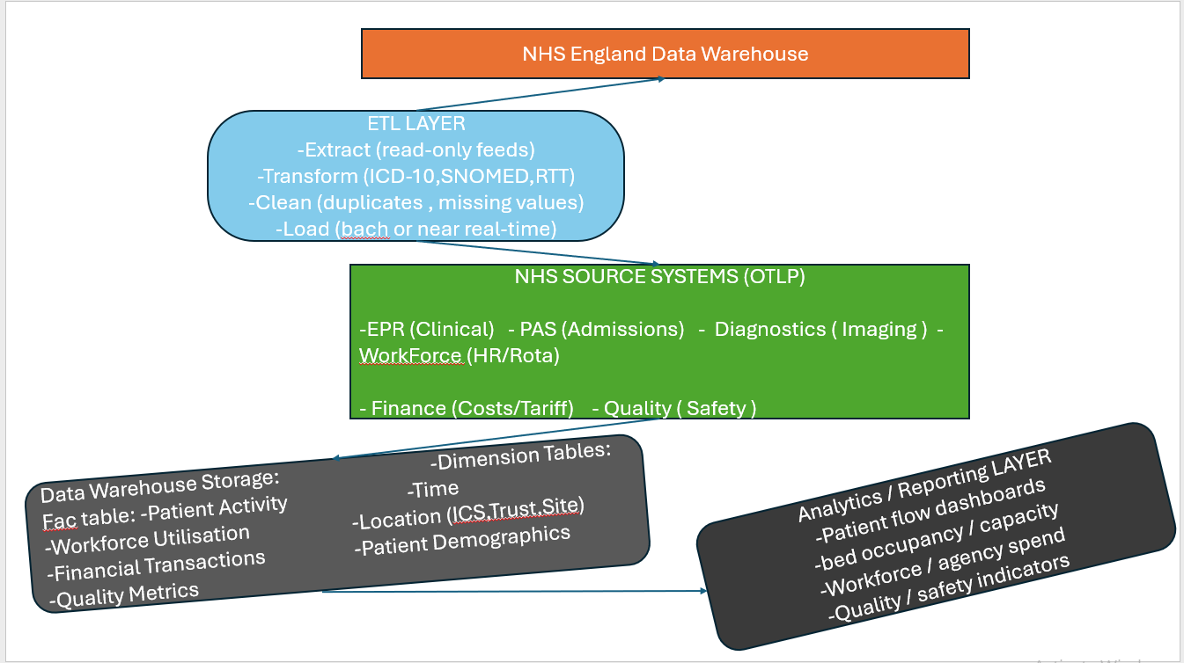

1.3. Data Marts for Management Decision-Making
When a national data warehouse's material is arranged into data marts—specialized analytical subsets created to satisfy the demands of particular leadership roles—it becomes much more valuable. NHS England uses data marts to make sure senior executives don't get overwhelmed by the complexity of national healthcare data and receive accurate, pertinent, and useful information. The Chief Executive, Finance Director, and Medical Director's decision-making roles are taken into consideration when designing each data mart, which is constructed on the same unified warehouse.

Chef Executive: A high-level, comprehensive picture of the health system's performance across all regions and Integrated Care Systems (ICSs) is necessary for the Chief Executive. This comprises:
-Trends and bottlenecks in the country's patient flow
-Pressures from bed occupancy and capacity
-trajectories of the elective backlog
-Resilience of the workforce amid staffing shortages
-financial results at the ICS and Trust levels

Strategic choices about the distribution of resources, national planning, and performance enhancement are supported by this data mart. It makes it possible for the CEO to assess the effects of national initiatives and spot new dangers early.
Finance Director: To guarantee responsibility and value for money, the finance director needs precise, trustworthy financial intelligence. Clinical activity and financial data are combined in a finance data mart to offer:
-cost per episode, speciality, and treatment
-Income flows and tariff performance
-Trust and ICS's commitment to the budget
-Workforce-related expenses and agency spending
-measures for productivity (activity vs. cost)
This facilitates the detection of inefficiencies or overspending and allows for evidence-based investment decisions. Additionally, it makes the organization's financial openness stronger.
Medical Director: To guarantee safe, efficient care, the Medical Director needs to have a thorough understanding of clinical quality and patient outcomes. The goals of a clinical data mart are:
-complications, readmissions, and mortality metrics
-RTT performance and wait times
-Serious events, safety accidents, and harm profiles
-patient satisfaction, complaints, and experiences
-differences in results by demographic type, trust, or speciality
This data mart aids in reducing unnecessary variation throughout England and supports focused quality improvement programs. It gives the Medical Director the data necessary to promote patient safety and clinical quality. [9]

1.4. OLTP Normalisation vs. Data Warehouse Dimensional Modelling
Fully standardised OLTP architectures are used in the construction of operational NHS systems like EPR, PAS, diagnostics, workforce, and finance platforms. Normalised structures, however, are not analytically optimised. Leadership finds it challenging to assess trends or system performance when queries that integrate several tables become slow and complicated.
In contrast, dimensional modelling is used in a data warehouse to reorganise data into understandable analytical models. The star schema, which consists of a core fact table encircled by descriptive dimension tables, is the most popular method. NHS England is able to investigate patient activity, outcomes, workforce utilisation, and financial performance across time, geography, and speciality thanks to this approach, which also streamlines analysis and enhances query performance.
[10]

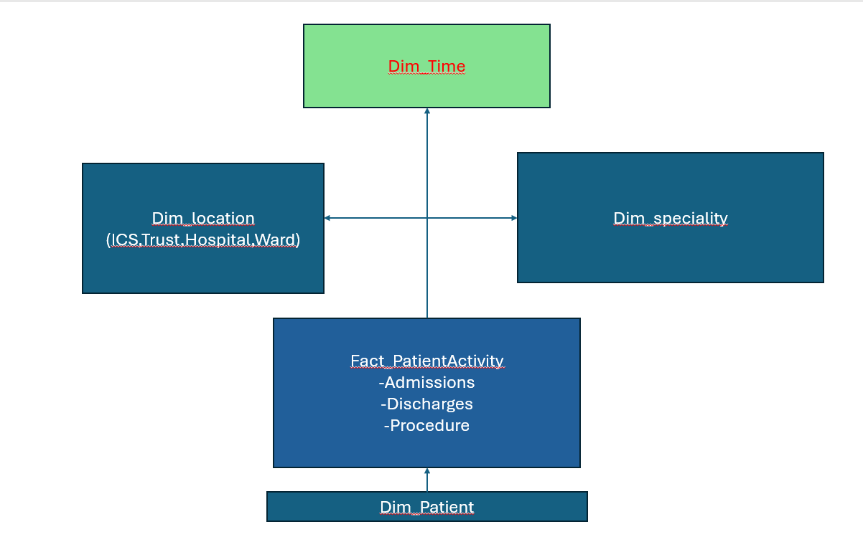

Task2.
2.1. Source System Identification
NHS England's comprehensive data warehouse will be fed by a vast network of internal and external data sources. Electronic patient records (EPR), patient administration systems (PAS), laboratory and imaging diagnostic platforms, theatre management systems, and community care systems are examples of core internal operating systems. These include comprehensive clinical events, patient activity, and therapy details. Staffing and capacity data are provided by workforce systems, which include HR, rostering, illness, training, and agency usage.

2.2. Star Schema Design
A strong and scalable dimensional model that can integrate patient activity, worker utilisation, financial performance, and quality indicators is necessary for a national data warehouse for NHS England. The best method is a star schema architecture, which provides ease of use, analytical effectiveness, and a distinct division between quantifiable events and descriptive characteristics. In order to guarantee consistency across all analytical domains, the design below describes a multi-star schema strategy that is backed by shared master data and metadata dimensions. [11]

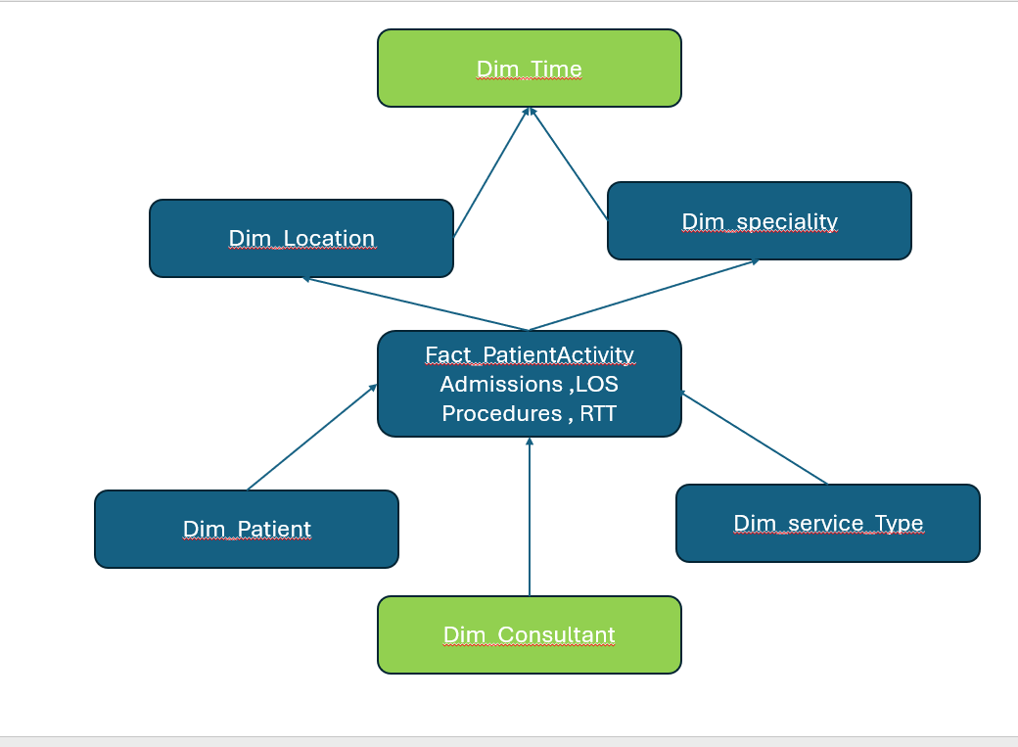
Patient Star Schema:
The warehouse's central component, the Patient Activity Star, records every clinical and operational event. Quantitative metrics including admissions, discharges, procedures, outpatient attendances, emergency visits, duration of stay, and RTT milestones are kept in the core Fact_PatientActivity database. Every record connects to important dimensions that offer context for analysis.
Dim_Patient, which contains NHS number, demographics, and GP registration, and Dim_Consultant, which stores clinician identification and speciality, are examples of master data dimensions.

Workforce Star Schema:
The Workforce Star facilitates the analysis of resilience, utilisation, and workforce capacity. Contracted hours, worked hours, overtime, agency usage, sick leave, and vacancies are all documented in the Fact_WorkforceUtilization database. It connects to both Dim_StaffRole (metadata: clinical/non-clinical, role category) and Dim_Staff (master data: staff ID, band, occupation, contract type). Workforce-to-demand modelling is made possible by shared dimensions like Dim_Time and Dim_Location, which provide alignment with patient activity analysis.
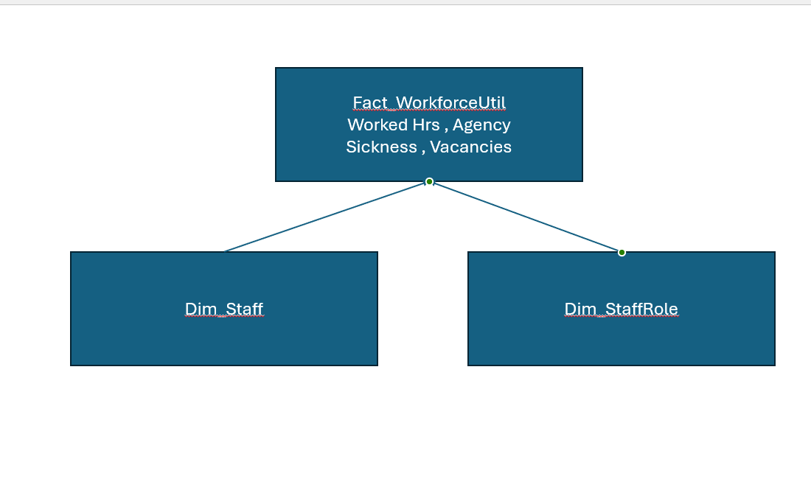

Finance & Performance Star Schema:
Financial flows and efficiency measurements are recorded by the Finance Star. Cost, income, tariff value, budget, variance, and agency spend are all stored in the Fact_FinancialPerformance database.
Key KPIs including bed occupancy, RTT compliance, readmission rates, mortality indicators, elective backlog size, and workforce sickness rates are compiled in a special Fact_MonthlyPerformanceIndicators table to facilitate executive reporting. For senior leadership, this pre-aggregated structure guarantees quick dashboard performance.
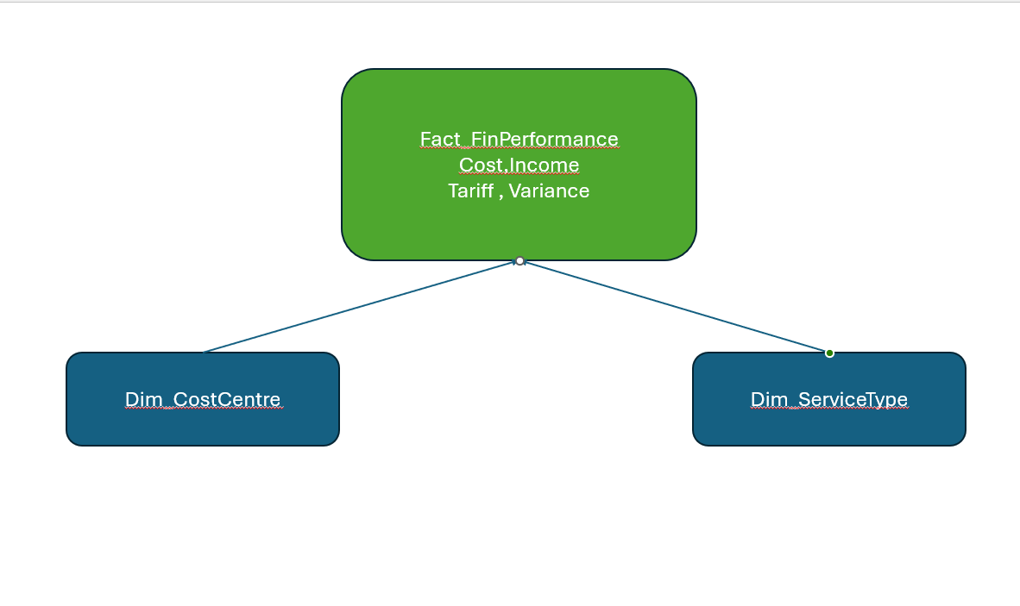

Master Data / Integration:
Consistent identity management across all facts is ensured by master data dimensions (patients, personnel, consultants). Service categories, specialisations, and cost centers are examples of metadata dimensions that facilitate consistent reporting and standardise classification. NHS England can examine connections between patient activity, workforce capacity, and financial performance using a single integrated model thanks to shared attributes across stars.[11]

2.3. Data Marts and Schema
To guarantee that every department receives targeted, pertinent, and useful information, NHS England needs specialised data marts. Data marts arrange this information into department-specific schemas that are optimised for decision-making, whereas the enterprise data warehouse offers unified, granular data.

-Finance Data Mart: Budgeting, tariff analysis, cost control, and productivity tracking are all supported by the financial mart. Cost, income, tariff values, budget variance, and agency spend are all stored in its main fact table, Fact_FinancialPerformance. Dim_CostCentre, Dim_ServiceType, Dim_Time, and Dim_Location are examples of dimensions. This schema supports financial governance and value-for-money evaluations by allowing analysis of spending by Trust, service line, speciality, and month.
-Operation Data Mart: Patient flow, demand, capacity, and performance are the main concerns of the operations mart. Admissions, discharges, procedures, outpatient visits, emergency visits, and length of stay are all included in the primary fact table, Fact_PatientActivity. Dim_Patient, Dim_Specialty, Dim_Location, and Dim_Time are examples of dimensions. Operational leaders may monitor bed occupancy, elective backlog trends, RTT compliance, and regional activity variation with the use of this mart.
-Quality Data Mart: Medical directors and quality teams can examine results and safety indicators with the help of the clinical quality mart. Readmissions, mortality indicators, complications, safety events, and patient experience measures are all stored in its Fact_ClinicalQuality fact table. [12]

2.4. ETL Plan
Data from various operational systems is extracted, standardised, and fed into uniform analytical frameworks thanks to the ETL process for NHS England's data warehouse. For patient activity tables, extraction uses data from EPR and PAS systems; for workforce tables, it uses data from ESR and rostering systems; and for financial performance tables, it uses data from Trust finance systems. NHS England performance results include additional KPI data.[13]

2.5. Data Quality & Governance
To guarantee that NHS England's data warehouse provides trustworthy, secure, and compliant insights, effective data quality and control are crucial. A number of important factors need to be taken into account during ETL and continuing operations.
Completeness and accuracy are fundamental. To guarantee that NHS numbers, dates, speciality codes, and financial values are accurate, source data from EPR, PAS, ESR, and finance systems must go through validation procedures. Duplicates, missing fields, and improper formats should all be found via automated cleaning procedures. ETL procedures must use role-based masking, enforce pseudonymization when necessary, and guarantee that only authorised individuals can access identifiable data. GDPR, the Data Protection Act of 2018, and NHS information governance regulations must all be adhered to.
Role-based permissions are used to maintain access control, guaranteeing that clinical, operational, and financial teams can only access information pertinent to their duties. [14]

References:

[1] | NHS England, “NHS Long Term Plan,” 2019. Accessed: Jul. 30, 2026. [Online]. Available: https://www.england.nhs.uk/long-term-plan/

[2] | S. Tan, “Big Data and Analytics in Healthcare: Introduction to the Special Section,” 2024. Accessed: Jul. 30, 2026. [Online]. Available: https://www.researchgate.net/publication/297727083_Big_data_and_analytics_in_healthcare_Introduction_to_the_special_section

[3] | D. Bender, K. Sartipi, and P. Eng, “HL7 FHIR: An Agile and RESTful Approach to Healthcare Information Exchange,” Accessed: Jul. 30, 2026. [Online]. Available: https://sartipi.azurewebsites.net/papers/CBMS2013.pdf

[4] | S. Arnold and D. Jefferies, “The NHS Budget and How It Has Changed,” Mar. 2025. Accessed: Jul. 30, 2026. [Online]. Available: https://www.kingsfund.org.uk/insight-and-analysis/data-and-charts/nhs-budget-nutshell
[5] | R. Mannion and J. Braithwaite, “Unintended Consequences of Performance Measurement in Healthcare: 20 Salutary Lessons From the English National Health Service,” Internal Medicine Journal, vol. 42, no. 5, pp. 569–574, May 2012, doi: 10.1111/j.1445-5994.2012.02766.x.
[6] | M. Jalalpour, Y. Gel, and S. Levin, “Forecasting Demand for Health Services: Development of a Publicly Available Toolbox,” Operations Research for Health Care, vol. 5, pp. 1–9, Jun. 2015, doi: 10.1016/j.orhc.2015.03.001.

[7] | J. Baptist Alzog, Handbuch Der Patrologie Oder Der Ältern Christlichen Literärgeschichte. Wentworth Press, 2019.

[8] | R. Kimball and M. Ross, The Data Warehouse Toolkit: The Definitive Guide to Dimensional Modeling, 3rd ed. John Wiley & Sons, Inc., 2013. Accessed: Jul. 30, 2026. [Online]. Available: https://ia801609.us.archive.org/14/items/the-data-warehouse-toolkit-kimball/The%20Data%20Warehouse%20Toolkit%20-%20Kimball.pdf
[9] | NHS England, “What Are Integrated Care Systems?,” 2022. Accessed: Jul. 30, 2026. [Online]. Available: https://www.england.nhs.uk/integratedcare/what-is-integrated-care/
[10] | A. Lamer, Chloé Saint-Dizier, N. Paris, and E. Chazard, “Data Lake, Data Warehouse, Datamart, and Feature Store: Their Contributions to the Complete Data Reuse Pipeline,” JMIR Medical Informatics, vol. 12, pp. e54590-e54590, Jul. 2024, doi: 10.2196/54590.
[11] | A. A. Maraj, A. Hossain, S. Islam, and N. Uddin, “INFORMATION SYSTEMS in HEALTH MANAGEMENT: INNOVATIONS and CHALLENGES in the DIGITAL ERA,” May 2024. Accessed: Jul. 31, 2026. [Online]. Available: https://www.researchgate.net/publication/380369517_INFORMATION_SYSTEMS_IN_HEALTH_MANAGEMENT_INNOVATIONS_AND_CHALLENGES_IN_THE_DIGITAL_ERA

[12] | R. Kimball and M. Ross, “The Data Warehouse Toolkit Second Edition the Complete Guide to Dimensional Modeling,” Accessed: Jul. 31, 2026. [Online]. Available: http://www.r-5.org/files/books/computers/databases/warehouses/Ralph_Kimball_Margy_Ross-The_Data_Warehouse_Toolkit-EN.pdf
[13] | B. Inmon, “Integrating Data – Technics Publications,” Technicspub.com. Accessed: Jul. 30, 2026. [Online]. Available: https://technicspub.com/integrating-data/

[14] | Ico.Org, “Key Data Protection Concepts,” ICO, Feb. 2024. Accessed: Jul. 31, 2026. [Online]. Available: https://ico.org.uk/for-organisations/uk-gdpr-guidance-and-resources/lawful-basis/biometric-data-guidance-biometric-recognition/key-data-protection-concepts/

