Module name: Sustainable Hospitality and Tourism Management
Module code: BMIH5006
Student name: Andreea Ursu
Student ID: 2227582
Lecturer: Lisa Knight

REPORT

Executive summary
Green practices, which emphasise resource conservation and waste reduction to improve operational efficiency, constitute a significant change towards environmental sustainability in the hotel business. Carroll's CSR pyramid outlines the economic, legal, ethical, and charitable aspects that build public trust. Corporate Social Responsibility (CSR) has expanded to include wider environmental and social responsibilities inside organisations. This essay looks at Hilton Hotels' "Travel with Purpose" campaign, which uses its Light Stay program to reduce waste and carbon emissions. The study assesses the incentives, difficulties, and advantages of introducing sustainable practices in hotels using the Triple Bottom Line (TBL) framework and the Hotel Sustainability Business Model (HSBM). The results show that green practices are influenced by both external and internal factors, such as customer expectations and regulatory compliance and operational efficiency. Sustainable tourism also improves community well-being and brand value by producing social and economic advantages. However, challenges including customer scepticism and high implementation costs continue to exist, as do the dangers of "greenwashing," in which businesses misrepresent themselves as environmentally conscious. Diverse outcomes across Hilton's locations highlight the significance of location-specific and guest-driven involvement to achieve consistent impact, even while industry-wide acceptance of third-party certifications may combat greenwashing and increase trust in green initiatives.

Table of Contents
Introduction 3
Findings 4
Sustainability Frameworks 4
Green Practices Motivations and Challenges 5
Hilton Hotels’ Sustainability Strategy 5
Economic and Social Benefits of Sustainable Tourism 6
Greenwashing In the Hospitality Industry 8
Conclusion 9
References 10

Introduction
Greener practices in the hotel industry are programs that strive to reduce environmental effect by conserving energy and water, reducing waste, and implementing sustainable resource management, ultimately improving operational efficiency and sustainability. (Abdou et al., 2020)
Corporate Social Responsibility (CSR) dates to the 17th century and has evolved to emphasise corporations' accountability to society and the environment. CSR lacks formal criteria, but the European Union defines it as a voluntary commitment by businesses to improve environmental and social well-being, thereby benefiting stakeholders and improving long-term results. Carroll's CSR pyramid categorises CSR into four levels: economic (profitability), legal (compliance), ethical (moral conduct), and philanthropic (charity), which all influence public trust. While CSR is a business-focused strategy, sustainability is a broader societal goal that includes economic, environmental, and social considerations. (Thorisdottir & Johannsdottir, 2020)

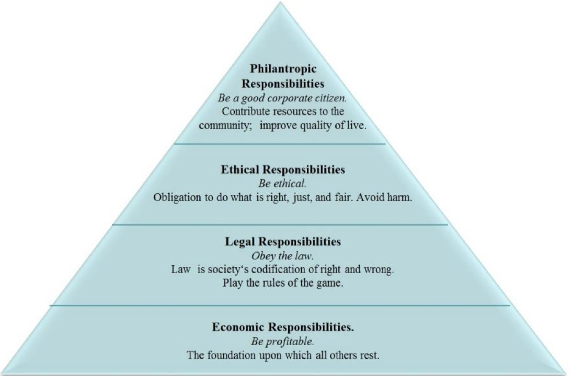
(Lund-Durlacher, 2015)
By 2030, Hilton's Travel with Purpose initiative seeks to cut its environmental impact in half, emphasising waste reduction, plastic eradication, water conservation, renewable energy, and carbon reduction. Hotels such as Hilton New York Midtown and Hilton London Bankside use renewable energy and sophisticated energy systems. To reduce food waste, Hilton encourages collaborations, trash diversion, and water-saving technologies. Additionally, the business promotes biodiversity, including the restoration of coral at Conrad Bora Bora Nui, and lessens plastic usage. Hilton raises the bar for eco-friendly luxury. (World Travel Awards, 2024)

Findings

Sustainability Frameworks
For the travel and hospitality sectors to advance sustainability, green practices and measuring frameworks are crucial. The Triple Bottom Line (TBL), first proposed by Elkington in 1997, is a well-known concept that evaluates business success in three areas: the economy, society, and environment (Elkington, 2018). The success of TBL in real-world applications may be hampered by its inconsistent approach to assessing social and environmental performance, despite its basic role. Sector-specific models, such as the Hotel Sustainability Business Model (HSBM), have been created to address these issues. The HSBM incorporates indicators specific to the environmental and social dynamics of the hotel business, hence adapting TBL ideas. This methodology offers a more thorough means of assessing hotel sustainability operations by utilising a collection of quantifiable indicators from the social, environmental, and economic spheres. (Mihalič et al., 2012)

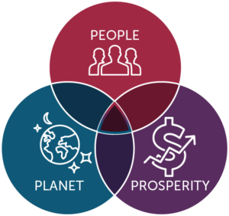

Green Practices Motivations and Challenges
Adopting environmental practices in the hotel sector is driven by both external (such as regulatory obligations and customer requests) and internal (such as management convictions and efficiency improvements) considerations. Cost cutting and uniqueness are important internal motivators, whereas client expectations and legal compliance are important external motivators. Adoption is hampered by both external and internal issues, such as consumer scepticism and legal obstacles, as well as internal ones like ignorance, unwillingness to change, financial worries, and operational difficulties. The integration of environmental practices in the supply chain entails working with suppliers on energy efficiency, waste reduction, and sustainable procurement to minimise environmental impacts throughout the value chain. (Alonso-Almeida et al., 2017)

Hilton Hotels’ Sustainability Strategy
In accordance with TBL principles, Hilton employs a thorough sustainability strategy that considers the social, environmental, and economic aspects. Introduced in 2018, their Travel with Purpose program emphasises ethical travel and incorporates sustainability objectives like lowering carbon emissions, water and energy use, and promoting positive community effects. TBL-related metrics including resource conservation, community development, and generating shared value for stakeholders are frequently included in Hilton's sustainability reports. Hilton's internal objective to increase operational effectiveness and cut expenses is what motivates the company's dedication to sustainability, as seen in its water and energy conservation initiatives. Introduced in 2008, Hilton's LightStay initiative aims to measure and enhance sustainable efforts throughout its properties. In line with internal efficiency motivators, it monitors environmental parameters that contribute to waste reduction, energy conservation, and efficiency improvement. (Mihalič et al., 2012) External forces, like as legal mandates and consumer expectations, also influence Hilton's environmental policies. (Iddawala et al., 2024) To comply with the law and meet consumer demand for sustainable practices, they have set high standards, such becoming carbon neutral by 2050. Hilton satisfies customer demand and regulatory trends by implementing eco-friendly amenities, sustainable sourcing, and energy and water conservation. (Hilton, 2023)
Hilton is committed to sustainability, but there are obstacles in the way of its full execution, especially when it comes to funding long-term sustainability objectives and operational adjustments. (Kaur, 2021) The initial cost of adopting eco-friendly technologies and practices has presented difficulties for the hotel sector, potentially affecting short-term profitability.
Hilton's sustainability strategy is an example of strategic corporate social responsibility (CSR), in which the business aims to balance its operational objectives with more general social, environmental, and financial results. Frameworks and resources that promote responsible management, assist this strategy by highlighting how crucial it is to incorporate CSR into organisational strategy for long-term sustainability. Theories of responsible management, which stress the significance of incorporating corporate social responsibility (CSR) into fundamental business operations, inform Hilton's internal sustainability motivators. By incorporating sustainability into its operations, Hilton is strengthening its long-term strategic objectives of efficiency and social responsibility in addition to lessening its impact on the environment. Using effective CSR tools, like Hilton's Light Stay program, shows a dedication to responsible management, which is becoming more and more crucial in the hospitality sector. Hilton's efforts to cut resource consumption and make a beneficial influence on communities are supported by CSR tools and frameworks, which give businesses the ability to systematically evaluate their environmental, social, and economic impacts. (Haski-Leventhal an Cooperrider, 2018).

Economic and Social Benefits of Sustainable Tourism
There are many wider advantages to sustainable tourism, especially when it comes to long-term financial success and community involvement. Strategic environmental, social, and economic strategies that support the tourism industry's overall resilience frequently serve as the foundation for these advantages. By increasing brand value, cutting expenses, and boosting operational efficiency, sustainable tourism projects can result in long-term profitability. Companies in the tourism industry that adopt sustainability typically see lower energy expenses, fees for disposing of garbage, and water usage, all of which result in financial savings. Additionally, businesses can draw in eco-aware customers by showcasing their dedication to sustainability, which will boost their market share and foster greater customer loyalty. (Font et al., 2016)
By making companies more resilient to changes in the economy, sustainable tourism practices increase long-term profitability. Incorporating green practices improves a company's competitive edge and lessens its impact on the environment, which attracts both investors and customers. Sustainable business practices demonstrate a dedication to ethical management, fostering consumer loyalty and trust among environmentally conscious customers and putting the company in a strong position in a market that is becoming more and more focused on sustainability. In the tourist and hospitality industries, this dual benefit of economic and environmental resilience supports a business's stability and expansion potential by coordinating short-term decisions with long-term financial success. (Chan & Hawkins, 2010)
By guaranteeing that local communities gain from tourist-related activities, sustainable tourism promotes significant community involvement. In addition to fostering economic growth, it encourages cooperative decision-making that safeguards cultural and natural resources. Building stronger relationships between businesses and local communities promotes infrastructure upgrades that improve the quality of life for locals, generate employment opportunities locally, and assist small businesses. By balancing economic gains with social and environmental well-being, this collaborative strategy enables tourism to have a beneficial influence on the community and build a more resilient, inclusive local economy that prioritises long-term sustainability. (Bramwell & Lane, 2011) Furthermore, when properly run, sustainable tourism practices contribute to the preservation of cultural heritage and environmental resources, guaranteeing the long-term profitability of the travel and tourism sector. Sustainable practices lessen the environmental impact of tourism and preserve regional customs by emphasising resource efficiency, cutting waste, and honouring cultural assets. In addition to appealing to environmentally concerned tourists, this strategy builds industry resilience, ensuring its continued profitability in the face of changing consumer demands and environmental difficulties. Thus, sustainable tourism puts the industry in a position to succeed going forward, offering long-term financial gains while protecting vital natural and cultural resources for coming generations. (Mihalič et al., 2012) By empowering local people and encouraging their active involvement in decisions about tourism development, sustainable tourism promotes social fairness. Such involvement promotes inclusivity, enabling locals to mould tourism to suit their needs and values, according to UNWTO. Sustainable practices promote social cohesion and resilience by promoting equitable economic opportunities, enhancing local culture, and encouraging community resource ownership. Sustainable tourism fosters reciprocal benefits and lessens inequality by incorporating local perspectives into planning and fostering trust between communities and tourism partners. For tourism to be viable over the long run and benefit all parties, this participative approach is crucial. (Canton, 2021)
The Hotel Sustainability Business Model (HSBM) (Mihalič et al., 2012) and the Triple Bottom Line (TBL) by Elkington (1997) are two theoretical frameworks that highlight how sustainable tourism practices can improve profitability and brand loyalty in addition to reducing environmental impact. These models demonstrate a clear connection between economic advantages and environmental responsibility, arguing that adopting green practices should boost resilience, draw in customers, and increase long-term profitability.
These theoretical expectations, however, may be hampered by practical constraints. Haski-Leventhal and Cooperrider (2018) draw attention to the difficulties and expenses involved in putting CSR into practice, such as restricted resource availability and organisational resistance to change. Other obstacles that can jeopardise sustainable initiatives include budgetary limitations, operational disturbances, and customer scepticism, as discussed by Lozano (2013) and Doody (2010). Organisations may not be able to fully realise theoretical gains despite the HSBM's metrics due to practical restrictions including regulatory gaps and infrastructure problems (Mihalič et al., 2012).

Greenwashing In the Hospitality Industry
The term "greenwashing," coined by Jay Westerveld in 1986 (Freitas Netto et al., 2020), refers to businesses that make exaggerated claims about being environmentally friendly to draw clients (Johnson, 2023). Customers are misinformed because companies frequently take little action to protect the environment (Delmas & Burbano, 2011). Researchers and regulators advise third-party certifications, such as Earth Check or Green Key, to assure legitimacy and combat greenwashing (Lyon & Montgomery, 2015).
In 2006, the advocacy group Tourism Concern accused Hilton of greenwashing, alleging that, despite Hilton’s claims of eco-friendly practices, the company had removed numerous palm trees and mangroves to construct its resort complex on Mandhoo Island. Some consumers claim that Hilton’s environmental initiatives prioritise profit over genuine ecological concern, viewing them as examples of greenwashing. (Tark & Oh, 2022)
Through its Light Stay platform, which has helped drastically cut down on waste, water use, CO2 emissions, and energy use while saving millions on utility bills, Hilton Worldwide encourages sustainability. The corporation does, however, confront difficulties, particularly in the United States, where issues with guest satisfaction have postponed the implementation of key-card energy-saving technologies that are popular in Europe. Hilton's sustainability impact varies by region because of things like recycling infrastructure and local climate, and it also depends on guest actions like reusing towels or controlling room temperature. Although the program works well, Hilton's properties might all be more consistent in their sustainability. While Hilton could consider more direct guest engagement strategies, the reliance on guests’ choices limits impact consistency across properties. Hilton’s impact on sustainability may be inconsistent, varying by location and local support for recycling and energy efficiency. (Gunther, 2012)

Conclusion
To promote sustainability in the travel and hospitality industries, green practices must be implemented. While sector-specific models like the Hotel Sustainability Business Model (HSBM) offer a more customised approach to the challenges of the hospitality industry, the Triple Bottom Line (TBL) framework offers a useful starting point for evaluating sustainability across economic, social, and environmental dimensions (Elkington, 2018; Mihalič et al., 2012). With programs designed to lessen environmental effects, advance social welfare, and strengthen economic resilience, businesses like Hilton Hotels are prime examples of how sustainability may be incorporated into corporate plans (Hilton, 2023; Iddawala et al., 2024).
But even with these developments, there are still obstacles in the way of fully implementing sustainable practices. The widespread adoption of green techniques is hampered by obstacles such high upfront costs, scarce resources, and aversion to change, particularly in smaller businesses (Kaur, 2021). Furthermore, external factors like unclear regulations and sceptical consumers make it more difficult to accomplish sustainable objectives throughout the supply chain. (Alonso-Almeida et al., 2017)
The situation is made more difficult by the emergence of "greenwashing," in which businesses exaggerate their sustainability initiatives to meet the rising demand for environmentally friendly offerings. This not only deceives customers but also jeopardises sincere sustainability initiatives, hence it is crucial that companies have open, verifiable procedures and that authorities impose precise guidelines (Delmas & Burbano, 2011; Lyon & Montgomery, 2015).

References
Abdou, A.H., Hassan, T.H. and El Dief, M.M. (2020) ‘A description of Green Hotel practices and their role in achieving sustainable development’, Sustainability, 12(22), p. 9624. doi:10.3390/su12229624.
Alonso-Almeida, M.-M. et al. (2017) ‘Revisiting green practices in the hotel industry: A comparison between mature and emerging destinations’, Journal of Cleaner Production, 140, pp. 1415–1428. doi:10.1016/j.jclepro.2016.10.010.
Bramwell, B. and Lane, B. (2011) ‘Critical research on the governance of Tourism and Sustainability’, Journal of Sustainable Tourism, 19(4–5), pp. 411–421. doi:10.1080/09669582.2011.580586.
Canton, H. (2021) The Europa Directory of International Organizations. 2021. Abingdon, Oxon, USA: Routledge.
Chan, E.S.W. and Hawkins, R. (2010) ‘Attitude towards emss in an international hotel: An exploratory case study’, International Journal of Hospitality Management, 29(4), pp. 641–651. doi:10.1016/j.ijhm.2009.12.002.
Delmas, M.A. and Burbano, V.C. (2011) ‘The drivers of greenwashing’, California Management Review, 54(1), pp. 64–87. doi:10.1525/cmr.2011.54.1.64.
Elkington, J. (2018) 25 years ago I coined the phrase ‘triple bottom line.’ here’s why it’s time to rethink it., Harvard Business Review. Available at: https://hbr.org/2018/06/25-years-ago-i-coined-the-phrase-triple-bottom-line-heres-why-im-giving-up-on-it (Accessed: 02 November 2024).
Font, X., Garay, L. and Jones, S. (2016) ‘Sustainability motivations and practices in small tourism enterprises in European Protected Areas’, Journal of Cleaner Production, 137, pp. 1439–1448. doi:10.1016/j.jclepro.2014.01.071.
Freitas Netto, S.V. et al. (2020) ‘Concepts and forms of greenwashing: A systematic review’, Environmental Sciences Europe, 32(1). doi:10.1186/s12302-020-0300-3.
Gunther, M. (2012) How hilton measures sustainability, Trellis. Available at: https://trellis.net/article/how-hilton-measures-sustainability/ (Accessed: 07 November 2024).
Haski-Leventhal, D. and Cooperrider, D.L. (2018) Strategic Corporate Social Responsibility: Tools & Theories for Responsible Management. London, UK: SAGE.
Hilton (2023) 2023 travel with purpose report, Hilton. Available at: https://esg.hilton.com/wp-content/uploads/sites/4/2024/05/2023-Travel-with-Purpose-Report-ADA-final.pdf (Accessed: 02 November 2024).
Iddawala, J., Welengoda, B.M. and Rathnayaka, B.T. (2024) ‘Sustainability practices in the hospitality industry: Evidence from Chain Hotels in Kandy’, International Conference on Tourism Research, 7(1), pp. 130–139. doi:10.34190/ictr.7.1.2038.
Johnson, E. (2023) What is greenwashing?, CPD Online College. Available at: https://cpdonline.co.uk/knowledge-base/business/what-is-greenwashing/ (Accessed: 06 November 2024).
Kaur, B. (2021) ‘A study of barriers to environmentally sustainable practices in hotel businesses in Punjab, India: Preliminary findings’, Academica Turistica, 14(1), pp. 71–86. doi:10.26493/2335-4194.14.71-86.
Lund-Durlacher, D. (2015) ‘Corporate Social Responsibility and tourism’, CSR, Sustainability, Ethics &amp; Governance, pp. 59–73. doi:10.1007/978-3-662-47470-9_4.
Lyon, T.P. and Montgomery, A.W. (2015) ‘The means and end of greenwash’, Organization &amp; Environment, 28(2), pp. 223–249. doi:10.1177/1086026615575332.
Mihalič, T., Žabkar, V. and Cvelbar, L.K. (2012) ‘A hotel sustainability business model: Evidence from Slovenia’, Journal of Sustainable Tourism, 20(5), pp. 701–719. doi:10.1080/09669582.2011.632092.
Tark, J. and Oh, W.-Y. (2022) ‘Chapter 35, Hilton Faces Greenwashing Challenge’, in Social and Sustainability Marketing. 1st edn. Boca Raton, USA: Rutledge.
Thorisdottir, T.S. and Johannsdottir, L. (2020) ‘Corporate Social Responsibility influencing sustainability within the fashion industry. A systematic review’, Sustainability, 12(21), p. 9167. doi:10.3390/su12219167.
World Travel Awards (2024) 10 best sustainable hospitality hotel groups, Home. Available at: https://www.10bestsustainablehospitalityhotelgroups.com/10-Best-Sustainable-Hospitality-Hotel-Groups/recs2ai1tAVIlL769 (Accessed: 01 November 2024).

