Table of Contents
Task 1: e-Commerce Website Builders 4
1.1 Introduction to Contemporary e-Commerce Builders 4
1.2 Analysis of Solution 1: Shopify 4
1.3 Analysis of Solution 2: WooCommerce 5
Task 2. Mind-map of Contemporary Software Applications 6
2.1 Description and Benefits of Mind Mapping in Business Operations 6
2.2 Academic Description and Analysis of Core Software Mind Map 7
Task 3. Office Applications for Creating, Storing, Presenting, and Analysing Information/Data 9
3.1 Exhaustive Analysis of Four Core Office Software Solutions 9
2. Microsoft PowerPoint (Multimedia Presentation and Strategic Visualisation) 10
3. Microsoft Excel (Spreadsheet Engine and Analytical Intelligence) 11
4. Microsoft Access (Relational Database Management System) 12
Feature 1: Mail Merge (MS Word & MS Excel Integration) 15
Feature 2: Goal Seek (MS Excel What-If Analysis Engine) 18
A. Objective and Mathematical Setup 18
4.1 Section A: Comprehensive Analysis of Contemporary Communication & Collaboration Tools 21
4.1.1 Communication Platform Analysis: Slack 21
4.1.2 Online Collaboration Platform Analysis: Microsoft Teams 22
Feature 1: Slack – Dynamic Project Channel Creation 23
A. Objective and Operational Scenario 23
B. Steps for Implementation 23
Feature 2: Microsoft Teams – Launching an On-Demand Collaborative Meeting 23
A. Objective and Operational Scenario 23
B. Step-by-Step Implementation and Screenshot Walkthrough 23
Conclusion 24
References 25

List of figures
Figure 1 Screenshot of the MS Word workplace interface showing the connection setup via the 'Select Recipients' dropdown menu linking to the external Excel dataset. 15
Figure 2 Shows options of Insert Merge Field 16
Figure 3 Final generated output of Sarah Ahmed's along with other two unique data row. 17
Figure 4 View of the spreadsheet with the active Goal Seek contextual dialog box appearing on screen. 18
Figure 5 Close-up view of the Goal Seek parameters filled out with cell paths and values prior to execution. 19
Figure 6 The updated spreadsheet showing the completed calculation status box alongside the adjusted cell values matching the $6,000 profit objective. 20

Task 1: e-Commerce Website Builders

1.1 Introduction to Contemporary e-Commerce Builders
Today, having a digital shopfront has become a fundamental business requirement, not just an option for retail operations. Today’s e-Commerce website builders are software-as-a-service (SaaS) platforms or open source ecosystems that allow organisations to design, deploy and manage commercial websites without the need for extensive backend coding knowledge [1]. Companies can significantly improve their technological workflow, automate inventory tracking and enhance decision-making with built-in analytic dashboards by incorporating these tools into business processes.
In this section, we will look at two current market leaders, Shopify and Woocommerce to assess how these solutions improve workplace productivity.

1.2 Analysis of Solution 1: Shopify
Shopify is a leading fully hosted SaaS e-Commerce platform, providing businesses with an all-in-one infrastructure [2].
Impact on Workflow and Productivity Shopify reduces IT overhead required to maintain a digital shopfront significantly. The platform natively manages security management (PCI compliance) and hosting infrastructure, enabling internal teams to focus entirely on commercial operations, order fulfilment, and marketing.
Key Features: Provides a centralised dashboard that aggregates multichannel sales (e.g., website, social media marketplaces, and physical Point of Sale terminals) [3]. This synchronisation ensures that inventory levels are updated simultaneously across all channels in real-time, preventing stock discrepancies and minimising human error in warehouse workflows.
Decision-Making Support: Shopify provides robust integrated reporting that tracks customer acquisition costs, conversion rates and historical sales trends, enabling managers to make informed purchasing decisions.

1.3 Analysis of Solution 2: WooCommerce
WooCommerce is an open-source, customisable e-Commerce plugin specifically built for WordPress, making it the best choice for organisations that want to have full ownership of their digital infrastructure [4]. Unlike Shopify,

Effect on Workflow and Productivity WooCommerce integrates easily into an existing WordPress content management system (CMS). If a business is already using WordPress for corporate blogging or content marketing, staff don’t have to learn a whole new software ecosystem, greatly reducing the training bottleneck and speeding up operational deployment.
Key Features: Open Source Architecture for Unlimited Flexibility. Businesses can add thousands of extensions to customise checkout funnels, connect to local shipping APIs, or add specialised Customer Relationship Management (CRM) tools to automate communication after a sale.
Decision-Making Support: WooCommerce’s granular data filtering through extension ecosystems and native analytics enables businesses to export highly detailed reports about product performance, regional sales distributions, and customer tax metrics, which can aid in long-term financial planning [5].
Operational Feature | Shopify | WooCommerce
Hosting Model | Fully hosted (SaaS) | Self-hosted (Open-source)
Technical Skill Required | Low to Moderate | Moderate to High
Workflow Automation | High (via ecosystem & built-in features) | High (requires manual configuration/plugins)
Data Control & Ownership | Proprietary platform constraints | Absolute control over data structures

Task 2. Mind-map of Contemporary Software Applications

2.1 Description and Benefits of Mind Mapping in Business Operations
A mind map is a diagram used to visually organise information. A mind map is hierarchical and shows relationships among pieces of the whole. A mind map is not a conventional list. It employs a radiating design of branches, keywords, colours, and images to replicate the natural cognitive processes of the human brain.

Mind mapping is a powerful tool in modern business operations that can enhance corporate workflows, boost productivity and improve strategic decision-making in several distinct ways [6]:
Speed up Project Planning and Brainstorming Ideas The collaborative team utilises mind mapping in the early stages of project development to rapidly gather ideas and ensure that the thinking process is not restricted. It lets teams decompose complex projects into granular, manageable work breakdown structures (WBS) on the fly.
Better Information Recall and Communication: Representing the complex operations or workflows of an organization in regular text leads to information overload. Mind maps distil large quantities of corporate data into a single visual snapshot, which greatly simplifies the ability of stakeholders to understand the interrelations of various aspects of the operation [7].
Structured Decision-Making: By visually charting the potential risks, resource allocations and operational dependencies of a business decision, managers can view a holistic picture of organisational workflows. That minimises oversight and makes the execution of strategy smoother.

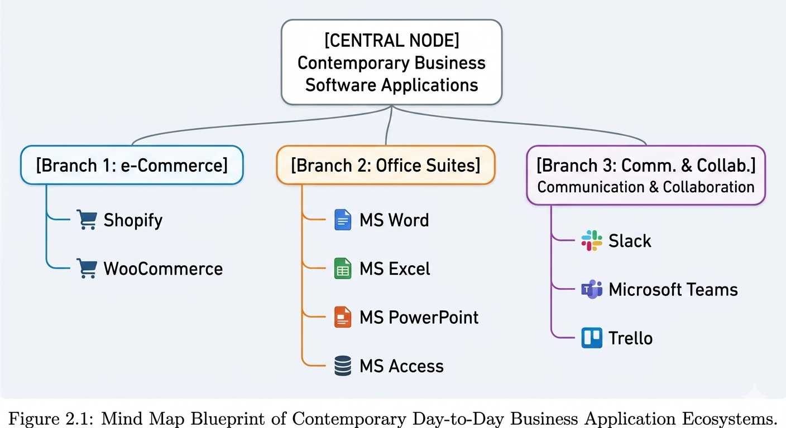

2.2 Academic Description and Analysis of Core Software Mind Map
The visual architecture shown in the figure is an all-encompassing representation of the modern software tools needed to keep the day-to-day operations of the organization running smoothly. Instead of analysing software programs in isolation, this mind map clusters programs into 3 interdependent functional pillars that build a modern business infrastructure.
1. E-Commerce Infrastructure (External Facing Operations)
The first main branch is about the platforms that deal with sales operations on the consumer-facing side: Shopify and WooCommerce. This node is responsible for generating revenue, automating the digital checkout funnel and processing payments in the daily business workflows. From an operational perspective, this branch provides critical transactional data to the rest of the business ecosystem. For example, a sale entered on the e-Commerce arm automatically updates inventory numbers and funnels work down to logistics and accounting teams.
2. Office Suites & Productivity (Internal Data Processing & Administration)
The largest branch in the middle is the Microsoft Office Ecosystem (Word, Excel, PowerPoint, and Access). This pillar is the operational engine room of the organization:
• MS Word & PowerPoint enable semantic communication – translating abstract strategies into corporate reports, employee handbooks and stakeholder presentations.
• MS Excel & Access is for structured data. They draw raw transactional data straight from the e-Commerce branch to keep relational employee databases, to apply complex formulas for financial analysis, and to track physical metrics of the supply chain.
3. Teamwork & Communication (Team Cohesion & Project Flow)
The last branch contains Slack, Microsoft Teams, Trello. This pillar is the digital workspace where human capital interacts. The Collaboration branch ensures staff can discuss, assign and execute projects related to those elements if the Office branch creates the data and the e-Commerce branch generates the revenue. It connects across physical or remote boundaries through instant messaging (Slack), synchronous face-to-face meetings (Teams) and transparent task management tracking (Trello’s Kanban boards).
Operational Synthesiser
The mind map ultimately shows that the seamless loop between these three categories is what makes day-to-day business productivity possible. Disruption in one branch cascades into the others. For example, a breakdown in internal communication (Branch 3) can prevent a marketing update on an e-Commerce site (Branch 1), which can then cause an immediate drop in sales figures to be recorded in a financial spreadsheet (Branch 2). Mind mapping these systems makes it easier for management to see operational dependencies and facilitate technology driven workflows.

Task 3. Office Applications for Creating, Storing, Presenting, and Analysing Information/Data

3.1 Exhaustive Analysis of Four Core Office Software Solutions
This section offers a detailed analysis of the four basic applications that constitute the Microsoft Office suite, namely MS Word, MS PowerPoint, MS Excel, and MS Access. The review of each app is based on the basic technical features, immediate impact on improvement of the workflow in the office, organisational or functional restrictions.
1. Microsoft Word (Processing of Text and Creating Advanced Documentation)
A. Main technical features
The modern organisational environment uses Microsoft Word as the main channel for semantic communication and formal corporate documentation. It also has advanced features beyond simple text editing . A powerful Styles and Themes Engine lets you standardise corporate typography , heading hierarchy and geometric layouts across multiple page documents .
The Mail Merge Engine is a key workflow feature, an automation tool that joins static text documents to structured data sources (such as an Excel spreadsheet or an Access database table). It facilitates the automated compilation and dynamic personalisation of bulk correspondence, legal letters and individual employee forms [8].
Its References and Automation Subsystems also allow users to generate dynamic tables of contents, index sheets and real-time cross-references that automatically update as content scales. Word has a sophisticated Reviewing and Tracking Engine that supports collaborative environments with features like fine-grained change-tracking, contextual comment threading, and asynchronous cloud-based document co-authoring.
B. Direct business benefits & workflow optimisation
The direct use of MS Word enhances the productivity of administration through reduction of time spent in formatting document manually. An organization can leverage pre-configured corporate templates that contain standardised Styles to ensure that all outgoing proposals, stakeholder reports and legal agreements all have a unified, professional brand identity.
The Mail Merge subsystem integration transforms administrative workflows, turning what was once hours of manual copy-pasting into a macro-driven, single-click automated pipeline. Additionally, real-time cloud collaboration capabilities reduce operational latency, and multidisciplinary teams can simultaneously edit policy documents or grant proposals without creating conflicting file versions, thus maintaining a single source of truth.
C. Structural and Functional Limitations
Heavy enterprise data operations are constrained by structural thresholds in MS Word despite its dominance. It is basically ill-equipped to handle complex relational data, or deep mathematical calculations. Its internal tables are missing the formulaic agility of a dedicated spreadsheet engine.
Also, Word documents are susceptible to structural XML layout degradation when working with very large files (e.g., reports over several hundred pages filled with heavy high-res imagery and complex floating tables). In these circumstances, the software can become laggy, the pagination may be buggy and the cursor may behave erratically, and the app may even crash and irreversibly corrupt the file if local autosave caches are corrupted [9].

2. Microsoft PowerPoint (Multimedia Presentation and Strategic Visualisation)
A. Basic technical specifications
Microsoft PowerPoint is designed to translate abstract business strategies, complex data structures and operational paradigms into simple-to-understand, high-impact visual stories. Built around an asset-driven canvas, the core features include Slide Master Architecture, a centralised design engine in which changes to global layouts, background vectors and typographic hierarchies are automatically populated throughout the entire presentation deck.
In more recent iterations of the software, Microsoft introduced the Morph Transition Engine, a sophisticated algorithmic tool that determines the geometric trajectory of assets from one slide to the next, producing seamless, cinema-quality animations that emphasise structural changes or process flows.
PowerPoint also offers a comprehensive Multimedia Embedding Framework which handles native playback of high-definition video loops, interactive vector graphics (.SVG), and 3D CAD models. It boasts a dynamic Chart and SmartArt Linking Engine that keeps a live data hook to underlying Excel spreadsheets, so visual charts get updated automatically as financial or operational metrics fluctuate. This makes it the go-to for data-driven storytelling [10].
B. Workflow Improvement and Direct Business Benefits
PowerPoint is the main way to cross the communication gap between technical analytical teams and non-technical executive stakeholders in the corporate world. With Slide Masters organisations eliminate layout drift and save hundreds of hours in design time, freeing staff to work on content refinement rather than pixel alignmen [11]t.
In high-stakes pitches or inside quarterly reviews, the precise use of logical animations and integrated multimedia supports cognitive processing, helping audiences retain critical strategic information. Since data visualisations can be linked directly to Excel, financial analysts can quickly update monthly performance decks without having to manually re-export and re-paste graphics ahead of executive briefings.
C. Limitations of Structure and Operations
The biggest operational limitation of PowerPoint is the low density of information layout. It condenses complicated multi-layer data arrays into brief bullet points, which can remove vital context from complex corporate analysis and might result in shallow decision-making if utilised as a sole reporting tool.
Embedding uncompressed multimedia or long live links to spreadsheets results in dramatically larger file sizes, from a technical perspective. This can cause severe performance degradation, long delays in file sharing across the email infrastructure, and presentation lag during live deployment on hardware with limited processing power [12].

3. Microsoft Excel (Spreadsheet Engine and Analytical Intelligence)
A. Main technical features
Excel is the analytical backbone of the modern workplace. It provides a grid-based computational canvas with a high-performance calculation engine. Its feature set is built on a massive library of Logical, Financial and Lookup Formulas. These include industry-standard analytical functions such as IF, VLOOKUP, INDEX/MATCH, and the super-efficient XLOOKUP [13] .
Another strength of Excel is the ability to aggregate complex data using Pivot Tables and Pivot Charts . This allows the user to ingest thousands of rows of raw transactional data and then slice, filter, group and cross-tabulate variables dynamically in seconds.
It also has Data Validation Tools to ensure cell input types are restricted to specific data types (like dates, integers or dropdown arrays) to encourage tight data integrity. Power Query and Power Pivot ETL (Extract, Transform, Load) engines allow advanced users to connect directly to external corporate databases, clean up messy data automatically, and create complex data models natively within the spreadsheet workbook.
B. Benefits to the Business and Streamlining of Workflows
Excel converts raw and disorganised corporate data into clear and actionable business intelligence to optimise operational decision-making. Pivot Tables and financial models enable managers to instantly determine product profit margins, detect regional sales anomalies, and conduct real-time predictive forecasting scenarios.
Strict Data Validation rules are in place to reduce human errors in data entry at source and protect the sanctity of operational tracking sheets. For example, accounting and logistics teams can automate repetitive data-cleaning steps with Power Query, saving hours of manual file processing and freeing up staff time for strategic analysis [14].
C. Limitations of Structure and Operation
Excel is a flat file spreadsheet application, not a relational database management system at the enterprise level. It cannot enforce strict relational integrity between independent table. This leaves datasets vulnerable to human erro , accidental deletion , or broken cell references when multiple users edit structural columns .
Also, Excel has a hard physical limit of 1,048,576 rows by 16,384 columns per worksheet. Processing data sets that approach these limits leads to huge RAM consumption, major computational delays and workbook instability. Ultra large big data streams or automated machine generated log files are not efficient to process [15].

4. Microsoft Access (Relational Database Management System)
A. Key technical features
Microsoft Access provides a bridge between flat-file desktop spreadsheet tools and complex enterprise SQL databases. Its core technical capability is to create and enforce strict Relational Data Models with primary and foreign keys across discrete tables. It is built on Jet/ACE Relational Database Engine. This architecture ensures that data is clean and mathematically valid throughout its life cycle [16].
Access is based on four key elements:
• Tables: The underlying repositories where data is stored to explicit, unchanging data types.
• Queries: An engine that uses Structured Query Language (SQL) or graphical Query-By-Example (QBE) interfaces to filter, join, update, or delete records in several disconnected tables at the same time.
• Forms: Scriptable, highly customisable user interfaces providing a clean front end for workers to input data without having to interact directly with the underlying database infrastructure.
• Reports: A professional formatting engine to extract complex query outputs and group, organise and format them into polished documents optimised for digital printing or executive distribution.
B. Workflow Optimisation and Direct Business Benefits
With Microsoft Access, organisations can avoid the data redundancy and file duplication that typically plague environments that rely solely on flat spreadsheets. Relational organization means that if you change a customer’s address in one master table, the address in all related order logs, invoices and shipping histories change at the same time.
Create Custom Forms hide underlying database logic from non-technical staff. This creates a safe data-entry environment with few errors and no accidental database corruption. Pre-built Queries can also help automate complex monthly reports that cross-reference information from different departments to give management an accurate, comprehensive performance review at a fraction of the normal administrative cost [17].
C. Structural and functional constraints
Access is perfectly adequate for a departmental application, but it obviously lacks scalability. A single Access database file is limited to 2 Gigabytes (2 GB) of technical capacity including all systemic system objects and localised indexes. If an organization has transactional data or attachments that are larger in volume than this, performance breaks down very quickly and there's a much higher likelihood of total file corruption.
Access is also primarily designed for contained local area network (LAN) environments. It lacks native web-architected deployment workflows and is not inherently capable of supporting high volumes of concurrent remote users, which often leads to record-locking conflicts and latency bottlenecks when distributed teams try to write data simultaneously.
Operational Stage | Primary Application | Input Source | Primary Function | Output Destination
1. Secure Storage | MS Access | Raw Operational Inputs / Field Forms | Enforces relational integrity and records historical transactional data securely. | MS Excel (via data connection query)
2. Deep Analysis | MS Excel | Relational Database Queries | Executes analytical formulas, groups variables, and runs Pivot Table metrics. | MS Word (via Mail Merge) / MS PowerPoint (via live link)
3. Documentation | MS Word | Analytical Data / Formatted Customer Lists | Generates personalized high-volume correspondences and official corporate reports. | Final External Stakeholders / Corporate Archives
4. Presentation | MS PowerPoint | Excel Pivot Charts / Executive Summaries | Visualizes key insights into interactive slide decks for strategic review. | Boardroom Briefings / Executive Decision Makers
Table: FOUR OFFICE COMPARSION

Feature 1: Mail Merge (MS Word & MS Excel Integration)

A. Objective and Simulated Data Setup
The objective of this test is to automate the generation of personalized staff notification letters regarding mandatory information security training. A simulated dataset containing three records was constructed in MS Excel (Staff_Data.xlsx) to serve as the external data source [18].
Table 2: Simulated Data Array for Mail Merge Source File.
First_Name | Last_Name | Department | Training_Deadline
Sarah | Ahmed | HR | June 15, 2026
David | Smith | IT | June 18, 2026
Elena | Rostova | Finance | June 22, 2026

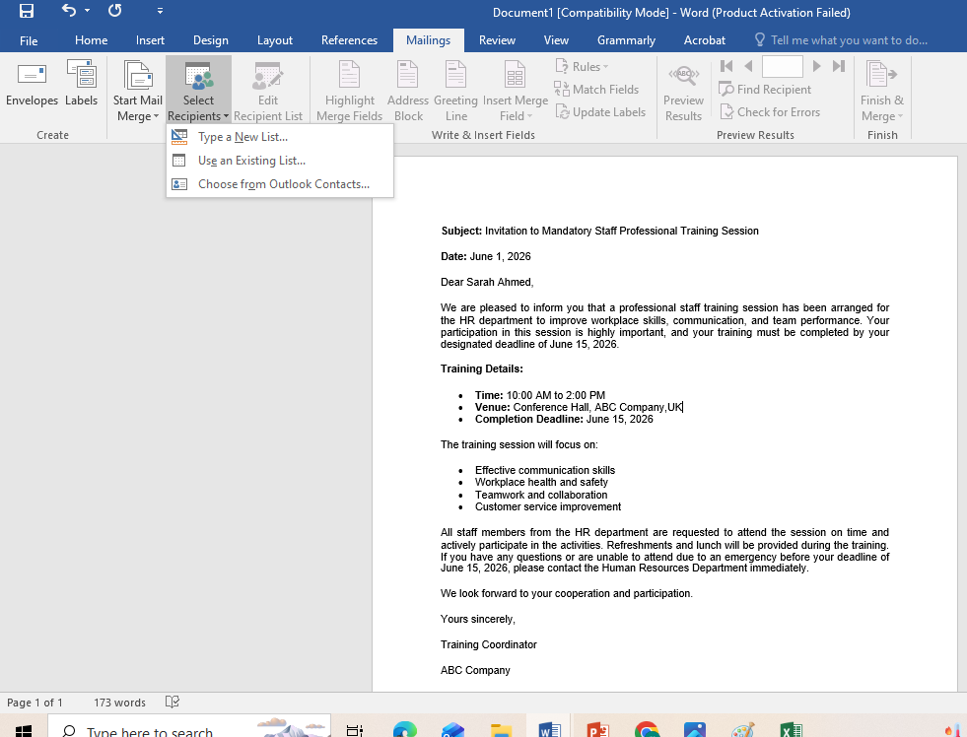
Figure 1 Screenshot of the MS Word workplace interface showing the connection setup via the 'Select Recipients' dropdown menu linking to the external Excel dataset.

- Step 2: Position the text cursor at the appropriate points within the Word document and utilize the Insert Merge Field utility to position the dynamic placeholders: «First_Name», «Last_Name», «Department», and «Training_Deadline».
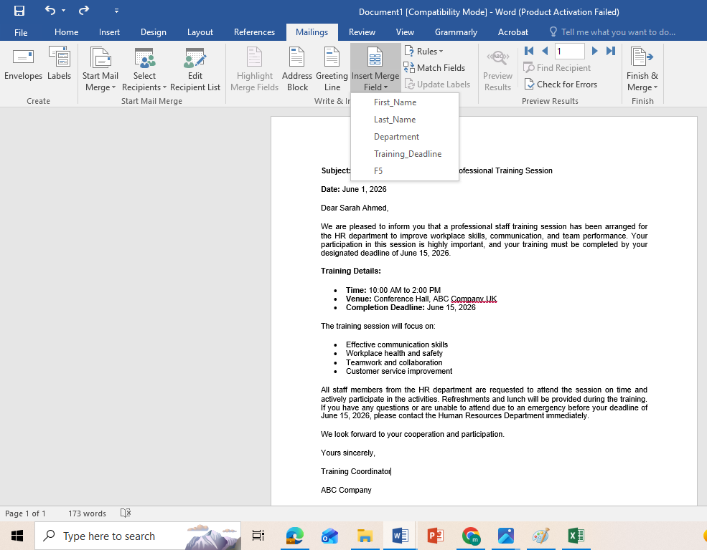
Figure 2 Shows options of Insert Merge Field
- Step 3: Click on Preview Results to verify data alignment. Finally, execute the merge by selecting Finish & Merge followed by Edit Individual Documents... to compile the final individualized communication files.
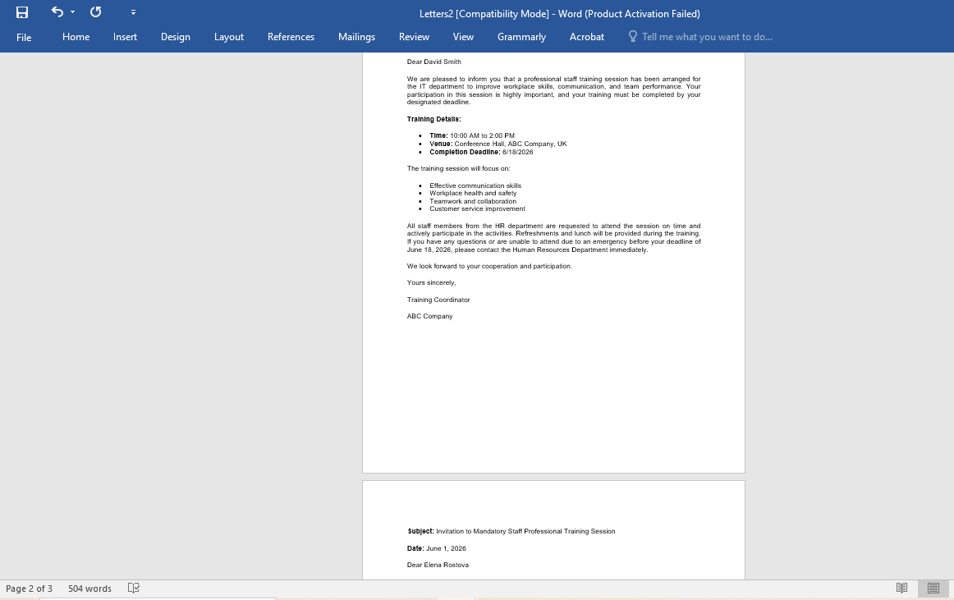
Figure 3 Final generated output of Sarah Ahmed's along with other two unique data row.

Feature 2: Goal Seek (MS Excel What-If Analysis Engine)

A. Objective and Mathematical Setup
The objective of this test is to utilize Excel’s iterative calculation engine to determine the exact unit volume sales required to reach a specific target net profit [19].
A simulated business model for a product line was established using the following structural financial parameters:
- Fixed Costs (Cell B1): $15,000 (Static overhead)
- Unit Selling Price (Cell B2): $50 (Static revenue per unit)
- Unit Variable Cost (Cell B3): $20 (Static cost per unit)
- Projected Unit Sales (Cell B4): 400 (The initial variable baseline)
- Total Revenue (Cell B5): =B2*B4
- Total Variable Costs (Cell B6): =B3*B4
- Net Profit Formula (Cell B7): =B5-(B1+B6) (Initial calculated baseline profit at 400 units is -$3,000).
The executive mandate requires the business branch to achieve a Net Profit of exactly $6,000. Goal Seek will be deployed to find the required sales volume.
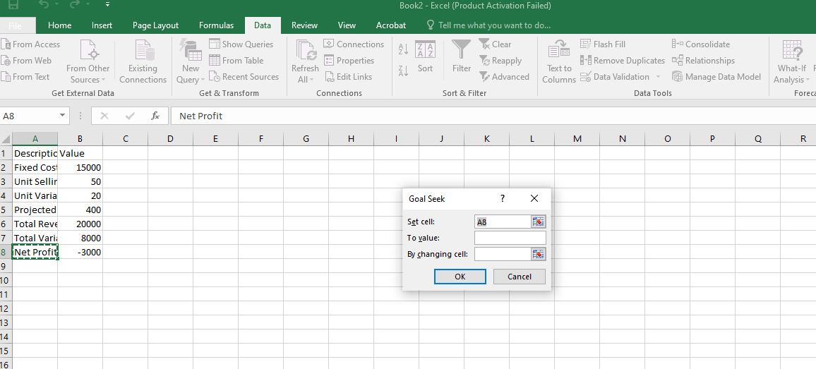
Figure 4 View of the spreadsheet with the active Goal Seek contextual dialog box appearing on screen.

- Step 2: Populate the three parameters within the interactive Goal Seek modal pop-up box as follows:
  - Set cell: B8 (Target cell containing the profit formula)
  - To value: 6000 (Desired financial outcome)
  - By changing cell: $B$5 (The independent variable representing unit sales volume)
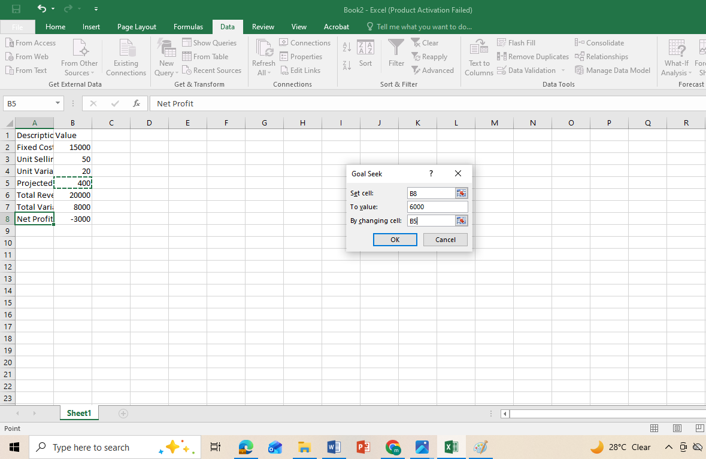
Figure 5 Close-up view of the Goal Seek parameters filled out with cell paths and values prior to execution.
- Step 3: Click OK. Excel's iterative processor runs calculations until an exact match is discovered. The dialog box returns an optimization message stating that a solution has been found, shifting cell B5 from its original value of 400 to the optimized target of 700 units.
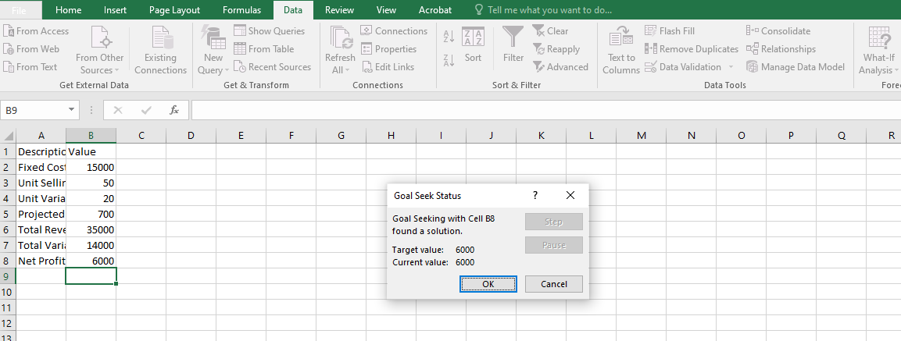
Figure 6 The updated spreadsheet showing the completed calculation status box alongside the adjusted cell values matching the $6,000 profit objective.

4.1 Section A: Comprehensive Analysis of Contemporary Communication & Collaboration Tools
In the digital workplace today, productivity in an organization is dependent on software architectures that support synchronous and asynchronous interactions. To maintain business operations in distributed, hybrid, or co-located enterprise environments, businesses implement dedicated communication and collaboration ecosystems. In this section we discuss two recent market leaders, Slack (a communication-centric platform) and Microsoft Teams (an online collaboration-centric suite) [20].

4.1.1 Communication Platform Analysis: Slack
Slack is a modern cloud-based instant messaging application that aims to replace the traditional high-latency email correspondence in corporate environments.
• Platform Architecture: The platform architecture comprises Channels, which are segmented communication streams and can be public or private. These channels can be divided by department, project milestone, or client account. Slack can be integrated with third-party software using APIs, allowing you to receive real-time notifications from services like GitHub, Jira, or Google Drive via webhooks. It also has a sophisticated Keyword Tagging and Search Subsystem which indexes all past files and messages for fast retrieval [21] .
• Operational Workflow Impact: Slack improves the efficiency of administrative workflows by breaking down conversational silos. Instead of long, messy email threads, communication occurs in dedicated channels so team members can easily browse project histories and jump into conversations with

4.1.2 Online Collaboration Platform Analysis: Microsoft Teams
Microsoft Teams is a single workspace hub that brings together chat, video, voice, document and business process management into a single application interface.
• Key Technical Features: Microsoft Teams is built on top of the Microsoft 365 SharePoint Infrastructure natively, unlike standalone chat clients. This architecture allows multi-user live co-authoring of files (Word, Excel) inside the application pane in real-time. Microsoft Teams has an enterprise-grade Video Conferencing Engine that provides automated live transcription, digital breakout rooms, and interactive whiteboards. It also takes advantage of Tab Extensions, giving managers the ability to pin interactive Power BI performance dashboards or Trello boards right into a shared workspace [22].
Impact on the way you work: Teams changes the way your business works together by being a single place to get work done. It eliminates the inefficiencies of toggling between different apps by integrating communication channels, cloud-based file storage, and video meetings. Teams can easily handle cross-departmental operations, large-scale web briefings to hundreds of remote employees.
Technical Parameter | Slack (Communication Focus) | Microsoft Teams (Collaboration Focus)
Primary Architectural Design | Channel-based instant messaging. | Unified workspace hub and video conferencing.
File Storage & Lifecycle Engine | Cloud attachment hosting (Flat index). | Native SharePoint Document Library integration.
Ecosystem Synergy | Highly flexible third-party API webhooks. | Deep, native Microsoft 365 software integration.
Table 3: Slack and Microsoft Teams

Feature 1: Slack – Dynamic Project Channel Creation

A. Objective and Operational Scenario
The goal of this test is to create a workspace channel on Slack that will be isolated, secure, and topic-specific to centralise team communication for a mock project. This eliminates email clutter in actual business operations and consolidates project assets in one easily accessible place. This phase of testing was performed in a simulated project environment named “Project Alpha”.

B. Steps for Implementation
• Step 1: Starting the channel creation. Open the app for your Slack workspace. In the left-hand navigation interface panel, find the main Channels directory heading. Click the nearby + (Add Channel) icon to open the structural setup prompt window and select Create a new channel from the context drop-down menu [23].
• Step 2: Configure Metadata and Visibility. Input the desired simulated configuration parameters in the configuration modal interface. Channel name: exactly #project-alpha-operations. Description of operational purpose: "Simulated workspace for tracking operational deliverables". Choose Public in the privacy setting so all team members can find it. Then click Create.
• Step 3: Integrate the user and verify. During structural compilation, the system prompts the user to add participants. Add (or skip) mock team members (e.g. User_A, User_B). Type a first operational check message into the dynamic text box: “Welcome to the Project Alpha operations stream.” Press Enter to acknowledge that the channel is alive, indexing text, and ready for collaborative workflows.

Feature 2: Microsoft Teams – Launching an On-Demand Collaborative Meeting

A. Objective and Operational Scenario
The goal of this test from an operational perspective is to start an ad-hoc video conference right within a given departmental workspace container in Microsoft Teams. This capability allows agile corporate teams to instantly launch emergency standups or synchronised file-review sessions without waiting for an email calendar invite or pre-scheduled link [24].

B. Step-by-Step Implementation and Screenshot Walkthrough
• Step 1: Getting Around the Team Infrastructure Start the Microsoft Teams desktop workspace interface. Click on the Teams icon from the leftmost structural app bar to populate the corporate organisational directory. Select the pre-configured business container "Operations Department Team" and go into its main nested communication channel "General".
• Step 2: Turn on the Meet Now Engine. Click near the top right corner of the channel workspace panel. Click the drop-down accent arrow to the right of the primary camera icon. Click on Meet now from the contextual choices that result to start the localised synchronous video broadcasting engine interface.
• Step 3: Setting up Media Canvas and Joining the Call. In the pre-join multimedia audio/video configuration screen, type in a simulated title for the session: Simulated Morning Standup. Enable the virtual audio microphone settings, calibrate the hardware inputs and click Join Now. That opens the active, multi-party video call grid interface, and completes the test of the collaboration feature [25].

Conclusion
This project offered a full review of the digital tools in use and their transformational effect on current business practices. Reviewing e-Commerce platforms, it was found that Shopify’s SaaS fully hosted model offers reduced IT infrastructure overhead, and WooCommerce provides organisations with unparalleled structural flexibility due to its open-source WordPress architecture. In addition, exploration of core office suites demonstrated how strategic arrangement of applications such as MS Word, Excel, PowerPoint and Access produces an integrated operational loop. This pipeline turns raw corporate data from secure relational databases into analytical models, professional text documentation and persuasive executive presentations. Finally, the investigation of collaborative platforms such as Slack and Microsoft Teams showed how the dismantling of communication silos directly reduces operational latency. At the end of the day, successful deployment and integration of these interdependent technological infrastructures are essential to optimise workflows, protect data integrity, and enable sound, data-driven strategic decision-making in a competitive corporate environment.

References
[1] R. Rai, P. Chettri, and L. Chettri, “E-commerce and its software,” in Sustainable Business: Concepts, Methodologies, Tools, and Applications, IGI Global, 2020, pp. 696–726.
[2] S. Bang, “Top E-Commerce CMS platforms (Shopify/WordPress/BigCommerce),” 2023.
[3] E. Tabaku, E. Duçi, and A. Lazaj, “From Physical Stores to Virtual Marketplaces: The Evolution of Shopping,” Interdiscip. J. Res. Dev., vol. 11, no. 3, p. 175, 2024.
[4] A. H. Sutopo, Developing Modern E-commerce: WooCommerce for Digital Products. Topazart, 2024.
[5] P. Rauland, Mastering WooCommerce: Build, customize, and launch a complete e-commerce website with WooCommerce from scratch. Packt Publishing Ltd, 2024.
[6] M. J. Somers, K. Passerini, A. Parhankangas, and J. Casal, “Using mind maps to study how business school students and faculty organize and apply general business knowledge,” Int. J. Manag. Educ., vol. 12, no. 1, pp. 1–13, 2014.
[7] B. G. Wilson, Exploration of mind mapping as an organizational change tool. Pepperdine University, 2016.
[8] A. I. Akubos, “The Role of Word Processing Applications in Enhancing Administrative Efficiency in Business Education Departments in Tertiary Institutions in Bayelsa State,” J. Educ. Res. Libr. Pract., 2025.
[9] C. Rapp, T. Heilmann, and O. Kruse, “Beyond MS Word: alternatives and developments,” in Digital writing technologies in higher education: Theory, research, and practice, Springer, 2023, pp. 33–47.
[10] A. G. Gross and J. E. Harmon, “The structure of PowerPoint presentations: The art of grasping things whole,” IEEE Trans. Prof. Commun., vol. 52, no. 2, pp. 121–137, 2009.
[11] O. Marjanovic, G. Patmore, and N. Balnave, “Visual analytics: Transferring, translating and transforming knowledge from analytics experts to non-technical domain experts in multidisciplinary teams,” Inf. Syst. Front., vol. 25, no. 4, pp. 1571–1588, 2023.
[12] J. E. Susskind, “Limits of PowerPoint’s power: Enhancing students’ self-efficacy and attitudes but not their behavior,” Comput. Educ., vol. 50, no. 4, pp. 1228–1239, 2008.
[13] J. M. Lindquist and C. A. Sulewski, “Microsoft Excel: The Universal Tool of Analysis,” in Handbook of Military and Defense Operations Research, Chapman and Hall/CRC, 2024, pp. 21–72.
[14] H. Barreto, “Why excel?,” J. Econ. Educ., vol. 46, no. 3, pp. 300–309, 2015.
[15] M. M. El-Awad, “Computer Applications for Engineers using Excel,” Available SSRN 5412105, 2024.
[16] T. Hennig, T. L. Bradly, L. Linson, L. Purvis, and B. Spaulding, Microsoft Access small business solutions: state-of-the-art database models for sales, marketing, customer management, and more key business activities. John Wiley & Sons, 2010.
[17] J. Eckstein and B. R. Schultz, Introductory relational database design for business, with Microsoft Access. John Wiley & Sons, 2018.
[18] L. Q. Thede, “Mail merge: a time-saving tool,” CIN Comput. Informatics, Nurs., vol. 25, no. 3, pp. 134–138, 2007.
[19] P. Cornell, Beginning Excel What-If Data Analysis Tools: Getting Started with Goal Seek, Data Tables, Scenarios, and Solver. Springer, 2006.
[20] A. Januszewski, “MS Excel in Management Accountants Education. Examples of the Goal Seeking Tool Application,” in INTED2018 Proceedings, 2018, pp. 7562–7571.
[21] H. A. Johnson, “Slack,” J. Med. Libr. Assoc. JMLA, vol. 106, no. 1, p. 148, 2018.
[22] M. M. U. Hoque, X. Zhang, M. F. F. Rahman, B. Zahra, and M. S. Hasnat, “A comprehensive review of enhancing collaboration and performance in virtual teams,” Review of Busines
and Economics Studies, vol. 13, no. 1, pp. 93–108, 2025.
[23] E. M. Woldesembet, Unleashing the Power of Communication: Exploring the Dynamics of Slack Channel Networks and Project Success, Ph.D. dissertation, Universitat de Barcelona, Barcelona, Spain, 2023.
[24] M. Inoue, Y. Suhara, M. Ichikawa, X. Chen, and T. Wagatsuma, “Planning and implementation of large-scale online project-based learning and flipped classes,” in 2020 IEEE International Conference on Teaching, Assessment, and Learning for Engineering (TALE), Dec. 2020, pp. 918–921.
[25] B. N. Ilag, Understanding Microsoft Teams Administration. Berkeley, CA, USA: Apress, 2020.

