Component 2 - Research Report
Student Name: Naima Amin
Student Number:2222407
Lecturer Name: Olu Adegbite
LCHS4002_BIRM
Digital Skills and Research Methods.

Contents
1. Introduction 3
2. Research design 3
2.1. Research Question 3
2.2. Method 4
2.3. Ethical Considerations 4
3. Results 5
4. Discussion 5
5. Conclusion 7
6. Reference List 8
7. Appendix A – A blank copy questionnaire. 9

Introduction
Digital skills and the importance of having these skills is being able to use information and communication skills, this report focuses on research design, research methods, ethical considerations and also questionnaires. Research that has been conducted is background literature on digital skills and tools that were most used by students, overall, most used tools were Moodle, Whatsapp, (ebook) online library and MS word. The literature reveals a variety of digital skills areas where social factors have varying effects. A unified division of digital skills is made between a technical part of digital skills required to use a computer, a browser and a knowledge component associated with the capacity to choose, assess, and reuse information (Steyaert 2000, Mossberger et al 2003, Van Dijik 2005). A detailed typology is divided into three categories “operational skills” needed to operate computers and network hardware and software, “formal skills” ability to understand and handle the formal characteristics of computer network and web environments and “information skills” skills to select, analyse and process information (Deursen, and Dijik 2009). Having ethics and social responsibility’s, not having to include anyone’s names in any type of research for their privacy.

Research design
The questions we have picked for our research is “Which digital tool is most used by students”. By the research conducted the primary programme where lecturers can distribute to their students is called Microsoft 365, an open-source e-learning platform is Moodle. The five questions in this survey are as follows.
- I consent to take part in this search?
- Do you use WhatsApp more than other digital tools?
- Do you use one digital tool more than others?
- I use WhatsApp more than I use Ms teams to collaborate with others?
- I use a range of different digital tools to collaborate?
- Rank the application in order according to how frequently you use them?

Research Question
What digital tool is most used by students at UWTSD?
Digital tools are the person’s ability to use modern technologies with knowledge, self-direction, and scientific aptitude. These abilities are necessary for them to have reflecting information, media and communication technology culture, digital technology use (Sailer, 2021). A person’s capacity to use content effectively and share it with others is referred to as having digital skills. This ability typically requires a high level of proficiency with digital devices and computer information. Students of today demand that they be able to learn anything at anytime, anywhere and that professors and universities take their needs seriously and adopt to meet them. It is commonly known that colleges and other institutions of higher learning must change in order to accommodate students, current market demands, and the extensive role of the instructor in the digital age (Tauma,2021, Loncar ,2019, Al-Rikabi, 2013).

Method
The method in which students have implemented into this research was to analyse correlation using a questionnaire, we choose five questions which were all based on which digital tools students most use at UWTSD, they implemented these online and sent out questionnaires to students to fill in. There was different type of questions methodologies used from closed questions, rank questions and linkert questions. To enable respondents to reflect on their digital expertise and knowledge competences, the method was used with linkert method, as well as other questions with more qualitative responses. The data can be used to assess how well technology is being utilised, take into consideration the knowledge and abilities necessary for safe and effective technology use, and identify the areas where respondents lack sufficient training or understanding (Albalat J. 2000). Given that ICTs are being more aggressively introduced in basic educational settings (primary and secondary), such as classroom digital whiteboards, tablets, use of email, content stored in the cloud for educational digital platforms, the use of mobile phones in classes, and online consultations are among the digital-savvy practices of today’s generation. As higher education is implemented, the teacher’s infrastructures and jobs modified to meet these new societal demands, they want to compare the digital competencies of students at the university of Wales of Saint Trinity David for all of the above reasons. The research’s working premise is that the availability of teachers with digital abilities is the primary factor driving digitalisation in student training. Similar concepts have been examined in other studies of digitalization, it is becoming clear that having access to technology is less significant than having knowledge and training in digital skills. As a collective, teachers are redefining their professional selves, and as part of this process, they are enhancing their digital literacy to meet the demands of the emerging digital society (Kearney, 2013 and, Avidov-Ungar 2018).

Ethical Considerations
“According to Bryman and Bell, (2007) the following ten points represent the most important principles related to ethical considerations”.
- No harm of any kind should ever be done to research participants.
- Priority should be given to treating research subjects with respect.
- Prior to the study, complete consent from the subjects should be obtained.
- It is necessary to ensure that research participants privacy is protected.
- The confidentiality of the study data should be adequately protected.
- It is necessary to guarantee the anonymity of the people and organisations taking part in the research.
- Avoid lying or exaggerating the researchers’ goals and objectives in anyway.
- All affiliations, funding sources, and conflicts of interest must be disclosed.
- Any form of communication on the study should be done in an honest and open manner.
All these ethical considerations have been complied to our research.

- Results
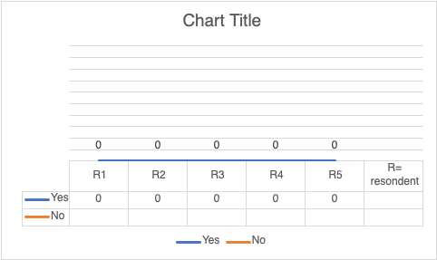

Figure 1. I consent to take part in this search?

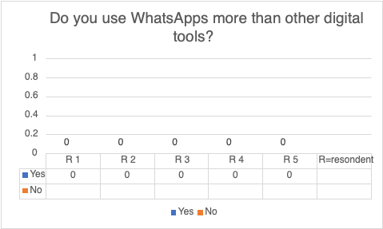
Figure 2. Do you use WhatsApp more than other digital tools?

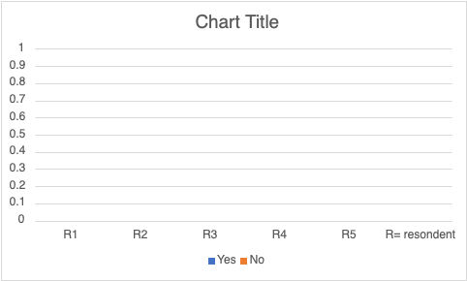
Figure 3. Do you use one digital tool more than others?
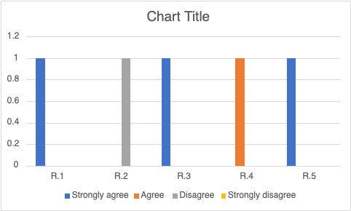
Figure 4.I use WhatsApp more then I use Ms teams to collaborate with others?

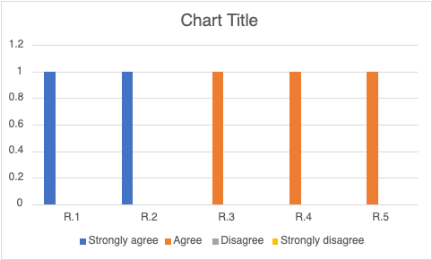
Figure 5. I use range of different digital tools to collaborate?

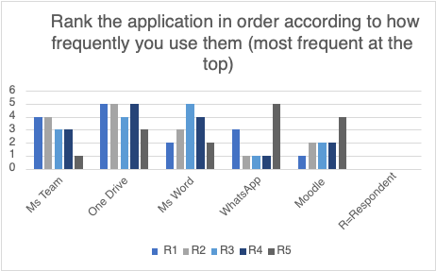
Figure 6. Rank the application in order according to how frequently you use them? (most frequent at the top).

Discussion
As our results indicate that majority of students at universities use One Drive, Moodle and WhatsApp more than any other apps, but digital technology is taking over any other form of studying and learning. Figure one demonstrates that students were asked for their permission before answering the survey, and they did so without hesitation. The second graph demonstrates that while students are not on campus, WhatsApp is used more frequently than any other apps, since it became available. Figure three demonstrates how pupils favour one digital tool over another, by utilising these tools, which give the pupils the confidence to use these apps for anything. Figure four demonstrates that several students strongly concur that they prefer WhatsApp, while others object to using one app. Students in figure five were questioned about whether they use a variety of different digital tools for collaboration some students firmly support the use of certain tools. Students were asked to order the applications in figure six based on how frequently they might use Moodle, WhatsApp and One Drive which were ranked by some students as being more popular than Ms word and Ms Teams. Applications of technology are constantly being developed to satisfy our individual demands as technology becomes increasingly integrated into our daily lives at work and at home. Postgraduate students must also comprehend that learning must be both textual and digital in today’s 21st century learning. Academic textual practises are progressively being digitally mediated in todays learning environments (Kaur, 2016). According to the study “Digital literacies as postgraduate attribute?” Students today are frequently daunted by the variety of options and accessibility to digital resources and gadgets. These students frequently employ a broad range of technology tools for their studies which are always evolving (Gourlay and Oliver 2014). Notwithstanding its shortcomings, the study’s findings provide some insight into how dependant postgraduate students are on their supervisors for and using digital technologies and managing their academic work. The postgraduate supervision of students is affected by these findings. In order for students to become self-assured researchers, instructors must first assist them acquire the abilities needed to foster learner autonomy. According to Azevdo and Jacobson (2008) stressed the need for learners in the modern day to have self-regulated learning abilities, including efficient planning and monitoring along with pertinent techniques to carry out these plans. Our theory is based on a number of theoretical frameworks, some of which have been mentioned in the conversation and some of which we are making more clear here. Concepts of particular psychological processes that are operationalized in functional layout have been employed. We use theoretical concepts that situate students learning growth within social, cultural, and ecological systems to recognize these processes like feedback, imitation, and scaffolding as parts of larger influence systems. Cultural resources are present in digital contexts in the Vygotskyon sense. They may perform certain functions(affordances), which could increase human potential and lead to the development of novel and possibly better types of activity. In this instance, we are thinking of them as instruments that, when deployed can enhance the functions of teaching and learning non-cognitive skills. They can also change the way that learning and teaching are done, and by extension of the idea, how the skills themselves are done certain tool functionalities from various tools, including personal devices, dashboards for teachers and students, and the internet, add to the digital environment’s overall advantages (McNoughton, 2018). Task redesign and the development of new ones require activities that are made possible by technological affordances. Through interactions in particular activities, learners engage in with peers and more knowledgeable individuals, development, especially that connects the design of learner agency is so co-constructed. The objectives, actions, and conditions pertinent to the activities that characterise continuous practises within and across settings and groups are acquired by learners through involvement in activities (Rogoff, 2003).

- Conclusion
The most crucial thing for supervisors to do is foster a positive supervisory culture that can guide their pupils along a path of growing independence and lifetime learning. In order to emancipate students and inspire them to question and work towards becoming autonomous researchers and self-assured members of the disciplinary community. It is important to equip them with the tools necessary for lifelong learning (Sidhu and fook, 2016). Humans currently inhabit a special ecology scientific data today suggests that the world is changing even at the human level awareness. The online world and modern technology are influencing our current world, so it is essential to search for changes in the educational sector. We must be open to new teaching and learning settings created by technical resources if we want future generations to gain access to education that integrates technology. We were able to confirm in our study that teachers who are digitally proficient can better support their pupils in learning these abilities and using technology more critically, therefore it is crucial that teachers receive training and develop these skills. It must be emphasised again how important it is to keep educating both students and teachers about digital literacy, which they will gradually learn during training. In this new context, its essential to build digital abilities and contribute to the creation of a new learning methodology (Matias-solanilla, 2022).
The
- Reference List

Avidov-Ungar, O.; Forkosh-Baruch, A. Professional identity of teacher educators in the digital era in light of demands of pedagogical innovation. Teach. Teach. Educ. 2018, 73, 183–191. [Google Scholar] [CrossRef]
Azevedo, R., & Jacobson, M. (2008). Advances in scaffolding learning with hypertext and hypermedia: A summary and critical analysis. Educational Technology Research and Development, 56(1), 93–100.
Bryman, A. & Bell, E. (2007) “Business Research Methods”, 2nd edition. Oxford University Press.
Gómez-Poyato, M.J.; Eito-Mateo, A.; Mira-Tamayo, D.C.; Matías-Solanilla, A. Digital Skills, ICTs and Students’ Needs: A Case Study in Social Work Degree, University of Zaragoza (Aragón-Spain). Educ. Sci. 2022, 12, 443. https://doi.org/10.3390/educsci12070443
Gourlay, R. & Oliver, M (2014). Developing digital literacies. Retrieved on 12 July 2015 from https://
Gurnam Kaur Sidhu, Sarjit Kaur, Chan yuen Fook, Postgraduate students’ level of dependence on supervisors in coping with academic matters and using digital tools(2018).
H. Salim, and H. Tauma, “Enhanced data security of communication system using combined encryption and steganography,” International Journal of Interactive Mobile Technologies, vol. 15, no. 16, pp. 144–157, 2021. https://doi.org/10.3991/ijim.v15i16.24557
H. T. Al-Rikabi, Enhancement of the MIMO-OFDM Technologies. California State Univer- sity, Fullerton, 2013.
M. Loncar, W. Schams, and J.-S. Liang, “Multiple technologies, multiple sources: Trends and analyses of the literature on technology-mediated feedback for L2 English writing pub- lished from 2015–2019,” Computer Assisted Language Learning, pp. 1–63, 2021. https:// doi.org/10.1080/09588221.2021.1943452
M. Sailer, M. Stadler, F. Schultz-Pernice, U. Franke, C. Schöffmann, V. Paniotova, L. Husagic, and F. Fischer, “Technology-related teaching skills and attitudes: Validation of a scenario-based self-assessment instrument for teachers,” Computers in Human Behavior, vol. 115, p. 106625, 2021. https://doi.org/10.1016/j.chb.2020.106625
McNaughton, S (2022).Meeting of minds, Wellington, NZ: Learning media Learning.
Rogoff, B. (2003). The cultural nature of human development. New York, NY: Oxford University press.
Saunders, M., Lewis, P. & Thornhill, A. (2012) “Research Methods for Business Students” 6th edition, Pearson Education Limited.
Steyaert, 2000; Mossberger et al, 2003; Van Dijik, 2005.
Vygotsky, L. S. (1978). Mind in society :The development of higer psychological processes. Cambridge, MA: Haverd university press.
Wastiau, P.; Blamire, R.; Kearney, C.; Quittre, V.; Van de Gaer, E.; Monseur, C. The use of ICT in education: A survey of schools in Europe. Eur. J. Educ. 2013, 48, 11–27. [Google Scholar] [CrossRef]
www.jisc.ac.uk/full-guide/developing-digital-literacies.

- Appendix A – A blank copy questionnaire.


