

Nike
An Application of the Strategy-Formulation Analytical Framework and comparison to the business position in 2009

Student Name: Dean Chilcott
Student ID: 1403144

Contents
Executive summary 1
1 Introduction 2
1.1 Company Overview 2
1.2 Company History 2
1.3 Company Vision and Mission Statement 2
1.4 The Strategy-Formulation Analytical Framework 3
2 Application of the Strategy-Formulation Analytical Framework to Nike 4
2.1 Input Stage 4
2.1.1 SWOT analysis of Nike 4
2.1.2 CPM 5
2.1.3 External Factor Evaluation (EFE) Matrix 6
2.1.4 Internal Factor Evaluation Matrix (IFE) 7
2.2 Matching Stage 8
2.2.1 Strategic Position and Action Evaluation Matrix (SPACE) 8
2.3 Decision Stage 9
2.3.1 Quantitative Strategic Planning Matrix (QSPM) 9
3 Conclusion 9
Works Cited 10

Executive summary

The aim of this report is to apply the Strategy-Formulation Analytical Framework based on NIKE in 2018 and to support a comparison to the business position in 2009 accompanied with a Power point presentation to present the findings.

The report will focus on the following strategic tools:

Stage 1 consisting of the External Factor Evaluation (EFE) Matrix, Internal Factor Evaluation (IFE) Matrix, and Competitive Profile Matrix (CPM).

Stage 2 includes Strengths-Weaknesses-Opportunities- Threats (SWOT) and Evaluation (SPACE) Matrix

Finally stage 3 consists of a single technique named the Quantitative Strategic Planning Matrix (QSPM).

The report concludes that Nike remains a very competitive within the industry it focuses, utilising the Strategy-Formulation Analytical Framework the best method of progression for the business to pursue its aggressive strategy would be that of the expansion of the product line and whilst comparing the business to its position in 2009 it is evident that it is still a strong performer within the industry and has had to adapt quite substantially over time to the rise of new threats and opportunities with technological advancement.

1 Introduction

Company Overview

Nike was originally founded by William Jay Bowerman and Philip H. Knight in 1964 under the original name Blue Ribbon, the business is headquartered in Beaverton in the USA. (CNN Business, 2019)
Nike outlines is principal business activity as the design, development and worldwide marketing and selling of athletic footwear, apparel, equipment, accessories and services. Nike is the largest seller of athletic footwear in the world and distributes its products through a range of medium including retail outlets, internet sales, mobile applications and a range of independent distributors globally. Almost all of the businesses product production is outsourced to contractors and are produced outside of the businesses home country of the USA. (NIKE, Inc, 2017)
As of 2012 Nike employed over 44,000 people globally and in 2014 the brand was valued at an estimated 19 Billion dollars proving the business to be the most valuable brand in the sporting industry. (Ozanian, 2014)
Nike operates across the globe in North America, Europe, Middle East & Africa; Greater China; and Asia Pacific & Latin America. (CNN Business, 2019)

Company History

Nike was established in 1964 under the brand name Blue Ribbon by Bill Bowerman, a track athlete coach and a former student Phil Knight. The first retail outlet opened in 1966 and from this outlet the “NIKE” Shoe was launched in 1972, following its launch in 1978 the business was rebranded as NIKE. (The Editors of Encyclopaedia Britannica, 2010)

As of 1980 Nike has experienced huge growth and expanded the business whilst diversifying the product line, NIKE achieved and continued to achieve this through a series of sideways and forward integration, undertaking numerous acquisitions, including the shoe companies Cole Haan 1988; Converse, Inc. 2003, the sports-equipment producer Canstar Sports, Inc. 1994 further to this the athletic apparel and equipment company Umbro 2008. In 1996 NIKE created Nike ACG (“all-conditions gear”) aimed at diversifying its offering further by heading to markets for products specific to extreme sports. In recent times the business has once again adapted, selling sports-technology accessories, including portable heart-rate monitors and high-altitude wrist compasses. (The Editors of Encyclopaedia Britannica, 2010)

Company Vision and Mission Statement

NIKE defines its mission as “To bring inspiration and innovation to every athlete* in the world *If you have a body, you are an athlete. (NIKE Inc, 2019)

NIKE identifies its vision as “to remain the most authentic, connected, and distinctive brand.” (NIKE Inc, 2019)

This mission statement is typical of the businesses strategic goal of reaching out to a global leisure, sports footwear and equipment market by fostering the mindset of a winner and an achiever, the mission statement also illustrates the businesses desire for continued innovation a goal that it implements through the business strategy of continuous improvement, a further noteworthy aspect of this statement is “every athlete in the world” this element is indicative of the businesses desire to appeal to multiple market segments and really apply itself to every consumer in the world. (Smithson, 2019)

The Strategy-Formulation Analytical Framework

In order to evaluate issues facing NIKE regarding the management of contemporary e-Business systems and their use for gaining competitive advantage, this report will apply the strategy formulation framework to the NIKE on the sale and marketing of Sporting footwear, apparel and equipment.

The Framework in illustrated in three stages;

- Input Stage
- Matching Stage
- Decision Stage

The initial stage consisting of the External Factor Evaluation (EFE) Matrix, Internal Factor Evaluation (IFE) Matrix, and Competitive Profile Matrix (CPM).

Secondly Stage 2 includes Strengths-Weaknesses-Opportunities- Threats (SWOT) Matrix, Strategic Position and Action Evaluation (SPACE) Matrix, Boston Consulting Group (BCG) Matrix, Internal-External (IE) Matrix, and Grand Strategy Matrix.

Finally stage 3 consists of a single technique named the Quantitative Strategic Planning Matrix (QSPM).

For the purpose of this report the tools focused on will include all of the input stage, from the matching stage SPACE will be utilised and finally for the decision stage the QSPM.

Application of the Strategy-Formulation Analytical Framework to Nike

Input Stage

SWOT analysis of Nike

Strengths | Weaknesses
Legacy and Heritage  Diversified Port Folio  Financial Position  Distribution Network  Branding and community  Collaborations and Memberships | High Price Range  Outsourcing of Manufacturing  Limited product line
Opportunities | Threats
Changing Lifestyles  Market Development  Expanding Product lines  Demand for Premium products  Backward integration | Competition  Supplier Dominancy  Government Regulation
(Business Stratagy Hub, 2019)
An easily identifiable strength of the NIKE business includes its history and legacy, NIKE is a long-established brand and utilises its brand awareness to gain customer loyalty, NIKE is a quality relevant brand within the premium segment, furthermore the NIKE brand increases awareness of the brand through celebrity endorsements and sponsorship of large sporting events, ensuring that the band is placed in-front of its target audience.

A further key strength NIKE enjoys is its financial position and distribution network, NIKE has over 790 stores employing over 73,100 globally and taking in excess of $36.39 Billion in turn over for 2018, The businesses distribution system is effective in achieving this figure due to its advances online, on the high street and through supermarket stores presence (Statista, 2019).

Weaknesses of NIKE include its premium price range contributed to by its use of innovative products and materials, the brand has positioned itself in such a place in the market accessible only to limited customers within the premium sector, NIKE has outsourced almost all of its manufacturing to reduce costs, although this may be regarded as a positive NIKE could become over reliant upon its suppliers shifting the balance of power when trading. (Business Stratagy Hub, 2019), NIKE could be damaged by supplier dominancy due to the fact that the vast majority of production is outsourced, suppliers could have more power than the company when negotiating deals. (Business Stratagy Hub, 2019)
Opportunities that NIKE could further capitalise on include backwards integration this is the process whereby a business acquires segments of its supply chain, this could provide the business with an opportunity to more easily secure patent rights and could have ultimately reduce costs by manufacturing in house. (Riordan, 1991) Another opportunity NIKE could capitalise upon would be an expansion of its product line, the would expose NIKE to new opportunities whilst simultaneously differentiating itself from its competitors.
Threats to NIKE include government regulation, the majority of the businesses production takes place in developing countries and so government policy such as import regulations, duty and tariffs are critical in the pricing structure of the business and could heavily influence the businesses costs.

CPM

The Competitive Profile Matrix is a tool utilised to compare a business to its competitors to reveal key strengths and weaknesses (Jurevicius, 2013), In order to produce the CPM for Nike this report has focused on the competitors Adidas and PUMA, the information utilised features in the findings below with data used from Statista (Statista, 2019).
Findings

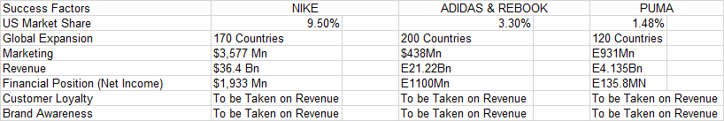

(Statista, 2019)

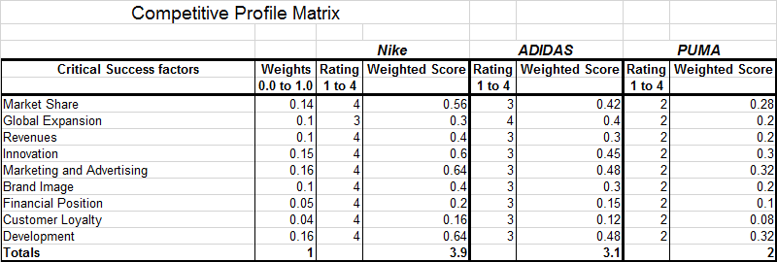

The Nike competitive profile matrix illustrates that Nike is currently in the most competitive position demonstrating the highest weighted score; Adidas is considered its closest competitor followed by PUMA.

External Factor Evaluation (EFE) Matrix
The External Factor Evaluation (EFE) Matrix is a strategic management tool useful in examining a business’s external environment with a view to identify the available opportunities and threats. (Jurevicius, 2013)
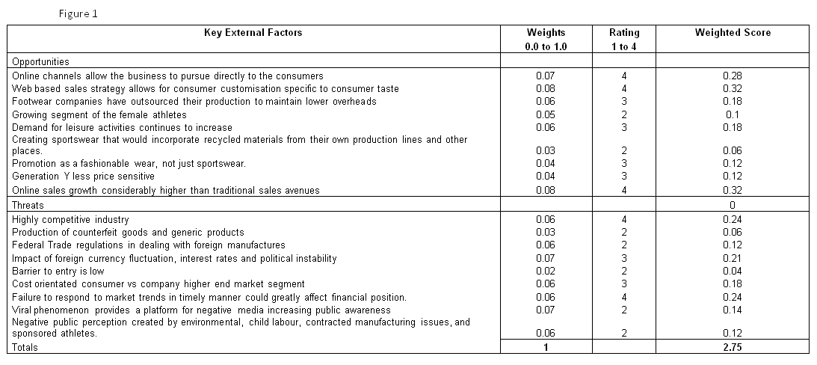
Drawing information from the EFE matrix above, an example of an opportunities that NIKE is positioned to exploit initially is that web-based sales allow for customisation specific to consumer taste, NIKE as a result has invested in a customisation engine allowing its customers to create their own products, a form of value creation. (Randall, 2017) The EFE Matrix provides NIKE a score of 2.75, above the average of 2.5, this is indicative of the company’s strategies being well designed to meet the opportunities and defend against threats, NIKE is successful in exploiting opportunities and defending against threats.
Comparing this to the EFE conducted in 2009 a number of opportunities and threats have changed in that time due to technological development with a few staying constant, Due to these changes it is difficult to directly compare on a performance basis, however, NIKE has seen a small drop in its EFE score from 3.03, this can be attributed to the differing external environment since that time and as a result different challenges for the business to respond to such as technological advances and the rise of WEB 2.0 and more recently “the internet of things”. (The European Commission, 2017) (Carey, 2017)

Internal Factor Evaluation Matrix (IFE)
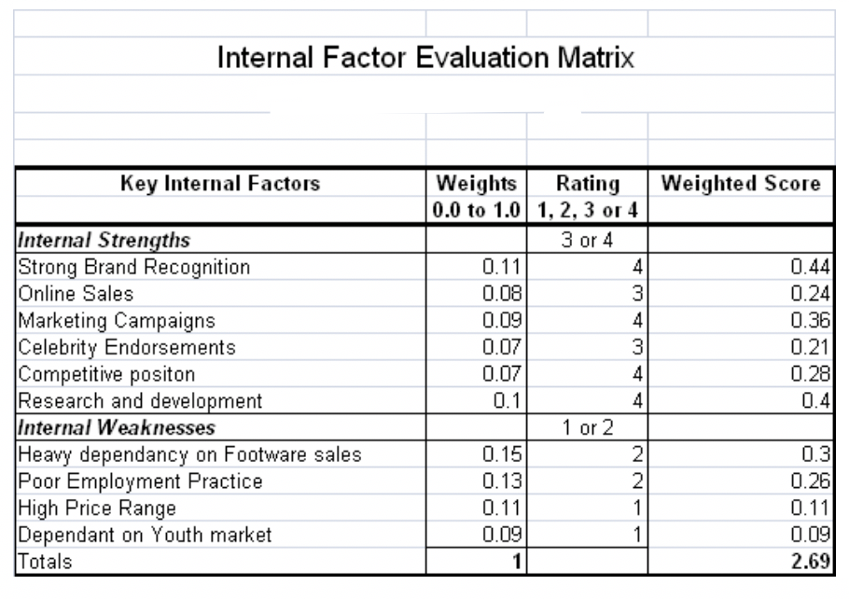
The internal factor evaluation matrix is a strategic management tool utilised to evaluate a business’s internal environment, specifically its strengths and weaknesses, this tool also gives a foundation for recognising and assessing associations among the identified strenghs and weaknesses. (Jurevicius, 2013)
The IFE matrix when applied to Nike demonstrates that NIKE’S Key strengths when looking to stay competitive are its Brand recognition, a wealth of successful marketing campaigns and its Research and Development.
Nike has long since been regarded as a powerful recongisable brand by its logo alone, the logo can be presented without the name and is instantly recongisable, the bands popularity is demonstrated as stated in Forbes “Nike commands 62 per cent of the US athletic footwear market, including the Jordan brand” (Forbes, 2016)

Innovation is at the forefront of factors to consider to keep this competitive advantage Nike currently holds, since 2009 comparing the SFF frame work undertaken at that time, NIKE has invested money into its research and development to keep up with new demands both in design and functionality. In order to stay ahead of the curve, research and development is regarded with high importance withing the business, Nike enlistst specialists including engineers, athletes, biomechanics and industrial designers to work together in the design process to produce the very best and relevent products. Nike has established a longstanding collabaration with Apple as an example of the businesses innovation. Businesstoday suggests that constant innovation has been the driving factore for Nike's success (Sanusi et al, 2014) NIKE established a partnership with Apple in in doing so branched into the waerable sport wear market, once established NIKE was able to produce an app for its users, NIKE attributes this technological leap as the reason the business was able to cut down on advertising expenses by 40 per cent, without compromising on efficiency and results. (Sanusi et al, 2014)

Focusing on one of NIKE’s weaknesses, NIKE’s poor track record with employment practises is its down fall, NIKE’s own Chairman at the time had been forced to acknowledge these claims "The Nike product has become synonymous with slave wages, forced overtime, and arbitrary abuse," (Nisen, 2013) NIKE began addressing this issue and continues to do so as illistratued under its corperate social responsibility secontion of its website; NIKE states “We have been working to improve labor conditions in our supply chains for more than 20 years. Our purpose includes driving positive change for workers in Nike contract factories and across the industry” (NIKE INC, 2019)

Matching Stage

Strategic Position and Action Evaluation Matrix (SPACE)

The Strategic Position & Action Evaluation matrix or short a SPACE matrix is a strategic management tool that focuses on strategy formulation related to the competitive position of an organization, the matrix provides a basis frame work to detemrine the style of strategy a business should undertake;
(Maxi-pedia, 2019)
- Aggressive
- Conservative
- Defensive
- Competitive
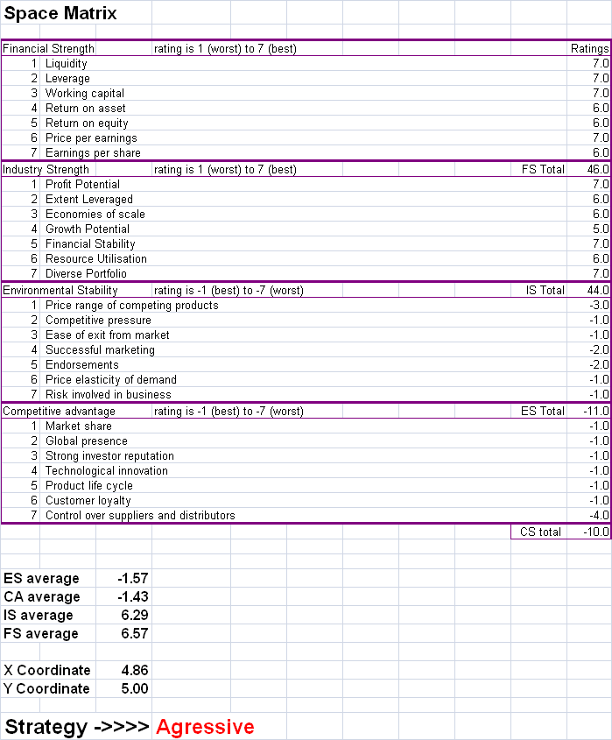

After applying the SPACE matrix to NIKE it is apparent that NIKE should persue an aggressive strategy which could include forward and horizontal and vertical integration, market development, market penetration and product development and diversification. Investopedia suggests that Forward integration is a business strategy involving a form of vertical integration whereby business activities are expanded to include control of the direct distribution or supply of a company's products. This type of vertical integration is conducted by a company moving down the supply chain. (Kenton, 2018)
Following the findings from the SPACE matrix the decision stages seek to identify the best approach to persue after establishing an aggressive stance.

Decision Stage

Quantitative Strategic Planning Matrix (QSPM)
The Quantitative Strategic Planning Matrix is a strategic management tool utilised to evaluate alternative set of strategies as identified in the initial stages of the framework, The QSPM incorporates earlier established details in an organised way to calculate the score of multiple strategies in order to predict the best match strategy for the business. (mba-tutorials, 2019)
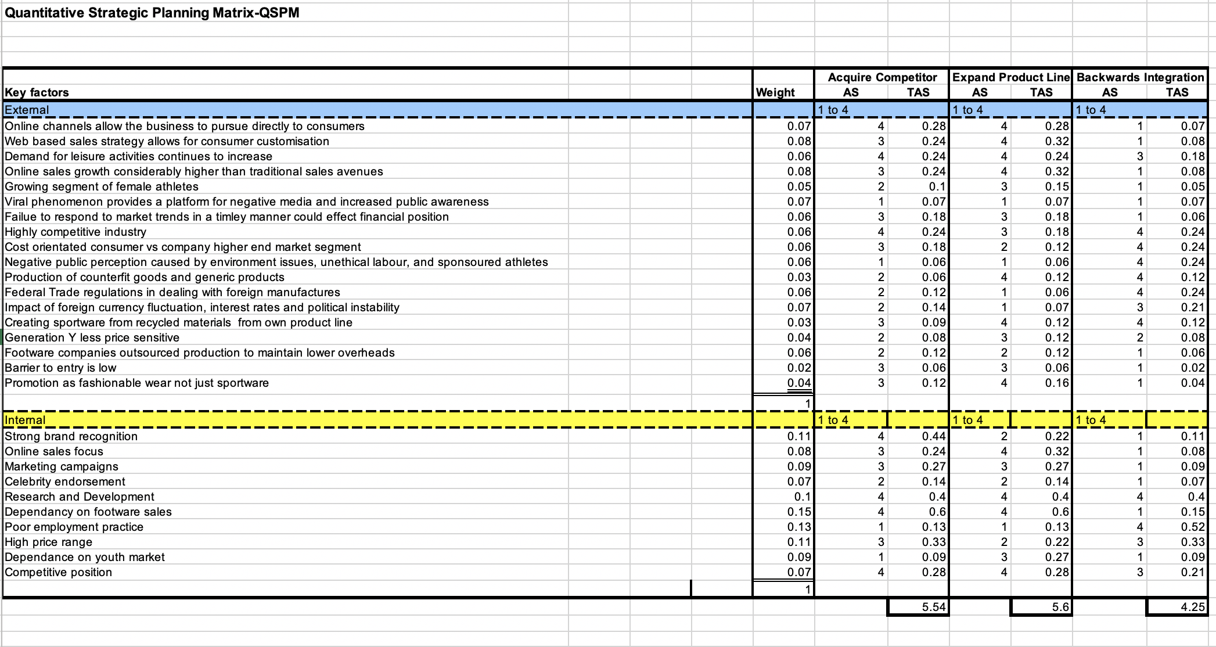

Utilising the calculations in the Quantitative Strategic Planning Matrix QSPM, it can be concluded that the expansion of the product line is a preferential option. This is afforded by the sum total attractiveness score figure. The expansion strategy provides a higher score than the acquisition expansion or backwards integration strategy.

Conclusion

In conclusion Nike remains in a very competitive position within the industry it focuses and after analysis of the strategic tools of the Strategy-Formulation Analytical Framework is can be concluded that the best method of progression for the business to pursue its aggressive strategy would be that of the expansion of the product line as this yields the most favourable outlook as ascertained by the QSPM Matrix.

Comparing to the businesses position in 2009 it is evident that it is still a strong performer within the industry and has had to adapt quite substantially over time, this is reflected the slightly lower scores of 2018 as although the business has competently adapted the advancement of today far exceeds that of 2009, and with a faster changing environment comes a more challenging business environment, never the less the business is still performing highly as demonstrated using all matrix.

Works Cited

Business Stratagy Hub, 2019. Bstrategyhub. [Online]
Available at: https://bstrategyhub.com/swot-analysis-of-nike-nike-swot-analysis/
[Accessed 11 03 2019].
Carey, J., 2017. The Troubling Future For Nike Inc. Seekingalpha, 27 11, p. 1.
CNN Business, 2019. CNN.com. [Online]
Available at: money.cnn.com/quote/profile/profile.html?symb=NKE
[Accessed 26 02 19].
Forbes, 2016. Sneaker Culture Fuels $1 Billion Secondary Market. Forbes, 18 03, p. 1.
Jurevicius, O., 2013. strategicmanagementinsight.com. [Online]
Available at: https://www.strategicmanagementinsight.com/tools/competitive-profile-matrix-cpm.html
[Accessed 07 03 2019].
Kenton, W., 2018. Investopedia. [Online]
Available at: https://www.investopedia.com/terms/f/forwardintegration.asp
[Accessed 11 03 2019].
Maxi-pedia, 2019. maxi-pedia.com. [Online]
Available at: http://www.maxi-pedia.com/SPACE+matrix+model+strategic+management+method
[Accessed 11 03 2019].
mba-tutorials, 2019. QUANTITATIVE STRATEGIC PLANNING MATRIX (QSPM). [Online]
Available at: https://mba-tutorials.com/quantitative-strategic-planning-matrix-qspm/
[Accessed 11 03 2019].
NIKE Inc, 2019. about.nike.com. [Online]
Available at: https://about.nike.com
[Accessed 27 02 19].
NIKE INC, 2019. purpose.nike.com. [Online]
Available at: https://purpose.nike.com/making-product-responsibly
[Accessed 11 03 2019].
NIKE Inc, 2019. store.nike.com. [Online]
Available at: store.nike.com
[Accessed 27 02 2019].
NIKE, Inc, 2017. NNUAL REPORT PURSUANT TO SECTION 13 OR 15(D) OF THE SECURITIES EXCHANGE ACT OF 1934 FOR THE FISCAL YEAR ENDED May 31, 2017, Washington, D.C.: UNITED STATES SECURITIES AND EXCHANGE COMMISSION.
Nisen, M., 2013. How Nike Solved Its Sweatshop Problem. Business Insider, 09 05, p. 1.
Ozanian, M., 2014. Forbes.com. [Online]
Available at: https://www.forbes.com/sites/mikeozanian/2014/10/07/the-forbes-fab-40-the-worlds-most-valuable-sports-brands-2014/#4ecf74783885
[Accessed 2019 02 26].
Randall, G., 2017. econsultancy.com. [Online]
Available at: econsultancy.com/the-10-principles-for-creating-amazing-online-retail-experiences/
[Accessed 27 02 2019].
Ratner, J., 2017. Financial Post. Does Nike have a problem?, 27 10, p. 1.
Riordan, M., 1991. Ownership without control: Toward a theory of backward integration. Journal of the Japanese and International Economies, Volume 5(Issue 2), pp. Pages 101-119.
Sanusi et al, M., 2014. The Swoosh of Creativity. Business Today, 06 07, p. 1.
Smithson, N., 2019. Nike Inc.’s Mission Statement & Vision Statement (An Analysis). [Online]
Available at: http://panmore.com/nike-inc-vision-statement-mission-statement
[Accessed 27 02 2019].
Statista, 2019. statista.com. [Online]
Available at: https://www.statista.com/topics/1360/puma/
Statista, 2019. www.statista.com. [Online]
Available at: https://www.statista.com/statistics/241683/nikes-sales-worldwide-since-2004/
[Accessed 11 03 2019].
The Editors of Encyclopaedia Britannica, 2010. Nike, Inc. 15th edition ed. Edinburgh: Encyclopædia Britannica, Inc..
The European Commission, 2017. The Internet of Things: reshaping the sport industry, Brussels: The European Commission.

