PROGRAMME: BA (HONS) LEADERSHIP AND MANAGEMENT SKILLS FOR THE WORKPLACE
MODULE: ORGANISATIONAL CULTURE
MODULE CODE: LCLM 5005
SELECTED COMPANY: WALMART
STUDENT NAME:Alexandru Buzatu
STUDENT ID:2312847
Table of Contents
1. Introduction 3
2. Organisational Culture and Structure at Walmart 3
2.1 Organisational Structure: Definitions and Walmart’s Configuration 3
2.2 How Culture Shapes Structure and Decision-Making 3
2.3 Critical View: Structure: Culture Implications 4
3. Frameworks for Analysing Walmart’s Culture 5
3.1. Schein’s Model of Organisational Culture 5
3.2. Hofstede’s Cultural Dimensions 6
3.3. Handy’s Cultural Typology 7
4. Adapting Organisational Culture to External Environment 8
5. Organisational Culture as a Barrier to Effective Functioning 9
6. Impact of Organisational Culture on Performance 10
7. Recommendations for Improvement 11
8. Conclusion 12
References 14

1. Introduction
Norms, beliefs, and shared values that contribute significantly to managing and shaping decisions and employee behaviour within a business can be considered organisational culture. It remains responsible for encouraging company performance, employee motivation, communication, and styles of leadership. Walmart’s culture is backed by offering affordable products and services to customers, along with demonstrating important values such as acting with integrity, focus on excellence, adequate customer service, and individual respect. The present report evaluates the corporate culture of Walmart and its influence on performance, decision-making, and structure.

2. Organisational Culture and Structure at Walmart

2.1 Organisational Structure: Definitions and Walmart’s Configuration
Organisational structure spells out the way activities like supervision, coordination and task allocation are guided in order to achieve company objectives, which is also related to organisational behaviour (Gutterman, 2023; Mullins & Christy, 2016). It defines reporting relationship, flow of communication and decision-making authority in an organisation. The Annual Report of 2025 of Walmart emphasises the amount of its global presence as at 31 January 2025, Walmart U.S. had 4,605 retail stores, such as 3,559 Supercenters, 355 Discount Stores and 691 Neighbourhood Markets and internationally 5,230 retail stores and 336 wholesale stores, making it 10,771 stores worldwide (Walmart, 2025a). The most frequent are the functional structure, the divisional structure, and the matrix structure. The Walmart Company mainly uses a hierarchical but decentralised structure, which integrates both the functional and divisional models.
This huge scale of operation requires a structure that can still sustain standardisation in any market, but which can also serve local responsiveness. Walmart has a centralised corporate headquarters at Bentonville, Arkansas, which makes the global strategic decisions such as pricing, supply chain strategy and corporate policy (Walmart, 2025b). Nonetheless, the firm leaves a lot of freedom to local and store managers who tailor operations to suit local needs, regulatory environment, and competition. This hybrid is an indication of efficiency and adaptation in that the corporate directives are always followed, whereas the local leadership is allowed to make a swift response to the environment.

2.2 How Culture Shapes Structure and Decision-Making
The organisational culture within Walmart is entrenched in its long-term business philosophy of Everyday Low Prices that creates a cost-conscious, task-focused and performance-driven organisational culture of the business (Choo, 2024). This culture directly affects the way in which the company organises its operations and decision-making process. The emphasis on cost-effectiveness is high, and the choice of purchasing and logistics, staffing decisions are reconciled with the goal of cost leadership. Decision-making is mostly top-down, in which the strategic decisions that flow down through the corporate leaders to the regional divisions make sure that the same tactical decisions are consistent and controlled throughout the global network (Stanikzai and Mittal, 2025). However, regional discretion is also promoted in Walmart; the local managers are given the right to adjust assortments, marketing campaigns, and service models to suit local consumer needs and cultural preferences. This two-sidedness of corporate standardisation and local adaptation is observed to explain why the culture of Walmart can facilitate both central control and distributed leadership.
The structural lean design of the company is also a demonstration of the frugal and efficient culture, as the design of the company minimises redundancy and minimises the cost of operations. The huge network of stores that Walmart has is maintained through standardised procedures, economies of scale, and sophisticated logistics systems (Yuan et al. 2024). As an example, the global supply chain of the firm is based on real-time data transmission and integrated technological platforms that ensure that costs are kept down, as the product availability is not compromised. The practices are operational strategies and reflections of the cultural promise of the company to be thrifty and to excel in performance. Respect for the individual further strengthens accountability in the structural hierarchy, where associates and store managers are advised to give ideas and own performance outcomes even in a highly regulated system.

2.3 Critical View: Structure: Culture Implications
Theoretically, the organisational form at Walmart is analogous to the Bureaucratic Theory, which is typified by hierarchies, roles, and regulated procedures, as analysed in the evaluation of Almhairat (2025). Through this kind of system, Walmart can exercise their rigorous control and predictability that is critical in a company this large. Nevertheless, bureaucratic systems also have a set of drawbacks: the most prominent are the lack of flexibility and the inability to respond more swiftly in case innovation or creative solutions are needed. The massive focus on efficiency and compliance with rules can hinder experimentation, especially in constantly changing online shopping industries.
Using the Mechanistic and Organic Theory in the works of Burns and Stalker, the organisational form at Walmart is mainly mechanistic. Corporate form must be very organised, the powers have a line of control, and the decision-making is centralised, which helps in making its operations consistent (Tavares et al. 2024). However, at certain levels, especially in those related to its digital and supply chain innovation unit, Walmart is showing new organic characteristics. The supply chain change implemented by the company, as described in a July 2025 corporate release, emphasises the usage of AI-based decision-making systems that are intended to facilitate the creation of real-time signals and real-time action, which promotes responsiveness and flexibility. This can be interpreted to mean that Walmart is already in the process of transformation into a more flexible hybrid model that merges mechanistic control and selective organic innovation.

3. Frameworks for Analysing Walmart’s Culture

3.1. Schein’s Model of Organisational Culture
The model by Schein describes organisational culture as three levels interconnected such as artefacts, espoused values, and basic underlying assumptions, which all form how members conceive and act in their respective organisation (Akpa, 2021).
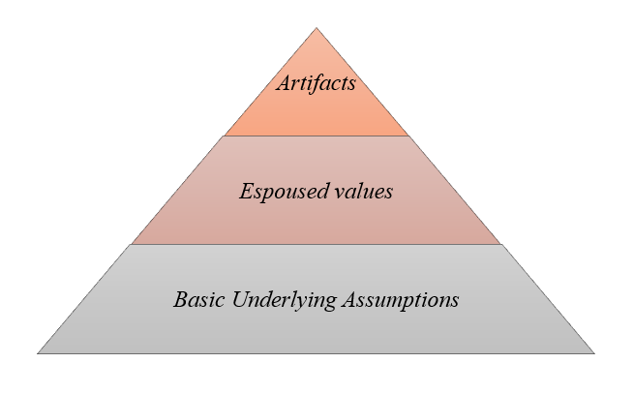
Figure 1: Aspects of Schein’s Model
(Source: Self-developed)
These three levels are of use in analysing the cultural composition of Walmart Inc. in this case. On the artefact level, the open-door communication policy, displays with the signature blue-and-white branding, the "Everyday Low Prices" displays, and price-matching schemes are the manifested symbols of Walmart (Walmart, 2025b). These artefacts warn of a customer-oriented and low-cost ambience. The espoused values, as they are stated in the careers section of the Walmart organisation, are service to the customer, respect for the individual, seek excellence, and do what is right (Walmart, 2025c).
On the most fundamental level, the core assumptions of Walmart represent the belief that the company can be successful by being cost-effective, leadership visible and community-based retailing (Wood, 2025). Basically, the consideration is that the firm could succeed by doing less and serving its customers as well as respecting its people. These three levels are well aligned with each other since the artefacts that are evident and the values that are expressed to a high degree are the results of underlying assumptions. The fit has, however, been challenged, especially in popular discussions on the welfare of the employees, which more clearly reveals a conflict between cost-effectiveness and the supposed respect for people.

3.2. Hofstede’s Cultural Dimensions
The Hofstede cultural framework of six dimensions of national and organisational culture, namely power distance, individualism vs collectivism, uncertainty avoidance, masculinity vs femininity, long-term orientation, and indulgence vs restraint that can be used to explain workplace behaviours across different environments (Yeganeh, 2025).
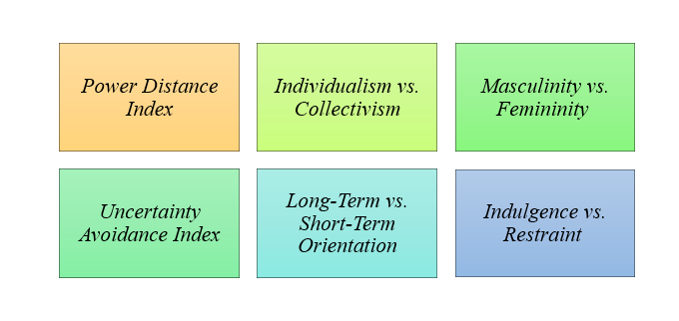
Figure 2: Components of Hofstede’s Model
(Source: Self-developed)
Applying this model to Walmart demonstrates that the company has moderate to high power distance, and the hierarchical decision-making is balanced with approachable leadership. Its individualism and collectivism are embodied in the fact that it rewards personal performance and teamwork, and collective accountability.
Uncertainty avoidance is also moderate, with Walmart adopting elaborate systems and standardisation to minimise ambiguity without deterring calculated risks (Volpe and Boland, 2022). The company ranks high on masculinity, where competition, performance and achievement are the priorities, sustainability efforts, as well as investment in technology-driven logistics, indicate high long-term orientation.
Finally, the indulgence of Walmart is low as it focuses on frugality and strict control over costs. Cultural misfit has sometimes weakened the international expansion of Walmart, especially in Germany, where the expectations of the employees conflicted with the U.S.-centred ideals of Walmart. In general, the high-performance and low-profile culture of Walmart is consistent with the American business ideals, but needs adaptation in the international markets.

3.3. Handy’s Cultural Typology
The typology offered by Handy suggests four most prevalent types of organisational cultures that are power, role, task, and person, which are characterised by the distribution of power and the relations of people to organisational objectives (Abdala et al. 2021).
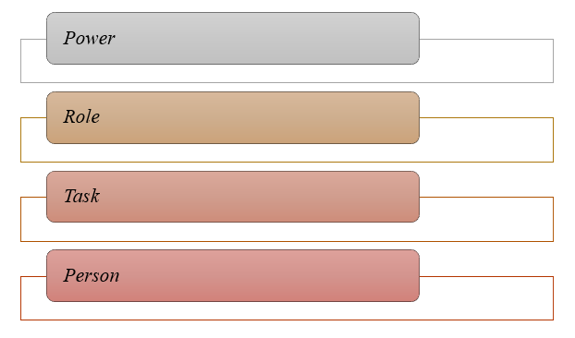
Figure 3: Handy’s Cultural Typology
(Source: Self-developed)
Within the corporate headquarters of Walmart, there exists a power culture where the leadership influences the strategic forms of decisions and regulates the direction of the company. In store operations, most visible role is the culture in which employees take specific procedures, supervision by hierarchical positions, and set job roles that provide consistency and control.
In the meantime, the task culture has appeared in the innovation and digital divisions of Walmart, including its e-commerce and technology functions, which also focus on teamwork, cross-functionality, and problem-solving (Dani, 2022). The individualistic culture, in which individuals are preferred over organisational goals, is low in the Walmart system, as it pays attention to group performance. Walmart can therefore be described as having a hybrid cultural blend, with the consistency of role culture being balanced by the existence of some task culture in specks that promote innovation. Nevertheless, the pre-eminence of role culture based on rules can inhibit creativity and flexibility in dynamic retail markets.

4. Adapting Organisational Culture to External Environment
Economic adaptation
At times of inflation, Walmart can be placed strategically due to its culture of frugality and efficiency. As an example, in the period between January 2022 and February 2023, the price of Walmart baskets has only risen by 3%, whereas similar baskets at other retailers had risen by an average of 7.5% (Cavale, 2023). This is an indication that the company is using its culture of cost leadership as a competitive edge by taking the cost pressure instead of transferring it to consumers entirely. Walmart has been able to maintain its promise of everyday low prices during even economic crises due to the culture of operational discipline and cost-consciousness, thus ensuring a strategy is consistent with culture.
Technological adaptation
The culture of customer focus and excellence at Walmart helps it invest in innovation and technology. The establishment of special teams like Walmart Labs, purchases of other companies like Jet.com, or the drive towards system AI-cored supply chains all point to a willingness of the culture to adopt tech in favour of efficiency (Repko, 2020). Even though Walmart has lagged behind some of its digital-native competitors in some areas in the past, the organisational value of constant betterment and scale is used to propel its digital transformation.
Social and global adaptation
Being a global retailer with a variety of markets, Walmart's culture of respecting individuals and serving the customer is the basis of its social and global adaptation programs. As an illustration, Walmart has conducted all-inclusive hiring and workforce growth programmes in markets like India and Mexico that meet the universal social demands of an employer. Walmart, in its 2024 ESG reports, emphasised its diverse and inclusion initiatives as part of the development of community trust and international legitimacy (Walmart, 2025d). A culture of people value would help the company have the power to react to social and cultural expectations throughout its presence.
Environmental and ethical adaptation
The sustainability culture of Walmart has its visible manifestation in the Gigaton project. Introduced to involve suppliers in the process of reducing, avoiding or sequestration of 1 billion metric tons of greenhouse-gas emissions by 2030, Walmart declared that its suppliers had offered enough projects to reach the goal six years early (Segal, 2024). This illustrates how the culture of Walmart helps in long-term thinking and stakeholder strategy, not just based on short-term profit. Nevertheless, the company also recognises the difficulties in achieving certain of the company's operational emissions targets of Scope 1 and 2 and will miss its 2025 and 2030 targets.

5. Organisational Culture as a Barrier to Effective Functioning
Although the culture of Walmart Inc. has played a central role in its cost leadership and global supremacy, some of the cultural attributes serve as hindrances to efficiency and innovation. The first obstacle is the over-cost orientation in the company, where operational efficiency and reduction of prices are prioritised over the development of employees and innovation. Walmart had around 2.1 million associates on January 31, 2024, but the business stated that it would cut training and support functions to further cost-optimise its operations (Business Standard, 2024). These are short-term, effective decisions that will ultimately demotivate long-term employee participation and creativity, thus hindering innovation.
The other significant obstacle is associated with the top-down decision-making culture that is adopted by Walmart. Local store managers are granted a very low level of autonomy in their day-to-day operations, although strategic decisions are closely centralised at the corporate level. As an example, in 2025, Walmart declared that it was removing less than 1,500 jobs in its technology sectors across the world, as part of an assault on organisational complexity, a decision that was reported to lead to increasing operational efficiency; however, it could also diminish the ability to be innovative (Pradhan, 2025). This is a good example of how the hierarchical decision-making at Walmart enhances efficiency at the expense of flexibility and experimentation.
This incompatibility of the American culture of Walmart with the local expectations has led to disengagement and eventual withdrawal from the market (Nyamweya, 2020). These illustrations explain why an ethnocentric corporate culture, which is very robust, can be a barrier to flexibility and localisation in the various markets.
Nonetheless, these obstacles do not mean that the unified culture of Walmart does not lead to positive results. Significant efforts by the company in the direction of flexibility and inclusivity include virtual reality-based diversity and inclusion training that is aimed at combating unconscious bias and encouraging an accommodative mentality among employees (Walmart, 2025e). It also brings about discipline, role clarity and consistency throughout the operations so that employees work in line with similar goals.
In terms of the Change Model, created by Lewin, it may be stated that Walmart is in the process of transition between the state of unfreeze and change by considering the necessity to redefine internal norms and structures, which will lead to agility and innovation. The continuous reorganisation of corporate and technology units implies a slow cultural transformation of more flexible and accommodating practices.

6. Impact of Organisational Culture on Performance
The organisational culture of Walmart is a major contributor to the quantifiable performance outputs of the organisation because it is what determines its performance in terms of financial achievements and modes of operation. Its cost leadership and customer service have brought about outstanding financial performance, which only solidifies its position as the largest retailer in the world. The 2024 Annual Report reports that Walmart earned a total revenue of 648 billion in fiscal year 2024, which represents stable growth and a high market share in the world market (AssetRoom, 2025). This financial success is a result of a culture that adheres to efficiency, low-cost of operation and good management of the workforce. The lean systems and logistics excellence form part of the company's waste reduction, and the culture of affordability gives the company customer loyalty and repeat patronage across markets.
With these accomplishments, some cultural attributes make Walmart unable to adapt and innovate. Efficiency-oriented mentality is the same measure that maximises productivity at the expense of experimentation and innovation (Hofmeister et al. 2024). The high standards of its operations and the centralised decision-making process may make Walmart slow in its innovation relative to its more responsive competitors. In addition, reputational issues still exist because of the criticism of employee wages and opposition to unionisation. The average hourly wage of the company in the U.S. is approximately $17.50, and although this is better than it was in 2024, it remains a target of labour advocates who want higher living wages (Walmart, 2024). This shows that excessive cost-oriented culture can destroy employee satisfaction and brand image.
The Organisational Culture Model created by Denison gives even more light; Walmart has a high score in mission and consistency, which guarantees a good understanding of direction and purpose, but a moderate score in the areas of involvement and adaptability, which indicates weak empowerment and slower cultural responsiveness. Likewise, McKinsey 7-S Framework reveals an agreement between shared values, strategy, and systems of Walmart, but demonstrates the deficiency in leadership style and staff motivation.

7. Recommendations for Improvement
To be better placed in achieving long-term competitiveness and the need to accelerate the organisational culture, Walmart ought to work towards a more balanced, adaptive as well and employee-centred approach to culture.
To begin with, it is necessary to improve a culture that is employee-centric (Hector andCameron, 2023). Walmart needs to implement more participative decision-making practices where the front-line employees and managers are allowed to give ideas that can enhance business efficiency and customer satisfaction. Increasing reward and recognition can also be used to encourage employees and minimise turnover rates. A sense of belonging and a sense of commitment are also created.
Secondly, international success depends on cultural localisation (Singh and Pipaliya, 2024). The past difficulties that Walmart had experienced in Germany and South Korea have highlighted the significance of practice tailoring to the local culture. Global acceptance and operational harmonisation would be increased by customisation of leadership style, communication, and service delivery to make them meet regional norms.
Third, the firm ought to work on the creation of a digital mindset among its employees. By fostering a risky and innovation-based subculture in digital divisions, facilitated by continuous learning and intrapreneurship programs, Walmart can speed up its technological revolution and competitive ability in online sales.
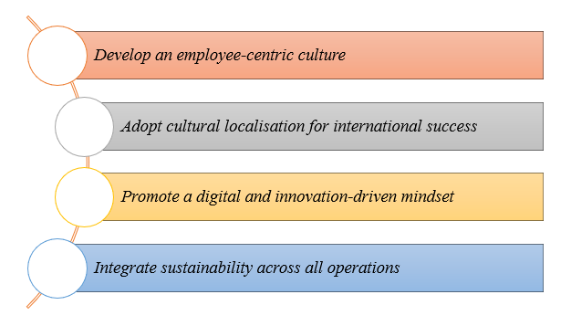
Figure: Recommended strategies
(Source: Self-developed)
An adequate and critical rule must be taken by Walmart in terms of incorporating sustainable practices with the help of clear and transparent eco objectives. Individual functional areas of Project Gigaton have to be measured and evaluated to guarantee coordination among responsibilities of leaders, staff incentives, and sustainable performance.

8. Conclusion
In order to ensure adequate corporate agility and operational excellence of Walmart a perfect coordination among sustainability, flexibility of culture, and empowerment of employees must be practised. Its long-term competitiveness will be increased more through the strengthening of digital capabilities and the creation of inclusive and localised practices. After all, the key to future success of Walmart lies in the ability to strike a balance between the disciplined culture and the willingness to be innovative, collaborate, and act responsibly in global expansion.

References
Abdala, E. C., Morais, G. G., & Rebelatto, D. N. (2021). ‘Remuneration Strategies related to Charles Handy’s cultural typology: A case study in a small digital market business in pandemic times’, Brazilian Journal of Operations & Production Management, 18(2), 1-13.
Akpa, V. O., Asikhia, O. U., & Nneji, N. E. (2021). ‘Organizational culture and organizational performance: A review of literature’, International journal of advances in engineering and management, 3(1), 361-372.
Almhairat, A. (2025). ‘Bureaucracy Theory Revisited: Max Weber's Ideal Type and its Contemporary Relevance in Organizational Science’. Australian Academic & Educational Services (AAES), Business and Administrative Studies, 2(3), 16-27.
AssetRoom, (2025) Walmart Reports $681 Billion Revenue for Fiscal Year 2025, Up 5.1%. Available at: https://www.assetroom.net/s/walmart/pOf9MQ/walmart-reports-681-billion-revenue-for-fiscal-year-2025-up-5-1. (Accessed 1st November, 2025)
Business Standard, (2024) Retail giant Walmart to fire hundreds of corporate staff, relocate others. Available at: https://www.business-standard.com/amp/world-news/retail-giant-walmart-to-fire-hundreds-of-corporate-staff-relocate-others-124051400105_1.html. (Accessed 1st November, 2025)
Cavale, S., (2023) Walmart keeps grocery prices steady amid inflation, antitrust claims. Available at: https://www.reuters.com/business/retail-consumer/walmart-keeps-grocery-prices-steady-amid-inflation-antitrust-claims-2023-05-05/. (Accessed 1st November, 2025)
Choo, J., (2024) Walmart Business Strategy: A Comprehensive Analysis. Available at: https://strategyjourney.com/walmart-business-strategy-a-comprehensive-analysis/. (Accessed 1st November, 2025)
Dani, D., (2022) Five Ways to Foster a Culture of Innovation for Your Tech Workforce. Available at: https://public.walmart.com/content/walmart-global-tech/en_us/blog/post/five-ways-to-foster-a-culture-of-innovation-for-your-tech-workfo.html. (Accessed 1st November, 2025)
Gutterman, A. S. (2023). ‘Designing the organizational structure’. Available at SSRN 4548234.
Hector, O., & Cameron, R. (2023). ‘Human-centric management: Nurturing talent, building culture, and driving organizational success’, International Journal of Science and Society, 5(4), 511-525.
Hofmeister, J., Kanbach, D. K., & Hogreve, J. (2024). ‘Service productivity: a systematic review of a dispersed research area’, Management review quarterly, 74(3), 1249-1281.
Mullins, L., & Christy, G. (2016). Management & Organisational Behaviour (Eleventh ed., Always learning).
Nyamweya, S., (2020) Why Walmart Failed in German Market: A Critical Analysis. Available at: https://discover.hubpages.com/business/Why-Walmart-Failed-in-German-Market-Analysis. (Accessed 1st November, 2025)
Pradhan, B., (2025) Walmart slashes 1,500 jobs in technology team amid reorganisation push. Available at: https://www.business-standard.com/industry/news/walmart-cuts-corporate-jobs-tariff-impact-technology-division-125052200431_1.html. (Accessed 1st November, 2025)
Repko, M., (2020) Walmart winds down Jet.com four years after $3.3 billion acquisition of e-commerce company. Available at: https://www.cnbc.com/2020/05/19/walmart-winds-down-jetcom-four-years-after-3point3-billion-acquisition.html#:~:text=Walmart%20acquired%20Jet.com%20for,and%20phase%20out%20the%20brand. (Accessed 1st November, 2025)
Segal, M., (2024) Walmart Hits Goal to Reduce 1 Billion Tons of Supply Chain Emissions 6 Years Ahead of 2030 Target. Available at: https://www.esgtoday.com/walmart-hits-goal-to-reduce-1-billion-tons-of-supply-chain-emissions-6-years-ahead-of-2030-target/. (Accessed 1st November, 2025)
Singh, H., & Pipaliya, S. (2024). ‘Cross Cultural Behavior and Product Localization (adapting to diverse market for global success)’.
Stanikzai, M. E., & Mittal, E. (2025). ‘Strategic alignment of organizational structure based on decisions for sustainable organizational performance: a bibliometric-systematic literature review’, Cogent Business & Management, 12(1), 2560650.
Tavares, M. C., Vale, J., & Costa, A. (2024). ‘The Role of Decentralised Managers in Decision-Making in a Large Industrial Company’, Administrative Sciences, 14(9), 202.
Volpe, R., & Boland, M. A. (2022). ‘The economic impacts of walmart supercenters’, Annual Review of Resource Economics, 14, 43-62.
Walmart, (2024) Notice of 2024 Annual Shareholders' Meeting. Available at: https://www.assetroom.net/s/walmart/pOf9MQ/walmart-reports-681-billion-revenue-for-fiscal-year-2025-up-5-1. (Accessed 1st November, 2025)
Walmart, (2025a) Annual Report 2025. Available at: https://corporate.walmart.com/content/dam/corporate/documents/newsroom/2025/04/24/walmart-releases-2025-annual-report-and-proxy-statement/walmart-inc-2025-annual-report.pdf. (Accessed 1st November, 2025)
Walmart, (2025b) Walmart Home Office. Available at: https://corporate.walmart.com/about/newhomeoffice/faq-new-home-office. (Accessed 1st November, 2025)
Walmart, (2025c) The business of better. Available at: https://careers.walmart.com/values. (Accessed 1st November, 2025)
Walmart, (2025d) Sustainability. Available at: https://corporate.walmart.com/purpose/sustainability. (Accessed 1st November, 2025)
Walmart, (2025e) Diversity & Inclusion. Available at: https://public.walmart.com/content/wal-paper/en_in/lod/learning/home-office-academy/wmcore/virtual-reality/diversity---inclusion.html. (Accessed 1st November, 2025)
Wood, R., (2025) How Walmart’s Pricing Strategy Built Retail Dominance. Available at: https://corporate.walmart.com/about/newhomeoffice/faq-new-home-office. (Accessed 1st November, 2025)
Yeganeh, H. (2025). ‘Hofstede, GLOBE, Schwartz and Inglehart’s cultural dimensions: a critical examination and assessment’, European Business Review.
Yuan, Y., Song, D., & Huang, Y. (2021, September). ‘The Limitations of Traditional Retail Enterprises’ Self-built Logistics System——A Case Study of Walmart’, In 2021 International Conference on Financial Management and Economic Transition (FMET 2021) (pp. 487-494). Atlantis Press.

