

Student ID: 2542500
Student Name: PATEL PRINCEKUMAR HARSHADBHAI

Module name: HUMAN CAPITAL MANAGEMENT
Module code: LCMB7023
ASSESSMENT COMPONENT 1: INDIVIDUAL REPORT
DESIGNING A HUMAN CAPITAL ARCHITECTURE FOR STRATEGIC RENEWAL: A CASE OF HELIOS URBAN MOBILITY (HUM)

Lecturer name: Gladius Kulothungan
Submission date: 17th July 2026
Word count: 2639
Executive summary

This report is focused on analysing the case study company, named Helios Urban Mobility. It is seen to be facing major employment ramp-up times, reduced engagement and higher graduate turnover. This shows weaknesses in socialisation, job design and onboarding approaches. The report has recommended a strategic socialisation framework considering pre-boarding, the first 90 days, and the first year for enhancing organisational identification, professional standards and retention rates. Key initiatives include realistic job previewing, mentoring, cross-functional collaboration, innovation communities, and stakeholder exposures. To enhance adaptability and motivation, the report proposed enriched role-based on the Job Characteristic Model, supported job crafting and a skill-based internal talent marketplace. The discussions have finally shed light on responsible AI usage for HR decision-making and highlighted the future capability development priorities for ensuring sustainable performance and growth.

Table of Contents

Introduction 4
TASK A: Socialisation, Identity & Business Activism 4
1. Evaluation of traditional onboarding vs. strategic organisational socialisation 4
2. Structured socialisation framework for Helios 6
3. Proposed mechanisms to cultivate 7
TASK B: Job Design 9
1. Innovative job design strategy 9
2. Design stimulation explanations 11
TASK C: Reflective report 13
1. Use of AI as a decision-support tool without hindering Human judgement 13
2. Personal capability development plan 13
Conclusion 14
References 15

Introduction
As per the given case study, Helios Urban Mobility is observed to face some significant organisational challenges, with an average ramp-up period of eight months, reducing engagement levels, and loss of high-potential graduates. Employees were seen to be considering too much time to become productive and are not creating a strong organisational bond. As a result, traditional onboarding cannot be efficient enough in this case, requiring the company to consider a strategic organisational socialisation system. This report has analysed how organisational socialisation and innovative job design can support strategic renewal in the company. The reflective account focuses on the AI’s responsible use in HR setting and how capability development initiatives are crucial for sustainable future career growth.

TASK A: Socialisation, Identity & Business Activism

1. Evaluation of traditional onboarding vs. strategic organisational socialisation
Based on the current situation of Helios, it can be identified how the traditional approach is not meeting the current demands. Jeske and Olson (2022) argued how traditional onboarding is designed for familiarising new employees with new business processes, policies, and job tasks, focusing on individuals understanding what they are required to do and how the company operates. Regardless of whether this model can reduce uncertainty for a short time, it can shift its focus of adjustments to short-term processes. On the contrary, the strategic organisational socialisation is focused on how appropriate integration is not limited to a short time, especially while considering Van Maanen and Schein’s socialisation framework, which identified how companies can influence how new employees learn company operations, values, and behaviours through socialisation approaches (Hein, 2023). Institutionalised approaches like formal mentoring and collective learning approaches are effective to reduce uncertainties and enhance adjustment approaches. For Helios, this is crucial as the long ramp-up time is showing how employees may not be gaining proper support.
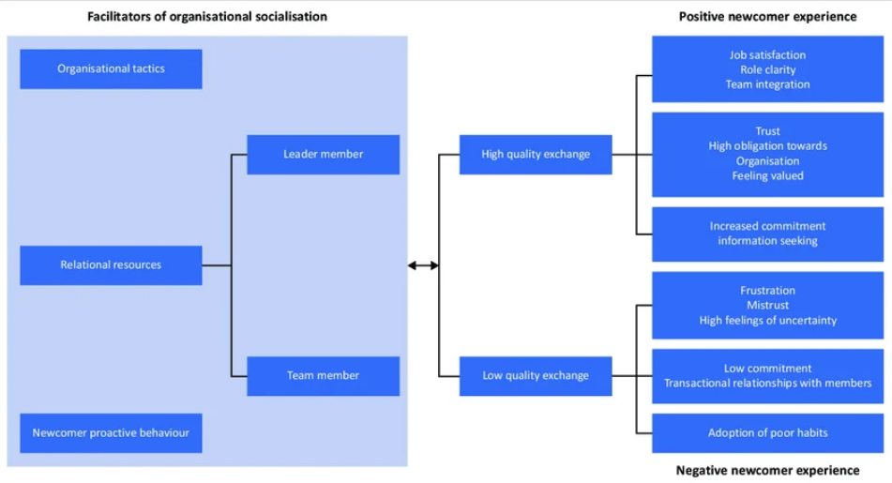

Figure 1: organisational socialisation framework
(Source: Inspired by the ideas of Mohatla and Bussin, 2022)
Although a single institutionalised approach can also not be crucial for this type of innovative technology company. Critics often argue how a majorly structured socialisation approach can pressure employees to adapt to group norms and not consider independent thinking (Næss, 2025). Considering how Helios operated in the AI-based mobility context, innovation is based on employees and their independent thinking for new idea development. Therefore, a strict standardisation may not be effective alone. The Psychological Contrast theory sheds light on the context of how onboarding only can potentially not allow Helios to overcome retention issues. Samson and Swink (2023) identified how new employees develop expectations for career development, management support, and proper work and organisational culture before joining a company.
If these expectations are not being fulfilled, employees can feel that the psychological contract has been broken. In such cases, their engagement will be reduced, thereby increasing turnover intentions. Based on the identity construction concept, ways in which employees can become committed to company engagement have been identified when they can develop their identity and negotiate a sense of self (Anderson et al., 2022). This allows them to remain engaged as they might consider company success being personally meaningful. For Helios, the issue is to ensure that its employees can consider it as technical support and even conditions for a future sustainable urban mobility concept. Therefore, alignment with personal values and meeting employee identity development demands can support Helios in this case.

2. Structured socialisation framework for Helios
To overcome the current challenges, Helios should focus on implementing a strict custom socialisation framework from pre-boarding to the first year of employment while considering the traditional four phases of onboarding.
Stages | Objectives | Key efforts
Pre-boarding | Developing connection and realistic expectations | Digital onboarding hubs, realistic job previewing
First 90 days | Enhance adjustments and performance | Cross-function projects, supervision and stakeholder exposure
1st year | Enhance identity and retention | Mentoring, innovation communities, career development reviews

The pre-boarding stage should start right after contract acceptance. Helios should focus on providing access to a digital onboarding hub, shedding light on organisational approach, values and operations (Sunarjo et al., 2025). Realistic job showcases should be able to shed light on opportunities and challenges that will align with employee expectations before employment starts.
In the first 90 days, socialisation should consider improving integration while developing organisational purpose. The analysis of Jeske and Olson (2022) showed how the transition to a new workplace can be challenging, Helios should allow new hires to participate in cross-functional projects with colleagues from Singapore, Berlin, and London. This will allow for a supportive environment for newcomers and make them understand how the company functions in various geographical locations. The first-year market is important for ensuring proper employee retention and overcoming the issues with engagement and turnover of Helios. For Helios, employee relations need to focus not only on initial onboarding, but also focus on professional development, organisational management and career planning. It is also essential for employees to be engaged in formal career development opportunity conversations. The views of Dewi et al. (2021) have portrayed these to be crucial for long-term organisational commitment development. There should also be innovation communities where they can collaborate on operational challenges across locations of Helios operations.
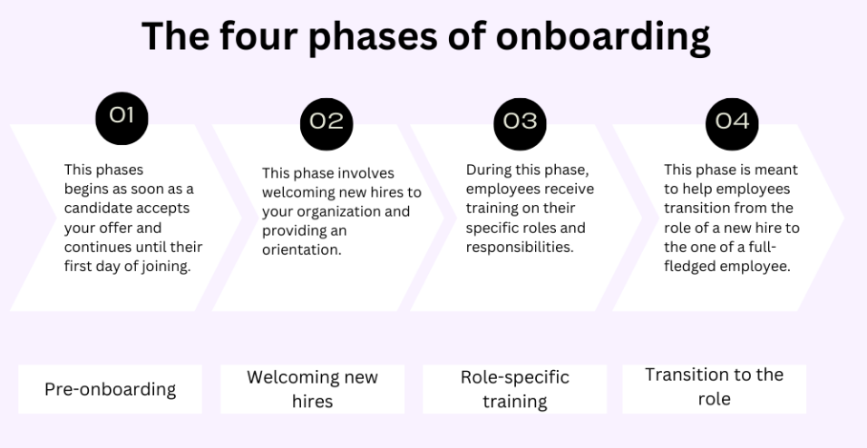

Figure 2: The traditional four phases of onboarding
(Source: Tarika, 2025)
This framework is suitable for Helios, as it balances the structure of traditional onboarding phases while considering flexibility in it (Tarika, 2025). Furthermore, it supports consistency in international locations without major standardisation.

3. Proposed mechanisms to cultivate
Organisational identification can be enhanced via meaningful stories, shared experiences and value considerations. Management should show employees how they can contribute towards organisational outcomes, which can eventually allow better engagement (Babalola et al., 2021). Cross-location collaboration is also crucial for shared experience development and develops a centred company identity, regardless of Helios’s diverse geographical separation. Montani et al. (2020) have identified that recognition programmes can reward employee behaviour for showcasing collaboration and developing meaningful collaborative approaches.
Employee professionalism is also crucial, especially due to the AI reliance and public-sector partnership of Helios. Risks like algorithmic bias, data privacy and responsible innovation can develop major ethical challenges, requiring ethical consideration in operations, to ensure decision-making is guided through ethical vision (Bahangulu and Owusu-Berko, 2025). Scenario-based workshops including realistic organisational challenges can allow employees to analyse stakeholder interest and justify their decisions in a professional setting. There is a dire need for Helios to also foster a business activist mindset through considering Ulrich's evolving concept of HR. As identified by Sarvaiya et al. (2021), this will focus on creating value for various stakeholders and not only focus on internal organisational efficiency. Furthermore, stakeholder capitalism can also be considered. This focuses on how sustainable organisational performance is based on balancing investor, employee, consumer and government interest balancing (Paine, 2023). For Helios, this concept is relevant as the products are directly influencing public infrastructure and urban development concepts.

TASK B: Job Design

1. Innovative job design strategy
Helios Urban Mobility showcased declining engagement levels and higher turnover among high-potential graduates, showing existing jobs are not properly supporting employee development or motivation for long-term engagement. Therefore, to overcome this issue, Helios should focus on integrating the job design approach. This will be focused on the Job Characteristics Model (JCM), Job Crafting theory and skill-based internal talent marketplace. The JCM of Hackman and Oldham has five key characteristics, including skills variety, task identity, autonomy, task significance and feedback for developing psychological conditions for intrinsic motivations (Kamani, 2020). It identifies the structural characteristics instrumental to an effective course design and presents related instructional strategies for maximizing student motivation in business school classrooms. This model is still crucial as it can link job design to employee performances and engagement. However, this model is also criticised, especially for its potential focus on being a one-size-fits-all approach (El-Farr, 2023). For Helios, this model will provide a solid base of basis for job design.
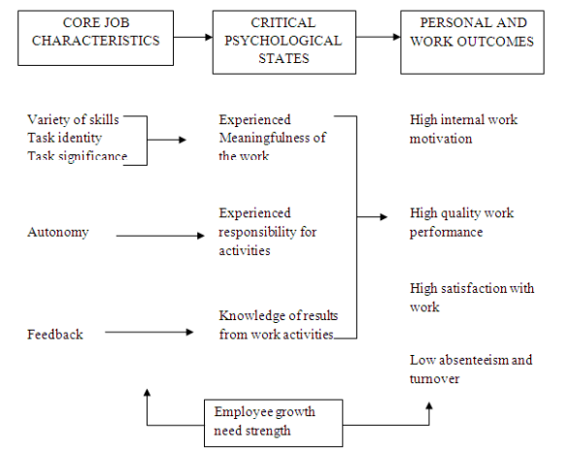

Figure 3: The Job characteristic model
(Source: MUWANGUZI et al., 2022)
The job crafting theory addresses the limitations through considering employees as active participants in managing their own work. It allows employees to make meaningful changes to their roles, which can lead to better alignment with their personal strengths and aspirations (Rashmi et al., 2025). Based on this, employees can alter their tasks, relations, and perceptions to efficiently fit their individual strengths and company values. Based on Signore et al. (2025), job crafting can increase engagement and adaptability. Therefore, Helios needs to adapt a structured job crafting approach in which flexibility is focused, with clear strategic boundaries to align. Finally, the skills-based architecture supported through an internal talent marketplace can provide storing support. In contrast to traditional job structures, a skills-based approach of an internal talent marketplace is more focused on the concept that capabilities can be deployed in projects, teams, and even locations (Devine, 2021). This model is increasingly related to organisational agility, as it can ensure talent to move rapidly in relation to emerging priorities.
Summary of job design components
Component | Features | Strategic benefits
Job enrichment | Wider responsibilities and ownership | Better engagement
Supported job crafting | Employee-focused role adjustments | Higher adaptability
Internal Talent marketplace | Skills-based project allocation | Retention and innovations

In terms of implementation, the first stage includes redesigning existing job roles based on the principles of the Job Characteristics Model. It will be a mandate for every employee to have better visibility of the complete mobility solution lifecycle with greater transparency. For example, the software engineer must participate in client implementation review, while data analysts can contribute to discussions for policy outcomes and service betterment. This approach will help increase task identity by allowing employees to have better observation for the final impact of their tasks and connecting it to wider societal outcomes like sustainable mobility solutions, aligning with the characteristics model (Raihan, 2020). These connections are crucial, especially for young professionals who seek purpose in their work while considering career progression. A focus on skill variety should be given through enhancing it via rotational opportunities in product development, implementation or stakeholder engagement. As per Mlekus and Maier (2021), allowing them to engage with various disciplines will increase organisational understanding while reducing monotony in work. Autonomy will also be included through workflow design and problem-solving tasks. Finally, continuous feedback sessions will help understanding stakeholder perspectives and employee concerns or queries.
In the second stage, guided job crafting is done. Employees will participate in quarterly development discussions for opportunity identification and manage aspects of their roles (Kooij et al., 2022). For example, an engineer interested in sustainability policy can support stakeholder engagement approaches. Furthermore, data analysts can gain leadership experience in terms of coordinating a cross-functional approach. These adjustments will increase the feel of ownership and allow employees to align their work with personal strengths and aspirational goals.
The third stage will focus on implementation of an internal talent marketplace. Employees will manage their digital skills profile with technical expertise analysis, certifications, languages and developmental interests. While managers can advertise innovation projects, international assignments, and strategic work through a primary platform. This marketplace will allow to directly address graduate turnover issues faced by the company through showing visible career opportunities (Borg et al., 2021).

2. Design stimulation explanations
The proposed architecture is supporting intrinsic motivation as it can develop meaningful work, developmental opportunities, and strong company connections. Taking support of the Job Characteristics Model, employees are motivated when their work is considered significant and they feel the responsibility for outcomes (Judge et al., 2023). Redesigned roles support these aspects through wider responsibilities, better autonomy, and continuous learning potential. As per Olafsen et al. (2025), this strategy is well-aligned with the concept of Self-Determination Theory (SDT) that focuses on project ownerships and job crafting approaches for better autonomy development. The competence can also be created via marketplace opportunities for growth and rotational tasks. SDT identifies three core psychological needs that are essential for optimal functioning, such as Autonomy (voluntary and self-endorsed actions), Competence (capable of meeting challenges and achieving desired outcomes) and Relatedness (feeling connected to and valued by others) (Kurt, 2025).
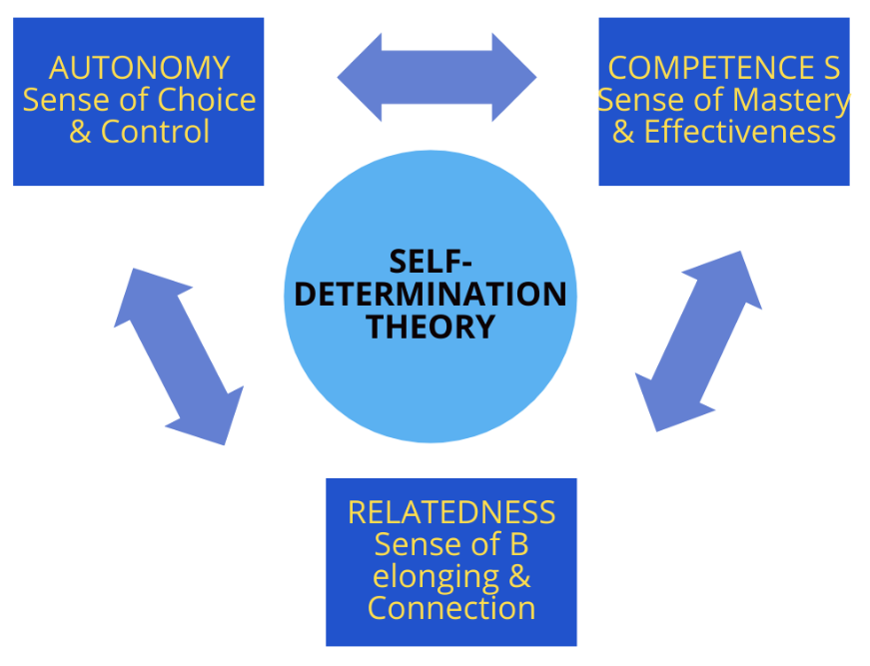

Figure 4: Self-determination theory (SDT)
(Source: Kurt, 2025)
Innovation is based on job design, as strict structures can hinder experimentation, as employee focus is narrowed to single assigned tasks. While enriched jobs, guided job crafting, and talent marketplace ensures exploring and collaboration. The benefits of cross-functional collaboration go beyond teamwork. A cross-functional team mixes people from different areas of a company. This mix creates a lively space for teamwork in innovation projects. Team members have different skills and views, leading to better solutions (Dsouza, 2025). In the case of Helios, the internal talent marketplace is especially crucial, as it focuses on innovation. Employees can gain structured access to projects that are not limited to their assigned roles only. This develops potential for knowledge recombination that is a key driver for innovation in technological situations (Kim et al., 2026). It can also allow for overcoming barriers of the company's diverse location presence and ensure collaboration in London, Berlin, and Singapore.

TASK C: Reflective report

1. Use of AI as a decision-support tool without hindering Human judgement
The concept of Artificial Intelligence has become a crucial tool for modern HR approaches, especially while analysing workforce data, identifying trends, and developing insights. Although I do not consider AI as a replacement for professional judgement, regardless of its capability to analyse a significant portion of data rapidly. It is because it cannot understand the wider concept of organisational culture, and employee emotions influencing decisions. Thus, I aim to use the capabilities of AI to enhance the speed of analysis while keeping authority over decision-making. I will also ensure all results or recommendations via AI are properly evaluated against real data and evidence. This approach will allow me to keep the sense of empathy, professional responsibility and even accountability while utilising the benefits of AI.

2. Personal capability development plan
Capability | Development activity | Timeline | Success measurement indicator
Data literacy | Complete people analytics training and practices dashboard interpretation | 10 months | Confidence in utilising HR data for decision-making.
AI augmentation for HR | Learn AI-supported HR tools and prompt designing | 1 year | Efficient analysis and planning through AI.
Strategic influencing | Participate in presentations negotiations and stakeholder projects | 14 months | Enhanced communication and persuasion capabilities
Global mobility awareness | Study international HRM and global workforce trends. | Ongoing | Strong understanding for cross-border employee management

To enhance future employability, I will consider the need for continuous capability development and not focus on academic qualifications only. The first focus will be on enhancing data literacy. As companies are increasing workforce analytics, HR professionals need to be capable of analysing data and turning findings into meaningful business recommendations. Developing confidence in analysing metrics and dashboards will allow enhancing my evidence-based decision-making skills. I will also focus on AI Augmentation in HR. In contrast to considering AI as a threat, I aim to consider the capability to work alongside it. This will include understanding the capabilities and limitations. These skills will allow me to enhance productivity while managing professional judgments.
Strategic influencing is another key area for my development. HR professionals are raising expectations for contribution towards company strategy and not just focus on administrative functions. Therefore, I will mainly focus on improving my existing negotiation and communication skills, while also considering stakeholder management through various real-world experiences and collaborative approaches. These will altogether help me to create skills for influencing the final decision-making.

Conclusion
Based on the above report, it can be identified that Helios Urban Mobility can overcome issues in the workforce through combining strategic socialisation and innovative job design. An onboarding process in a structured manner and development framework have shown to be effective for creating organisational identification, improve employee engagement, and reduce turnovers. On the other hand, the findings highlighted guided job crafting, enriched roles, and skill-based talent marketplaces for better motivation and adaptability in the company. The effective implementation will allow Helios to develop a capable and engaged workforce aligned with its objectives. Finally, the reflective account supported understanding how AI can be used in HR decision-making without compromising the human touch in it. While the development plan ensured to understand best practices for future employment capabilities, considering key practices that should be done in pre-defined timelines.

References
Anderson, H., Stocker, R., Russell, S., Robinson, L., Hanratty, B., Robinson, L. and Adamson, J., 2022. Identity construction in the very old: A qualitative narrative study. PloS one, 17(12), p.e0279098. https://journals.plos.org/plosone/article/file?id=10.1371/journal.pone.0279098&type=printable
Babalola, M.T., Mawritz, M.B., Greenbaum, R.L., Ren, S. and Garba, O.A., 2021. Whatever it takes: How and when supervisor bottom-line mentality motivates employee contributions in the workplace. Journal of Management, 47(5), pp.1134-1154. https://researchportal.northumbria.ac.uk/ws/files/27028624/JOM_RR3_manuscript_Final_03_01_2020.pdf
Bahangulu, J.K. and Owusu-Berko, L., 2025. Algorithmic bias, data ethics, and governance: Ensuring fairness, transparency and compliance in AI-powered business analytics applications. World Journal of Advanced Research and Reviews, 25(2), pp.1746-1763. https://www.researchgate.net/profile/Louis-Owusu-Berko-2/publication/389397603_Algorithmic_bias_data_ethics_and_governance_Ensuring_fairness_transparency_and_compliance_in_AI-powered_business_analytics_applications/links/67c1200e207c0c20fa9ab59e/Algorithmic-bias-data-ethics-and-governance-Ensuring-fairness-transparency-and-compliance-in-AI-powered-business-analytics-applications.pdf
Borg, J., Borg, N., Scott-Young, C.M. and Naderpajouh, N., 2021. The work readiness–career resilience linkage: implications for project talent management. International journal of managing projects in business, 14(4), pp.917-935. https://www.researchgate.net/profile/Jessica-Borg-5/publication/348017105_The_work_readiness-career_resilience_linkage_implications_for_project_talent_management/links/6004b440a6fdccdcb860837a/The-work-readiness-career-resilience-linkage-implications-for-project-talent-management.pdf
Devine, M., 2021. Navigating to a skills-based approach to talent development. Conference Board. https://www.alaskasafetyalliance.org/wp-content/uploads/2024/09/skills-based_approach_to_talent_development.pdf
Dewi et al., 2021. The Effect of Career Development on Turnover Intention with Job Satisfaction and Organizational Commitment as Mediators, Study at PT Control Systems Arena Para Nusa. Available at: https://www.researchgate.net/publication/353003585_The_Effect_of_Career_Development_on_Turnover_Intention_with_Job_Satisfaction_and_Organizational_Commitment_as_Mediators_Study_at_PT_Control_Systems_Arena_Para_Nusa [Accessed at: 10/07/2026]
Dsouza, J., 2025. The Importance of Cross-Functional Collaboration in Innovation Projects. Available at: https://zoetalentsolutions.com/cross-functional-collaboration-in-innovation-projects/ [Accessed at: 10/07/2026]
El-Farr, H., 2023. Job Characteristics Theory. Available at: https://www.researchgate.net/publication/371483979_Job_Characteristics_Theory [Accessed at: 10/07/2026]
Hein, A., 2023. Essays on the organizational socialization of new recruits in the public sector. https://ora.ox.ac.uk/objects/uuid:5f7d065c-cecc-4aa8-8efd-c889379f473c/files/d9c67wn60t
Jeske, D. and Olson, D., 2022. Onboarding new hires: recognising mutual learning opportunities. Journal of Work-Applied Management, 14(1), pp.63-76. https://www.emerald.com/jwam/article-pdf/14/1/63/1708061/jwam-04-2021-0036.pdf
Judge, T.A., Klinger, R. and Li, M., 2023. Promote job satisfaction through mental challenge. Principles of Organizational Behavior: The Handbook of Evidence‐Based Management 3rd Edition, pp.161-178. https://www.academia.edu/download/46406951/Organizational_behavior.pdf#page=139
Kamani, T., 2020. Analysis of the job characteristics model. Available at SSRN 3600844. http://dx.doi.org/10.2139/ssrn.3600844
Kim, K., Kogler, D.F., Lee, J., Maliphol, S. and Lee, C., 2026. Mapping knowledge recombination for innovation: cognitive proximity and business method patents in the digital era. Journal of Knowledge Management, 30(11), pp.57-82. https://www.emerald.com/jkm/article-pdf/doi/10.1108/JKM-05-2025-0751/11166545/jkm-05-2025-0751en.pdf
Kooij, D.T., De Lange, A.H. and Van De Voorde, K., 2022. Stimulating job crafting behaviors of older workers: The influence of opportunity-enhancing human resource practices and psychological empowerment. European Journal of Work and Organizational Psychology, 31(1), pp.22-34. https://www.tandfonline.com/doi/pdf/10.1080/1359432X.2021.1899161
Kurt, S., 2025. Self-Determination Theory: Understanding Motivation Across Contexts. Available at: https://educationlibrary.org/self-determination-theory-understanding-motivation-across-contexts/ [Accessed at: 10/07/2026]
Mlekus, L. and Maier, G.W., 2021. More hype than substance? A meta-analysis on job and task rotation. Frontiers in psychology, 12, p.633530. https://www.frontiersin.org/journals/psychology/articles/10.3389/fpsyg.2021.633530/pdf
Mohatla, S. and Bussin, M., 2022. Exploring the socialisation experiences of female board members. SA Journal of Human Resource Management, 20, p.1710. https://repository.up.ac.za/bitstream/handle/2263/79617/Mohatla_Exploring_2020.pdf?sequence=1
Montani, F., Boudrias, J.S. and Pigeon, M., 2020. Employee recognition, meaningfulness and behavioural involvement: Test of a moderated mediation model. The International Journal of Human Resource Management, 31(3), pp.356-384. https://cris.unibo.it/bitstream/11585/788770/5/Employee%20recognition.pdf
MUWANGUZI et al., 2022. Applying Hackman and Oldham (1975) Job Characteristic Model in the analysis of Job Satisfaction at Makerere University: An Empirical Paper. Available at: https://www.iosrjournals.org/iosr-jrme/papers/Vol-12%20Issue-1/Ser-4/B1201042027.pdf [Accessed at: 10/07/2026]
Næss, H.E., 2025. Leave Me Alone. A Process Model Exploring how Excessive Socializing can Contribute to More Exclusionary Workplaces. Available at: https://www.degruyterbrill.com/document/doi/10.1515/joso-2025-0014/html [Accessed at: 10/07/2026]
Olafsen, A.H., Marescaux, B.P. and Kujanpää, M., 2025. Crafting for autonomy, competence, and relatedness: A self‐determination theory model of need crafting at work. Applied Psychology, 74(1), p.e12570. https://iaap-journals.onlinelibrary.wiley.com/doi/pdf/10.1111/apps.12570
Paine, L.S., 2023. What does “stakeholder capitalism” mean to you. Harvard Business Review, 101(5), pp.108-119. https://www.ew360.mx/clientes/Ado/especiales/271023/HBR1.pdf
Raihan, T., 2020. Role of job characteristics model on employee job satisfaction: An empirical study. Journal of Business Administration, 32(1), pp.179-196. https://www.researchgate.net/profile/Tarik-Raihan/publication/348742451_Role_of_Job_Characteristics_Model_on_Employee_Job_Satisfaction-_An_Empirical_Study/links/602ca217a6fdcc37a8300c4c/Role-of-Job-Characteristics-Model-on-Employee-Job-Satisfaction-An-Empirical-Study.pdf
Rashmi, A. and Maurya, V., 2025. Examining the Relationships between Job Crafting, Work Engagement, and Job Satisfaction. International Journal of Indian Psychology, 13(1), pp.9-41. https://ijip.in/wp-content/uploads/2025/04/18.01.288.20251301.pdf
Samson, D. and Swink, M., 2023. People, performance and transition: A case study of psychological contract and stakeholder orientation in the Toyota Australia plant closure. Journal of Operations Management, 69(1), pp.67-101. https://onlinelibrary.wiley.com/doi/pdfdirect/10.1002/joom.1218?utm_source=consensus
Sarvaiya, H., Arrowsmith, J. and Eweje, G., 2021. Exploring HRM involvement in CSR: variation of Ulrich’s HR roles by organisational context. The International Journal of Human Resource Management, 32(21), pp.4429-4462. https://www.academia.edu/download/121443806/09585192.2019.166069820250219-1-igbffj.pdf
Signore, F., Ingusci, E., De Carlo, E., Catalano, A.A., Cortese, C.G. and Ciavolino, E., 2025. Job crafting and its role in fostering personal resources and adaptation to change in the context of a pandemic. Frontiers in Organizational Psychology, 3, p.1576289. https://www.frontiersin.org/journals/organizational-psychology/articles/10.3389/forgp.2025.1576289/pdf
Sunarjo, R.A., Pujiati, T., Apriliasari, D. and Hardini, M., 2025. Digital onboarding in agricultural platforms and its impact on agricultural productivity. IAIC Transactions on Sustainable Digital Innovation (ITSDI), 6(2), pp.205-214. https://www.aptikom-journal.id/itsdi/article/download/688/327
Tarika, 2025. What are the 4 phases of onboarding?. Available at: https://www.zoho.com/people/hrknowledgehive/What-are-the-four-phases-of-onboarding.html [Accessed at: 08/07/2026]

