

Gender and Health Inequalities among Adolescent Girls (10–19 Years): A Social Epidemiological Analysis
Student Name: Misbabanu Amanullah khan
Student ID :2538422
Lecturer Name: Junaid
Module Code: LCHS7000
Module Name: Social Epidemiology and Public Health Development
Assignment: Component 2 – Analytical Report

Table of Contents
TASK 1 – Social Epidemiological Analysis 4
1. Introduction 4
2.1 Mental Health Problems 4
2.2 Sexual and Reproductive Health Problems 5
2.3 Eating Disorders and Obesity 5
2.4 Gender-Based Violence 6
2.5 Poverty and Educational Inequality 6
2.6 Barriers to Healthcare Access 6
3. National Responses to Reduce Health Inequalities 7
4. Organisation Supporting Adolescent Girls 7
5. Conclusion 8
References 9
TASK 2 – Epidemiological Analysis 12
1. Introduction 12
2. Incidence and Prevalence 12
3. Public Health Measures Using the 3 Ps 13
4. Determinants and Risk Factors 14
5. Epidemiological Studies and Health Needs Assessment 14
6. Monitoring and Surveillance Systems 15
7. Public Health Impact 15
8. Proposed Health Intervention Programme 15
9. Strengths and Weaknesses of the Epidemiological Approach 16
10. Conclusion 16
References 17

TASK 1 – Social Epidemiological Analysis

1. Introduction
Adolescents (10-19 years) have a developmental window of opportunity. Gender health inequalities are health inequalities that are unfair and due to social, economic and cultural factors (Hammami et al., 2022). Adolescent girls in the UK are over-represented on the list of vulnerable people who are at risk of health problems. The evidence from the UKHSA as well as the Black Report, 1980; Acheson Report, 1998; and Marmot Review, 2010 all have identified these enduring inequalities within society.

2.1 Mental Health Problems
Adolescent girls are more likely to suffer from depression, anxiety and self-harm than adolescent boys (Rai et al., 2023). The UK surveys have reported higher rates of emotional disorders in young people, especially girls (11 to 19 years). Hormones, schoolwork, social media, cyberbullying and gender discrimination play a major role . Mental illness has a negative impact on education, relationships and future wellbeing when not treated. (Lozano-Sánchez et al., 2024) This involves broadening school-based counselling, increasing the range of Child and Adolescent Mental Health Services (CAMHS), increasing resilience programmes and minimizing stigma and having timely access to psychological help through NHS and community services across the country (World Health Organization, 2025).
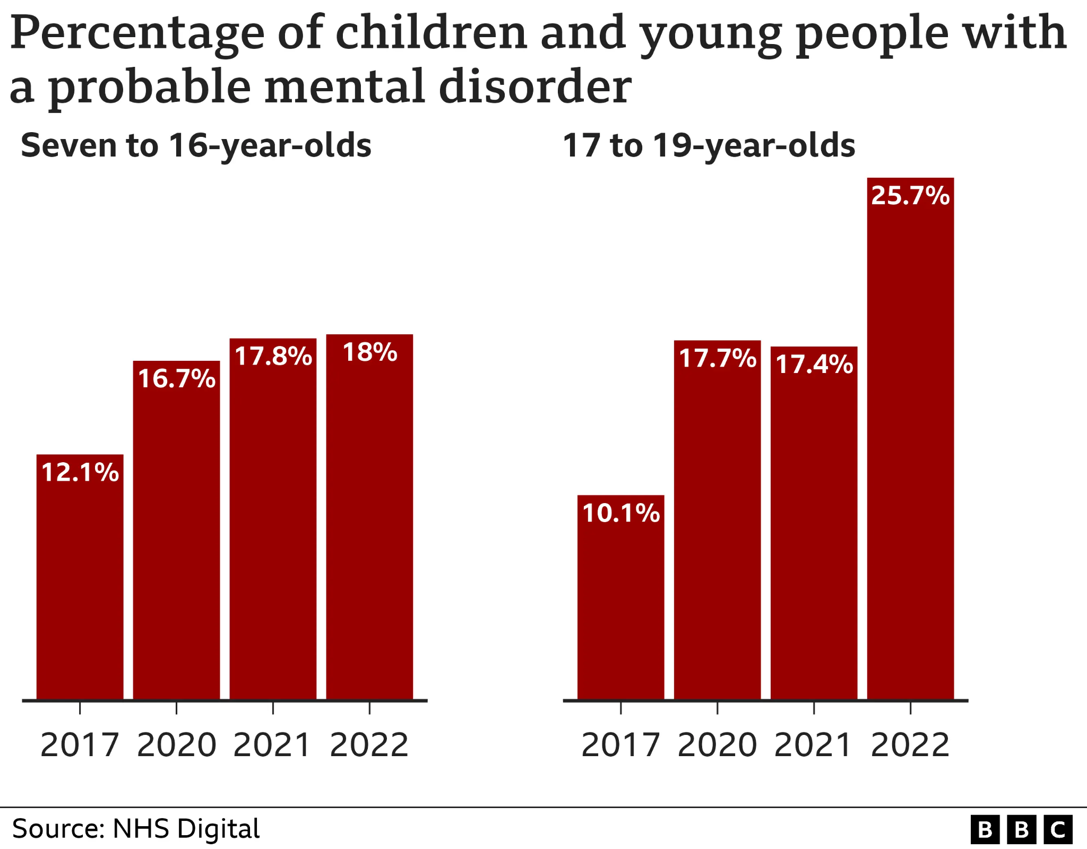
Figure: NHS Digital mental health prevalence adolescent girls UK graph
(Rai et al., 2023)

2.2 Sexual and Reproductive Health Problems
Adolescent girls are still vulnerable to STI's, menstrual problems and adolescent pregnancy. Teen pregnancy rates overall have reduced in the UK, but there are inequalities in deprived communities (Cullen et al., 2024). Risks include limited sexual education and poor contraceptive access, stigma, and misinformation. Menstrual poverty also has an impact on educational participation. They include full Relationships, Sex and Health Education, accessible and confidential sex health clinics, free contraceptives, and improved menstrual education support and targeted awareness campaigns of informed reproductive health choices and wellbeing (Adolescent sexual and reproductive health and rights, n.d.).

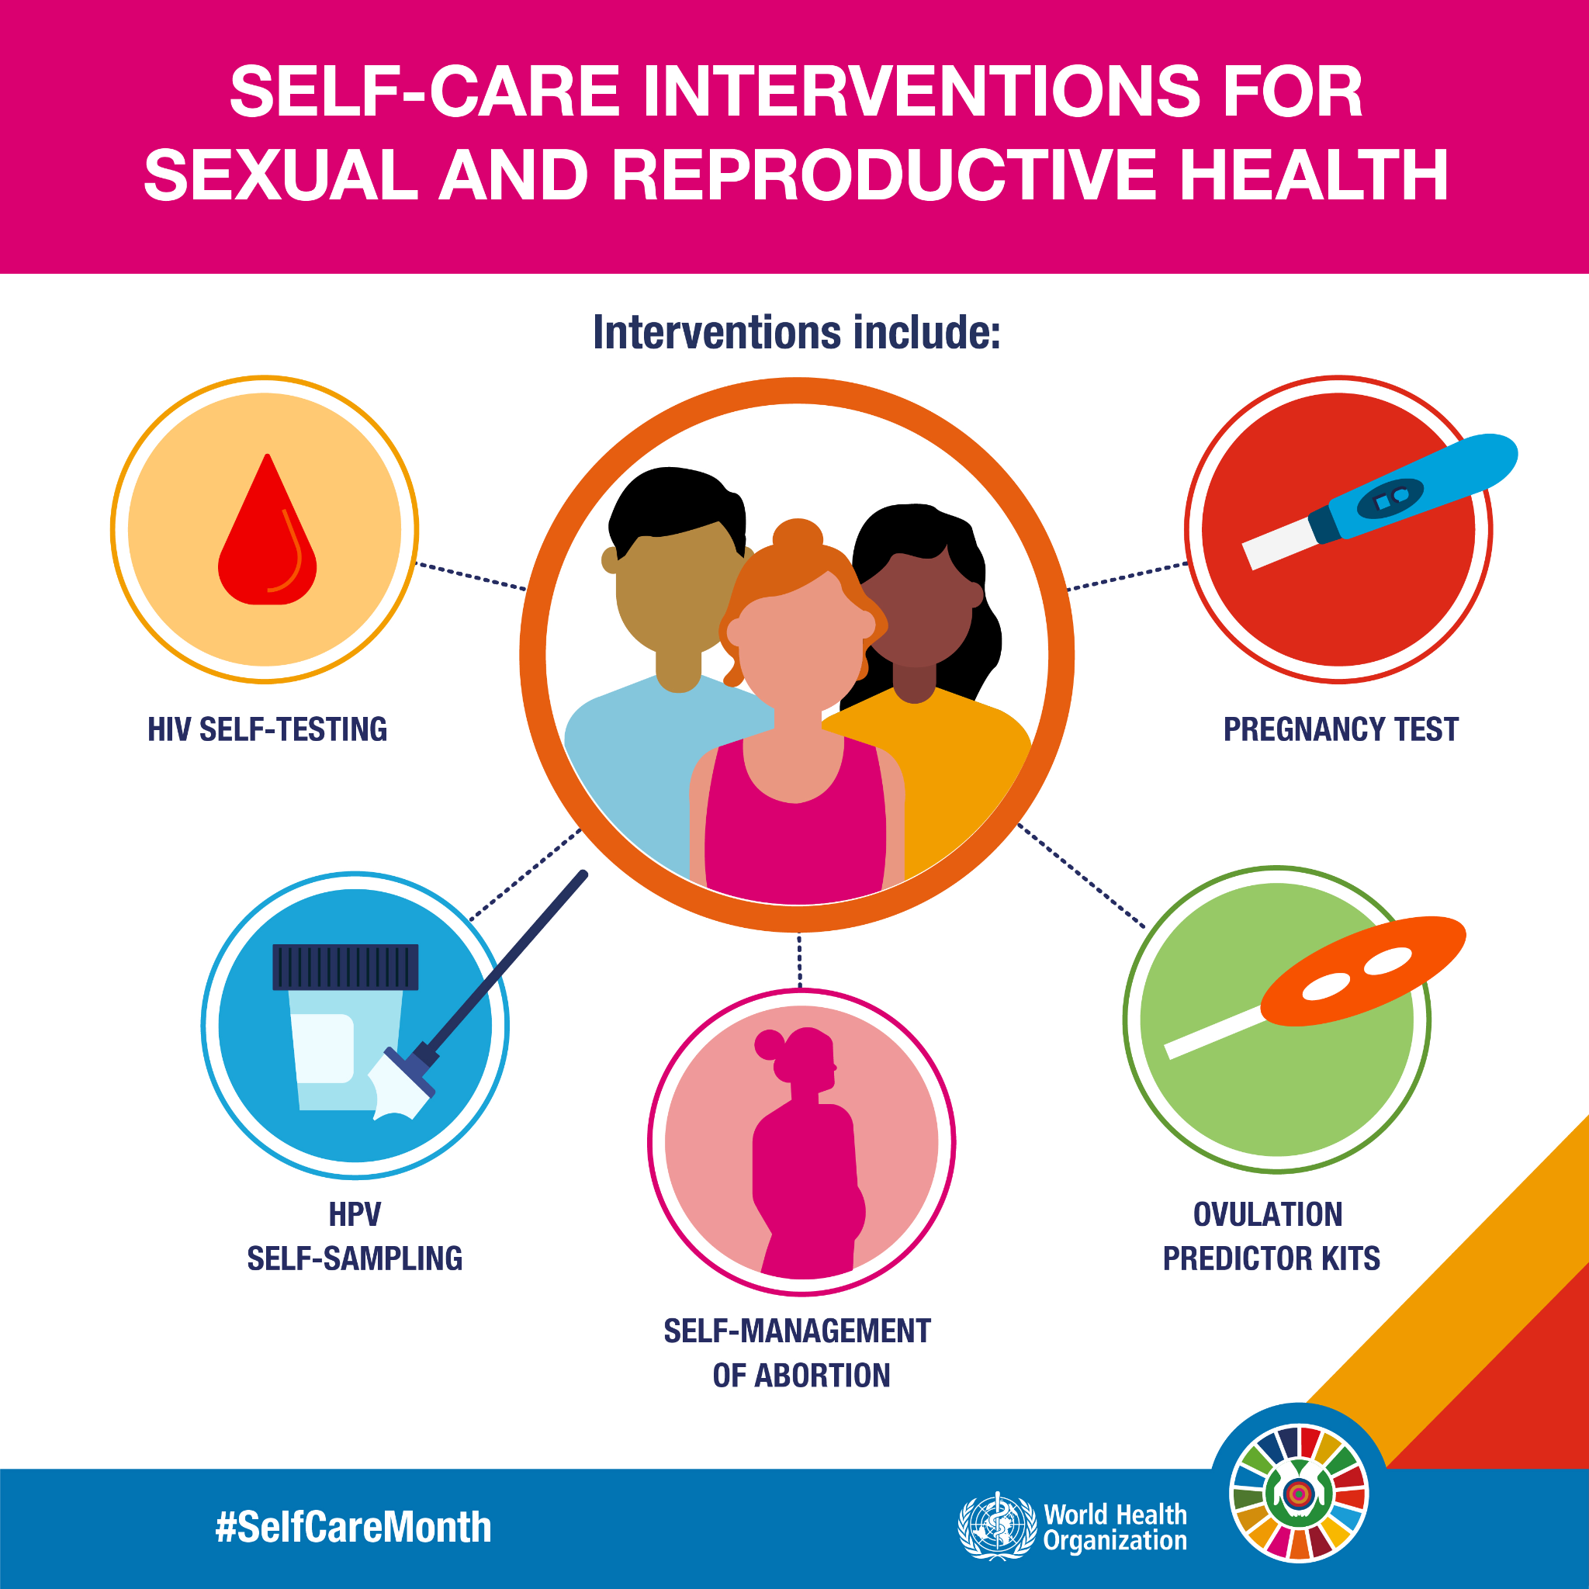
Figure: Sexual and reproductive health infographic adolescents WHO
( Cullen et al., 2024)

2.3 Eating Disorders and Obesity
Adolescent girls are more likely to be at risk for obesity, anorexia nervosa and bulimia due to pressure on their body image (Lemos et al., 2023). There is evidence in the UK that girls have a greater likelihood of having body dissatisfaction than boys and this is because of unrealistic expectations, peer pressure and social media. Excess weight increases the likelihood of developing chronic diseases and eating disorders are associated with poor growth and mental health (Laurenzi et al., 2023). Healthy lifestyle education, early screening, family support, positive body image campaigns and specialist eating disorder treatment (via multidisciplinary healthcare services) are effective interventions.

2.4 Gender-Based Violence
Gender-based violence (GBV) includes domestic violence, sexual violence, and online harassment of adolescent girls. In the UK, many girls are victims of unwanted sexual behaviours prior to their adulthood, which results in trauma, anxiety and lowered educational achievement. Gender norms, power imbalances and digital abuse are part of the way that young people become vulnerable (Perestrelo et al., 2025). Prevention strategies include school based safeguarding programmes, consent education, expanded protection of online spaces, confidential reporting, provision of specialist counselling and multi-agency co-ordinated services for the protection of girls and the reduction of long-term health inequalities nationally (Guide: Adolescents and gender equality, 2025).

2.5 Poverty and Educational Inequality
Adolescent girls are particularly affected by school dropouts, school absences, and period poverty (Alemu et al., 2025). Low-income girls may have to skip periods because of lack of menstrual products, which can impact their attendance and learning. Financial difficulties also limit access to healthy nutrition, extracurricular activities and healthcare. This encompasses providing free sanitary items in school, providing support to poorer families to afford menstrual products, educational support programmes, enabling better school attendance and policies promoting issues beyond social and economic inequalities that impact girls' health and future opportunities (Aggarwal et al., 2023).

2.6 Barriers to Healthcare Access
Cultural expectations, confidentiality concerns and limited health knowledge are impediments for many adolescent girls in accessing health services (Mar et al., 2024). Hesitation about judgement keeps people from seeking sexual, reproductive and mental health care. There may be more language and cultural barriers for minority ethnic communities. Strengthening the delivery of confidential youth friendly services, culturally competent services, health literacy education and health information resources online can boost the use of health services by adolescent girls, and mitigate inequalities and improve health outcomes for adolescent girls in the United Kingdom (Embleton et al., 2023).

3. National Responses to Reduce Health Inequalities
The NHS Long Term Plan focussed on enhancing children and young people's mental health services and increasing preventive care and early help (Shukla et al., 2023). The Women's Health Strategy for England will tackle inequalities throughout the female life course with a particular focus on reproductive, menstrual and mental health services. Relationships, Sex and Health Education ensures that pupils are taught information and understanding around building healthy relationships, consent and sexual wellbeing. Additionally, UKHSA is involved in disease prevention by health promotion and surveillance (Carries et al., 2024). They work together to address the health needs of adolescent girls, enhance health access, health literacy and health opportunities for a healthy life and lower the health inequities for girls that persist in the country.
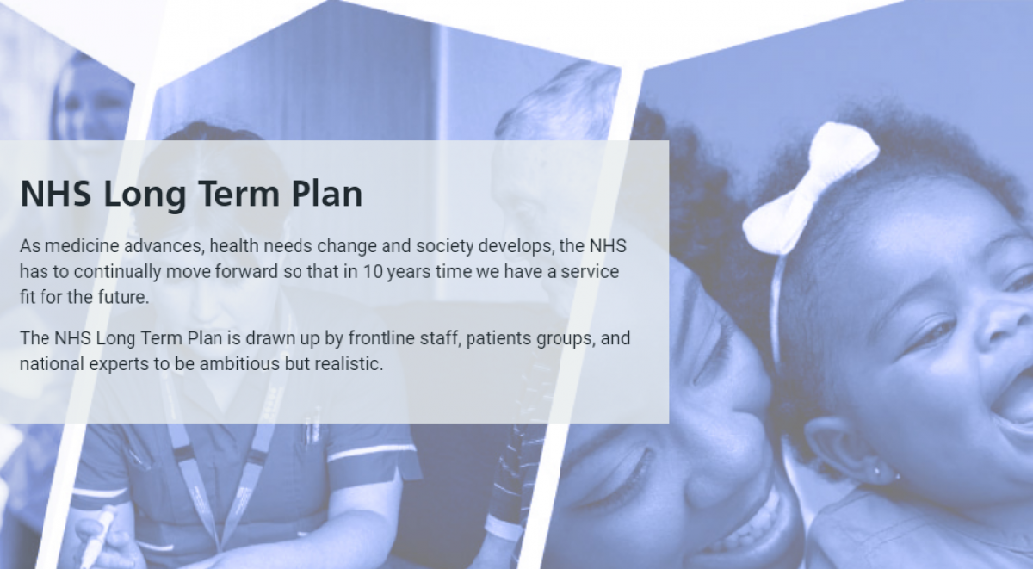
Figure: NHS Long Term Plan children's health England
( Shukla et al., 2023)

4. Organisation Supporting Adolescent Girls
Brook is a United Kingdom based charity focused on sexual health and wellbeing for young people (Pandurangi et al., 2022). A place where information, education and clinical services are available to the adolescent in an anonymous and confidential environment. Brook provides condoms and sex immunity testing, counselling and education materials and advocates for all aspects of relationships and sex education. The organisation also conducts research to help enhance youth sexual health policies and decrease inequities (Cosma et al., 2022). Through collaboration with schools, health systems and communities, Brook raises awareness, supports decision-making and supports vulnerable adolescent girls in the UK to improve their physical, emotional and reproductive health. Other organisation name ActionAid UK, Girls friendly society.

5. Conclusion
Gender health inequality persists among adolescent girls because of mental illness, reproductive health issues, violence, poverty, access to health care. The disparities are also significantly reduced by national policies and charities, but inequalities still exist. Early intervention, evidence-based public health strategies and equity in access to health services remain integral pillars of good health for adolescent girls' health throughout life in the United Kingdom.

References
Hammami, N., Da Silva, M.A. and Elgar, F.J., 2022. Trends in gender and socioeconomic inequalities in adolescent health over 16 years (2002–2018): findings from the Canadian Health Behaviour in School-aged Children study. Health Promotion and Chronic Disease Prevention in Canada: Research, Policy and Practice, 42(2), p.68. https://pmc.ncbi.nlm.nih.gov/articles/PMC8935898/
Rai, A., Chan, M.T. and Nambiar, S., 2023. Social and ecological disparities in anaemia among adolescent girls 15–19 years old in Nepal. Public Health Nutrition, 26(12), pp.2973-2981. https://www.cambridge.org/core/journals/public-health-nutrition/article/social-and-ecological-disparities-in-anaemia-among-adolescent-girls-1519-years-old-in-nepal/25A3F1D7691F1D880952365668937D1E
Cullen, P., Peden, A.E., Francis, K.L., Cini, K.I., Azzopardi, P., Möller, H., Peden, M., Sawyer, S.M., Nathan, S., Joshi, R. and Patton, G.C., 2024. Interpersonal violence and gender inequality in adolescents: A systematic analysis of global burden of disease data from 1990 to 2019. Journal of Adolescent Health, 74(2), pp.232-245. https://www.sciencedirect.com/science/article/pii/S1054139X23004573
Lemos, V.C., Barros, M.B.D.A. and Lima, M.G., 2023. Chronic diseases and health conditions in adolescents: sex inequalities. Revista brasileira de epidemiologia, 26, p.e230009. https://www.scielosp.org/article/rbepid/2023.v26/e230009/en/
Perestrelo, E.D., Sanyang, S. and Jumaa, J.A., 2025. The burden and associated social determinants of mental health among adolescent girls and young women in Sub-Saharan Africa. Discover Public Health, 22(1), p.207. https://link.springer.com/article/10.1186/s12982-025-00601-x
Alemu, T.G., Fentie, E.A., Belay, D.G., Asmamaw, D.B., Shewarega, E.S., Negash, W.D., Eshetu, H.B., Aragaw, F.M., Fetene, S.M. and Teklu, R.E., 2025. Socioeconomic inequality in the co-occurrence of anemia and stunting among adolescent girls aged 15–19 years in Sub-Saharan African countries: a decomposition analysis. BMC Public Health, 25(1), p.573. https://link.springer.com/article/10.1186/s12889-025-21841-1
Mar, J., Larranaga, I., Ibarrondo, O., González-Pinto, A., Las Hayas, C., Fullaondo, A., Izco-Basurko, I., Alonso, J., Mateo-Abad, M., de Manuel, E. and UPRIGHT Consortium, 2024. Socioeconomic and gender inequalities in mental disorders among adolescents and young adults. Spanish Journal of Psychiatry and Mental Health, 17(2), pp.95-102. https://www.sciencedirect.com/science/article/pii/S1888989122000763
Shukla, S., Ezebuihe, J.A. and Steinert, J.I., 2023. Association between public health emergencies and sexual and reproductive health, gender-based violence, and early marriage among adolescent girls: a rapid review. BMC public health, 23(1), p.117. https://link.springer.com/article/10.1186/s12889-023-15054-7
Pandurangi, R., Mummadi, M.K., Challa, S., Reddy, N.S., Kaliaperumal, V., Khadar Babu, C., Telikicherla, U.R., Pullakandham, R., Geddam, J.B. and Hemalatha, R., 2022. Burden and predictors of malnutrition among Indian adolescents (10–19 years): insights from Comprehensive National Nutrition Survey Data. Frontiers in Public Health, 10, p.877073. https://www.frontiersin.org/journals/public-health/articles/10.3389/fpubh.2022.877073/full
Lozano-Sánchez, A., Aragonès, E., López-Jiménez, T., Bennett, M., Evangelidou, S., Francisco, E., García, M., Malgosa, E., Codern-Bové, N., Guzmán-Molina, C. and Jacques-Aviñó, C., 2024. Temporal trends and social inequities in adolescent and young adult mental health disorders in Catalonia, Spain: a 2008–2022 primary care cohort study. Child and Adolescent Psychiatry and Mental Health, 18(1), p.159. https://link.springer.com/article/10.1186/s13034-024-00849-2
Laurenzi, C.A., Toska, E., Tallarico, R., Sherr, L., Steventon Roberts, K.J., Hansen, M., Tolmay, J., Jochim, J., Ameyan, W. and Yates, R., 2023. Key normative, legal, and policy considerations for supporting pregnant and postpartum adolescents in high HIV-burden settings: a critical analysis. Sexual and Reproductive Health Matters, 31(1), p.2249696.https://www.tandfonline.com/doi/abs/10.1080/26410397.2023.2249696
Aggarwal, S., Francis, K.L., Dashti, S.G. and Patton, G., 2023. Child marriage and the mental health of adolescent girls: a longitudinal cohort study from Uttar Pradesh and Bihar, India. The Lancet Regional Health-Southeast Asia, 8. https://www.thelancet.com/journals/lansea/article/PIIS2772-3682(22)00118-4/fulltext
Embleton, L., Braitstein, P., Di Ruggiero, E., Oduor, C. and Wado, Y.D., 2023. Sexual and reproductive health service utilization among adolescent girls in Kenya: A cross-sectional analysis. PLOS Global Public Health, 3(2),p.e0001508 .https://journals.plos.org/globalpublichealth/article?id=10.1371/journal.pgph.0001508
Carries, S., Sigwadhi, L.N., Moyo, A., Wagner, C., Mathews, C. and Govindasamy, D., 2024. Associations between household food insecurity and depressive symptomology among adolescent girls and young women during the COVID-19 pandemic in South Africa. Adolescents, 4(1), pp.185-199. https://www.mdpi.com/2673-7051/4/1/13
Cosma, A., Elgar, F.J., De Looze, M., Canale, N., Lenzi, M., Inchley, J. and Vieno, A., 2022. Structural gender inequality and gender differences in adolescent substance use: A multilevel study from 45 countries. SSM-population health, 19, p.101208. https://www.sciencedirect.com/science/article/pii/S2352827322001872
World Health Organization (2025). Mental health of adolescents. [online] World Health Organization. Available at: https://www.who.int/news-room/fact-sheets/detail/adolescent-mental-health [Accessed 20 July 2026].
Adolescent sexual and reproductive health and rights. (n.d.). [online] www.who.int. Available at: https://www.who.int/teams/sexual-and-reproductive-health-and-research-(srh)/areas-of-work/adolescent-and-sexual-and-reproductive-health-and-rights [Accessed 20 July 2026].
Guide: Adolescents and gender equality | UNICEF Adolescent Kit for Expression and Innovation

TASK 2 – Epidemiological Analysis
Epidemiological Analysis of HIV/AIDS among Adolescents and Young Adults (15–24 Years)

1. Introduction
Human Immunodeficiency Virus (HIV) is a communicable viral infection that infects the CD4 T lymphocytes, which form the body's immune system, and therefore cause the body to be weaker than normal in resisting infection and disease (Zhang et al., 2022). AIDS is the most advanced form of HIV infection, when the immune system is so weakened that opportunistic infections or some cancer arises. AIDS is the clinical syndrome that has evolved because of the unmanaged or untreated HIV infection. Despite progress in treatment and prevention, HIV continues to be one of the world's most important public health issues, with millions of people living with the virus, says the World Health Organization (WHO) and the Joint United Nations Programme on HIV/AIDS (UNAIDS). HIV transmission remains in the United Kingdom, but the number of new HIV diagnoses has reduced because of higher levels of HIV testing and early HIV diagnosis and treatment with antiretroviral therapy (ART). The risk among the adolescents and young adults (15-24 years) is high because of risky sexual practices, low level of sexual health knowledge, low condom use, stigma, drug and alcohol abuse, limited access to health care services (Zhao et al., 2020). The fact that HIV also has significant health, psychological, social and economic effects (including treatment dependency, stigma and discrimination, mental health problems, and reduced quality of life) means that effective public health interventions are needed.

2. Incidence and Prevalence
The World Health Organisation estimates that approximately 1.3 million new HIV infections occur around the world annually, and approximately 39 million people are infected with the virus. Adolescents and young adults continue to be at high risk, especially in sub-Saharan Africa (Ganu et al., 2024). In the United Kingdom, HIV cases continue to be reported, but the number of people diagnosed with HIV is decreasing. HIV cases continue to be reported in the United Kingdom, despite the reduction in HIV diagnoses. NHS services provide lifelong treatment with improved survival and reduced transmission. The gap is found in people who are treated; according to data from the office for national statistics, life expectancy has improved for those who are treated (Desmonde et al., 2020). The number of cases of the infection has fallen, but this is partly due to increased testing and diagnosis of the infection, and there is still an increased risk of infection in certain groups in Britain.
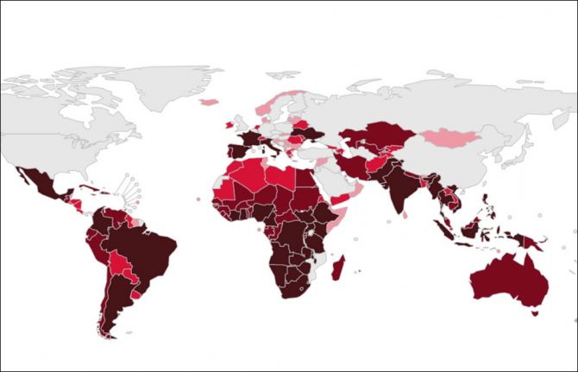
Figure: UNAIDS global HIV prevalence map 2024
(Desmonde et al., 2020)

3. Public Health Measures Using the 3 Ps
Public health goals for people ages 13-24 are focused on HIV prevention, protection and promotion. There are two pathways to prevention: encouraging the use of condoms and providing extensive HIV education and increasing access to pre-exposure prophylaxis (PrEP) for individuals at higher risk of acquiring HIV (Baldeh et al., 2024). Comprehensive Relationships, Sex and Health Education helps young people make decisions for safer sexual practices, and to learn about risk factors and remove misinformation about how HIV is transmitted. Prevention measures are regular HIV testing, partner notification and contact tracing (PNC), blood donation screening, and infection prevention and timely linkage to ARVs following diagnosis. These interventions decrease the chance of spreading the virus, facilitate timely treatment and enhance health outcomes. Being asked to participate in screening programs is also higher if youth-friendly sexual health services are confidential.
Health promotion aims to raise awareness and reduce stigma through national health promotion campaigns, community health promotion programmes and school, university and youth health promotion campaigns. Social networking digital media campaigns are a good choice to deliver trusted health information, testing services and prevention tips to teens (Nyongesa et al., 2022). Health services, schools and charities/community organisations can work together to enhance programme delivery and support healthy behaviours. Prevention, protection and promotion activities reduce the transmission of an HIV infection, promote health literacy, access to health services, national public health goals and reduce inequities for adolescents and young adults.

4. Determinants and Risk Factors
Adolescents and young adults are at risk for HIV transmission due to behavioural, social, biological and environmental risk factors (Tan et al., 2025). Unprotected sex, having multiple sexual partners and sharing of injecting equipment, especially needles, are risk factors for behaviour. Those with poor social determinants of health, such as poverty, gender inequality, and discrimination and HIV-related stigma, are less likely to seek health care and more vulnerable. Biological risk factors include untreated STIs that can put young adolescents at risk for HIV infection, and the immature reproductive and immune systems of adolescents. Sexual health services are geographically inequitable, there are fewer youth-friendly clinics offering the same services that are confidential, and inequitable access to health care services are all environmental factors (Ajiboye et al., 2023). Integrated policies should be implemented to tackle these interdependent determinants to ensure access to health services, social inclusion and prevention, as well as education for vulnerable youth populations.

5. Epidemiological Studies and Health Needs Assessment
Epidemiological studies have identified adolescents and young adults (15-24 years) as an important target group because of an increased risk of HIV exposure during adolescence (Worku et al., 2022). High risk groups defined by health needs assessment include young men who have sex with men, young people from high-risk communities and socially deprived young people. Information on the patterns of infection and on health services use and prevention requirements comes from population screening programmes, surveillance databases and behaviour surveys. The data will be utilized for planning for resources, targeted interventions and service planning (Li et al., 2024). Behavioural studies on sexual practices, HIV knowledge and health seeking behaviours provide information that helps to identify vulnerabilities for young people and adolescents as they relate to HIV and early detection and treatment, complementing epidemiological surveillance.

6. Monitoring and Surveillance Systems
HIV surveillance systems need to be comprehensive, have the capacity to identify trends, and monitor population-level trends and effectiveness of HIV interventions to inform public health decisions (Lv et al., 2024). Passive surveillance refers to routine notification received from HCPs, and active surveillance is when cases are actively identified and investigated. Sentinel surveillance systems picked up clinics or high-risk groups to watch for shifting patterns of transmission. Laboratory surveillance refers to the ongoing testing for HIV infection using standardized tests, and the monitoring of HIV treatment outcomes. Behavioural surveillance considers knowledge, attitudes and practices which impact the risk of infection. HIV surveillance is organised nationally by UKHSA through health care reporting systems and WHO collects HIV surveillance data globally to track global trends (Habib et al., 2024). Linking surveillance is a more effective way to detect outbreaks, assess a programme and inform evidence-based action on HIV prevention and control.

7. Public Health Impact
HIV has a short-term and a long-term effect on adolescents and young people. Short-term impacts encompass opportunities missed for infection, psychological stress, anxiety, depression and lack of school attendance due to illness or stigma. If a delay in diagnosis, complications and increased risk of transmission (Naidoo et al., 2022). Consequences over a longer period of time are in the transition to AIDS in cases of lack of treatment, shortened lifespan, higher health care costs and social exclusion because of discrimination. HIV can also impact on employment, educational attainment and family dynamics. Comprehensive prevention, early detection and sustained ART can substantially reduce these adverse effects and improve quality of life and survival.

8. Proposed Health Intervention Programme
The Healthy Futures HIV Prevention Programme aims to reduce HIV transmission among adolescent and young adults (ages 15-24). The goals are to increase awareness of HIV, promote safer sex and increase early HIV testing (Tabliga and Melford, 2026). Activities include school education sessions, condom distribution events (free condoms), confidential HIV screening events, awareness campaigns (digital), peer-led workshops. Increased health literacy, increased testing uptake and reduced HIV incidence are anticipated (Odokonyero et al., 2023). Attendance, testing rates, behavioural change and participant satisfaction would be assessed with SMART indicators and used as a programme evaluation of attendance, testing rates, behavioural change, participant satisfaction, which would allow for ongoing improvement and evidence-based decision making for future public health interventions.

9. Strengths and Weaknesses of the Epidemiological Approach
Epidemiological approaches offer valid surveillance information, can detect trends in disease and have a supporting role in early detection of HIV outbreaks (Muleia et al., 2022). They are used to inform policy development, evidence-based resource allocation and planning for interventions. There are however weaknesses, which are identified as under-reporting due to stigma, surveillance data incompleteness and delayed diagnosis and unequal access to health care for vulnerable populations (Chicanequisso et al., 2025). There could also be reporting bias affecting behavioural data. Notwithstanding these limitations, epidemiology has helped to unravel the mode of HIV transmission and the effectiveness of prevention efforts for adolescents and young adults.

10. Conclusion
Despite the progress in prevention and treatment, HIV is still a significant public health issue for adolescents and young adults. Surveillance systems are critical in delivering evidence to inform the identification of transmission patterns and assess interventions. Thoughtful prevention and protection and health promotion actions combined with comprehensive education and accessible health services reduce rates of infection and improve health. The early diagnosis and containment of the disease remain the crucial point in basic expanded testing. Capacity building of youth-friendly services should be continued to rise, while further reducing the stigma, raising awareness and addressing other social determinants of HIV vulnerability is key to achieving sustained reductions in HIV-related disparities.

References
Zhang, J., Ma, B., Han, X., Ding, S. and Li, Y., 2022. Global, regional, and national burdens of HIV and other sexually transmitted infections in adolescents and young adults aged 10–24 years from 1990 to 2019: a trend analysis based on the Global Burden of Disease Study 2019. The Lancet Child & Adolescent Health, 6(11), pp.763-776. https://www.thelancet.com/journals/lanchi/article/PIIS2352-4642(22)00219-X/abstract
Zhao, H., Liu, H., Wang, L., Yang, X., Wang, S., Han, M. and Li, J., 2020. Epidemiological characteristics of newly-reported HIV cases among youth aged 15− 24 years—China, 2010− 2019. China CDC Weekly, 2(48), p.913. https://pmc.ncbi.nlm.nih.gov/articles/PMC8422364/
Ganu, V., Oladele, O., Amankwa, E., Okine, R. and Puplampu, P., 2024. Clinico-epidemiological characteristics of adolescents and young adults living with HIV in Ghana. The Pan African Medical Journal, 48, p.54. https://pmc.ncbi.nlm.nih.gov/articles/PMC11419576/
Desmonde, S., Ciaranello, A.L., Malateste, K., Musick, B., Patten, G., Vu, A.T., Edmonds, A., Neilan, A.M., Duda, S.N., Wools-Kaloustian, K. and Davies, M.A., 2020. Age-specific mortality rate ratios in adolescents and youth aged 10–24 years living with perinatally versus nonperinatally acquired HIV. AIDS (London, England), 35(4), p.625. https://pmc.ncbi.nlm.nih.gov/articles/PMC7904586
Baldeh, M., Kizito, S., Lakoh, S., Sesay, D., Williams, S.A., Barrie, U., Dennis, F., Robinson, D.R., Lamontagne, F., Amahowe, F. and Turay, P., 2024. Advanced HIV disease and associated factors among young people aged 15—24 years at a tertiary hospital in Sierra Leone: a cross-sectional study. BMC infectious diseases, 24(1), p.611. https://link.springer.com/article/10.1186/s12879-024-09524-5
Nyongesa, M.K., Mwatasa, M.H., Kagonya, V.A., Mwambingu, G., Ngetsa, C., Newton, C.R. and Abubakar, A., 2022. HIV virological non-suppression is highly prevalent among 18-to 24-year-old youths on antiretroviral therapy at the Kenyan coast. BMC Infectious Diseases, 22(1), p.449. https://link.springer.com/article/10.1186/s12879-022-07428-w
Tan, Y., Ma, Z., Cao, Q., Gao, S.C. and Xiong, Y., 2025. Prevalence of common mental disorders and sleep disorder among adolescents and young adults with HIV: a systematic review and meta-analysis. BMJ open, 15(5), p.e093320. https://bmjopen.bmj.com/content/15/5/e093320.abstract
Ajiboye, A.S., Eshetu, F., Lulseged, S., Getaneh, Y., Tademe, N., Kifle, T., Bray, R., Eshete, H., Demissie, Y., Dykewicz, C.A. and Hoos, D., 2023. Predictors of HIV testing among youth 15–24 years in urban Ethiopia, 2017–2018 Ethiopia population-based HIV impact assessment. PloS one, 18(7), p.e0265710. https://journals.plos.org/plosone/article?id=10.1371/journal.pone.0265710
Worku, M.G., Teshale, A.B. and Tesema, G.A., 2022. Prevalence and associated factors of HIV testing among young (15–24) women in eastern Africa: a multilevel analysis of demographic health survey data (2008-2018). Archives of Public Health, 80(1), p.117. https://link.springer.com/article/10.1186/s13690-022-00879-2
Li, X., Zhang, N., Ma, L., Wang, Q., Liang, Y., Liu, X. and Zhou, F., 2024. Prevalence trends of anemia impairment in adolescents and young adults with HIV/AIDS. BMC Public Health, 24(1), p.1301.https://link.springer.com/article/10.1186/s12889-024-18730-4
Lv, J.J., Zhang, Y.C., Li, X.Y., Yang, C.H. and Wang, X., 2024. Global, regional, national epidemiology and trends of neglected tropical diseases in youths and young adults aged 15–39 years from 1990 to 2019: findings from the global burden of disease study 2019. BMC Public Health, 24(1), p.2088. https://link.springer.com/article/10.1186/s12889-024-19190-6
Habib, A., Goswami, K., Ojah, J. and Bharali, M.D., 2024. Knowledge and attitudes about HIV/AIDS among adolescent students in 15-19 years age group based on the adolescent education programme: a cross-sectional study conducted in Kamrup (metro), Assam. Cureus, 16(6), p.e62122. https://assets.cureus.com/uploads/original_article/pdf/259988/20240711-3576-by6fcg.pdf
Naidoo, I., Takatshana, S., Sewpaul, R., Jooste, S., Siyanai, Z., Maseko, G., Moyo, S., Zuma, K., Mabaso, M. and Nompumelelo, Z., 2022. Past and current status of adolescents living with HIV in South Africa, 2005–2017. BMC research notes, 15(1), p.132. https://link.springer.com/article/10.1186/s13104-022-06006-2
Tabliga, C.B. and Melford, C.M., 2026. HIV in the Philippines, 1984-2025: A Longitudinal Analysis of National Surveillance Data and Youth Vulnerability Patterns. Available at SSRN 6532718. https://papers.ssrn.com/sol3/papers.cfm?abstract_id=6532718
Chicanequisso, E.M., Sabonete, A., Sacarlal, J., Rossetto, É.V., Cassimo, M.N. and Baltazar, C.S., 2025. Factors associated with HIV infection among adolescents and young people in Mozambique: sub-analysis of immunization, malaria and HIV/AIDS indicator survey in Mozambique-IMASIDA 2015. BMC Public Health, 25(1), p.2932. https://link.springer.com/article/10.1186/s12889-025-24122-z
Odokonyero, R.F., Ocan, M., Kinengyere, A.A., Nakasujja, N., Muhwezi, W.W., Camlin, C.S. and Hahn, J.A., 2023. Prevalence of, and factors associated with, alcohol use disorder among young adults (aged 15–24 years) living with HIV/AIDS in low-income and middle-income countries: protocol for a systematic review. BMJ open, 13(1), p.e068108. https://bmjopen.bmj.com/content/13/1/e068108.abstract
Muleia, R., Aerts, M., Loquiha, O. and Faes, C., 2022. HIV risk factors among adolescent and young adults: A geospatial–temporal analysis of Mozambique AIDS indicator survey data. Spatial and Spatio-temporal Epidemiology, 41, p.100499. https://www.sciencedirect.com/science/article/pii/S1877584522000235

