ACCA7002 Database Systems
Tutorial Tasks

Tutorial 1: Installing PostgreSQL and pgAdmin4, Create a Scot= Database, Create tables with
Primary and Foreign Keys

1.1: What is PostgreSQL?

1.2 List some features of PostgreSQL.

1.3: Install PostgreSQL on Windows

There are three steps to complete the PostgreSQL installation:

- Download PostgreSQL installer for Windows
- Install PostgreSQL
- Verify the installation

- Download PostgreSQL Installer for Windows from h=ps://www.enterprisedb.com/downloads/postgres-postgresql-downloads

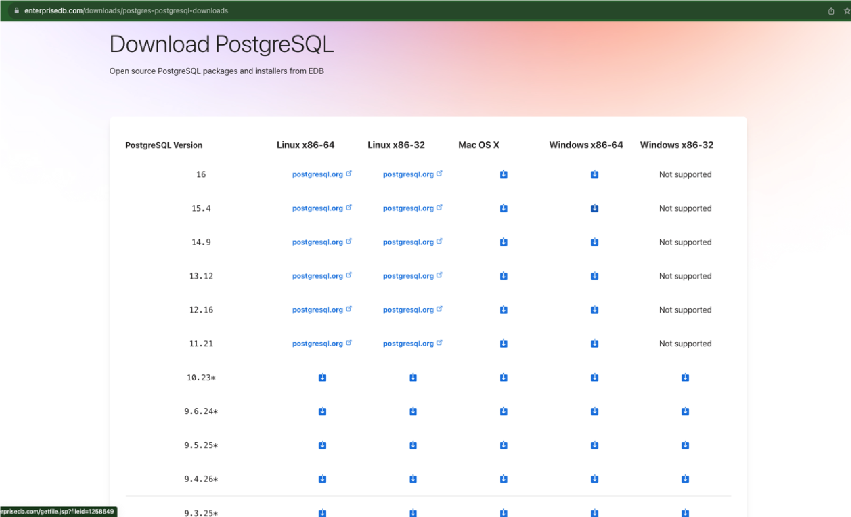

- Install PostgreSQL on Window step by step

To install PostgreSQL on Windows, you need to have administrator privileges.

Step 1. Double click on the installer file, an installaKon wizard will appear and guide you through mulKple steps where you can choose different opKons that you would like to have in PostgreSQL.

Step 2. Click the Next bu=on

Step 3. Specify installaKon folder, choose your own or keep the default folder suggested by
PostgreSQL installer and click the Next bu=on

Step 4. Select soWware components to install: o The PostgreSQL Server to install the PostgreSQL database server o pgAdmin 4 to install the PostgreSQL database GUI management tool.
  - Command Line Tools to install command-line tools such as psql, pg_restore, etc. These tools allow you to interact with the PostgreSQL database server using the command-line interface.
  - Stack Builder provides a GUI that allows you to download and install drivers that work with PostgreSQL.

Step 5. Select the database directory to store the data or accept the default folder. And click the Next button to go to the next step:
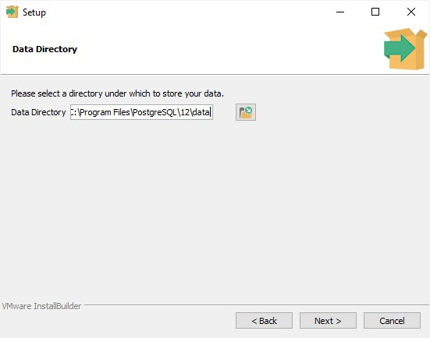
Step 6. Enter the password for the database superuser (postgres)
PostgreSQL runs as a service in the background under a service account named postgres. If you already created a service account with the name postgres, you need to provide the password of that account in the following window.
After entering the password, you need to retype it to confirm and click the Next button:
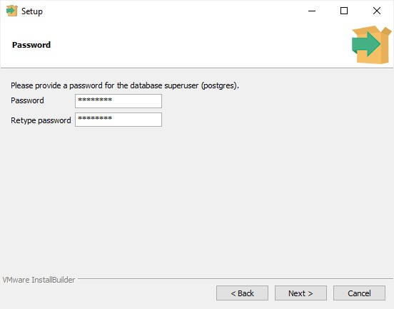
Step 7. Enter a port number on which the PostgreSQL database server will listen. The default port of PostgreSQL is 5432. You need to make sure that no other applications are using this port.
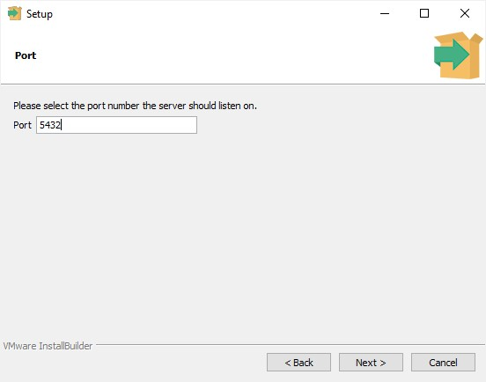
Step 8. Choose the default locale used by the PostgreSQL database. If you leave it as default locale, PostgreSQL will use the operating system locale. After that click the Next button.
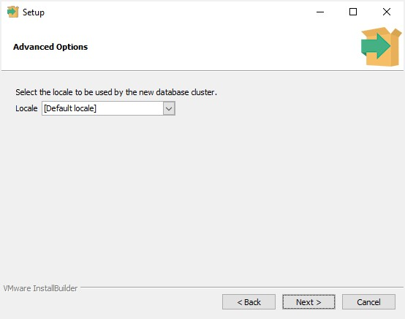
Step 9. The setup wizard will show the summary information of PostgreSQL. You need to review it and click the Next button if everything is correct. Otherwise, you need to click the Back button to change the configuration accordingly.
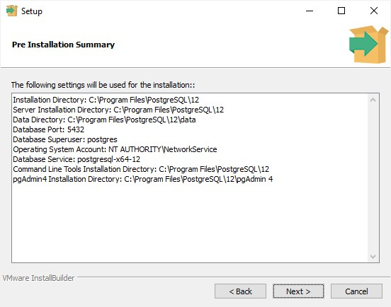
Now, you’re ready to install PostgreSQL on your computer. Click the Next button to begin installing PostgreSQL.
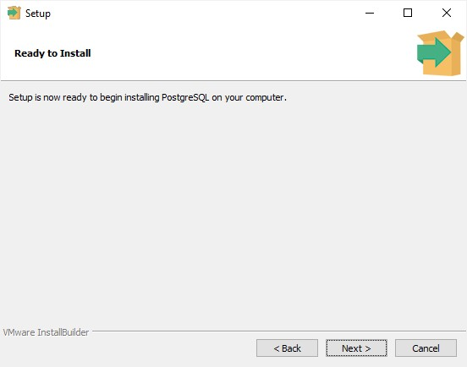
The installation may take a few minutes to complete.
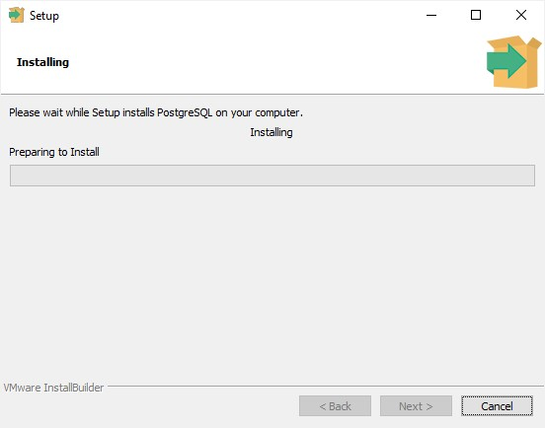
Step 10. Click the Finish button to complete the PostgreSQL installation.
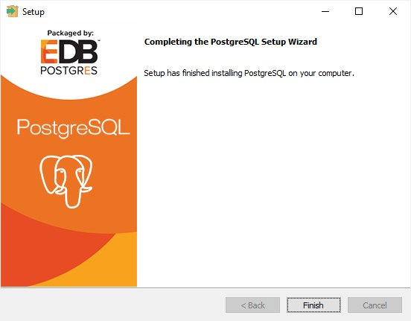

3) Verify the Installation
There are several ways to verify the PostgreSQL installation. You can try to connect to the PostgreSQL database server from any client application e.g., psql and pgAdmin.
The quick way to verify the installation is through the psql program.
First, click the psql application to launch it. The psql command-line program will display.
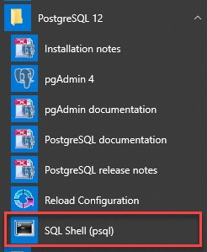
Second, enter all the necessary information such as the server, database, port, username, and password. To accept the default, you can press Enter. Note that you should provide the password that you entered during installing the PostgreSQL.
Server [localhost]:
Database [postgres]:
Port [5432]:
Username [postgres]: Password for user postgres:
psql (12.3)
WARNING: Console code page (437) differs from Windows code page (1252)
8-bit characters might not work correctly. See psql reference page "Notes for Windows users" for details.
Type "help" for help.

postgres=#Code language: Shell Session (shell)
Third, issue the command SELECT version(); you will see the following output:
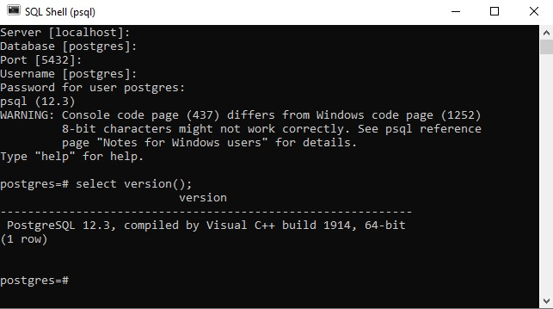
Well done you’ve successfully installed PostgreSQL database server on your local system.

1.4 Connect to a PostgreSQL Database Server
Steps to connect to the PostgreSQL database server via the following tools:
- psql – a terminal-based front-end to PostgreSQL database server.
- pgAdmin – a web-based front-end to PostgreSQL database server.
First, launch the psql program and connect to the PostgreSQL Database Server using the postgres user:
Second, enter all the information such as Server, Database, Port, Username, and Password. If you press Enter, the program will use the default value specified in the square bracket [] and move the cursor to the new line. For example, localhost is the default database server. In the step for entering the password for user postgres, you need to enter the password the user postgres that you chose during the PostgreSQL installation.
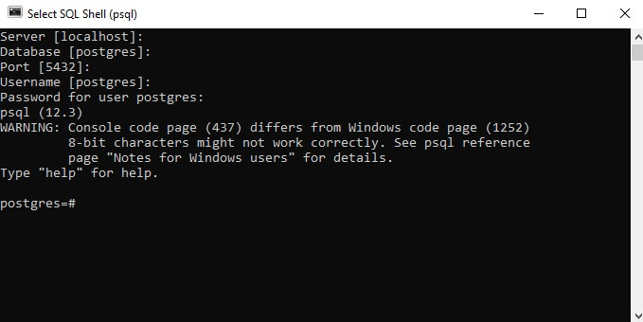

Third, interact with the PostgreSQL Database Server by issuing an SQL statement. The following statement returns the current version of PostgreSQL:
SELECT version();Code language: SQL (Structured Query Language) (sql)
Please do not forget to end the statement with a semicolon (;). After pressing Enter, psql will return the current PostgreSQL version on your system.
2) Connect to PostgreSQL database server using pgAdmin
The second way to connect to a database is by using a pgAdmin application. The pgAdmin application allows you to interact with the PostgreSQL database server via an intuitive user interface.
The following illustrates how to connect to a database using pgAdmin GUI application:
First, launch the pgAdmin application.
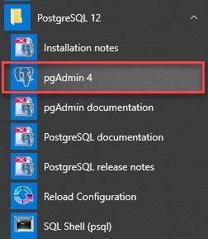
The pgAdmin application will launch on the web browser as shown in the following picture:
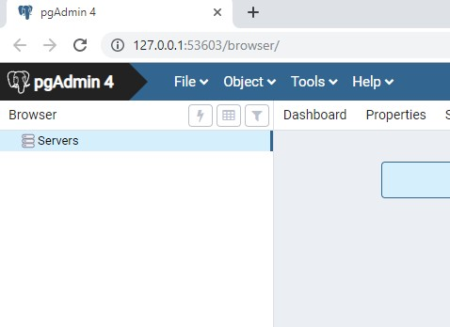
Second, right-click the Servers node and select Create > Server… menu to create a server
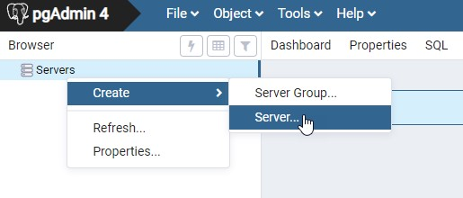
Third, enter the server name e.g., PostgreSQL and click the Connection tab:
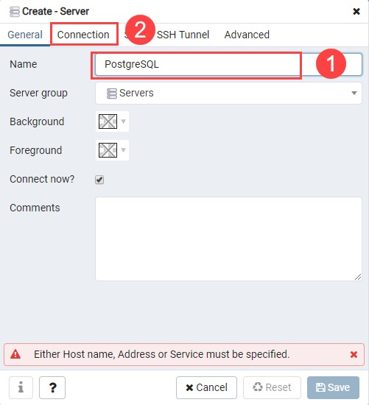
Fourth, enter the host and password for the postgres user and click the Save button:
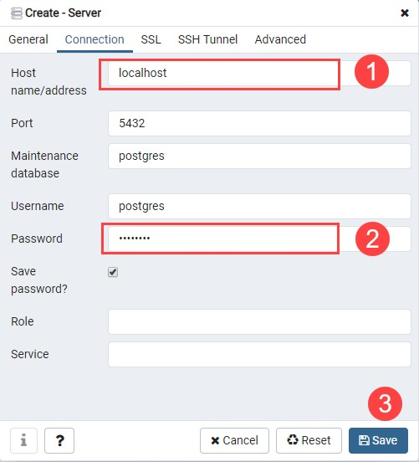
Fifth, click on the Servers node to expand the server. By default, PostgreSQL has a database named postgres as shown below:
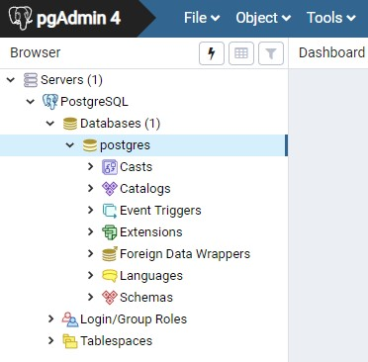
Sixth, open the query tool by choosing the menu item Tool > Query Tool or click the lightning icon.
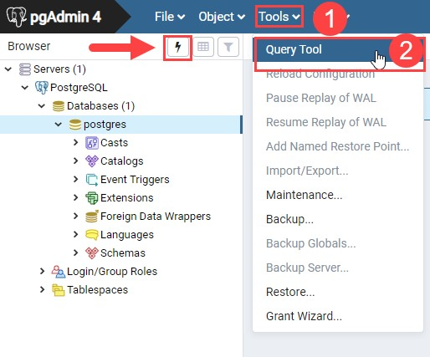
Seventh, enter the query in the Query Editor, click the Execute button, you will see the result of the query displaying in the Data Output tab:
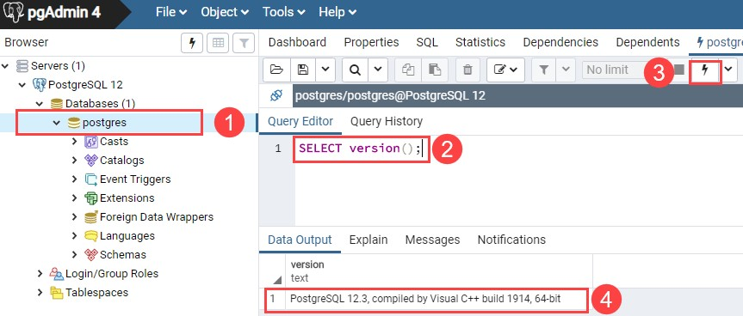

1.5 Create Database ‘Sco=’
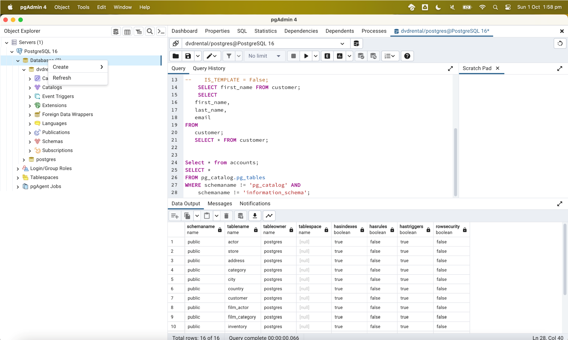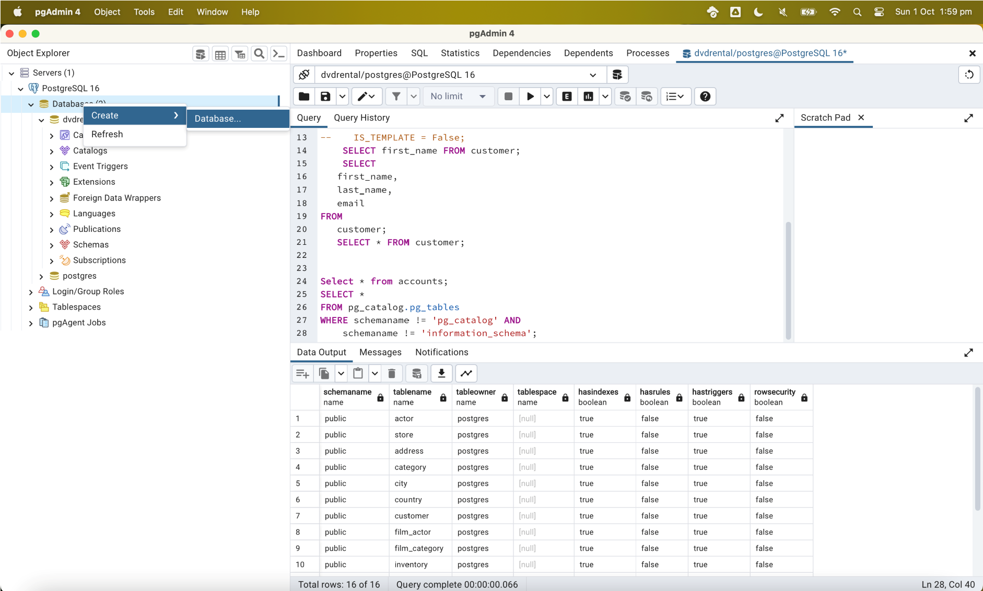

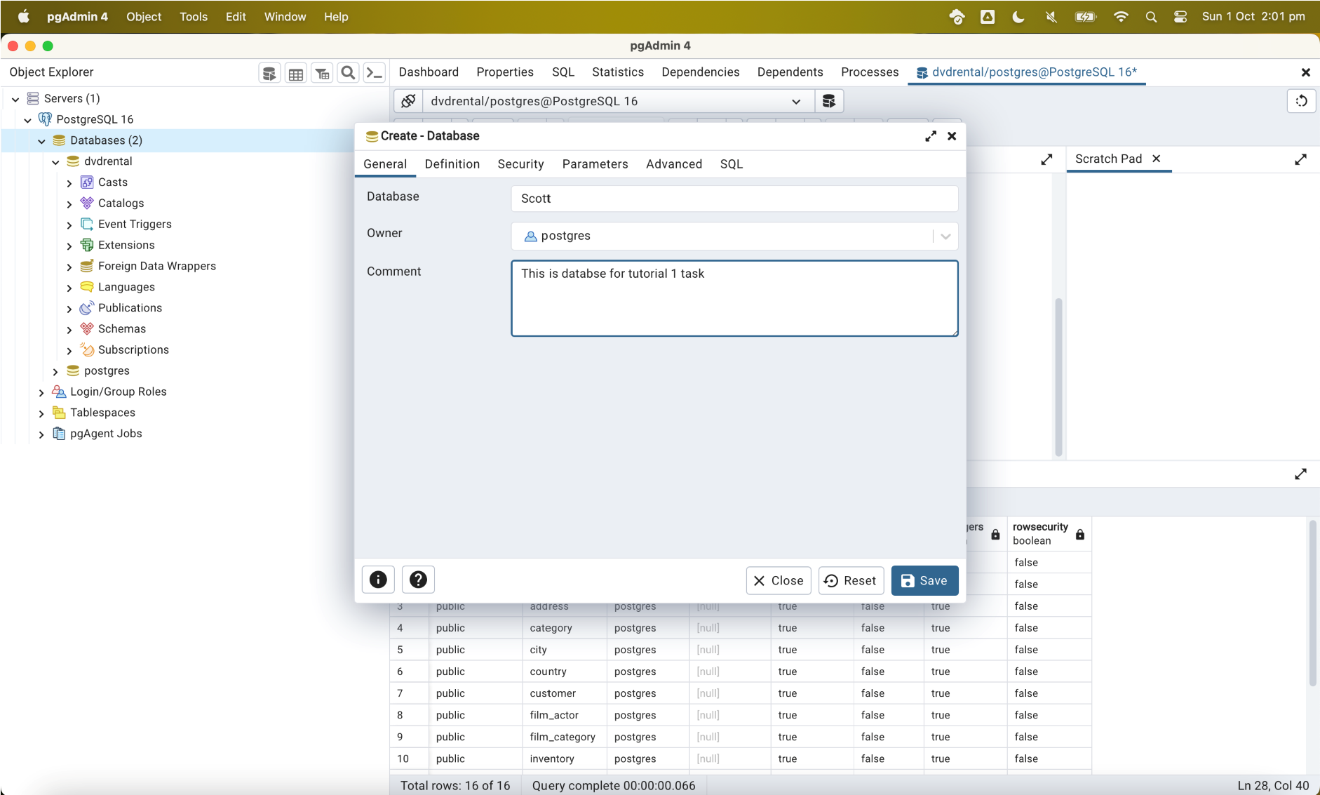

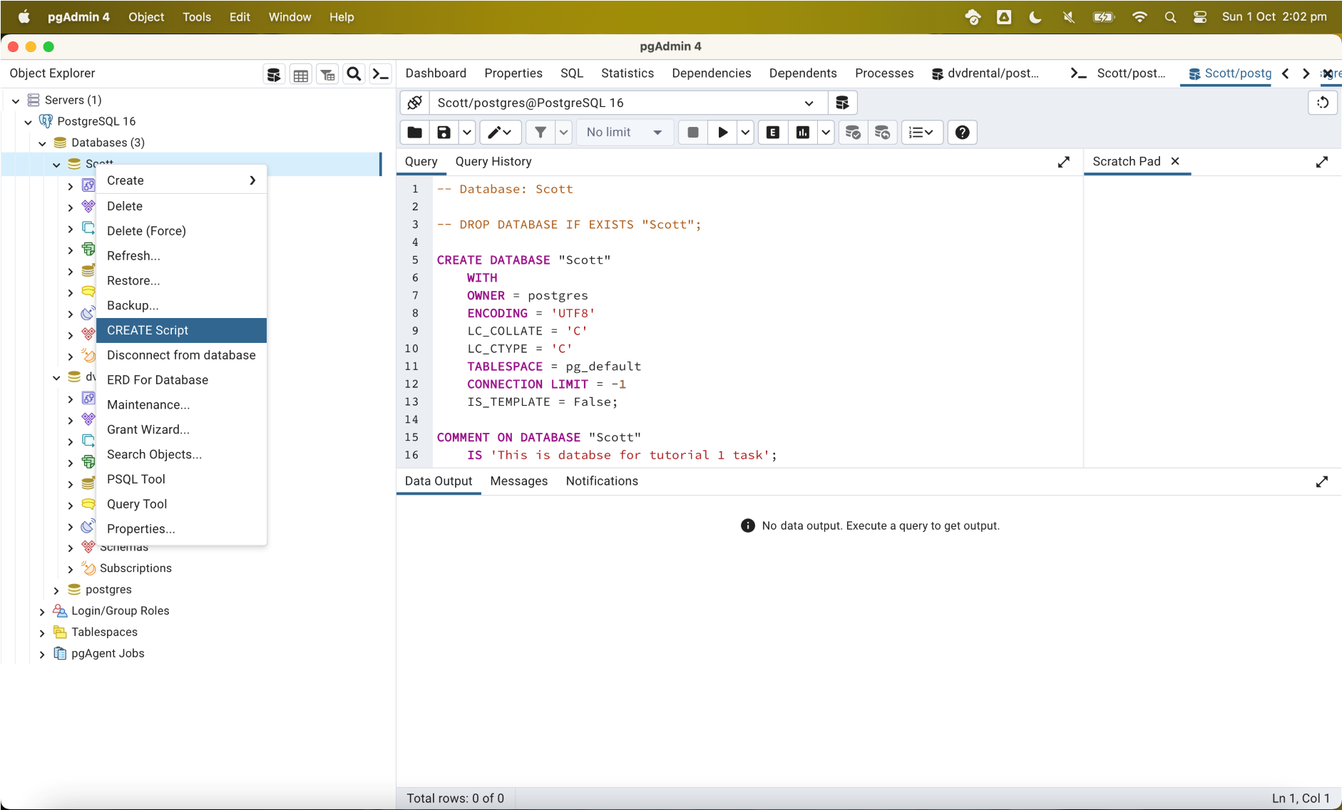
1.6 Create Table

PostgreSQL CREATE TABLE syntax
A relational database consists of multiple related tables. A table consists of rows and columns. Tables allow you to store structured data like customers, products, employees, etc.

To create a new table, you use the CREATE TABLE statement. The following illustrates the basic syntax of the CREATE TABLE statement:

CREATE TABLE [IF NOT EXISTS] table_name ( column1 datatype(length) column_constraint, column2 datatype(length) column_constraint, column3 datatype(length) column_constraint,
table_constraints
);
PostgreSQL includes the following column constraints:

- NOT NULL – ensures that values in a column cannot be NULL. o UNIQUE – ensures the values in a column unique across the rows within the same table.
- PRIMARY KEY – a primary key column uniquely identify rows in a table. A table can have one and only one primary key. The primary key constraint allows you to define the primary key of a table.
- CHECK – a CHECK constraint ensures the data must satisfy a boolean expression. o FOREIGN KEY – ensures values in a column or a group of columns from a table exists in a column or group of columns in another table. Unlike the primary key, a table can have many foreign keys.

Note: Table constraints are similar to column constraints except that they are applied to more than one column.

Try the below PostgreSQL statements

1.6.1 Basic Table Creation:

CREATE TABLE employee ( employee_id serial PRIMARY KEY, first_name VARCHAR(50) NOT NULL, last_name VARCHAR(50) NOT NULL,
hire_date DATE,
is_active BOOLEAN DEFAULT true
);

1.6.2 Now alter the above to include [IF NOT EXISTS] and record the output.

