Joseph Ogden
1704684
Word Count: 1418
Based on a critical discussion of selected Latin inscriptions that you consider significant, discuss how Latin epigraphy contributes to our understanding of the Augustan era

Within this essay I will examine a number of inscriptions relating to the Augustan period that I believe illuminate our knowledge of the era. In particular I will pay close attention to the Res Gestae Divi Augusti; Augustus’ autobiographical funerary inscription, relevant dedications from Alison Cooley’s case study of epigraphy in Tripolitania, and a range of coins that bring to light both the usefulness of epigraphy in understanding the period, and some of the issues that Latin epigraphy can present to historians. In doing so, I ultimately aim to show that whilst extremely useful, epigraphical sources must be carefully considered and contextualised in order to become a satisfactory accompaniment to other source materials in the study of the Augustan era and, more broadly, the ancient world as a whole.

Augustus’ Res Gestae is an important benchmark in examining the period. Above all else, Cooley argues that the Res Gestae ‘offers an invaluable insight into the political ideology of the Augustan era’, and that when studied alongside other inscriptions, coins and literary texts reveals key themes (such as that of world conquest and restoring the constitutional government) of the period. Güven argues that the Res Gestae is a ‘master narrative’, one that unfolds ‘like a historical film’, listing Augustus’ many achievements, his endowments to the Roman people, his successful campaigns and his many reforms. The inscription is useful because, as Güven argues, there is no major falsification of events, although others have noted certain omissions and ‘suppression of facts’, such as not naming Brutus and Mark Antony, his enemies. The Res Gestae, then, serves as an important reference in the study of the period, as it provides us with a wealth of information that can arguably be carefully relied upon. Despite this, Augustus’ ‘narrative’ remains problematic in that it is self-aggrandising and arguably serves as propaganda, which Güven tells us was to ‘ensure the continuity of empire spawned and nurtured by Augustus’, and therefore the continuity of the Julio-Claudian dynasty.

A positive aspect of the Res Gestae, Gordon argues, is the fact that there are literary references to it, such as Suetonius’ accounts, which is uncommonly characteristic of inscriptions. Equally positive is that the reproduction of the Res Gestae into stone is also the reason for its preservation, Gordon says. Due to the original inscription being made in bronze, as a valuable material it would have later been melted for re-use. The use of material is not a trivial point and can be an important feature of epigraphy. It has been noted that the use of bronze in the Res Gestae evoked notions of ‘sacrosanctity’ and ‘moral authority’, as-well as alluding to religious sanctity that underpinned Augustus’ rule. Gordon, however, presents a number of problems with the epigraphical nature of the Res Gestae, such as mistakes when inscriptions were copied or translated between Latin and Greek, as-well as the unfortunate fact that many inscriptions were lost during the destruction of cities, hence the surviving copies of Res Gestae being found in remote places. It is also safe to assume that nuances in content and translation issues between the copies of the Res Gestae, as discussed by Gordon and also by Cooley, would indicate that the copies cannot be verbatim reflections of the original.

Other epigraphical sources pertaining to the Augustan era highlight the rise of Roman Imperialism and changes across the empire under Augustus. In particular, dedications to Augustus have been found from across Italy and in the furthest reaches of the provinces and allied territories. Examples found in Lepcis Magna, a city located in the Roman province of Africa in what is now Libya, paint a narrative of events under Augustus’ reign. One prominent inscription lying within the theatre there featuring Augustus, dated to 1-2 AD (Fig. 1), is pertinent to this narrative. Another is a direct dedication to Augustus at the chalcidicum, dated 11-12 AD (Fig. 2).
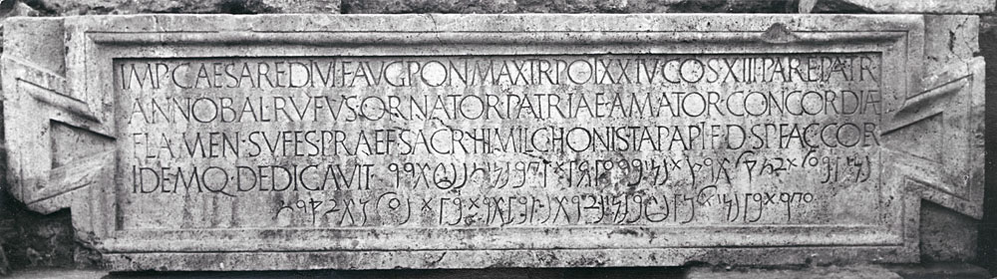
Figure 1 - Dedication at the theatre in Lepcis Magna - IRT2009 321

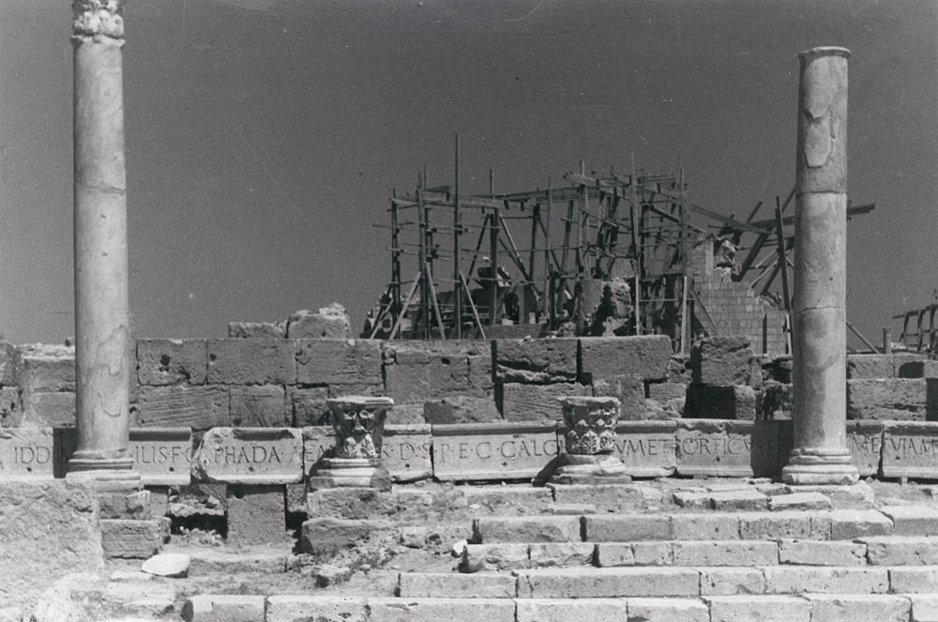
Figure 2 - Dedication to Augustus at the chalcidicum in Lepcis Magna - IRT2009 324

Cooley identifies the role of Augustus in the dedication at the theatre as prominent, but notes that whilst ‘imperial rule remained firmly in the background’, the buildings at this time were not dedicated directly to Augustus (Cooley indicates Augustus’ name is in the ablative case in the theatre dedication), but rather his titles serve primarily as a ‘dating formula’. The ability to date particular events through such inscriptions is, of course, an extremely useful quality of Latin epigraphy in general, with it being a quality of a vast number of inscriptions throughout Roman history. Regardless of the specificity of the dedication in Fig. 1, Roman imperialism is clearly present. Moreover, Cooley notes a shift in later years, as the dedication at the chalcidicum is made directly to the ‘divine spirit’ of Augustus. Here, Latin epigraphy is able to construct a narrative of increasing Roman influence and grip on the province under Augustus, particularly given the renewed bonds between Lepcis and Rome following local campaigns against the Gaetulians in 6 AD. A striking example of the deification and veneration of Augustus in a dedication that followed also serves both as evidence for the events and, again, as a method of dating said events. (Fig. 3).
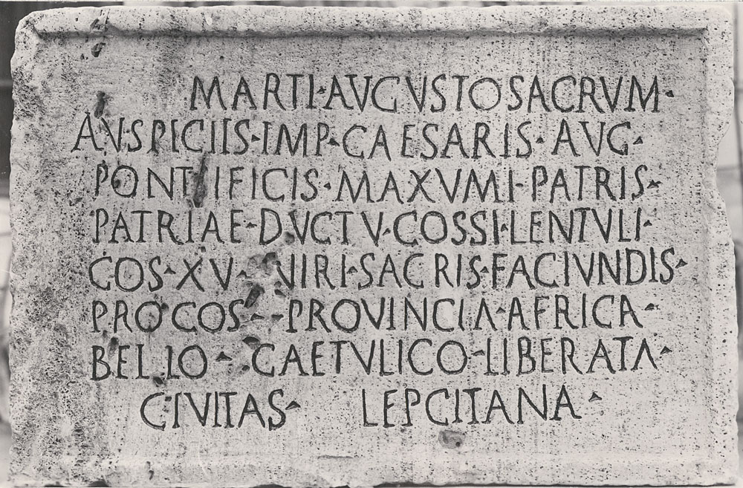
Figure 3 - Dedication to Mars Augustus in Lepcis Magna – IRT2009 301

Another interesting form of epigraphy relating to the Augustan era is the use of coins. Whilst typically not considered as epigraphy proper, falling under the category of numismatics, Cooley notes that coins acted as monumenta in the same fashion as monumental inscriptions, making their position in epigraphy a somewhat semantical debate. The Augustan period typifies this, Cooley says, with coins not just displaying the status of an individual, but in some cases depicting inscriptions themselves (see Fig. 4).

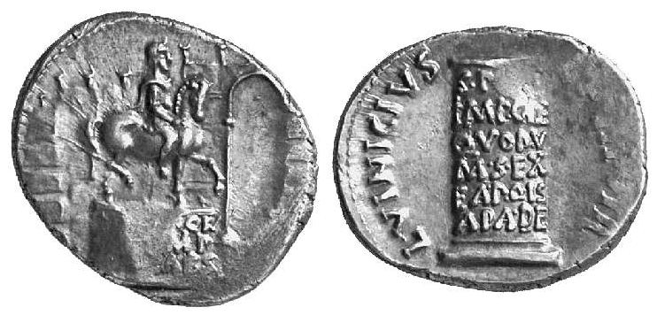
Figure 4 - Augustus Denarius, 16BC, featuring an inscribed equestrian statue – RIC I² 362
The large number of coins dated to the Augustan era is largely telling of Augustus’ reformations of coinage, and the coins are equally important as iconographic evidence of the portrayal of his public image during the period. It has also been noted by West that whilst Augustus permitted many cities to continue to issue their own coins, this was done ‘under imperial supervision’ with the emphasis on the unity of the Roman World. Further to this, West notes that coins served a unique function in spreading news and influencing public opinion across the empire, and that the images on the reverse of the coins change ‘in close agreement with current political changes’.
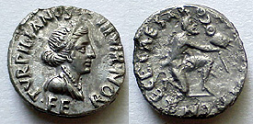
Figure 5 - Augustus Denarius, 19 BC, featuring a kneeling Parthian presenting a standard - RIC I² 288

West provides an example of coins used in this context (Fig. 5), with coins minted in approximately 19 BC to commemorate the return of army standards captured by the Parthians at the Battle of Crassus in 53 BC, evidencing exactly how coins could be used to spread news and celebrate victories throughout the provinces. West also notes the circulation of these coins in the eastern parts of the empire, where emphasis of the achievement would also be ‘psychologically important’. Here, Latin epigraphy is invaluable in providing us with tangible evidence and information relating to the era.

There are clear advantages and disadvantages in the use of Latin epigraphy. Through the Res Gestae Divi Augusti, which has been aptly named ‘the Queen of inscriptions’, we are given an enormous account of events and justifications that forms a core part of our knowledge of the Augustan era. Similarly, I have indicated scholarship that shows coins and other inscriptions also reinforce many of the key themes (expansionism; reformation; religion; propaganda) that we see in the Res Gestae. Inscriptions are also useful as they almost always behave as a first-hand account, and so are always ‘true’ in some sense of the word. Even when they convey misinformation or propaganda, they become tangible evidence of the psychology behind the creation of the inscription, provided there is other source material to contextualise the issues. The epigraphy of the Augustan era, then, is perhaps best examined alongside other source materials in order to create an enriched, coherent narrative and understanding of the era.

Bibliography
Cooley, A. 2011. Res Gestae Divi Augusti: Text, Translation and Commentary. Cambridge University Press.
Cooley, A. 2012. The Cambridge Manual of Latin Epigraphy. Cambridge University Press.
Gordon, A. 1968. Notes on the "Res Gestae" of Augustus. California Studies in Classical Antiquity. University of California Press.
Güven, S. 1998. Displaying the Res Gestae of Augustus: A Monument of Imperial Image for All. Journal of the Society of Architectural Historians. University of California Press.
Reynolds, J.M; Ward-Perkins, J.B. 2009. Inscriptions of Roman Tripolitania. http://inslib.kcl.ac.uk/irt2009/ [Accessed: 30th April 2018]
Sutherland, C.H.V. 1984. Roman Imperial Coinage Volume I. Spink & Son Ltd.
West, L. 1949. Imperial Publicity on Coins of the Roman Emperors. The Classical Journal. The Classical Association of the Middle West and South, Inc.

Cooley, A. 2011. 2.
Güven, S. 1998. 31; Gordon, A. 1968. 135.
Güven, S. 1998. 30-31.
Cooley, A. 2011. 3.
Gordon, A. 1968. 129-131.
Cooley, A. 2012. 303-304.
Cooley, A. 2012. 258-259.
Cooley A. 2012. 254
Cooley, A. 2012. 125-126.
West, L. 1949. 19.
West, L. 1949. 20.

