Student Name: Saira Zaeed
Student Number: 2332216
Module Name: Changemaker: Creativity and Value Creation
Module Code: BMHP5014
Lecturer Name: Precious Igbinigie
Assignment Title: component 1 Online Portfolio of Set Exercises

Task 1 – Concept Map

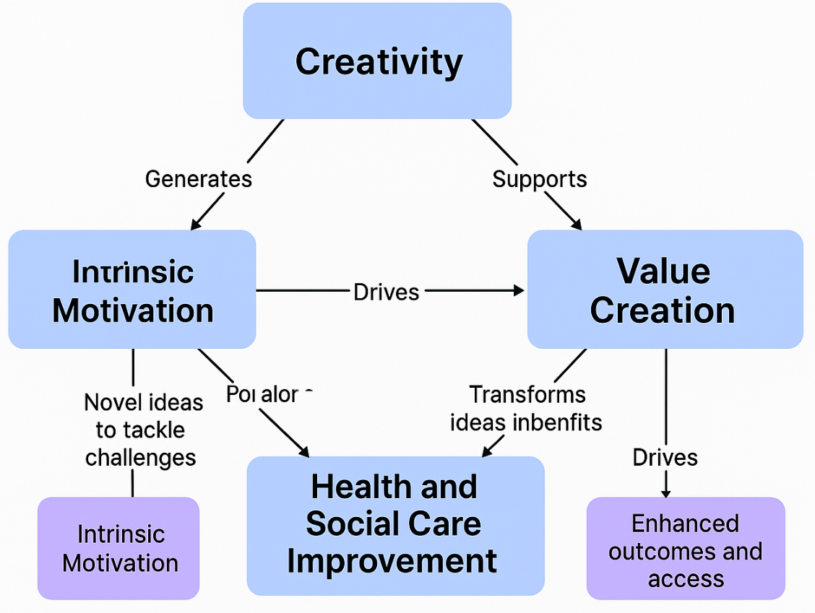
concepts of (H&SC) are intrinsically link and contribute to the development of innovation, improved patient outcomes, and resilience of organisations. Creativity is the mental and imaginative capacity to produce innovative ideas that will solve healthcare problems, so the key to solving complicated H&SC problems.
Value creation converts creative concepts into concrete patience, practitioner, and systems benefits. Healthcare value is the best results at the least cost, but in the H&SC, there is value in compassion, equality, and user satisfaction. As an example, such interventions as Pre-Moed Prep show that creative interventions can decrease the anxiety of children prior to the treatment, enhancing their wellbeing and the quality of the services. H&SC improvement fuelled by both creativity and value creation, which encourage prevention, digital inclusion, and integrated care. Creativity, when paired with intrinsic motivation, improves the interest of staff and creative problem-solving. This engagement guarantees sustainable development in which professionals can think dynamically, match care with the demands of the community, and provide equal access.
Simply put, creativity leads to new thinking, value creation makes it measurable, and they both reinforce continuous improvement and whole person’s health in the changing healthcare environment.

Task 2 - Self-Reflection of Group Activity
I applied to the Experiential Learning Cycle created by Kolb to reflect on the paper-clip group activity in Week 2, which covered the topic of divergent and convergent thinking in creative problem-solving.
Concrete Experience: Our four members given the task of enlisting as alternative uses of a paperclip as possible in ten minutes. It started off in a messy manner but before long turned out to be invigorating as everyone produced imaginative suggestions- rudimentary phone stands, miniature sculpture.
Reflective Observation: I observed the role of openness and humour in promoting psychological safety, which promoted participation. My habit was to judge too soon, and this constrained the flow of ideas at the beginning, and this demonstrates how premature judgement inhibits divergence.
Abstract Conceptualisation: The session helped me understand that divergent thinking allows us to produce various possibilities freely, whereas convergent thinking needs the synthesis and rational consideration of these possibilities to determine what is possible. Using either of them in turn leads to innovative but feasible solutions, which agrees with the claim by researcher that switching between the two modes enhances creative cognition and reflective learning (Zainal Abidin aet al., 2022).
Active Experimentation: I will apply this dual-thinking model in future projects in addressing complicated care issues by initially broadening the brainstorming ideas through brainstorming and then narrowing them down through critical prioritisation. Deliberate alternations between the two modes can be practise, which can improve the innovation in care planning, patient engagement, and team problem-solving (Slåtten et al., 2023).
This experience enhanced my comprehension that creativity in health and social care is not a solitary inspiration but a process of structured and reflective cycles of balancing imagination and analytical rigour.

Task 3 - Case Study of a UK innovation
Case Study: NHS at Home Remote Monitoring of Chronic Disease Management: The NHS at Home is a new digital healthcare model intended to support patients with long-term conditions such as heart failure, diabetes, and chronic respiratory diseases. It was the result of the NHS’s strategic intention to reduce hospitalisation and improve patient autonomy through remote care solutions.
Case Study 1 - NHS at Home:
The model combines wearable technologies, home-based monitoring tools, and digital communication systems to ensure continuous monitoring of patients’ home conditions, comfort, and independence.
Practical Application: The innovative aspect of this programme’s use of technology is the combination of human-centred design and predictive analytics. Wearable sensors help patients gather health data, which is relay to clinicians in real time. AI algorithms detect abnormalities early, enabling timely clinical intervention.
Case Study 1 - NHS at Home
. The design was based on co-creation, with clinicians, technologists, and patients involved in the process to make the platform intuitive and personalised. Such a strategy demonstrates the principles of design thinking, in which creativity lies between technological innovation and caring.
Value Creation for Service Users: This innovation provides value by enhancing patient outcomes, satisfaction, and resource utilisation. It minimises emergency admissions and waiting period, enabling hospitals to direct staff to acute care. Self-efficacy is another aspect of the programme, and it teaches patients to make sense of their health data, so they feel in control and share responsibility. Research shows that patient engagement and readmission rates have enhanced by up to 22 per cent using digital remote-monitoring systems within the NHS, creating tangible value (Po aet al., 2024). On the same note, Vats (2024) highlights that innovative digital integration enhances patient safety, equity, and accessibility while maintaining operational efficiency.
Conclusion: The NHS at Home initiative demonstrates how innovative problem-solving and digital technologies can transform the delivery of care. It is an example of how innovation can deliver quantifiable value, leveraging technology, patient empowerment, and the active use of data to improve not only the patient experience but also system performance across the UK environment.

Task 4 - Research Task
Current Issue: Mental Health Stigma and Barriers: The Stigma of mental health significant challenges has observed to exclude people seeking timely support and has led to persistent inequalities in access to mental health care. Stigma expressed in the form of negative attitudes towards the population, stereotypes, and internalised shame, which together dishearten to seek help and undermine confidence in the professional care systems.
Study 1: Chukwuma et al. (2023) conducted a systematic review of the effects of stigmatisation on psychiatric outcomes and found that its direct impact includes reduced treatment adherence, reduced engagement, and reduced help-seeking behaviour. The victims who internalise stigma tend to put off seeking treatment due to the fear that they can be judge, discriminated against, or regarded as weak. The research finds that social stigma (misunderstandings about mental illness in society) and self-stigma (acceptance of the stereotypes by the individual) both support the process of disengagement with healthcare, thus leading to worse recovery outcomes and reduced well-being. The authors propose combined stigma-reduction programmes to enhance health equity and patient outcomes.
Study 2- Hajizadeh aet al. (2024). How to Combat Stigma: A 2024 meta-analysis in BMC Psychiatry identified that internalised stigma is a phenomenon that impacts almost 29 per cent of individuals with mental health conditions around the world. The study identifies that stigma discourages disclosure, restricts access to therapeutic services, and discourages open dialogue about the symptoms. The authors emphasise that stigma is a social and psychological barrier to effective care and promote evidence-based methods to overcome stereotypes and improve access to support, including education, social contact programmes, and narrative interventions.

Task 5 - Podcast

Task 6 - NHS Leadership Framework Analysis
Overview of the NHS Leadership Framework: The NHS Leadership Framework is a set of seven interrelated areas that aimed at influencing leadership behaviours and professional growth at all levels of health and social care. These are the qualities of showing personal qualities, collaboration with others, (2025). The framework encourages values-based inclusive leadership that is in line with the NHS Constitution, which focuses on collaboration, accountability, and patient-centred improvement. It is based on the principle of distributed leadership, which acknowledges that leadership is a collective practise that is not just the preserve of top managers. All the domains combine competencies of communication, integrity, evidence-based decision-making, and ongoing improvement to influence the quality of services and innovation. The framework facilitates the influence of transformation on staff by promoting self-awareness, teamwork, and collaboration across the entire system of care delivery. It continues to form the foundation of professional growth, connecting ethical leadership to sustainable innovation and enabling healthcare teams to be creative in addressing the complex and changing needs of patients.
Selected Component: Improving Services: Improving Services domain dedicated to the culture of innovation, critical assessment, and patient safety (NHS Leadership Academy, 2025). One way a leader can use this element is to establish multidisciplinary innovation centres in their NHS trust, where workers invited to challenge the current practise and suggest data-driven changes. Indicatively, they may open forums in which nurses, clinicians, and patients co-design care pathways, including the use of digital tools to improve efficiency and safety. Research shows that reflective learning and psychological safety are promote by inclusive leadership that positively influences creative problem-solving and patient outcomes (Benjamin and Chung, 2023). With curiosity modelling, creative input recognition, and feedback loop incorporation, such a leader turns improvement into a management role into a shared, creative process, which constantly changes services to fit the evolving needs of patients without sacrificing quality, safety, and compassion.

Task 7 - Self-Reflection Journal Entry
Experience with this module changed my perspective in health and social care. In the beginning, I perceived as an individual competence of a designer or an innovator, but due to lectures and activities, I now realise it as a systematic, group process that leads to improved quality of care and problem solving. The implementation of design thinking and leadership models helped me understand how compassion and innovation can transform into quantifiable patient outcomes improvements.
I have also understood that value creation does not only take place in cost efficiency, but in creating holistic benefit, which is emotional, ethical, and clinical. Case studies, including NHS at Home and reflective group exercises, helped me to realise that small creative changes, such as enhancing communication or co-designing interventions with patients, yield long-term system value.
The module has also made me adopt the spirit of an entrepreneur by viewing every problem as a chance to make a creative change. In the future, I will also consider reflective thinking and collaborative ideation as part of my everyday practice to provide compassionate, evidence-based, and innovative care.

Reference List
- Benjamin, C. & Chung, D., 2023. Leadership practices and behaviours that enable and inhibit a continuous improvement in culture in an NHS trust. BMJ Leader, 7(2), pp.117–121. Available at: https://bmjleader.bmj.com/content/7/2/117 [Accessed 13 October 2025].
- Chukwuma, O.V., Ezeani, E.I., Fatoye, E.O., Benjamin, J., Okobi, O.E., Nwume, C.G. & Egberuare, E.N., 2024. A Systematic Review of the Effect of Stigmatization on Psychiatric Illness Outcomes. Cureus, 16(6), e62642. Available at: https://pmc.ncbi.nlm.nih.gov/articles/PMC11258934/ [Accessed 10 October 2025].
- Hajizadeh, A., Amini, H., Heydari, M. & Rajabi, F., 2024. How to combat stigma surrounding mental health disorders: a scoping review of the experiences of different stakeholders. BMC Psychiatry, 24, Article 782. Available at: https://bmcpsychiatry.biomedcentral.com/articles/10.1186/s12888-024-06220-1 [Accessed 14 October 2025].
- NHS Leadership Academy, 2025. Leadership Framework. Available at: https://www.leadershipacademy.nhs.uk/leadership-framework/ [Accessed 13 October 2025].
- Po, H.-W., Chu, Y.-C., Tsai, H.-C., Lin, C.-L., Chen, C.-Y. & Ma, M.H.-M., 2024. Efficacy of Remote Health Monitoring in Reducing Hospital Readmissions Among High-Risk Postdischarge Patients: Prospective Cohort Study. JMIR Formative Research, 8, e53455. Available at: https://pmc.ncbi.nlm.nih.gov/articles/PMC11437225/ [Accessed 11 October 2025].
- Slåtten, T., Mutonyi, B.R., Nordli, A.J. & Lien, G., 2023. The role of ambidextrous leadership and employee ambidexterity in enhancing service quality of care and creativity – a study of health professionals. BMC Health Services Research, 23(1252). Available at: https://bmchealthservres.biomedcentral.com/articles/10.1186/s12913-023-10275-3 [Accessed 1 November 2025].
- Vats, K., 2024. Navigating the Digital Landscape: Embracing Innovation, Addressing Challenges, and Prioritizing Patient-Centric Care. Cureus, 16(4), e58352. Available at: https://doi.org/10.7759/cureus.58352 [Accessed 10 October 2025].
- Zainal Abidin, M.R., Che Ishak, F.A., Ismail, I.A. & Juhari, N.H., 2022. Explicating chefs’ creativity in utilising Malaysian local herbs toward the development of modern Malaysian cuisine: A proposition of a conceptual framework for creative culinary process. Thinking Skills and Creativity, 46, 101133. Available at: https://doi.org/10.1016/j.tsc.2022.101133 [Accessed 11 October 2025].

