WORKSHEET 3 – TESTING (Arrays)

- Original code:
using System.Globalization;

internal class Program
{
private static void Main(string[] args)
{
string pizza;
string chips;
string tea;
string coffee;
string banana;
string[] Items = new string[] {pizza, chips, tea, coffee, banana};

double Pizza = 3.45;
double Tea = 1.35;
double Coffee = 1.82;
double Chips = 1.20;
double Banana = 0.17;
double[] ItemsPrice = new double[] { Pizza, Tea, Coffee, Chips, Banana };

// Ask the user for the number of pizzas they want to order
Console.Write("How many Items would you like to order? ");
int numberOfItems;
while (!int.TryParse(Console.ReadLine(), out numberOfItems) || numberOfItems <= 0 || numberOfItems > 5)
{
Console.WriteLine("Invalid input. Please enter a valid number of Items:");
}

}
}
}

- Code Testing

For each test below, run your code and enter the values provided. Provide a screenshot of the programme output. Did the programme behave correctly or did it do something unexpected? Fill in a box for each test below.

- Enter the 5 normal values as shown on the example screenshot (on the question sheet)
ie pizza 3.45, chips 1.20, tea 1.35, coffee 1.82 and banana 0.17
Double check the staff discount for the above values, is it correct?

- Enter pizza -2.34 chips -1.10, tea -1.22, coffee -2.05 and banana -0.18

- Enter your own values, but leave some of them blank

Test: i. Enter the 5 normal values as shown on the example
ie pizza 3.45, chips 1.20, tea 1.35, coffee 1.82 and banana 0.17
Double check the staff discount for the above values, is it correct?
Screenshot(s) of output:
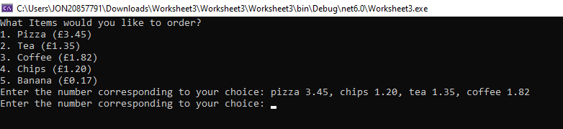
Result: Did the programme behave as expected ie syntactically and logically correct?
YES/NO (delete as appropriate)
If NO, what went wrong?
No , I couldn’t finish the code and do what I wanted due to running out of time, I changed the way I wanted to do it multiple times and just couldn’t find the way I wanted it to work

Test: ii. Enter pizza -2.34 chips -1.10, tea -1.22, coffee -2.05 and banana -0.18

Screenshot(s) of output:
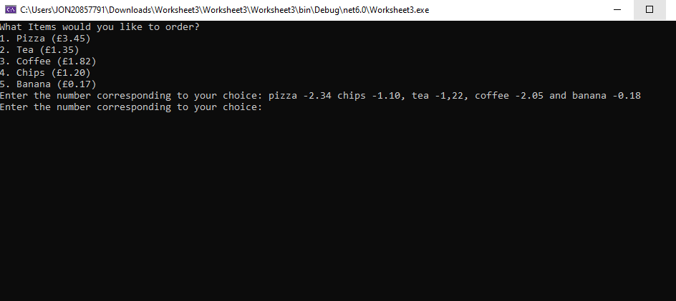
Result: Did the programme behave as expected ie syntactically and logically correct?
YES/NO (delete as appropriate)
If NO, what went wrong?

No , I couldn’t finish the code and I should’ve done a validation check to make sure the prices are anything above 0

Test: iii) Enter a few of your own values, leave some of the inputs blank

Screenshot(s) of output:
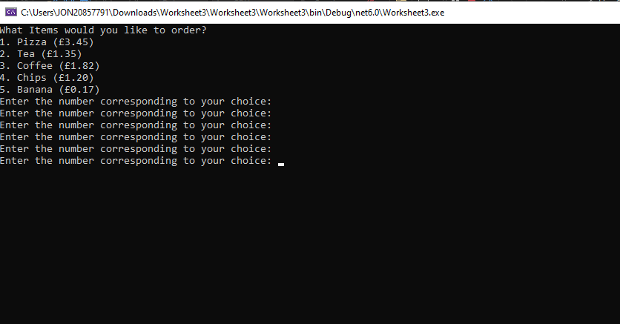
Result: Did the programme behave as expected ie syntactically and logically correct?
YES/NO (delete as appropriate)
If NO, what went wrong?

No , I couldn’t finish the code, I needed to add a presence check so I could check whether the user has inputted anything

Any other tests you feel may be relevant, or reveal a strength or deficiency in your original code, please detail below:
Test:

Screenshot(s) of output:

Result: Did the programme behave as expected ie syntactically and logically correct?
YES/NO (delete as appropriate)
If NO, what went wrong?

- Consider the results of the above tests and revisit your code in order to solve any problems discovered at the testing phase. (Note: you may not be able to solve all of them, but solve as many as you can.)

Paste your revised code here:
No revised code but what I needed to do was make it so the user could input items into an array, then the prices of the items into another array , I would’ve then had to output the total cost by adding up what was in the prices array as the user had inputted it, then outputted the total before and after applying the 15% staff discount

