survey of a littoral zone using remote sensing platforms
Samuel Darcy-Page (1910580)

University of Wales Trinity Saint David
Remote Sensing and Imaging

Contents
Table of Figures 2
Table of Tables 3
1. Introduction 4
2. Remote Sensing Platforms 4
2.1. Sensor Systems 4
2.2. Manned Aerial Survey Systems 6
2.3. Unmanned Aerial Survey Systems (Drones) 7
2.4. Satellites 7
3. Recommendations 7
4. Data Processing 7
References 8

Table of Figures
Figure 1 - LiDAR Output Graphs
Figure 2 - Point Cloud Data from a LiDAR Survey (blue Poins show the ground reflections, Orange Points show the Canopy Reflections) [2]
Figure 3 - An example of aerial photogrammetry [4]
Figure 4 - Examples of a re-sampled image using Interpolation Methods [17]

Table of Tables
Table 1 - An Example Sensor to be fitted for aerial survey [6]

Introduction
There is a requirement to gather a new data set of the littoral zone in an urban area. This data is to be gathered remotely and processed to show the features required. The features to be shown are the topography, local structures and accessways to a resolution of 15cm. In recent years, a focus has been placed on aerial remote sensing to move away from ground-borne and ship-born surveys as they have limited special coverage [1]. This report focusses on aerial solutions to this task.

Remote Sensing Platforms

Sensor Systems
There is a wide array of sensor arrays that can be used for the survey of an area and subsequent creation of a Digital Terrain Model. One method of remote sensing being used increasingly is LiDAR which in the recent years has been used to map areas such as Stonehenge [2]. This would be appropriate for mapping the local structures in the area to be surveyed as per the requirement.
LiDAR works on the principle of elastic scattering which is where a laser is emitted from the sensor without any wavelength changes [3]. This allows a time-of-flight measurement to be taken from the laser pulse being emitted and the subsequent received signal allowing a distance measurement to be calculated provided that the precise geolocation of the sensing element is known [3].
LiDAR is very effective at penetrating certain types of woodland canopy and is also capable of picking out details of accessways such as roads or pathways [2].
This gives a graph of the topography as shown in Figure 1 that can be interpreted into a topographical representation when later processed.

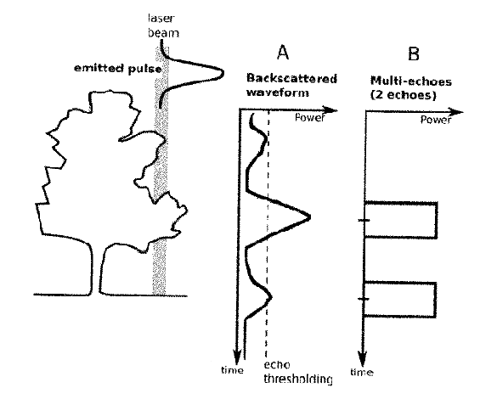
Figure 1 - LiDAR Output Graphs
Most LiDAR systems, work in an eye safe wavelength range of 900 – 1550 nm [2]. This is generally sufficient, however for the survey of a littoral zone, where there is an area if water to be surveyed, a twin beam system should be considered. This is where a green beam is used to detect the seabed whereas, the blue beam detects the sea surface and terrain [2]. This is known as Bathymetric LiDAR [2].
Whilst the LiDAR systems being employed don’t provide all that much detail over a single point, it has one major advantage and that is that it is an active sensor. This means that it sends a signal from the sensor as well as receives which means that the limitations of certain sensors where they can’t be used in extreme darkness don’t apply to LiDAR sensors [2]. A Point Cloud showing the received data from a LiDAR sensor is shown in Figure 2.

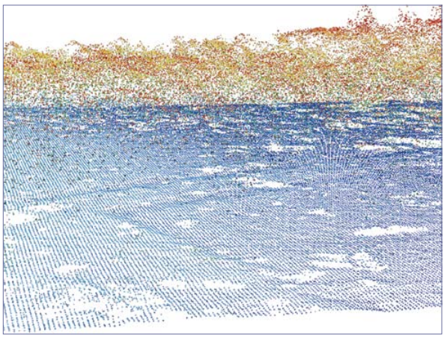
Figure 2 - Point Cloud Data from a LiDAR Survey (blue Poins show the ground reflections, Orange Points show the Canopy Reflections) [2]

Should there be a requirement for aerial photography, high resolution RGB cameras can be used. The technique is referred to as photogrammetry. Photogrammetry is a technique where multiple images are taken of a feature and then used to construct an accurate 2D or 3D model which allows special information to be obtained [4].
An example is shown below in Figure 3

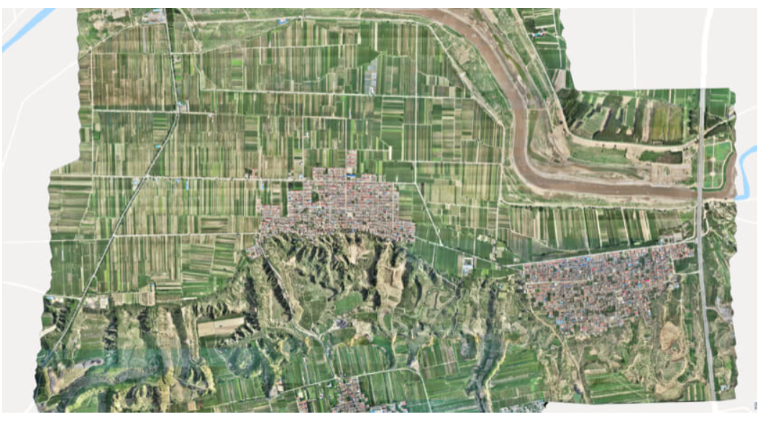
Figure 3 - An example of aerial photogrammetry [4]

Photogrammetry can be divided roughly in to two main categories. These are Metric Photogrammetry and Interpretive Photogrammetry [4]. The main distinction between these two methods are the methods used to determine feature height. Metric Photogrammetry uses coordinate points to accurately measure the distance whereas Interpretive Photogrammetry uses an interpretation of shadows, shapes and any patterns that may be apparent in the image [4].
Other options for multi-spectral analysis are optical scanners that operate in multiple wave bands. An example of this technology is the Airborne Visible/Infrared Imaging Spectrometer (AVIRIS) which works continuously in the Wavelengths from 0.4 – 2.4 µm [5]. This is useful as it picks up all visible spectra as well as the near-IR wavelengths to identify objects that are not as visible to the naked eye through the visible spectrum such as obscured accessways.

Manned Aerial Survey Systems
Manned aerial surveys are one common remote sensing platform where the sensor suite is attached to a piloted fixed wing aircraft [6]. These have been used successfully for decades for a wide range of applications such as wildlife management and can cover large areas in in a short period of time [6].
These types of mission can be very advantageous, however, there are some well documented limitations to this method of data collection. The first is effect of operator fatigue over the course of the mission [6]. This has the potential to limit the flight times for the mission and also extend the time required to see the mission to completion.

Unmanned Aerial Survey Systems (Drones)
An emerging technology in the civilian research area is the use of Unmanned Aerial Systems (UAS) [6]. UASs until recently have only been used in military application but have now been employed for law enforcement and even research settings, therefore, it is now an option to use them for airborne surveys [7].
The main advantage to Unmanned Aerial Systems is that they tend to incorporate GPS and inertial measurements automatically allowing easy georeferencing saving time when processing the data [7].
A potential limitation to the use of drones (assuming that the drone to be used is a small, lightweight civilian drone) is that the flight height is limited to 400 ft [8]. However, this is less of a problem, due to the requirement to have a Ground Spatial Resolution of 15cm requiring a low flight height [9].

Satellites
The final sensor platform to be considered in this report is satellite imagery and sampled data. Satellites, unlike the other methods described above which require a specific mission to be launched, can continuously monitor the areas, the globe over building an ever more detailed image of the area to be surveyed [10]. The likelihood of launching a new satellite specifically to map a small littoral zone is very low, meaning that the survey of the littoral zone will be limited to data that can be found on existing satellite imagery. This presents several limitations, such as limitations on the sensor properties and the resulting spatial resolution [10].
Whilst this is likely to be a limitation in the short term, as the satellite passes the area multiple times, there is a greater chance to overlap imagery and data sets to create a digital surface model of sufficient resolution.
Another limitation is that the orbit must match that of the littoral zone to be mapped. This may mean that the time to map the required zone is prohibitively long. Also, should the satellite to be used be in a Low Earth Orbit, the effects of speed and image blur will be greater enhanced, therefore requiring a fast shutter speed camera to reduce this effect potentially increasing cost [11].

Recommendations
Table 1 - An Example Sensor to be fitted for aerial survey [6]
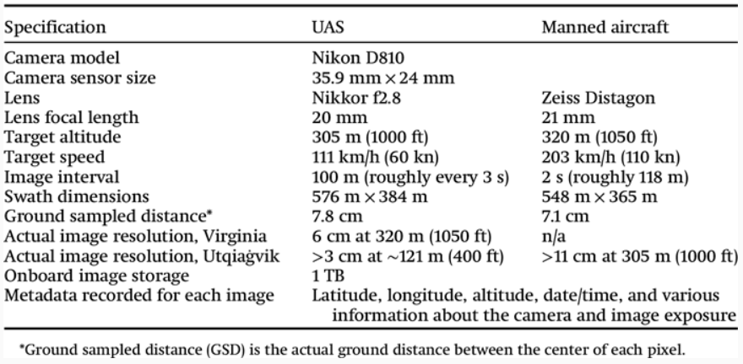
The most basic way of collecting the data is to select an appropriate camera system and use a manned aerial survey to mount it to. An example of a suitable camera system is shown above in Table 1.
However, as discussed above, there are drawbacks to this method, not least of which is the human element. Also, should the sensor system be strapped to an aircraft, there are very specific heights that they can be flown at. As the special resolution at the ground is directly related to the height of the survey, the closer to the ground that the remote data can be captured, the greater the resolution [9].
The use of manned aircraft can also be expensive, so a more cost-effective method is to use an Unmanned Aerial System, as there is no limit on operator fatigue, and often, the data is automatically georeferenced using a GPS link. The main limitation is the ability to conduct out of line-of-sight missions [6]. This might be a limitation as multiple launch sites may be required to gather the required data set.
As there is a requirement to map the littoral zone and all accessways, it is recommended to use a Bathymetric LiDAR sensor to allow the sea floor to be mapped as well as the sea surface. In the future, this can also be used to map sea level rises in the area. The properties of LiDAR also mean that it can’t be used to see through canopies but as the requirement is to create a Digital Surface Model, this isn’t a concern. Extra care should be taken to ensure the survey is conducted on a day with limited cloud cover to ensure the highest quality data is obtained.

The overall recommendations are to use an Unmanned Aerial System equipped with a Bathymetric LiDAR system and 4k RGB CCD Camera to capture both detailed colour imagery and the relevant topographical measurements to produce an eventual Digital Surface Model.

Data Processing
Once the remotely sensed data has been captured, it must be geo-referenced and subsequently linked to the Ordnance Survey 1:1250 scale maps. The first step in this process is that of Georeferencing.
This can only occur once corrections for any parallax errors introduced have been performed. Geometric Correction is necessary as most remotely sensed imagery has geometric distortion. This can be so severe that commonly, these images can’t be used directly within GIS programmes [12]. Recently, this has become of greater importance especially as the requirement is to have a ground resolution of 15cm. In the past, where ground resolution was approximately 100m, the effect of geometric distortion was negligible whereas sub metre resolution requires much more precise imaging when comparison to Ordnance Survey Maps is necessary [12]. This correction process does have the ability to introduce errors however, mainly from the detection and accurate matching of features [13].
The most likely parallax error is due to an oblique viewing angle, which will have a greater effect the closer to the ground that the remotely sensed imagery is captured from. This is most common from linear arrays where the viewing angle changes on each sweep of the sensor [13].
Georeferencing is the process of referencing known control points on the Raster Data provided by the sensor platforms to the same control points on the Ordnance Survey maps mentioned above [14]. This allows the remotely sensed data to be related to the area that the data was gathered for and allows it to be visualised in real space [15].
Georeferencing can be achieved in two main ways, however, there is one predominant way. The less frequently used method is to assign geospatial coordinates directly to the data sets obtained [15]. The main drawback to this is the coordinates are seldom known for specific parts of remotely sensed data, therefore, the main method is to informally relate objects in the image to one or more known features with previously established coordinates as discussed above [15].
Another task that needs to be performed is the remotely sensed data needs to be geocoded. This process allows the remotely sensed data to be linked to known locations such as addresses [16]. This will ensure that the data is accurately referenced to the location allowing any observers of the data to accurately identify features and identify their accurate location when referenced to other features in the immediate surroundings.
This will also allow for further investigation to be carried out on specific locations later should more detail be required.
Once the image has been transformed, the image must be re-sampled. This is achieved in several ways, such as Nearest Neighbour where the new geocoded image pixel assumes the value of the nearest pixel from the original image [17]. Another form is to use Bilinear Interpolation which assigns the pixel value from the weighted average of four pixels surrounding the re-sampled pixel and the final method is Bicubic Interpolation [17]. This is where the 16 pixels surrounding the pixel to be re-sampled are used to create a weighted average which is then assigned to the re-sampled pixel [17]. An example of the outcomes from these re-sampling methods is shown below in Figure 4

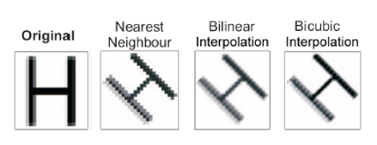
Figure 4 - Examples of a re-sampled image using Interpolation Methods [17]

References

[1] | E. Salameh, “Monitoring Beach Topography and Nearshore Bathymetry Using Spaceborne Remote Sensing: A Review,” Remote Sensing, vol. 11, 2019.
[2] | S. Crutchley, “The Light Fantastic: Using Airborne LiDAR In Archaeological Survey,” English Heritage, Swindon, 2010.
[3] | P. Chazette, J. Totems, L. Hespel and J.-S. Bailly, “Principle and Physics of the LiDAR Measurement,” in Optical Remote Sensing of Land Surface, Amsterdam, Elsevier, 2016, pp. 201-247.
[4] | DJI Enterprise, “Drone Surveying: What is the Difference Between Aerial Photography and Photogrammetry?,” DJI, 23 Feb 2021. [Online]. Available: https://enterprise-insights.dji.com/blog/aerial-photography-vs-photogrammetry. [Accessed 20 Dec 2023].
[5] | R. DeFries, “Remote Sensing and Image Processing,” in Encyclopedia of Biodiersity, Academic Press, 2013, pp. 389-299.
[6] | R. P. Angliss, M. C. Ferguson, P. Hall, V. Helker, A. Kennedy and T. Sformo, “Comparing manned to unmanned aerial surveys for catacean monitoring in the Arctic: methods and operational results,” NRC Research Press, vol. 6, pp. 109 - 127, 2018.
[7] | J. Lisien, “Aerial Surveys Using an Unmanned Aerial System (UAS): Comparison of Different Methods for Estimating the Surface Area of Sampling Strips,” Tropical Conservation Science, vol. 6, no. 4, pp. 506-520, 2013.
[8] | Civil Aviation Authority, “The Drone and Model Aircraft Code,” Civil Aviation Authority, Oct 2019. [Online]. Available: https://register-drones.caa.co.uk/drone-code/where-you-can-fly. [Accessed 21 Dec 2023].
[9] | DJI Enterprise, “Ground Sample Distance,” DJI, 29 Mar 2022. [Online]. Available: https://enterprise-insights.dji.com/blog/ground-sample-distance. [Accessed 21 Dec 2023].
[10] | J. Yang, “The role of satellite remote sensing in climate change studies,” Nature Climate Change, vol. 3, pp. 875-883, 2013.
[11] | N. Whitehead, RSI Lecture 3 - Sensor Systems, Swansea: UWTSD, 2023.
[12] | T. Toutin, “Geometric Corrections of Remotely Sensed Images,” in Remote Sensing of Forest Environments, Boston, MA, Springer, 2003, pp. 143-180.
[13] | C. Wang, X. Liu, X. Zhao and Y. Wang, “An Effective Correction Method for Seriously Oblique Remote Sensing Images Based on Multi-View Simulation and a Piecewise Model,” Sensors (Basel), vol. 16, no. 10, 2016.
[14] | esri, “Overview of Georeferencing,” ArcGIS Pro, 2023. [Online]. Available: https://pro.arcgis.com/en/pro-app/latest/help/data/imagery/overview-of-georeferencing.htm. [Accessed 21 Dec 2023].
[15] | J. T. Hastings and L. L. Hill, “Georeferencing,” in Encyclopedia of Database Systems, Boston, MA, Springer, 2009, pp. 1246-1249.
[16] | ArcGIS, “What is Geocoding?,” ArcGIS, 2023. [Online]. Available: https://desktop.arcgis.com/en/arcmap/latest/manage-data/geocoding/what-is-geocoding.htm#:~:text=Geocoding%20is%20the%20process%20of,at%20once%20in%20a%20table.. [Accessed 22 Dec 2023].
[17] | N. Whitehead, RSI Workshop 4 - Geometric Corrections, Swansea: UWTSD, 2023.

Report on the QGIS Model

Introduction
A chance has been presented for an area of scrubland on the Swansea Harbour to be used as a potential Testing Range for Explosives and Explosives Ordnance. A QGIS model was constructed to demonstrate the possibility of this due to proximities to built up areas as well as any other potential issues.

Data to identify the areas of interest
A wide range of data was collected to identify features in the area of interest. As the potential testing range was located on the coast, it is logical to use it as an area to launch projectiles out to sea for extended range testing. This immediately identified the area directly forward of the site to be surveyed for seabed depths and active marine lanes. As it is likely to be used for explosive testing, it is also important to assess the surrounding area on land for proximity to buildings and any topographical features that may have an adverse effect on personnel or structures. The limits on proximity are set out in the HSE Explosive Regulations so should this not fit those standards, no license can be obtained.

Data used to enhance the visual imagery
A wide array of remotely sensed data has been added to enhance the visual image whether that be for sea depth and likely shipping lanes or for building proximity and topography of the surrounding area.
As the area is being investigated for an explosives testing range, the first bit of data to be added was bathymetric data for the Swansea Bay area. This provides a great amount of information on seabed depths and water levels. It is gathered by using a Bathymetric LiDAR scanner most likely captured from an aerial survey. A bathymetric LiDAR is a conventional LiDAR scanner that has both a green and a blue laser, one for measuring the seabed depth and one for measuring the surface of the sea water. This is a very useful data set for assessing the maritime shipping lanes as the deepest areas will be visible to the observer where they are normally obscured using standard RGB imagery.
The next data set to be used is to assess the topography of the surrounding area. It is important to assess the surrounding topography through a LiDAR survey. This is where a laser is pulsed onto objects on the ground which allows the sensing equipment to create an accurate elevation image of the ground surface. This can be visualised in many ways but for this application contour lines were chosen. This ensures the RGB satellite imagery can still be seen showing what features occupy he land at those elevations.
Finally, the buildings and surrounding man-made structures needed to be shown along with those most likely at risk from the sites change of use. For this once again, LiDAR data was used to show the Digital Surface Model and show the surrounding buildings. From this, the buildings and residences most at risk could be identified and highlighted to the authorities.

Factors affecting the accuracy
There are a number of factors that affect the accuracy of the visualisation data. This can be anything from the data acquisition platform to the ambient conditions on the day.
Most commonly, aerial surveys are taken using an aircraft, or for smaller scale surveys, unmanned drones. The accuracy, therefore, is affected by many factors such as image blur. If the survey is undertaken by an airborne platform that is unable to pause during data capture, then the ground will have moved in relation to the sensor during data capture. Drone data capture is therefore desirable as the platform can pause to capture the data but this may be problematic for LiDAR surveys as they require very heavy sensor systems.
Another limitation is the accuracy of the GPS information provided by the data capture system. This will have a great influence on the ability to match the images captured to an ordnance survey map and limits the ability to scale the maps and provide accurate distance information.
Should the geocoding of the remotely sensed data be inaccurate, then there is the possibility that intended areas won’t match the actual spatial location. This can be seen in many areas particularly when relating addresses to their actual location as can be seen below.


