University of Wales Trinity St Davids
School of Engineering


Engine Performance Testing and Analysis of a Honda D16 Internal Combustion Engine
ACHA4012 Motorsport and Vehicle Technology

Harvey Levell
2300714
17th March 2024

Contents
1 Introduction 2
2 Methodology and equipment used 3
3 Results 5
3.1 Specific Fuel Consumption against Engine Speed 5
3.2 Torque against Engine Speed 6
3.3 Brake Power against Engine Speed 8
4 Conclusion 9
5 Evaluation 10
6 References 11

Introduction
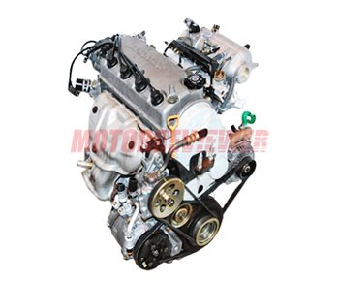
In this test, a 2000/01 Honda D16 engine will be ran on a Schenck W230 Engine Dynamometer. The results obtained will be used to perform calculations to gather data on change in values such as power output, Specific Fuel Consumption (SFC) and Brake Mean Effective Pressure (BMEP). These values will be compared to their rates of changes as the engine speed changes. These resuts will be evaluated and explained in this report.
Honda D16 Vtec (Motor reviewer, 2014-2022)

Methodology and equipment used
The engine that was tested is Honda D16 Vtec engine commonly found in Honda Civics and CRX. The specification are as follows:
Cylinders: 4
Factory stated power: 127 horsepower
Bore and Stroke: 75 mm and 90 mm
Compression ratio: 9.6:1
Normal fuel pressure: 3 bar
The dynamometer has a variety of tests that it can run. The simplest of these is manually operated in which the throttle position on the engine can be controlled using a dial. Opening the throttle allows an increase in the engines speed. There is a second dial that increases current to the dynamometer. This creates a stronger electric field, in turn increasing resistance to the engine as a resisting torque is applied. When the engine experiences these resisting forces, its speeds decreases. This decrease is in direct correlation with the torque increase. Using manual mode allows the operator to target specific torque values.
The next mode is referred to as Test Sequencing. This method involves an extensive list of steps that the software will follow to determine how the engine is to perform. Each step can be set to last a desired time and can include a large variety of detail to simulate a variety of circumstances. Test sequencing is used to reduce the labour and time that is required to be spent manually testing an engine for a large amount of time. Furthermore, it is more precise than manual mode as strict limits of engine rpm and run time can be applied.
A mode that is used to test specific areas of engine speed is the Step Test. These can be used to find running issues or data at certain engine speeds. It provides values for a multitude of outputs such as lambda or exhaust emissions. A step test uses a start and finish rpm with set engine speed increments. As the engine speed increases it pauses for one second at each increment, takes the data reading and proceeds to increase speed to the next increment. To do this the throttle is opened all the way from the start of the test but the dyno provides a resisting torque to the limit the engine to the set speed. Due to the consistent pauses the sensors have a sufficient time to take accurate readings leading to more reliable results. However, a disadvantage of these times spent at specific rpm is an increase in engine temperatures. High engine temperatures can lead to excessive and accelerated wear or component failure.
The final test is a Sweep Test. This test type is the one used for this analysis of the Honda D16. Similarly to the step test it has a start and finish engine speed with set increments in between however, it does not pause at each increment but only takes data readings. This means the sensors can not provide as accurate results but reduces the risk of overheating and excessive engine wear. For this analysis we used a start speed of 1000rpm and a finish speed of 5500rpm with increments of 50rpm. The test is run over a time of 15 seconds and finishes at idle speed with zero throttle. This decrease is set to take 5 seconds.

Results
Raw data in appendix.

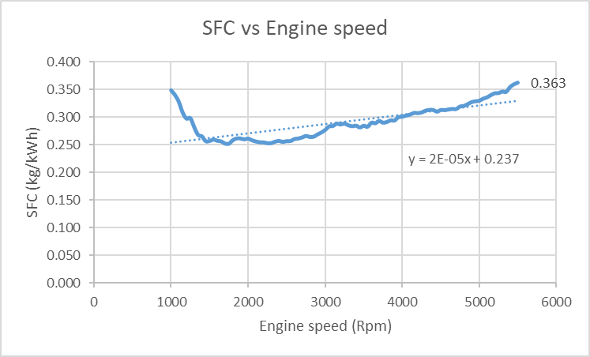
Specific Fuel Consumption against Engine Speed
Figure 3.1.1 Graph of SFC vs Engine Speed
The graph comparing the engine speed with SFC shows an initial decrease in in SFC when the engine speed begins to increase until 1750rpm. From this point it shows a positive correlation as SFC increased at a slowly accelerating rate up to a maximum of 0.363 kg/KWh at the maximum engine speed of the test, 5500rpm.

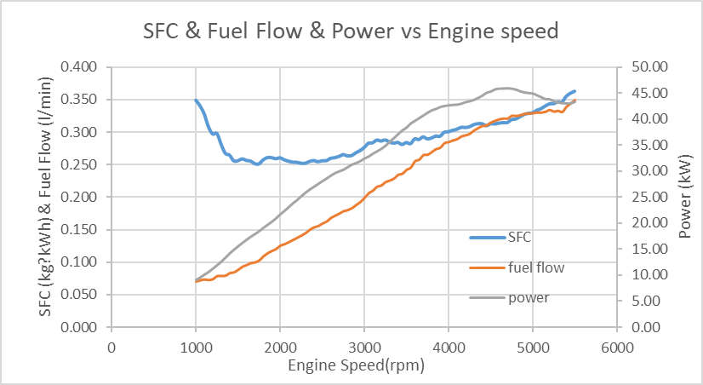
SFC is calculate by Fuel flow rate (kg/hour)/Engine corrected power (kW). The fuel flow rate will increase as engine speed increases due to the fuel injectors being opened for longer. With the increase in fuel, SFC does not necessarily increase because there is a power factor generated by the engine (B Irawan*, Y A Winoko, E Puspitasari and T Dwiyono, 2021, p6). So, if the fuel flow rate is not increasing enough whilst the engine power increases the SFC will decrease.
Figure 3.1.2 Graph of SFC & Fuel Flow & Power vs Engine speed

Figure 3.1.2 shows that the power increases at a faster and more consistent rate than fuel flow at the initial increase in engine speed. This explains the initial decrease in SFC.

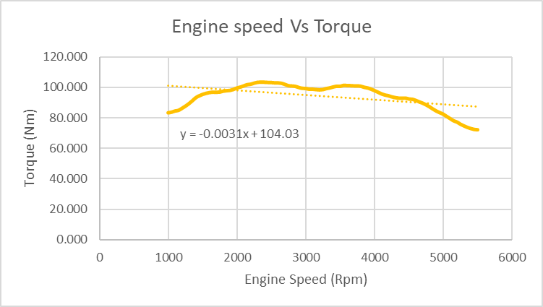
Torque against Engine Speed
Figure 3.2.1 Graph of Engine speed against torque
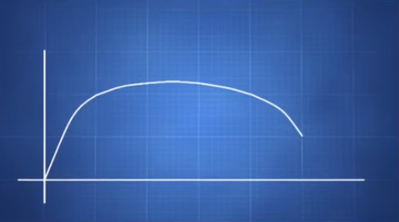
Figure 3.2.1 shows an inconsistent change in torque as engine speed increases. This engine has a very undesirable torque curve which may be due to factors such as worn components or that it is not using an air filter with correct or optimum air flow. A more desirable torque curve looks like figure 3.2.2. It has a smoother gradient with a consistent rise and fall.
Figure 3.2.2 Ideal torque curve

Initially in figure 3.2.1 there is an increase up to 103Nm at 2500rpm which then gradually decreases to a minimum of 72Nm at maximum engine speed of 5500rpm. A decrease in torque at higher engine speeds can be due to a variety of factors such as friction, ignition delay and incomplete combustion. Torque is a rotational force that can be calculated using force x perpendicular distance from the axis of rotation. When the engine speed increases the friction between the piston and cylinder wall increases. This friction force opposes the direction of travel of the piston reducing the force it can apply to the crankshaft. Furthermore, when the engine speed is greater there is less time for combustion. As the D16 tested had an air filter with limited flow it can lead to less energy being released from the ignition leading to less kinetic energy in the piston therefore less force is applied to the crank. Furthermore, at higher rpm the valve train will struggle to operate as efficiently. This is due to the valves traveling at a higher velocity meaning they carry greater kinetic energy. This leads to more force being required to slow them down and retract them out of the cylinders. This is why to gain greater torque from an engine and achieve higher engine speeds upgraded valve springs may be required. If they have higher spring rates, they are able to return to the closed position much faster.

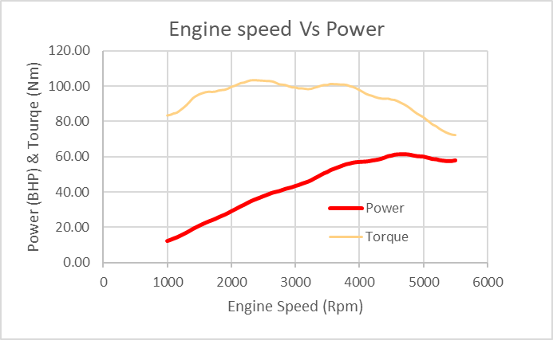
Brake Power against Engine Speed
Figure 3.3.1 Graph of Engin speed against Power
Figure 3.3.1 shows a linear increase in power with increase in engine speed up to 61bhp at 4700rpm at which point it level off and gradually decreases. This figure is considerably smaller than that stated by the manufacturer. This is due to the wear of components such as bearings and valves. Aswell as this due to the limited flow from the air filter the engine will not be able to combust as efficiently leading to less energy per combustion.

Power is calculated using: (2π x Engine speed x Engine Torque)/60. Hence as the engine speed increases there are more power stroke per minute leading to an increase in engine power. As engine power is directly correlated with torque the limit of the engines power determined by the reduction in torque at high rpm.

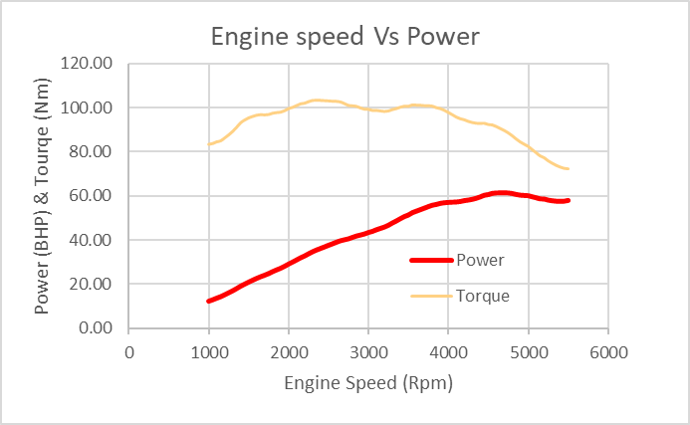
Conclusion
Looking at the graph of engine speed vs torque and power we can see the engine produces a rough torque line but smoother power increase, however neither the peak power or torque figure reach the engines original stated specifications. This shows that the engines components have been worn down through continued usage.

Evaluation
To improve this investigation differing variables could have been introduced, for example different air filters or induction kits could be added to the engine. The test would be repeated identically for each filter and the results compared to find an optimum set up for power or fuel consumption.
A further improvement to this test would be a comparison to a new identical engine or a freshly rebuilt one. This would allow a comparison of data highlighting the effect of old and worn components. The data from the comparison could be an indicator of ideal mileage at which components should be replaced to ensure the engine retain optimum efficiency and power.

References
Motor Reviewer (2014-2022) D16a (B, V, W, Y, Z) engine - in-depth look at design and reliability, MotorReviewer. Available at: https://www.motorreviewer.com/engine.php?engine_id=82
Irawan, Bambang & Winoko, Y & Puspitasari, Etik & Dwiyono, T. (2021). Analysis of fuel pressure on the performance of motorcycle engine with ethanol fuel. IOP Conference Series: Materials Science and Engineering. 1073. 012081. 10.1088/1757-899X/1073/1/012081.

