Task 1: Locating Sources
Identify and locate three different sources (a report, a journal article, and a website) related to the question
“What employability skills do business graduates need to succeed in the modern workplace?”
Show how you used keywords, search terms, and Boolean operators to find them, and explain how you know which type of source each one is and why it is appropriate for the research question.

Source Type & Why It Is Appropriate | URL/DOI | What search engine did you use? Google/Online Library/Library AI Assistant | Keywords/Boolean Operators Used
Academic sources like journal acticle | Journal article of energy sources. Tatiana Morozuk.Editor | Online search engine is online library | And

Task 2: Evaluating Information (CRAAP Test)
Your colleague has forwarded you a source from a peer reviewed journal, and they are not sure whether it is appropriate to use and has asked for your help. Your task is to evaluate the source by using the CRAAP Test to assess its appropriateness.
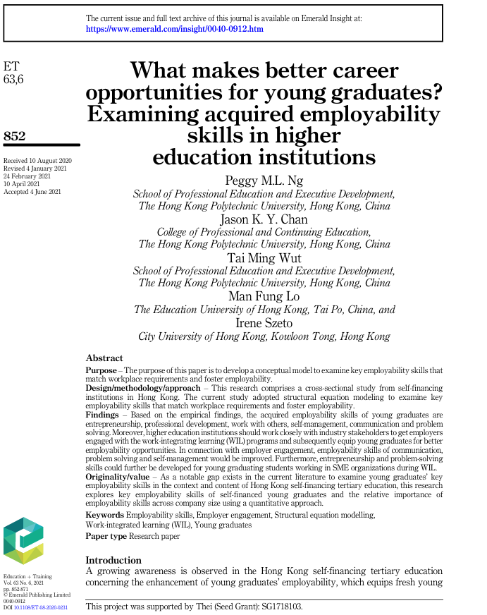

CRAAP Test
Currency | The information is up-to-date and recent.  (2021)
Relevance | The relevance of is the information is important to pass across with great importance
Authority | The information is pre-reviewed, and the reliability is supported by experts such as the lecturers from University of Hong Kong
Accuracy | The information has been check-mated and presented with accuracy after being evaluated and pre-reviewed. So is reliable and credible. So, it is presented in a very clear and credible manner.
Purpose | The information is to pass it across for public consumption, especially the university students who are aspiring to become successful in their academic field.

Task 3: Source Analysis
Your manager has provided you with a short extract from a source and has asked you to analyse the source by Identifying one strength, one weakness, and providing a brief explanation of the strength and weakness identified.
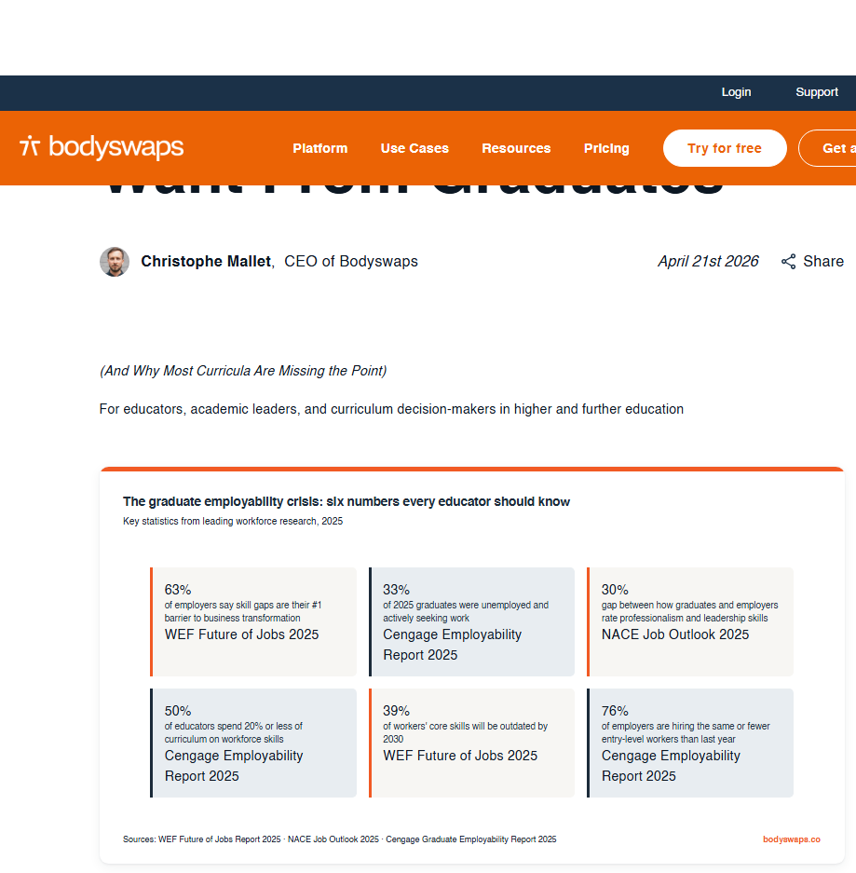
.

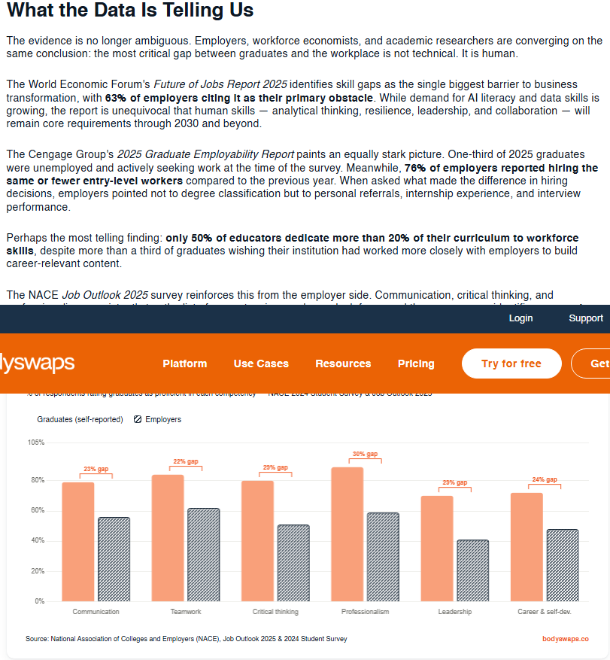

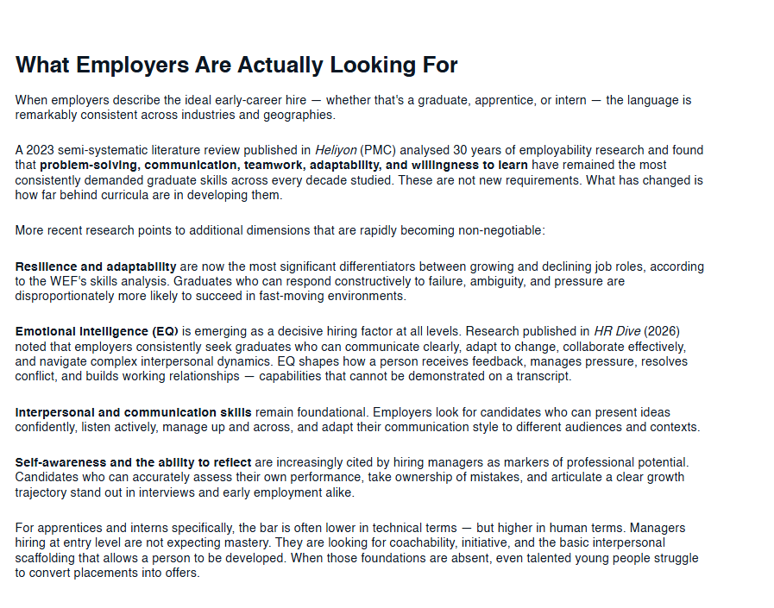

Please click the link, if you wish to read the article online.
What Employers Actually Want From Graduates

Strength of the Source:

Research found that in 30 years of employability problem-solving, communication, adaptability, teamwork and wiliness to learn have remained consistent and credible.

Weakness of the Source:

Future job identifying skill gaps as the biggest barrier to business transformation according 63% of the employers.

