
IMPLEMENTATION PLAN


January 10, 2025
UNIVERSITY OF WALES TRINITY SAINT DAVID

Student: Andrei Stafi
Student number: 2114799
Module: Contemporary Themes in Leadership and Management
Module code: BMSW7000

Summary
This implementation plan builds on the 20-minute presentation "Opportunities for Female Leaders in 21st Century Organisations" findings, which identified critical challenges and opportunities for fostering gender diversity in leadership within mechanical engineering. The plan identifies barriers and proposes evidence-based solutions by critically analysing the role of education, organisational practices, and societal perceptions.
The plan emphasises the importance of early STEM engagement, mentorship, and flexible workplace policies while tackling unconscious biases and challenging public stereotypes about women in engineering. Drawing on global best practices and contemporary leadership theories, it presents a phased approach to implementation, supported by robust monitoring and evaluation mechanisms to ensure sustainability.
Ultimately, this plan aims to empower women to progress into leadership roles, contributing to a more equitable, innovative, and competitive mechanical engineering industry.

Table of Contents
Summary 2
1. Implementation Plan 5
1.1 Introduction 5
2. Rationale 6
2.1 Aims and Objectives 7
2.1.1 Overall Aim 7
2.1.2 Specific Objectives 8
2.2 Action Plan 9
2.2.1 Educational Initiatives 9
2.2.2 Organisational Strategies 10
2.2.3 Public Perception 10
2.2.4 Timeline 11
2.2.5 Risk Management 11
2.2.6 Critical Analysis 12
3. Recommendations 14
3.1 Education ..................................................................................................................... 14
3.2 Organisational Practices 15
3.3 Public Perception 15
3.4 Monitoring and Evaluation 16
4. Conclusion 17
Bibliography 18
Table of Figures
Figure 1 – Women vs Men in leadership roles …………………………………….………….6
Figure 2 - Business case for diversity ……………………………………….……………..... 7
Figure 3 - Mentorship and sponsorship programs …………………………………………… 8

1. Implementation Plan

1.1 Introduction
The mechanical engineering sector remains one of the most male-dominated fields in the modern workforce, with women holding less than 11% of leadership roles in the UK engineering industry (EngineeringUK, 2022). This disparity highlights a significant underrepresentation of women, particularly in senior and leadership positions, which is influenced by systemic barriers such as societal stereotypes, organisational biases, and a lack of early educational support. Addressing this imbalance is not just a matter of equity but a strategic imperative. Research shows that organisations with diverse leadership teams are 25% more likely to outperform their peers in profitability, as diversity fosters innovation, adaptability, and collaboration (McKinsey & Company, 2020).
The aim is to develop actionable strategies that promote women's leadership opportunities, leveraging contemporary management and leadership theories to ensure the proposed solutions are grounded in evidence-based practices.
The plan will focus on three key areas: the role of education in shaping career opportunities, the influence of societal and organisational perceptions of women's aspirations, and the broader cultural and political dynamics that impact gender diversity in the workplace. The plan seeks to pave the way for a more inclusive and equitable leadership structure in the mechanical engineering sector by addressing these themes.

2. Rationale
The underrepresentation of women in leadership roles within the mechanical engineering sector is not only a social equity issue but also a missed opportunity for innovation and organisational growth. Despite progress in addressing gender diversity, women still face significant barriers, including cultural biases, limited access to mentorship, and systemic challenges in career progression. In 2021, women represented only 16.5% of the engineering workforce in the UK (Figure 1), with their presence in leadership roles being even lower (Royal Academy of Engineering, 2021).
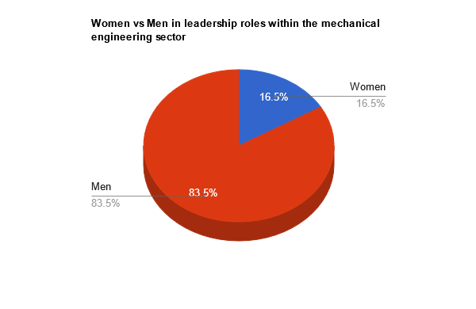
Figure 1
The mechanical engineering sector, characterised by its technical rigour and reliance on innovation, benefits significantly from diverse leadership. Research shows that gender-diverse teams are more innovative, resilient, and better equipped to handle complex challenges (McKinsey & Company, 2020). However, achieving this diversity requires targeted strategies to address educational gaps, organisational culture, and societal perceptions that limit women's opportunities.

2.1 Aims and Objectives

2.1.1 Overall Aim
This implementation plan addresses the systemic barriers limiting women's progression to leadership roles in the mechanical engineering sector. By fostering an inclusive leadership pipeline, this plan seeks to promote gender equity, organisational innovation, and long-term sectoral growth. Studies have shown that organisations with gender-diverse leadership outperform their peers by 25% in profitability (Figure 2), underlining the business case for diversity (McKinsey & Company, 2023).
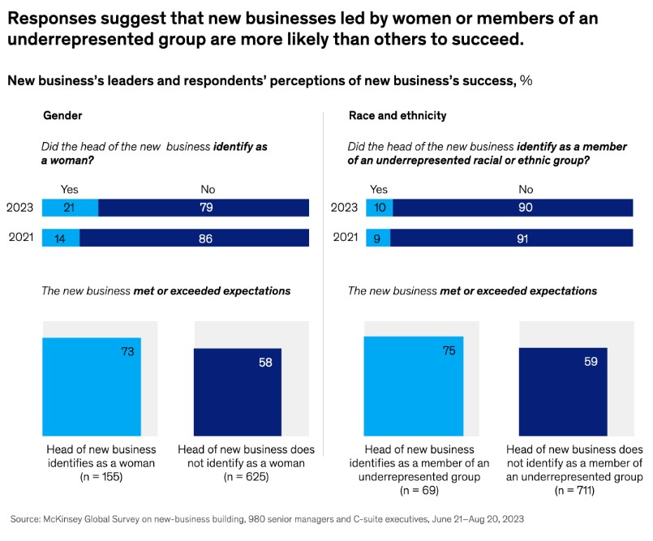
Figure 2 - Business case for diversity

2.1.2 Specific Objectives
Educational Initiatives:
Increase girls' participation in STEM education through tailored outreach programs and early exposure to engineering careers. For example, initiatives like Engineer Girl and Siemens' Women in Engineering Leadership Program have effectively addressed gender gaps in STEM engagement (National Academy of Engineering, 2024; Siemens, 2023).
Promote scholarships for female students in engineering fields, mirroring successful models such as Accenture's Getting to Equal program, which has achieved 50% representation of women in leadership by 2025 (Accenture, 2024).
Organisational Strategies:
Establish mentorship and sponsorship programs inspired by Siemens' approach, which resulted in a 30% increase in women advancing to managerial roles (Siemens, 2023).
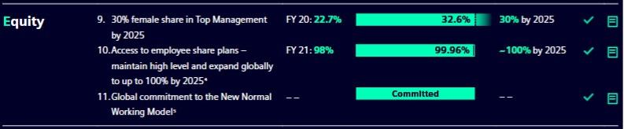
Figure 3 - Mentorship and sponsorship programs
Implement flexible work policies and unconscious bias training to create equitable workplaces. Evidence suggests that companies offering remote work options retain 20% more female employees in engineering roles (Journal of Women in Engineering, 2024).
Align recruitment and promotion practices with diversity-focused policies, as outlined in the UK's Equality Act 2010, which mandates gender equality in hiring and promotions (Equality Act, 2010).
Challenging Public Perceptions:
Combat stereotypes about women's capabilities in engineering through media campaigns and community engagement. Research highlights that visible role models, such as Marillyn Hewson at Lockheed Martin, challenge biases and inspire future leaders (Forbes, 2023).
Collaborate with industry bodies like WES (Women's Engineering Society) to celebrate the achievements of female engineers, fostering a culture of inclusion (WES, 2023).
Evaluation and Monitoring:
Develop robust mechanisms for monitoring progress, using frameworks like the Diversity and Inclusion Maturity Model by Deloitte to track improvements in gender diversity (Deloitte, 2021).
Conduct annual surveys to measure changes in organisational culture, public perception, and educational outreach success rates (Royal Academy of Engineering, 2021).

2.2 Action Plan

2.2.1 Educational Initiatives
A significant barrier to women's progression in mechanical engineering leadership stems from limited engagement with STEM education at an early stage. Programs like Engineer Girl in the U.S. have shown the effectiveness of targeted outreach in encouraging young women to pursue engineering careers (National Academy of Engineering, 2024). Similarly, initiatives like WES (Women's Engineering Society) in the UK provide mentorship and support to female students, fostering a sense of belonging in the field (WES, 2023).
Proposed Actions:
- Collaborate with schools to incorporate STEM career workshops and role-model programs, targeting girls from underrepresented backgrounds.
- Partner with universities and industry leaders to offer scholarships and internships designed for female students in engineering disciplines.
- Introduce early mentoring programs, pairing students with female engineers to build confidence and career aspirations.

2.2.2 Organisational Strategies
Organisations are crucial in dismantling internal barriers and creating pathways for women's leadership progression. Research highlights that companies with structured mentorship programs see a 30% increase in women advancing to leadership roles (Siemens, 2023).
Proposed Actions:
- Mentorship Programs: Develop formal mentorship and sponsorship frameworks within organisations, ensuring senior leaders actively support high-potential female employees.
- Bias Training: Conduct workshops to address unconscious bias in recruitment and promotion processes, drawing on frameworks like Harvard's Implicit Association Test (Greenwald et al., 1998).
- Flexible Work Policies: Implement remote work and flexible scheduling to accommodate diverse life responsibilities and reduce attrition rates among women in the workforce (Journal of Women in Engineering, 2024).

2.2.3 Public Perception
Societal stereotypes about women in engineering leadership limit their aspirations and opportunities. Media campaigns and community engagement can challenge these narratives and promote inclusivity (McKinsey & Company, 2020).

Proposed Actions:
- Launch awareness campaigns showcasing successful female engineers and leaders, such as Marillyn Hewson's tenure at Lockheed Martin (Forbes, 2023).
- Collaborate with industry associations to run diversity awards and recognition programs, celebrating companies advancing gender equity.
- Partner with media outlets to highlight the value of diversity in STEM fields and the tangible impact of inclusive leadership (McKinsey & Company, 2020).

2.2.4 Timeline
A phased approach is critical for achieving these objectives within realistic timeframes.
Year 1: Establish partnerships with schools, universities, and industry leaders; pilot mentorship and outreach programs.
Year 2–3: Scale successful initiatives, integrate bias training into organisational practices, and launch public awareness campaigns.
Year 4–5: Evaluate the effectiveness of strategies through surveys and performance metrics; refine initiatives based on feedback.

2.2.5 Risk Management
Every initiative carries inherent risks that must be identified and mitigated to ensure success. Key risks in this plan include financial constraints, cultural resistance, and policy barriers.
Risk Mitigation Strategies:
- Financial Risks: Seek funding from government grants and corporate social responsibility (CSR) budgets.
- Cultural Resistance: Engage with stakeholders, including parents and community leaders, to address biases and emphasise the benefits of diversity.
- Policy Barriers: Support supportive policies through industry associations and government collaborations.

2.2.6 Critical Analysis
The Role of Education
Education is crucial in shaping women's career paths in mechanical engineering, yet gender disparities persist, with only 28% of engineering graduates being women globally (UNESCO, 2022). Societal stereotypes and a lack of female role models deter girls from pursuing engineering and leadership roles (Royal Academy of Engineering, 2021). Initiatives like the Engineer Girl program in the U.S. and Germany's inclusive vocational training have increased female participation (National Academy of Engineering, 2024; World Economic Forum, 2023). Addressing these challenges requires inclusive curricula and efforts to counter unconscious biases from parents and educators (Greenwald et al., 1998).
Assumptions and Biases
Societal and organisational biases often hinder women's leadership progression, driven by the "think manager, think male" stereotype favouring men as natural leaders (Eagly and Karau, 2002). These assumptions impact hiring practices and women's confidence. The leadership labyrinth framework highlights interconnected barriers such as cultural biases, lack of mentorship, and presenteeism (Eagly and Carli, 2007). Transformational leadership, emphasising inclusivity and empowerment, offers a way to challenge these stereotypes. Examples like Marillyn Hewson at Lockheed Martin demonstrate how such leadership can inspire change (Forbes, 2023). To address these issues, organisations should implement bias-awareness training and mentorship programs, which have been shown to increase female leadership participation by up to 30% (Siemens, 2023).
Organisational Culture
Organisational culture often mirrors societal norms, creating additional barriers for women in mechanical engineering, including gender discrimination and implicit biases (Journal of Organizational Behavior, 2024). Addressing these challenges requires leaders to exhibit emotional intelligence and foster diversity, as inclusive environments help all employees thrive (Goleman, 1995). Exclusion from informal networks and decision-making processes limits women's influence (Royal Academy of Engineering, 2021). Transparent policies and equitable decision-making can help counter these dynamics. Additionally, implementing and monitoring diversity-focused policies, such as the UK's Equality Act 2010, has enhanced organisational performance and employee satisfaction (McKinsey & Company, 2020).

3. Recommendations

3.1 Education
Expand STEM Outreach Programs:
Partner with schools to establish STEM-focused career workshops targeting girls modelled after successful initiatives like the Engineer Girl program (National Academy of Engineering, 2024).
Introduce scholarships for women pursuing mechanical engineering degrees, similar to Accenture's Getting to Equal program, which achieved notable progress in female representation (Accenture, 2024).
Inclusive Curricula:
Revise school and university curricula to include practical engineering projects and success stories of female engineers, fostering early interest and breaking stereotypes (Royal Academy of Engineering, 2021).
Collaborate with teachers and educators to address implicit biases and ensure equitable encouragement for all students to pursue technical subjects (Greenwald et al., 1998).
Mentorship for Students:
Implement early mentoring programs where female students are paired with industry professionals to build confidence and career aspirations (Siemens, 2023).

3.2 Organisational Practices
Structured Mentorship Programs:
Establish company-wide mentorship and sponsorship initiatives to support women's career advancement. Siemens' mentorship program, which increased female leadership by 30%, is a valuable model (Siemens, 2023).
Bias Awareness Training:
Conduct regular workshops to identify and mitigate unconscious biases in hiring, promotions, and day-to-day operations (Harvard Business Review, 2024).
Utilise tools like the Implicit Association Test (IAT) to measure and address bias at all levels of the organisation (Greenwald et al., 1998).
Flexible Work Policies:
Introduce remote work, job-sharing, and flexible hours to accommodate diverse life responsibilities and reduce attrition rates among women (Journal of Women in Engineering, 2024).
Ensure transparency in promotion and evaluation processes, as recommended by the UK's Equality Act 2010, to foster trust and fairness (Equality Act, 2010).

3.3 Public Perception
Awareness Campaigns:
Launch industry-wide campaigns showcasing successful female engineers and their impact, drawing inspiration from leaders like Marillyn Hewson (Forbes, 2023).
Use social media, television, and print media to highlight the benefits of diversity in mechanical engineering (McKinsey & Company, 2020).
Community Engagement:
Collaborate with local organisations and parent groups to promote the value of engineering careers for girls and challenge societal stereotypes (Royal Academy of Engineering, 2021).
Industry Recognition Programs:
Establish awards and recognition events to celebrate organisations and individuals driving gender diversity in engineering (WES, 2023).

3.4 Monitoring and Evaluation
Diversity Metrics:
Develop and track key performance indicators (KPIs) for recruiting, retaining, and promoting women in leadership roles. Use tools like Deloitte's Diversity and Inclusion Maturity Model to measure progress (Deloitte, 2021).
Annual Surveys and Feedback:
Conduct surveys among employees and stakeholders to assess the effectiveness of implemented strategies and identify improvement areas (Royal Academy of Engineering, 2021).
Long-Term Reporting:
Publish annual progress reports to maintain transparency and accountability, encouraging continuous improvement and stakeholder engagement (McKinsey & Company, 2020).

4. Conclusion
The mechanical engineering sector stands at a critical juncture where addressing gender disparities in leadership is not just a moral imperative but a strategic necessity. This implementation plan has outlined a comprehensive approach to fostering an inclusive leadership pipeline, leveraging the interconnected roles of education, organisational practices, and public perception.
The proposed educational initiatives aim to inspire and prepare more women to enter and thrive in mechanical engineering by addressing early engagement, inclusive curricula, and mentorship opportunities. Complementary organisational strategies, such as mentorship programs, bias-awareness training, and flexible work policies, are designed to dismantle systemic barriers and create equitable opportunities for career advancement. Additionally, targeted public perception campaigns and recognition programs are essential for challenging societal stereotypes and celebrating progress.
By integrating these strategies, the plan addresses women's systemic challenges in mechanical engineering and offers actionable solutions rooted in evidence-based practices. Monitoring and evaluation mechanisms will ensure accountability and continuous improvement, making this plan sustainable and impactful.
Looking ahead, the successful implementation of these strategies requires commitment and collaboration from all stakeholders—educators, industry leaders, policymakers, and society at large. The long-term benefits of achieving gender diversity in leadership go beyond individual organisations, contributing to a more innovative, competitive, and equitable industry that reflects the talents and aspirations of all.

Bibliography
Accenture (2024) Getting to Equal: Progress Report. Available at: www.accenture.com [Accessed 4 Jan 2025].
Armstrong, M. (2016) Management and Leadership for HR (4th ed). London: Kogan Page.
Bratnicka, K. (2015) 'Relationship Between Leadership Styles and Organizational Creativity'. Management and Business Administration. Central Europe, 1(128), pp. 48.
Deloitte (2021) Diversity and Inclusion Maturity Model. Available at: www.deloitte.com [Accessed 6 Jan 2025].
Eagly, A.H. and Carli, L.L. (2007) Through the Labyrinth: The Truth About How Women Become Leaders. Harvard Business Press.
Eagly, A.H. and Karau, S.J. (2002) 'Role Congruity Theory of Prejudice Toward Female Leaders'. Psychological Review, 109(3), pp. 573–598.
EngineeringUK (2022) Engineering UK 2022 Report. Available at: www.engineeringuk.com [Accessed 28 Dec 2024].
Equality Act (2010) UK Legislation. Available at: www.legislation.gov.uk [Accessed 5 Jan 2025].
Forbes (2023) Top Women Leaders in Engineering. Available at: www.forbes.com [Accessed 27 Dec 2024].
Gold, J. and Anderson, L. (2017) Developing Leadership and Management Skills. UK: Kogan.
Goleman, D. (1995) Emotional Intelligence: Why It Can Matter More Than IQ. Bantam Books.
Greenwald, A.G., McGhee, D.E., and Schwartz, J.L.K. (1998) 'Measuring Individual Differences in Implicit Cognition: The Implicit Association Test'. Journal of Personality and Social Psychology, 74(6), pp. 1464–1480.
Harvard Business Review (n.d.) Articles referenced. Available at: www.hbr.org [Accessed 5 Jan 2025].
ILM (2021) Institute for Leadership and Management. Available at: https://www.i-l-m.com [Accessed 21 Dec 2024].
Journal of Organizational Behavior (2024) Gender Bias in Workplace Dynamics.
Journal of Women in Engineering (2024) Gender Diversity in STEM: Progress and Challenges.
Management Today (n.d.) Articles referenced. Available at: www.managementtoday.com [Accessed 16 Dec 2024].
McKinsey & Company (2020) Diversity Wins: How Inclusion Matters. Available at: www.mckinsey.com [Accessed 17 Dec 2024].
McKinsey & Company (2023) Diversity Wins: How Inclusion Matters. Available at: www.mckinsey.com [Accessed 18 Dec 2024].
Mullins, L. (2019) Organisational Behaviour in the Workplace (12th ed). London: Pearson.
National Academy of Engineering (2024) Engineer Girl Program. Available at: www.nae.edu [Accessed 12 Dec 2024].
Reed, D. (2015) Skills of Management and Leadership: Managing People in Organisations. London: Palgrave.
Royal Academy of Engineering (2021) Diversity and Inclusion Progress Report. Available at: www.raeng.org.uk [Accessed 5 Jan 2025].
SAGE Organization Studies (n.d.) Articles referenced. Available at: www.sagepub.com [Accessed 5 Jan 2025].
Siemens (2023) Diversity and Inclusion Report. Available at: www.siemens.com [Accessed 28 Dec 2024].
Trusts and Estates (n.d.) Articles referenced. Available at: www.trustsandestates.com [Accessed 15 Dec 2024].
UNESCO (2022) Gender in STEM Education Report. Available at: www.unesco.org [Accessed 18 Dec 2024].
Women’s Engineering Society (WES) (2023) Annual Report. Available at: www.wes.org.uk [Accessed 14 Dec 2024].
World Economic Forum (2023) Gender Parity in Technical Fields. Available at: www.weforum.org [Accessed 5 Jan 2025].
Wyatt, S. (2020) Leadership and Management in the 4th Industrial Revolution. London: Kogan.

