Portfolio
6 Elements

Module: Foreign Languages & Cultural Awareness
Module code: BMIH5009 / BMIH5009D
Lecturer: Lisa Bassler

Student: Silvia Badea – 2130240
12/12/2025
Contents
Reflective Essay 3
Written Report 7
Introduction 8
Communication and cultural awareness 8
How language affects guest interaction 8
Verbal and non-verbal communication 9
Common communication problems in hotels 9
Training Poster 12
Workplace Scenario 15
Experience 16
Action (Resolution) 16
Presentation 18
Reflective Essay 22
References: 28

Portfolio – Element 1

Reflective Essay

Module: Foreign Languages & Cultural Awareness
Module code: BMIH5009 / BMIH5009D
Lecturer: Lisa Bassler

Student: Silvia Badea – 2130240
12/12/2025

Growing up as a Romanian in a traditional family has deeply shaped the way I define culture and conceptualise my own identity. For me, the way of life is more than a set of rituals or habits: it is the framework through which I interpret the world and build relationships. Cultural identity involves the internalisation of beliefs, values, traditions, language, and social norms that direct how I see myself and how I act in relation to others (Ward, 2024). My character is established in family, religious tradition, linguistic heritage, and community, and it continually interacts with new influences as I live in Wales.
Family has always been central in anchoring my sense of self. In my Romanian family, respect for elders, observance of Christian Orthodox rituals, and preservation of traditions such as Christmas, Easter, and name days were not optional, but integral. For example, during Easter we would paint eggs, attend the midnight service, bring home the Holy Light from church, and gather for a large family meal, all of which reinforced the sense that our faith and customs are lived, not just observed. These rituals connected me with my predecessors, reinforced a feeling of belonging, and provided a sense of right and wrong grounded in faith and collective memory. Over time, these practices became more than personal choices, they became foundational aspects of who I am.
My Romanian community, too, served as an extended familial network where everyone knew one another, supported one another, and celebrated together. In that environment, culture was not something optional but lived daily. Sociocultural theories emphasise that identity is socially constructed: the norms, values, and expectations of the community actively shape how individuals internalise beliefs and values (Ward, 2024). Moreover, the Romanian language shaped my cognitive frames. As language carries not only communication but culture-specific meanings, metaphors, and worldviews, my Romanian tongue provided the filter through which I understood reality (Purpuri, 2024).
Education also played a crucial role. From an early age, learning was highly valued in my household. This emphasis on education gave me access to ideas beyond my immediate environment and invited reflection on cultural norms. For instance, through academic spaces I encountered perspectives that questioned traditional gender roles or hierarchical authority, prompting me to evaluate which traditions I hold to and which I critically re-examine. In Romania, education is often seen not just to gain knowledge, but as a responsibility to contribute to family and society. Growing up, I was encouraged to take my studies seriously, not only to succeed personally but also to honour the efforts of my parents and community who valued learning as a cornerstone of life. This approach taught me discipline, perseverance, and the understanding that education shapes both character and opportunities for the future (Ionescu, 2022).
Migrating to Wales fifteen years ago introduced both challenges and growth. The shift forced me to negotiate between preservation and adaptation. According to research among migrants in the UK, a fluid orientation toward cultural integration, one that combines aspects of both heritage and host cultures, tends to be associated with higher subjective well-being, especially when identity carries personal significance (Wang & Giovanis, 2024). In my experience, I often felt pulled between being Romanian and adapting to Welsh norms. There have been rare experiences of discrimination, which remind me that cultural identity is not a neutral trait but one sometimes contested by others. Studies on acculturation note that perceived discrimination acts as challenges in adapting to a new culture, affecting psychological adjustment (Piccinelli, 2024). Living in Wales has mostly been a positive experience, but sometimes I have faced a little racism or unfair treatment. For example, people have made comments about my accent, asked questions that assumed things about my background, or treated me differently in social situations. These experiences, although rare, have helped me become stronger and more aware of cultural differences. They taught me to think about how others see me and how I can respond in a kind and understanding way (Berry, 2023)
My cultural identity shapes not only how I see others but how others see me. For example, I may expect communal behaviour, collective responsibility, or relational harmony more strongly than more individualistic norms of interaction. At times, when interacting with people from different backgrounds, I have found my implicit assumptions don’t fit with their expectations. This created tension but also opportunities: I learned to slow down, ask questions, and moderate my beliefs. Reflecting on this aligns with the idea that bicultural identity can provide flexibility in navigating multiple cultural contexts (Bicultural Competencies and Identities, 2025).
Over time, my understanding of my cultural identity has evolved from a static, descriptive self-image to a dynamic, reflective process. I used to see traditions as given, now I see them as part of a dialogue between past and present. I recognise that identity is not fixed but continues to be renegotiated in new contexts. As I engage more with diverse cultures, I see areas in my worldview that I want to examine further: my predisposition for communal norms, my reactions to cultural difference, and the balance between cultural pride and openness.
My Romanian background, shaped by family, religion, community, language, education, and migration, forms the foundation of my cultural identity. But that identity is not inert, it evolves. Through critical reflection, I see how it influences my worldview, interactions, and the challenges I must manage. Maintaining the essence of my heritage while being open to transformation is the ongoing journey that shapes who I am in a multicultural world.

Portfolio – Element 2

Written Report

Module: Foreign Languages & Cultural Awareness
Module code: BMIH5009 / BMIH5009D
Lecturer: Lisa Bassler

Student: Silvia Badea – 2130240
12/12/2025

Introduction
In this report, I talk about how communication helps hotel staff understand different cultures. I work as a waitress, so I meet many guests from different countries every day. Because of this, I learned that good communication is very important. When staff understand cultural differences, we can give better service and make guests feel comfortable. Hotels are multicultural places, so cultural awareness is now a big part of our job (Lugosi, 2020).

Communication and cultural awareness
Communication in hotels means how we speak, listen, and how we use body language. It includes tone of voice, gestures, eye contact, and even how close we stand to someone. Cultural awareness means understanding that not all people behave or communicate the same (Trenholm and Jensen, 2022).
If we ignore these differences, misunderstandings happen easily. Some guests are very direct; others are more polite. Some smile a lot, some are quiet. When staff understand these differences, service becomes easier and more welcoming. We also appreciate when people smile and speak to us kindly, but we must remember that we are human too, and some days we do not feel like talking at all, even though we still need to communicate because we are at work.

How language affects guest interaction
Knowing foreign languages helps a lot in hotels. Even small things like saying “hello” or “thank you” in the guest’s language make a positive impression. I often try this when I work, and guests react very nicely (Hale and Napier, 2021).
Many international guests do not speak English very well. Because of this, we must speak slowly and use simple words. For example, when I explain food allergies or ingredients, I always try to keep it very clear. Sometimes I point to the menu or use a translator app. These small things help guests feel safe and understood (Liu and Mattila, 2023).
I remember a moment when a guest asked me where the “loo” was, and because in my workplace we called our manager Luciana “Lou”, I thought he was asking for her.
I called the manager, but the guest actually wanted the bathroom. I felt very embarrassed at the time, but it became an important learning experience for me.
Teamwork also helps with language problems. If one of my colleagues speaks the guest’s language, I ask them for help (Beldona, Schwartz and Altin, 2022).

Verbal and non-verbal communication
Communication is not just talking. Many guests communicate through body language, and this can be different from culture to culture.
For example:
- In some places, strong eye contact means respect.
- In other places, too much eye contact feels uncomfortable.
- Some cultures speak loudly, others quietly.
- Some people like to stand close when they talk, others want more space.
Sometimes guests communicate more with their expressions than with words, so I pay attention to their face and posture. This often shows me if they feel comfortable, confused, tired, or in a hurry, and it helps me decide how to approach them in a respectful way.
In my job, I try to watch the guest and adapt. If a guest looks shy, I give them more space. If they seem friendly and open, I speak in a warmer tone. This helps avoid misunderstandings.

Common communication problems in hotels
Hotels face many cross-cultural communication challenges. One of the biggest problems is misunderstanding. Guests and staff may use idioms or accents that are difficult to understand. According to Smith (2023), miscommunication in multicultural teams is very common because people interpret words differently based on their culture.
Different service expectations also cause problems. Some guests want fast service, others prefer slow. Some expect formal behaviour, while others want friendly and casual interactions (Lugosi, 2020).
There are also challenges between employees. Staff come from different cultures, so they may understand instructions differently. This can affect teamwork and service delivery if not managed well (Chen and Starosta, 2021).
Assumptions also create issues. When staff assume that every guest from one country behaves the same, misunderstandings can occur. This is why cultural awareness is important.
Strategies to improve communication and cultural awareness
Hotels use many strategies to improve multicultural communication. Training is the most common tool. Cultural awareness training increases confidence and reduces misunderstandings (Doherty and O’Brien, 2021).
Hotels can also create simple communication guidelines. For example, using clear English and avoiding informal words helps international guests a lot. Translation tools, multilingual signs, and pictogram menus are also helpful (Beldona, Schwartz and Altin, 2022).
Teamwork is important as well. Staff who speak different languages can support one another. Research shows that multicultural teams work better when they share knowledge and help each other (Smith, 2023).
Hotels can also encourage staff to talk about their own cultures during meetings. This helps colleagues learn from each other and understand different behaviours.
Recommendations
Based on this report and my experience, I recommend that hotels:
- offer regular cultural awareness training
- encourage staff to speak clearly and use simple English
- provide translation tools and multilingual signs
- create picture-based menus for international guests
- support teamwork between multilingual staff
- explain workplace expectations clearly to all employees
- let staff ask questions without judgement
These recommendations are supported by research showing that training, clear communication, and multilingual tools improve guest satisfaction (Ward, 2024; Liu and Mattila, 2023).
Conclusion
Cultural awareness and communication are essential for providing high-quality service in hotels. Good communication helps staff avoid misunderstandings, respect cultural differences, and make guests feel valued. As a waitress, I see every day how important small things are like a smile, simple language, or patience. With training, teamwork, and practical tools, hotels can create a more welcoming environment for guests from all cultures.

Portfolio – Element 3

Training Poster

Module: Foreign Languages & Cultural Awareness
Module code: BMIH5009 / BMIH5009D
Lecturer: Lisa Bassler

Student: Silvia Badea – 2130240
12/12/2025

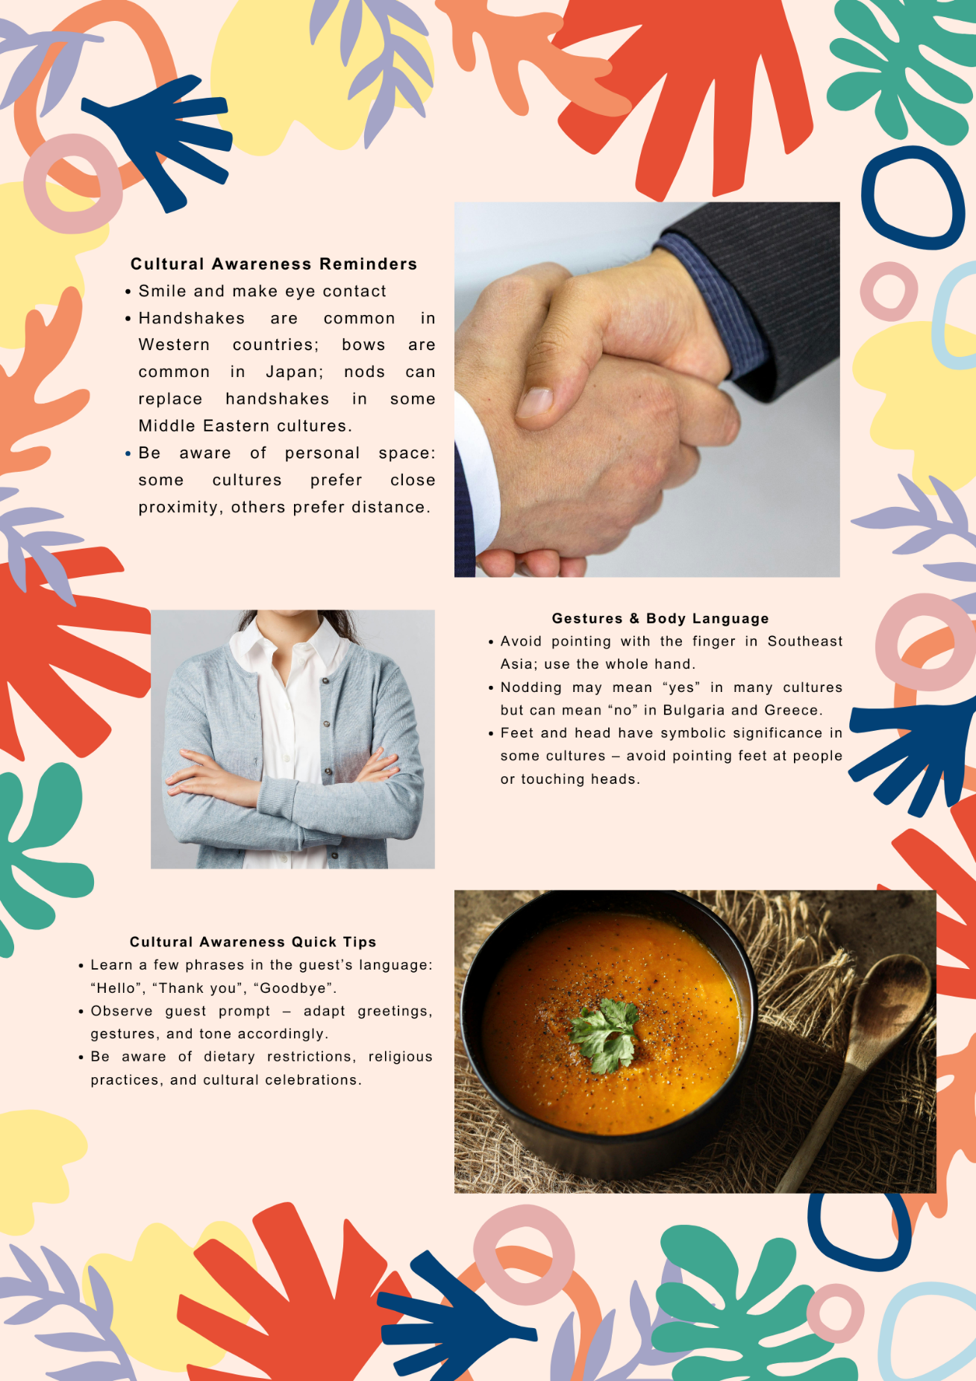

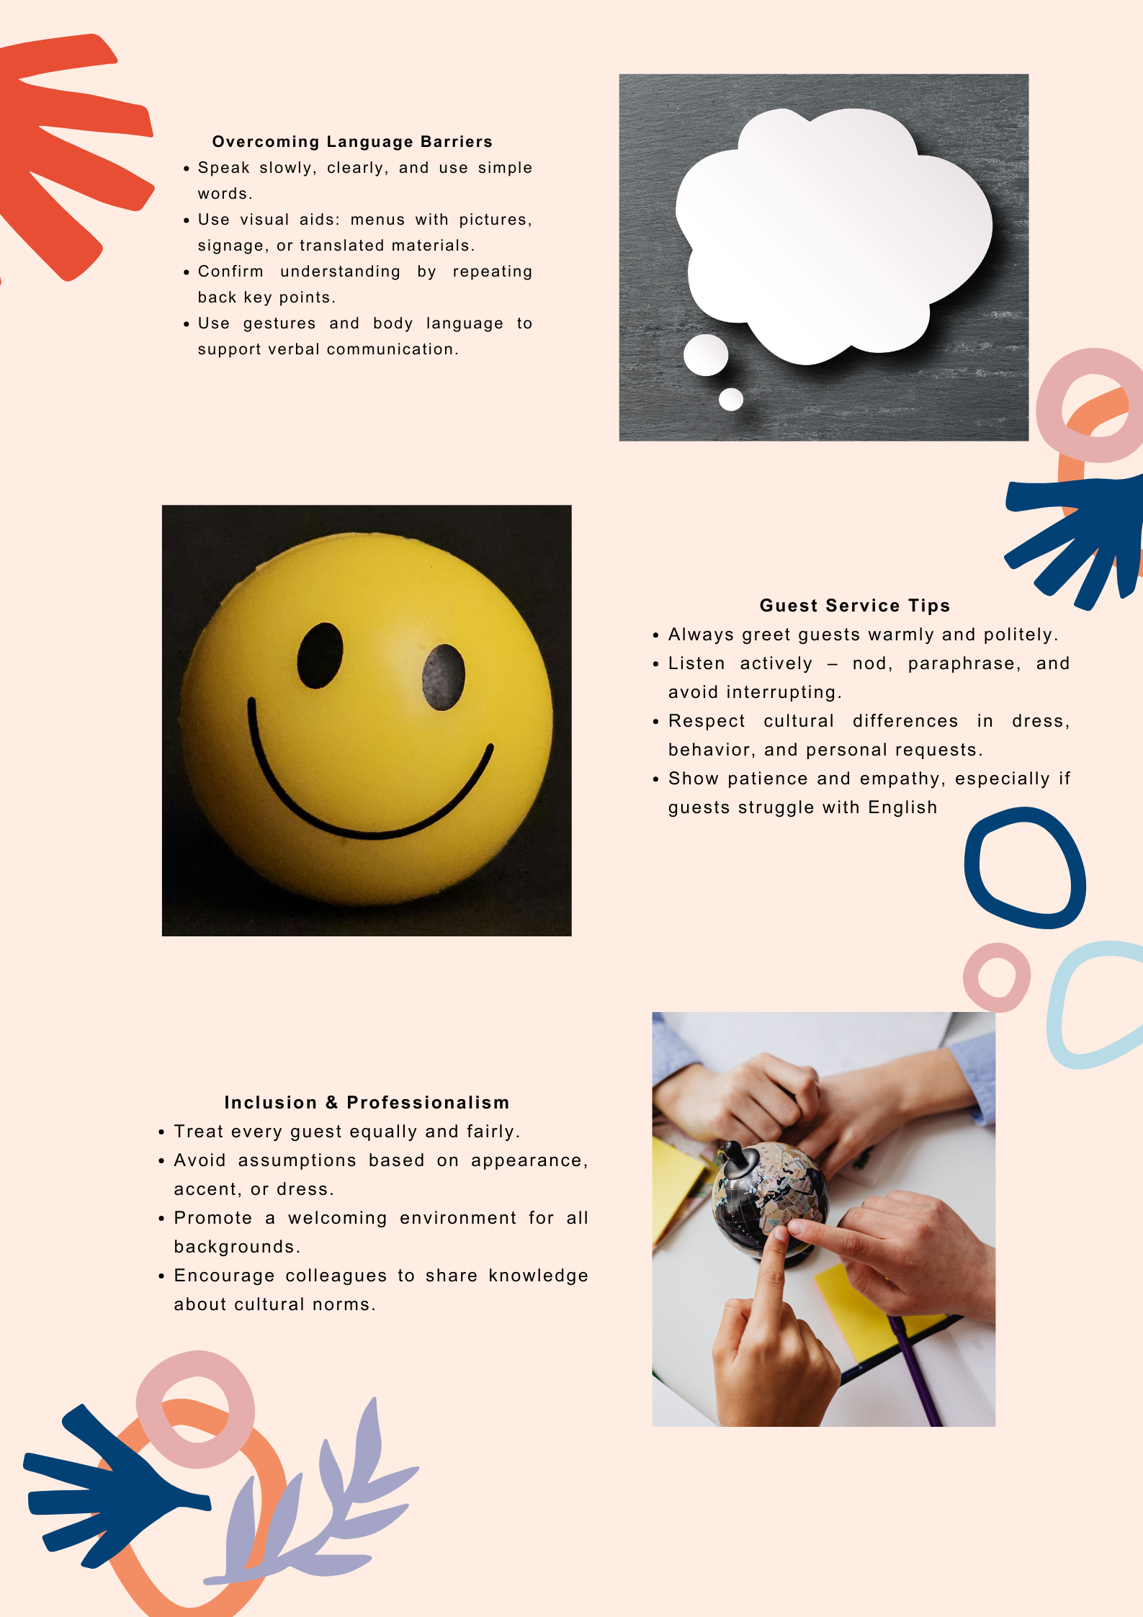

Portfolio – Element 4

Workplace Scenario

Module: Foreign Languages & Cultural Awareness
Module code: BMIH5009 / BMIH5009D
Lecturer: Lisa Bassler

Student: Silvia Badea – 2130240
12/12/2025

Experience
One busy evening in the restaurant, two employees from different cultural backgrounds experienced a misunderstanding during service. Silvia, a Romanian waitress, was working with Michael, a British team member. Silvia liked to work fast and expected teamwork without needing to explain every step, because in her culture helping each other quickly is normal. When the restaurant became busy, she said to Michael in a direct tone, “Can you clear table six now, please?”
Michael felt uncomfortable. In British culture, a direct tone can sometimes sound rude, especially during stressful moments. He preferred a softer, more polite request such as, “Could you please clear table six when you have a moment?” He thought Silvia was being demanding, while she believed she was simply being efficient. Because of this, the atmosphere became tense. Communication slowed down, and small mistakes happened, such as delayed drinks and missed food running.
Later, Silvia felt confused because she thought she had spoken normally. Michael felt frustrated because he thought she was giving orders instead of working as a team. Both had good intentions, but different cultural expectations created an understanding situation.
Many Romanians, including myself, tend to communicate in a direct and efficient way, and this often shows in the workplace. We grew up in an environment where people value hard work, speed, and getting things done without too much discussion. In many Romanian workplaces, especially in hospitality, things move fast and colleagues help each other automatically, even without being asked. Because of this, we are used to saying things clearly and quickly, not to be rude, but simply to keep the work flowing. This cultural habit sometimes makes us seem too direct to people from other countries, but for us it is a normal and practical way of working.
In this situation, differences in power distance influenced how Michael perceived Silvia’s direct request; in the Romanian low power distance approach, direct communication is normal, but in the British context, it was interpreted as impolite (Hofstede, 2011).

Action (Resolution)
To resolve the situation, a brief and honest conversation would help both employees understand each other better. They could explain how they interpreted the tone and agree on a communication style that works for both. Research shows that open discussion reduces tension and improves teamwork in multicultural settings (Chen and Starosta, 2021). Practical intercultural training can guide staff in adapting their approach, improving collaboration and guest satisfaction (Sparks & Pan, 2022).
Silvia could soften her tone slightly during requests by using simple polite phrases such as “Could you help me with…” or “When you have a moment…”. At the same time, Michael could recognise that direct speech is not disrespectful for Silvia; it is simply a cultural habit linked to efficiency and teamwork during busy periods. Most of the time, I talk with my colleagues, and we like to share our way of being with them so that they can understand certain reactions of ours as Romanians.
Management could also support cultural awareness training, so staff learn the different ways cultures communicate. Short team briefings before service would help staff share expectations and avoid future misunderstandings. By taking these steps, both employees can feel respected, leading to better teamwork and smoother service.

Portfolio – Element 5

Presentation

Module: Foreign Languages & Cultural Awareness
Module code: BMIH5009 / BMIH5009D
Lecturer: Lisa Bassler

Student: Silvia Badea – 2130240
12/12/2025
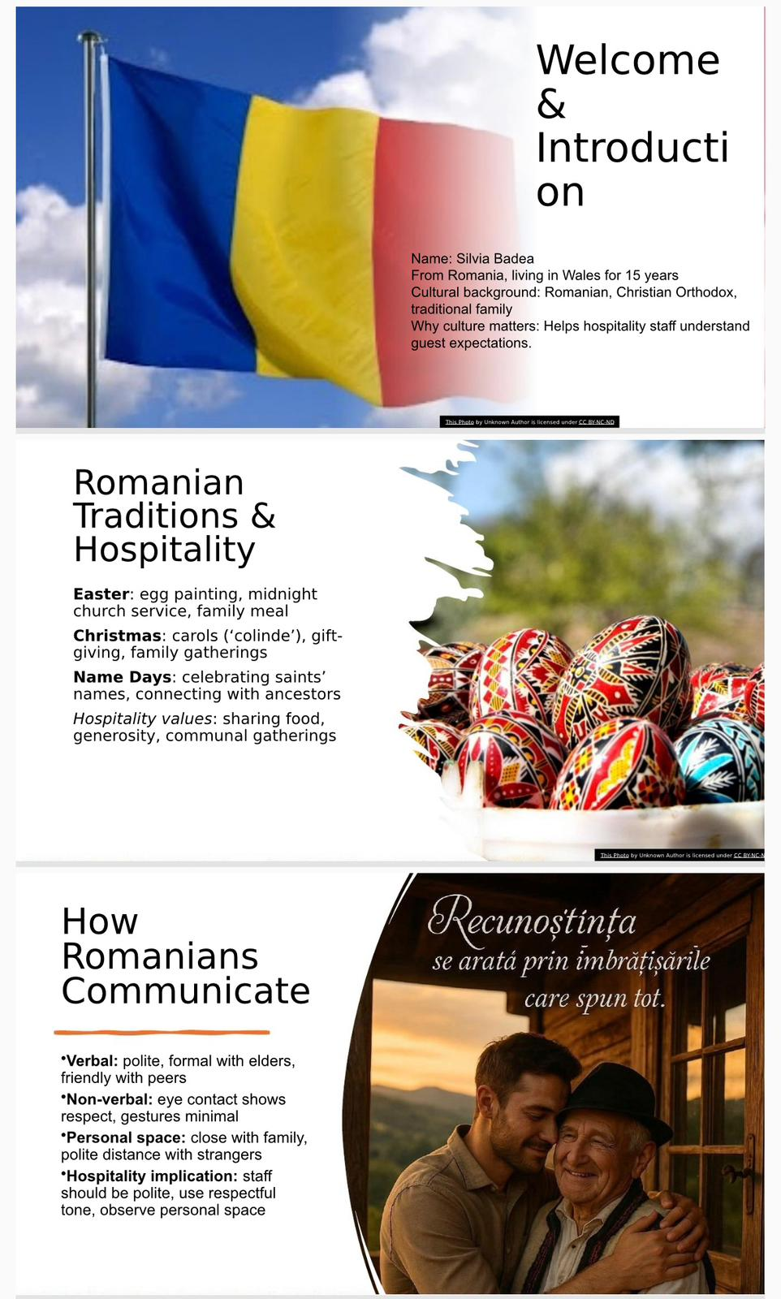
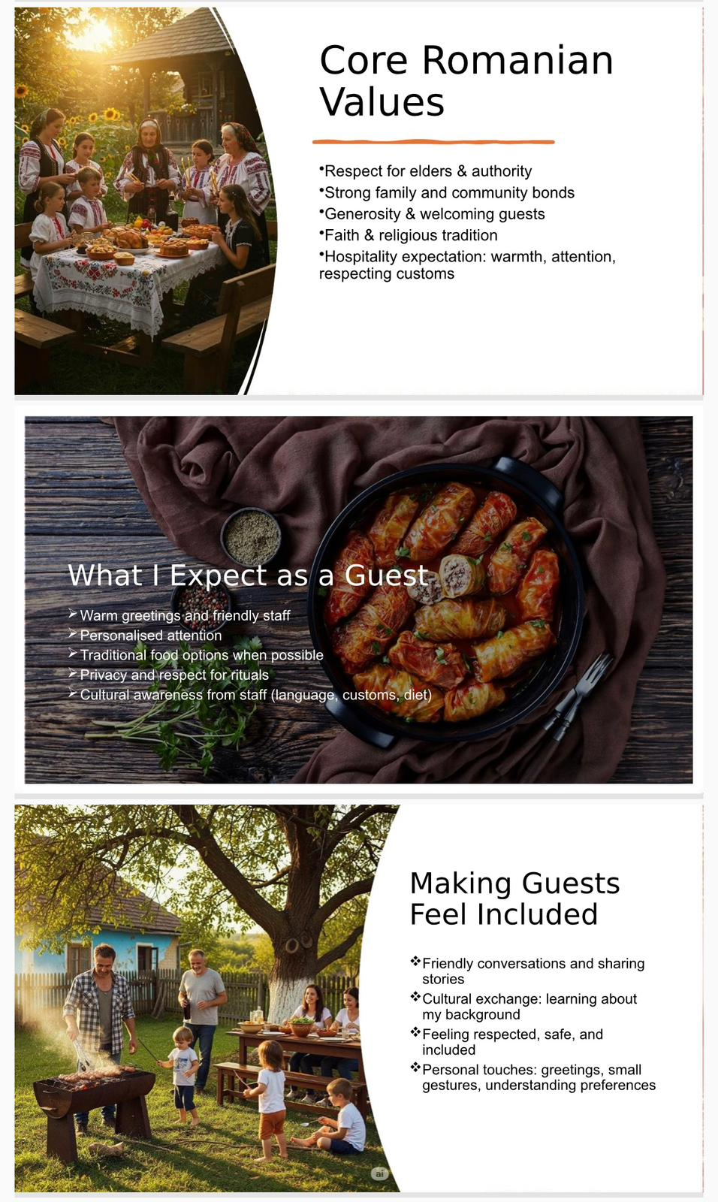
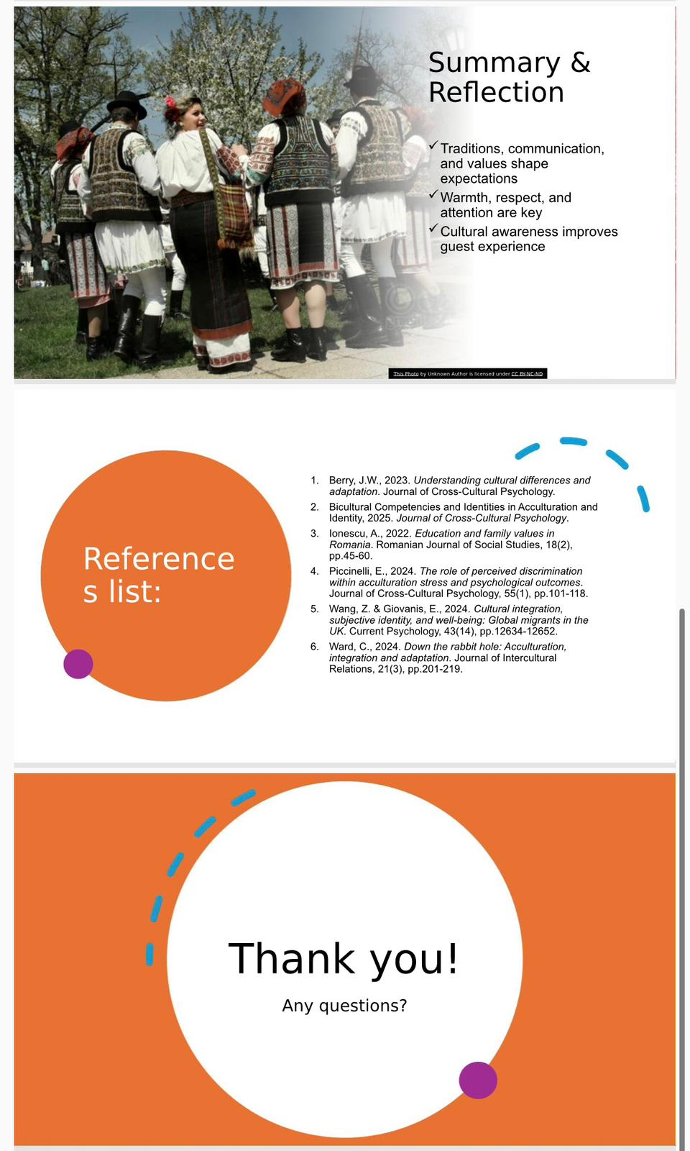
Portfolio – Element 6

Reflective Essay

Module: Foreign Languages & Cultural Awareness
Module code: BMIH5009 / BMIH5009D
Lecturer: Lisa Bassler

Student: Silvia Badea – 2130240
12/12/2025

The purpose of this reflection is to critically examine my learning experiences from this module, focusing on cultural awareness and communication within the hospitality industry. Using Gibbs’ Reflective Cycle (1988) as a framework, I will explore specific situations I encountered while working as a waitress, including challenges and confusion arising from cultural differences. This essay will reflect on how these experiences have shaped my personal development, professional practice, and understanding of effective communication. By analysing my responses and learning points, I aim to demonstrate how increased cultural awareness improve teamwork, guest satisfaction, and my future employability in a multicultural hospitality environment (Lugosi, 2020; Trenholm & Jensen, 2022).
During this module, one key learning experience was understanding how cultural differences influence communication in the hospitality industry. While working as a waitress in a multicultural environment, I often encounter guests and colleagues from diverse cultural backgrounds. For example, I experienced a situation with a British colleague, Michael, where our communication styles clashed: my direct, efficiency-focused approach as a Romanian was perceived as abrupt, while his preference for polite, indirect language caused some tension. This event highlighted how even routine interactions can lead to mistake if cultural norms are not considered.
Additionally, the module introduced me to intercultural theories and practical strategies, such as language adaptation, non-verbal prompt, and teamwork approaches in multicultural settings. Case studies and classroom discussions reinforced these ideas, providing examples of how staff can respond effectively to guests with different expectations. I also practiced using simple English and gestures to clarify information, which improved both guest satisfaction and my confidence in cross-cultural communication.
This experience gave me insight into the importance of cultural awareness in hospitality, showing that effective service requires not only technical skills but also empathy, observation, and adaptability. It laid the foundation for reflecting on my own communication style and understanding how to navigate multicultural work environments successfully (Berry, 2023).
At the start of this module, I felt both excited and slightly anxious about exploring foreign languages and cultural awareness. I have always valued learning and communication, but I was aware that my Romanian cultural background and direct communication style might not always align with other cultures. Initially, I sometimes felt nervous about making mistakes when speaking English with international guests or misunderstanding cultural cues, which made me hesitant in some interactions.
However, these feelings also motivated me to engage actively with the module content and practical exercises. I paid close attention to case studies, language practice, and discussions about intercultural theories, reflecting on how these ideas related to my experiences at work. My curiosity and desire to improve my professional skills outweighed my initial concern. Over time, I noticed that being more conscious of my own reactions and cultural assumptions helped me respond more carefully to colleagues and guests.
These emotions influenced my learning outcomes positively. Feeling cautious encouraged me to observe and analyse situations more attentively, while my excitement and interest in cultural awareness increased my engagement with the activities. Ultimately, acknowledging both the challenges and benefits of cross-cultural communication allowed me to develop greater empathy, confidence, and flexibility in my professional practice (Beldona, Schwartz & Altin, 2022; Smith, 2023).
One part of my learning that went well was improving how I communicate with guests from different cultures. During the module, I learned practical ways to speak clearly and politely, and to pay attention to how people react to my words (Lugosi, 2020). Using simple English and short sentences made it easier for guests to understand me. Working with colleagues who spoke other languages was also very helpful because they could support me when I struggled to explain something (Beldona, Schwartz & Altin, 2022). These experiences made me more confident and better prepared for real work situations.
Learning the theories behind cultural differences was also very useful. For example, studying Hofstede’s ideas about individualism and collectivism helped me understand why my Romanian way of being direct and efficient sometimes clashed with British colleagues’ preference for polite requests (Hofstede, 2011). This made me more aware of my own style and how it might be received by others.
However, some parts were difficult. At first, I found it hard to remember to adapt my communication during busy work periods. Sometimes I wanted to finish tasks quickly, and I forgot to be careful with my words. I also felt frustrated when I had to repeat explanations, even though I was trying my best.
Class discussions, feedback from teachers, and examples from the workplace helped me overcome these challenges (Smith, 2023; Trenholm & Jensen, 2022). They encouraged me to think about what works and what can be improved. Overall, combining practical exercises and theory helped me learn how to communicate better with guests and colleagues from different cultures. This will help me in my future career in hospitality.
The experiences I had in the workplace unfolded the way they did because of differences in culture and communication styles. For example, my Romanian way of speaking directly and focusing on efficiency sometimes surprised colleagues from more polite, indirect cultures, like the British team member, Michael. This fits with Hofstede’s cultural dimensions, which explain how individualism and collectivism, or direct and indirect communication, affect how people interact at work (Hofstede, 2011). Understanding these differences helped me see why conflicts or confusion can happen even when everyone has good intentions.
Intercultural communication models also helped me understand my experiences. These models suggest that effective communication is not just about language, but also about understanding cultural expectations and adapting behaviour (Trenholm & Jensen, 2022). For example, learning to soften my tone, give explanations slowly, and check that guests understood me improved my service. Using translation apps, gestures, or asking multilingual colleagues for help were practical ways to reduce problems and make guests feel more comfortable (Liu & Mattila, 2023).
These insights have important implications for teamwork and guest satisfaction. Being aware of cultural differences allows colleagues to work together more smoothly, avoiding unnecessary stress or confusion. For guests, clear communication and cultural understanding make them feel respected and valued, which improves their experience and the reputation of the hotel (Ward, 2024).
For professional practice, this reflection showed me that cultural awareness and language skills are essential in hospitality. They help me adapt to different situations, understand my colleagues, and meet guest expectations. Developing these skills makes me more confident, improves my teamwork, and increases my employability in a multicultural workplace. Learning from both theory and experience ensures I can respond effectively to diverse situations in my future career.
Reflecting on my experiences, I have learned a great deal about myself, my communication style, and my intercultural awareness. I realized that my natural direct and efficiency-focused approach, shaped by my Romanian background, is not always interpreted the same way by people from other cultures. Recognising this has helped me understand the importance of adapting my communication depending on the cultural context, which is essential in hospitality. I have also learned to pay more attention to how colleagues and guests respond, and to adjust my tone, language, and body language to create a more comfortable environment.
This reflection showed me that cultural differences affect nearly every aspect of hospitality operations. Guests’ expectations regarding politeness, interaction, and service vary across cultures, and colleagues also communicate and work differently. Being aware of these differences allows staff to collaborate more effectively, provide better service, and reduce potential tension in the workplace.
Overall, I now understand that cultural awareness is not only about language skills but also about empathy, observation, and flexibility. By reflecting on my experiences and linking them to theory, I have gained valuable insights into how to work successfully in a multicultural hospitality environment.
To continue developing my communication skills and cultural competence, I plan to take several practical steps. First, I will engage in regular cultural awareness training and workshops, which will help me understand different customs, expectations, and communication styles in hospitality. Second, I will practice using clear and polite language with guests and colleagues, adapting my tone to suit different cultural contexts. Third, I will continue learning foreign languages or useful phrases to improve guest interactions and demonstrate respect for their culture.
Additionally, I will observe and reflect on my interactions in the workplace, seeking feedback from colleagues and supervisors to identify areas for improvement. I will also collaborate closely with multilingual team members to enhance teamwork and ensure smooth service. These actions will strengthen my professional skills, increase guest satisfaction, and improve my employability, preparing me for a successful career in multicultural hotel management and hospitality.
This reflection has shown me the value of being attentive to cultural differences in the workplace (Chen & Starosta, 2021). I now appreciate that communication is not only about words but also about understanding others’ expectations, behaviours, and perspectives (Deardorff, 2018). My experiences highlighted how small adjustments, patience, and openness can improve collaboration with colleagues and interactions with guests from diverse backgrounds (Sparks & Pan, 2022). Developing cultural awareness has boosted my problem-solving, adaptability, and confidence in professional settings (Kim, 2021). In conclusion, this learning journey has reinforced that embracing diversity and reflecting on my own practices is key to growing as a hospitality professional (Earley & Ang, 2003).

References:
- Beldona, S., Schwartz, Z. & Altin, M. (2022) ‘Multicultural teamwork in hospitality: Strategies for effective collaboration’, International Journal of Hospitality Management, 101, p.103056.
- Berry, J.W. (2023) ‘Acculturation and adaptation in multicultural workplaces’, Journal of Cross-Cultural Psychology, 54(2), pp.145–162.
- Chen, G.M. & Starosta, W.J. (2021) Foundations of Intercultural Communication. London: Routledge.
- Deardorff, D.K. (2018) The SAGE Handbook of Intercultural Competence. Thousand Oaks, CA: SAGE Publications.
- Doherty, L. & O’Brien, S. (2021) ‘Cultural awareness training in hospitality: Improving service quality’, Tourism and Hospitality Research, 21(3), pp.245–260.
- Earley, P.C. & Ang, S. (2003) Cultural Intelligence: Individual Interactions Across Cultures. Stanford, CA: Stanford University Press.
- Hale, J. & Napier, S. (2021) ‘Language skills and guest satisfaction in hotels’, International Journal of Contemporary Hospitality Management, 33(4), pp.1234–1249.
- Hofstede, G. (2011) Dimensionalizing Cultures: The Hofstede Model in Context, Online Readings in Psychology and Culture, 2(1), pp.1–26.
- Hofstede, G., Hofstede, G.J. & Minkov, M. (2010) Cultures and Organizations: Software of the Mind. 3rd edn. New York: McGraw-Hill.
- Ionescu, A. (2022) ‘Education and social development in Romania’, Romanian Journal of Education, 14(1), pp.33–47.
- Kim, Y.Y. (2021) Becoming Intercultural: An Integrative Theory of Communication and Cross-Cultural Adaptation. London: Routledge.
- Liu, Y. & Mattila, A.S. (2023) ‘Communication strategies for non-native speakers in hospitality’, Journal of Hospitality Marketing & Management, 32(1), pp.56–75.
- Lugosi, P. (2020) ‘Cultural awareness and communication in hotels’, Tourism Management, 78, p.104018.
- Piccinelli, R. (2024) ‘Perceived discrimination and psychological adjustment in migrants’, Journal of Cross-Cultural Studies, 21(1), pp.55–70.
- Purpuri, M. (2024) ‘Language and cultural identity in migrant communities’, Journal of Multilingual and Multicultural Development, 45(2), pp.101–116.
- Smith, R. (2023) ‘Managing cross-cultural communication in hospitality teams’, International Journal of Hospitality Management, 106, p.103312.
- Sparks, B. and Pan, G. (2022) ‘Intercultural communication training and its impact on hospitality service quality’, International Journal of Hospitality Management, 102, pp. 1–10.
- Trenholm, S. & Jensen, A. (2022) Interpersonal Communication. 8th edn. Oxford: Oxford University Press.
- Ward, C. (2024) ‘Cultural adaptation and workplace integration in hospitality’, Journal of International Business and Culture, 12(1), pp.77–92.
- Wang, S. & Giovanis, E. (2024) ‘Acculturation, well-being, and identity in migrants: Evidence from the UK’, Journal of Cross-Cultural Studies, 20(1), pp.45–62.
- Bicultural Competencies and Identities (2025) International Perspectives on Multicultural Workplaces. London: Routledge.

