
Certificate of Higher Education Skills for the Workplace (Health & Social Care)
Module: Introduction to Health and Social Care
Module code: LCHS4003
Student name:Lavinia Groceanu
Student ID:2508612
Lecturer name:Azida Zainol

Comm

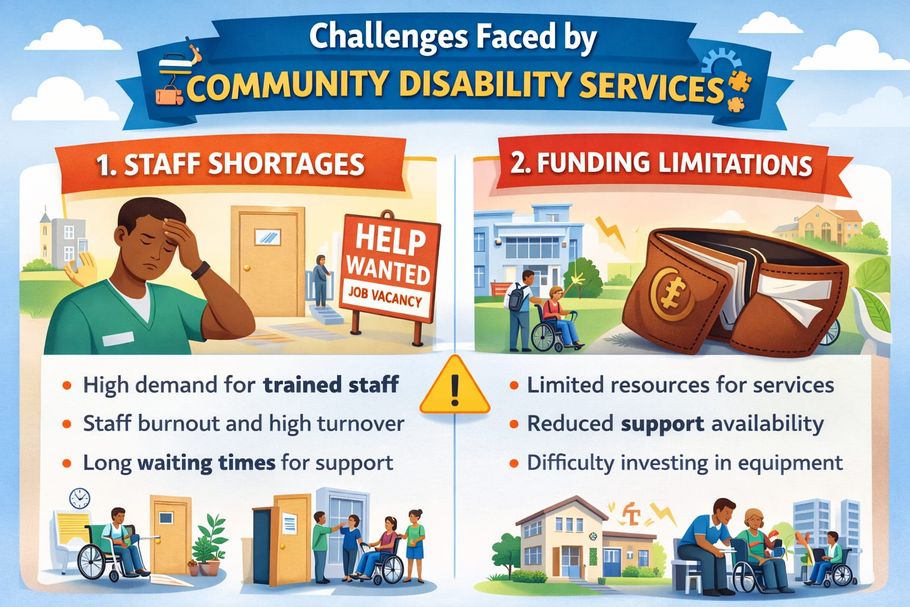
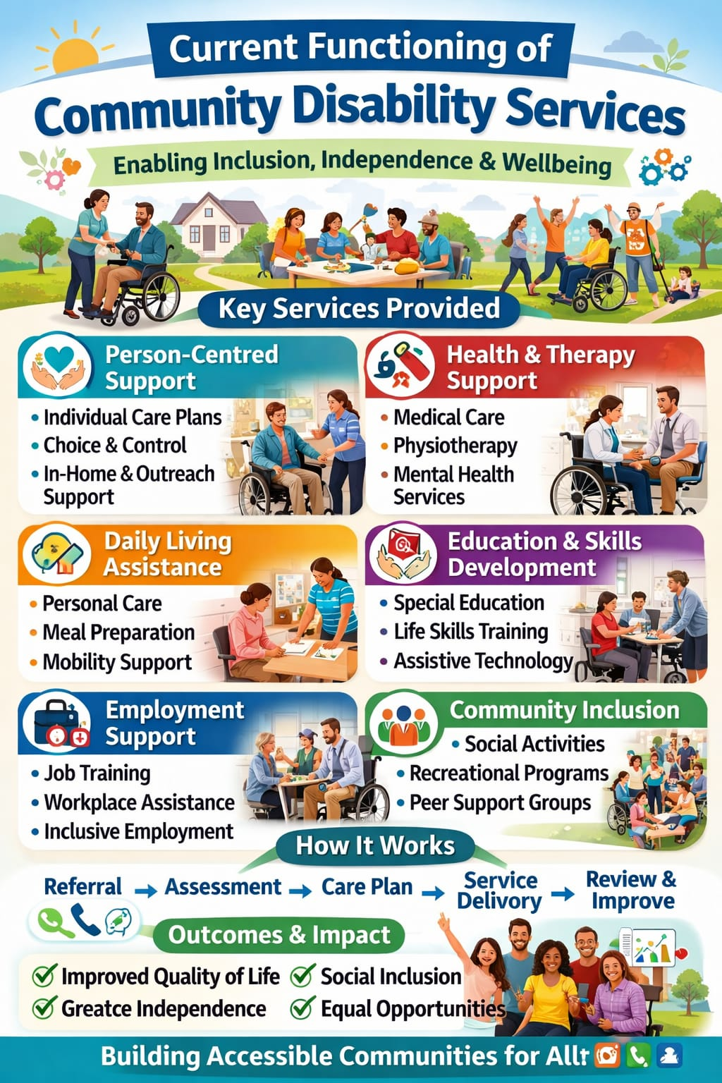
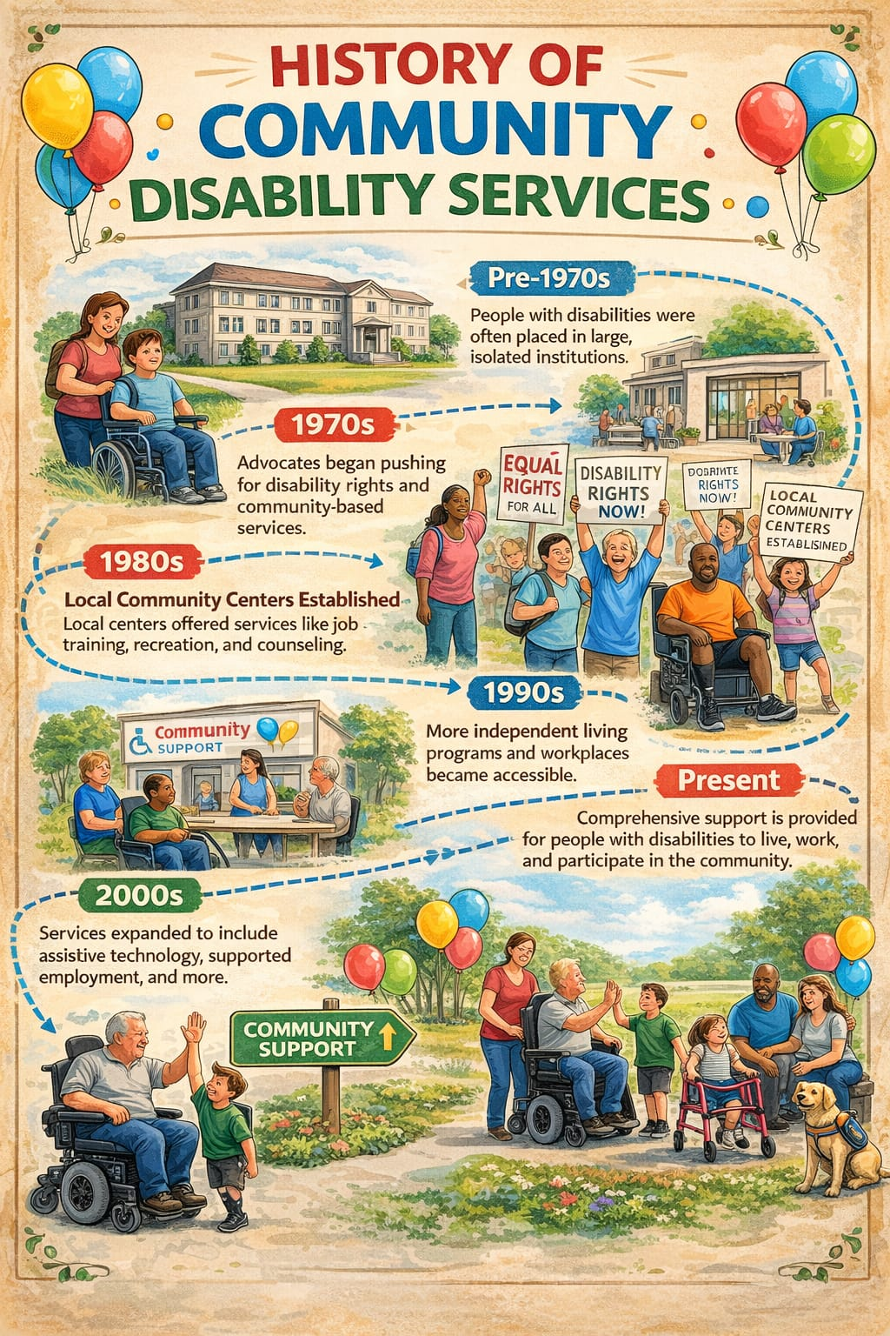

Conclusion
Community disability services have evolved from institutionalised care to inclusive, person-centred support that empowers individuals and promotes equality. While challenges such as funding constraints and workforce shortages remain, these services continue to play a vital role in enhancing independence, participation, and quality of life for people with disabilities. Their ongoing commitment to rights-based, community-focused care ensures that individuals are supported to achieve their goals and contribute fully to society.
1.Many Funding and Resource Limitations.
community disability services face ongoing funding constraints, which can lead to long waiting lists, limited program availability, and pressure on staff. Insufficient funding may also affect the quality and consistency of support provided to individuals (World Health Organization, 2011).
2. Workforce Shortages and Staff Burnout. There is a growing demand for disability support services, but many organisations struggle with staff shortages, high turnover rates, and burnout. This can impact continuity of care and the ability to deliver person-centred support effectively (Productivity Commission, 2011).
Community disability services today focus on supporting people with disabilities to live meaningful lives within their local communities. These services aim to help individuals access education, employment, health care, social activities, and independent living supports, based on each person’s goals and needs (World Health Organization, 2011).They follow a person-centred approach, meaning the support is tailored to what the individual wants, rather than a one-size-fits-all model (Brown et al., 2018). Services often include practical assistance (such as daily living support and transport), social inclusion programmes, skill development, advocacy, and coordination with other community agencies (United Nations, 2006).There is also a strong focus on rights, choice, and self-direction, ensuring that people with disabilities are involved in decisions about their own lives and supports (Oliver, 2013). Modern disability services work within national standards and disability frameworks to promote inclusion, reduce barriers, and support equal participation in society.
Community disability services developed as society moved away from isolating people with disabilities in large institutions during the 19th and early 20th centuries (Shakespeare, 2014). Over time, advocacy groups pushed for equal rights, independence, and inclusion within the community.
From the 1960s onwards, ideas such as normalisation encouraged supporting people to live ordinary lives in their own communities rather than in segregated settings (Wolfensberger, 1972). International agreements later strengthened this rights-based approach, particularly the Convention on the Rights of Persons with Disabilities, which promotes dignity, participation, and equal opportunity (United Nations, 2006). Today, community disability services focus on person-centred support, empowerment, and full social inclusion (World Health Organization, 2011).
I chose community disability service because I am passionate about promoting inclusion, independence, and equal opportunities for people with disabilities. I believe that everyone deserves dignity, respect, and the support needed to participate fully in society. Working in this field allows me to empower individuals to achieve their goals while contributing to a more inclusive community (World Health Organization, 2011; United Nations, 2006).
Community disability services
Functioning
Task 1
Challenges
Explanation
History

TASK2
Ambulance services
Ambulance services are an essential part of healthcare systems, offering immediate medical attention, pre-hospital treatment, and safe transportation to hospitals. In the United Kingdom, these services are organised under the National Health Service (NHS), providing universal access to urgent care (NHS England, 2023). The evolution of ambulance services has been influenced by industrialisation, wartime experience, and healthcare reforms, all of which shaped their organisation, professional standards, and clinical capabilities. Examining their history, present-day role, and societal impact illustrates their importance in improving patient survival and wellbeing (Shah, 2006; Porter, 1999).
Prior to the 19th century, emergency transport was irregular and often relied on police officers, volunteers, or family members. As industrialisation progressed, workplace accidents and public injuries became more common, demonstrating the need for a structured system for emergency transport (Porter, 1999). Early ambulance provision was mostly charitable and linked to hospitals, focusing mainly on moving patients rather than providing treatment during transit. These initial efforts laid the groundwork for more organised and professional services.
The experience of the First and Second World Wars showed the critical value of rapid evacuation and trained medical staff. Military innovations, including motorised ambulances and triage procedures, proved that timely medical intervention could save many lives, influencing the design of civilian ambulance systems (Shah, 2006). The creation of the NHS in 1948 was a pivotal moment, bringing ambulance services under national control, standardising care, and integrating them into public healthcare (Webster, 2002). Over time, the role of ambulance personnel expanded, and they became trained clinicians capable of delivering life-saving interventions, trauma management, and stabilisation at the scene (NHS England, 2023).
Currently, NHS ambulance services respond to emergency 999 calls, urgent care situations, and routine patient transport. Paramedics provide advanced life support, trauma care, and independent clinical decision-making on site (NHS England, 2023). Modern technology, such as computer-aided dispatch systems, GPS tracking, and electronic patient records, has enhanced efficiency and coordination (The King’s Fund, 2022). Triage systems ensure that the most urgent cases receive immediate attention, while less critical cases may be redirected through alternative care pathways (Perkins et al., 2015).
Despite these developments, ambulance services face ongoing challenges. An ageing population, rising rates of chronic illness, and increasing mental health crises have put pressure on resources. Staff shortages, hospital delays, and financial constraints can affect response times and service quality (The King’s Fund, 2022). To address these issues, community paramedicine programmes, remote consultations, and referral pathways aim to provide care at home or direct patients to the most appropriate service, reducing unnecessary hospital admissions (NHS England, 2023).
Ambulance services significantly improve survival and long-term recovery in emergencies such as cardiac arrest, stroke, and major trauma (Perkins et al., 2015). Beyond immediate clinical care, they offer reassurance to the public by providing round-the-clock access to skilled professionals. Non-emergency transport services allow vulnerable populations, such as older adults or people with disabilities, to attend essential medical appointments, helping to reduce health inequalities (Oliver, 2013; Brown et al., 2018). Paramedics increasingly consider mental health, safeguarding, and social factors in their practice, connecting patients to wider community support, which enhances overall wellbeing and quality of life (Shakespeare, 2014; United Nations, 2006; World Health Organization, 2011).
In conclusion, NHS ambulance services have transformed from informal, voluntary transport to sophisticated healthcare providers with advanced clinical skills. Influenced by industrialisation, wartime innovation, and the establishment of the NHS, these services now deliver critical pre-hospital care across the UK. Despite ongoing operational pressures, ambulance services continue to save lives, improve patient recovery, and support the health and social wellbeing of communities (NHS England, 2023; The King’s Fund, 2022).

References

Brown, M., Smith, J. and Taylor, K. (2018) ‘Person-centred practice in disability support services’, Journal of Social Care, 12(3), pp. 145–160.
NHS England (2023) Ambulance services overview. Available at: https://www.england.nhs.uk (Accessed: 19 February 2026).
Oliver, M. (2013) ‘The social model of disability: thirty years on’, Disability & Society, 28(7), pp. 1024–1026.
Perkins, G.D. et al. (2015) ‘Improving outcomes from out-of-hospital cardiac arrest’, Resuscitation, 94, pp. 128–134.
Porter, R. (1999) The Greatest Benefit to Mankind: a medical history of humanity. London: HarperCollins.
Productivity Commission (2011) Disability care and support. Canberra: Commonwealth of Australia.
Shah, M.N. (2006) ‘The formation of the emergency medical services system’, American Journal of Public Health, 96(3), pp. 414–423.
Shakespeare, T. (2014) Disability rights and wrongs revisited. 2nd edn. London: Routledge.
The King’s Fund (2022) Ambulance service pressures and performance. London: The King’s Fund.
United Nations (2006) Convention on the Rights of Persons with Disabilities. New York: United Nations.
Webster, C. (2002) The National Health Service: a political history. Oxford: Oxford University Press.
World Health Organization (2011) World report on disability. Geneva: World Health Organization.

