Oppression, Desexualisation and Liberation of the Female Body
Joanne Caunter
P145376
Fine Art: Studio, Site and Context
Word Count: 5,116
Tutor: Marilyn Allen

For centuries artists have chosen to depict the female nude, to carve and to paint it into the annals of art history. This subject has spanned a multiplicity of movements to become a cornerstone of the art world, a “shorthand for art more generally; […] an icon of Western culture, a symbol of civilisation and accomplishment” (Nead, 1992:1). This trend arguably began with the creation of ‘Sleeping Venus’ by Giorgione, which introduced the world to the ideal female nude, “a beautiful and passive vision of perfection” (Borzello, 2012:14). Giorgione’s portrayal of Venus placed her firmly under the gaze of men, offering her up as an object to be enjoyed by her male onlookers. Women have arguably continued to be portrayed in this way ever since, with numerous male artists continuing to present their depictions of the female form through a filter of idealism. The male gaze has been defined and described by Mulvey, who argues that
In a world ordered by sexual imbalance, pleasure in looking has been split between active/male and passive/female. The determining male gaze projects its fantasy onto the female figure, which is styled accordingly. (Mulvey 1989:19)
While the male gaze continues to inform the depiction of women in our society, contemporary female artists have attempted to subvert the traditional expectations of the female nude within their practice. As Borzello explains, “the nude in commercial photographs is beautiful, handsome, sexy, perfect, the nude that interests the artists of today is none of these things” (Borzello 2012:10). Some female practitioners aim to remove the sexual connotations placed upon the female form, while others portray female sexuality from their perspective, reclaiming sexualised images of women from popular culture and reinventing them through their own, often divisive, works. However, it is important to consider and discuss whether these images are successful in their aim to recover the nude image of a female from the authorship of the patriarchy, or whether these images of women continue to exist within the expectations of a male-dominated culture. Can the nude image of a woman ever escape the control of the male gaze?

While the world has been saturated with images of nude women for centuries, the female form was not always considered a symbol of high art. Prior to the Renaissance, the female nude “remained a relatively unimportant player on the stage of fine art” (Borzello, 2012:15), with artists favouring an unashamed, active and upright male nude, embodiments of the Gods in their perfection and power. Portrayals of women were restricted to that of Eve, and her body was a reflection of her sin, whereas the nude male form was displayed with pride, his genitalia uncovered for all to see. Giorgione’s ‘Sleeping Venus’ arguably altered the course of art history, introducing to the world an accepted form of the female nude, one free from the sin of the nudes that preceded her. This nude became the archetypal representation of the female form, a woman whose feminine sexuality could be enjoyed by the men who viewed her. In contrast to the ideal male form, a standing figure, representative of power and godliness, the ‘Sleeping Venus’ is passive, reclining, her gaze shifted from the viewer so they may look upon her without confrontation or unease. This passive portrayal of the female body became typical of the nudes to follow, and is a trend which exists purely to satisfy the scopophilic tendencies of the male onlooker. Scopophilia (or voyeurism) refers to the pleasure that arises from viewing the naked body, from observing others in their nudity. It is around this core concept that the traditional female nude has been designed – to arouse excitement in the viewer. When Freud described this concept in his Three Essays on Sexuality, he described the power associated with the act of looking.
Freud isolated scopophilia as one of the component instincts of sexuality which exist as drives quite independently of the erotogenic zones. […] he associated scopophilia with taking other people as objects, subjecting them to a controlling and curious gaze. (Jones, 2003:46)
The traditional depictions of the female nude are designed to satiate this voyeurism, and in doing so, allow the viewer to assert their controlling gaze, and thus their power, over the female subject. The male, therefore, is the central figure in the narrative created by these depictions.
In the average European oil painting of the nude the principal protagonist is never painted. He is the spectator in front of the picture and he is presumed to be a man. Everything is addressed to him. Everything must appear to be the result of him being there. It is for him that the figures have assumed their nudity. (Berger, 1972:54)
As Berger explains, the traditional representation of the female body in art history has never attempted to be a reflection of female sexuality, instead choosing to appeal to the desires of an assumed male onlooker. This portrayal of the female nude is therefore an oppressive one, a portrayal that favours the desires of men and positions the woman accordingly, so that men may feel welcome to view and enjoy her body. The woman lies passive as she is viewed, never exuding a sexuality of her own. Her gaze does not fall on the viewer, so that he may view her without having to feel her eyes on him. From Giorgione’s ‘Sleeping Venus’, to the many depictions of the female nude which have been created in the years since, the woman has been presented as the oppressed and passive object of a male-centric society.
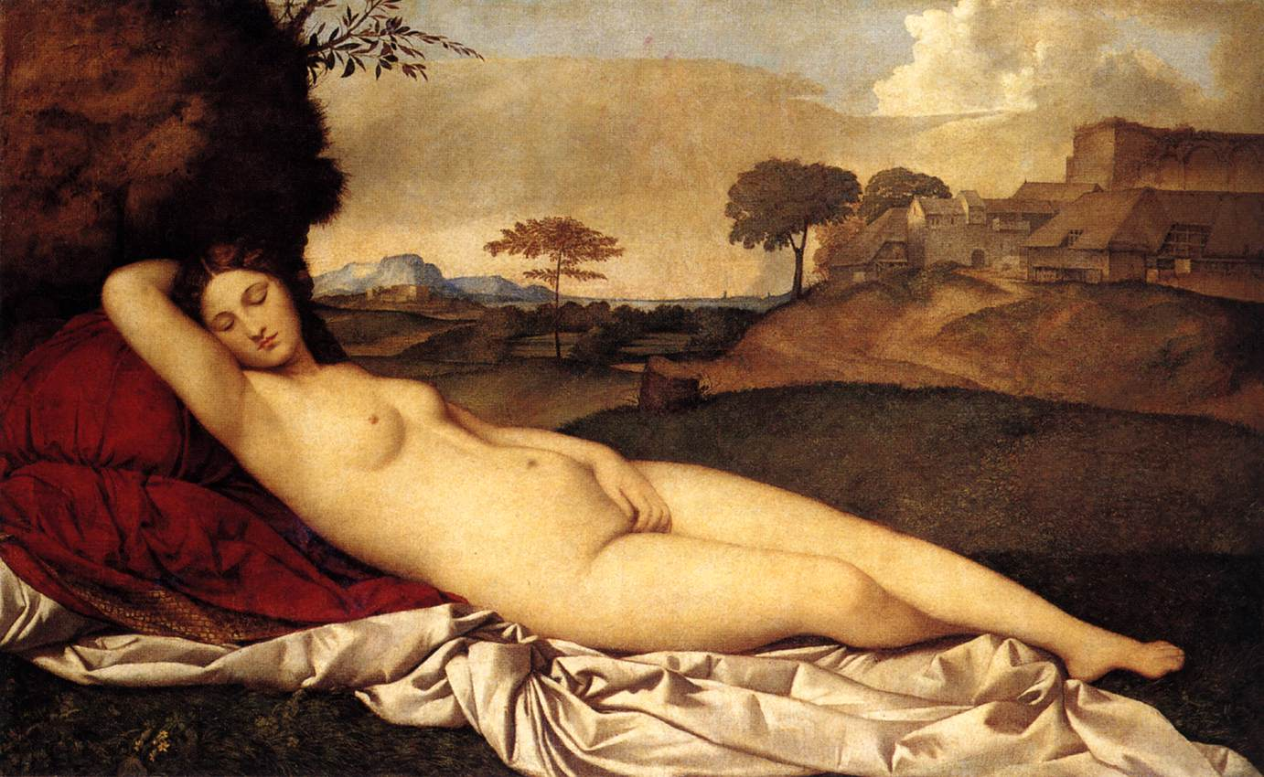

Giorgione, (1510) Sleeping Venus
The typical male nude created in the years preceding the painting of ‘Sleeping Venus’ was never compelled to be covered. His genitals were displayed proudly, whereas female genitalia continued to be hidden. While the traditional female nude exists to satiate the sexual desires of her male audience, she is not exposed in the unashamed, uncovered manner of the male nudes that came before her. In traditional depictions of the female nude, the subject “revealed her body in a much coyer fashion; whereas male genitalia were displayed, the female hid hers beneath a hand” (Borzello, 2012:15). Unlike her male counterparts, Venus’ genitalia is not depicted, a choice that is reflective of attitudes towards the female body as a site of mystery, an unknown and obscene entity, a body which must be controlled if it is to be enjoyed. The covering of the woman’s genitalia allows for this enjoyment to occur – the male onlooker can now view the female’s nude form, free from feelings of shame. This covering is essential, for she is presented as an object of male desire, to be enjoyed by her male onlookers. The reality of the female body is disguised, because “No nude, however abstract, should fail to arouse in the spectator some vestige of erotic feeling […] and if it does not do so, it is bad art and false morals” (Clark, 1956:6). Any depiction of the naked female form that does not conform to this tradition, which does not exist to please the male onlooker, is met with disgust. An image of the female body, which displayed her genitalia, may be considered indecent, and derided by its male audience. Therefore,
The female nude can thus be understood as a means of containing femininity and female sexuality. If […] the female body has been regarded as unformed, undifferentiated matter, then the procedures and conventions of high art are one way of controlling this unruly body and placing it within the securing boundaries of aesthetic discourse. (Nead, 1992:2)
A nude portrait of Cambridge Fellow Dr Victoria Bateman by painter Anthony Connolly is a recent example of this view presented by Nead. In the painting, Dr Bateman has chosen to assume an upright position, and to pose fully naked. However, the work became the subject of a derisive article by the Daily Mail, in which the author chose to “spare Dr Bateman’s blushes (by deciding) to cover up her virtue with the college crest” (Shakespeare, 2014). From the wording of the author, it is clear that the expectation is that Bateman should feel embarrassed or ashamed by her nudity, and therefore the male author has taken it upon himself to cover her vagina, sparing her from the humiliation of being exposed. This attitude, reflected clearly by Giorgione’s depiction of Venus, is displayed once again, only this time in a contemporary article by a widespread British newspaper. By covering Bateman’s vagina, the author here attempts to assert control over her body and its representation, deciding what should and should not be displayed for the audience’s pleasure. This control over the female body has been present within art history for hundreds of years, and continues to exist in our contemporary society.

Traditional nudes, such as Giorgione’s ‘Sleeping Venus’, may be viewed as an oppressive representation of women due to the fact that they promote a heterosexual agenda, one that reduces female sexuality to merely its impact on that of a man. Within this prominent heterosexual narrative, women are presented as an object of desire, to satiate the needs of the man. “Women are there to feed an appetite, not to have any of their own” (Berger, 1972:55). This representation of women creates a system in which men and women are viewed as distinctly different from one another, “a binary split between woman as passive objects of the look, and men as active subjects of their own desires” (Betterton, 1996:11). By placing women under the authorship of patriarchy, by presenting them as a sexual object to be enjoyed by a man, we reiterate this binary system, the idea that men and women are inherently different and should be treated as such. As Butler explains,
The institution of a compulsory and naturalised heterosexuality requires and regulates gender as a binary relation in which the masculine term is differentiated from a feminine term, and this differentiation is accomplished through the practices of heterosexual desire. (Butler, 1990:22-23)
The acceptance of gender as a binary system therefore encourages a difference between the behaviour of man and woman. A separation between the genders results in a different set of rules for each, to which they must conform. As a result of this, “gender is performatively produced, and compelled by the regulatory practices of gender coherence” (Butler, 1990:24). The behaviours of each gender do not come naturally to them, they are reinforced by our society’s perception of how men and women should act. This gender performativity ultimately results in an expectation of how women should present themselves, and allows men to continue to exert their control over depictions of women’s bodies. The reiteration of expected behaviours allows for a depiction of women that is sanctioned by men, creating a homogenised ideal for the female body to which women must conform. This ideological construction serves to reinforce male dominance over the female body, and its presentation throughout art and the media.

Although Giorgione’s ‘Sleeping Venus’ was completed in 1510, the influence of the painting and the expectations it created for the depiction of women are still felt within contemporary society. The norms by which we are supposed to abide can be seen across all forms of media, presenting us with the ideal female body, and exerting male dominance over the female nude. As Borzello explains
Today’s media bombard us with […] the perfect body, the sexualised body, the young body […] these are the modern-day photographic versions of the ideal nude. (Borzello, 2012:10)
This body is particularly present in advertising, and is used to sell a variety of products to both men and women. Controversial fashion brand Calvin Klein is a particularly prevalent example of how the female nude continues to be used within our culture. Taking 2015’s campaign featuring supermodel Lara Stone alongside Justin Bieber as an example, it is clear that the positioning of Stone within these images conforms to the traditional depiction of a naked woman. Stone is not exposed in the same way as Venus, her breasts must be covered for the advertisement to be published in the public sphere, but she lies passive as Venus does, her eyes closed to allow the eyes of her male audience to gaze freely upon her body. The man in the image, however, looks directly at the viewer, and while his body is not upright, he holds the topless Stone in his arms and leans over her, showcasing his dominance. The two figures in the image are presented as distinctly different from one another, reiterating the accepted binary split between the masculine and the feminine, and encouraging the normalisation of this difference. Interestingly, this image is advertising the company’s range of jeans, and yet the jeans are barely visible in the photograph. The jeans here are almost unimportant, as the nude image of the woman alone is enough to arouse the viewer’s interest. Additionally, Calvin Klein can be said to promote a homogenised, sanctioned ideal for women through their advertisements. Their use of supermodels, women who are typically very tall and thin, who conform to a very specific typology, continually presents to their audience the one body type woman are supposed to possess. In showcasing this unrealistic ideal and highlighting an anticipated difference between what is considered masculine and feminine, Calvin Klein’s advertisements can be said to conform to the traditional depiction of the female nude, a depiction which aims to exert power over women and place limits upon how they may express themselves and present their bodies. As Berger states;
The essential way of seeing women, the essential use to which their images are put, has not changed. Women are depicted in quite a different way from men – not because the feminine is different from the masculine – but because the “ideal” spectator is always assumed to be a male and the image of the woman is designed to flatter him. (Berger, 1972:64)
Women continue to be contained by these accepted depictions of their bodies, and with these images being so prevalent within our society, it is no surprise that women continue to be oppressed by the way they are presented in contemporary culture.


Alas and Piggott for Calvin Klein, (2015)

There are those who, in an effort to remove the image of the female nude from the control of the male gaze, have attempted to lift the sexual connotations placed on such imagery within their practice. One such artist is Annie Sprinkle, a former porn star and prostitute turned artist and activist, whose performative work challenges the patriarchal view of the nude woman. ‘A Public Cervix Announcement’ is a series of performances in which Sprinkle inserted a speculum into her vagina and invited the audience to view her cervix through it. In doing so, Sprinkle “takes on the role of an educator” (Kapsalis, 1997:124), placing the female body firmly within the realm of an educational and medical discourse. There are many myths and misconceptions regarding the vagina, and Sprinkle’s performance tackles these, aiming to inform her audience of the realities of vaginal anatomy.
One reason why I show my cervix is to assure the misinformed, who seem to be primarily of the male population, that neither the vagina nor the cervix contain any teeth […] Lots of folks, both men and women, know very little about female anatomy and so are ashamed and/or afraid of the cervix. That’s sad, so I do my best to lift that veil of ignorance. (Sprinkle: n.d.)
By deconstructing the female anatomy in such a way, Sprinkle is arguably able to remove the connotations of sexuality from her naked body. The female body is presented as series of functioning parts, rather than as an object of desire conforming to a heterosexual agenda. As Johnson states, “her body cannot be reduced to the objectifying, voyeuristic, exploitative social (norm)” (Johnson, 2012:63), instead it becomes a tool to educate and remove the pervasive stigma surrounding the anatomy of the vagina. However, some have contested that Sprinkle’s performance does not lift this stigma successfully. Prior to the presentation of her cervix, Sprinkle douches, an act which prevents her body being presented as it naturally appears. Through the act of douching, Sprinkle strips her cervix of its natural secretions and discharge, in order to make it more palatable for her audience, suggesting that even the cervix must be altered in some way in order for it to be presentable for the viewer (Kapsalis, 1997:124). While it is undeniable that the act of douching does alter the appearance of the cervix, the impact on the viewer may not be hindered by this. The act of presenting her cervix not only changes the gaze under which Sprinkle is viewed, but in turn alters the gaze she returns to the viewer. In a typical painting, the female nude is presented as a passive figure, and will not return the gaze of her onlookers. However, Schneider comments that while viewing ‘A Public Cervix Announcement’, she “found (herself) encountering Sprinkle’s cervix as a theoretical third eye, like a gaze from the blind spot, meeting the spectator’s – my – gaze” (Schneider, 2013, 55). This counter-gaze subverts the traditional relationship between the female figure and her viewer. The audience is unable to look without encountering Sprinkle’s gaze, a gaze which undermines the patriarchal traditions that the female nude has been placed under.
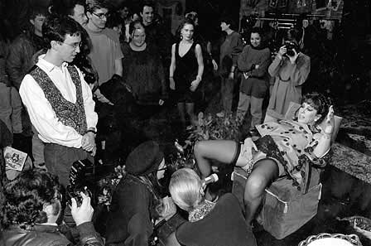

Annie Sprinkle, (n.d.) A Public Cervix Announcement

Placing the body in the realm of a medical discourse is not the only way in which Sprinkle subverts the traditional representation of a passive, objectified female body. Through performances such as “Bosom Ballet”, Sprinkle also desexualises the female form using parody. In these performances, Sprinkle moves her breasts to music in a comedic manner, lifting, stretching and manipulating them to the tune of “The Blue Danube Waltz”. In doing so, Sprinkle subverts the traditional expectations placed on women and the way they should present their bodies. Women’s breasts have for centuries been viewed as a key part of feminine sexuality and have been presented so as to arouse those who view them. In traditional depictions of women, such as Giorgione’s ‘Sleeping Venus’, the breasts are a focal point of the image – while the subject’s genitalia is concealed, her breasts are “displayed for all to see” (Borzello, 2012:15) The use of breasts to amuse rather than arouse the viewer therefore challenges societal notions of femininity and how a woman should behave. As Heywood states
The parody of femininity, along with the performance of excess, works to undermine dominant ideological constructions of the human subject in general, and of “women” in particular (Heywood, 1997:129)
However, there are those who would argue that parody is not a successful tactic with which to challenge preconceived notions of sexuality and the performative nature of gender. Sabet claims that
While it seems that comedy, parody, and farce can be useful in challenging social expectations about identity, even revealing the ways in which gender is falsely naturalised, they certainly do not function outside of power relations, and thus can never be fully liberating. (Sabet, 2015:70)
Parody often serves as a mockery of pre-existing norms and expectations through the exaggeration of their opposites. For this reason, it can be argued to be existing within the same binary system it is attempting to challenge. For example, drag performers subvert the notion of masculinity by performing as “feminine” to excess, distorting traditional ideas of femininity and magnifying them for comedic effect. However, it could be said that these performers are exaggerating or amplifying preconceived expectations of what it means to be feminine or masculine, rather than providing an alternative to this binary split. In this way, parody may not be a successful tactic for challenging sexual and gender norms within our society. On the other hand, it could be suggested that that is not what Sprinkle achieves with her performance of ‘Bosom Ballet’. With this performance, Sprinkle targets women as her audience, and they are the main protagonists in this work, rather than men. As Campbell says
She kneaded her breasts (…) as an invitation to women spectators, after the manner of the ‘Video Sluts and Goddesses’ workshop, to fondle their own bodies and explore their own sexuality (Campbell 2014:56)
In ‘Bosom Ballet’, Sprinkle subverts the heteronormative codes of the presentation of a nude female body by encouraging women to explore themselves and express their sexualities without considering the male viewpoint. The traditional depiction of the female nude serves to please the male onlooker, and women are conditioned to present themselves as such, in order to arouse the attentions of men. By actively imploring women to explore their sexuality without consideration of the male point of view, Sprinkle begins to dismantle the dominant heterosexual agenda and allows women the space to exist as sexual beings independently of male expectations. This is what ultimately makes her use of parody a useful strategy to challenge preconceived notions of female sexuality and the presentation of the female body.

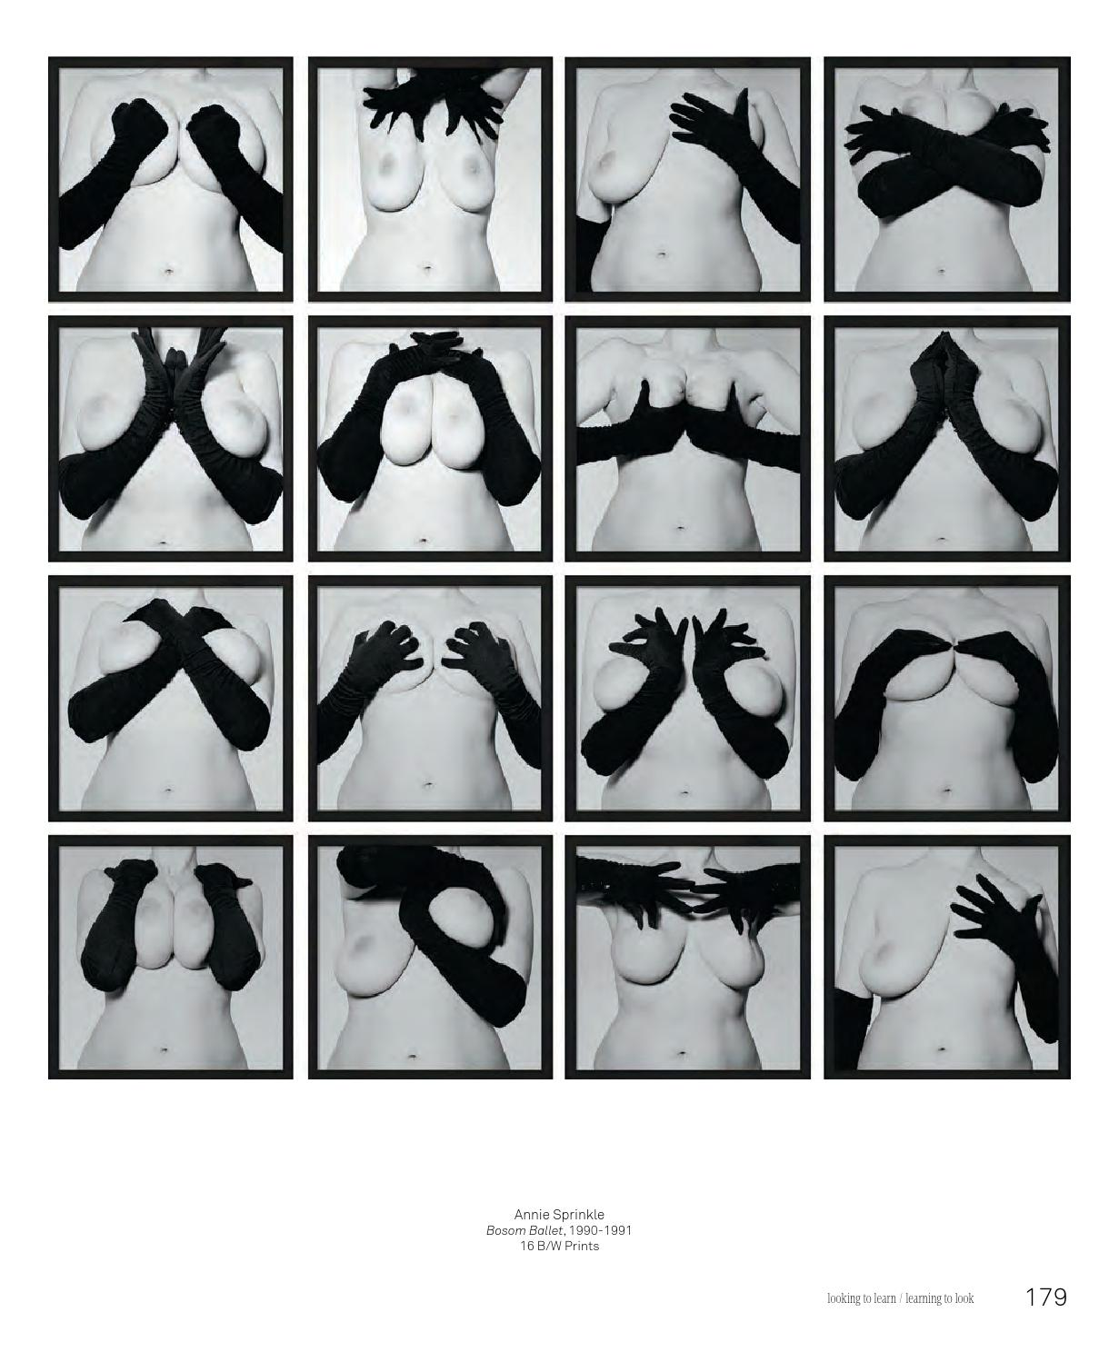 Annie Sprinkle, (1990-1991) Bosom Ballet

While the work of artists such as Sprinkle arguably aims to desexualise the female body, many contemporary female practitioners subvert traditional notions of the female nude by creating highly sexual works. As Betterton explains,
The nervousness about the body in feminist art of the 1980s has been replaced by its full-bodied embrace – sometimes literally, as sexually explicit and transgressive art practices run riot (Betterton: 1996, 18)
One such artist is Vanessa Beecroft, who has created performance works involving numerous models in various states of undress since the 1990s. Her early performances consisted of models wearing wigs, makeup, and underwear but, beginning with VB35 in 1998, her performances have largely displayed her models naked. Her work has not been without controversy, and one particular issue has followed Beecroft consistently throughout her career. Is her work “reclaiming sexualised images of women from the pages of Penthouse” (Johnstone, 2005), or do her performances continue to pander to the voyeur, to exist within the spectrum of the male dominated images that we continue to be exposed to in our daily lives? There are those who would argue that Beecroft’s work liberates the female body from the confines it has been placed under by our male-dominated culture. In performances such as VB45, Beecroft’s models stand en masse, subverting the expectation of the passive, reclining woman with their upright poses. There is no attempt to cover these women; they stand, fully nude but for their black high heeled boots, genitals as unashamedly exposed to the viewer as the carved sculptures of men that preceded the traditional depiction of the woman. Beecroft does not merely present her models in a way that challenges the expected composition and presentation of a female nude, one of her principle interests seems to be the effect her performances have on their audience. Beecroft states that;
The most exciting moment is when it starts and when you see the people coming in and not knowing where to go and how to behave - the embarrassment, the friction, and the non-entertaining aspect of it (Beecroft, 2014)
Traditionally, the nude image of a woman was designed to be enjoyed by her male onlooker. That is not the case here – Beecroft aims to create a discomfort for her audience, a shame and embarrassment. “There’s a kind of ironic play on the notion of voyeurism, in a way she’s setting a trap” (Thurman, 2014). Beecroft seems to acknowledge the voyeuristic nature of her spectators, and uses it against them, forcing them to question their own behaviour. In this way, her models cannot be enjoyed for their nudity, they are not presented in such a way that allows the audience to view their bodies and enjoy them without challenge. The clothing choices Beecroft makes seem to contribute to this subversion. Her decision to use objects typically considered feminine, like bikinis and high heels, do not serve to increase the appeal of the women wearing them, defying the mainstream use of such objects. Instead,
Beecroft turns them into weapons, disarming viewers who are more accustomed to Venus of Urbino-style representations than being confronted with a tour de force of live, mute women (Schwendener, 2003:35)
Ultimately, it can be argued that the women Beecroft presents to her audience do not conform to the ideal of the passive, reclining nude, the object of desire presented to her male audience for their gratification. Beecroft challenges these traditional notions, through the upright, active poses of her models, the clothing they wear, and the overall atmosphere of discomfort that she creates for her audience. These aspects of her performances force her viewers to question their own voyeuristic tendencies, as opposed to satisfying them, as has been the aim of the female nude for centuries.
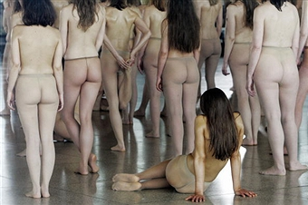

Vanessa Beecroft, (2005) VB55

Alternatively, there are those who would suggest that Beecroft’s performance works are not a progressive, liberating display of female power, but merely another continuation of the trends that have defined the female nude throughout history. In the words of Johnstone, “some say she’s demeaning women, parading them like hunks of meat, in the process creating a male wet dream” (Johnstone, 2005). Many critics of Beecroft’s work have noted the use of stereotypical models in many of her performances and the issues that arise from this. She will often use models who conform to the typical standards of the contemporary beauty industry, who conform to the body type women are conditioned to aspire to in our society, through their use in advertising and the fashion industry. By using these models almost exclusively within her work, Beecroft contributes to a culture which teaches women that they must conform to a strict and homogenised ideal of beauty in order to be considered attractive and have worth.
(Beecroft) gets women to participate in performance art versions of the fashion shoot. Their bodies all conform to the strictures of the fashion industry, and they have gradually stripped from performance to performance until now they appear nude. The spectacle is cold, cruel and comic. (Jones, 2000)
What is perhaps most concerning when considering Beecroft’s use of models is that Beecroft herself admits that she was unaware of her selection of a specific type of woman for her performances. In selecting a certain type of body, Beecroft has reiterated the expectations of the female nude within our society and the norms to which we all unconsciously adhere.
For a long time I believed that my performances were representing the entire feminine gender, but the more I went to lecture at universities, the more I realised that was my idea but it was not true, because the women do not represent all women, but just a specific typology. (Beecroft, 2014)
Here Beecroft demonstrates the difficulties that female artists face when attempting to challenge preconceived notions of beauty and the female body. Women have been so conditioned to perform in certain ways, to accept and admire the ideal female body type, that it becomes incredibly difficult to remove those expectations from ones work. Women are so accustomed to existing within the controlling gaze of the male and acting accordingly that they will often fail to recognise these behaviours for the ideological performances they are. Beecroft’s performance works may be said to exhibit this ignorance, and for that reason are not liberating portrayals of the female body, but rather ones that continue to exist within the confines of a male-centric ideology. Furthermore, one could criticise Beecroft’s use of clothing and accessories as an attempt to disguise her models’ nudity in a way that is reflective of the traditional depictions of women in the art world. In Giorgione’s ‘Sleeping Venus’, Venus covers her vagina with a carefully placed hand, displaying her breasts to be enjoyed, while shielding her genitalia from the viewer so as to contain her body and place it within the confines of male expectation. Beecroft’s use of clothing works in a similar way, and in her own words was used to “make the women less real, to be a little bit detached from an immediate nudity, a naturalistic type of nudity” (Beecroft, 2014). Beecroft, like Giorgione and the many painters that followed him, has used accessories to disguise her models’ nudity, to make them more palatable and enjoyable for the audience. While her use of the upright female nude arguably challenges the traditional depiction of a naked woman, her covering of her models in this way reduces the impact of this portrayal, as it suggests, as ‘Sleeping Venus’ did before it, that parts of the female body must be contained and controlled. Beecroft unconsciously performs in the way that women have been conditioned to for centuries, to cover parts of the female body which may cause disgust or discomfort to their male viewer.
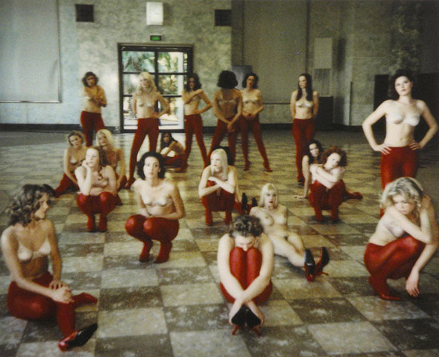
Vanessa Beecroft, (1999) VB40

To conclude, it can be argued that the traditional depiction of women that has persisted for centuries is ultimately an oppressive one. This representation is one which is sanctioned by men, for men, and serves to place women and their bodies under the control of the male gaze. It is essential, therefore, that in contemporary society women continue to reimagine the female nude from their perspective, to reclaim these images of women from the authorship of men. As de Beauvoir notes, “to emancipate women is to refuse to confine her to the relations she bears to a man” (de Beauvoir, 1997:740). However, in doing so, women face numerous challenges. Gendered behaviours are so engrained into our society that often it is difficult to recognise when one conforms to them, and identify them for the expected acts that they are. In depicting a reimagined nude, female artists face the risk of reiterating a male-centric viewpoint, one which presents women as an object of desire who exists to please the male onlooker. Consequently, it is necessary to remove the female nude from these restrictions, to allow her to exist without consideration of male expectation. Work of artists such as Annie Sprinkle, which not only implore women to explore their own sexuality independently of men, but also educate men and women about the anatomy of the female body, are critical in challenging the accepted depiction of women in our media. Reimagined female nudes created by women are essential in changing the discourse surrounding the female body, and removing the confines placed upon them by centuries of oppressive, male-centric depictions of the female nude.
Acknowledging and recognising that part of the social, sexual and psychic body which has been excluded is not only to celebrate it, but to demythologise its fearful power. In the end we have no choice but to re-invent the project of modernity and to re-inhabit its social body with, among others, the absent bodies of women. (Betterton, 1996: 19)

Reference List
Books:
Berger, J. (1972) Ways of Seeing. UK: Penguin
Betteron, R. (1996) An Intimate Distance: Women, Artists and the Body. Oxfordshire: Routledge
Borzello, F. (2012) The Naked Nude. UK: Thames and Hudson Ltd
Butler, J. (1990) Gender Trouble: Feminism and the Subversion of Identity. New York: Routledge
Campbell, P. (2014) The Body in Performance. London: Routledge
Clark, K. (1956) The Nude. UK: Pelican Books
De Beauvoir, S. (1949) The Second Sex. Translated by Parshley, H. M. (1997) London: Vintage Books
Heywood, L. (1997) Third Wave Agenda: Being Feminist, Doing Feminism. USA: University of Minnesota Press
Johnson, D. (2012) Theatre and the Visual. UK: Palgrave Macmillan
Jones, A. (ed) (2003) The Feminism and Visual Culture Reader. London: Routledge
Kapsalis, T. (1997) Public Privates: Performing Gynaecology from Both Ends of the Speculum. USA: Duke University Press
Mulvey, L. (1989) Visual and Other Pleasures. UK: Macmillan Publishers Ltd
Nead, L. (1992) The Female Nude: Art, Obscenity and Sexuality. London: Routledge
Sabet, N. (2015) ‘The Ways of the Secular Flesh – Destabilising the Heteronormative and Negotiating Non-Monolithic Sexualities’ in Barton, K. (ed) A State of Arrested Development: Critical Essays on the Innovative Television Comedy. USA: McFarland Books: 68-85
Schneider, R. (1997) The Explicit Body in Performance. London: Routledge
Schwendener, M. (2003) in Dailey, M. et al. Curve: The Female Nude Now. USA: Universe Publishing

Online Newspaper Articles:
Johnstone, N. (2005) ‘Dare to Bare’ The Guardian. 13 March [Online] Available at: https://www.theguardian.com/artanddesign/2005/mar/13/art (Accessed: 21 November 2017)
Jones, J. (2000) ‘A Baroque Theatre of Real People’ The Guardian. 25 September [Online] Available at: https://www.theguardian.com/artanddesign/2000/sep/25/art.artsfeatures (Accessed: 21 November 2017)
Shakespeare, S. (2014) ‘Cambridge don strips off and says it’s educational’ Daily Mail. 14 May [Online] Available at: http://www.dailymail.co.uk/news/article-2627659/SEBASTIAN-SHAKESPEARE-Cambridge-don-strips-says-educational.html (Accessed: 22 November 2017)

Websites:
Sprinkle, A. (n.d.) A Public Cervix Announcement. Available at: http://anniesprinkle.org/a-public-cervix-anouncement/ (Accessed: 12 October 2017)

YouTube Videos:
Beecroft, V. and Thurman, J. in Reserve Channel (2014) The Female Body as Art: Vanessa Beecroft Available at: https://www.youtube.com/watch?v=T-VOCXimwaQ (Accessed: 1 December 2017)

Paintings:
Giorgione, (1510) Sleeping Venus, [Oil on canvas] Gemäldegalerie Alte Meister, Dresden

Photographs:
Alas, M. and Piggott, M. for Calvin Klein, (2015) Name Unknown [Online] Available at: https://mumbrella.com.au/calvin-klein-rolls-justin-bieber-campaign-270005 (Accessed: 12 December 2017)
Beecroft, V. (1999) VB40 [Online] Available at: http://kaldorartprojects.org.au/projects/project-12-vanessa-beecroft (Accessed 12 December 2017)
Beecroft, V. (2005) VB55 [Online] Available at: http://www.gettyimages.co.uk/detail/news-photo/some-out-of-a-total-of-hundred-naked-models-are-seen-news-photo/52598800#germany-some-out-of-a-total-of-hundred-naked-models-are-seen-through-picture-id52598800 (Accessed: 12 December 2017)
Sprinkle, A. (n.d.) A Public Cervix Announcement, [Online] Available at: http://anniesprinkle.org/a-public-cervix-anouncement/ (Accessed: 12 October 2017)
Sprinkle, A. (1990-1991) Bosom Ballet, [Online] Available at: https://issuu.com/artports/docs/learningtolook_galerieclairefontain/179 (Accessed: 12 December 2017)

Bibliography
Books:
Beecroft, V. and Hickey, D. (2000) VB 08-36: Vanessa Beecroft Performances. USA: Hatje Cantz
Greer, G. (1970) The Female Eunuch. USA: Paladin Press
Harris, G. (1999) Staging Femininities: Performance and Performativity. Manchester: Manchester University Press
Pollock, G. (1999) Differencing the Canon: Feminist Desire and the Writing of Art’s Histories. London: Routledge
Russo, M. (1995) The Female Grotesque. London: Routledge
Segal. L. (1994) Straight Sex: Rethinking the Politics of Pleasure. USA: University of California Press
Wolf, N. (1990) The Beauty Myth: How Images of Beauty Are Used Against Women. USA: Random House Publishing

Online Newspaper Articles:
Harding, L. (2005) ‘Ruthlessly Exposed’, The Guardian, 8 April [Online] Available at: https://www.theguardian.com/world/2005/apr/08/worlddispatch.germany (Accessed: 4 December 2017)
Pilger, Z. (2014) ‘Why such a scandal over a nude painting of a Cambridge academic?’ The Guardian. 18 May [Online] Available at: https://www.theguardian.com/theobserver/2014/may/18/cambridge-nude-painting-scandal-society-attitudes (Accessed: 22 November 2017)
Smith, R. (1998) ‘Critic’s Notebook; Standing and Staring, Yet Aiming for Empowerment’ The New York Times. 6 May [Online] Available at: http://www.nytimes.com/1998/05/06/arts/critic-s-notebook-standing-and-staring-yet-aiming-for-empowerment.html (Accessed: 7 November 2017)
Thorpe, V. (2015) ‘From Venus to Katie Price: A Brief History of the Breast’ The Guardian. 25 January [Online] Available at: https://www.theguardian.com/lifeandstyle/2015/jan/25/beauty-breast-the-sun-female-form (Accessed: 1 December 2017)

