DS 1 Template

My Screenshots/Photos
- Please add 4–6 screenshots or photos of your digital life.
- You can use your phone or laptop.
- For each screenshot, write one or two sentences explaining what it shows.

Screenshot/Photo 1

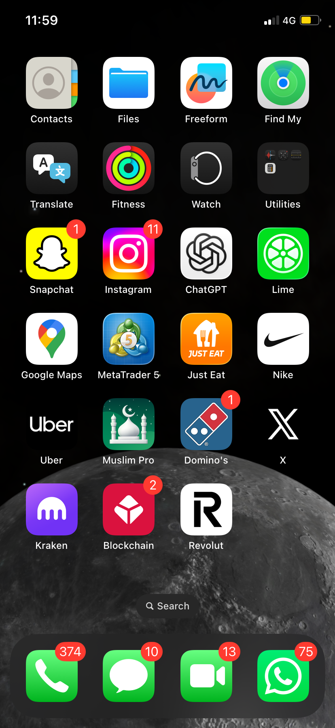
This screenshot shows some of the different apps I use on my phone. I use digital apps for communication, travelling, social media, shopping and other everyday activities.

Screenshot/Photo 2
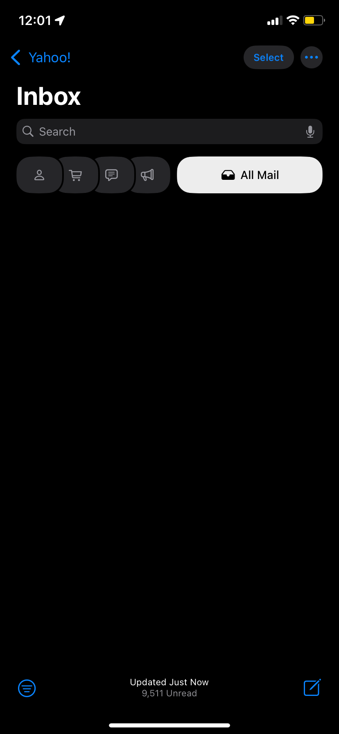
This screenshot shows my email inbox. I use email to receive important messages and information and to communicate online.

Screenshot/Photo 3
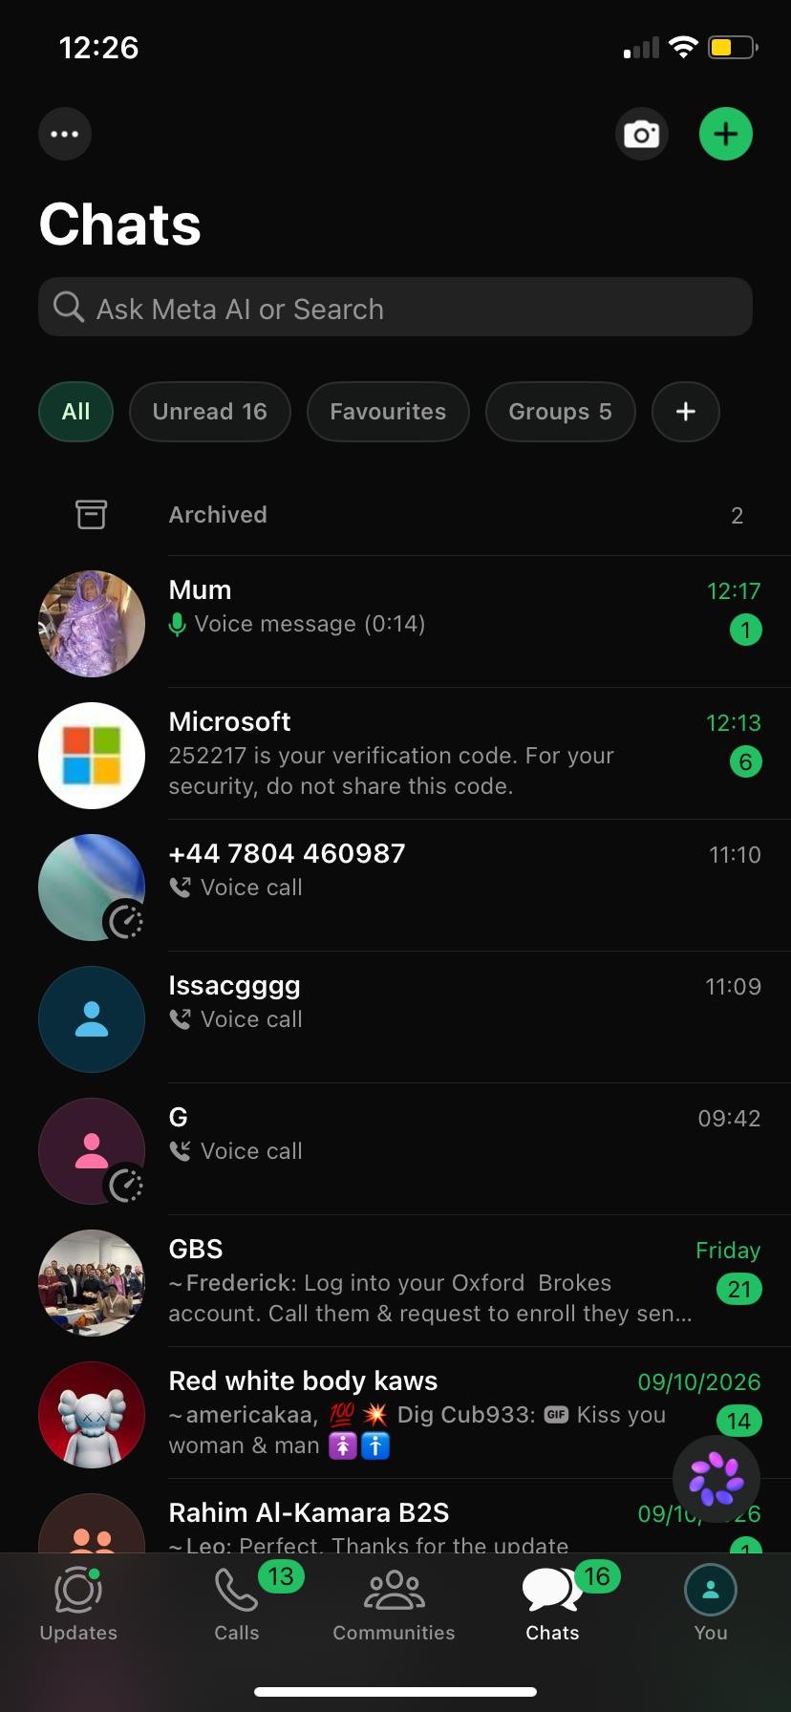
This screenshot shows WhatsApp, which I use to communicate with friends, family and groups. I use it for messages, calls and sharing information.

Screenshot/Photo 4
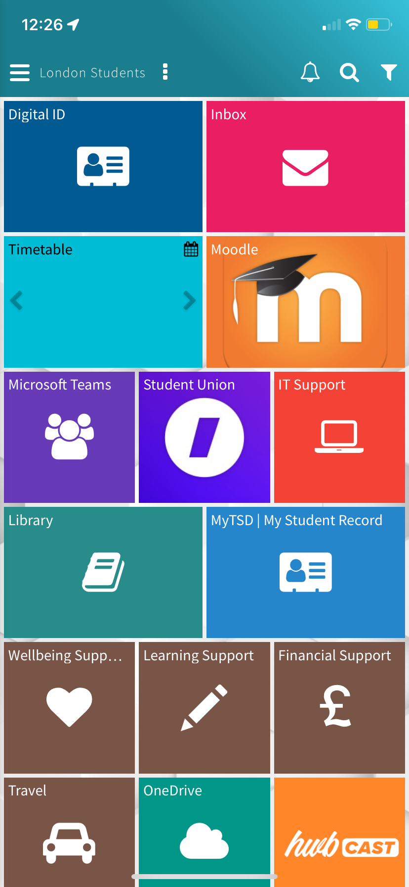
This screenshot shows my college student portal. I use it to access Moodle, Microsoft Teams, my timetable and other resources that help with my studies.

Screenshot/Photo 5
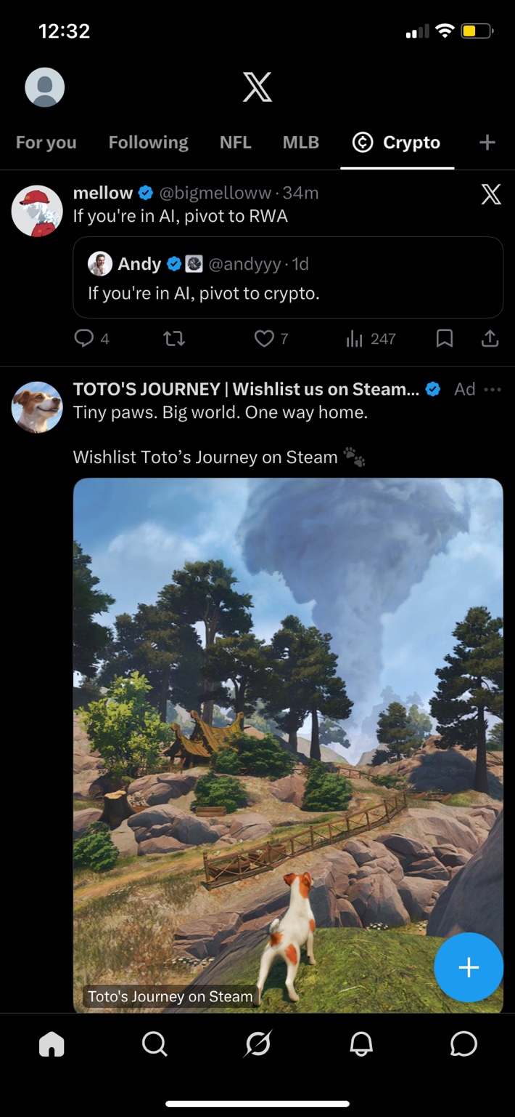
This screenshot shows one of the social media platforms I use. I use social media to keep up with news, topics I am interested in and things happening online.

Screenshot/Photo 6 (optional)
Five screenshots have been included, as required.

My Short Reflection
- Write 5–8 simple sentences about your digital life.
- You can use the sentence starters below if helpful.
I use digital tools every day for communication, education and entertainment. I often use email and WhatsApp to stay in contact with people and receive important information. I use my college student portal, Moodle and Microsoft Teams to support my studies. I also use social media to keep up with news and topics that interest me. I feel confident using common apps on my phone, but I want to improve my digital skills further. I hope this module will help me use digital tools more confidently and effectively. Digital skills are important to me because they help with studying, communication and everyday tasks.

Sentence starters
- I use digital tools to …
- I feel confident when I …
- I want to improve …
- I often use these tools: …
- I sometimes feel nervous about …
- I hope this module will help me …
- Digital skills are important for me because …
You can write more if you want.

Submission Checklist
Before you submit, please check:
☒ I added 4–6 screenshots
☒ I wrote short sentences for each screenshot
☒ I wrote my short reflection
☒ My work is my own
☒ My file opens correctly
☒ My file opens correctly

References
Department for Education (2019a) Essential digital skills framework. Available at: https://www.gov.uk/government/publications/essential-digital-skills-framework/essential-digital-skills-framework (Accessed: 18 October 2026).
Department for Education (2019b) National standards for essential digital skills. Available at: https://www.gov.uk/government/publications/national-standards-for-essential-digital-skills (Accessed: 18 October 2026).
UK Council for Internet Safety (2020) Education for a Connected World: 2020 edition. Available at: https://www.gov.uk/government/publications/education-for-a-connected-world (Accessed: 18 October 2026).

