Can Graphic Design really save your life?
Explore the association of wellbeing and personal growth in design. In your discussion focus on a maximum of three specific areas.
Student Name: Anastasiia Muzyka
Student Number: 2246347
Program of Study: BA Graphic Design
Module: Research in Context (ADAD5003)
The length: 2254 words
Lecturer: Donna Williams

The Cambridge Dictionary briefly describes graphic design as "the art of designing pictures and text for books, magazines, advertising, etc." (n.d.). To an uninitiated observer, graphic design may be perceived merely as a tool for enhancing the visual appeal of brands or products. However, its significance goes far beyond this perception. Paul Rand (2017), a pioneer in the field of advertising design and typography, defined design as a tool that solves problems and transforms chaos into order. Through visual communication, graphic design can effectively convey essential information by organising complex data and making it understandable and accessible.
This essay explores the question: Can graphic design really save your life? It analyses three examples: the design of street defibrillator signs, a local visual campaign informing the public about the Ebola virus, and the UK's AIDS campaign from the 1980s. By examining these case studies, this essay aims to demonstrate how thoughtful design solutions can promote public health and enhance societal well-being.
A prime example of a life-saving design is the design of an automated external defibrillator sign and the information poster. Defibrillators in public access can be seen across England and Wales. According to the UK Department for Education (2023), research shows that that access to a defibrillator within 3 - 5 minutes after a heart attack can increase the likelihood of survival to hospital discharge from 9% to 50%. This is why it is so important to make defibrillators as accessible as fire extinguishers and to ensure their design is easy for people to understand.
Research by Smith et al. (2017) identified low public awareness and fear of misusing AEDs as significant barriers. To overcome these issues, designers incorporated intuitive visuals, universally recognisable symbols, and simple step-by-step instructions into the AED signage and devices. To make the signs as clear as possible, Christopher M. Smith and colleagues at the University of Warwick conducted public consultations during their development. This is the first instance where public consultations were used to develop a public AED location sign. The British Heart Foundation's Customer Insight team has developed these questions based on its extensive previous experience in this area. As a result of the initial survey, a term was selected that best helps people understand the AED sign. Nearly 40% of respondents chose "Heart Restart Kit" over technical terms like "AED". In the second survey, over 83% preferred a graphical representation of the heart with a stylised ECG cardiogram instead of the previous lightning bolt symbol. Also was added the image of a person lying on their back with the defibrillator pads placed on them (Smith et al., 2017). The final design is presented in Figure 1.
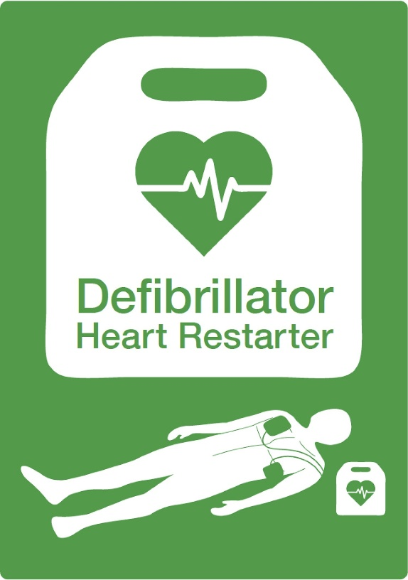
Figure 1. New AED location sign (2017)
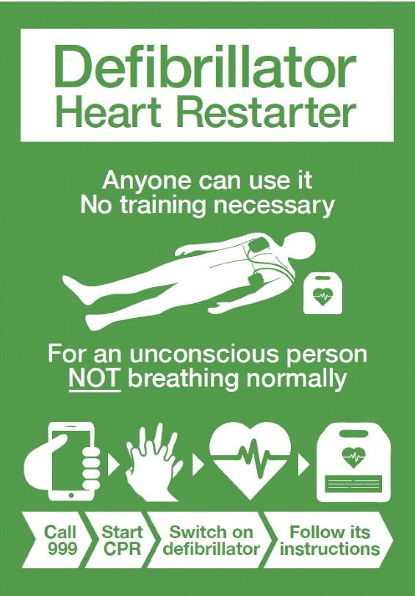
Figure 2. New AED location poster (2017)
Resuscitation Council UK (n.d.) informed that in some cases, the sign may be accompanied by an infographic poster that states:
- Anyone can use an AED – no training necessary
- It is for use on an unconscious person not breathing normally.
- It is easy to use – just follow its instructions.
The final design of the poster, featuring encouraging wording and instructions, is presented in Figure 2. This poster not only informs but also motivates action through calls to action, and the use of icons simplifies the communication of messages by making information intuitive. This is supported by research conducted by Wogalte M. S. et al. (2006), which examined the use of text and symbols in warning signs, medication instructions, and device manuals. They concluded, “together these results suggest that textual warnings can be enhanced with the presence of symbols” (Wogalte et al., 2006, p.169). I should also note that this research discusses a caution against using ambiguous symbols or symbols that explain a complex process but lack accompanying textual clarification. In my opinion, these cautions were taken into account during the development of the new AED sign design, as the multi-stage survey aimed to eliminate ambiguity in the sign's interpretation. Additionally, the sign was enhanced with a contrasting and highly legible inscription.
Although specific information regarding the colour choice for this sign was not found, I believe it to be another carefully considered detail. Perception of colour may vary depending on culture or context. However, most characteristics of green colour perception are consistent. For example, Kate Strachnyi (2022) described green as a colour associated with nature, “refreshing and tranquil” (Strachnyi, p.19). Another study supports the same conclusion. Louise Lankston et al. (2010), studying the impact of visual art in hospitals, found that blue and green tones evoke 'the positive distraction and state of calm' (Lankston, p.490). From this, it can be concluded that a green-coloured sign positively affects viewers and calms them when they turn to instructions for providing aid.
In summary, a well-thought-out and simple redesign of Automated External Defibrillators (AED) signage demonstrates the role of graphic design in conveying information concisely and clearly, ultimately contributing to saving lives.
However, is it always necessary for specialists from different fields to collaborate on a life-saving design and to repeatedly test and verify the research results? In my opinion, such collaboration is not always required. I would like to present another graphic design solution created in response to the Ebola outbreak as an example of an immediate reaction to an emergency and evaluate its effectiveness. A mural depicting Ebola symptoms by Liberian designer Stephen Doe.
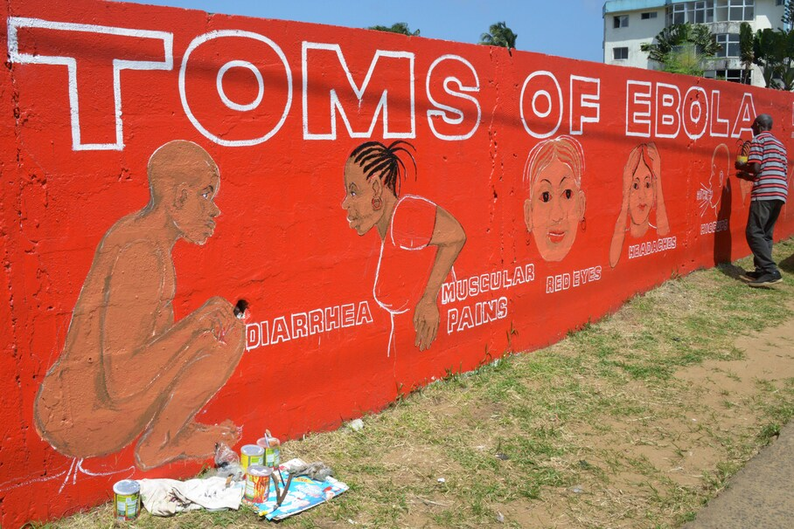
Figure 3. The mural spotlights Ebola's symptoms (2014)
The 2014 outbreak of the Ebola virus in West Africa posed a real challenge to healthcare structures. Liberia is the worst hit among the nations affected by the Ebola epidemic. According to a WHO report from 2015, there was ‘a ratio of only one to two doctors per nearly 100,000 population’. In addition to medical difficulties, the spread of the virus was complicated by misinformation and distrust of medical institutions. Rumours spread, including claims that the virus was artificially created or that doctors were actually spreading the disease (Turner et al., 2022). Many people did not understand the symptoms of the disease and associated it with curses or conspiracies. The specifics of burial rituals and reliance on traditional healers were also problematic (WHO, 2015). This led to avoidance of medical facilities. Therefore, effective communication has played a crucial role in the fight against the epidemic.
Stephen Doe's mural is part of a Liberian initiative to inform people about the deadly effects of Ebola (Freedom du Lac, 2014). This mural is located in Monrovia, the capital of Liberia. The author painted walls red to evoke strong emotions and show danger (Strachnyi, p.19). He utilized simple iconography to depict the disease's symptoms, such as fever, weakness, diarrhoea, and bleeding. He used effective graphic elements adapted to the cultural context. The people depicted had hairstyles and accessories that reflected local traditions, which helped build trust within the local communities. Instead of abstract symbols, he used scenes that every Liberian could understand and relate to.
The relationship between written language and visual imagery is very close (Barry, 1997, p. 107). In this case, the presence of visuals played a key role, as traditional text-based messages were ineffective due to low literacy rates. In Liberia, the population speaks 30 different languages, and only 43% can read and write (Gorvett, 2017). Therefore, awareness campaigns aimed to overcome these barriers through visuals that contributed to a better understanding. Images of ill people served as a reminder of the severity of the situation and encouraged people to seek help. These visuals were accompanied by bold, sans-serif text in English, providing essential information.
The author further extended his mural by illustrating the ways the disease is transmitted, a call to stop the spread of Ebola by breaking the chain of transmission, and encouragement to seek help if symptoms appear. Image 4 showcases another section of the mural. This long, brightly red wall is impossible to overlook. It took two months to complete the large mural. 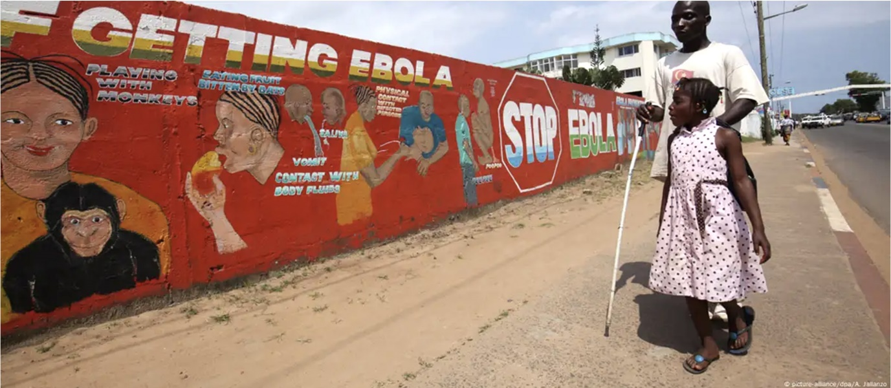
Figure 4. The mural in Liberia (n.d.)
Stephen Do’s mural is an example of how local art can be an effective tool in the fight against a crisis. The use of pictograms, culturally relevant imagery, and effective colour schemes allowed for vital messages to be conveyed even in communities with low literacy levels. Considering the data presented above, it can be concluded that this design is tailored to its audience, which makes it effective.
I would like to present another powerful example of design focused on problem-solving and capable of saving lives. AIDS-education campaign, ‘Don’t aid AIDS’, often referred as the ‘Don’t Die of Ignorance’ campaign. As Creswell (2013) notes, qualitative research plays a crucial role in understanding the audience, their challenges, and the context, which is essential for achieving set objectives. To critically evaluate the success of this campaign and its impact on the public, I will examine the circumstances that led to its implementation, the target audience, and the method of execution.
In the mid-1980s, AIDS became one of the biggest public health threats. However, little was known about the disease, which led to the spread of rumours. According to Jonze (2017), the AIDS epidemic caused panic, and many people did not understand how the virus was transmitted. In response to this situation, the Department of Health and Social Services (DHSS) launched an education campaign in 1986 to reduce misinformation and the spread of the virus. As "there was no treatment and no prospect of survival" at the time, prevention through education was the only defence against the spread of the virus (The National Archives, 2016). According to Placing the Public (2018), the target audience of the campaign was sexually active adults and intravenous drug users who were at risk. In addition, the campaign targeted the general public to raise general awareness of the disease and to warn people. A key goal of the campaign was to change behaviour, in particular to promote condom use. Information was disseminated through television and leaflets. Leaflets conveyed information that a short TV ad could not, and each medium complemented and reinforced the other (Placing the Public, 2018). The television advert was intended to shock the audience and make them pay attention to the leaflets. Malcolm Gaskin, whose agency worked on this campaign, stated that "scaring people was deliberate", to guarantee that the viewers would read the leaflets (Jonze, 2017).
The apocalyptic, exploding volcano, clanging noises and terrifying voiceover: "There is now a danger that has become a threat to us all. It is a deadly disease, and there is no known cure… anyone can get it, man or woman." A huge black monolith with the word AIDS etched onto it topples backwards and a funeral bouquet of lilies falls onto the 'grave' (Calman, 2020). According to Peirce, we think in signs (1932). In this case, the tombstone became central to the system of signs that represent death and convey the seriousness of the situation. The colour palette also plays an important role. The strategic use of colour can have a significant impact on the emotions, mood and behaviour of viewers (Kraus, 2019). The black and white design enhanced the sense of tragedy. These elements were aimed at creating a strong emotional impact and memorability.

Figure 5. Stills from the 1987 TV Campaign ‘Don’t Die of Ignorance’ (1986)
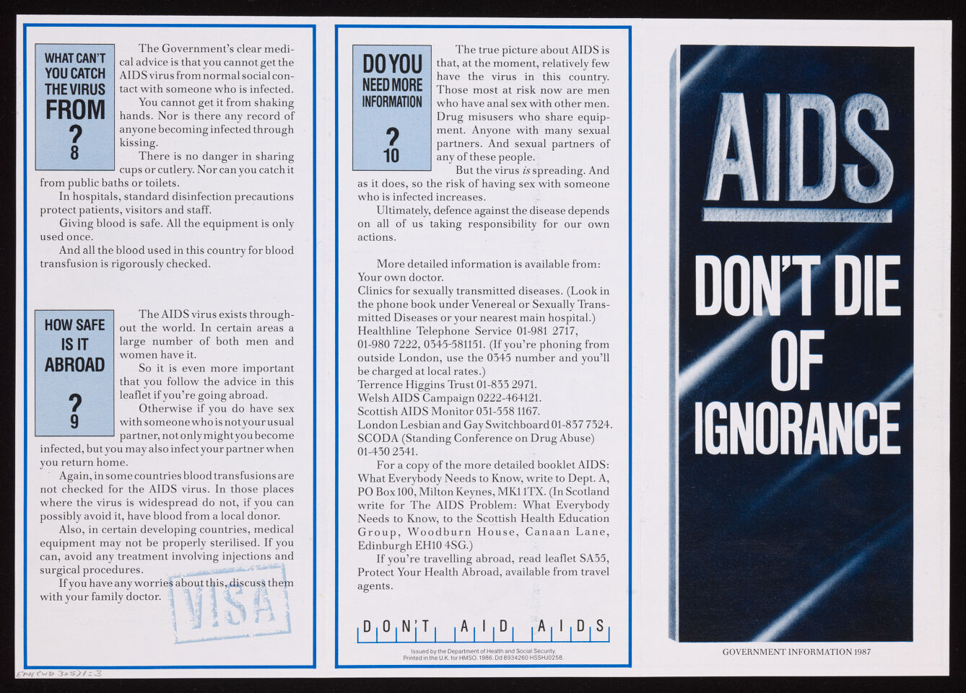
Figure 6. AIDS: Don't die of ignorance (1986)
Image 5 shows the booklet that was sent in a sealed envelope to every household. The cover resembles black marble slab, with "AIDS" chiselled out of it and "Don't die of ignorance" below in white capital letters.
John Kelly, in his article for the BBC (2011), notes that this campaign was successful and its tactics were replicated in many countries. The campaign also helped to reduce the rate of new infections: by 1990, the UK's infection rate remained lower than in Europe and the USA.
The informational campaign was so successful in achieving its goal that, even today, some people continue to fear AIDS and avoid those affected as if it were the plague. The Terrence Higgins Trust has launched a campaign aimed at combating stigma surrounding HIV and raising awareness about the advancements in HIV treatment (Louis, 2023).
Graphic design goes beyond aesthetic appeal. Together, the three case studies collectively illustrate how graphic design depicts health narratives, making them more accessible and impactful. Each example reflects a balance between emotional engagement and practical clarity, ensuring that the messages are memorable and call to action. These examples of graphic design I have presented differ in terms of their time of creation, country of origin, and the number of designers involved in the projects. However, they all share a common purpose – saving lives. Can design alone save lives? Unlikely. However, it is a powerful tool that, combined with efforts originating from other fields, can really help save lives. Graphic design has the power to influence the public by drawing their attention to specific products or events or, conversely, by deterring them from certain actions. Graphic design has a wide range of tools to achieve this. For example, the strategic use of colour or well-structured visual materials. Graphic design serves as a universal language, that can overcome cultural barriers and promote global communication. It has the ability to quickly and clearly deliver important information to a diverse audience. At the sometime, design can reflect the values of a specific group of people or a country and exert a powerful influence within a particular context.
Consequently, art and graphic design make an evident contribution and offer extensive opportunities for improving the medical and social sectors. And also has the ability to promotes personal growth by encouraging people to make informed decisions.

Bibliography:
Barry, A. M. S. (1997) Visual Intelligence: Perception, Image, and Manipulation in Visual Communication. Albany: State University of New York Press.
Butdisuwan, S. et al. (2024) Visualising Medical Research: Exploring the Influence of Infographics on Professional Dissemination, TheScientificWorld, 2024, pp. 5422121-. Available at: https://doi.org/10.1155/2024/5422121.
Calman, B. (2020) ‘The 'Don't Die of Ignorance' AIDS TV advert proved scaring us witless ISN'T the way to beat Covid’, Daily Mail, 31 October. Available at: https://www.dailymail.co.uk/health/article-8900489/AIDS-TV-advert-proved-scaring-witless-ISNT-way-beat-Covid-writes-BARNEY-CALMAN.html (Accessed: 23 November 2024).
Cambridge Dictionary (n.d.) Graphic design. Available at: https://dictionary.cambridge.org/dictionary/english/graphic-design (Accessed: 22 November 2024).
Creswell, J. W. (2013) Qualitative Inquiry and Research Design: Choosing Among Five Approaches. 3rd edn. London: Sage Publications.
Department for Education (2023) Defibrillators: All state schools now have lifesaving equipment. Available at: https://educationhub.blog.gov.uk/2023/07/25/defibrillators-all-state-schools-now-have-lifesaving-equipment/ (Accessed: 16 November 2024).
Eco, U. (1976) A Theory of Semiotics. Bloomington: Indiana University Press.
Freedom du Lac, J. (2014) ‘This is how people are being warned about the Ebola epidemic in West Africa’, The Washington Post, 10 September. Available at: https://www.washingtonpost.com/news/to-your-health/wp/2014/09/10/this-is-how-people-are-being-warned-about-the-ebola-epidemic-in-west-africa/ (Accessed: 23 November 2024).
Gorvett, Z. (2017) ‘The graphic design that can help save lives’, BBC, 5 October. Available at: https://www.bbc.com/future/article/20170927-the-graphic-design-that-can-help-save-lives (Accessed: 22 November 2024).
Jonze, T. (2017) 'How we made the "Don't Die of Ignorance" AIDS campaign', The Guardian, 4 Septembre. Available at: https://www.theguardian.com/culture/2017/sep/04/how-we-made-dont-die-of-ignorance-aids-campaign (Accessed: 22 November 2024).
Kelly, J. (2001) ‘HIV/Aids: Why were the campaigns successful in the West?’, BBC, 28 November. Available at: https://www.bbc.co.uk/news/magazine-15886670 (Accessed: 29 November 2024).
Kraus, M. (2019) ‘Color as a Psychological Agent to Perceived Indoor Environmental Quality’, IOP conference series. Materials Science and Engineering, 603(5), pp. 52097-. Available at: https://doi.org/10.1088/1757-899X/603/5/052097 (Accessed: 22 November 2024).
Lankston, L. et al. (2010) ‘Visual art in hospitals: case studies and review of the evidence’, Journal of the Royal Society of Medicine, 103(12), pp. 490–499. Available at: https://doi.org/10.1258/jrsm.2010.100256 (Accessed: 22 November 2024).
Louis, Y. (2023) ‘First HIV TV ad in 40 years says stigma is ‘more harmful’’, Marketing Beat, 16 October. Available at: https://www.marketing-beat.co.uk/2023/10/16/hiv-aids-tv-ad-40-years-1980/ (Accessed: 25 November 2024).
Morris, T. (2021) ‘It's a Sin: casting the public eye on public health’, TrunkBBI, 11 February, Available at: https://trunkbbi.com/news/its-a-sin-casting-the-public-eye-on-public-health/ (Accessed: 29 November 2024).
Peirce, C. S. (1932) Collected papers of Charles Sanders Peirce (7-8 Vols.). Cambridge: Harvard University Press
Placing the Public (2018) Remembering the "Don't Die of Ignorance" campaign. Available at: https://placingthepublic.lshtm.ac.uk/2018/05/20/remembering-the-dont-die-of-ignorance-campaign/ (Accessed: 29 November 2024).
Rand, P. (2017). Design, Form, and Chaos. New Haven: Yale University Press.
Resuscitation Council UK (n.d.) Guidance: Standard sign for AEDs. Available at: https://www.resus.org.uk/library/additional-guidance/guidance-defibrillators/guidance-standard-sign (Accessed: 16 November 2024).
Smith, C.M., Colquhoun, M.C., Samuels, M., Hodson, M., Mitchell, S., O'Sullivan, J. (2017) New signs to encourage the use of Automated External Defibrillators by the lay public. Available at: https://doi.org/10.1016/j.resuscitation.2017.03.012 (Accessed: 15 November 2024).
Strachnyi, K. (2022) ColorWise. Sebastopol: O'Reilly Media.
The National Archives (2018) AIDS: A public health campaign. Available at: https://blog.nationalarchives.gov.uk/aids-health-campaign (Accessed: 29 November 2024).
Turner, M.M., Lisse, S., Rimal R., Kamlem, T., Shaikh, H. and Biswas, N. (2022) ‘Rumour spread and control during the West African Ebola epidemic in Liberia‘ Disasters, 47(2), pp. 346-36. Available at: https://onlinelibrary.wiley.com/doi/10.1111/disa.12552 (Accessed: 22 November 2024).
World Health Organization [WHO] (2015), Factors that contributed to undetected spread of the Ebola virus and impeded rapid containment. Available at: https://www.who.int/news-room/spotlight/one-year-into-the-ebola-epidemic/factors-that-contributed-to-undetected-spread-of-the-ebola-virus-and-impeded-rapid-containment?utm_source=chatgpt.com (Accessed: 23 November 2024).
Wogalter, M.S., Silver, N.C., Leonard, S.D., Zaikina, H. (2006) ‘Warning Symbols’, in M.S. Wogalter (eds) Handbook of warnings. Mahwah: Lawrence Erlbaum Associates, pp. 159-176.
List of figures:
Figure 1: New AED location sign (2017) Available at: https://www-sciencedirect-com.ezproxy.uwtsd.ac.uk/science/article/pii/S0300957217301120 (Accessed: 16 November 2024).
Figure 2. New AED location poster(2017) Available at: https://www-sciencedirect-com.ezproxy.uwtsd.ac.uk/science/article/pii/S0300957217301120 (Accessed: 16 November 2024).
Figure 3. Dominique, F. (2014) The mural spotlights Ebola's symptoms. Available at: https://www.washingtonpost.com/news/to-your-health/wp/2014/09/10/this-is-how-people-are-being-warned-about-the-ebola-epidemic-in-west-africa/ (Accessed: 22 November 2024).
Figure 4. Jallanzo, A. (n.d.) The mural in Liberia. Available at: https://www.dw.com/en/liberia-declared-ebola-free-ending-west-africa-outbreak/a-18977645 (Accessed: 23 November 2024).
Figure 5 Weston J, Berridge V. (1987) Stills from 1987 TV Campaign ‘Don’t Die of Ignorance’. Available at: https://www.ncbi.nlm.nih.gov/books/NBK540465/?report=reader (Accessed: 24 November 2024).
Figure 6. Gaskin, M., O’cconor-Thompson, D. (1986) AIDS : Don't die of ignorance. Available at: https://wellcomecollection.org/works/kx943x59 (Accessed: 24 November 2024).

