Name: Nia Davies

Student Number: 2518521
__________________________________________________________

WORKSHEET 5 – TESTING (Pointless)

For this worksheet, there are several possible approaches to the problem.
Create your own test set to show the strengths and/or limitations of your solution. Use as many of the boxes below as you need.

Test: 1. Player 1, input an answer from CitiesinWales list

Screenshot(s) of output:
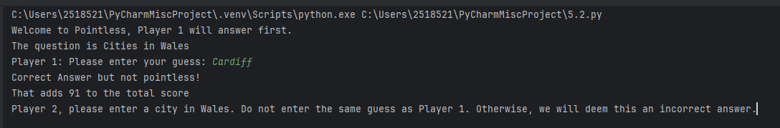
Result: Did the programme behave as expected ie syntactically and logically correct?
YES.
Input accepted and output shows points attained from input based on values assigned within code.

Test: 2. Players 1 and 2 enter answers

Screenshot(s) of output:
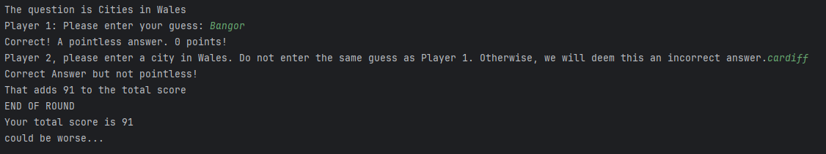
Result: Did the programme behave as expected ie syntactically and logically correct?
YES. Code run, accepted both answers from both players. Points assigned and correctly updated throughout code and total points displayed at end of program.
Test: 3. Enter incorrect answer

Screenshot(s) of output:
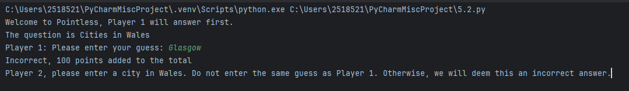
Result: Did the programme behave as expected ie syntactically and logically correct?
YES. Code executed and output shows that given info is incorrect. Points assigned to PointsCounter and shown to players, as written.

Test: 4. Both players enter same guess

Screenshot(s) of output:
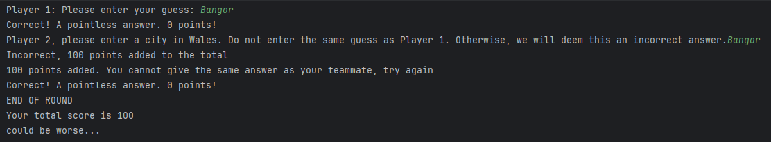
Result: Did the programme behave as expected ie syntactically and logically correct?
YES. Code written to deem duplicated answers as incorrect. Output shows correct response with specific note to inform players they cannot provide same guess as previous player.

Test: 5. Enter “swanSEA” (opposed to Swansea)

Screenshot(s) of output:
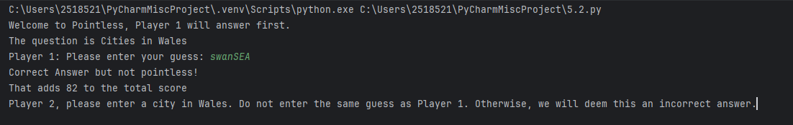
Result: Did the programme behave as expected ie syntactically and logically correct?
YES. Code written to allow to users to enter text without constraint on capital letters so does allow this input and works functionally.

Test: 6. Enter “pointless”

Screenshot(s) of output:
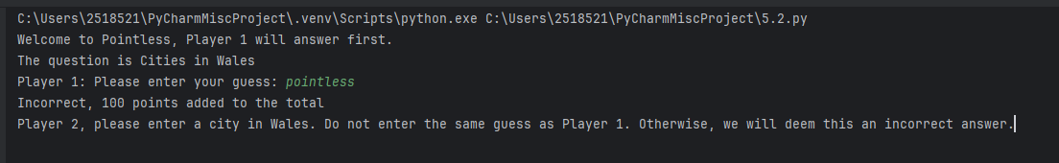
Result: Did the programme behave as expected ie syntactically and logically correct?
YES. As “pointless” not within CitiesinWales list, appears as incorrect answer, points assigned based on an incorrect answer. To expand, further code could be written to advise players to only enter Cities in Wales

Test: 7. Enter “0”

Screenshot(s) of output:
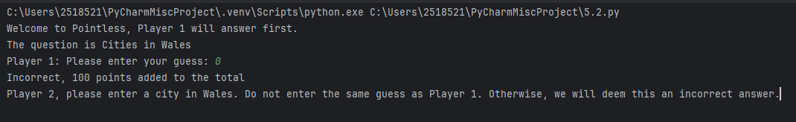
Result: Did the programme behave as expected ie syntactically and logically correct?
YES. Similar to test 6, code written to only allow specific cities in Wales. As this value is not within coded list, appears as incorrect answer. For further development, code could be expanded to not allow or provide alternate output if an inappropriate value is entered.

Test: 8. Enter “Saint Davids”

Screenshot(s) of output: 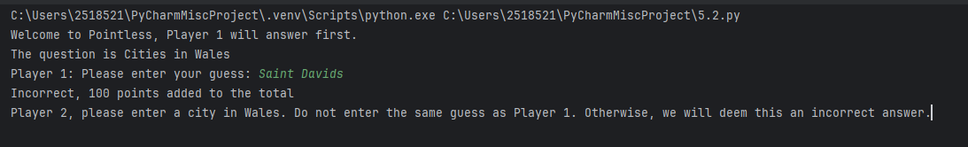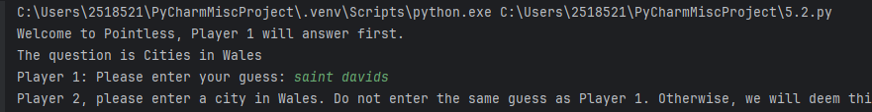

Result: Did the programme behave as expected ie syntactically and logically correct?

NO – although a correct answer, the formatting in the Cities list prevents this from appearing as a correct answer. Code written to allow lower or upper casing in any order but above format has not worked. Code reworked (shown in final code, below) to allow this.

Retested and screenshot shown above. No output of points shown based on the input here, but can be added, similarly to the various if statements throughout to resolve and make fully functional.

Final code:

[Copy and paste your code here – note, do not use a screenshot.

Note that there is no “before” and “after” code for this Worksheet because it is “Open” – not done in class. Therefore just post your final code below]

def PointsAnswer():
print("Correct Answer but not pointless!")
def PointlessAnswer():
print("Correct! A pointless answer. 0 points!")
def WrongAnswer():
print("Incorrect, 100 points added to the total")
CitiesinWales=["Cardiff", "Swansea", "Newport", "St.Davids", "Saint Davids", "St.Asaph", "Saint Asaph", "Wrexham", "Bangor"]
CardiffPoints=91
SwanseaPoints=82
NewportPoints=62
StDavidsPoints=7
StAsaphPoints=0
WrexhamPoints=0
BangorPoints=0
pointCounter=0
print("Welcome to Pointless, Player 1 will answer first.")
print("The question is Cities in Wales")
guessAnswer1=input("Player 1: Please enter your guess: ")
guessAnswer1 = guessAnswer1.strip().title()
if guessAnswer1 not in CitiesinWales:
WrongAnswer()
pointCounter=pointCounter+100
if guessAnswer1 == "Cardiff":
PointsAnswer()
print("That adds", CardiffPoints, "to the total score")
pointCounter=pointCounter+CardiffPoints
if guessAnswer1 == "Swansea":
PointsAnswer()
print("That adds", SwanseaPoints, "to the total score")
pointCounter=pointCounter+SwanseaPoints
if guessAnswer1 == "Newport":
PointsAnswer()
print("That adds", NewportPoints, "to the total score")
pointCounter=pointCounter+NewportPoints
if guessAnswer1 == "St.Davids":
PointsAnswer()
print("That adds", StDavidsPoints, "to the total score")
pointCounter=pointCounter+StDavidsPoints
if guessAnswer1 == "St.Asaph":
PointlessAnswer()
pointCounter = pointCounter + StAsaphPoints
if guessAnswer1 == "Wrexham":
PointlessAnswer()
pointCounter = pointCounter + WrexhamPoints
if guessAnswer1 == "Bangor":
PointlessAnswer()
pointCounter = pointCounter + BangorPoints
guessAnswer2=input("Player 2, please enter a city in Wales. Do not enter the same guess as Player 1. Otherwise, we will deem this an incorrect answer.")
guessAnswer2 = guessAnswer2.strip().title()
if guessAnswer2 == guessAnswer1:
WrongAnswer()
print("100 points added. You cannot give the same answer as your teammate, try again")
pointCounter=pointCounter+100
if guessAnswer2 not in CitiesinWales:
WrongAnswer()
pointCounter=pointCounter+100
if guessAnswer2 == "Cardiff":
PointsAnswer()
print("That adds", CardiffPoints, "to the total score")
pointCounter=pointCounter+CardiffPoints
if guessAnswer2 == "Swansea":
PointsAnswer()
print("That adds", SwanseaPoints, "to the total score")
pointCounter=pointCounter+SwanseaPoints
if guessAnswer2 == "Newport":
PointsAnswer()
print("That adds", NewportPoints, "to the total score")
pointCounter=pointCounter+NewportPoints
if guessAnswer2 == "St.Davids":
PointsAnswer()
print("That adds", StDavidsPoints, "to the total score")
pointCounter=pointCounter+StDavidsPoints
if guessAnswer2 == "St.Asaph":
PointlessAnswer()
pointCounter=pointCounter+StAsaphPoints
if guessAnswer2 == "Wrexham":
PointlessAnswer()
pointCounter=pointCounter+WrexhamPoints
if guessAnswer2 == "Bangor":
PointlessAnswer()
pointCounter=pointCounter+BangorPoints
print("END OF ROUND")
print("Your total score is",pointCounter)
if pointCounter ==0:
print("AMAZING! You win!")
elif pointCounter <=10:
print("What a result!")
elif pointCounter <=30:
print("Well done!")
elif pointCounter <=50:
print("nicely done")
elif pointCounter <=70:
print("Not too bad at all!")
elif pointCounter <=90:
print("on the higher end there")
elif pointCounter <=120:
print("could be worse...")
elif pointCounter <=150:
print("Better luck next time")
else:
print("Who let you come on Pointless?")

