

BA LEADERSHIP AND MANAGEMENT

DEVELOPING AND MANAGING INDIVIDUALS AND TEAMS

LECTURER: Dr Doreen Nyaa Amundam

MODULE CODE: LCLM 5002

TASK 2- INDIVIDUAL REPORT

By Tesenai Bertram
2409077

Introduction
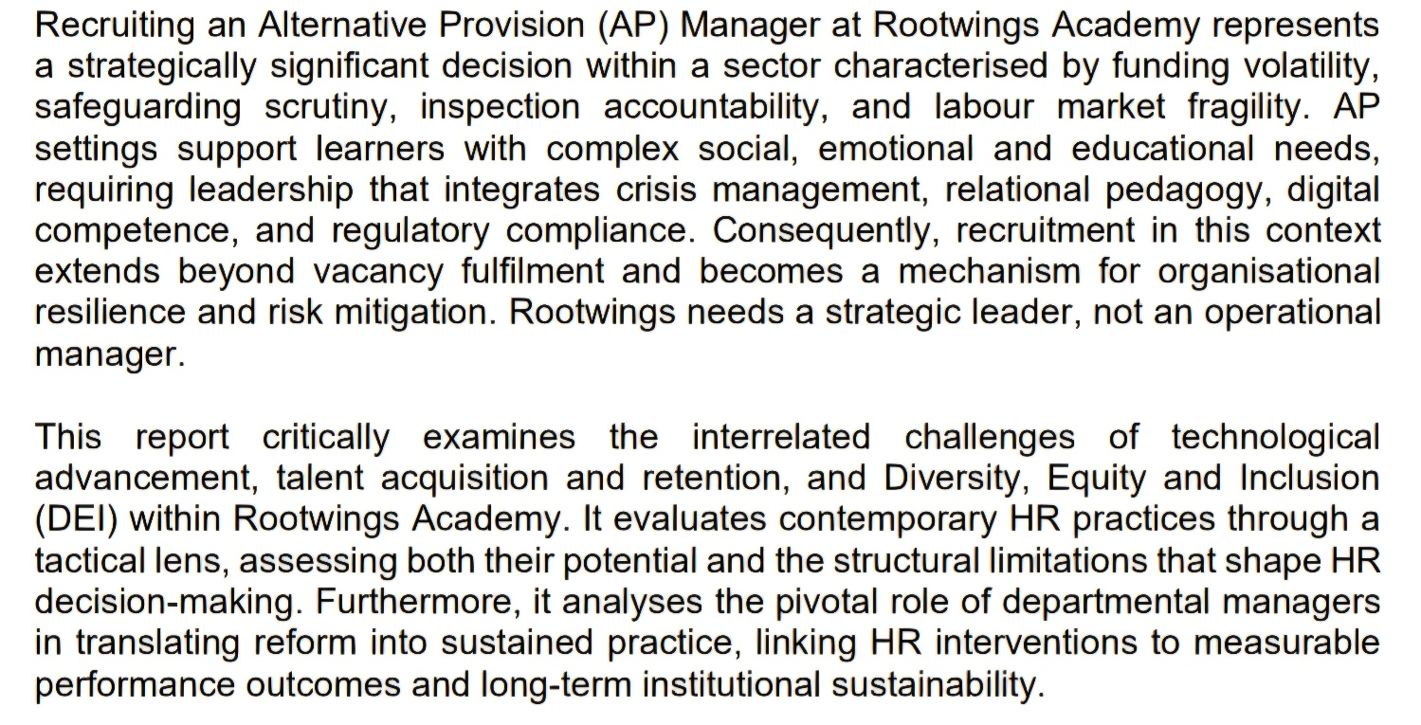



List of Abbreviations
Abbreviation | Full Term
ACEs | Adverse Childhood Experiences
AI | Artificial Intelligence
AP | Alternative Provision
ATS | Applicant Tracking System
BSC | Balance Score Card
CIPD | Chartered Institute of Personnel and Development
CPD | Continuing Professional Development
CPH | Cost-Per-Hire
DEI | Diversity, Equity and Inclusion
DSG | Dedicated Schools Grant
DSL | Designated Safeguarding Lead
EHCP | Education, Health and Care Plan
eNPS | Employee Net Promoter Score  (a measure of staff likelihood to recommend Rootwings as a workplace)
ESFA | Education and Skills Funding Agency
GDPR | General Data Protection Regulation
HR | Human Resources
HRM | Human Resource Management
LA | Local Authority
MAT | Multi-Academy Trust
MIS | Management Information System
PRU | Pupil Referral Unit
QTS | Qualified Teacher Status
SEMH | Social, Emotional and Mental Health
SEND | Special Educational Needs and Disabilities
SHRM | Strategic Human Resource Management
SIMS | School Information Management System
STEM | Science, Technology, Engineering and Mathematics
TNA | Training Needs Analysis
VFM | Value for Money

Key HR Challenges

Meeting Technological Advancement
Technological advancement at Rootwings Academy is essential due to pressures in the AP sector, facing unstable financing influenced by local authority commissioning and per-pupil allocations. Council budgets require demonstrable value, efficiency, and measurable student outcomes (CIPD, 2023). Investing in digital HR systems, such as AI-driven Applicant Tracking Systems (ATS), aims to reduce administrative workload, improve recruitment accuracy, and demonstrate cost-effectiveness to commissioners and governing bodies.
AP environments support vulnerable learners with SEMH needs and complex safeguarding histories. The Department for Education enforces strict recruitment standards, which make manual systems prone to error. Digitised workflows and Management Information Systems (MIS) such as Arbour or SIMS improve compliance and traceability for Ofsted inspections. Weak data infrastructure can harm reporting and reputations. Implementing HR technology improves recruitment efficiency and defensibility, with real-time dashboards providing key workforce metrics critical for leadership and safeguarding. The Equality Act 2010 states that UK GDPR data protection obligations heighten recruitment risks involving sensitive personal data. Inadequate system configurations or insufficient training can lead to legal penalties; therefore, any implementation of AI and ATS must incorporate strong data protection protocols, encryption, access controls, and staff training. Student identity exposure and sensitive AP information must be protected when using social media.
Technological advancement in education faces challenges due to digital capability gaps among veteran educators. While experienced AP leaders excel in relational pedagogy, they often struggle with advanced MIS and predictive analytics. It's essential to identify candidates with emotional intelligence and digital skills while upskilling current staff to prevent digital stratification in leadership.
The shift to hybrid learning post-pandemic poses challenges, as AP settings increasingly rely on digital platforms for students with attendance issues. The new AP Manager must possess pedagogical leadership, digital curriculum skills, digital safeguarding expertise, and remote engagement analytics to adapt to changing educational needs.
Failure to modernise exposes Rootwings Academy to recruitment risks and inefficiencies, threatening its financial resilience. Embracing technology like AI-enabled ATS and digital dashboards can help navigate unpredictable subsidies, regulatory scrutiny, workforce gaps, and evolving educational models, demonstrating a commitment to innovation and effective risk management.
Talent Acquisition and Retention
The UK is experiencing a recruitment and retention crisis in education, particularly in Alternative Provision (AP). with 38% of teacher-training targets missed and a 44% rise in staff turnover, particularly in STEM fields (CIPD, 2024). Traditional recruitment methods are inadequate. The AP Manager role at Rootwings requires Qualified Teacher Status (QTS), expertise in Special Educational Needs and Disabilities (SEND), and strong emotional intelligence to support vulnerable students. Staffing shortages in Pupil Referral Units (PRUs) and AP settings are often underreported, underscoring the urgent need for qualified professionals to help at-risk youth.
Attracting and retaining high-quality talent in the Alternative Provision (AP) sector is challenging, especially in the fragile UK education labour market. Rising teacher attrition rates, particularly within the first five years, are driven by workload intensity, accountability pressures, and well-being concerns (CIPD, 2023). In AP settings, these issues are exacerbated, leading to burnout and high staff turnover.
At Rootwings Academy, retention must be viewed in the context of competition from mainstream schools, multi-academy trusts, and specialist SEND provisions, all vying for the same qualified leaders. The flux of Local Authority aid in AP settings further complicates long-term planning and stability, potentially deterring experienced leaders. Primarily driven by the ‘high needs block’ of the Dedicated Schools Grant (DSG), roughly £10,000 per place, with top-ups commissioned for students with an EHCP, grants are harder for APs to obtain, as mainstream and specialist school pupils have higher priority due to a more standardised National Funding Formula. In contrast, AP students require higher costs due to their varying levels of need. For the first two years, 100% of MAT placements are funded by the Education and Skills Funding Agency (ESFA), which is initially more attractive to LAs. Still, after this period, the ESFA deducts approximately. £5833 per place from the LAs' budgets, reducing the support available for APs (Perera, 2019).
To address these issues, an intentional retention framework is essential. Beyond competitive salaries, a Total Reward approach that includes professional autonomy, structured CPD, clinical supervision, flexible work arrangements, and wellbeing support is crucial. Employer branding should position Rootwings as a psychologically safe and developmental environment that fosters long-term leadership resilience in a competitive labour market.
Diversity, Equity and Inclusion (DEI)
Students in AP settings often come from minority ethnic backgrounds and lower socio-economic backgrounds, yet this diversity is rarely reflected in senior leadership roles. Structural inequalities, such as limited access to mentoring and qualifications, hinder advancement into headship. Additional barriers, such as unpaid leadership placements and mobility constraints, further restrict access to senior positions. Thus, the underrepresentation in leadership is a systemic pipeline issue, not just a recruitment problem.
Addressing unconscious bias in recruitment through methods such as blind shortlisting and diverse panels treats symptoms, not the causes. While Rootwings Academy can enhance shortlisting diversity, it may not lead to meaningful senior-level representation. True DEI requires systemic changes beyond recruitment, such as structured interviews, inclusive job descriptions, proactive leadership development, mentoring for underrepresented staff, and clear promotion criteria. Monitoring DEI metrics and pay equity is essential to identify stagnation. By overcoming recruitment and systematic barriers, Rootwings can advance from compliance to leadership that reflects its student community and strengthens its competitive advantage as an inclusive employer.

Evaluation of Contemporary HR Practices

Transitioning from traditional personnel management to Strategic Human Resource Management (SHRM) is crucial for addressing the complexities of the alternative provision sector (Armstrong and Taylor, 2023). The following section evaluates contemporary practices to mitigate the three core issues identified.

Meeting Technological Advancement
The adoption of Applicant Tracking Systems (ATS) and AI tools marks a shift to data-driven workforce planning. While ATS increases efficiency by parsing CVs and ranking candidates, it poses organisational risks. If based on biased historical data, ATS may perpetuate demographic imbalances, favouring traditional career paths linked to higher socio-economic status and elite education. This bias is evident in tools such as LinkedIn and Indeed.
Predictive analytics can forecast candidate performance and employee turnover, but may be biased and oversimplify human motivation, overlooking essential contextual factors like emotional labour and safety in high-stress environments.
Virtual interviews and digital assessment platforms expand geographical reach and accessibility. However, digital literacy disparities may disadvantage candidates from lower-income backgrounds or those less technologically confident, subtly filtering the applicant pool. In addition, asynchronous video tools risk privileging candidates with greater presentation confidence rather than relational leadership competence.
Employee analytics platforms enhance engagement tracking and performance management, but excessive monitoring may generate surveillance perceptions, undermining psychological safety. Therefore, technological integration at Rootwings must be accompanied by bias audits, human oversight, transparent governance, and ethical design principles. Digital competence cannot be forced. Kotter's first step (Create Urgency) in his 8 Step Change Model implies that an AP manager should frame new safeguarding AI as vital for regulatory compliance. Step 5 (Empower Action) suggests that HR must provide necessary training to tech-resistant staff to overcome structural limitations. Without critical scrutiny, digital efficiency may inadvertently entrench inequality rather than resolve it.

Talent Acquisition & Retention
In a competitive education labour market, salary alone is insufficient to attract or retain an AP Manager. Procter-Legg (2025) found that early-career teachers in England, including those in special school settings, are most at risk of leaving within 5 years. A Total Reward framework combining transactional and relational aspects is essential. While pay may entice applicants, intrinsic motivators like professional growth and meaningful work are crucial for long-term retention, along with structured supervision and wellbeing initiatives.
Total Reward models pose challenges, as informal distribution of development opportunities can reinforce power hierarchies, limiting advancement for underrepresented groups. Transparency in Training Needs Analysis (TNA) is crucial for equitable access to opportunities (Torrington et al, 2020).
Competency-based selection methods, such as micro-teaching from Kolb’s Experiential Learning Theory, enhance predictive validity by assessing skills through simulations rather than self-reports. However, they may disadvantage non-traditional applicants. Emphasising cultural fit can perpetuate homogeneity, necessitating equitable implementation and transparency to prevent the reinforcement of leadership inequalities.
Departmental managers must consistently monitor the Cost-Per-Hire (CPH) to ensure it remains within the £3,000–£5,000 threshold. Any variance should trigger a review of the "Strategic Sourcing" mix to ensure maximum Value for Money (VFM).

Diversity, Equity, and Inclusion (DEI)
Rootwings uses a scientific recruitment approach to enhance Diversity, Equity, and Inclusion (DEI) through methods like blind shortlisting, which aim to reduce bias. However, despite improved fairness in trials, minority representation at senior levels remains low, suggesting more profound discrimination in decision-making.
Diverse interview panels are intended to minimise in-group bias, in line with Social Identity Theory (Tajfel and Turner, 1979). However, diversity doesn’t guarantee fair outcomes if influenced by dominant organisational norms. Without shared authority and structured scoring, panel diversity might remain symbolic rather than transformative.
The distinction between equity and equality is essential. Reasonable adjustments align with the Equality Act 2010 and reflect Adams’ (1965) Equity Theory, which emphasises fairness through proportional treatment. However, unclear equity practices may lead to perceptions of favouritism, threatening organisational cohesion due to opacity.
Language auditing of job ads, using software to eliminate gender-coded terms, can broaden applicant pools. However, without focusing on progression pathways, mentoring, and promotion criteria, these efforts may be merely performative (Muller, 2018). Rootwings demonstrates procedural fairness, but meaningful change necessitates fundamental alignment that influences leadership representation and organisational culture.
Rootwings Academy's contemporary HR practices focus on creating a resilient, tech-savvy, and inclusive workforce ready to meet the unique challenges of the alternative provision sector. The effectiveness of these practices can be evaluated using measurable performance frameworks, such as the Balanced Scorecard.
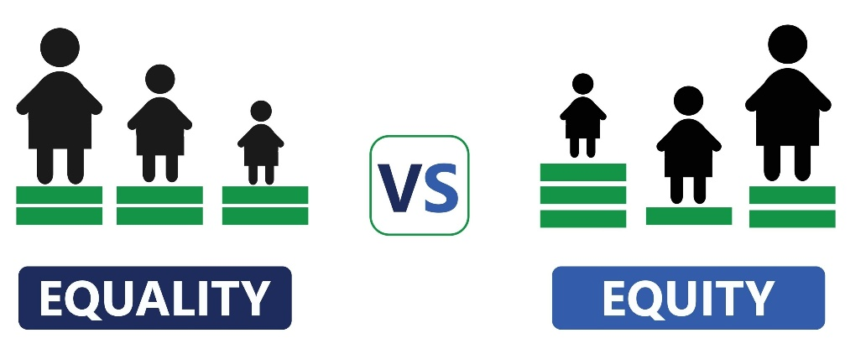

(Interaction Design Foundation, 2024)
A Critical Evaluation of How Departmental Managers at Rootwings Academy Can Ensure Urgent Implementation of Contemporary HR Practices
Rootwings Academy needs modern HR practices to support digital transformation, DEI, and quality leadership, such as the AP Manager. Factors such as accountability and labour market instability create a limited “window of opportunity” for reform. Kotter (1996) emphasises that successful change starts with a strong sense of urgency to counter complacency. In education, reforms are often slow due to tradition and autonomy, so urgency must be managed to prevent mere surface-level reform. Recruitment requires a legally defensible decision architecture. Departmental managers are crucial for effectively implementing these policies.
Rootwings must ethically govern AI-driven recruitment and ATS to avoid perpetuating biases (Raghavan et al., 2020). Managers should implement oversight, conduct bias audits, and maintain human authority in selections. Integrating AI governance indicators into the Balanced Scorecard can measure digital adoption in terms of fairness and quality, but qualitative reviews should complement it to prevent performative accountability (Muller, 2018).
However, Muller (2018) warns that reliance on metric-driven accountability risks procedural conformity rather than genuine behavioural change. The Four-Stage Learning Agreement addresses this by integrating within leadership routines, clarifying expectations, diagnosing digital and DEI capability gaps, operationalising applied learning, and reviewing outcomes.
Purcell and Hutchinson (2007) emphasise the role of front-line managers in shaping HRM performance. Resistance from middle managers to reforms, such as blind shortlisting, may arise due to perceived threats to norms. Social Identity Theory (Tajfel and Turner, 1979) highlights how in-group dynamics can hinder inclusion, underscoring the need for transparent communication about equity-based changes. Adams’ (1965) Equity Theory suggests that perceptions of fairness depend on the proportionality between inputs and outcomes, rather than on identical treatment. Therefore, departmental managers should effectively articulate the DEI rationale, using data dashboards, stakeholder briefings, and performance evidence to build legitimacy and sustain trust.
Resistance from middle managers and reform fatigue represent institutional roadblocks to HR modernisation. Educational settings are particularly vulnerable to cultural inertia, where professional autonomy and reform saturation generate passive resistance. Kotter (1996) argues that without visible short-term wins, urgency dissipates and change momentum stalls. Rootwings must deliberately stage implementation, demonstrating early gains such as reduced time-to-hire and strengthened safeguarding compliance.
Retention strategies should focus on a Total Reward approach that combines competitive pay, professional development, wellbeing initiatives, and recognition. Herzberg’s Two-Factor Theory (1959) indicates that intrinsic motivators drive engagement more sustainably than financial incentives. Development opportunities must be equitably available, especially for underrepresented groups, as inclusive management is essential.

Departmental managers have a fiscal responsibility to protect the Recruitment Budget Strategy. Given that a failed hire costs 30% of an annual salary, managers must implement the "90-day review" as a financial safeguard. By tracking Cost-Per-Hire (CPH) against candidate performance, managers provide the "Scientific Decision-Making" data needed to justify future HR investments (Metaview, 2025).
CPH RECRUITMENT METRIC= $\frac{Internal costs+External Costs}{Total number of Hires}$
Rootwings Academy is a small, independently commissioned AP constrained by LA funding cycles and per-pupil allocations. Full-scale ATS implementation may not be immediately financially viable. A phased approach, beginning with a low-cost tracking tool such as Pinpoint or Hireful, would be more appropriate, scaling towards AI-enabled platforms as the APs' digital maturity and budgets allow.
Given current budget constraints, urgently establishing a fully resourced DEI function may not be feasible. A more practical approach would be to designate an existing senior leader, such as the SENCO, and conduct a basic annual audit using free tools, such as the CIPD's Inclusion Health Checker.
To address funding uncertainty, non-pay retention strategies — such as flexible working and structured supervision — should be implemented immediately as a priority strand of the Total Reward framework. Standardising a 90-day induction for new hires can reduce early attrition. Long-term, applying for DfE grants can fund supervision programs, thereby enhancing motivation, as identified by Procter-Legg (2025), and positioning Rootwings as a competitive employer.
Delay increases inspection vulnerability, heightens exposure, and exacerbates competitive fragility in the AP labour market. While urgency is necessary, it must be ethically balanced. Purcell and Hutchinson (2007) highlight that front-line managers are crucial in the HRM-performance chain. When they embrace reform and embed strategy into everyday practice, HR modernisation becomes sustainable rather than merely symbolic. Using the Four-Stage Learning Agreement alongside Kotter’s change framework as a strategic tool effectively translates strategy into behaviour.
.

Contemporary Practices
The following pages will detail how Rootwings will implement these practices to explore the effectiveness of each model.
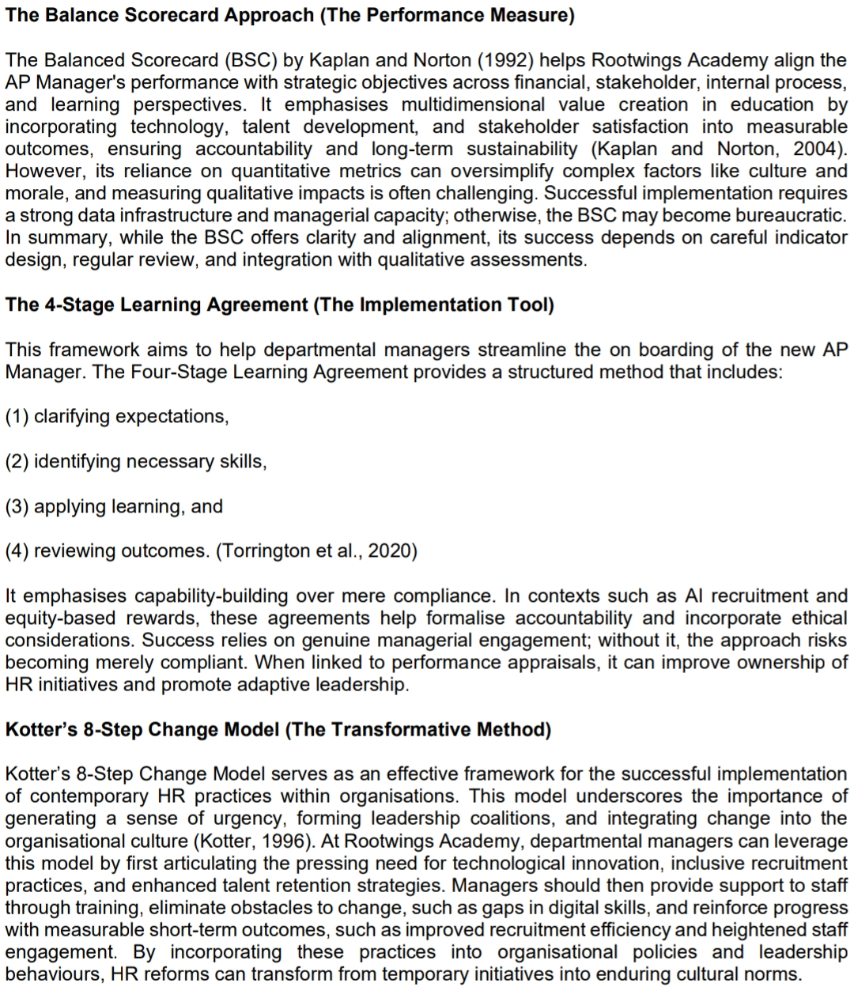
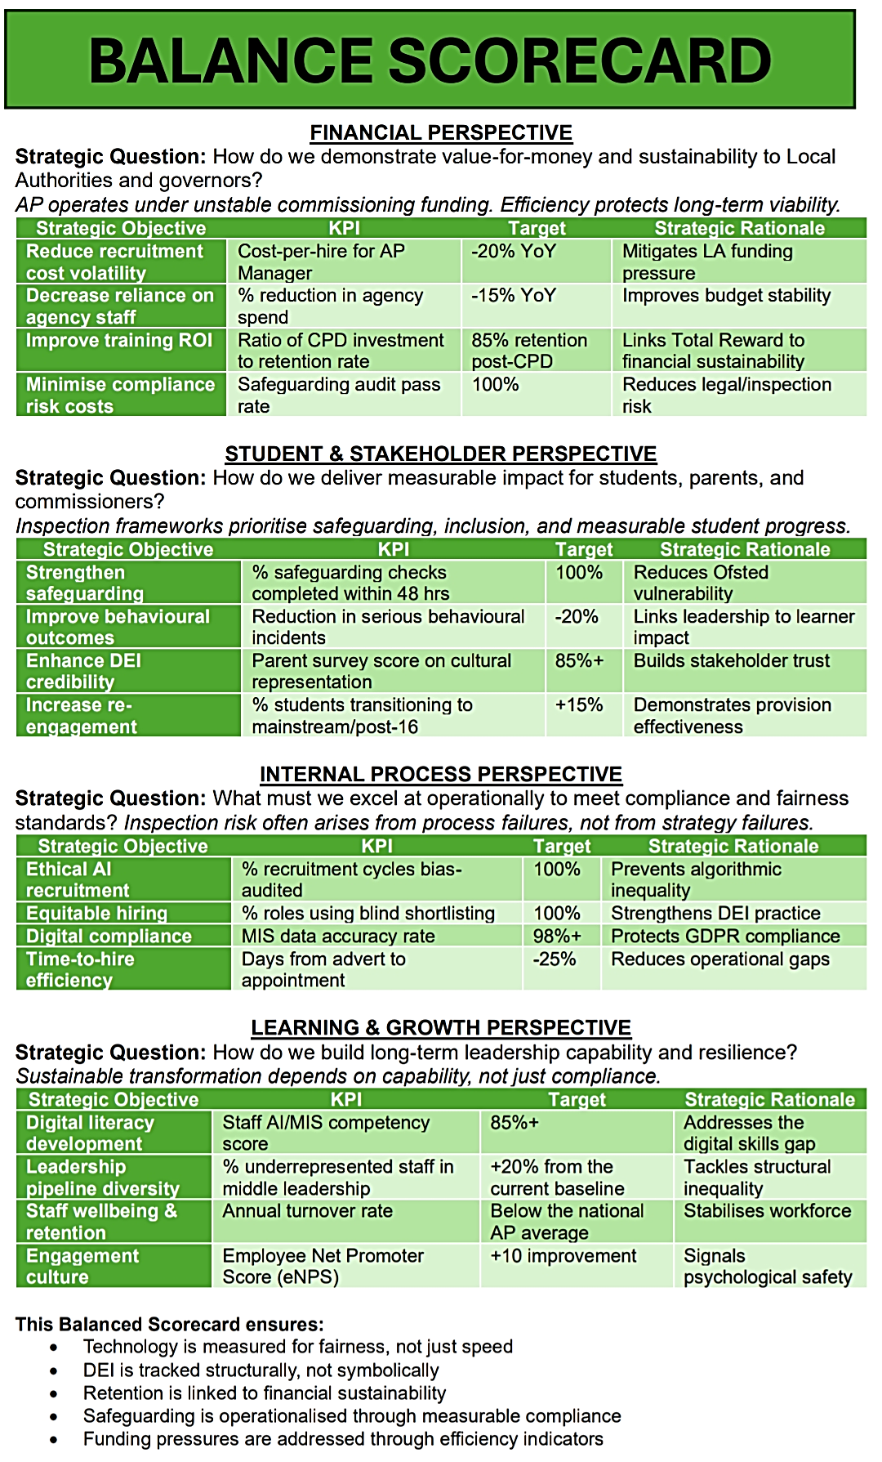
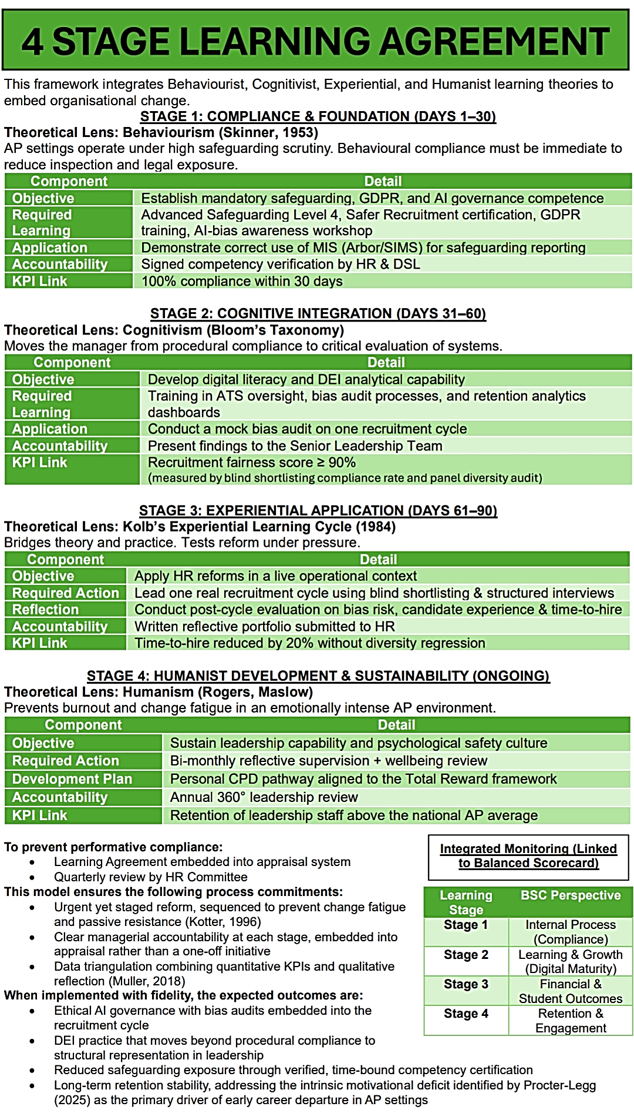



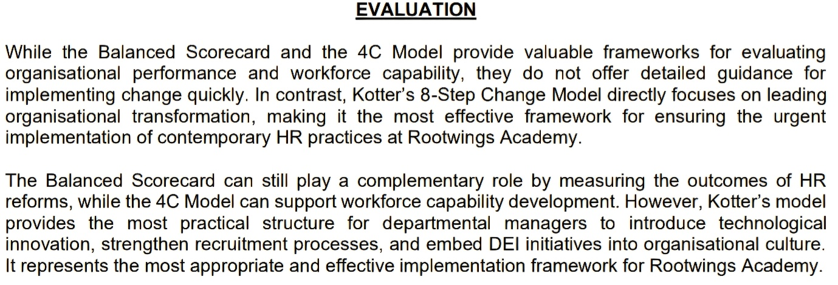

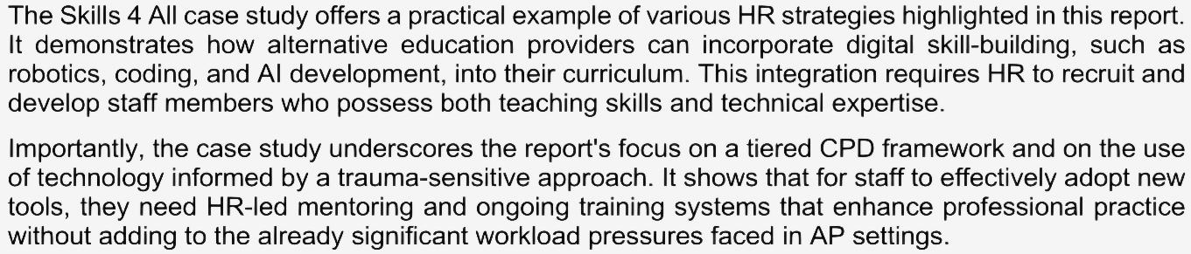
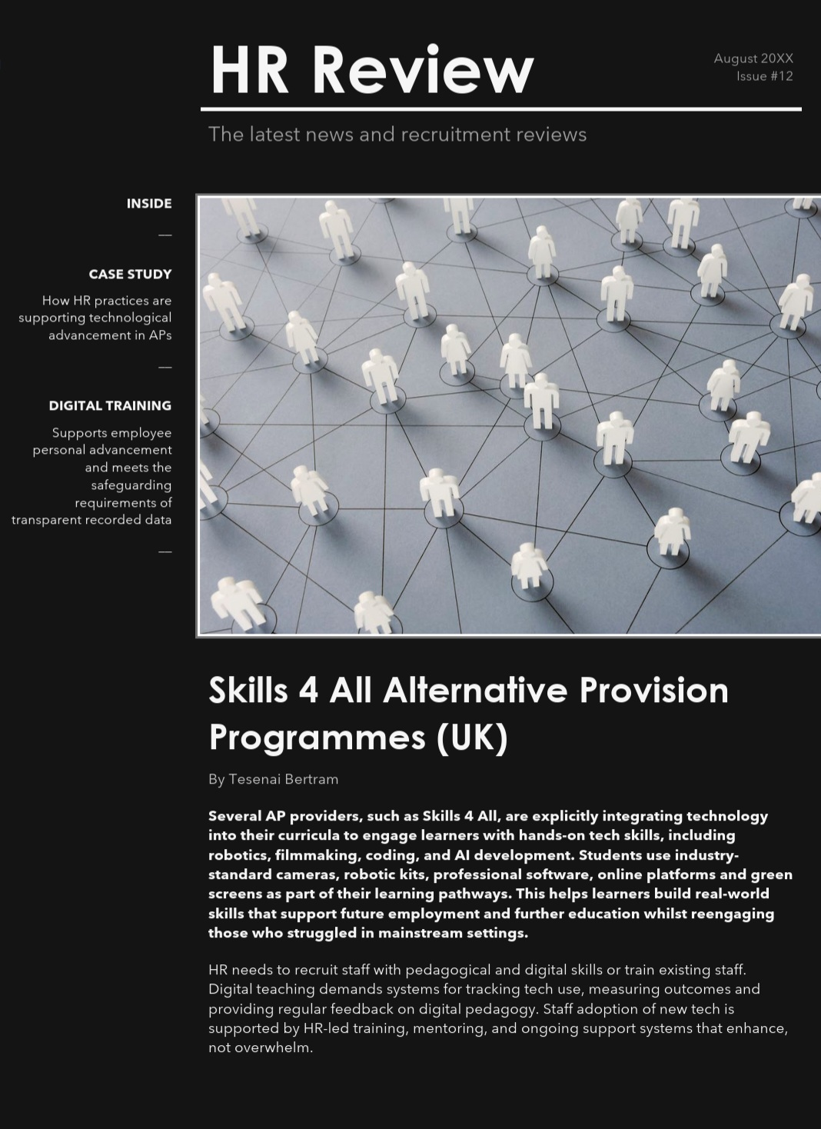
CASE STUDY: SKILLS 4 ALL (2026)

Conclusion

For Rootwings Academy, contemporary HR reform is not a discretionary enhancement, but a strategic necessity shaped by heightened accountability expectations, financial uncertainty, labour market constraints and regulatory scrutiny. Consequently, technological modernisation, equitable talent development and equity-centred organisational transformation must operate as interconnected mechanisms that strengthen institutional resilience rather than as isolated initiatives.
While the Balanced Scorecard provides a structured framework for aligning performance objectives with organisational strategy, ethical AI governance and transparent career progression systems ensure that principles of fairness and accountability are translated into operational practice. In addition, the Four-Stage Learning Agreement framework and 8-Step Model bridge the gap between policy formulation and managerial behaviour by embedding reflective learning, responsibility and continuous improvement into leadership practice.
When implemented through coherent governance structures and ethical oversight, these reforms reposition human resource management from a largely administrative function to a strategic capability that supports sustainable organisational performance. In doing so, HR becomes a central driver of leadership stability, workforce engagement and long-term institutional legitimacy within the Alternative Provision sector.

Recommendations

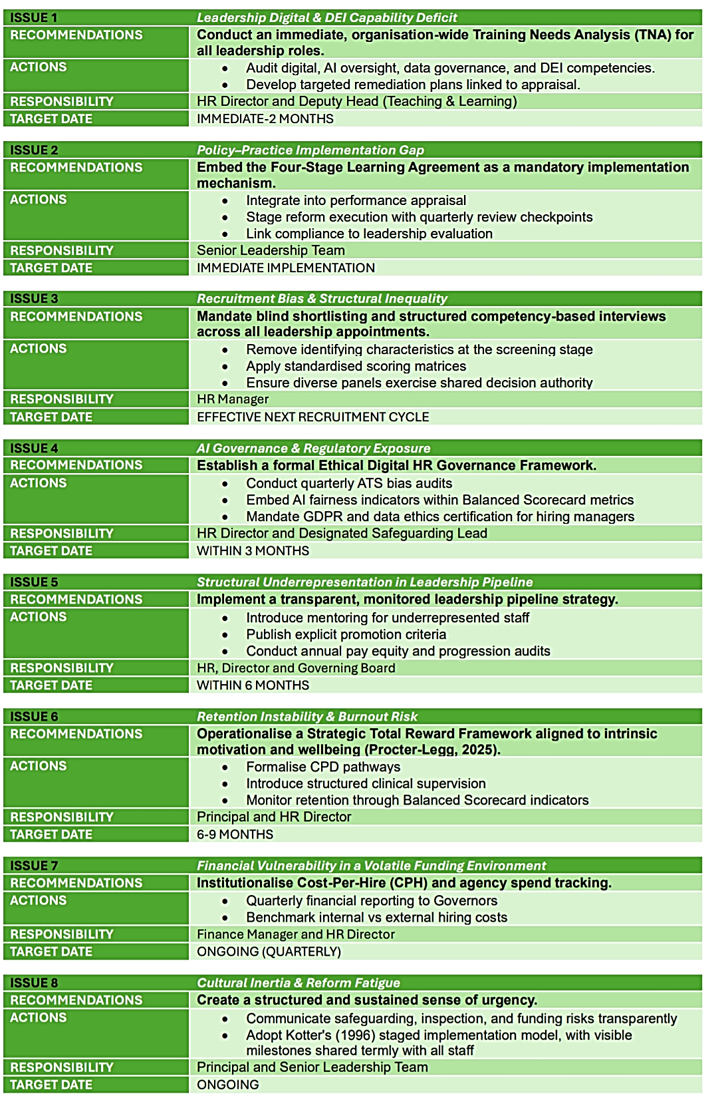

References

Adams, J.S. (1965) ‘Inequity in social exchange’, Advances in Experimental Social Psychology, 2, pp. 267–299.
Armstrong, M. and Taylor, S. (2023). Armstrong's Handbook of Human Resource Management Practice. 16th edn. London: Kogan Page.
Chartered Institute of Personnel and Development (CIPD) (2023) Good Work Index 2023. London: CIPD.
Chartered Institute of Personnel and Development (CIPD) (2024). Inclusion and diversity in the workplace. [online] Available at: https://www.cipd.org (Accessed: 26 January 2026).
Department for Education (2025) Keeping Children Safe in Education (KCSIE) 2025. London: HMSO.
Equality Act 2010. c.15. London: The Stationery Office. Available at: https://www.legislation.gov.uk/ukpga/2010/15/contents(Accessed:14 February 2026)
Herzberg, F. (1959). The Motivation to Work. New York: Wiley.
Interaction Design Foundation (2024) Equality vs Equity [Graphic]. Available at: https://www.interaction-design.org [Accessed 16 Jan 2026].

Kaplan, R.S. and Norton, D.P. (1992) ‘The Balanced Scorecard: Measures that drive performance’, Harvard Business Review, 70(1), pp. 71–79.
Kaplan, R.S. and Norton, D.P. (2004) Strategy-Focused Organisation. Boston: Harvard Business School Press.
Kolb, D.A. (2014). Experiential Learning: Experience as the Source of Learning and Development. 2nd edn. New Jersey: Pearson Education.
Kotter, J.P. (1996). Leading Change. Boston: Harvard Business School Press.
Metaview (2025) Cost Per Hire: How to calculate and reduce recruiting expenses. Available at: https://www.metaview.ai/resourcing/blog/costperhire (Accessed: 15 February 2026)
Muller, J.Z. (2018). The Tyranny of Metrics. Princeton: Princeton University Press.
Mullins, L.J. (2023). Management and Organisational Behaviour. 13th edn. London: Pearson.
Perera, N. (2019). High Needs Funding: An overview of the key issues. London: Education Policy Institute. Available at: https://epi.org.uk/wp-content/uploads/2019/04/EPI_High-Needs-Funding_2019.pdf (Accessed 20 February 2026)
Procter-Legg, C. (2025) 'The five-year itch: Motivational factors that influence the career decisions of early career teachers in England', British Educational Research Journal, [online first]. Available at: https://doi.org/10.1002/berj.4149 (Accessed: 19 March 2026).
Purcell, J. and Hutchinson, S. (2007) ‘Front-line managers as agents in the HRM-performance causal chain’, Human Resource Management Journal, 17(1), pp. 3–20.
Raghavan, M., Barocas, S., Kleinberg, J. and Levy, K. (2020) ‘Mitigating bias in algorithmic hiring’, Proceedings of the 2020 Conference on Fairness, Accountability, and Transparency, pp. 469–481.
Skills 4 All (2026) Our Alternative Provision Programmes. Available at: https://skills4all.org/our-alternative-provision-programmes/?utm_source=chatgpt.com (Accessed: 23 February 2026)
Tajfel, H. and Turner, J.C. (1979) ‘An integrative theory of intergroup conflict’, in Austin, W.G. and Worchel, S. (eds.) The Social Psychology of Intergroup Relations. Monterey: Brooks/Cole.
Torrington, D., Hall, L., Taylor, S. and Atkinson, C. (2020). Human Resource Management. 11th edn. Harlow: Pearson.

