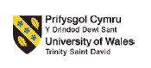

MBA – Masters of Business Administration
MARKETING MANAGEMENT
LCMB7001

Assessment 2

Student name: SHANAVAS MANAGATTU PARAMBAN
Student ID:2128680
Lecturer : TUSHARA BALENDRAN

MBA MARKETING MANAGEMENT
ASSIGNMENT

Executive summary
The PESTLE analysis of the macro-environmental factors has managed to demonstrate both favourable and unfavourable aspects for the selected organisation. On the other hand, using Porter's five forces has managed to explain the impact of different forces on the business operability of L’Oréal. The strength, weaknesses, opportunities and threats are analysed in the report for the company L'Oreal to expand its business by overcoming the adversities in the long run. The segmentation, positioning and targeting of the company to reach the masses are also analysed in the report. Recommendation for future marketing strategies has been discussed in this report as well. This study shows the 4Ps marketing mix strategy of L’Oreal. The pricing, people, product and promotion strategy of L’Oreal is discussed here.

Table of Contents
Introduction 3
Question a 3
Analysing macro-environment factors to the company 3
Applying Porter’s five forces model to the selected company 6
Relating to the SWOT analysisfor L’Oreal 7
Implementation of STP analysis to the chosen organisation 9
Description of Marketing Mix 4Ps for L’Oreal 10
Advantage and disadvantage of L’Oreal’s management practices 12
Conclusion 13
Question b 14
Recommendations for future marketing strategies that can be applied by L’Oreal 14
References 15

Introduction
Marketing management is essential for attaining a competitive advantage within an international market by enhancing customer satisfaction rate. This study has assessed the application of Porter's five forces for the assessment of the competitive strategy of L’Oreal. The internal environment of L’Oreal such as SWOT and the implementation of Segmentation, Targeting, and Positioning (STP) of the firm have been vastly elaborated to understand the marketing strategy of the globally-recognised brand. The 4P marketing mix such as pricing, product, promotional and place strategy of L’Oreal has been discussed in this study to evaluate the effective marketing strategy of L’Oreal. Moreover, the comparative assessment of L’Oreal has been discussed.

Question a

Analysing macro-environment factors to the company
Factors | Key aspects | Situation
Political | - The corruption index of the UK is 78 as of 2021 (tradingeconomics.com, 2022).  - No presence of strong trade restrictions apart from EU directives  - As of 2020, the political stability of this country is 0.47 (theglobaleconomy.com, 2021). | Favourable
Economic | - In 2022, the GDP growth of the UK was 3.75% (statista.com, 2022).  - The total GDP of the UK as of 2021 is 3186.86 billion (tradingeconomics.com, 2022).  - As of July 2022, CPI increased by 5.7% (ons.gov.uk, 2022).  - Interest rate 1.75% after increasing by 0.5% (bankofengland.co.uk, 2022). | Favourable/ Unfavourable
Social | - Population density 281 per square km (worldometers.info, 2022).  - 0.87% of the total world population (worldometers.info, 2022).  - High consumption rate  - Changing preferences to online purchasing | Favourable
Technological | - £25 billion investment in R&D (gov.uk, 2022).  - High adherence to technological advancements such as AI, 5G, and AR  - Implementation of automation in different industries | Favourable
Legal | - “Consumer Rights Act 2015” (legislation.gov.uk, 2022).  - “Updated employment Law 2022” (brachers.co.uk, 2022). | Favourable/ Unfavourable
Environmental | - The annual growth rate in the agricultural sector is 0.14% (statista.com, 2022).  - As of 2022, the gross production value in the agricultural sector USD$21.61 billion (statista.com, 2022). | Favourable
Table 1: PESTLE Analysis for L’Oreal
(Source: created by author)
An explanation for each factor
Political stability and corruption index represents a favourable condition for the selected organisation as L’Orealhas an opportunity to improve their performance. On the other hand, despite a favourable growth in GDP rate increase in inflation rate has imposed an unfavourable situation for the selected organisation due to an increase in production cost to operate in this market.
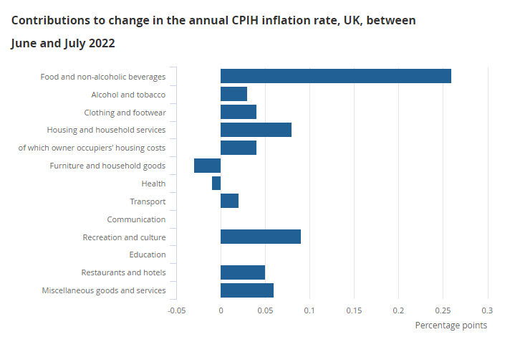
Figure 1: CPI Growth in the UK
(Source: ons.gov.uk, 2022)
High consumption rate and population density present in the UK represents an opportunity for L’Oreal to enhance its sales and marketing activities whereas a favourable investment is also noticeable in the R&D sector.
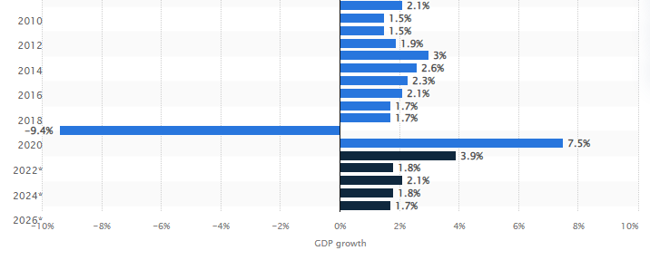
Figure 2: GDP Growth Rate in the UK
(Source: statista.com, 2022)
Furthermore, changes in employment law have become beneficial for employees as it has included consideration of neonatal leave, unpaid leave, and others both organisations and employees can gain favour from it, and vice versa (brachers.co.uk, 2022). However, sudden changes in the legislative framework may create an unfavourable situation for L’Oreal in demonstrating its compliance with it. Apart from that, an overall favourable macro-environment is present in the UK for L’Oreal to operate their business operations.

Applying Porter’s five forces model to the selected company
Five forces | Description | Force Impact
Industry Rivalry | - Strong market rivals such as Chanel, Unilever, Revlon  - 20% of market share in Europe whereas Chanel has over $5.55 billion revenue in the UK (statista.com, 2022). | High
Threat of new entry | - The organisation has global market presence  - Availability of major market player products | Low
Bargaining power of the suppliers | - Strong presence of suppliers  - Global supplier base | High
Bargaining power of the buyer | - Presence of a wide range of alternative products  - Availability of affordable price range in comparison to other market rivals | Medium
Threats of substitution | - Active presence of international and national brands  - Accessibility to alternative products | High
Table 2: Porter’s Five Forces Analysis for L’Oreal
(Source: created by author)
Explanation
L’Oreal has a strong market presence that helped this organisation to achieve a profitable position in a highly competitive market such as the UK. The following figure demonstrates a clear understanding of global market share of this brand. The company has a 41% global market share making it cap[able of addressing strong market rivals such as Chanel and Unilever (statista.com, 2022). Nonetheless, due to presence of such market rivals and global supplier base, the organisation may face a high force in these perspectives.
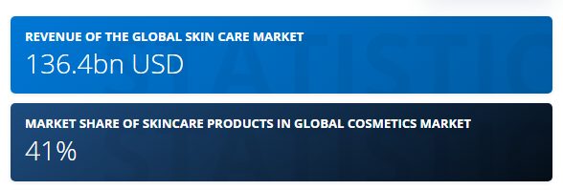
Figure 3: Global Market of L’Oreal
(Source: statista.com, 2022)
Availability of a wide range of product alternatives develops a moderate force in the bargaining power of buyers as they have an opportunity to shift their preferences with time. It developed an opportunity for the chosen organisation to keep its product integrated and according to customer preferences. Furthermore, customer services and quality of the product the range offered by L’Oreal has managed to reduce the threat of new entrants in its niche market despite having a strong industry rivalry.

Relating to the SWOT analysisfor L’Oreal
The SWOT analysis for L’Oreal is discussed under the following table:
Strengths  - Continuing research and development in their field of operations and innovations in various interests of beauty  - High-end advertising strategy to capture the audience on a large scale  - Operating in more than 130 countries (loreal-paris.co.uk, 2022)  - Having around 40 manufacturing plants which show their vast expansion | Weaknesses  - Decentralisation of their organisation leads to more division of labour and more units of production which are difficult to manage.  - Tough competition from the other leading cosmetic companies in operations.
Opportunities  - Opportunity to capture the masses of developed countries with their products.  - Got a greater market share and has various patent rights to capture the market. | Threats  - Growing competition from the other brands of cosmetics at a large scale on their marketing strategy.  - Does not produce products for basic needs. Hence, the demand for the product is dependent upon the choices of the masses.
Table 3: SWOT analysis for L’Oreal
(Source: Created by author)
The SWOT analysis for the company has been initiated to understand the market share and their competitive advantage in the economy of business and activities. The company faces tough competition from their rivals on a large scale which affects the business concern. The company produces goods which are of luxury rather than basic needs therefore, the demand for their product is not a necessity to the customer's advantage. The process of decentralisation in their production units in various spheres makes the cost of its operations much higher compared to the other cosmetic companies (Smith et al., 2022). The company is known for its expansion to the wider market base initialising proper patent rights to decentralise globally their products and services.

Implementation of STP analysis to the chosen organisation
The segmentation, targeting and positioning of the brand is analysed to gain the market position effectively.
Segmentation  - Demographic segmentation by providing superior value proposition  - Based on income, prospective customer and life cycle based  - Psychographic segmentation based on buying patterns, personality  Characteristics of the population.  - Behavioural segmentation based on attitude, knowledge of the product and the audience involved | Targeting  - Financial potential return of the target market  - A proper collaborative market system to reach the customers of the young generations | Positioning  - Value proposition positioning critical to the marketplace  - Brand positioning and product differentiation
Table 4: STP analysis of the L’Oreal Company
(Source: created by author)
The company has segmented the population based on certain demographic, behavioural and psychographic characteristics to reach the masses effectively. The targeting practice involved in the process is targeted marketing, differentiated as well as undifferentiated marketing in their sphere of activity (Chen et al., 2022). The positioning is dependent on their value proposition and involvement in the market share. The positioning of the brand is based on the competitive advantage, benefits to the end users and also on the brand personality and awareness among the masses. Therefore, the analysis of the STP leads to the better positioning of the brand in the market and providing services to the different target groups and customers more efficiently.

Description of Marketing Mix 4Ps for L’Oreal
4Ps Marketing Mix
Price strategy | - Value-based pricing strategy  - Promote lower price to attain competitive advantage
Product | Effective consumer products  - L’Oreal Paris,  - Garnier,  - Maybelline New York,  - Shampoo  Attractive and active products  - Vichy,  - La Roche-Posay  - Sanoflore  Product and Services  - 500 brands and over 1000 individual products (Loreal.com, 2021)  - Wide range of products such as haircare, makeup and skincare
Place | - Available in the global marketplace  - Presence in the marketplace of American, Chinese, Korean, Japanese, Indian, African, European and Brazilian market (Loreal.com, 2022)  - 4 complementary divisions and presence with 36 brands and over 3100 stores worldwide (Craft.co, 2021)
Promotion | - L’Oreal has used the digital promotion strategy by promoting their products in the social media platforms such as Facebook, Instagram and Twitter (Iide.co, 2021)  - Promote the women empowerment in the workplace and it can be useful to enhance the brand image to the women consumers (Loreal.com, 2022)  - Promote the eco-friendly sustainable business
Analysis
The effective assessment of the 4Ps marketing mix strategy of L’Oreal reflects that the effective value-based pricing strategy of the firm has helped the firm to expand their products to global consumers. Lower pricing for the L’Oreal for the consumers of the developed country is useful for the firm to expand their market growth to the large part of the globe. For instance, L’Oreal has lowered the price of their products in China to enhance the domestic sales as there was a tariff cut in China (In.fashionnetwork.com, 2015). The effective place and market positioning of L’Oreal firm has helped them to both elite and economic class consumers and expand their brand in China, India, Europe, Africa, America and other parts of the globe. The effective customer segmentation and market positioning has helped L'Oreal to open 4 complementary divisions and maintain 36 brands, 3100 stores globally (Craft.co, 2021). Digital marketing is useful for L’Oreal to attract the global consumer. The promotion through the social media channels such as Facebook, Twitter and the other social media sites can be useful for the brand to target more consumers worldwide. Moreover, the sustainable and eco-friendly brand promotion strategy of L’Oreal is useful for the firm to maintain a steady growth in the large part of the globe.

Advantage and disadvantage of L’Oreal’s management practices
Previous discussions regarding marketing management of L’Oreal has revealed that marketing practices of this company have managed to secure a high competitiveness in international market. Advantages and disadvantages regarding L’Oreal’s marketing practices that can further affect their operational efficiencies and effectiveness are discussed as follows:
Advantages
- Capability of offering diversified product range for every customer segment across the world.
- Development of strong brand image making it successful in global market.
- Preservation of fundamental values in products despite the difference in target audience and markets (thestrategystory.com, 2021).
- Promotion of innovative beauty products to facilitate innovation in beauty production including opportunities of product personalisation.
- Development of affordable price segments against others luxury cosmetic brand rivals accessing a wide range of customer base including middle-class population.
Disadvantages
- High investment in R&D process has led to heavy expenses.
- Severe management complexity due to presence of numerous product ranges and subdivision.
- Lack of online presence.
- Slow production in bulky products because of various products ranges and customer requirements.
- Requirements for strong human capital.
Marketing practices of L’Oreal although has proven to be beneficial and presence of these disadvantages may impact the overall operability of this company.

Conclusion
Thus, it can be concluded that the effective GDP growth of the UK can be an effective opportunity for L’Oreal to expand their revenue growth in the large part of the UK. The assessment of Porter's Five Forces has been useful to evaluate that the brand value and the value-based pricing and customer segmentation strategy of L’Oreal is useful to attract global consumers and to attain competitive advantage over the global and local brands in the UK and other parts of the globe. The 4Ps marketing mix of L’Oreal shows that the value-based pricing, the effective market positioning of the products in the marketplace for both elite and economic classes has helped the brand to enhance their brand image and revenue growth.

Question b

Recommendations for future marketing strategies that can be applied by L’Oreal
L’Oreal can use various types of marketing strategies to improve their business and globalisation. The most suitable marketing strategy that can be used in the future is “social media influencing” and “search engine optimisation”. The use of the latest trends in marketing strategy is capable of showing lucrative results increasing sales of the organisation (hbr.org, 2022). Social media influencers can launch the products of the respective organisation in a creative manner that can attract more customers. Social media influencers with paid partnerships with L’Oreal are capable of attracting more customers and thus are beneficial in increasing sales. People will rely on the reviews of the influencers which ultimately increase the demand for a particular product of the company. Increasing demand can help increase sales which ultimately contribute to the profit and revenue generation of the organisation.
“Search engine optimisation (SEO)” needs to be used to create more traffic while searching for a particular product. SEO can be used to increase traffic that is useful in the advertisement of the product (hbr.org, 2022). SEO will help a particular product appear more when people search for that product. The use of advanced techniques proves to be beneficial for the launching of new products that increase the sales of the organisation.

References
Bankofengland.co.uk, (2022). Bank Rate Increased to 1.75% - August 2022. Available at: https://www.bankofengland.co.uk/monetary-policy-summary-and-minutes/2022/august-2022#:~:text=The%20Bank%20of%20England’s%20Monetary, percentage%20points%2C%20to%201.75%25. [Accessed on: 27th August 2022]
Brachers.co.uk, (2022). Employment Law Update 2022. Available at: https://www.brachers.co.uk/insights/employment-law-update-2022. [Accessed on: 27th August 2022]
Chen, Y., Feng, X., He, Z. and Liu, Y., (2022), April. The Strategy of Maybelline to Increase Consumers’ Purchase Intentions. In 2022 7th International Conference on Social Sciences and Economic Development (ICSSED 2022) (pp. 1959-1966). Atlantis Press.
Craft.co, (2021), L'Oreal Company Profile - Office Locations, Competitors, Available at: https://craft.co/loreal/, [Accessed on: 01.09.2022]
Gov.uk, (2022). UK Research and Innovation Allocation. Available at: https://www.gov.uk/government/publications/beis-research-and-development-rd-partner-organisation-allocation-2022-to-2025/beis-research-and-development-uk-research-and-innovation-allocation-2022-2023-to-2024-2025#:~:text=to%2D2024%2D2025-,Introduction,%2D2023%20to%202024%2D2025. [Accessed on: 27th August 2022]
hbr.org (2022). Loreal masters multiculturism. Available at: https://hbr.org/2013/06/loreal-masters-multiculturalism [Accessed on September 1, 2022]
Iide.co, (2021), L'Oréal Marketing Strategy - Top Cosmetic Brand - IIDE, Available at: https://iide.co/case-studies/loreal-marketing-strategy//, [Accessed on: 01.09.2022]
In.fashionnetwork.com, (2015), L'Oreal to lower imported product prices in China as tariffs cut, Available at: https://in.fashionnetwork.com/news/l-oreal-to-lower-imported-product-prices-in-china-as-tariffs-cut,650669.html/, [Accessed on: 01.09.2022]
Legislation.gov.uk, (2022). Consumer Rights Act 2015. Available at: https://www.legislation.gov.uk/ukpga/2015/15/contents/enacted. [Accessed on: 27th August 2022]
Loreal.com, (2021), L'Oréal, world leader in beauty: makeup, cosmetics, haircare, Available at: https://www.loreal.com/en/our-global-brands-portfolio/, [Accessed on: 01.09.2022]
Loreal.com, (2022), Create the beauty that moves the world Discover more, Available at: https://www.loreal.com/en/, [Accessed on: 01.09.2022]
Loreal.com, (2022), Our Global Brands Portfolio, Available at: https://www.loreal.com/en/our-global-brands-portfolio/, [Accessed on: 01.09.2022]
loreal-paris.co.uk (2022) Available at: https://www.loreal-paris.co.uk/ [Accessed on: 26th August, 2022]
Ons.gov.uk, (2022). Consumer Price Inflation, UK: July 2022. Available at: https://www.ons.gov.uk/economy/inflationandpriceindices/bulletins/consumerpriceinflation/july2022#:~:text=The%20CPI%20all%20services%20index,July%202022%20came%20from%20food. [Accessed on: 27th August 2022]
Smith, S.A., Sorensen, J.A., Kurz, B.A., Heebink, L.V., Azzolina, N.A., Jin, L., Kong, L., Yu, X., Wan, X., Yu, Y. and Zhao, J.,(2022). Findings on Subtask 3.1-Bakken Rich Gas Enhanced Oil Recovery Project (No. DE-FE0024233). Energy & Environmental Research Center University of North Dakota.
Statista.com, (2022). Agriculture - United Kingdom. Available at: https://www.statista.com/outlook/io/agriculture/united-kingdom#:~:text=Gross%20production%20value%20in%20Agriculture,(CAGR%202022%2D2025). [Accessed on: 27th August 2022]
Statista.com, (2022). GDP Growth Rate in the United Kingdom. Available at: https://www.statista.com/statistics/263613/gross-domestic-product-gdp-growth-rate-in-the-united-kingdom/. [Accessed on: 27th August 2022]
Statista.com, (2022). L'Oréal. Available at: https://www.statista.com/topics/1544/loreal/#topicHeader__wrapper. [Accessed on: 28th August 2022]
Theglobaleconomy.com, (2021). Political Stability. Available at: https://www.theglobaleconomy.com/United-Kingdom/wb_political_stability/. [Accessed on: 27th August 2022]
thestrategystory.com, (2021). What Strategies Make L’Oreal The Unbeatable Beauty Company? Available at: https://thestrategystory.com/2021/01/12/loreal-beauty-company-strategies/. [Accessed on: 5th September 2022]
Tradingeconomics.com, (2022). United Kingdom Corruption Index. Available at: https://tradingeconomics.com/united-kingdom/corruption-index. [Accessed on: 27th August 2022]
Tradingeconomics.com, (2022). United Kingdom GDP. Available at: https://tradingeconomics.com/united-kingdom/gdp. [Accessed on: 27th August 2022]
Worldometers.info, (2022). UK Population. Available at: https://www.worldometers.info/world-population/uk-population/#:~:text=The%20population%20density%20in%20the,727%20people%20per%20mi2).&text=The%20median%20age%20in%20the%20United%20Kingdom%20is%2040.5%20years. [Accessed on: 27th August 2022]

