AC Response of an RLC network

Electrical Engineering ACDA5001

Andrew Hart 1803514



Abstract

This report will provide a visual representation on how resonant frequency can affect a parallel RLC circuit, the affect it has on the voltage and current within the circuit. Along with resonance, the various types of power, Active, Reactive and Apparent power have also been represented in graph form to aid in seeing how they are present in a single-phase AC circuit whilst also looking at how Power factor is important in producing efficient circuits to meet electrical suppliers regulations. Background information on all of the above has also been generated for the report

Introduction

The task given to students was to create a model of the circuit show in figure 1 in Microsoft excel, and to plot graphs for analysis and calculate desired values per task.
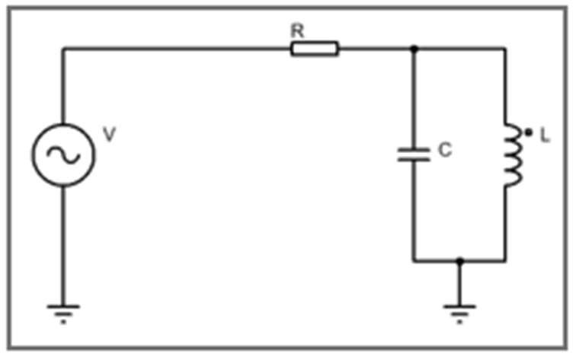
Figure 1 Circuit Given

The value of components varied from student to student as the values are derived from the student’s unique student number. The example in this report is for student number 1803514, resulting in the component values being as follows:

Resistor: 35Ω Inductor: 180mH Capacitor: 14uF
The results from the experiments and tasks will be shown and discussed later in the report.
The circuit shown in Figure 1 can be identified as a parallel RLC circuit, RLC circuits can be characterized as an electrical circuit containing impedances. These impedances can include total circuit impedance, capacitive reactance, inductive reactance, and source impedance [1]. These impedances can be calculated using the following formula as Bird [1] covers:

Circuit Impedance = Z=V/I Capacitive Reactance = XC=1/2πfc Inductive Reactance = XL=2πfL

Capacitors and inductors are both linear devices like resistors where the increase of the output waveform is directly proportional to the initial input waveform. The linearity property of having these components in a circuit does have significant consequence
as stated by Horowitz and Hill “The output if a linear circuit driven by a sinewave at the same frequency, is itself a sinewave at the same frequency, with changed amplitude and phase angle” [2]. Capacitors and inductors have the same feature of which the current and voltage are 90 degrees out of phase, meaning that both are reactive and have reactance [2]. Shown in figure 2 [2] is the graph of capacitor voltage and current against time, and as represented in the graph they do not start at the same point meaning that they are out of phase. Because of the 90 degree phase difference for each the capacitor and inductor, when capacitive reactance is equal to inductive reactance (XC=XL) resonance occurs. Floyd [3] explains at resonance the two currents are equal in magnitude, and because each component current is 90 degrees out of phase it results in the currents cancelling one another and the current and that frequency the current is zero and circuit impedance is infinitely large. To calculate the resonant frequency, we can use the formula [3]:

Resonant frequency = fr=1/(2π√LC)

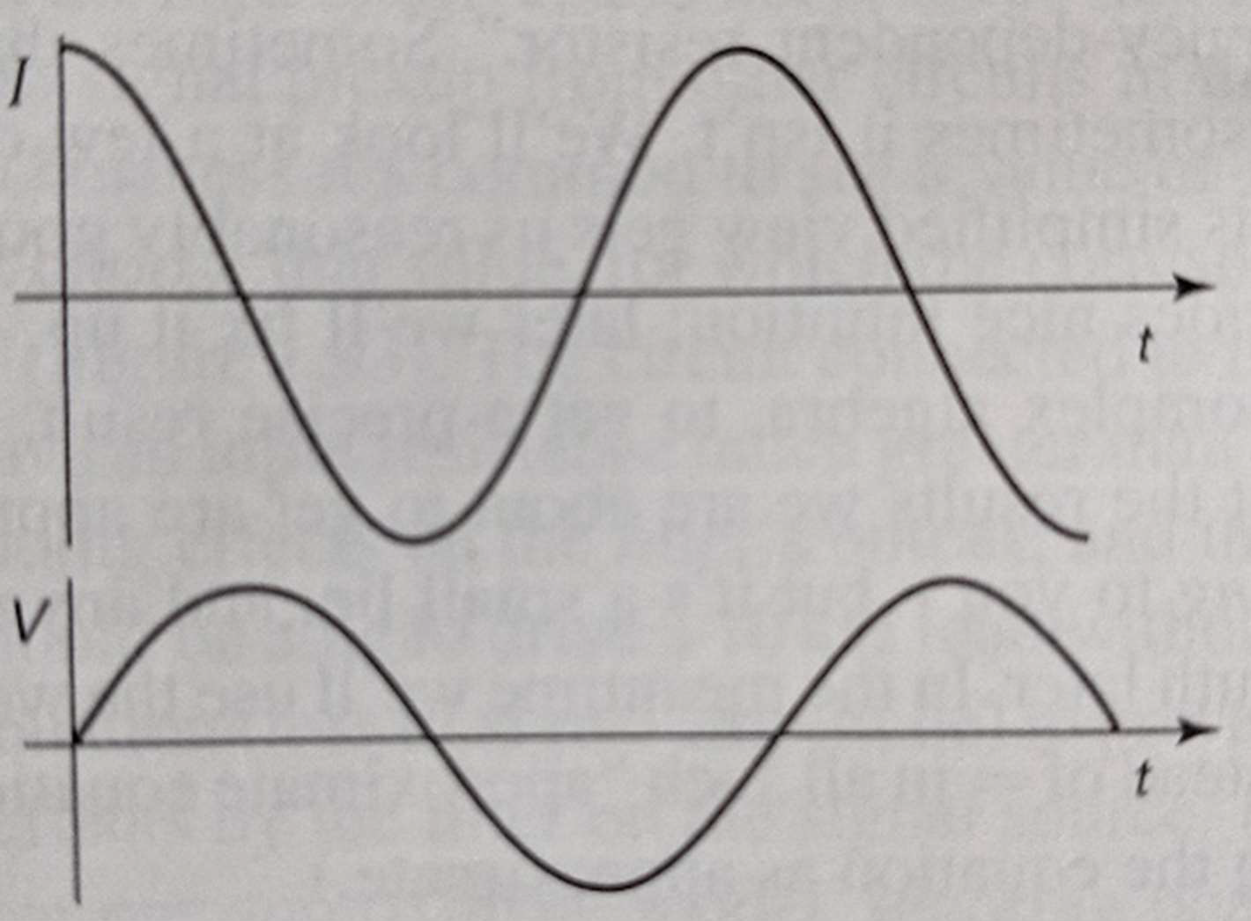

Figure 2 Capacitor Voltage and Current Graphs

An important method of circuit analysis and design as explained by Nilsson and Riedel is maximum power transfer [4] Circuits optimized for maximum efficiency, systems that are designed to generate and transmit electrical power. These systems require maximum efficiency to ensure minimal power is lost during distribution and transmission. Circuits optimized for maximum power, examples circuits for maximum power are communication and instrumental circuits when transferring the maximum amount of power is necessary [4]. Maximum power transfer theorem is a valuable tool in circuit design, to achieve maximum power to be delivered to a load, the load impedance must be equal to the source resistance [5].

Ideal voltage sources are active elements (battery/generator etc.) supplying a constant voltage through two terminals, not dependent on the value of current flowing have a fixed voltage value [6]. Practical voltage sources are sources that are encountered in the real world. Load current influences terminal voltage where load current increase will result in supply voltage dropping. The reason for this is that all practical voltage sources all have some sort of internal resistance. This internal resistance will act as a voltage drop. The impact of this voltage drop is the terminal voltage will never equal the nominal voltage od the source [6] [7].

To help find maximum power transferred to the load it is often that Thevenin’s theorem is used to find the Thevenin equivalent of the resistive network before the load resistance [4]. The condition needed for maximum power transferred to a resistive load is Rl=Rth [4]. Floyd states “Thevenin’s theorem provides a method for simplifying a circuit to a equivalent form”

[8]. For any resistive two terminal circuit a Thevenin equivalent can be given for the voltage source (Vth) and the resistance (Rth). This method can be applied to any circuit if there is a resistive two terminal present [8]. This is shown in figure 3
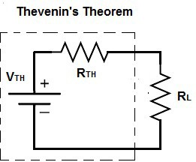
Figure 3 Thevenin's Theorem

In AC circuits there are several types of power that need to be accounted for when conducting any type of analysis or design. The first type of power is active power or alternatively known as real or true power, is the power that is distributed to the load in the circuit and is dissipated within the circuit. Active power is often denoted as P and is measured as watts(W). The formulas used to calculate active power differs for DC and AC circuits. As there is no reactance within DC sources it can be analyzed as a resistive circuit and P=VI is used [9]. Because of the reactive elements within AC circuits causing phase angle differences the formula used in AC is P=VIcosθ [9]. Reactive power or useless power, is denoted as Q and measured as VAr(Volts-Amperes Reactive) is present in AC circuits when there is a phase angle caused by the reactive elements. Var is the measurement of electricity that is stored within the magnetic and electric fields produced by inductors and capacitors respectively [10]. Nilsson & Riedel state “Inductors demand(absorb) magnetizing VArs and capacitors furnish(deliver) magnetizing VArs” [11]. It is beneficial to have for a circuit as it allows the power factor to be improved resulting in a more efficient system. Although excess amounts in reactive power can result in a drop in power, unwanted voltage drops and excess heat [10]. Apparent power measured in VA(Volt-Ampere) and denoted as S. This is the mix of both reactive and active power in the circuit. The formula for finding the different types of power is shown below:

Active Power =𝑃 = 𝐼²𝑅 Reactive Power =𝑄 = 𝐼²𝑋 Apparent Power =𝑆 = 𝐼²𝑍 [12]

Power factor is a crucial element of an AC circuit and has been summarized by Floyd “The relationship between volt-amperes and active power” [13]. Power factor is used to find out the amount of active power that is delivered to load. Power factor values can range from 0-1, 0 indicates that there is a large amount of reactive power within the circuit with current being 90 degrees out of phase. A value of 1 indicates that current is perfectly in phase and the circuit is purely resistive. The formula for finding power factor is:

𝑃𝐹 = 𝑐𝑜𝑠𝜃 [14].

Power factor mainly affects industrial companies for their demand to power large equipment. Companies power rates will depend on the efficiency of the circuits. Power factor correction is the process of raising the power factor as close to 1 as possible to ensure maximum efficiency. Most loads used are inductive (containing coils) so circuit current will be out of phase. To compensate the inductive element and increase the amount of active power a capacitor can be added in parallel to the load to help reduce the phase angle, because of the opposite effects of capacitors and inductors [15] [16].

Method

Task 1
- To be able to plot the graph for the first fast, the circuit current(I) must be found. Firstly, the circuit impedance(Z) is needed in order to calculate the current, for the impedance formula reactance must also be found. All formulas used and the Excel equivalent are shown below with example cells used. Some equations have also been converted to complex form to aid in calculation and plotting the graphs (Not that the $ used in cell references means that only that one cell is used for the equation):
𝑋𝐿 = 2𝜋𝑓𝐿 Excel: 2*pi()*C10x$G$3 (=COMPLEX(0.001,(2*PI()*C10*$G$3),"j"))

𝑋𝐶 = 1 2rrfC
Excel: =1/(2*PI()*C10*$G$4) (=COMPLEX(0,(-1/(2*PI()*C10*$G$4)),"j"))

Because of the use of imaginary numbers, the complex conjugate was needed to be found the total resistance of the inductor and capacitor and the formula used is:
=IMDIV(IMPRODUCT(G10,H10),IMSUM(G10,H10))
To convert this to a real number the excel function of IMREAL(K10) was used, this simply converts the complex number into a real number. Once the impedance of the LC part of the circuit that was simply added to the resistor in the circuit. Circuit current was found using the formula:
𝐼 = V Excel =IMDIV(COMPLEX($G$5,0,"j"),K10)
z
Again, the IMREAL function was used to convert to a real number.

- To find the voltage drop across the components the following formula were used:
𝑉 = 𝐼𝑅 Excel=M10*$G$2
- The following formula were used to find the active, reactive and apparent power: Active Power 𝑃 = 𝐼²𝑅 [12] Excel =IMREAL(IMPRODUCT(L10,L10,K10))
Reactive Power 𝑄 = 𝐼²𝑋 [12]Excel =IMAGINARY(IMPRODUCT(L10,L10,K10)) Apparent Power √𝑃² + 𝑄² [12] Excel =SQRT(S10^2+T10^2)
- Power factor was found by first calculating the phase angle using:

Phase angle $Cos^{-1}\frac{Q}{\begin{aligned}S \\ \end{aligned}}$

Excel =DEGREES(ACOS(T10/U10))

𝑃𝐹 = 𝐶𝑜𝑠𝜃 [14] Excel =COS(RADIANS(V10))

Task 2
To find resonance of the circuit the following formula was used:
1

𝑓𝑟 =

2𝜋√𝐿𝐶

Once resonance was found 25 was subtracted from the value and added to the value to produce the required graphs

Results

Task 1
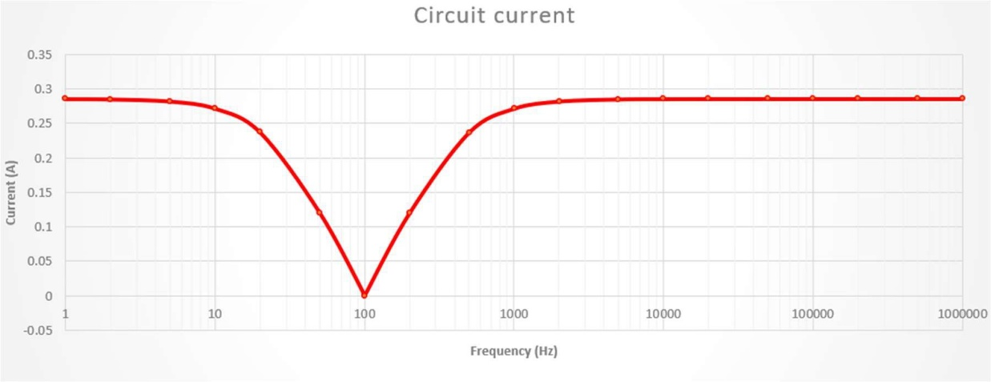
- Graph of circuit current against frequency
Figure 4 Circuit Current Graph

- Graph of voltage across resistive elements
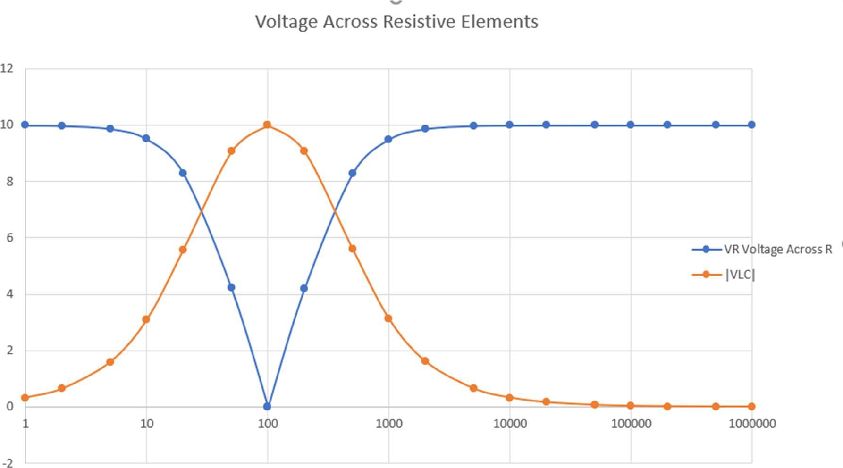
Figure 5 Graph of Voltage Across Resistive elements

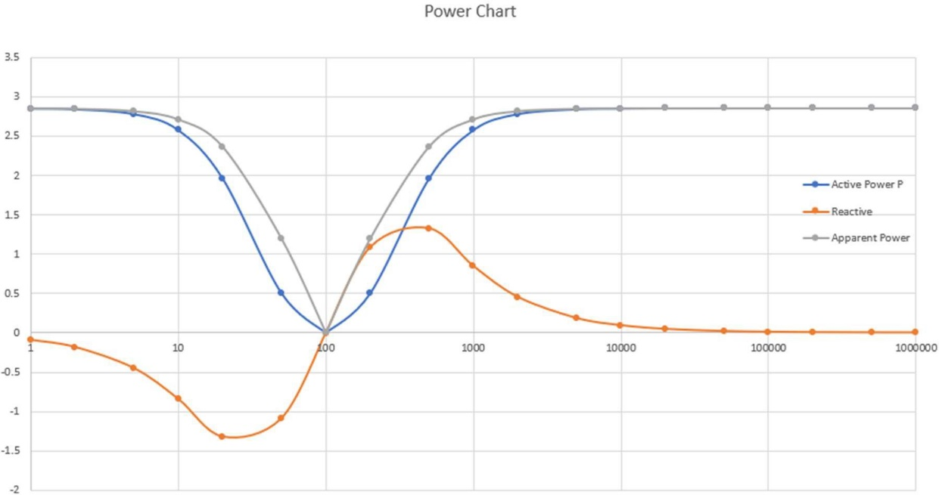
- Graph of Active, Reactive and Apparent power
Figure 6 Graph of Powers in The Circuit

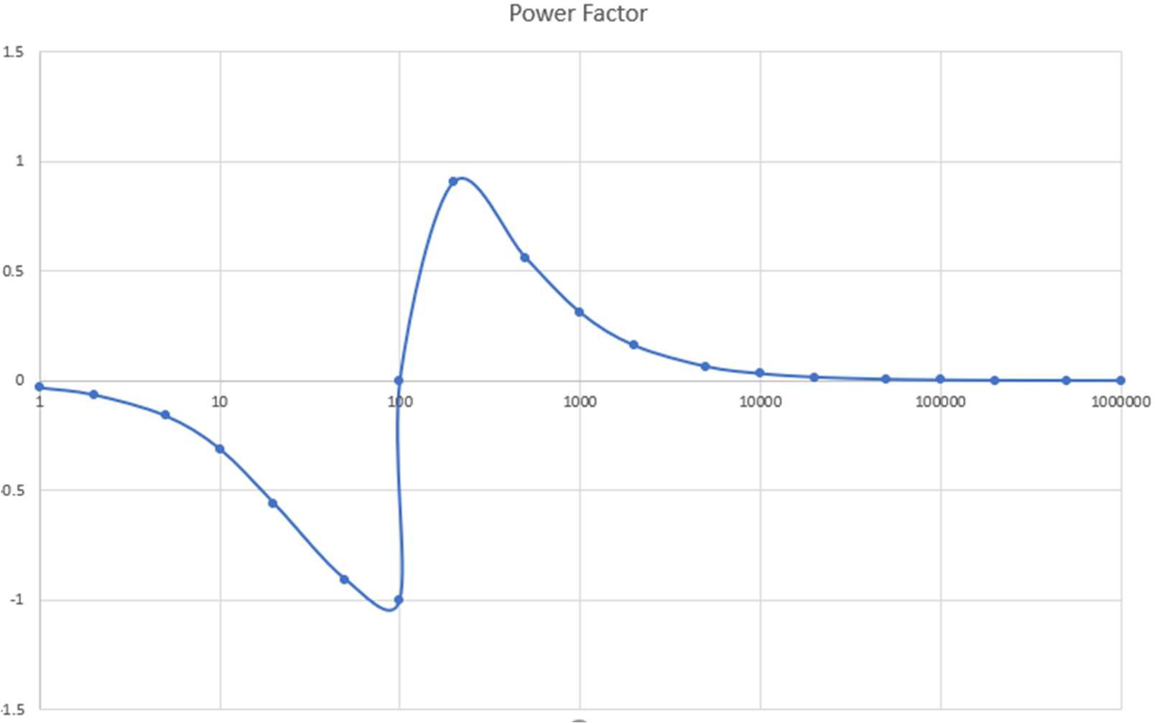
- Power Factor graph
Figure 7 Graph of Power Factor

Task 2

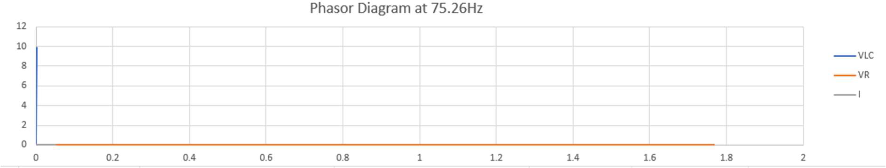
- Phasor diagram 25Hz below resonance
Figure 8 Phasor Diagram 25Hz Below Resonance

- Phasor Diagram at Resonance
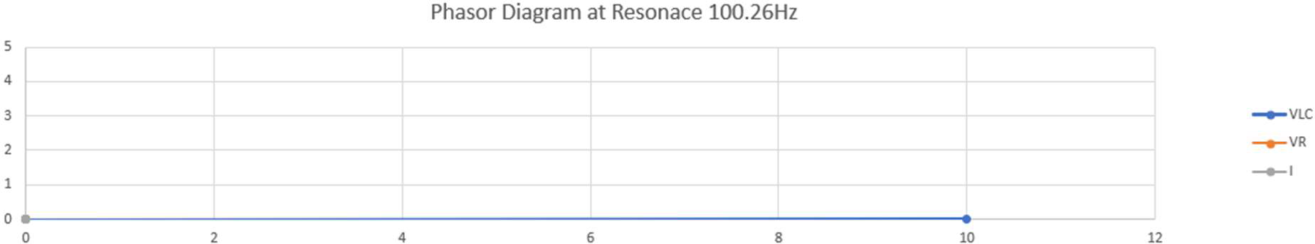
Figure 9 Phasor Diagram at Resonance
F

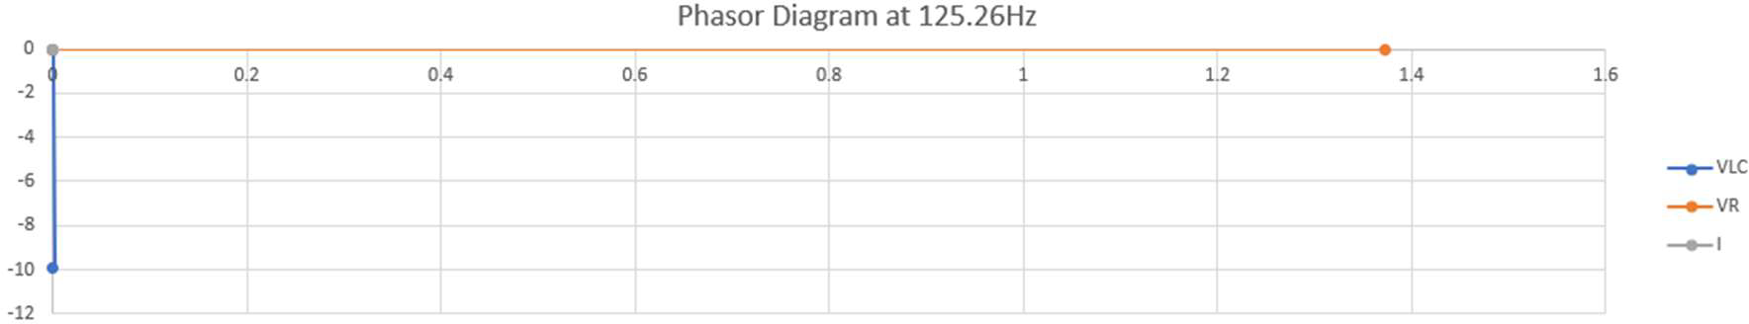
- Phasor Diagram at 25Hz above resonance
Figure 10 Phasor Diagram 25Hz Above Resonance

Discussion

From the results of the circuit current graph (figure 4), it is evident that the current is constant roughly at 0.25A. However, when the frequency starts to reach the circuits resonant frequency(100.258Hz) the circuit impedance is at is maximum resulting in very minimal current flowing the circuit at that given frequency, whilst voltage is at its highest. This is one of the features of having a parallel capacitor and inductor in a circuit.
On the graph (figure 5) of voltage across the resistive elements, at lower frequencies the voltage is mainly across the resistor and minimal across the capacitor and inductor. As frequency increases towards resonance the voltage across the resistor decreases and voltage across the LC network increases significantly. Again, at resonance all the voltage from the source is now across the LC network because of the features of these components ability to store and generate energy in electromagnetic fields. Once frequency passes the resonance the voltage started to shift back towards the resistor and away from the LC network.
Looking at the power graph (figure 6) it illustrates at lower frequencies active power is near its limit with apparent power, with reactive power being in the negative region. As frequency draws nearer resonance both apparent and active power start to decline and this time reactive power increasing towards a positive value. At resonance, all types of power are virtually zero, because of the properties of parallel inductors and capacitors at resonance circuit impedance is at a maximum, therefore not allowing current to flow resulting in power in the circuit at that moment. Increasing frequency above resonance results in a rise in all types of power with reactive power peaking at around 500Hz before starting to decline.
The power factor snows that the optimal frequency to achieve the most efficient circuit with the greatest power factor rating is around 200Hz with a power factor of 0.905
For question 5 of task one, Floyd explains that [17] The parallel inductor an capacitor are acting as a band pass filter or tank circuit, as shown in the graphs in the result section. Initial impedance is minimal at frequencies lower than the resonant frequency, meaning that voltage across these two components is also at a minimal. As frequency reaches closer to resonance, we can see that the volt drop is also increasing. At resonant frequency, the impedance between the capacitor and inductor is at its maximum and in an ideal circuit the reading would resemble an open circuit. Because of the maximum impedance voltage out is also at its maximum, resulting in current being completely opposite. Once frequency passes resonance the impedance and output voltage will again begin to decrease as current increases. This drop off in voltage either side of the resonant frequency gives this the bandpass property, in ideal circuits the point of the graph or the Q would be sharp. However, in circuits in the real world the point is not as prominent and adding a load across the filter will also reduce the Q value and increase the frequency width that is allowed through [17].

Conclusion

The tasks have shown how single phase RLC circuits are affected in their performance and efficiency with various frequencies. It has illustrated how important it is to have the most efficiency as possible to reduce the amount of wasted energy in the circuit. It has also highlighted how important the concept of power factor and the various types of power can influence an AC circuit.

References

[1] | J. Bird, "Single Phase Parallel AC Circuits," in Electrical Circuit Theory, 6th ed., pp. 278-293.
[2] | W. H. Paul Horowitz, "Frequency Analysis of Reactive Circuits," in The Art of Electronics, 3rd ed., pp. 40-41.
[3] | T. L. Floyd, "Rarallel Resonance," in Electric Circuits Fundamentals, 6th ed., pp. 617-629.
[4] | S. A. R. James W Nilsson, "Maximum Power Transfer," in Electric Circuits, 11th ed., pp. 154-155.
[5] | B. Dull, "Understanding the Maximum Power," 10 April 2018. [Online]. Available: https://info.triadmagnetics.com/blog/maximum-power-theorem . [Accessed Decemeber 2020].
[6] | "Voltage Sources," [Online]. Available: https://www.electronics-tutorials.ws/dccircuits/voltage-source.html. [Accessed December 2020].
[7] | S. Mosey, Maximum Power Transfer.
[8] | T. L. Floyd, "Thevenin's Theorem," in Electric Circuit Fundamentals, 6th ed., pp. 255-262.
[9] | "Active, Reactive, Apparent and Complex Power," [Online]. Available: https://www.electricaltechnology.org/2013/07/active-reactive-apparent-and-complex.html. [Accessed December 2020].
[10] | "Reactive Power," [Online]. Available: https://www.electronics-tutorials.ws/accircuits/reactive-power.html. [Accessed December 2020].
[11] | S. A. R. James W Nilsson, "Sinusoidal Steady State Power Calculations," in Electric Circuits, 11th ed., pp. 404-410.
[12] | "True, Reactive and Apparent Power," [Online]. Available: https://www.allaboutcircuits.com/textbook/alternating-current/chpt-11/true-reactive-and-apparent-power/. [Accessed December 2020].
[13] | T. L. Floyd, "RC Circuits," in Electric Circuits Fundamentals, 6th ed.
[14] | T. L. Floyd, "Power RL Circuits," in Electric Circuits Fundamentals, 6th ed., pp. 566-567.
[15] | S. Mosey, Power Factor Correction.
[16] | "Power Factor," [Online]. Available: https://www.electronics-tutorials.ws/accircuits/power-factor-correction.html . [Accessed December 2020].
[17] | T. L. Floyd, "Parallel Resonant Filters," in Electric Circuits Fundamentals, 6th ed.

