Reflective writing essay

Violeta Ilieva Kadieva 2030487

Module Code: BMSW4001

Lecturer: Joanna Walsh

Executive summary
In this report I will describe several topics that we have been introduced in class. For me, those topics will be: Time management; Public speaking and giving presentations; Academic writing and Paraphrasing. I will use the Gibbs reflection model to introduce these topics. I will also reflect on my experience during studying in this module and the presentation that I introduced in week nine of the classes.

Table of content

Introduction……………………………………………………………………………………………4
Time management……………………………………………………………………………………6
Paraphrasing………………………………………………………………………………………….7
Academic Writing……………………………………………………………………………………..7
Public speaking and giving presentations………………………………………………………….8
Conclusion…………………………………………………………………………………………….9
References…………………………………………………………………………………………..10

Introduction

During the studying for this module, we have been introduced a lot of different topics in class, that I did find to be very interesting and useful in my further studies and work life as well. I found it especially interesting when we had lectures about time management, I have learned that good time management is when time is correctly divided amongst various tasks. I learned that if I do that right I will end up with doing my tasks the smarter way, instead of putting more effort than needed, and also to do more in less time, even when I seemingly do not have enough time and the pressure is high (Mindtools, 2022). Particularly good for me was the lecture about paraphrasing. In simple words paraphrasing is when I have to present others opinions and knowledge in my own words, by doing that I can demonstrate my understanding of the subject and also shows my ability to transfer this information (University of South Australia, 2022). Another of the lectures that I found to be of great importance was academic writing, I have learned that academic writing is to give information in a straightforward, purposeful, compact way. Most of all, all the academic writings must stand behind evidence. The aim of the academic writing is to assist the understanding of the reader (University of Leeds, 2022). The lecture about public speaking and giving presentations was very important for me. By definition public speaking and giving presentations is speaking and presenting live, in front of an audience. This can comprise a large amount of various topics. The intention of public speaker is usually to educate, influence or just entertain the listeners (Envantotuts, 2022). During the course of this module, I have also learned about the different reflection models, the one that I found to be the easiest to use in my studies is the Gibbs reflection cycle. This model is a great way to work as a consequence of experience. Gibbs originally favoured the use of the model in recurring situations only, but with the time it became clear that the model works well in single occurring situations as well (The university of Edinburgh, 2022).
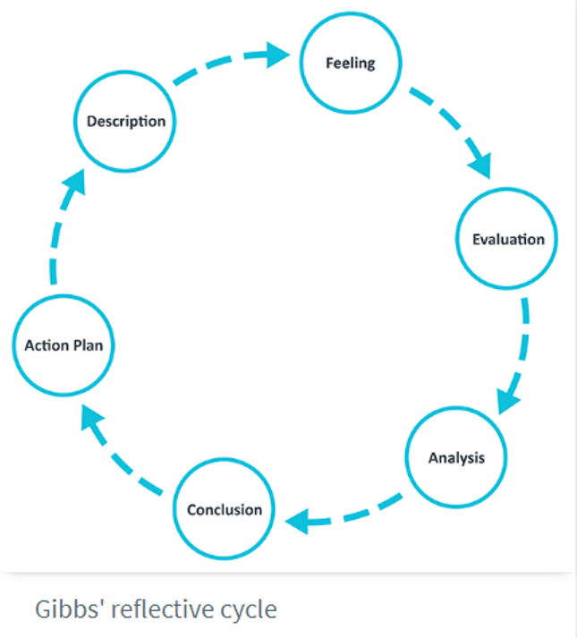
The cycle usually starts with a description of the situation, after that I have to describe my feelings about this situation. Then I go to evaluation of what happened, and I will do the analysis of the situation. I will then draw a conclusion and will make an action plan of how to deal with the situation. For recurring situations, I will go around the cycle repeatedly, while if it a single occurrence I will go around the cycle only once.

Time management

Before the start of this course, I was thinking I have a good time management. When the course started I found myself in situation where I did not have enough time for everything. Usually, I am not very tidy up person, particularly when comes to time, and while I always managed to do all of my tasks on time, when I added the school to my schedule it turn out that I need to do some changes so that I will be able to keep up with everything. That is when it became clear to me that I need more work on my time management. I have learned that time management is a crucial skill in modern life world. I learned that proper time management skill will give me the ability to do all my tasks for university, stay on my fulltime job and still have time for my other activities. I have learned how to put the Pareto rule in my life. Pareto rule is also called the 80-20 rule. Pareto explains that 80% of the tasks can be done with only 20% of the work. For me to implement this rule was easy because it was very easy to determine what the most important things in my life, which where my university studies and my job, from there on I have added time I needed for rest and sleep. It was then easy for me to tidy up my schedule and I found out that if I follow simple rules and at the begging a schedule for a whole day, I will have proper time to do my studies, to continue with my work and even have some time for other activities. I needed to give up some of the things I did before, for example I had to reduce to a minimum television time, but I still had time for reding that is more important for me. Because of this module I ended up more time organised and cutting up some toxic behaviours. Better time management skill will be of great use in my life, both in professional and personal aspect. The improved time management skill that I developed during this course will help me, because better time management means reduced stress, in both work and personal life, better work-life balance, more time freedom, means setting and achieving my biggest goals. Effective time management will help me improving my productivity and better focus on my goals. It will also help me with no procrastinating things anymore, it will improve my energy levels and will help me eliminate distractions. I am very glad that I did learned the time management skill(Lucemiconsulting, 2022).

Paraphrasing

When I first started this course I did know a very little about paraphrasing. I had a very vague idea of what paraphrasing is and I have been very anxious about that skill. I found it very difficult, because in general I am not a very creative person, I do well with math and other strict rules subjects and when we first had the lecture about paraphrasing I was very concerned about how will I do that. Later, when I reflected on the lecture and what we have learned about paraphrasing I figured out that it is not so hard to be done, but still requires some special skill. I have learned how to properly paraphrase. There is a few ways of paraphrasing that I have learned about, one of them being to reorder the sentence that I need to paraphrase while the knowledge is still there. Another way of paraphrasing that I find easy to use is, while I keep the original knowledge that a piece content, I will use the thesaurus to find different options to replace certain words in a sentence, I will also change the order of the words in a sentence. While doing all of these changes and trying to present the information I will make sure to not change the original information that a piece of information contents. Learning how to properly paraphrase will be of great use for me during my studies, the ability to paraphrase will show that I understand the information presented in class. It will show my lecturer I do fully understand the core ideas of a specific context (Writeneed, 2018). I am very glad that I had the chance to learn that skill.

Academic writing

As mentioned before, I am not highly creative person, so when I first heard about academic writing I was truly scared. I have been writing essays at school before and I did not present very well. But later, during the lectures I understood that actually academic writing have nothing in common with anything I have did before. First of all, writing an academic essay or paper must be supported by evidence, meaning I did not have to worry about imagining something or make something up, that made me feel a bit calmer. Also, academic writing must be written in very clear way, straight to the point, in formal language and without any unnecessary words. Academic writing skill will be of great use for me during my education, because when I am able to write in academic style, I can show my lecturers that I did understood the material they have introduced to me, and I can do my assignments without any problems. I do appreciate the academic writing skill and I feel confident that I am able to practice it correctly.

Public speaking and giving presentations

I have always been anxious about speaking in front of other people. I found it especially hard to give presentations or speaking in front of my teachers, managers or other people that will have to give feedback or grade on how I did with my presentation. During week nine of the studies, we had to present a PowerPoint presentation about future career development. From several years ago I know what is my dream career, so choosing a subject was not hard for me. I did my tiles about the presentation very early and I have practiced a lot on how will I speak, what I will talk about and how I will describe every aspect of my presentation. Although I was ready early and had a lot of time to practice as little time I have left, my anxiety grew stronger. I have learned a lot about public speaking skill meanwhile, I do now know that the proper public speaking skill will be of use for me not only while I do my studies but even in my career development. In the modern business world, it is expected everyone to be able to give presentations on tasks that they have been given, as well as present a new task to a team for example. I have learned that public speaking is very important for me as a student, because through this skill I will develop some others. For example, when I have to give presentation about something, I will have to think about the topic, I will have look it up from many different angles. That way I will also develop my critical thinking skill. Furthermore, as a non-native English speaker through public speaking I will also fine-tune my verbal skills, my language will become better with time. And lastly but most importantly to me, the more I develop my public speaking skill the more I will overcome my fears. At the end I did my presentation and although I felt really nervous, my hands was shaking and sweating, I believe I did well in my presentation and can gladly say that that little by little I overcome my fears, because of the public speaking skill I now possess.

Conclusion

In conclusion I have to say, during the lectures for this module, I have learned a lot of new skills. I believe that I have mastered some of them, specifically I am very proud of improving so much my time management skills. I will continue to use everything I learned in this course further in my life, both personal and professional. Another skill I think very well with is paraphrasing, I was very nervous about this skill, but because of the lectures and the things I learned about this skill I believe I did well with mastering it. On the other hand, despite that I have learned a lot, and now I have basis on these skills, I believe I have to further improve my academic writing and public speaking skills. For both skills I do know them in theory, I do know what is any of these skills, I know to do it, but when the time comes to actually doing it or put in practice these skills, I become anxious, nervous and end up with not good enough results. I will continue to improve myself in any way possible and I feel very grateful that I had chance to attend this course. I do believe that everything learned can be used in both my personal and professional development.

References

Envantotuts+, 2022, Available at: https://business.tutsplus.com/tutorials/what-is-public-speaking--cms-31255, (Accessed on 28/04/2022)
Lucemi Consulting, 2022, Available at: https://lucemiconsulting.co.uk/benefits-of-time-management/#:~:text=Effective%20time%20management%20increases%20your,achieve%20greater%20focus%20and%20prioritisation., (Accessed on 01/05/2022)
Mind tools, 2022, Available at: https://www.mindtools.com/pages/article/newHTE_00.htm, (Accessed on 28/04/2022)
The University of Edinburgh, 2022, Available at: https://www.ed.ac.uk/reflection/reflectors-toolkit/reflecting-on-experience/gibbs-reflective-cycle, (Accessed on 01/05/2022)
University of Leeds, 2022, Available at: https://library.leeds.ac.uk/info/14011/writing/106/academic_writing, (Accessed on 03/05/2022)
University of South Australia, 2022, Available at: https://lo.unisa.edu.au/mod/book/view.php?id=252144, (Accessed on 03/05/2022)
Writeneed, 2018, Available at: https://www.writeneed.com/post/2018/07/09/what-is-the-importance-of-rephrasing-or-paraphrasing, (Accessed on 08/04/2022)

