Data Handling and Business Intelligence - Component 2
Student Name: Florina Madalina Gugoi
Student ID:2111163
Lecturer Name: Abdallah Naser
Contents
Section 1 3
Introduction 3
(a) 3
(b) 8
(c) 11
Conclusion 17
Section 2 18
(a) Advantages and Disadvantages of Using Excel 18
Advantages of Excel 18
Disadvantages of Microsoft Excel 18
(b) The meaning and Importance of Data Mining Cycle 19
Importance of the Data Mining Cycle 19
References 21

Section 1

Introduction
The data of students have been provided, and based on their data, various types of analysis need to be performed. Mainly Micorosft Excel will be used for the analysis, but on part c, SPSS will also be used. It is expected that an effective analysis will be performed and the data will be presented throughout the section 1.

(a)

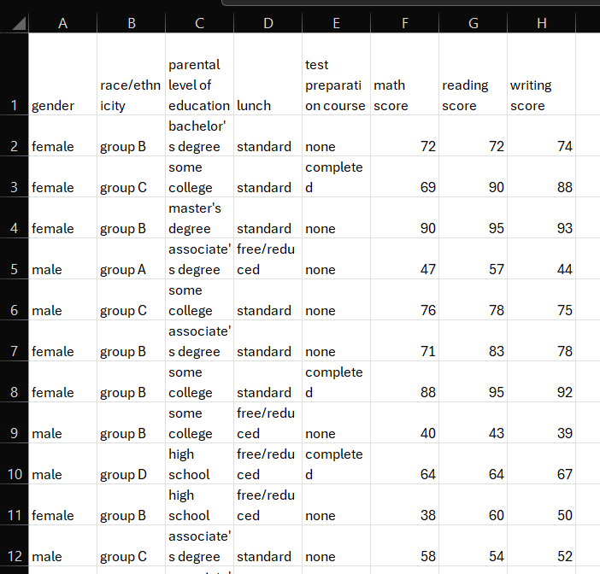
A dataset has been provided where various types of data related to the students are given. There are some data that are related to the gender of the students, race/ethnicity of the students, parental level of education, etc. are given. Based on these, it can be seen that there are male and female present among the students who have different ethnicity/race, and based on their race/ethnicity, they have been classified among various groups (Abbott, 2014). Also, the education level has been provided that shows that the students belong to various level of education. Also, test preparation on course, various marks that each of them have scored on various tests, etc. have been provided in the dataset.
The first three tasks that need to be found are mainly focused on the reading score of each student that has been provided in the Excel file. There are around 1000 data given, so 1000 students are present. Being able to find the data of each of these students manually can be difficult which is why the Microsoft Excel or SPPS software is needed here. The chosen software is Microsoft Excel as it provides the opportunity to write formula manually and showcase results of a specific type of data (Abbott, 2014). So, the process is simple and can be applied on various types of data.
First of all, the mean of the students’ reading score need to be found and for that, formula will be used that can directly provide the mean value of the data.
=AVERAGE($G$2:$G$1001)
This is the formula that has been written on the Microsoft Excel as the reading score of the students are available on the G column, and the values are present in cell 2 to cell 1001. The “$” sign has been used mainly because the same formula has been copied and pasted to find the later tasks as the same cells will be evaluated on those as well. The “$” sign refers that the value will remain unchanged even if the same formula is applied on the other cells. Using it, the value has been found to be 69.169, that means the mean of the reading score is 69.169 (Abbott, 2014).
The next task is to find the median of the reading score, so the same cells need to be used. The previously written formula has been copied to make the process simple, and instead of writing Average, the input this time was Median. So, the formula becomes:
=MEDIAN($G$2:$G$1001)
Here the same column, and values have been taken into account, and the instruction has been provided to find out median of the data. Using this formula, the median data has been obtained and the value has been found to be 70, that means the median of the reading score data of the students is 70 (Abbott, 2014).
The next task is to find the mode of the reading score, so the same data will be evaluated. Due to this reason, the same formula has been copied again so that the cell numbers and column gets included, and after that, the Mode was replaced in the formula.
=MODE($G$2:$G$1001)
This is the formula that has been used to find out the Mode present in the dataset, and by using the formula, it has been found that the mode of the reading score is 72. That means that most of the students obtained 72 in terms of their reading score.
The next task is to find out the standard deviation of the writing score, so a new formula is required where the cells will change as well. In terms of cells, the H column needs to be considered in this case as it contains the writing scores (Guerrero et al., 2019). Cell 2 to Cell 1001 contains the data, so these same cells need to be included in the formula as well.
=STDEV.S(H2:H1001)
The formula to find standard deviation in excel is the STDEV.S which has been used with all the cells number. Using this formula, the standard deviation of the writing score have been found to be 15.19566.
The next task is to find out the variance of the variables that are present in the dataset, and to be able to find that out, it is important to use the variance formula.
=VAR.S(F2:F1001)
This is the formula that has been written to be able to find the variance of F column which contains the math score data. Once the data has been included in the variance, it has been found that the Variance of the math score is 229.919 (Guerrero et al., 2019). Apart from this data, there are other variables that need to be evaluated to find out the variance of those data as well. To be able to find that out, the variance formula was simply copied on the right side columns with the help of CTRL+R which helped to write the same formula but changed the columns inside the formula (Salkind and Frey, 2021). The formula that was pasted on the next cells are:
=VAR.S(G2:G1001)
=VAR.S(H2:H1001)
Using these, the result for each of the variance have been obtained, and the obtained values are:
math score variance | reading score variance | writing score variance
229.919 | 213.1656 | 230.908
By comparing these numerical data, it can be easily found that the writing score has the larger variance among these three variables (Salkind and Frey, 2021).
Similarly, the standard deviation of the F column has been written as shown below:
=STDEV.S(F2:F1001)
The formula was selected and CTRL+R was applied which provided the data of each of the columns needed, and the formulas became:
=STDEV.S(G2:G1001)
=STDEV.S(H2:H1001)
math score standard deviation | reading score standard deviation | writing score standard deviation
15.16308 | 14.60019 | 15.19566
These are the standard deviation values that have been obtained using the formula provided in Excel, and by comparing these values, it can be identified that the writing score has the larger standard deviation (Guerrero et al., 2019).
The variance basically represents the spread of a dataset with comparison to the mean of the dataset. As the reading score has the lowest variance and the writing score has the highest, it can be interpreted as the dataset of reading score is less spread and the dataset of writing score is most spread from the mean of each variable’s dataset (Guerrero et al., 2019). The standard deviation basically represents the same, and is the squared root value of variance. Writing has the most variability so the highest variance as well as standard deviation (Guerrero et al., 2019). The math scores have a variance and standard deviation which is close to writing score but are slightly less spread. The reading scores have the lowest variance and standard deviation that means that these are least spread than the other two variables.

(b)
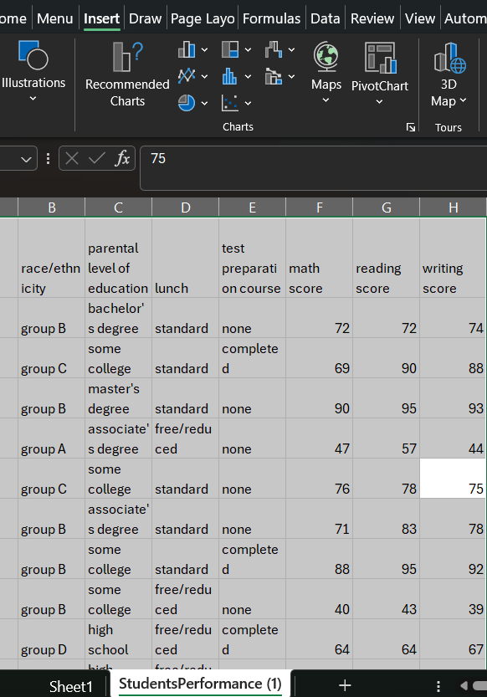
The data that has been provided is shown in the above picture and on the top ribbon under insert, an option can be found called Pivot Chart (Liengme, 2015). Using it, a new sheet has been created called Sheet1 where the Pivot Table has been created.
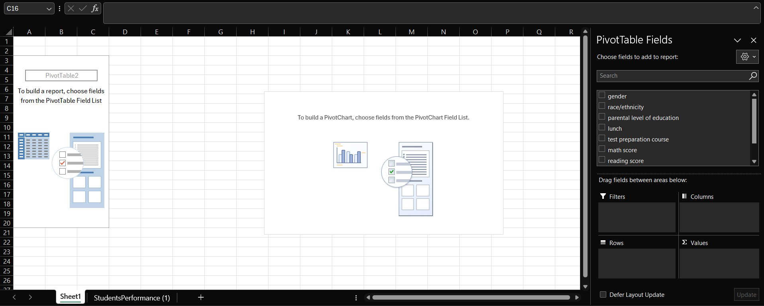
This is the Pivot Table that has been created on Microsoft Excel in the Sheet 1, and on the right hand side, various Pivot Fields can be found. Each of these fields can be used for various purposes to be able to find various types of data (Liengme, 2015). Each of the variables present in the main sheet is also available over here and these can be selected and utilized for the Pivot Table.
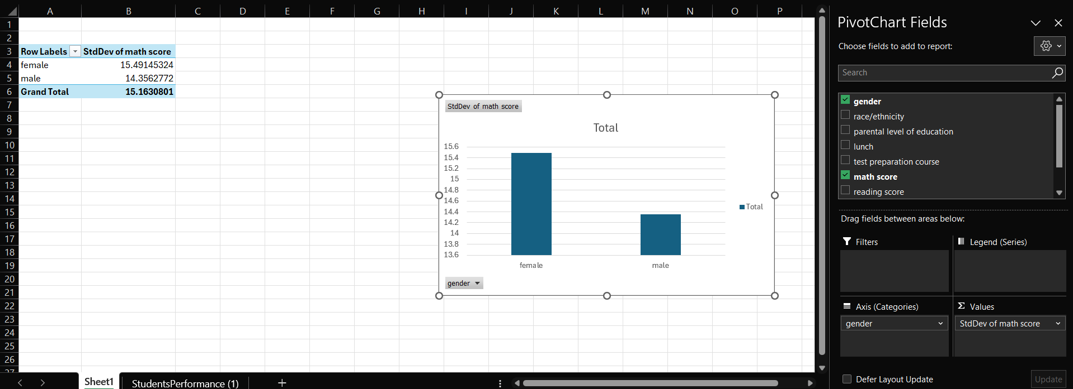
Here two variables have been taken into consideration, one is gender and the other one is math score. By ticking on the variable field, the variables have been placed on the Axis (categories) and Σ Values field, and from there, the Pivot Table has calculated the Standard Deviation of male and female which has been shown with the help of PivotChart as well (Liengme, 2015). Based on the chart, it can be clearly seen that male has a smaller deviation compared to the female respondents. This is how the Pivot Table is used in the Microsoft Excel and can be used to simply find and present various types of data.
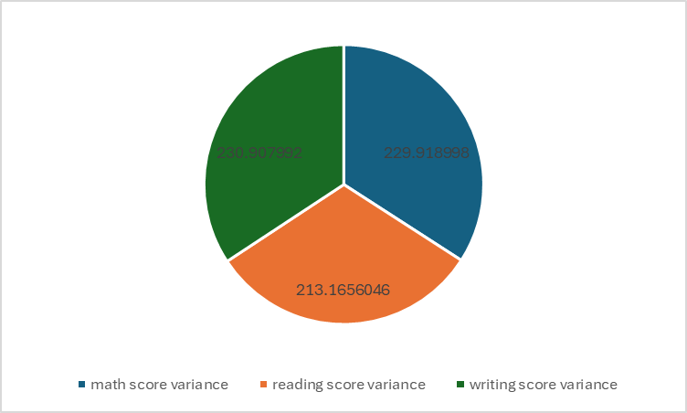
This pie chart has been created with the help of Excel, and the pie chart shows the variances of various variables. These type of charts can also be created using Microsoft Excel which can be helpful to be able to present the data effectively.

(c)
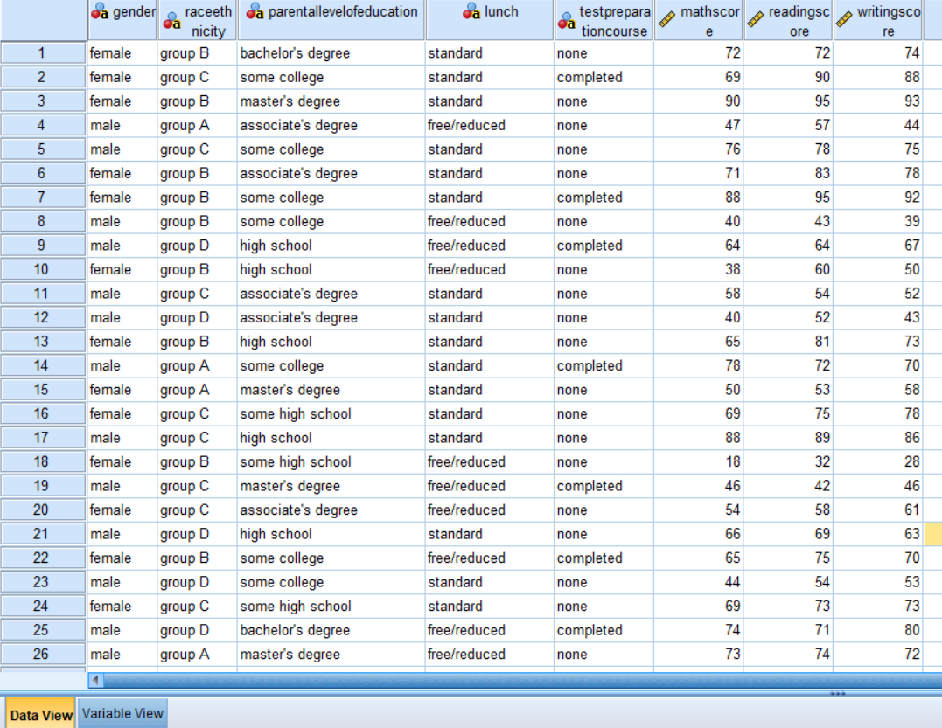
The CSV file has been opened in the SPSS so that the rest of the analysis can be performed on the SPSS file. All the data has been inputted, but another important criteria in case of SPSS is to check whether the variables have been identified effectively (Hinton et al., 2014).
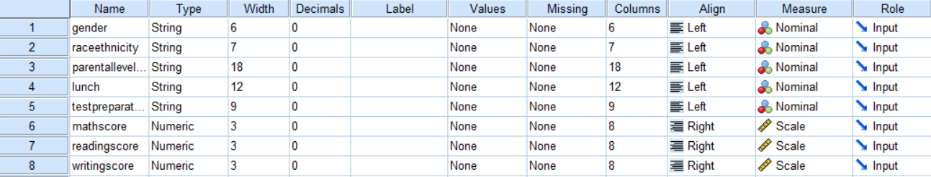
Here the variable view has been presented where it can be seen that the variables that contains text has been identified as string, and the variables that contain numeric values have been identified as numeric. Moreover, the measure column also plays an important role in case of the variables (Hinton et al., 2014). By checking the measure column, it can be identified that all the string variables have been identified as nominal, and all the numeric variables have been identified as scale. So, no other changes are required on the variables and these data can be used to perform the analysis.
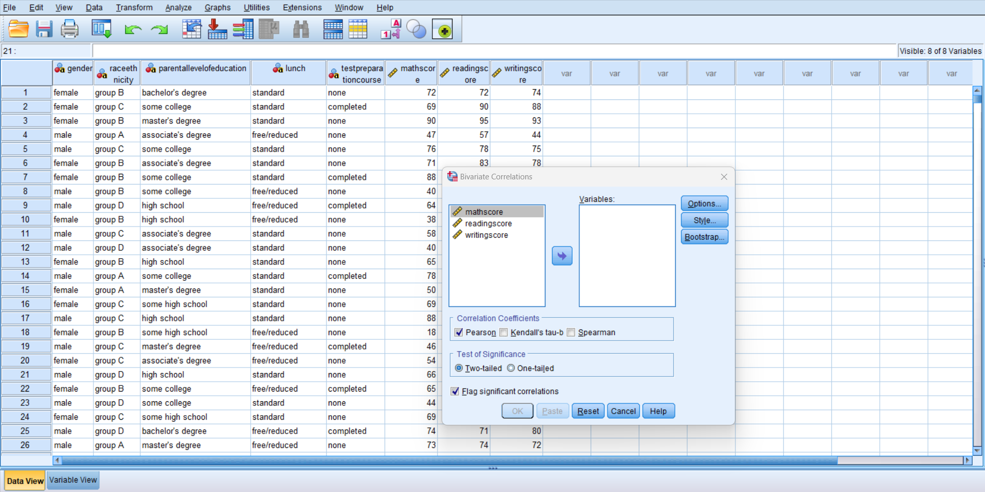
By clicking on the Analyse option on the ribbon, a set of options was obtained. From those options, the correlate option was chosen which provided with the option Bivariate (Hinton et al., 2014). By clicking on that option, the new tab has been found called Bivariate Corelations and from here the Pearson correlation can be effectively calculated.
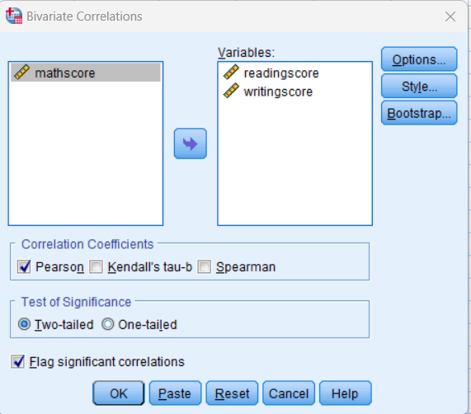
As reading and writing are the two variables that need to be analysed, so these two options have been chosen and sent on the right side using the right side arrow as shown in the centre of the tab (George and Mallery, 2019). As these two variables have been shifted on the right side, the result of the person correlation can be obtained by simply clicking OK.

Correlations
 |  | readingscore | writingscore
readingscore | Pearson Correlation | 1 | .955**
readingscore | Sig. (2-tailed) |  | .000
readingscore | N | 1000 | 1000
writingscore | Pearson Correlation | .955** | 1
writingscore | Sig. (2-tailed) | .000
writingscore | N | 1000 | 1000
**. Correlation is significant at the 0.01 level (2-tailed).
This is the result that has been obtained from the SPSS by running Pearson correlation where various types of data can be effectively found. Here, Pearson Correlation between the variables have been found to be .955 where as the Pearson correlation value can range from -1 to 1. The Pearson Correlation coefficient that have been obtained between the reading and writing scores is 0.955 that means this is a very positive correlation (George and Mallery, 2019). It means that there is a strong linear correlation between the variables, so the increase of writing score will also increase the reading score, and vice versa.
The significance value has been found to be 0.000 which basically is the p value and means that the correlation is statistically significant. Due to this value, it can be stated that the correlation did not occur by chance (George and Mallery, 2019). Also, there is a sample size (N) that has been found to be 1000 that means that the sample size is quite large, so the correlation coefficient that has been found is reliable.
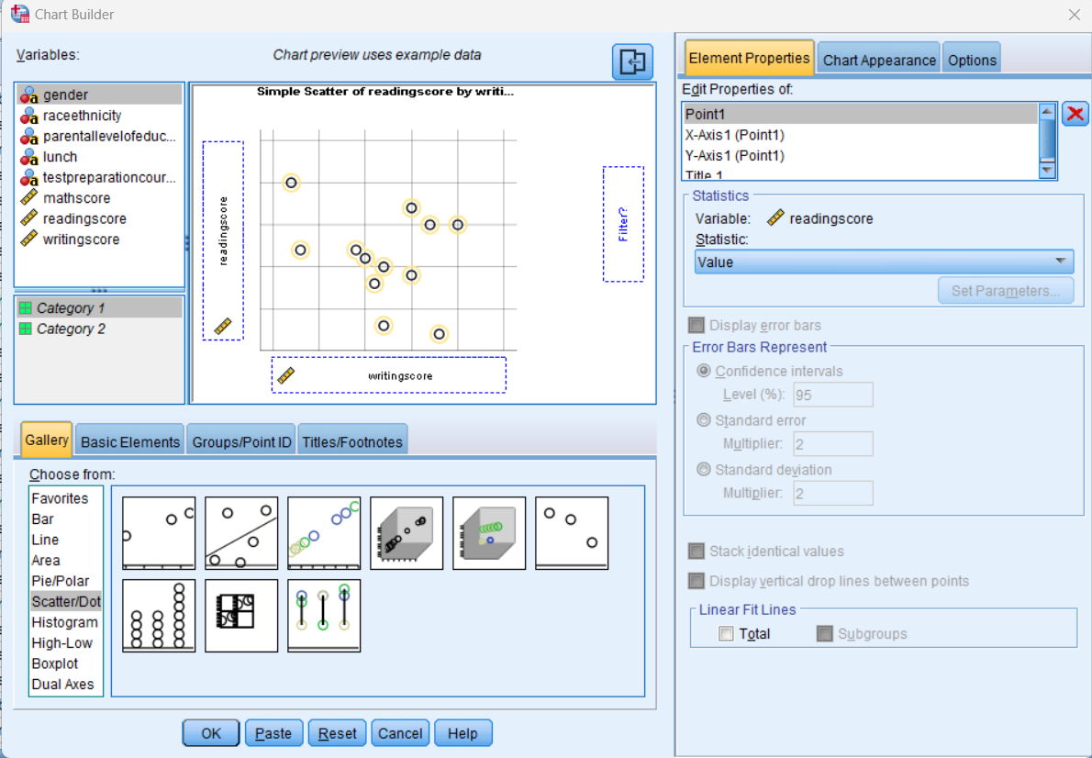
On the top ribbon of SPSS, the Graphs option is available which has been selected and provided with the above shown tab. Here all the variables have been shown on the top left corner, and there are various types of graphs option on the bottom left corner (Gerber and Finn, 2013).
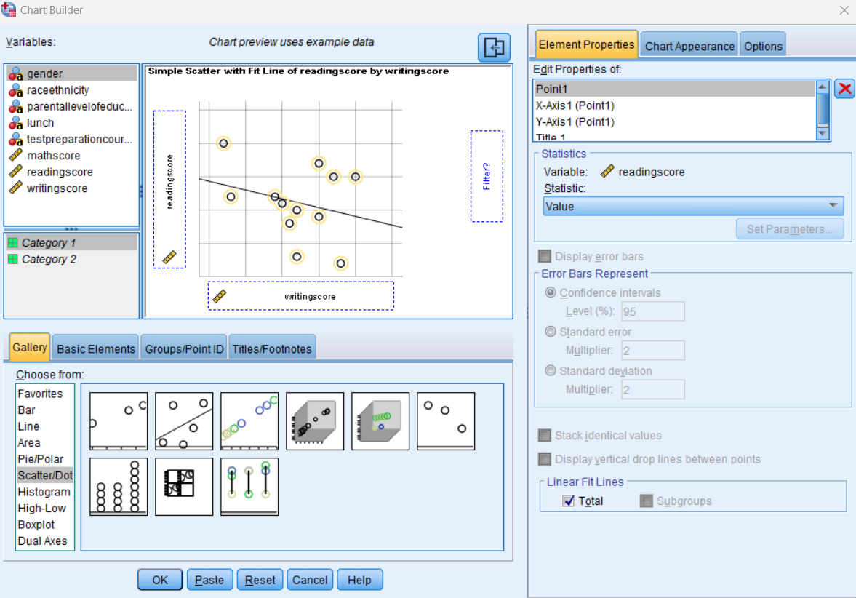
The Scatter/Dot option was chosen which provided the chart type on the right. From the chart options available, the second option was selected and the reading variable was dragged to place on the vertical axis, and writing score variable was placed on the horizontal axis. By doing so, the chart builder was ready to be able to create the chart, so OK was pressed (Gerber and Finn, 2013).
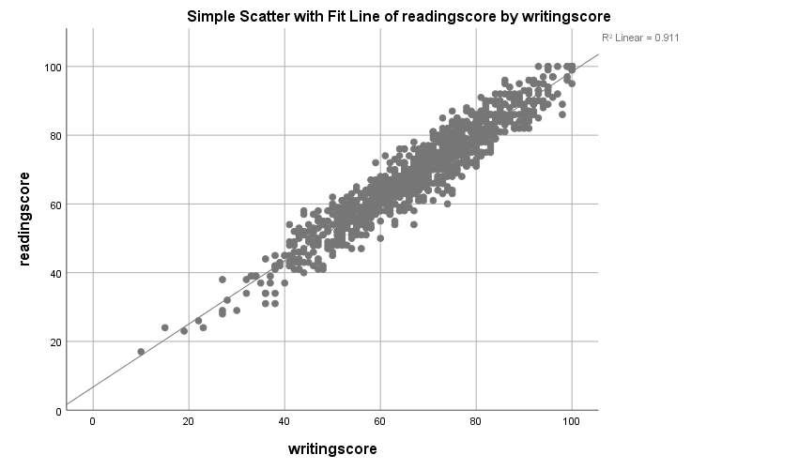

This is the chart that has been provided by SPSS where the scatter points can be viewed. The points are closely located around the fitted regression line which basically means that there is a strong positive linear relationship among the variables. So, if the reading score increases, the writing score will also increase and vice versa (Gerber and Finn, 2013). The Goodness of Fit (R²) value has been found to be 0.911 that means that 91.1% of the variance in the reading score can be explained by the variances in the writing score (Gerber and Finn, 2013). There are only a few outliers present but they do not impact the overall strong correlation.

Conclusion
The data of the students have been analysed, and various types of important data such as mean, median, mode, etc. have been identified using Microsoft Excel. Once done, the SPSS has also been used mainly for showing correlation and creating a scatterplot. These values can be helpful to be able to identify the necessary information of the students and take necessary steps to be able to make effective decision to improve the students.

Section 2

Advantages and Disadvantages of Using Excel

Advantages of Excel
Excel is a popular software mainly because it provides the opportunity to easily analyse as well as visualize the data. For this reason, the professionals are often found to be using Excel to perform various types of data analysis. For example, a sales manager can easily create an effective and accurate sales report with the help of Pivot Chart available on Microsoft Excel (Carlberg, 2013).
Microsoft Excel provides the opportunity to work with versatile data as it is capable of handling a wide range of tasks. Budgeting, scheduling, project management, etc. types of tasks can be easily performed with the help of Microsoft Excel.
The Microsoft Excel formula has been able to open up a huge opportunity for the users of Microsoft Excel. The Microsoft Excel formulas are easy to develop and can be applied on any types of tasks within a short period of time (Carlberg, 2013). A financial analyst may have to find the Net Preset value, Internal Rate of Return, etc. values, and each of these can be easily performed with the help of Microsoft Excel.
The compatibility of Microsoft Excel is well known as various types of data can be exported to input in Microsoft Excel (Carlberg, 2013). For example the accountants may have to use QuickBooks as well as Excel, so they can simply export the data from QuickBooks and import it in Microsoft Excel and start performing the analysis.

Disadvantages of Microsoft Excel
There are multitude of advantages of using Microsoft Excel but also there are a few disadvantages that needs to be considered. First of all, the scalability issue is present in Microsoft Excel as inputting millions of data can create issues for Excel (Salkind, 2015). The Excel may become slow or unresponsive if the dataset is too big, so these issues need to be considered.
The Excel required several tasks to be done manually which is an issue as various types of errors may come up. The manual data entry errors, incorrect formula references due to mistyping, and so on types of issues may come up.
The security concerns of a Microsoft Excel file is another major disadvantage as the sensitive financial information saved on a Microsoft Excel file may be easily accessed as most of the people do not work on securing the file (Salkind, 2015).

The meaning and Importance of Data Mining Cycle
The data mining cycle is a systematic process that is mainly performed with the aim to be able to identify various useful patterns that are present in a dataset (GeeksforGeeks, 2020). It becomes very important and helpful if the dataset is large. Data mining cycle includes various stages that mainly comes into play to ensure that the extraction of meaningful information that helps an organisation to make better decisions (GeeksforGeeks, 2020).
The first step of data mining cycle is collecting the raw data from various sources like point of sales or so on. The next stage is data processing where the data needs to be cleaned and prepared for the analysis part. Blanks, duplicates, etc. may be present within the data which need to be addressed effectively during this stage (GeeksforGeeks, 2020). The next stage is data mining where various algorithms are applied to be able to discover patterns, correlations, etc. that are present among the data. Later these data are evaluated and interpreted to determine the validity as well as the usefulness of these data (Gupta, 2014). Finally, the knowledge representation comes in where charts, graphs, etc. are presented in a dashboard.

Importance of the Data Mining Cycle
Data mining cycle often comes into play to be able to improve the decision making so that the decisions made within an organization become more effective (Gupta, 2014). A financial institution may use data mining cycle to be able to detect fraudulent transactions which will help them to decide whether they should enhance their security measures.
The data mining cycles helps to enhance the customer understanding and based on that, the organisations become capable of practicing personalized marketing (GeeksforGeeks, 2020). An e commerce company may use data mining to be able to recommend products to a customer based on their purchasing history which will be helpful for the organization to increase their sales.
Data mining can also be helpful to be able to improve the operational efficiency of an organisation as it can identify inefficiencies and optimize the process within an organisation (Gupta, 2014). A manufacturing company can use data mining to be able to predict equipment failure and based on that they can schedule preventive maintenance. It will be helpful for them to be able to reduce downtime and at the same time, reduce the maintenance cost.

References
Abbott, M.L., 2014. Understanding educational statistics using Microsoft Excel and SPSS. John Wiley & Sons.
Carlberg, C., 2013. Decision Analytics: Microsoft Excel. Que Publishing.
GeeksforGeeks (2020). Traditional Data Mining Life Cycle (Crisp Methodology). [online] GeeksforGeeks. Available at: https://www.geeksforgeeks.org/traditional-data-mining-life-cycle-crisp-methodology/ [Accessed 10 Jul. 2024].
George, D. and Mallery, P., 2019. IBM SPSS statistics 26 step by step: A simple guide and reference. Routledge.
Gerber, S.B. and Finn, K.V., 2013. Using SPSS for Windows: Data analysis and graphics. Springer.
Guerrero, H., Guerrero, R. and Rauscher, 2019. Excel data analysis. Springer International Publishing.
Gupta, G.K., 2014. Introduction to data mining with case studies. PHI Learning Pvt. Ltd..
Hinton, P.R., McMurray, I. and Brownlow, C., 2014. SPSS explained. Routledge.
Liengme, B., 2015. A guide to Microsoft Excel 2013 for scientists and engineers. Academic Press.
Salkind, N.J. and Frey, B.B., 2021. Statistics for people who (think they) hate statistics: Using Microsoft Excel. Sage publications.
Salkind, N.J., 2015. Excel statistics: A quick guide. SAGE publications.

‌

