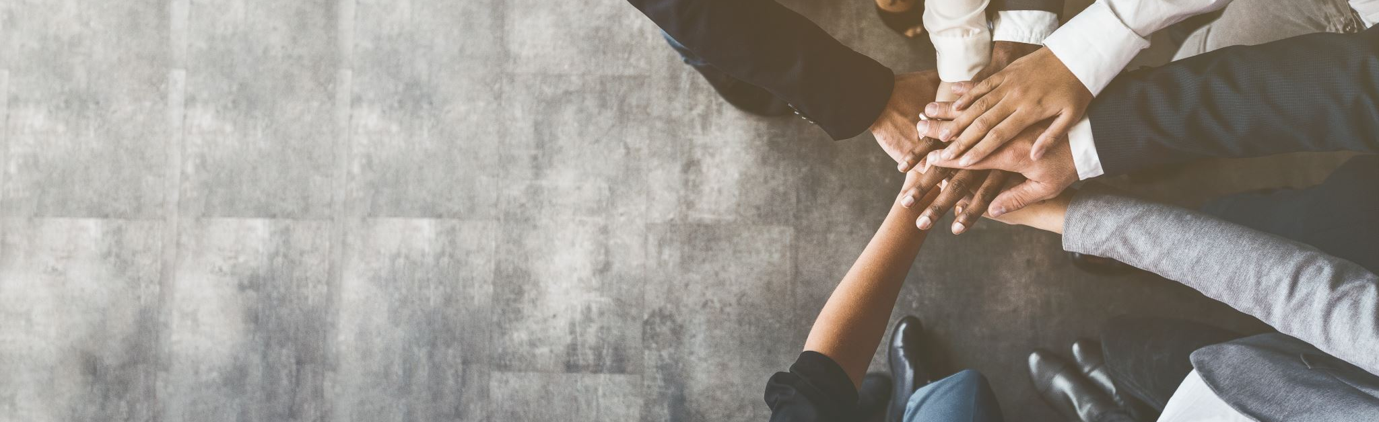

Effective Teamwork and Communication (BMSW4002_LON)

Models of Communication

Report

Yoanna Uzunova (2124312)
Lecturer: Balendran Kandasamy

^{Table of contents}

1. Introduction......................................................................................................................3
2.Models of Communication..............................................................................................3
2.1 Shannon and Weaver (1948) ….....................................................................3
2.2 Schramm (1954) …..........................................................................................4
2.3 Berlo (1960) …..................................................................................................5
3. Communication Skills.....................................................................................................6
3.1 Verbal Communication.....................................................................................7
3.2 Non-Verbal Communication............................................................................7
3.3 Listening.............................................................................................................8
3.3.1Active listening..........................................................................................8
3.3.2Empathetic listening.................................................................................8
4. The Advantages and Disadvantages of Modern Technology...........................................................................................................................9
5. Conclusion........................................................................................................................9
6. References.......................................................................................................................10
7. Appendix..........................................................................................................................11

1.Introduction.

The topic of this report is communication and forms of communication.
According to the Merriam-Webster dictionary, we can define communication as a process by which information is exchanged between individuals through a common system of symbols, signs, or behaviour.
From the lectures on teamwork and communication, we learned several models that explain the communication process. This report will discuss the Shannon-Weaver, Schramm, and Berlo models and also, will discuss types of communication, such as verbal, non-verbal, and listening.

2.Models of Communication.

2.1 Shannon and Weaver (1948).

The Shannon-Weaver model is famous for showing how signals can become confused and misunderstood between transmission and reception. In an article entitled "A Mathematical Theory of Communication" (1948), Shannon explained the purpose of his model:
"The basic problem of communication is the reproduction of a message sent from one point, exactly or approximately, to another point" (Shannon, 1948). The model was originally developed to improve technical communication. It was later widely applied in the field of human communication.
The components of Shannon and Weaver's communication model are Source of information, Transmitter, Channel, Noise, which can be external or internal, Decoder, Destination.

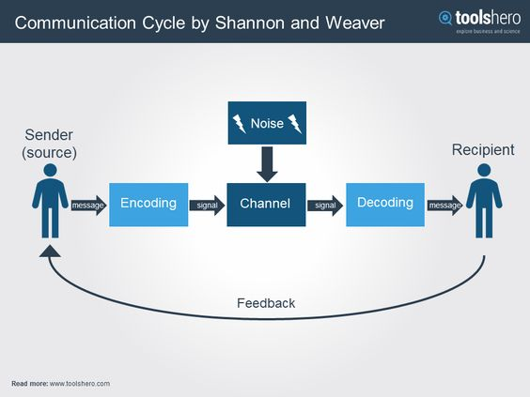

An example of the Shannon-Weaver communication model is the Maria and Pedro case we discussed in class. Pedro works at a construction site and Maria is his wife who calls him on the phone. Due to the noise of the construction site, Pedro is unable to understand what Maria is saying to him on the phone.
An example of internal noise is a case from my work. My colleague had to go to the office and get item labels. When she returned, she brought the wrong labels. She apologized and said she had a terrible headache and had not heard correctly which labels to take.

2.2 Schramm (1954).

Wilbur Schramm was a psychologist and noted communication theorist who in his book “The Process and Effects of Mass Communication” (1954) suggested that communication is a two-way process in which both sender and receiver take turns to send and receive a message and that communication always requires three elements–source, message, and destination. His model states that a message is encoded at the source and sent through some channels to its destination, where it is then received and decoded. Both parties in the communication process express opinions, give, and receive feedback.

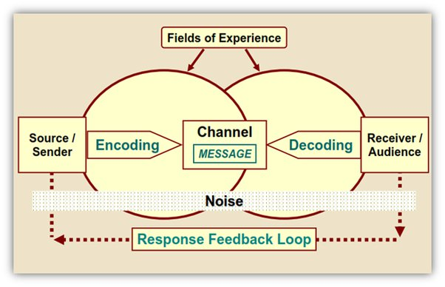

As an example of Schramm's model, I will refer to a case from my own experience. Before I moved to London I lived in Boston and every week on Monday I travelled by train to London to attend university lectures for the next two days. One Monday I had bought a ticket as usual. The trains were not running regularly, there were a lot of delays and timetable changes, so I only got as far as Peterborough. When I got off at Peterborough, I went to seek information from the station officials. The ticket agent I spoke to told me that the train to King's Cross would arrive in fifteen minutes. There were many people at the station. They were talking loudly, all wanting to know how they would continue their journey and after how long. The glass partition between me and the ticket clerk further hindered communication. In all the noise, I did not understand what she told me, so I asked her again which platform the train would arrive at.
I refer this case to Schramm's model because it covers his two-way model of communication. If there was no feedback between me and the clerk, I would have missed my train and had to wait longer.
According to Schramm's model, communication is two-way, which means that each of its participants is both a source and a receiver. Encoding and decoding are the two crucial steps for successful communication in Schramm's model.

2.3 Berlo (1960).

Berlo's model, developed in the 1960s, is based on Shannon and Weaver's model, but expands it with several new emphases. What is new is that two-way and equal relations between the source of information and the receiver of the message are required.
This model is also known as the SMCR: Source, Message, Channel, and Receiver.

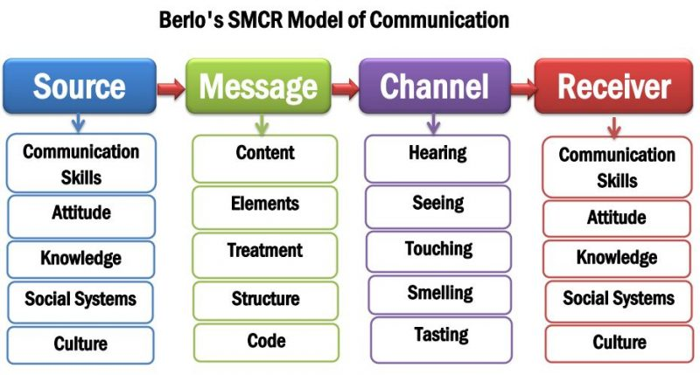

An example of Berlo's model is the case of the professor and the village people that we discussed in class. The professor lived near to a small village, but one evening his house caught on fire. He has run to the village for help, screaming that his house was on fire, but the village people paid no attention to him. No matter how much he asked them for help, they just kept on doing what they were doing. His house has burned down. When the professor went back to the village the next day, he asked the people why they did not help him last night. They replied that they would have helped him, but he did not tell them that his house was on fire.
Berlo's model says that for effective communication to take place, the sender and receiver must be on the same level. Here, the professor, who is used to expressing himself at an elevated level, was misunderstood by the people in the village. To be understood by them, he had to use simpler and understandable means of expression, let say, he needs to speak their language.
According to Berlo, the two parties in communication are as a pair and thus a "pairing" occurs. To put it another way, communication needs the conviction "I understand you" that is manifested by both sides simultaneously and to an equal degree. In this sense, pairing requires certain attitudes, knowledge, communication skills, etc.

3. Communication Skills.

As we said at the beginning, communication skills represent a set of abilities that an individual possesses and can develop throughout his life to be able to communicate more effectively and improve his social relationships. Most of the things we do in our daily lives require communication skills. From the communication patterns, we understood how the communication process takes place. However, people are different and one of the differences is the communication style they use. We can divide communication into verbal, non-verbal and listening.

3.1 Verbal Communication.

Verbal communication is the use of words to share information with other people and it can include both oral and written communication. For this process to take place, it is necessary for the participants to have, for example, a common language in which to speak or write. Examples of verbal communication can be classified according to their types: telephone conversation, conversation between people, voice memo, scream, whistle.
Examples of written verbal communication: digital or paper book, email, instant message, letter, document, ideograms, logos, hieroglyphs.
Also, verbal communication is divided into formal and informal. Formal communication follows principles and rules that are predefined. Such is, for example, the communication between a worker and his chief. Informal communication is used in communication between relatives, friends, neighbours.
Written communication can also be formal and informal. For example, when writing a formal letter, you should strictly follow the prescribed format for writing a formal letter. The use of colloquial words, abbreviations and jargon should be avoided when writing a formal letter. A formal letter should be accurate and to the point. The formal letter structure is not required when writing an informal letter to friends, family, or other close relatives.

3.2 Non-Verbal.

A significant part of our communication is non-verbal.
According to (Mehrabian, 1960) the percentage of non-verbal communication is four times greater than verbal communication and that most of what we communicate involves our actions and gestures and a much smaller part is conveyed in words. Categories of nonverbal communication include vocal expression; space, environment, and territory; appearance; body movement, gestures, and posture; facial and eye expressions; and touch (Quintanilla, K. M., 2020). We use many non-verbal signs in our daily life. Our nonverbal communication, which includes everything from handshakes to hairstyles, reflects who we are and influences how we interact with others.
An example of formal and informal communication is the case "A Day with the Chief" that we discussed in class. In the conversation with his chief, Mark ignores the accepted norms of formal communication. He loosens his tie, crosses his legs, and uses informal language, which is an example of poor verbal and non-verbal communication, as well.

3.3 Listening.

Communication starts with listening! (Nancy Foster, 2016).
To be effective participants in the communication process, even more so, to be able to decode the information we receive, we should manage the skill of listening. How can we develop our skills as a listener?
According to Business and professional communication: KEYS for workplace excellence (Quintanilla, K. M. 2020) we should always strive to limit and, whenever possible, isolate external noise that can interfere with our ability to listen to others, as well as their ability to listen to us. For example, while talking on the phone, we should not be distracted by checking emails on our computer.
There are few types of listening, but active listening and empathetic listening are the best to develop listening style and help to identify others’ styles.

3.3.1 Active listening:

Active listening is one of the most key characteristics of a communication culture. It is important for good interpersonal communication, an important criterion not only for personal but also for professional success. Many of our communication problems stem from not knowing how to listen. Active listening involves the overall verbal or non-verbal communication style. It is also observing the expression and overall appearance of the person in front of us. To listen actively, it is important to consider both the tone and the mood. The non-verbal elements of communication provide valuable clues to understanding what is being said. And our role as a good interlocutor consists in the ability to pay targeted attention to them.
Active listening aims to support the speaker, to make sure that they will be listened to carefully and that they will be understood and supported.

The basis of active listening is empathy.

3.3.2 Empathetic listening:

Empathy is not exactly a communication technique. It is an emotion-based approach to showing respect for the personality, needs, and individual desires of others. It is the ability to see the world through the other person's eyes by relating to the feelings they are experiencing.

An example of active listening is the "Max the Multitasker" case we discussed in class. Max is distracted and while talking to Tamara on the phone, he is doing other things. This prevents him from communicating effectively.

4. The advantages and disadvantages of modern technology.

A lot can be said and written about the benefits of modern technologies. They find a place and application in every field and are an invariable part of our life. Of course, this also includes communication technologies. There are many platforms like Facebook that we use daily to communicate with our family, friends, and colleagues. Technologies facilitate communication, but its use can also have unintended consequences. The biggest problem with introducing technology into our lives is that we become dependent on it. For example, if you have a calculator, you do not have to do mental calculations. You do not know something; you can google it. In many places, robotic technology is displacing people, thereby increasing unemployment. Another downside of our technological world is fraud. The most frequent problem is when we are shopping online.
Another frequent problem is bullying on social media. Anyone can be bullied or threatened on social media, but children are the most at-risk group.
Technology makes our lives easier, but on the other hand, it degrades the quality of our communication and changes the way we socialize and communicate.

5. Conclusion.

Based on the communication processes and their elements examined in the report, the following conclusions can be drawn. In general, communication represents an act of connection between a sender (sender, speaker) and a specific receiver (receiver, auditory). The communicator must have a clear thought, clear speech, and skills to support the interlocutor's interest. With the help of words, we convey content, and with the help of the non-verbal - form, context. Attitude is important; not just what you say, but how you say it. For communication to be effective, it is not enough just to be able to speak and write well. It is equally important to be an excellent listener. A conversation is not a conversation if one person is talking and the other is not listening. Communication skills are essential in everyday life, but there is only one way to become a good conversationalist and that is to be able to listen.

6. References.

- Bhasin, H. (2021) Schramm’s Model of Communication | Elements, Advantages & Limitations [Online], Available at: https://www.marketing91.com/schramms-model-of-communication/, (Accessed: 29. August.2022)
- British Library (n.d.) Albert Mehrabian [Online], Available at: https://www.bl.uk/people/albert-mehrabian, (Accessed: 03. September.2022)
- Business Jargons (2022), Verbal Communication [Online], Available at: https://businessjargons.com/verbal-communication.html, (Accessed: 27. August.2022)
- Cherry, K. (2022) Types of Nonverbal Communication [Online], Available at: https://www.verywellmind.com/types-of-nonverbal-communication-2795397#:~:text=Nonverbal%20communication%20types%20include%20facial,)%2C%20appearance%2C%20and%20artifacts., (Accessed: 03. September.2022)
- FOSTER, N. (2016) Good Communication Starts with Listening [Online], Available at: https://www.mediate.com/good-communication-starts-with-listening/, (Accessed: 28. August.2022)
- Griffith, B A. (2015) Working in teams: moving from high potential to high performance [Online], Available at: https://eu.alma.exlibrisgroup.com/leganto/readinglist/citation/6627918090002421?auth=SAML, (Accessed: 01. September.2022)
Online Learning Resources, Effective Team Working and Communication (BMSW4002_LON)
- Ismail N. (2017) Modern technology: advantages and disadvantages [Online], Available at: https://www.information-age.com/modern-technology-advantages-disadvantages-123465637/, (Accessed: 01. September.2022)
- JMC Study Hub (2019), Shannon and Weaver Model of Communication [Online], Available at: https://jmcstudyhub.com/shannon-and-weaver-model-of-communication-mass-communication/, (Accessed: 29. August.2022)
- Kobiruzzaman, M. M. (2021) SMCR Model of Communication- David Berlo’s SMCR Model of Communication [Online], Available at: https://newsmoor.com/smcr-model-of-communication-david-berlos-smcr-model-of-communication-example/, (Accessed: 29. August.2022)
- Merriam-Webster Dictionary (2022) “Communication.” [Online], Available at: https://www.merriam-webster.com/dictionary/communication, (Accessed: 10. December. 2022)
- Praxis (2019), Berlo [Online] Available at: https://www.praxisframework.org/en/library/berlo, (Accessed: 28. August.2022)
- Quintanilla, K. M. (2020), Business and professional communication: KEYS for workplace excellence [Online], Available at Moodle Online Learning Resources: https://eu.alma.exlibrisgroup.com/leganto/readinglist/lists/5956268810002421?auth=SAML, (Accessed: 01. September.2022)
- Toolshero (n.d.), Image [Online] Available at: https://www.pinterest.co.uk/pin/841399142859049805/, (Accessed: 29. August.2022)

7. Appendix.



