Word count- 4,272 words + 1,000 appendices= 5,272.

A critical evaluation and the identification of next teaching and learning steps focusing on a case study of an individual learner or a group of learners, based on an observed critical incident.

Introduction.

In the context of education and teaching, the definition of critical incidents has been adapting over time. Tripp (1993) states that “…a critical incident is an interpretation of the significance of an event” (p.8). Correspondingly, Richards and Farrell (2011) add that a critical incident triggers the thinking, learning and teaching of those monitoring the event. However, not all critical incidents are as dramatic as they may sound (Tripp, 2012; Joshi, 2018). This is confirmed by incidents tending to be ‘typical’ instead of ‘critical’ (Tripp, 2012:25). Gremler (2004) believes that critical incidents have made a powerful contribution to research in this field, be it negative or positive (McGarr and McCormack, 2016). There are various examples of critical incidents that take place in an educational setting. These include positive and negative behaviour (Barth et al., 2019), involvement of the staff in the school, communication, the use of questioning, the environment and the more able and talented children.

Critical incidents can be used in research in different reasons and used in different ways, however, it has had a significant impact on the way teacher’s use reflective practice in their learning and teaching. Ghaye (2010) describes reflective practice as ‘meaningful’ and ‘purposeful’ as it allows deeper thought and understanding of the critical incident to be made. Similarly, Moon (2006) highlights the importance of a more in-depth reflection as it brings to light alternative explanations, which allows the teacher to gather a holistic view on the critical incident. This coincides and agrees with what Mohammed (2016) found. This led to further considerations being made by teachers about future practice. In contrast, this can be challenged by Zeichner and Liston (2013) as they suggest reflective practice can be unrealistic as teachers have high demands with heavy workload including planning lessons and marking work as well as other pressures. Walshe and Driver (2019) also found that many teachers find it difficult to evaluate their own teaching practice. The downfall to this is that not all teachers will find reflecting on their own practice difficult, as some teacher’s may have less pressures than others (Dunne et al., 2007). Reflective practice can therefore be very beneficial in invoking teacher’s thinking and raising questions about their current practice and how this could be improved in order to provide the best education to children (McGarr and McCormack, 2016).

Furthermore, this essay will critically evaluate further areas of research linked to the critical incident observed. This will enable reflection and evaluation of next steps for personal and professional development to be considered.

Observation.

This essay will follow the BERA (2018) guidelines in order to ensure anonymity, respect and safety of the schools and the pupils participating within the critical incident observation. Due to the current situation with Coronavirus (COVID 19), it’s essential to consider that these are not normal circumstances (Welsh Government, 2020). Instead of using the actual name of the school involved, it will be referred to as School A. In the same instance, any pupil involved will be referred to as pupil A. School A is situated on the Gower Peninsula (West of Swansea) in a socially and economically affluent area. There are approximately 300 pupils between the ages of three to eleven in the school, with 11 mixed-aged classes. School A also includes two specialist teaching provisions for pupils who have language and speech difficulties. The foundation phase speech and language specialist teaching provision have no pupils there at this current time. In addition to this, there is a part-time nursery within the school. There are very few pupils with English as an Additional Language within school A. Additionally, there are no pupils that are first language Welsh speakers. The Estyn report reveals that around 5% of the pupils of School A are entitled to free school meals. This is notably lower than the ordinary figure for Wales which is 21%. Around 18% of the pupils within the school have additional learning needs which is slightly below the National average of 21% (Estyn, 2019).

Methodology.

A qualitative research method was appropriate for gathering data and information corresponding to the critical incident identified in school A. In an educational context, qualitative research allows the observer to explore individuals or groups of individuals experiences in their natural environment (Delamont, 2012). Having also considered a variety of qualitative research methods, observations methods were most appropriate for this task. An exploration into different observation methods was necessary in order to gain wider information on which method would be best to use in an educational setting. Observation methods can be structured or unstructured (Bell, 2005 cited in Hendry, Bell and Thomson, 2014; Hennink, Hutter and Bailey, 2020). Ciesielska, Boström and Öhlander (2018) emphasises the importance of observation methods used within research strategies such as case studies. Case studies are very common within qualitative research allowing an in-depth investigation to be carried out by the researcher (Stake, 2005). This includes identifying any relevant and significant incidents that occur within a classroom when researching critical incidents (Joshi, 2018). Ridder (2017) expands on this by stating that case studies can also develop different ideas and therefore create space for further research to be conducted. However, (Siggelkow, 2007) argues that case studies produce unreliable results with possible input of the researcher’s bias. A previous study has however, proven that bias can be avoided by ensuring thorough understanding of the term ‘bias’ and its possible effects on the results of a study are understood by all researchers (Pannucci and Wilkins, 2010).

Cohen (2000) outlines within a case study that there are two forms of observation methods that can be used: non-participant and participant observations. Participation observations allows the observer to obtain direct knowledge and experience of being within the educational setting being observed, this being the classroom (Musante and DeWalt, 2010; Gillham ,2000). Conversely, Kumar (2014) found that non-participant observations does not involve the participation of the observer in any classroom activities. In this instance, the observer must remain passive by simply listening and watching the classroom activities. There are many strengths and limitations of these two observation methods that needed to be considered before forming decisions on which observation method would be best to use. In relation to an educational setting, a strength of participant observations is that they are known to create vivid pictures of how the participants truly behave in their natural environment, a classroom. This strengthens the validity of the results gathered as the researcher can witness the incidents for themselves (Cohen, Manion and Morrison, 2013). Correspondingly, Atkinson and Coffey (2003) and Roberts-Holmes (2018) all reveal that researchers can gain further insight to the participants personal experiences and meanings which creates authentic data. Despite this, Cohen, Manion and Morrison (2013) noted a drawback of this could be that the researcher may allow themselves to become too involved within the activity and lose sight of the objectives. There is a possibility this could cause bias opinions, reducing the validity of the research.

According to Cooper, Lewis and Urquhart (2004) non-participant observations be a disadvantage as the researcher has a limited amount of time with the participants. In an educational setting, the observer may not collect enough evidence or enough critical incidents in order to complete the task and this may affect the results. Walliman (2011) argues that non-participant observations can be too informative, where a lot is happening at once. For example, in a classroom environment there may be a carrousel of tasks taking place and the researcher may not be able to observe and take not of everything. On the contrary, Green and Thorogood (2014) believes that it is easier to record information as the observer is not participating, allowing more time to record in-depth and informative results. The non-participant structured observation method was the most appropriate for identifying the critical incidents within the classroom environment in this task. Due to the current situation with COVID 19, an observation collecting relevant information with no involvement was needed. This is highlighted by Punch (2009) as they described it to be a “pure or direct” observational method.

Four Purposes.

Within this section, the critical incident used can be found in Appendix D. The critical incident took place in an afternoon session with a mixed ability class of year five and six. The lesson began in the sports hall, where the children were asked by the teacher to help set up the apparatus ready for the gymnastics lesson. This was done very promptly by all. As soon as the apparatus was set up, the class sat down on the floor waiting for the lesson to begin. However, there was one pupil (pupil A) who was very excited and decided to jump on a particular set of apparatus without permission. Pupil A performed some movements they had previously practiced in a lesson like this before (e.g. tuck jump). The teacher noticed this immediately and said “great work (pupil A’s name), I’d love to see you practice that routine after we’ve done the warmup! Would that be ok with you?”. Pupil A responded positively to this and agreed whilst sitting back down with the rest of their peers. The critical incident identified is the use of positive reinforcement given to the pupil by the teacher which redirected the pupil's undesirable behaviour at that current time.

The ‘Successful Futures’ aims to form successful and stimulating futures for children and young people in Wales which involves the application of the four purposes embedded throughout the curriculum. The four purposes allow children and young people to become ambitious, capable learners, enterprising, creative contributors, healthy, confident individuals and ethical, informed citizens (Welsh Government, 2015). As mentioned in the draft curriculum for Wales, the new curriculum sets out to enable children and young learners to immerse themselves within range of experiences including creativity, adaptability and digital skills. Therefore, it is desired that all learners guided and can realise these four purposes (Welsh Government, 2019).

The four purposes can play clear roles within education. More specifically, having considered all the four purposes with the critical incident, the one that seems most applicable for this critical incident is that learners should become healthy, confident individuals (Welsh Government, 2015). Teachers play a crucial role in developing the children’s confidence which includes supporting their emotional and mental well-being. Another important factor to consider is that overcoming challenges can be assisted by forming positive relationships between the teacher and pupil which is built upon mutual respect and trust.

Literature review.

In this literature review, there are two main areas that will be discussed further. As the critical incident involved a teacher redirecting undesirable behaviour at that current time, the use of positive verbal communication was significant, providing areas to further research. One area that the critical incident has led to further research is behaviourism. More specifically, the use of positive reinforcement implemented by a teacher to a pupil within a classroom environment. Secondly, well-being will be evaluated further, including the effects positive reinforcement has on primary aged children.

Positive Reinforcement.

The term ‘behaviourism’ branches back to the nineteenth century and has been developed further ever since. Its meaning is that learning occurs when there is a change in behaviour (Braddon-Mitchell, 2019). One of the main influencers of behaviourism was American psychologist Burrhus Frederic Skinner (B.F. Skinner). Skinner (1953) added value to research within the field of psychology. More specifically, Skinner (1953) carried out research looking at the concept of ‘reinforcement’ which included two types: positive and negative reinforcement. Skinner based a lot of his work and research on Thorndike’s (1898) Law of Effect, and that is where he developed his theory of Operant Conditioning (Leary, 2004; Skinner, 1953). Operant conditioning is where behaviour is learnt through rewards and punishments (Skinner, 1938). This was explored further when Skinner (1953) conducted an experiment by placing a hungry rat in what he called his ‘Skinner’ box, which included a lever on the side of the box which the rat pressed unknowingly. As the level dropped, food appeared in the container. This is where the rats learnt that going to the lever constantly, meant receiving food on repeat. This is also known as positive reinforcement.

Positive reinforcement is used widely throughout education in Wales (Estyn, 2020). There are many types of positive reinforcement that can be used by teachers including praise, which can be verbal or non-verbal. Conroy et al. (2009) states that teacher’s providing praise to children has a positive impact on their well-being. Expanding on this, praise from a teacher to a pupil also shows some sign of improved academic achievement (Conroy et al., 2009). For this to be effective, Mather and Goldstein (2001) notes that the teacher should be aware of the behaviour of the pupil and follow this up with the appropriate behaviour strategy. In addition to this, teachers play a significant role in understanding a pupil's basic needs mentioned in Maslow’s hierarchy of needs theory (Maslow and Lewis, 1987). Nevertheless, Skinner (1953) insists that this is a very complex matter, uncovering the relationship between the stimulus and response within human behaviour therefore extra considerations should be taken.

One possible issue of using positive reinforcement in the classroom was mentioned by Infantino and Little (2005). They suggest that different children prefer praise in different ways, for example, some prefer private praise, and some may enjoy praise being vocalised in front of their peers. They argued that some pupils felt embarrassed having received praise in front of the whole class, therefore some suggested the use of rewards or receiving private praise. This highlights the importance of the teacher getting to know the child properly for them to be able to provide positive reinforcement when applicable in the appropriate way (Welsh Government, 2012). Similarly, Mather and Goldstein (2001) believe that teachers usually focus on the misbehaviour of the child rather than dealing with it. This can have a negative impact on the child’s well-being and cause possible disruption to the class and hinder their learning. Martin Seligman’s PERMA model in 2011 has been recognised for its valuable opportunities allowing individuals to live a life of fulfilment and content. It focuses on five aspects such as relationships, engagement, achievement, meaning and positive relationships (Slavin et al., 2012; Seligman, 2018). This could be a potential strategy for teachers to implement in their classroom in order to increase level of self-esteem and well-being. However, Goodman et al. (2018) argues that subjective well-being which focuses on an individual's search for contentment and an enjoyable life is more effective than the suggestions of the PERMA model.

In summary, although many child theorists are thought to believe that praise has a positive impact on children’s well-being (Brummelman et al., 2014), much of the research above recognises the difficulties of teacher’s using praise appropriately for it to be effective.

Wellbeing.

The definition of well-being can be quite broad; however, it is typically known for individuals being content, healthy, comfortable and have a sense of purpose (Welsh Government, 2019). Within education, the Welsh Government (2020) provides insight into the involvement of health and well-being within the new curriculum. The draft curriculum for Wales 2022 strives to incorporate health and well-being within the new curriculum, including it within the six Areas of Learning Experience (AoLE). This also can create links involving and supporting the four purposes within the curriculum (Welsh Government, 2019).

Carol Dweck (1999) has played an influential role within education, as she introduced the two mindsets: a growth and fixed mindset. In an educational setting, growth mindset is where behaviour can be changed in time as children make more of an effort within the school environment and therefore, they are more likely to work harder, approve learning outcomes and increase levels of wellbeing (Good, Aronson and Inzlicht, 2003; Blackwell, Trzesniewski and Dweck, 2007; Yeager and Dweck., 2012). Additionally, individual’s with growth mindsets tend to use feedback given to them as a challenge and are eager to work and improve on this (Saunders, 2013). In another manner, fixed mindset is known to be quite harmful as individuals with a fixed mindset believe that they are either good or not good enough at something (Dweck, 2000). Saunders (2013) also adds that they can feel threatened by witnessing another pupil’s achievement and dismiss any form of feedback they are given.

Dweck’s theory of growth mindset has sparked opportunities for research to be made, especially within education. Research indicates that children having a growth mindset can have a positive effect on their well-being as they have a better and broader outlook within an educational setting (Zeng, Hou and Peng, 2016; Peterson, 2006). Zeng et al. (2019) supports this as they conducted a study on primary and secondary pupil’s in China exploring the role of growth and fixed mindsets of pupil’s and how it affected their well-being. Results portrayed a positive relationship between those having growth mindsets which increased their levels of well-being. Although this study is recent and up to date, there are issues regarding its generalisability. A limitation of this study is that as the research was conducted in China, this makes it less generalisable to the UK, but more specifically Wales due to the different education systems across the different countries. Therefore, it would be difficult to compare the results of this study. Blackwell, Trzesniewski and Dweck (2007) adds that children with a growth mindset are more likely to have increased motivation, which also has a positive impact on their well-being. King, McInerney and Watkins (2012) supports this as they found that children with fixed mindsets had negative emotions towards learning, for example feelings of anxiety, boredom or anger. Whereas, children with growth mindset had positive emotions and outlooks on learning.

Another aspect to consider is the role the teacher and schools play in supporting children’s well-being in school. Howard, Burton and Levermore (2019) makes an important point that teacher’s implementing positive reinforcement to deal with behaviour supports the pupil in not only understanding their behaviour but doing so in way that is does not cause any damage to their well-being. Seaton (2018) supports Howard, Burton and Levermore (2019) as she notes that pupil and teachers' beliefs are intertwined and those teachers who encourage the implementation of growth mindsets in pupils will get positive responses from the pupils. However, Stewart et al. (2012) argues that there are some dangers of praising a child’s intelligence, as it may cause that child to acquire a fixed mindset where they may not feel challenged enough. This can also add aspects of fear in the child where they may feel afraid to answer and make a mistake. This can be supported by evidence from the BBC News (2011) disclosing evidence that praising intelligence may harm children’s motivation, intelligence and well-being. However, this highlights the importance of using positive reinforcements in the correct and appropriate way for that individuals. On the other hand, Hewitt et al. (2019) showed results of around 71% of pupils feeling accepted by their teachers in comparison to 4% strongly disagreeing with this. This highlights the importance of positive relationships between teachers and pupils.

Rogers (2002) adds the important use of positive language used by a teacher such as praise and the use of direct choice which gives pupil’s a feeling of importance. This can be seen in the critical incident mentioned in Appendix D. additionally, evidence displays a higher level of self-esteem experienced by pupil’s who receive positive feedback (Mruk, 1999 cited in Zafar, Saleem and Mahmood, 2012). In addition to teachers, Kern et al. (2015) highlights the importance of school's contribution to supporting pupil's well-being as the school is where pupils spend most of their time. However, due to Covid19, children have been studying remotely from home for around 6 months. This has had an enormous impact on every aspect of their lives, including their well-being. The Welsh Government has provided additional mental health and well-being support for children who may have or still be experiencing difficulties. This is to ensure they don’t miss out on their education and are able to seek support for their wellbeing (Welsh Government, 2020).

Reflection and next steps.

With exciting changes across the curriculum coming into place in Wales (Welsh Government, 2020), reflection is playing a more significant role now more than ever within teaching and education. Using the Brookfield Reflective Model, the critical incident in this essay will be discussed further using the model (Brookfield 2000; Brookfield, 2017).

The critical incident identified can occur regularly within the classroom, however it is the behaviour management strategy the teacher decides to use that will decide on whether the behaviour reoccurs or comes to a halt. Within this critical incident, positive reinforcement was used and proved to have a positive impact on the pupil as their undesirable behaviour at that moment changed. The pupil was also asked if they were able to carry on with their gymnastic routine after the warmup. As an observer, the effect of this was positive as the teacher gave the pupil a chance to decide independently. Therefore, it is essential that teachers are fully supported and given. The observation was recorded in written form using Fletcher-Woods (2016) field notes model. This allowed me to write in detail about the environment, objectives, assessment and discuss the critical incidents further in detail. A benefit of this is that I was able to read back and reflect on the observation notes and look further into teaching strategies that I may like to implement in my teaching practice in the future. These field notes and observation forms can be found in the appendices.

The learner received positive reinforcement in front of the class by the teacher. Although this pupil had no issues with receiving praise in front of the entire class, alternative strategies should be considered by the teacher if this happens with another pupil as they may not feel as comfortable receiving public praise. One possible strategy is to provide private praise, so that the pupil is not exposed to any embarrassment or negative feelings. This could enhance their self-esteem, confidence and attitude towards their learning. Although the critical incident involved a teacher and one pupil, it is essential to consider the implications this may have had on the entire class, as it took place in front of them all. For instance, as the rest of the class were sitting down in the sports hall ready to begin, the teacher's attention was taken by the pupil who was practicing their routine on the apparatus. As the pupil was receiving positive reinforcement for practising the right routine, at the wrong time, the class sat down watched this. This could have sparked some confusion between the pupils sat down as they were not given praise for waiting patiently for the lesson to begin, but the other pupil was. To avoid this, the teacher could have praised the class also for waiting for the lesson to begin to avoid any upset or confusion.

The research mentioned in the literature review has provoked my thinking. For instance, in an educational setting, for teachers to create appropriate behaviour strategies, it is crucial that the teacher fully understands the pupa's behaviour and personal circumstances (Welsh Government, 2012). For example, Little and Infantino (2005) found that some children are more comfortable receiving private praise as it does not cause any harm to their emotional well-being. Whereas, some pupils found receiving praise in front of their peers embarrassing.

Having discussed the critical incident above, when this appears in my teaching practice my aim will be to ensure that using positive reinforcement is the suitable behaviour strategy to use for this situation. Before praising the pupil, I will assure that I am providing the praise in the appropriate way to suit the individual's needs, for example provide praise privately. Having discussed this, I will ensure all pupils are treated fairly whilst personalising the praise they are given in order to give them a sense of achievement that they celebrate in their own way. Reflecting on this will be essential, allowing myself to see what went well and what could be done to improve my practice even more.

Conclusion.

To conclude, reflective practice has shown to play a crucial role within teaching and education in Wales. The observation proved vital as it laid down a foundation for further research to be made. Due to the current circumstances with Covid19, extra measures were put in place to ensure the safety of the school, staff and pupils involved. Therefore, the observation method of non-participant structed observation was appropriate. Having considered the different areas of research the critical incident provided; the literature review helped gather worthwhile research that showed not all researchers and theories agreed with strategies such as positive reinforcement. Alternative strategies were identified. This then allowed reflections to be made and considered. Reflective practice also shares a clear link with the Professional Teaching Standards in Wales and the new curriculum. In particular, the aspects focused on are collaboration and innovation. Whilst identifying the critical incidents within the classroom, this not only provoked my learning and possible considerations for future teaching practice but allowed further research to be done on the variety of strategies that can be used to improve teaching practices in Wales in the future. From this essay, observations, research and reflections are playing a valuable part within teaching and learning. Further considerations and improvements can be made in future teaching practices which will support and coincide with the new curriculum in Wales.

References.

Atkinson, P. and Coffey, A. (2003) Revisiting the relationship between participant observation and interviewing. Postmodern interviewing, pp.109-122.

Barth, V.L., Piwowar, V., Kumschick, I.R., Ophardt, D. and Thiel, F. (2019) The impact of direct instruction in a problem-based learning setting. Effects of a video-based training program to foster preservice teachers’ professional vision of critical incidents in the classroom. International journal of educational research, 95, pp.1-12.

BBC NEWS. (2011). The words that could unlock your child. Available at: https://www.bbc.co.uk/news/magazine-13128701 [Accessed: 14th October 2020].

Blackwell, L., Trzesniewski, K. and Dweck, C. (2007) ‘Implicit theories of intelligence predict achievement across an adolescent transition: A longitudinal study and an intervention’, Child Development, 78(1), 246–63.

Braddon-Mitchell, D. (2019) Varieties of behaviourism. The Routledge Companion to Philosophy of Psychology.

British Educational Research Association (BERA) (2018) Ethical Guidelines for Educational Research (4th Edition) Available at:
https://www.bera.ac.uk/publication/ethical-guidelines-for-educational-research-2018 [Accessed: 3rd October 2020].

Brookfield, S.D. (2000) The concept of critically reflective practice. Handbook of adult and continuing education, pp.33-49.

Brookfield, S.D. (2017) Becoming a critically reflective teacher. John Wiley & Sons.

Brummelman, E., Thomaes, S., Overbeek, G., Orobio de Castro, B., Van Den Hout, M.A. and
Bushman, B.J. (2014) On feeding those hungry for praise: Person praise backfires in children with low self-esteem. Journal of Experimental Psychology: General, 143(1), p.9.

Ciesielska, M., Boström, K.W. and Öhlander, M. (2018) Observation methods. In Qualitative methodologies in organization studies, pp. 33-52. Palgrave Macmillan, Cham.

Cohen, L. (2000) Research Methods in Education and Introduction. (5th Edition). Boston: Allyn and Bacon.

Cohen, L., Manion, L. and Morrison, K. (2013) Research methods in education. Routledge.

Conroy, M. A., Sutherland, K. S., Snyder, A., Al-Hendawi, M., & Vo, A. (2009) Creating a positive classroom atmosphere: Teachers' use of effective praise and feedback. Beyond Behavior, 18-26.

Cooper, J., Lewis, R. and Urquhart, C. (2004) ‘Using participant or non-participant observation to explain information behaviour’, Information Research, 9(4), pp. 1-15.

Delamont, S. (2012) Handbook of qualitative research in education. Edward Elgar Publishing.

Dunne, M., Humphreys, S., Sebba, J., Dyson, A., Gallannaugh, F. and Muijs, D. (2007) Effective teaching and learning for pupils in low attaining groups.

Dweck, C. S. (1999). Self-theories: Their role in motivation, personality, and development. Psychology Press.

Dweck, C.S. (2000) Self-theories: Their role in motivation, personality, and development. Psychology press.

Estyn (2019) School A Report Available at:https://www.estyn.gov.wales/system/files/2020-08/Bishopston%2520Primary%2520School_0.pdf [Accessed at: 3rd October 2020].

Estyn. (2020). Establishing behaviour groups. Available at:
https://www.estyn.gov.wales/effective-practice/establishing-behaviour-groups
[Accessed: 14th October 2020].

Fletcher-Wood, H. (2016) Ticked Off: Checklists for teachers, students, school leaders. Crown House Publishing.

Ghaye, T. (2010) Teaching and learning through reflective practice: A practical guide for positive action. Routledge.

Gillham, B. (2000) Case Study Research Methods. London: Continuum.

Good, C., Aronson, J. and Inzlicht, M. (2003) ‘Improving adolescents’ standardized test performance: An intervention to reduce the effects of stereotype threat’, Journal of Applied Development Psychology, 24(6), 645–62.

Goodman, F.R., Disabato, D.J., Kashdan, T.B. and Kauffman, S.B. (2018) Measuring well-being: A comparison of subjective well-being and PERMA. The Journal of Positive Psychology, 13(4), pp.321-332.

Green, J. and Thorogood, N. (2014) Qualitative Methods for Health Research. 3rd ed. London: Sage

Gremler, D.D. (2004) The critical incident technique in service research. Journal of service research, 7(1), pp.65-89.

Hendry, G.D., Bell, A. and Thomson, K. (2014) Learning by observing a peer’s teaching situation. International Journal for Academic Development, 19(4), pp.318-329.

Hennink, M., Hutter, I. and Bailey, A. (2020) Qualitative Research Methods. 2nd ed. SAGE, pp.170.

Hewitt G., Anthony R., Moore G., Melendez-Torres G.J., Murphy S. (2019) Student Health and Wellbeing In Wales: Report of the 2017/18 Health Behaviour in School-aged Children Survey and School Health Research Network Student Health and Wellbeing Survey.

Howard, C., Burton, M. and Levermore, D. (2019) Children’s mental health and emotional well-being in primary schools. Learning Matters.

Infantino, J., & Little, E. (2005). Students' perceptions of classroom behaviour problems and the effectiveness of different disciplinary methods. Educational Psychology, 25, 491-508.

Joshi, K. (2018) Critical Incidents for Teachers’ Professional Development. Journal of NELTA Surkhet, 5, pp.82-88.

Kern, M.L., Waters, L.E., Adler, A. and White, M.A. (2015) A multidimensional approach to measuring well-being in students: Application of the PERMA framework. The journal of positive psychology, 10(3), pp.262-271.

King, R. B., McInerney, D. M., & Watkins, D. A. (2012). How you think about your intelligence determines how you feel in school: The role of theories of intelligence on academic emotions. Learning and Individual Differences, 22(6), 814–819.

Kumar, R. (2014) Research Methodology. London: SAGE.

Leary, D.E. (2004) On the Conceptual and Linguistic Activity of Psychologists: The Study of Behavior from the 1890s to the 1990s and beyond. Behavior and philosophy, 32(1), pp.13–35.

Maslow, A. and Lewis, K.J. (1987) Maslow's hierarchy of needs. Salenger Incorporated, 14, p.987.

Mather, N., & Goldstein, S. (2001) Learning disabilities and challenging behaviors: A guide to intervention and classroom management. Baltimore: Brookes Publishing.

McGarr, O. and McCormack, O. (2016) Counterfactual mutation of critical classroom incidents: implications for reflective practice in initial teacher education. European journal of teacher education, 39(1), pp.36-52.

Mohammed, R. (2016) Critical incident analysis: reflections of a teacher educator. Research in Teacher Education, 6(1), pp.25-29.

Moon, J.A. (2006) Learning journals: A handbook for reflective practice and professional development. Routledge.p.8

Musante, K. and DeWalt, B.R. (2010) Participant observation: A guide for fieldworkers. Rowman Altamira.

Pannucci, C. J., & Wilkins, E. G. (2010) Identifying and avoiding bias in research. Plastic and reconstructive surgery, 126(2), pp.619–625. doi: 10.1097/PRS.0b013e3181de24bc

Peterson, C. (2006) A primer in positive psychology. Oxford university press.

Punch, K.F. (2009) Introduction to Research Methods in Education. London: Sage
References

Richards, J.C. and Farrell, T.S. (2011) Practice teaching: A reflective approach. Cambridge University Press.

Ridder, H.G. (2017) The theory contribution of case study research designs. Business Research, 10(2), pp.281-305.

Roberts-Holmes, G. (2018). Doing your early years research project: A step-by-step guide. (4th edition). London: SAGE Publications Ltd.

Rogers B. (2002) Classroom Behaviour - A Practical guide to effective teaching, behaviour management and colleague support. Sage.

Saunders, S.A. (2013) The impact of a growth mindset intervention on the reading achievement of at-risk adolescent students. University of Virginia.

Seaton, F.S. (2018) Empowering teachers to implement a growth mindset. Educational psychology in practice, 34(1), pp.41-57.

Seligman, M., (2018) PERMA and the building blocks of well-being. The Journal of Positive Psychology, 13(4), pp.333-335.

Siggelkow, N. (2007) Persuasion with Case Studies. Academy of Management Journal, 50(1), pp.20-24.

Skinner, B. F. (1938). The behavior of organisms: An experimental analysis. New York: Appleton-Century.

Skinner, B. F. (1953). Science and human behavior. New York: Macmillan.

Slavin, S. J., Schindler, D., Chibnall, J. T., Fendell, G., & Shoss, M. (2012) PERMA: A model for institutional leadership and culture change. Response to the 2012 question of the year. Academic Medicine, 87(11), 1481. doi: 10.1097/ACM.0b013e31826c525a

Stake, R. E. (2005) Qualitative Case Studies. In N. K. Denzin & Y. S. Lincoln (Eds.), The Sage handbook of qualitative research, pp. 443–466. Sage Publications Ltd.

Stewart, N., Watson, J., Ramey, C., Grolnick, W., Frodi, A., Bridges, L. and Dweck, C. (2012) Mindset: The New Psychology of Success. Nursery World, 5(2), pp.72-82.

Tripp, D. (1993) Critical Incidents in teaching: developing professional judgement, Routledge.

Tripp, D. (2012). Critical incidents in teaching: Developing professional judgement. London: Routledge.

Walliman, N. (2011) Your Research Project: designing and planning your work. 3rd ed. London: Sage

Walshe, N. and Driver, P. (2019) Developing reflective trainee teacher practice with 360-degree video. Teaching and Teacher Education, 78, pp.97-105.

Welsh Government (2012) Practical approaches to behaviour management in the classroom. Available: https://gov.wales/sites/default/files/publications/2018-12/practical-approaches-to-behaviour-management-in-the-classroom-a-handbook-for-classroom-teachers-in-primary-schools.pdf [Accessed: 14th October 2020].

Welsh Government (2015) Successful Futures: Looking at the Curriculum and Assessment Arrangement in Wales. Available at: https://gov.wales/sites/default/files/publications/2018-03/succesful-futures-a-summary-of-professor-graham-donaldsons-report.pdf [Accessed: 5th October 2020].

Welsh Government (2019) A Guide to Curriculum for Wales 2022. Available at: https://s3-eu-west-1.amazonaws.com/hwb-live-storage/cd/b4/f8/7c/b7d34ffb968d9a09de4d460c/a-guide-to-curriculum-for-wales-2022.pdf [Accessed: 5th October 2020].

Welsh Government (2020). Guidance on learning in schools and settings from the autumn term. Available at: https://gov.wales/sites/default/files/publications/2020-07/guidance-learning-schools-settings-from-autumn-term.pdf [ Accessed: 10th October].

Welsh Government (2020). Introduction to Curriculum for Wales Guidance. Available at:
https://hwb.gov.wales/curriculum-for-wales/introduction/ [Accessed: 17th October 2020].

Yeager, D.S. and Dweck, C.S. (2012) Mindsets that promote resilience: When students believe that personal characteristics can be developed. Educational psychologist, 47(4), pp.302-314.

Zafar, N., Saleem, S., & Mahmood, Z. (2012). The Development of a Self-Esteem Scale for University Students. FWU Journal of Social Sciences, 6(1), 26B-37.

Zeichner, K.M. and Liston, D.P. (2013) Reflective teaching: An introduction. Routledge.

Zeng, G., Chen, X., Cheung, H.Y. and Peng, K. (2019) Teachers' growth mindset and work engagement in the Chinese educational context: Well-being and perseverance of effort as mediators. Frontiers in psychology, 10, p.839.

Zeng, G., Hou, H. and Peng, K. (2016) Effect of growth mindset on school engagement and psychological well-being of Chinese primary and middle school students: The mediating role of resilience. Frontiers in psychology, 7, p.1873.

List of appendices.

Appendix A- Observation sheet and critical incident identification record 1. 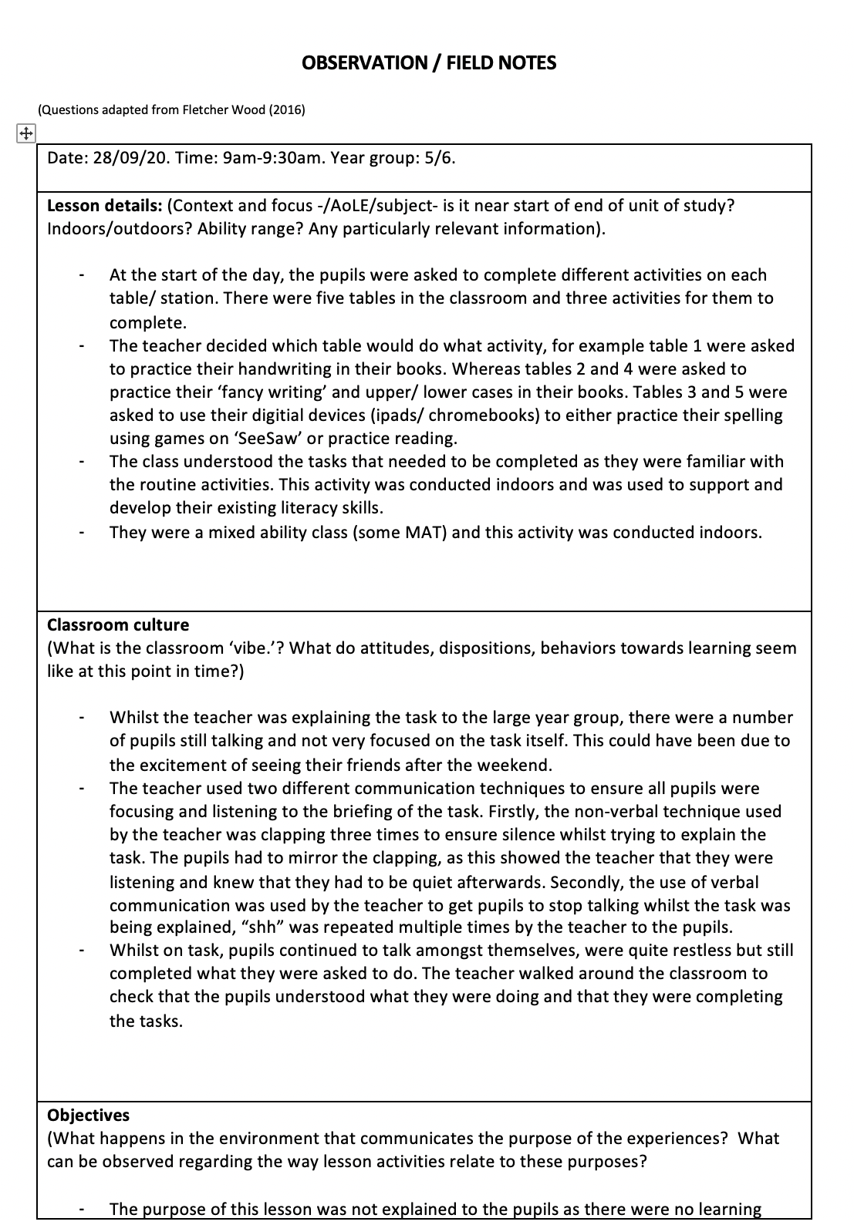

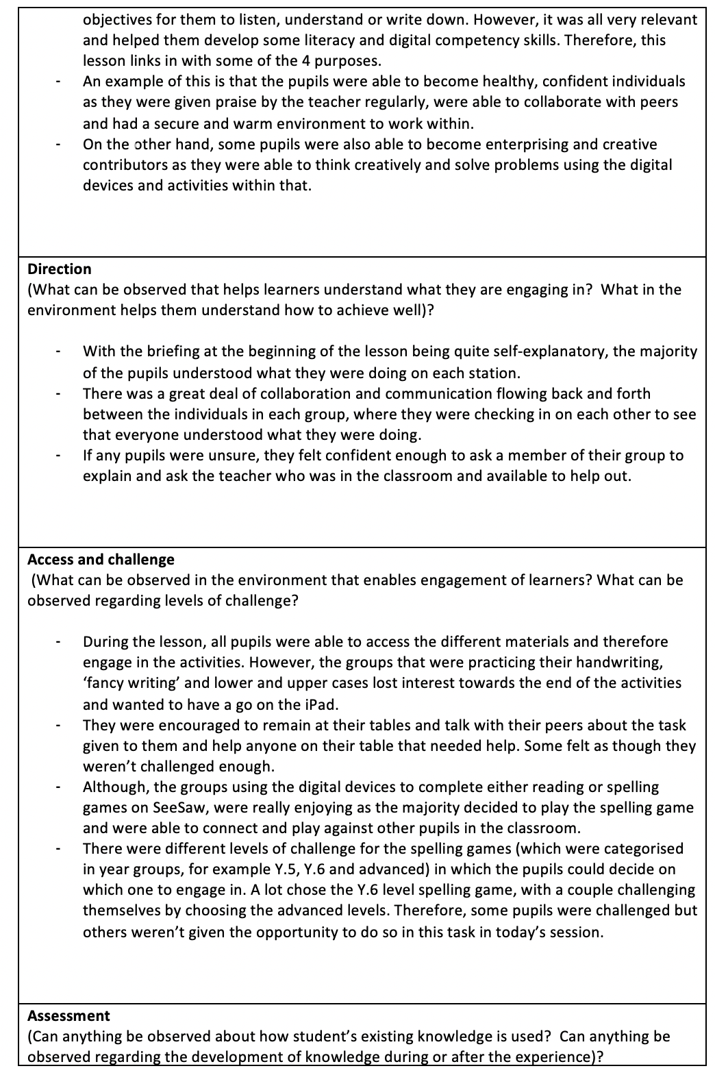

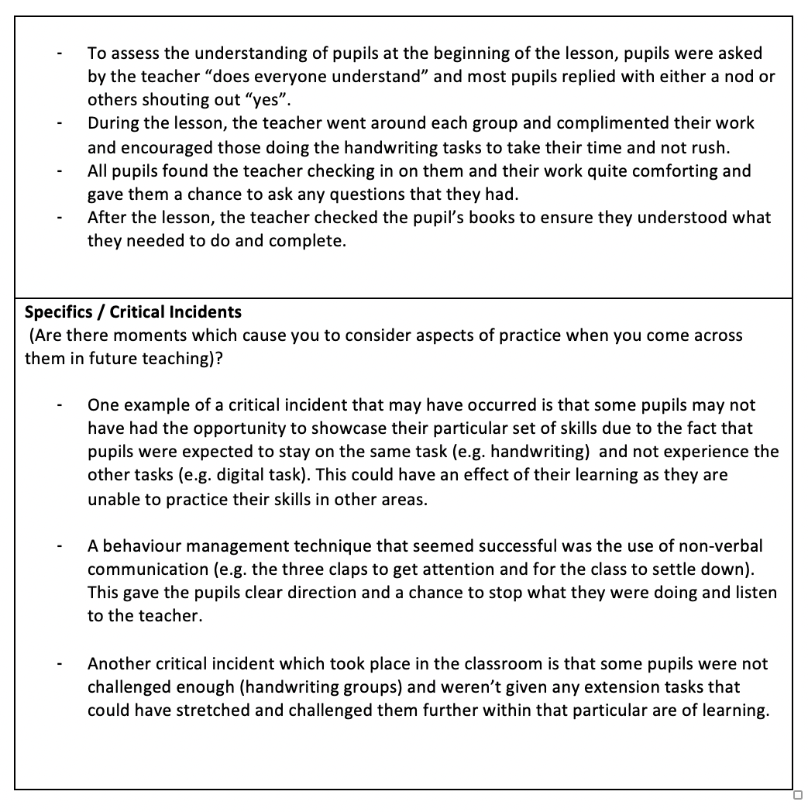

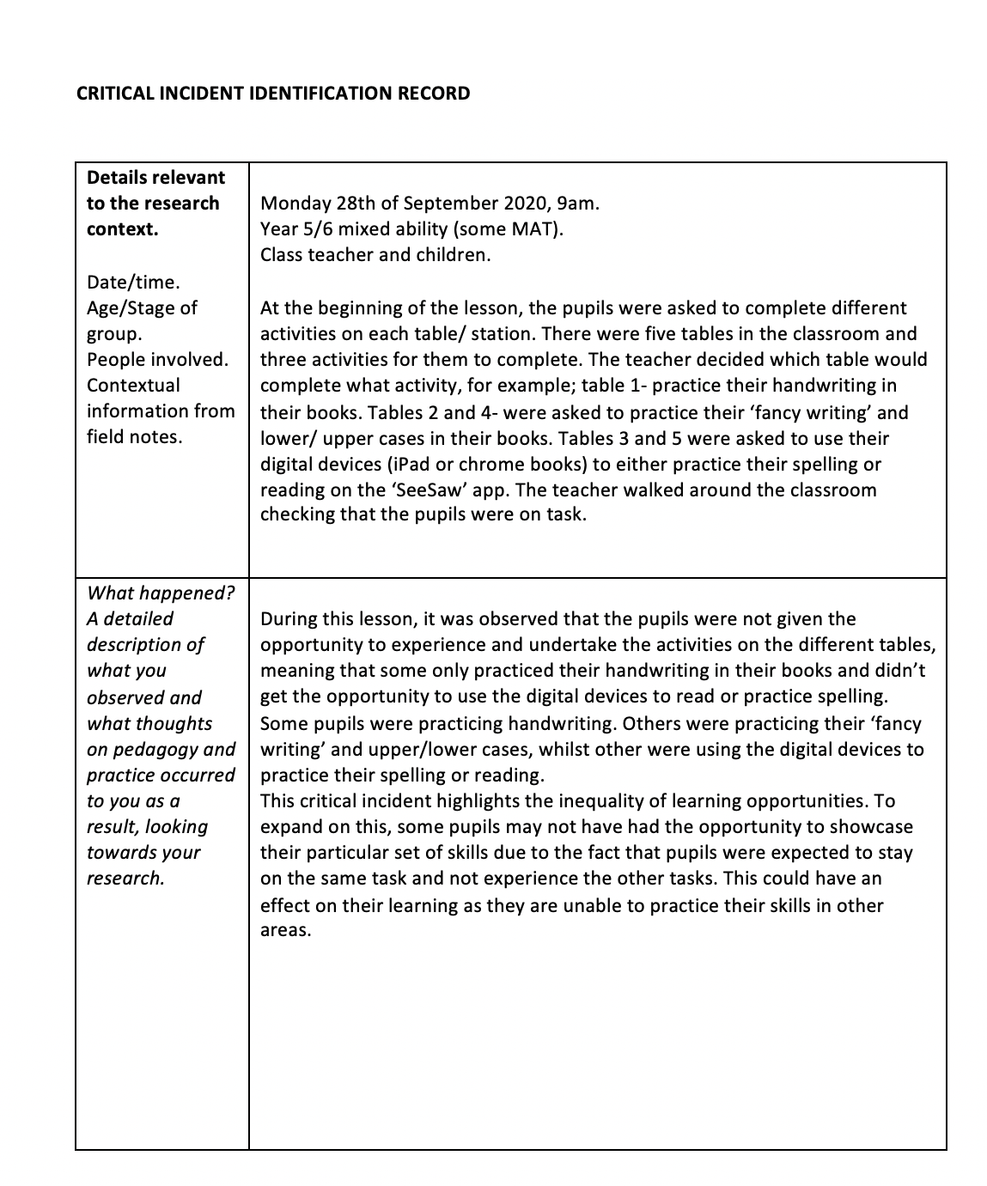

Appendix B- Observation sheet and critical incident identification record 2.

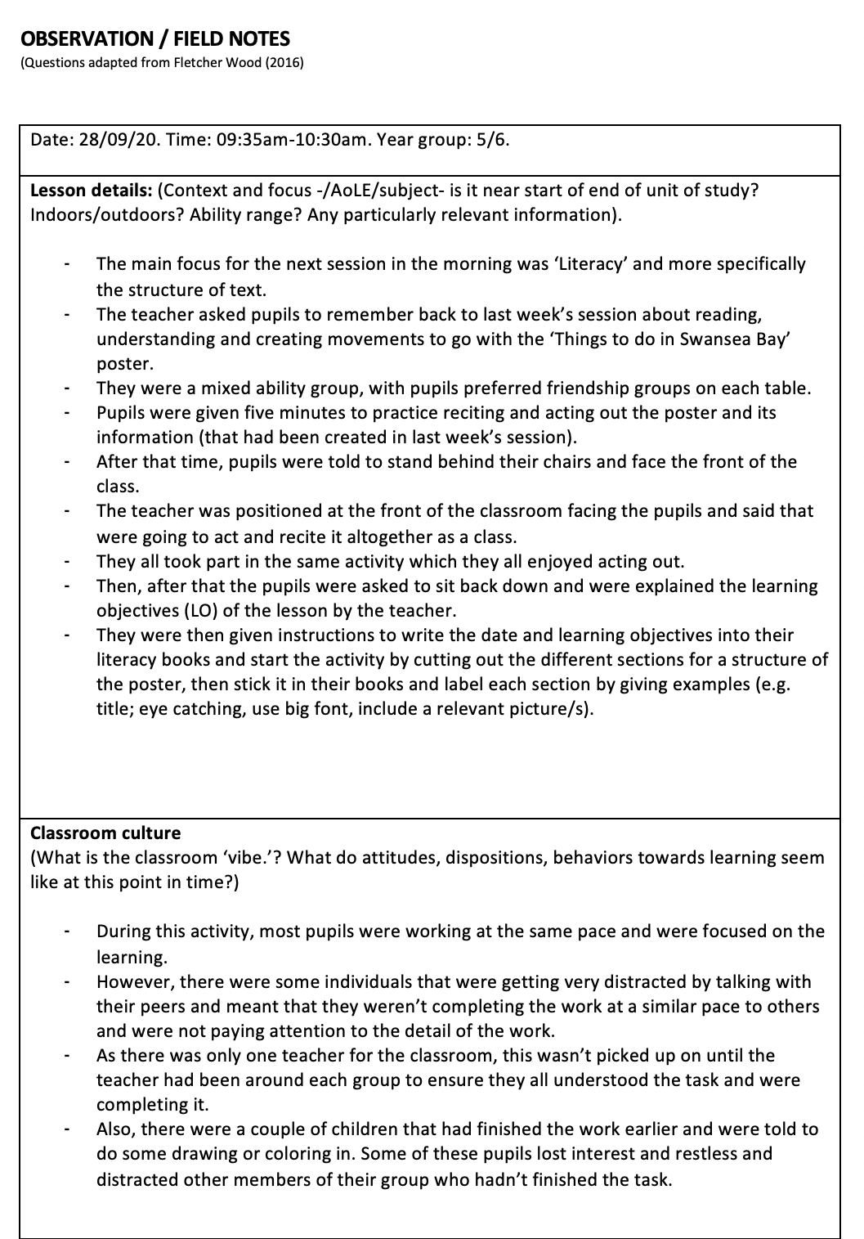

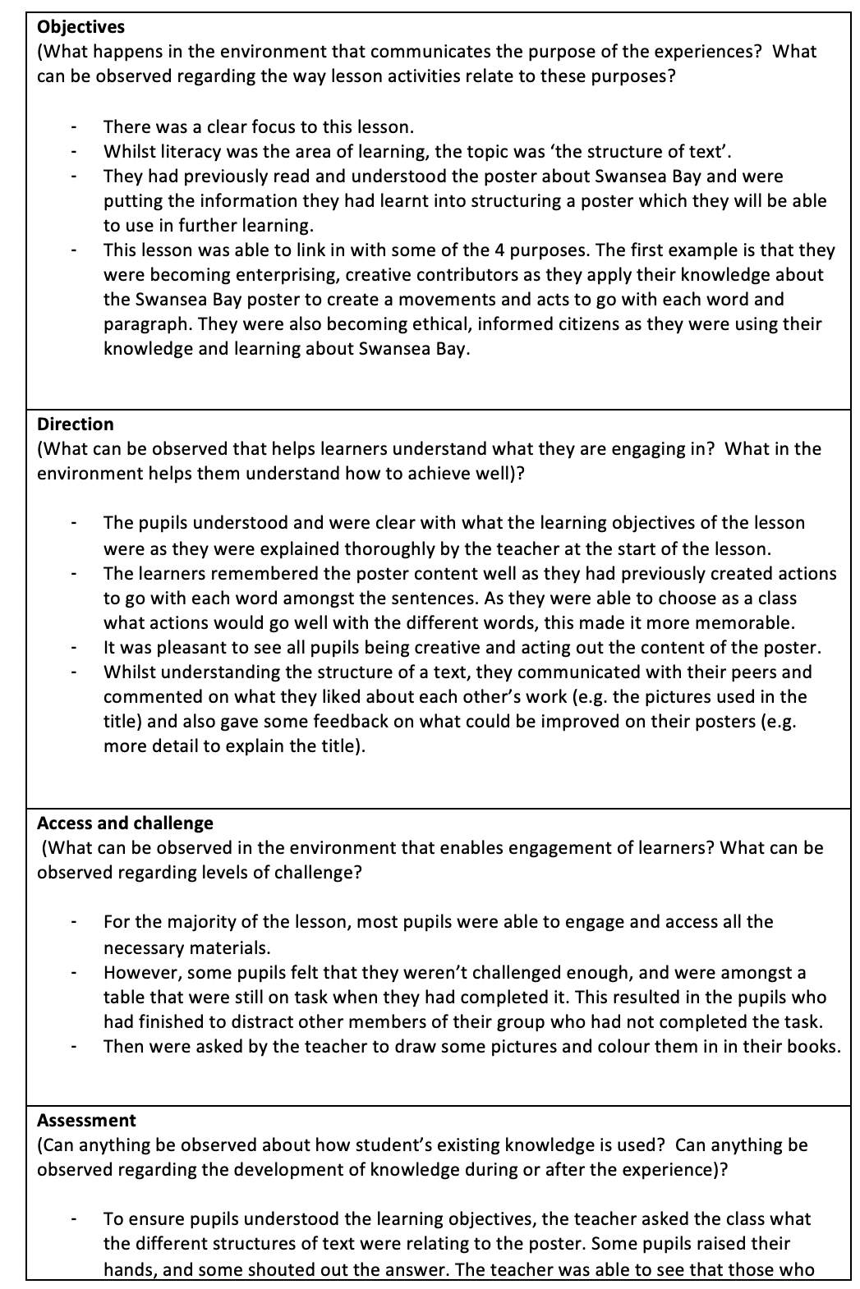
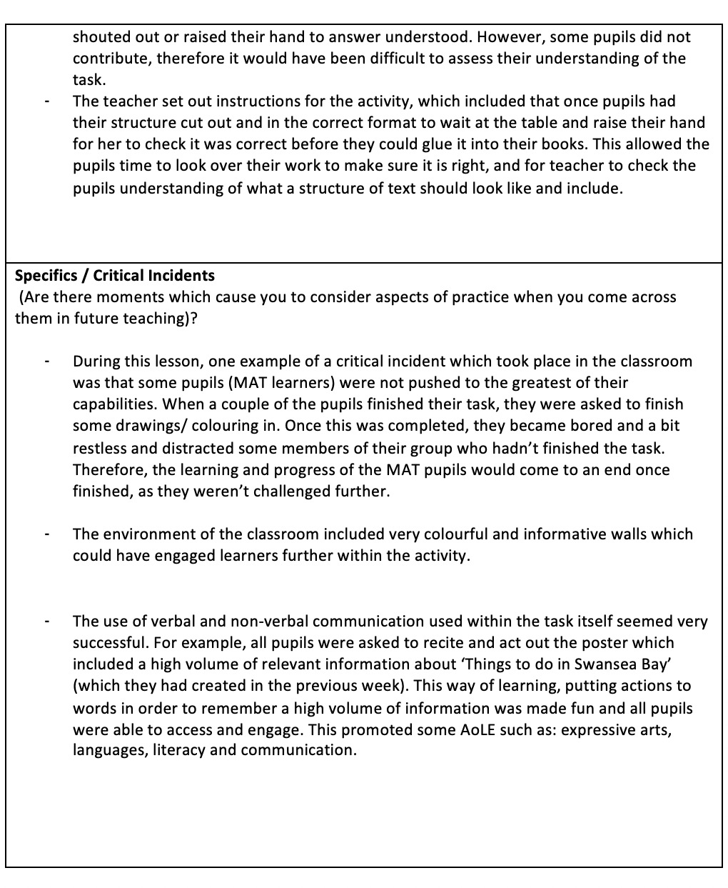

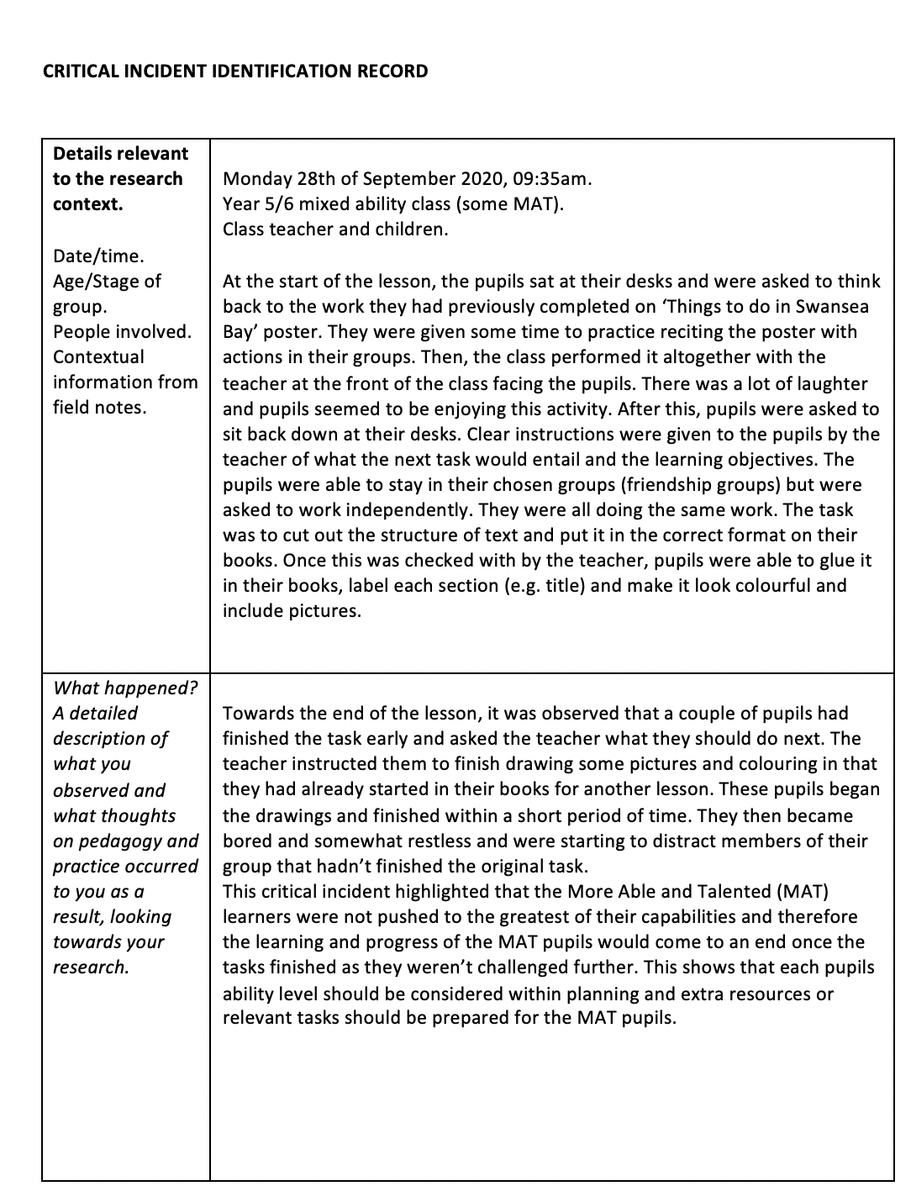

Appendix C- Observation sheet and critical incident identification record 3.

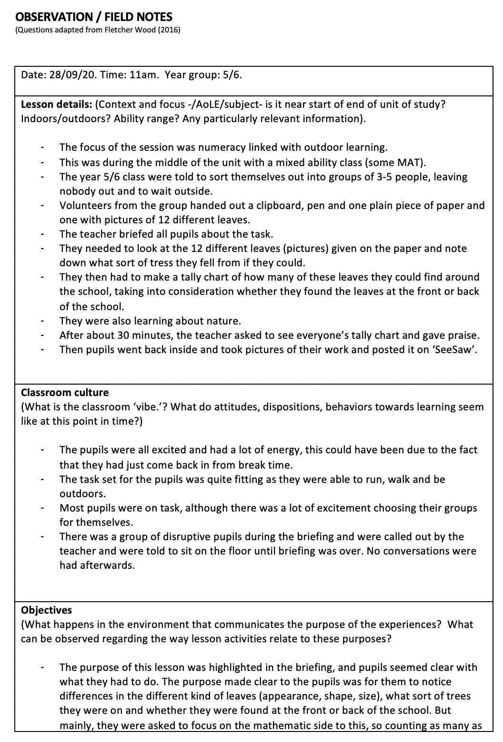

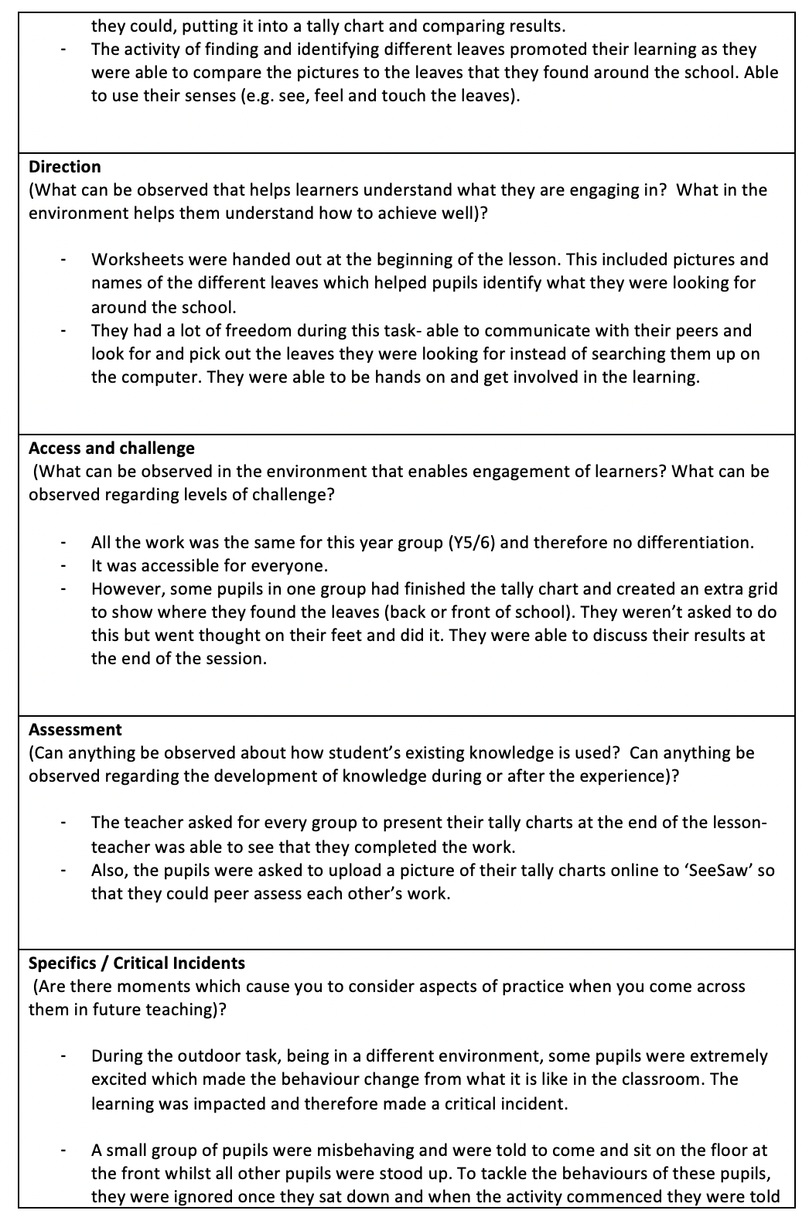

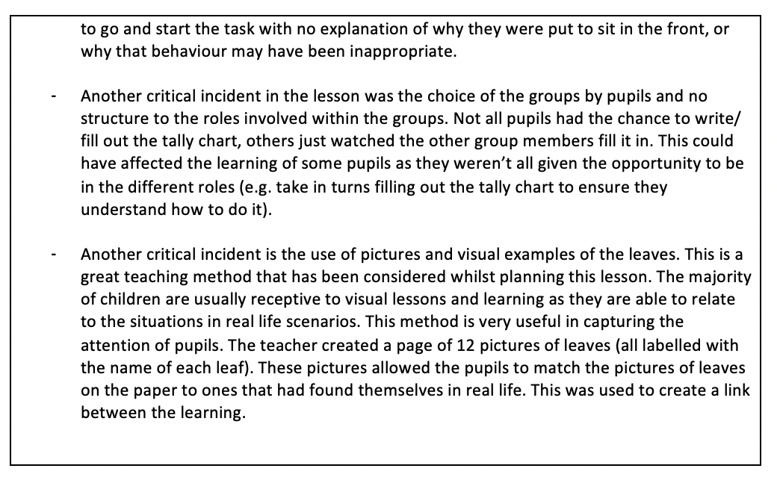

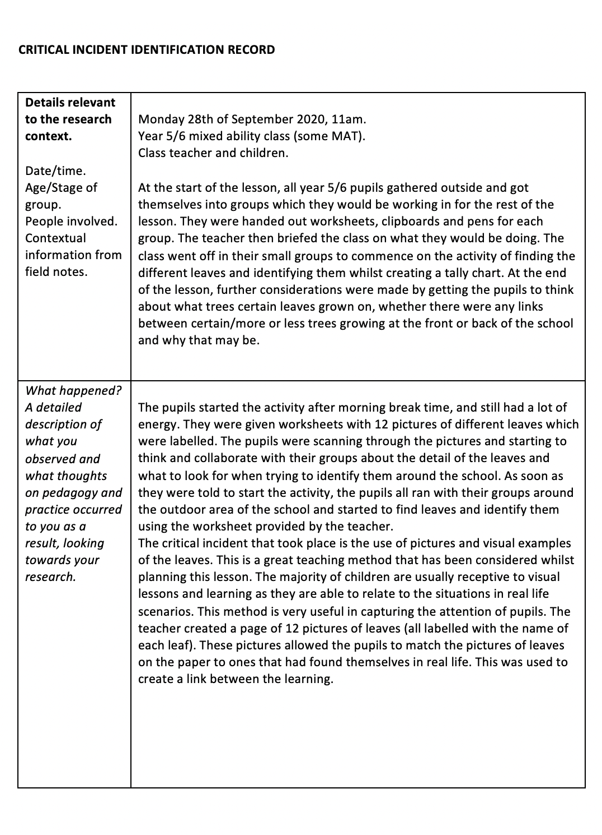

Appendix D- Observation sheet and critical incident identification record 4.



