Letter – Ysgol Bae Abertawe
Jonathan Triggs
54 Lewis Road
Neath, West Glamorgan
SA11 1DX

29th of April 2021

Swansea City & County Council
Civic Centre,
Oystermouth Rd,
Maritime Quarter,
Swansea
SA1 3SN

Dear Swansea Council,

As part of the Ysgol Bae Abertawe project we will be complying to Maturity level 2 throughout the project in line with the international standards BS EN ISO 19650 and the purpose of the project is to build a 1 form entry infant school for 90 pupils. To comply with BIM level 2 there will be a 3D model with data attached and this is to be linked in a collaborative manner, this data must be stored in a common data environment. A common data environment is where all data is stored that is part of the whole product life cycle of the project. This will always be accessible throughout the products life cycle. By doing this each discipline within the process all have access to the same information to ensure that everyone is communicating effectively. This allows each discipline to collaborate to create one single, intelligent, integrated model therefore following a BIM level 2 process. The common data environment is to be managed efficiently and must be up to date with all the updated information. Each discipline within the construction process must also comply with the use of the common data environment so that everyone can work in tandem with one and another once work begins. (bsi, 2019)
Every discipline within the process of the product life cycle of this school will all require different levels of access to different information within the CDE.
As part of the design stage of this project the architects and structural engineers will each have their own models that will collaborate with each other. To do this all models are to be drawn to the project survey point (265976.9E 192364.4N) to make sure that each model overwrites correctly. Each drawing that is produced must follow the correct naming conventions that is stated as part of BS EN ISO 19650 to allow for every file to be stored and organised efficiently. Specific details on how each discipline will collaborate throughout the process will be sated in the BEP.

To illustrate the process of how BIM will work throughout the life cycle of the project the BIM process diagram can be used as part of BS EN ISO 19650. This process evolves around the common data environment stated previously. This common data environment includes the PIM (project information model) which is all the information which is used to design and build the project. An example of this would be the 3D integrated model and the 2D drawings exported from this. The AIM (Asset information model) information is the as-built information of the project that is archived to allow for maintenance throughout the product life cycle. This is done by adding any trigger events that affect the final product to the common data environment so that it is updated with the correct, up to date information.
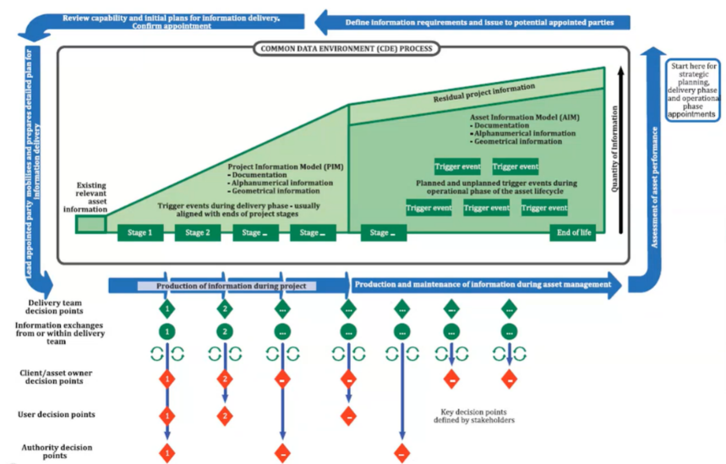
This information within the common data environment can be accessed by different disciplines throughout the project at any given required time. The process starts at the top right of the figure and this is where the client has stated what they require building which is usually in the form of an EIR (Exchange information requirements). This then moves around onto producing a BEP which then outlines the processes involved in delivering the project. Once then project has then been tendered for and award it moves around into the construction phase while still using information within the common data environment. Once construction is complete all information is archived so that required information is kept on the building to allow for maintenance work in the future. The correct access allowed by each discipline will be stated the in the BEP. At any given stage within the process information can be stored or updated within the common data environment allowing for flexibility throughout it. (bsi, n.d.)
Figure 1 ISO 19650-1
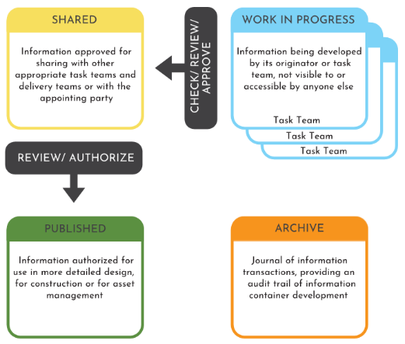
Within the common data environment, there are four stages the data progresses trough. This includes the work in progress stage which is the information that is in its initial stages. It then progresses through after approval to be shared with everyone else. This information can then be published to allow for construction or tender documentation. This information then goes into the archive to allow for ease of maintenance throughout the project product life cycle. Specifics of these four stages of information and how they are managed will be stated in the BEP.

Figure 2 ISO 19650-1

Regards,
Jonathan Triggs
Led Consultant

Appendix A
BIM Execution Plan
Ysgol Bae Abertawe
5010-JT-XX-XX-SP-Z-0001-BEP
Triggs, Jonathan
29/04/2021

Table of Contents
1.0 Project Information 4
2.0 Management 5
2.1 Roles & Responsibility’s 5
2.2 PIM Authorization Process 6
3.0 Planning Documentation 7
3.1 Process for Collaboration and Information Modelling – Common Data Environment 7
4.0 Standards, Methods, and Procedures 8
4.1 Project Zones 8
4.2 Measurement and Coordinate System 8
4.3 File Naming Structure 8
4.4 Applicable Standards 9
5.0 IT Solutions 10
5.1 Software Versions 10
5.2 Exchange Formats 10
References 11

Project Information

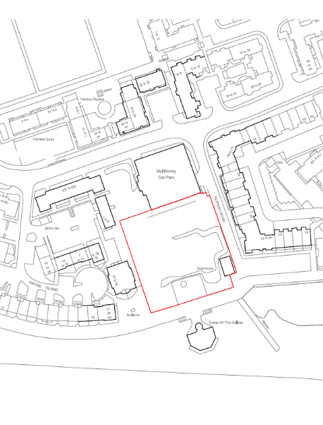
Client Name: Swansea Council
Figure 3 Site Extents
Project Name: Ysgol Bae Abertawe
Site Description: Unused green area that’s part of a residential area. The site has two existing buildings to be demolished and an existing retaining wall that needs to be removed before building works commence.
Project Location: Trawler Road/The Slipway, Maritime Quarter, Swansea SA1 1UW
Project Number: 5010
Design Start: 12th of April 2021.
Site Construction Start: 6th of May 2021.
Site Completion: 6th of May 2022.
Project Description: 1 form entry infant school for 90 pupils. Schedule of accommodation to comply with BB99.
Additional Project information: The school is single storey with a hall space that has double the height. Each classroom needs to have access to the outside. The site needs parking for 5 vehicles including 2 disabled bays. The school needs a drop off point for delivery and minibuses. The school needs a hard surface playground ad a soft landscaped playground.
Project Survey Base Point: 265976.9E 192364.4N
Approximate Gross Internal Floor Area: 756m²

2.0 Management
This sections of the BEP covers BS EN ISO 19650-3 on how the BIM process will be managed to comply with a maturity level 2 BIM process.

2.1 Roles & Responsibility’s
Name | Role | Contact Information
Swansea Council | Client | ####
Triggs | Lead Consultant | ####
Triggs | Architectural | ####
Triggs | Structural | ####
Table 1 Roles
Role  Company | Responsibilities
Client  Swansea Council | - To capture key decisions points and liaise with lead consultant to ensure that school is built to correct specification.  - Ensure correct standards, Methods and procedures are enforced.  - Appoint Project information Manager (PIM).
Lead Consultant  Triggs | - To ensure that all BIM information effectively integrates with each other and the 3D model overwrites correctly by using the correct survey point.  - Being in control of regulating the common data environment which includes the integrated 3D model.  - Filtering down the correct information to each discipline and ensured the correct guidance is put in place to allow everyone that is part of the process to efficiently follow BIM procedures.  - Keep common data environment up to date with all relevant information.
Project Information Manager  Triggs | - To ensure that BIM level 2 standards are kept throughout the project.  - Also, they are to make sure that the delivery of the School is carried out to the correct specifications by spending time on site to supervise work being carried out and answer any queries that could occur.  - This will need to be reported back to the lead consultant and any required change to the integrated model is enforced.
Task Team (Architectural  Structural)  Triggs | - Production of designs where required to caried out the given task.  - Confirmation that information is suitable for use.  - Ensure that information produced complies with the standards, Method and Procedures.  - Production of Project outputs  - Produce solutions to any clashes that could occur.
Table 2 Responsibilities (Rossiter, 2016)

2.2 PIM Authorization Process
This section illustrates the authorisation process when information is received and how it progresses into valid information.
- Check information against the Standards, methods and procedures to ensure it satisfies the need of this BEP.
- Check information for dimensional accuracy.
- Check information for spatial coordination.
- Check information for sufficient attribute data.
- Ensure this is signed off.
- Check information to ensure it satisfies purpose of issue.
- Update the suitability code.
- Update Revision code.
- Sign off.
(Rossiter, 2016)

3.0 Planning Documentation
This section covers BS EN ISO 19650 1+2 on the planning and documenting to comply with a maturity level 2 BIM process.

3.1 Process for Collaboration and Information Modelling – Common Data Environment
To complete this project at maturity Level 2 the CDE software nominated will be Viewpoint. This is to facilitate the requirement of ISO 19650 guidance C Facilitating the CDE (workflow and technical solutions).
The common data environment allows information to be efficiently shared throughout the project. Do this allow for clash detection when collaborating with different disciplines. It also eliminated the possibility of duplication of information within the project. This then making it easier to access the required information. All information to be stored under correct naming conventions as stated in the naming conventions section within this BEP.
The 4 stages to information within the CDE.
WIP
This information is only to be used by the originator and cannot be shared between disciplines. This information is still being worked on util it is approved to progress onto the next stage. This information could be continuously changing until it progresses to the next stage.
SHARED
This information has been approved from the WIP stage and will now be accessible to every discipline within the project. This is information has been checked so it should collaborate efficiently with each other. Every discipline should use this information to enable them to coordinate their own design to avoid clashes and to ensure that it fits correctly with the current information.
PUBLISHED
This information will have to have been approved by the client. This information can them be used as part of the construction or tender stage. This information will consist of the 2D drawings exported from the models.
ARCHIVE
The archive is the information that is stored to allow for maintenance throughout the product life cycle of the school. This information should be kept and made accessible to allow for easy remedial work should it need it.
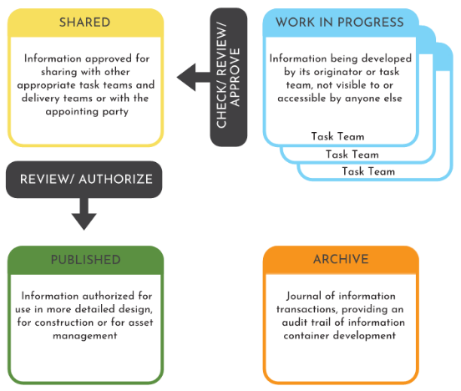
Figure 4 ISO 19650-1

4.0 Standards, Methods, and Procedures
This section covers BS EN ISO 19650 1+2 on the standards, Methods and procedures to comply with a maturity level 2 BIM process.

4.1 Project Zones
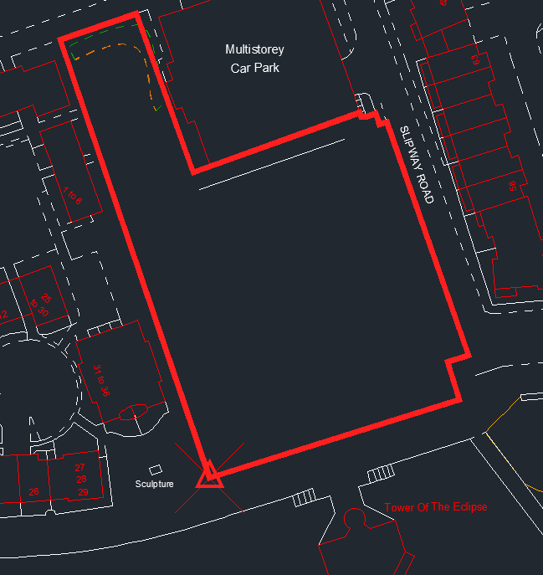
Due to the size of the project splitting the school up into different zones will not be required. All information should be stated with ‘XX’ as part of the file naming structure.
Figure 5 Project Base Point

4.2 Measurement and Coordinate System
Dimensions - All Dimensions In mm unless otherwise stated.
Coordinates - Coordinates to be based on ordnance survey datum.
Project Survey Base Point – 265976.9E 192364.4N – Coordinates are reference to ordnance survey datum and is shown in the figure adjacent. All drawings to be drawn to this point to allow for collaboration between the models.

4.3 File Naming Structure
This is how all information must be stored under ISO 19650-1 and BS 1192 standards to ensure an efficient BIM filling structure.
PROJECT- | ORIGNANATOR- | ZONE- | LEVEL- | TYPE- | ROLE- | NUMBER- | DESCRIPTION
Table 3 Naming Structure.
PROJECT | This column is the project number that is assigned to each individual project. In this case 4001.
ORIGINATOR | This column states where the project originated from each company involved will need a unique code.
ZONE | This describes what zone the drawing / information applies to. If this does not apply use XX
LEVEL | This describes what level the drawing is drawn at. If a level does not apply use XX or if it describes multiple levels use ZZ.
TYPE | This section describes what the documentation is. Drawing type abbreviations will need to follow ISO and will be shown in the table below.
ROLE | This is a one letter role code that shows what discipline the document originates from. A table below will show the required role codes as part of the project to follow ISO.
NUMBER | This is a 4-digit number the first digit being the group number and the remaining 3 being the individual ID number. Grouping stated in table 5.
DESCRIPTION | This will be required to give a short brief description of that the drawing is. It is important to abbreviate the drawing name where possible for ease of storage.
Table 4 File Naming Section Descriptions
Drawing Type Abbreviations | Description
CM | Combined Model
DR | 2D Drawing
M2 | 2D Model
M3 | 3D Model
MR | Model Rendering
VS | Visualisation
SH | Schedule
SP | Specification
Table 5 Drawing Type Abbreviations
Discipline | Abbreviation
Client | K
Architect | A
Structural Engineer | S
General | Z
Table 6 Role Abbreviations
1st Digit | Drawing Group
1 | General
2 | Substructure
3 | Openings
4 | Finishes
5 | Piped & Ducted Services
6 | Electrical
7 | Fixtures & Fittings
8 | Loose Furniture
9 | External Works
Table 7 Drawing Grouping.

4.4 Applicable Standards
Standard | Title
BS 19650-1: | Information management using building information modelling: Concepts and principles.
BS 19650-2: | Information management using building information modelling: Delivery phase of the assets.
BS 19650-3:2020 | Information management using building information modelling. Operational phase of the assets.
BS 19650-5:2020 | Information management using building information modelling. Security-minded approach to information management.
BS 8541 Series | Library objects for architecture, engineering and construction.
Table 8 Applicable Standards

5.0 IT Solutions
This section of BEP covers the requirement of BE EN ISO 19650 1+2 to comply with a maturity level 2 BIM process in relation to the IT solutions.

5.1 Software Versions
To ensure that information is accessible throughout the project the version of the software must stay the same throughout.
Company | Purpose | Software | Version
Autodesk | 2D Modelling – Site Extents, Floor plans | AutcoCAD | 2021
Autodesk | 3D Modelling – 3D integrated Model (Architectural + Structural), Phased 3D model to show existing and proposed, Exportation f 2D drawings from 3D model, Creations of visualisations. | Revit | 2021
ViewPoint | Common Data Environment | ViewPoint
Table 9 Software Versions

5.2 Exchange Formats
Export Software | Format | Version
AutoCAD | .dwg | 2021
AutoCAD | .pdf | 2021
Revit | .rvt | 2021
Revit | .pdf | 2021
Table 10 Exchange Formats

References
bsi, 2019. BSENISO19650-1&2:2018. [Online]
[Accessed April 2021].
bsi, n.d. Little Book of BIM. [Online]
Available at: https://www.bsigroup.com/globalassets/localfiles/en-us/brochures/bim/little-book-bim.pdf
[Accessed April 2021].
Kier, 2016. N7177-KCW-00-XX-SP-W-0001-BEP. [Online]
Available at: https://teams.microsoft.com/l/file/E93A0F5C-F5F3-4A08-9E7E-8A64E7F046E7?tenantId=4e0f11f9-046e-4505-9cb8-db2152311e21&fileType=pdf&objectUrl=https%3A%2F%2Fuowtsd.sharepoint.com%2Fteams%2FACBA5010BIM2020-21_GRP%2FClass%20Materials%2FSample%20BIM%20Document
[Accessed April 2021].
Rossiter, D., 2016. BIM Execution Plan (BEP). [Online]
Available at: https://drive.google.com/open?id=1GyEwzyXayPuRx08ZhdKnC2zsaAKFydiIcPxYn1-z2aE
[Accessed April 2021].
Rossiter, D., 2018. BimBlog. [Online]
Available at: https://bimblog.house/blogs/
[Accessed April 2021].
Trust, S. F., n.d. Overview of the Common Data Environment (CDE. [Online]
Available at: https://bimportal.scottishfuturestrust.org.uk/level2/stage/1/task/22/overview-of-the-common-data-environment-cde
[Accessed April 2021].

