Synthesize a solution to a potential real life scenario
Author: Timothy Edwards (2004445) Module Name: Networks and Cyber Security Essentials (ACCA4024) School of Applied Computing Wales Institute of Science and Art Date and Time of submission: 07/01/2021 <time>
Abstract
At the beginning of researching, it took a little longer than anticipated, thankfully the brief had the answer as to where to begin looking. “What is a Network?”, was the first research topic. From there on the direction of the report was set, everything began to fall into place.

Index
Introduction 3
Related Work 4
Design and Implementation 6
Mitigation, Strategies and recommendations 13
Conclusion 14

Introduction
Throughout this report, I will be covering the topic of Cyber Security, more specifically Cyber Security for Che-Si and the concerns of their security. Before I dive into the report, I will cover what exactly is meant by computer networking and the importance of security in a network.
To keep my discussion brief. A network can mean many things but from a computing standpoint, at its core, it is two or more devices which are connected as a means of communicating with each other [1]. There are many different types of computer networks, each is categorized differently based on the characteristics that they have [2].
Network Security can be defined as a wide magnitude of technologies or software, which is designed to protect a network from any threat, it does this with a set of rules and configurations [3]. The network security will allow authorised user to examine resources that are on the network, however, any non-authorised users are stopped from performing any actions on the network [4].

Related Work
To begin this section the report we will be taking a look at the various types of networks and the devices that make up a network. From there we will be looking at the possible threats and attacks on a network. And then to finish this section off we will look at possible mitigations from the threats and attacks.
There are many different types of networks. The first type of network that we’ll look at is a Local Area Network or LAN. A LAN is a network type that is exclusively in one place, it, however, may include both wired and wireless devices [5]. The transfer rate for data in a LAN is fast, which allows for tighter security [6].
The second type we’ll look at is a Wide Area Network or WAN. A WAN is effectively multiple LANs spread across a magnitude of areas [5]. The internet is often considered a WAN and is also one of the biggest WANs in the world [5], [6]. A WAN can connect with places all over the world it can do this via the use of telephone lines and satellite links [6].
Next, we will cover the devices that make up a network. Firstly let's list a few networking devices that we’ll be covering: Switch, Wireless Access Point (or just Access Point) and Router all seem to the most common networking devices. The end devices or the devices that will be connecting to the network most commonly would be Workstations, Mobile phones, Laptops, Tablets.
So let’s take that apart and cover one thing at a time. Switch, a Switch can effectively work as a bridge from one device to another, if the bridge had multiple ports on it that is, but it allows for data transmission from one device to another device, the fewer ports in use, the less traffic there is on the network [7], [8]. Switches, however, are susceptible to Distributed Denial of Service (DDoS) attacks [8]. Access Points, commonly, Access Points are used to create a wireless LAN, ultimately creating a network without cables, it then also boosts the bandwidth of a network, supporting devices that are further away. APs can also act like Switches, Routers and Firewalls [8], [9]. To top it off we have Routers, Routers are typically used to connect LANs and WANs [7]. But Routers are also smarter than that, Routers can also store information about networks that it is connected to [8]. Due to a router connecting networks, it allows multiple users to share connections and protect information from any threats to the network [9].
Considering that Che-Si is a large organisation with places all over the world it is more than likely that they are using a WAN. Also considering that the company allows for their clients, vendors and staff members to access their network from anywhere and from any device that would mean that a whole range of devices would have to connect to their network, those devices could range from a mobile phone, a laptop, a workstation, to anything and everything, thus leaving their WAN vulnerable to attacks, like a DDoS attack as an example, more on that in a moment. There’s also nothing stating how they secure the connection between those accessing the network and the network itself, baring, of course, the latest technologies, thus leading us to believe that the connection may not be secure.
Next, we’ll talk about the potential threats and attacks to the network, the aforementioned DDoS attack would be one of them, due to them possibly using switches. But also ARP poisoning could that DoS attack, as it will prevent clients, vendors and staff members from communicating.
Finally, we will talk about possible mitigations to the threats/attacks. There are many ways Che-Si can prevent ARP poisoning, and many DoS’ in general, the first would be Encryption, various protocols, like HTTPS and SSH will reduce the likelihood of an ARP poisoning attack. VPNs are also a great way, a VPN will encrypt the pathways that data leaves behind, thus preventing an attacker due to them only seeing encrypted data/connections. Finally, another solution would potentially be Packet filters, Packet Filters will analyze all packets that enter the network [10],[11].

Design and Implementation
As stated in a previous section I believe that the network as it currently stands has a weak point for ARP spoofing or just many variants of a DoS attack. Policies seem to make up a decent bit of the problems for these vulnerabilities or weak points. It isn’t the client's fault or the Vendors fault, after all, how are they to know the possible outcomes of their devices connecting to Che-Si’s network.
To demonstrate the effects of an ARP poisoning attack, we must understand the overall design of the network, In Cisco’s Packet Tracer we cannot recreate an ARP Poisoning attack in its entirety, however, we can get somewhat close. To begin we need to understand the type of devices that will be used in the network. For this demonstration, we will focus on the devices that we can expect to be in an office network, this would include workstations, router, just to keep it as close to Che-Si as possible. The demonstration network we’ll use will look something similar to this screenshot below.
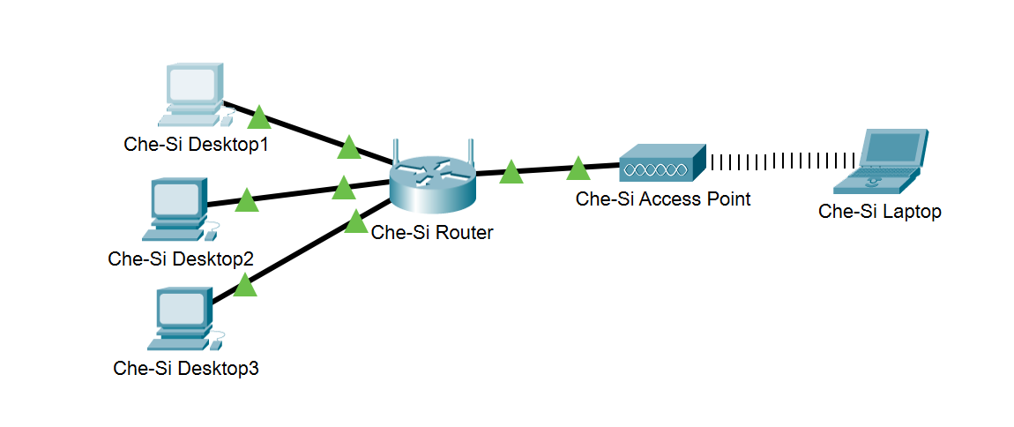
The first step we are to do is open up the simulation window, with the simulation window open we can view all traffic that happens on the network. Since there is no traffic the window will appear empty, as seen below.
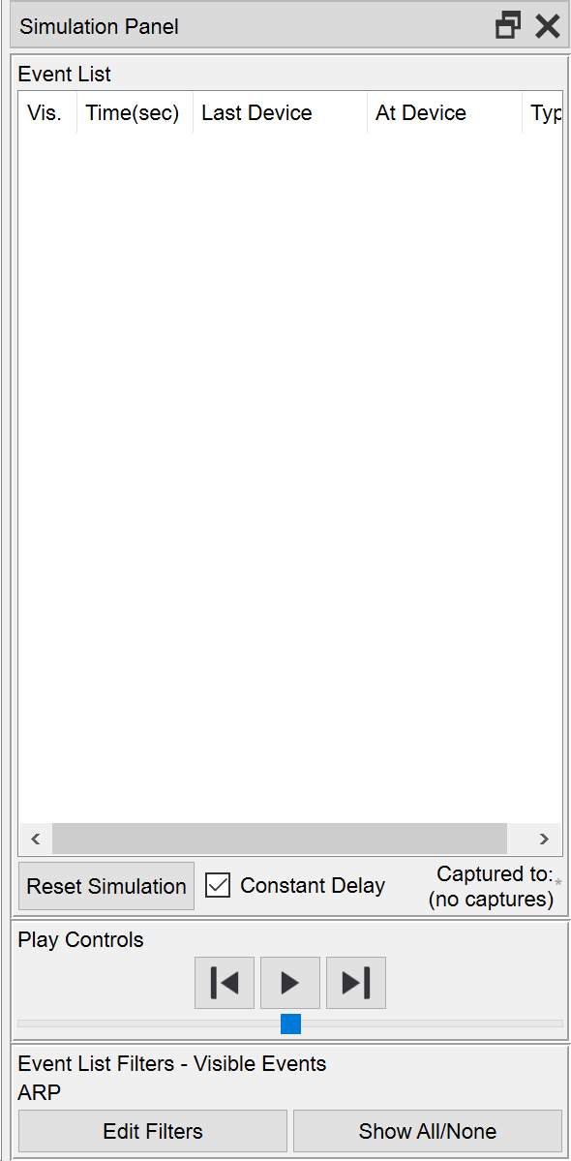
Next step is to check the IP address of Che-Si Desktop 1 and check the IP address of Che-Si Desktop 3, after learning the IP address of both devices, we’re going to head back to Che-Si Desktop 1 and head over to the Desktop tab and click on Command Prompt. We’ll be graced with this:
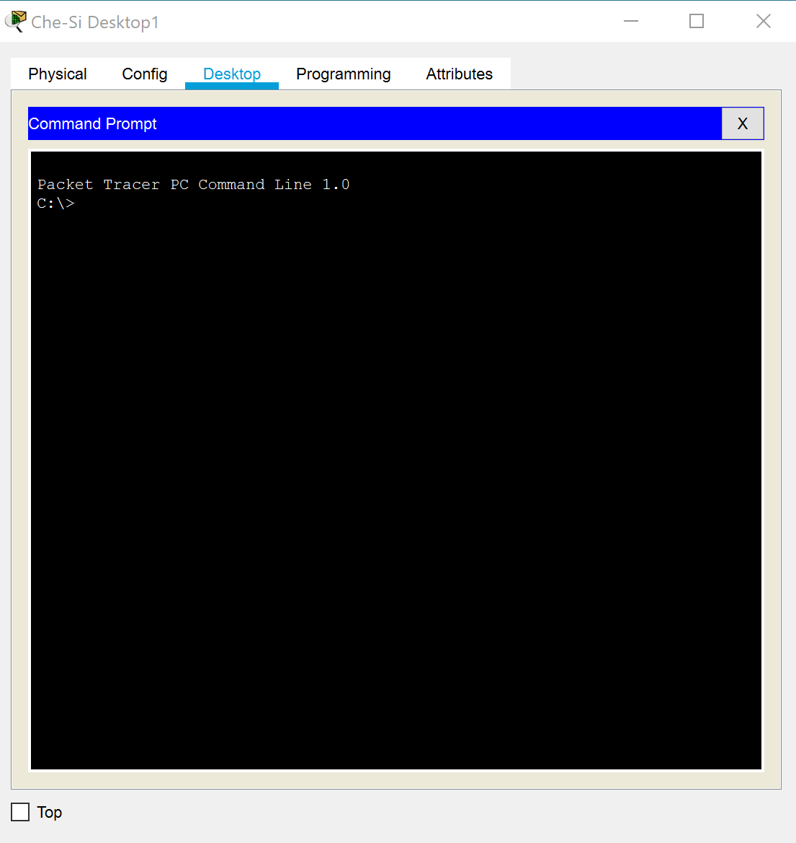
For the next step we have to make sure that there are no entries under the command arp -a, so type that into the command prompt, make sure that you click the play button on the simulation.
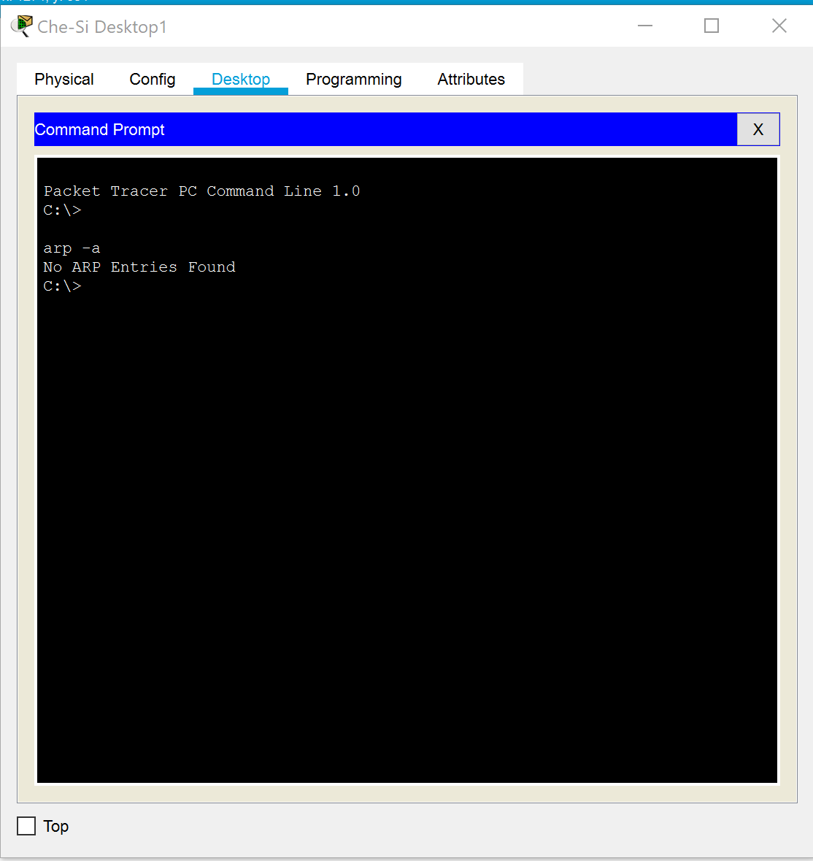
Next step is to ping router from Che-Si Desktop 1. Firstly the Simulation tab should now show events happening, as seen below: But also below is what the command prompt shows on Che-Si Desktop 1.
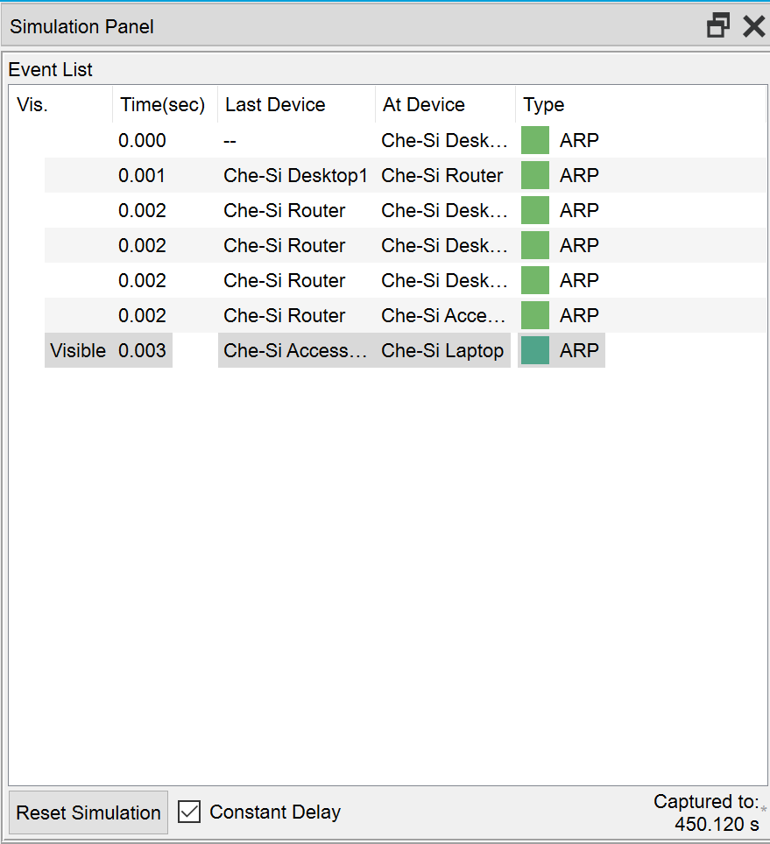
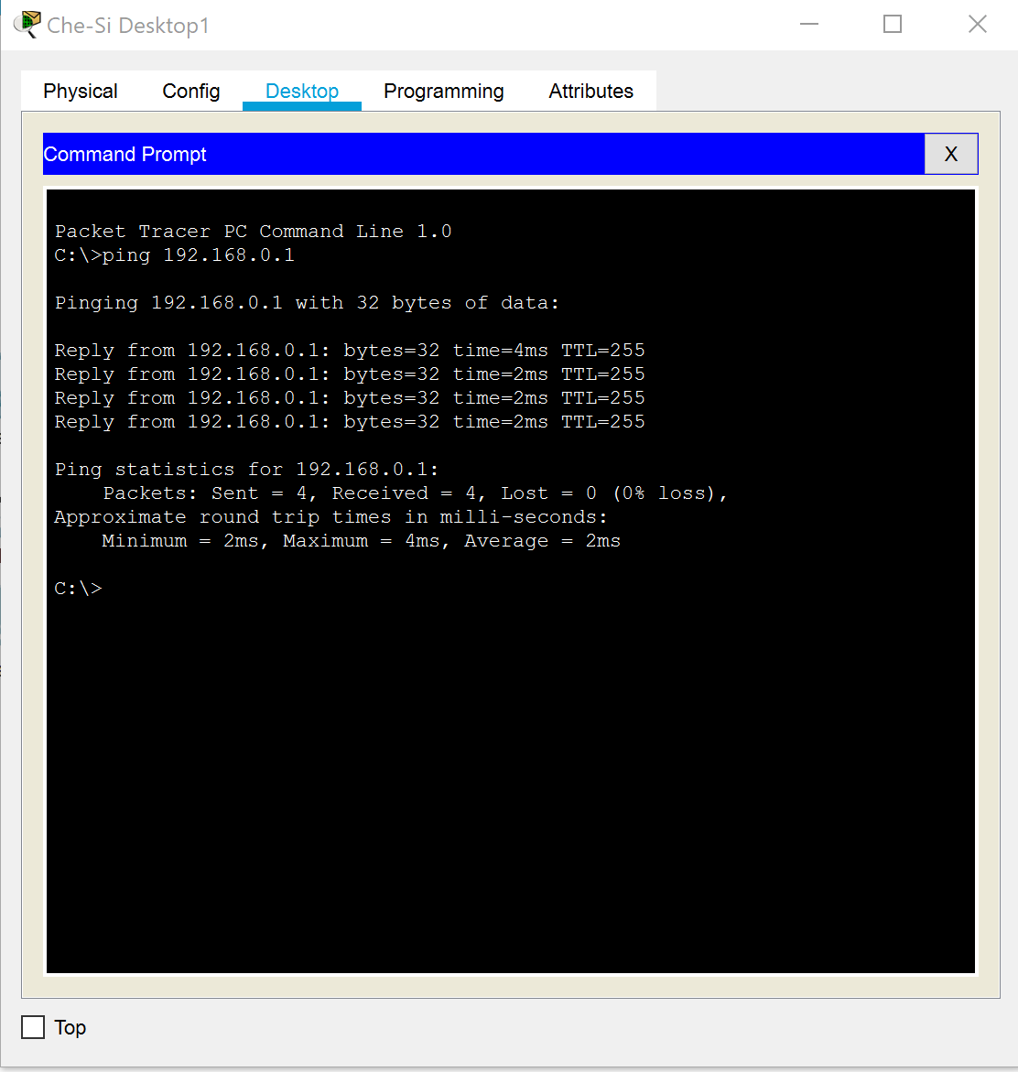
Now we do another arp -a and we should have an entry, as seen below:
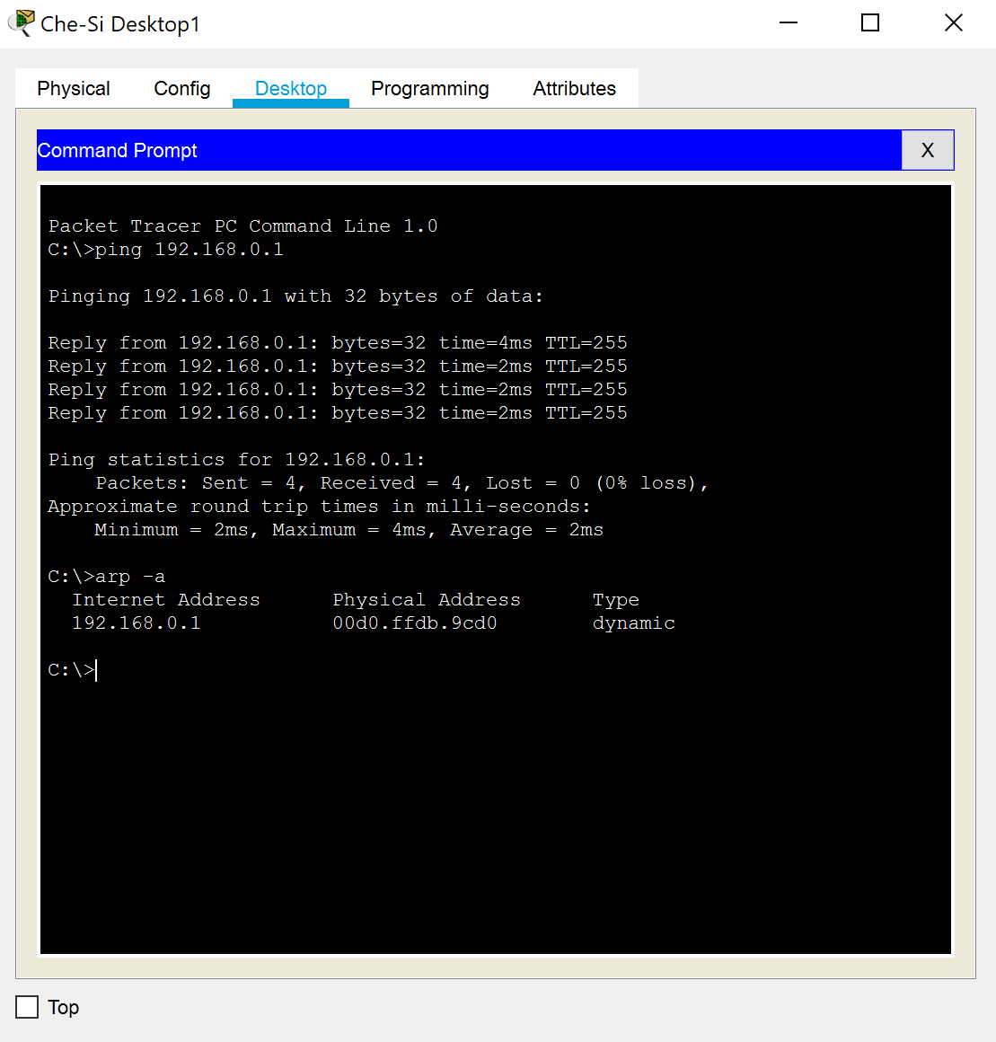
The next step is to change the IP address on Che-Si Desktop 3 to the same as the router:
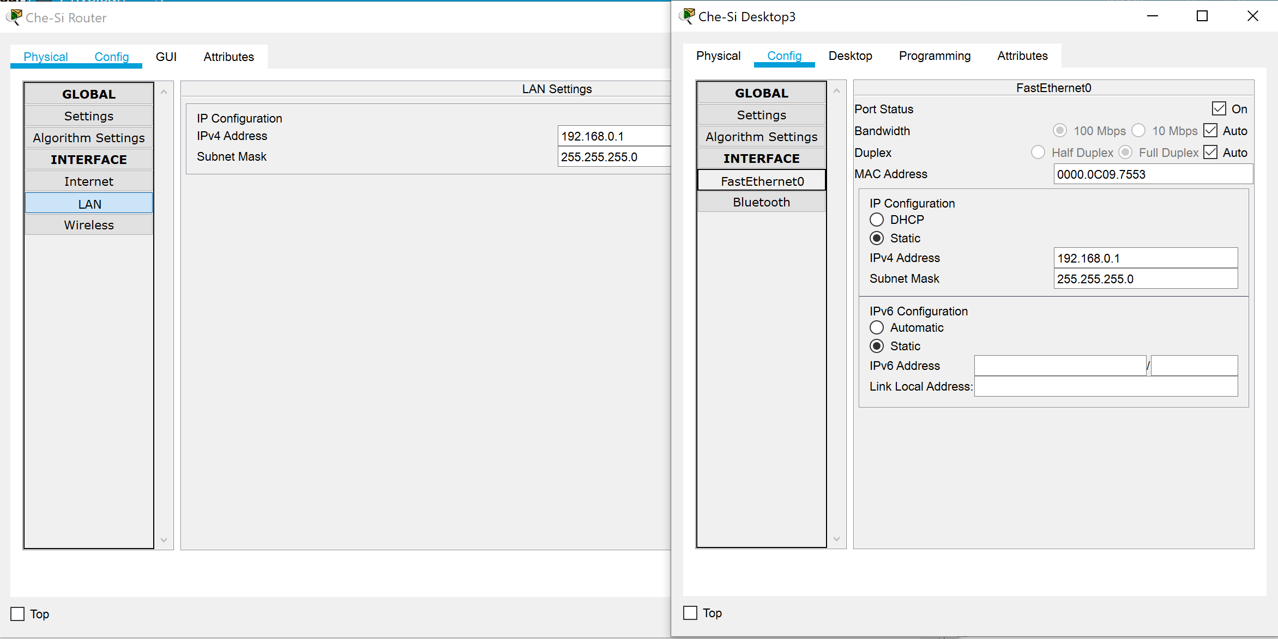
Next is to send a ping from Che-Si Desktop 3 to Che-Si Desktop 1, below is the simulation tab and the command prompt:
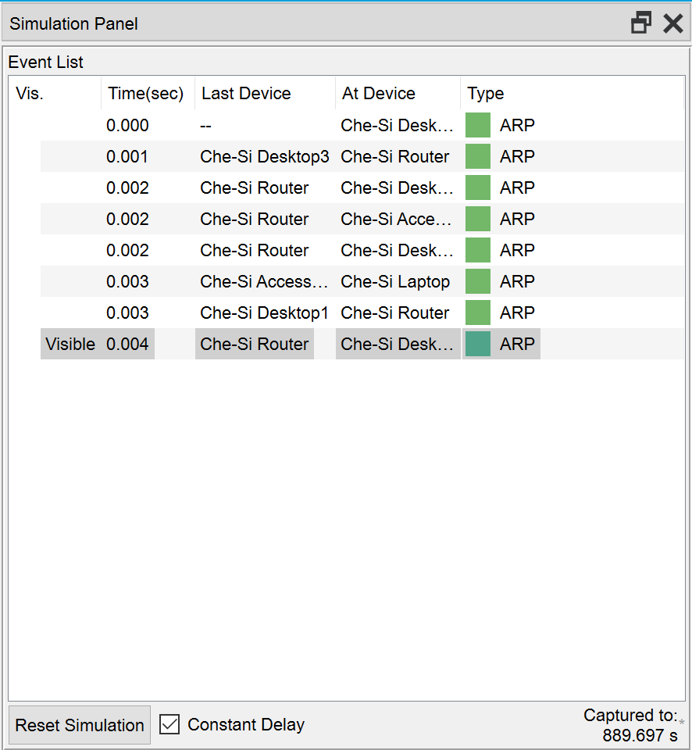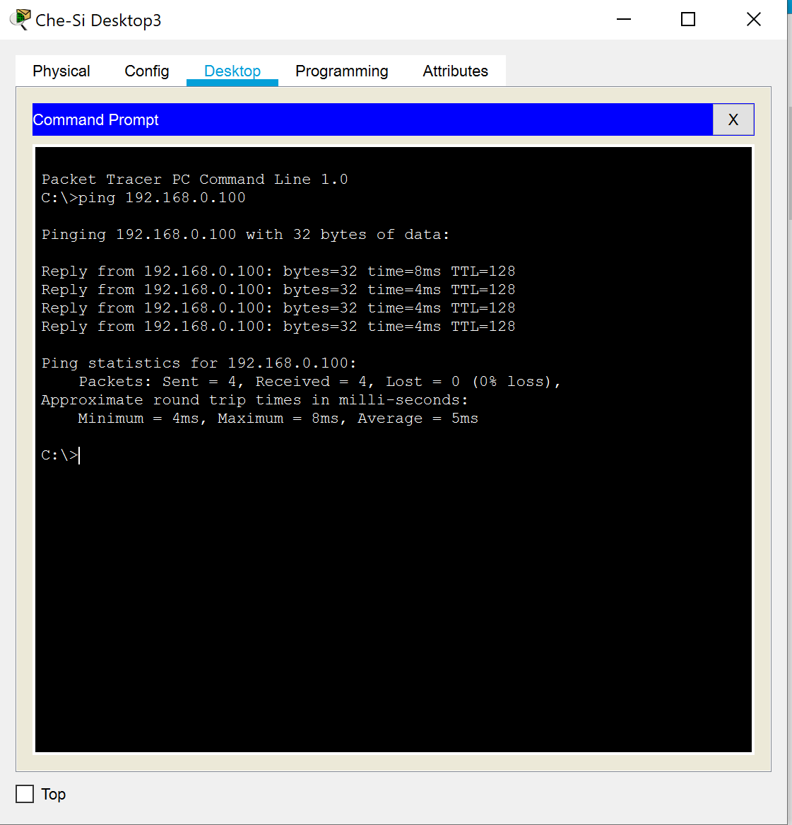
Next to check the arp cache:
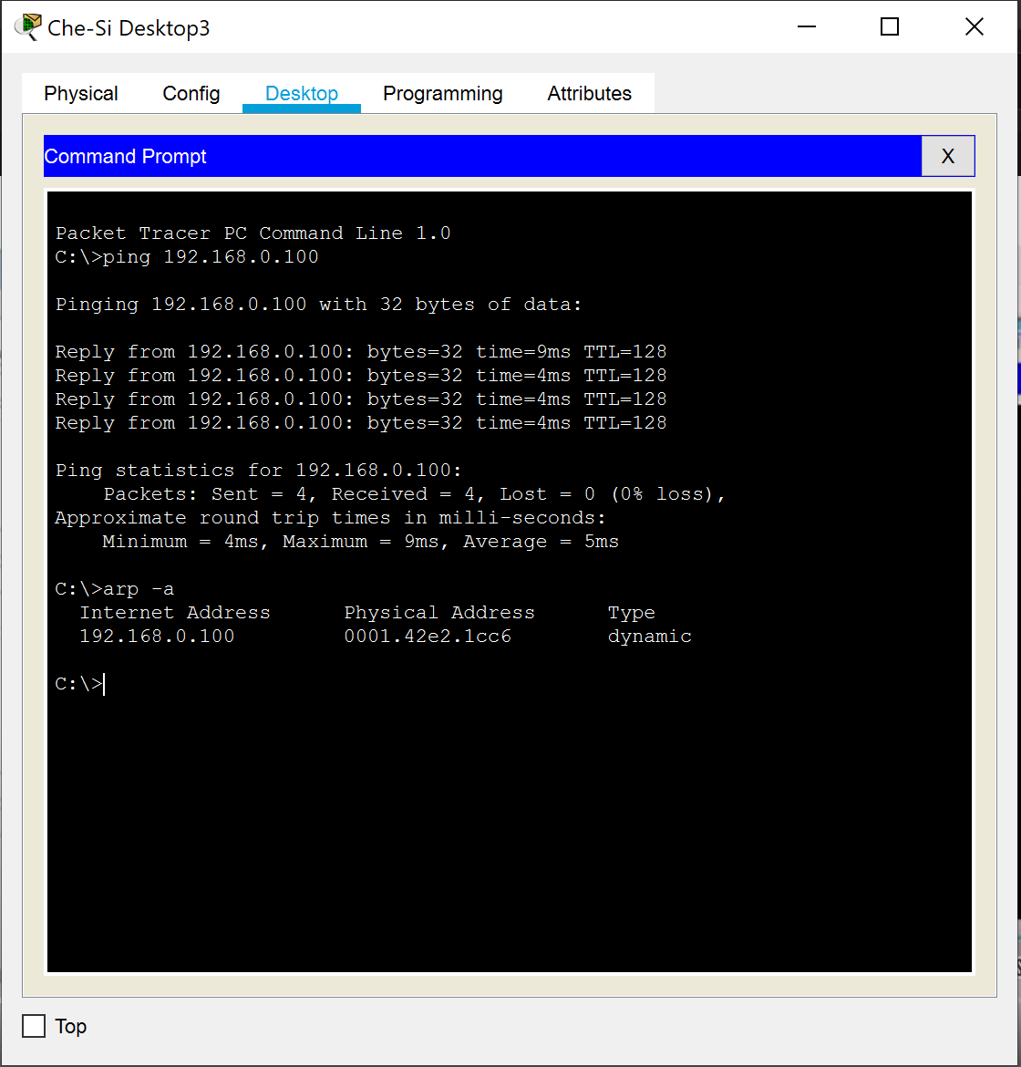
Then we check the arp cache on the Che-Si Desktop 1, the desktop thinks that the MAC address has changed:
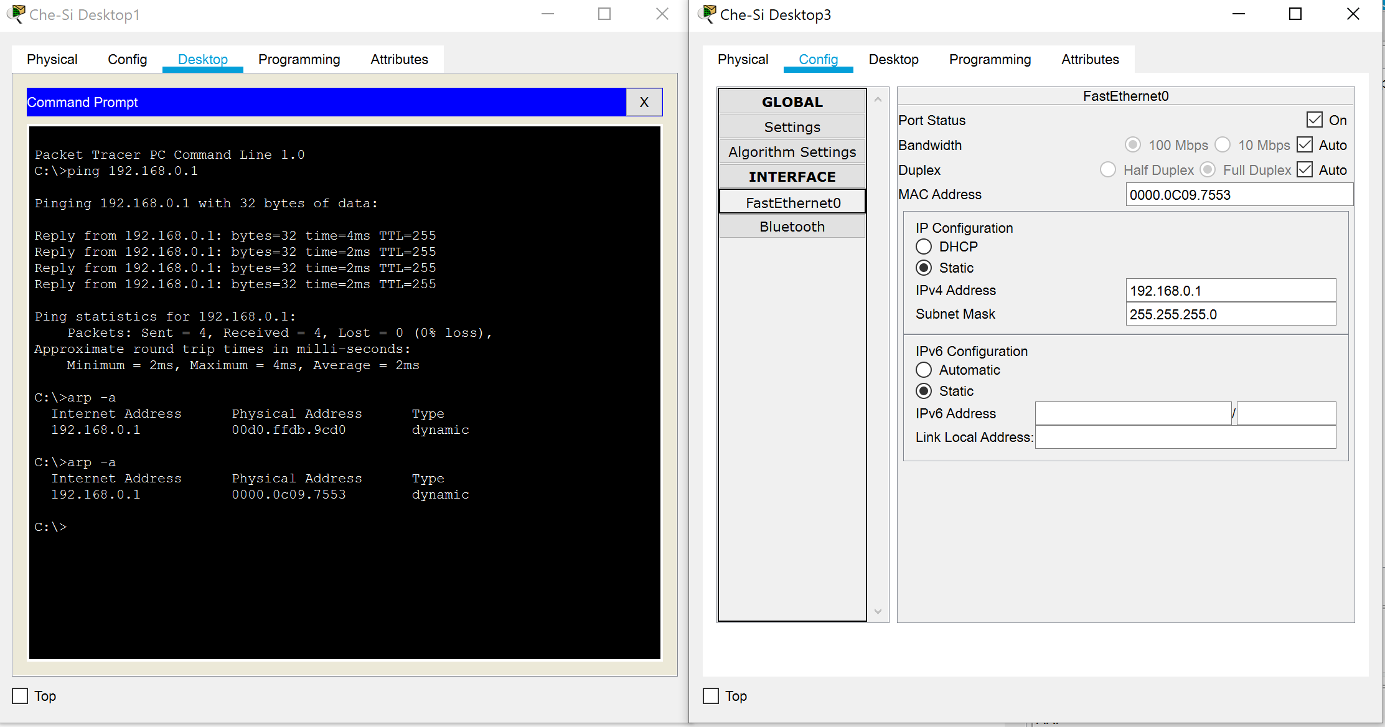
Now we are going to change the IP of Che-Si Desktop 3 back to its original IP (see below) and try another Ping from Che-Si Desktop 1 to the router and what should happen from there is that it will send the ping to the router and it will be redirected to Che-Si Desktop 3, due to the arp cache thinking that Che-Si Desktop 3 still owns the routers IP address, unfortunately, Packet Tracer doesn’t do this.
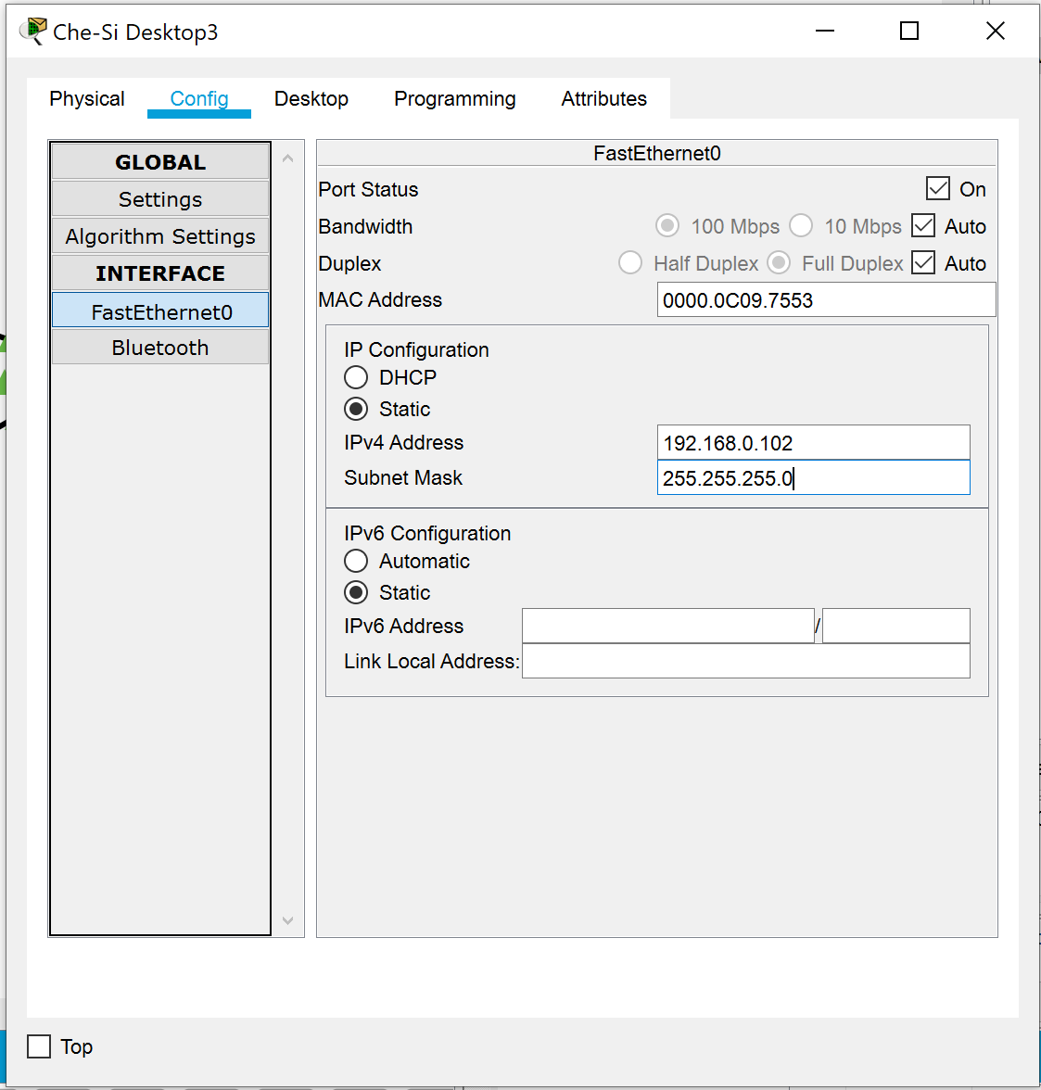
The outcome of the implementation should have been any packets that go to Che-Si Router would have instead gone to Che-Si Desktop 3. Thus allowing Che-Si Desktop 3 to gain all data coming to/from Che-Si Desktop 1.

Mitigation, Strategies and recommendations
Policies are essential in today’s business, but what exactly are they? In this section of the report, we’ll be going over what policies are. What digital signatures and what data encryption methods there are, and what policies are recommended to prevent the attack mentioned prior.
A Policy a way to outline the various rules and procedures that are in place at the company while someone is on their network [12]. Many different factors need to be taken into account when making policies, employees can be a threat by connecting their personal devices, thus there should be a policy in place for bringing your own devices [13]. There are 3 objectives for policies, Confidentiality, Integrity and Availability [12]. Policies are treated in a multi-layered fashion. While dealing with Policies there are a total of nine areas that should be addressed [12].
Digital signatures are like a digital variation on what we do when signing papers, true to its name. Digital signatures use an advance mathematical technique as a means of checking whether the digital message/document are authentic. It ensures to us the users that content of what is being transmitted is not altered in any capacity [14]. There are two digital signatures one being Private key the other being Public key [15]. Private key and Public key encryption is often referred to as “public key infrastructure”, this is due to the public key being made available on an online directory. Many people, therefore, rely on Public keys to authenticate any messages sent using it [15]. Many regions view a digital signature to carry the same weight as a handwritten signature, some of those countries as an example include; North America, Asia-Pacific and the European Union [14].
From what we witnessed with the demonstration, the policies need to be updated to counteract any attempt at ARP poisoning or ARP spoofing. There are many ways we can do this in terms of policies, the first option and the option we definitely won’t be going with is the to remove the use of “Bring your own devices”, while it is an option it could cause an uproar among the clients in particular but also among the various staff members. The policy upgrade we can therefore run with would be an “HTTP Strict Transport Security” policy. This policy helps defend against any Man in the Middle Attacks. As a means to ensure that employees, clients and vendors each adhere to this policy, an Acceptable use Policy can be put in place. If employees, clients or vendors are concerned about their data, Information Security Policy will be put in place, thus giving Che-Si some level of control of what happens in the network. The Encryption Policy should also be implemented, this will encrypt the data at requisite times. By implementing these policies the network will get more secure.

Conclusion
In conclusion, we learned via the demonstration performed on Packet Tracer that a man in the middle attack on the network that Che-Si has is easily performed. But from the that we can design policies that counteract any attacks that would be performed on the network. Policy examples would include HTTP Strict Transport Security policy, Information Security policy and the Encryption policy. From this report, we have learned the foundations of what makes a network, we have discussed the basics of network security, we have learned what could happen to Che-Si’s network without policies in place and we have given suggestions on what can be done to mitigate those happenings on Che-Si’s network.

References
[1] The Editors of Encyclopaedia Britannica, Computer Networks, Encyclopaedia Britannica, 13/03/2020, https://www.britannica.com/technology/computer-network, 30/12/2020
[2] Techopedia, Computer Networks, Techopedia, https://www.techopedia.com/definition/25597/computer-network, 30/12/2020
[3] Forcepoint, “What is Cyber Security? Network security defined, explained and explored”, Forcepoint, https://www.forcepoint.com/cyber-edu/network-security, 30/12/2020
[4] Cisco, “What is network security”, Cisco, https://www.cisco.com/c/en_uk/products/security/what-is-network-security.html, 30/12/2020
[5] Cisco, “Types of computer networks”, Cisco, https://www.cisco.com/c/en/us/solutions/enterprise-networks/what-is-computer-networking.html#~types-of-networks, 31/12/2020
[6] Java T Point, “Computer Network Types”, Java T Point, https://www.javatpoint.com/types-of-computer-network, 31/12/2020
[7] Geeks for Geeks, “Network Devices (Hub, Repeater, Bridge, Switch, Router, Gateways and Brouter)”, Geeks for Geeks, 01/12/2020, https://www.geeksforgeeks.org/network-devices-hub-repeater-bridge-switch-router-gateways/, 31/12/2020
[8] J. Melnick, “Network Devices Explained”, Netwrix Blog, 8/01/2019, https://blog.netwrix.com/2019/01/08/network-devices-explained/, 31/12/2020
[9] Cisco, “Small Business Network Solutions”, Cisco, https://www.cisco.com/c/en_uk/solutions/small-business/network-devices.html#~what-is, 31/12/2020
[10] J. Lake, “ARP poisoning/spoofing: How to detect & prevent it”, comparitech, 30/01/2019, https://www.comparitech.com/blog/vpn-privacy/arp-poisoning-spoofing-detect-prevent/, 31/12/2020
[11] V. Sunder, “How to Prevent ARP Spoofing Attacks”, Indusface, 11/10/2018, https://www.indusface.com/blog/protect-arp-poisoning/, 31/12/2020
[12] P. Pourkhimami, “IT Security Policies: Why Every Organization Must Have Them”, OSIbeyond, 03/05/2018 https://www.osibeyond.com/blog/it-security-policies-every-organization-must-have-them/, 31/12/2020
[13] C. Watson, “Why There Should Be a Network Security Policy in Place in All the Network Companies”, Chron, https://smallbusiness.chron.com/there-should-network-security-policy-place-networked-companies-58989.html, 31/12/2020
[14] Zoho, “What are Digital Signatures?”, Zoho, https://www.zoho.com/sign/how-it-works/electronic-signature/digital-signature.html, 31/12/2020
[15] Pinset Masons, “Encryption and digital sigantures”, pinset Masons, 30/03/2005, https://www.pinsentmasons.com/out-law/guides/encryption-and-digital-signatures#:~:text=Encryption%20refers%20to%20the%20use,data%20and%20make%20it%20understandable., 31/12/2020

