LCLM4006 Enterprise & Entrepreneurship
Assessment Component 1 – Business Plan

Programme of Study:
Module Name and Code: LCLM4006 Enterprise & Entrepreneurship
Assignment Title: Assessment Component 1 – Business Plan
Lecturer’s name: Doreen Dai
Student Name: Rut-Carmen Marcu
Student ID: 2520928



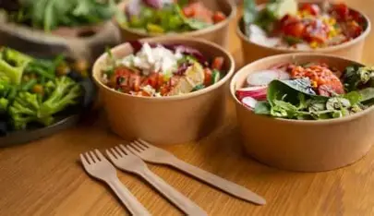

Executive Summary

FreshBite Lunch Ltd is a startup business that provides affordable, healthy homemade lunches to office workers, students and local businesses. The company aims to support the local community by offering jobs, providing nutritious meals and sourcing ingredients from local suppliers.

FreshBite Lunch will operate as a private limited company and will be managed by a small team consisting of a Managing Director, Kitchen Manager, Marketing Assistant and Delivery Driver. The business will be differentiated from competitors by offering freshly prepared meals made from locally sourced ingredients and using environmentally friendly packaging. The business intends to contribute to the local community by creating job opportunities and working alongside local suppliers. Sustainability will be increased as there will be a reduced use of unnecessary packaging, and recyclable or environmentally friendly materials will be used to reduce waste.

The market analysis shows that there is an increase in customer awareness of healthy eating and convenience, so there is a strong demand for meal delivery services. Marketing will focus on social media and partnerships with different businesses, and online ordering and customer loyalty programmes.

The business will require an initial investment of £20,000 to establish the business. The funding will contribute to the cover of the ingredients, equipment, marketing, packaging, staffing, and operating expenses. FreshBite Lunch Ltd will aim to build a sustainable and profitable business.

Table of Contents
1.Overview of the Business Idea 4
Business Description 4
Sustainability and Community Support 5
Legal Structure and Management 6
2. Market Research 7
PESTEL Analysis 7
Political 7
Economic 7
Social 7
Technological 7
Environmental 7
Legal 8
Competition 8
3. Marketing Communications 9
Social Media 9
Website and Online Ordering 9
Local Business Partnerships 9
Loyalty Schemes 9
Promotional Offers 10
4.Financials 11
Conclusion 13
Reference List 14

1.Overview of the Business Idea

Business Description

FreshBite Lunch Ltd is a food delivery startup business that specialises in preparing and delivering healthy homemade lunches. The business targets office employees, students, and local businesses that require convenient meal options during their working day, without having to rely on fast-food options. The main menu will include fresh sandwiches and wraps, homemade soups, salads, healthy bowls, fresh fruit, snacks, and healthy drink options. Customers can place orders online and can receive their order at the delivery location they wish, or workplace.

Many individuals have busy schedules, due to work or family commitments. Instead of ordering fast food meals, which can be expensive, FreshBite provides healthy homemade lunches at reasonable prices. The NHS Eatwell Guide recommends a diet containing fruit and vegetables, protein, dairy and high fibre foods (NHS, 2026). FreshBite will be implementing these principles when developing its menu.
The business's combination of fresh homemade-style food at reasonable prices, the convenience and local sourced will be their unique selling proposition (USP). Customers will still be able to order meals that will arrive quickly, but a healthier version. Therefore, the combination of affordability, and the convenience of the freshly prepared meals will help FreshBite attract customers that are looking for healthy lunches at a reasonable price.



Sustainability and Community Support

The business model will have environmental sustainability incorporated. FreshBite will aim to use recyclable or environmentally preferable food packaging, thereby reducing waste from unnecessary packaging. Food purchasing will also be monitored by the business to minimise food waste.

Businesses have responsibilities relating to the management and classification of packaging waste; therefore, it is a crucial focus for FreshBite Ltd.GOV.UK guidance explains that businesses must classify packaging waste correctly before it is collected, disposed of, or recovered (Environment Agency and DEFRA, 2025).
The local community will be supported as FreshBite will be purchasing ingredients from local suppliers and creating employment opportunities,

Legal Structure and Management
FreshBite Lunch Ltd will operate as a private limited company.
It will consist of:
- Managing Director- responsible for the overall business strategy, finances and decision making.
- Kitchen Manager- responsible for food preparation, food safety and stock control.
- Marketing Assistant- responsible for social media, promotions and customer communication.
- Delivery Driver- responsible for delivering customer orders efficiently and professionally.

To summarise, the company may recruit additional staff such as kitchen and delivery, as it grows and develops. The business will need to comply with food safety regulations before starting to operate. Food businesses in England must register with their local authority at least 28 days before trading (GOV.UK, 2026).

2. Market Research
PESTEL Analysis | 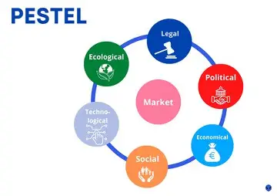

Political
There are Government policies that can affect FreshBite. The policies relate to food safety, employment, and environmental protection. The business needs to comply with food hygiene regulations and to budget for employment costs when recruiting staff.

Economic
There has been an increase in food prices, and inflation has gone up, which could affect FreshBite's profitability. The data from ONS shows that food prices increased by 4.5% in the year to December 2025 (ONS, 2025).

Social
The NHS recommends consuming at least five portions of fruits and vegetables each day (NHS,2026). FreshBite can respond to this by offering healthy meals such as salads, fruit, vegetables, and whole-grain options. The business can also respond to the convenience aspect by providing convenient food for customers who have limited time to prepare lunch.

Technological
Technology is a crucial element for FreshBite's operations. Customers place orders online and view the menu. Social media platforms such as TikTok, Instagram, and Facebook will be used to promote meals and to communicate with customers.

Environmental
Environmental issues can be seen as both a challenge and as an opportunity. FreshBite will use recyclable material for its food packaging, to reduce unnecessary materials and waste, therefore being environmentally friendly.
The GOV.UK website states that plastic packaging that contains at least 30% recycled plastic is not subject to Plastic Packaging Tax, subject to the relevant rules and thresholds (GOV.UK, 2026)

Legal
The business will need to comply with food hygiene regulations, food safety, employment and allergen requirements. Businesses that provide prepacked food for direct sale must provide ingredients and allergen information under Natasha's Law (Food Standards Agency, 2026).
When recruiting staff, the company must consider employment legislation and minimum wage requirements. From April 2026, the National Living Wage for workers aged 21 or over is £12.71 per hour (GOV.UK, 2026).

Competition
The UL business population has a large number of both small and medium-sized enterprises, which highlights the importance of understanding the competitive market when establishing a new business (Department for Business and Trade, 2024),
The business will operate in a competitive food market. There are many options customers can order healthy alternative meals from, including cafes, restaurants, and food delivery services.

For example, Grounded Kitchen in Birmingham already operates within the healthy food market, and Winny's Kitchen also provides food delivery services.
FreshBite’s advantage is that it will provide affordable, healthy meals that are home-made style and that source ingredients locally. Therefore, it will not be only price competition, but quality and accessibility.
The strategy framework by Porter's (1980) suggests that businesses need to establish a clear competitive position to remain at a competitive advantage. Therefore, the business needs to focus on a specific target market rather than attempting to serve every type of food.


3. Marketing Communications

FreshBite will combine both digital and traditional marketing methods.

Social Media
Social media will be one of the main marketing methods to promote the business. Platforms such as Instagram, TikTok, and Facebook will be used to promote the variety of meal options, advertise promotions, and communicate with customers.
Short TikTok videos can be created to show customers that the meals are being prepared freshly, which will demonstrate trust.

Website and Online Ordering
FreshBite will have a website that customers can go to explore the menu, prices, allergen information, and to place orders online.

Local Business Partnerships
FreshBite can establish regular lunch arrangements for local offices, universities, colleges, and businesses. For example, they can offer them discounted packages. This would lead to customer loyalty and repeat customers.

Loyalty Schemes
A customer loyalty scheme will ensure loyalty and repeat customers.
For example, FreshBite can offer customers a free product or a discount after a certain number of purchases.

Promotional Offers
FreshBite can offer discounts when they first launch as an incentive. This would encourage customers to try the service, whilst also allowing the business to build its customer base.
Marketing activities will be reviewed regularly through the information gathered from the website, social media, number of orders, and customer feedback. Therefore, for FreshBite, the best option for marketing is using social media such as Tiktok.

4.Financials

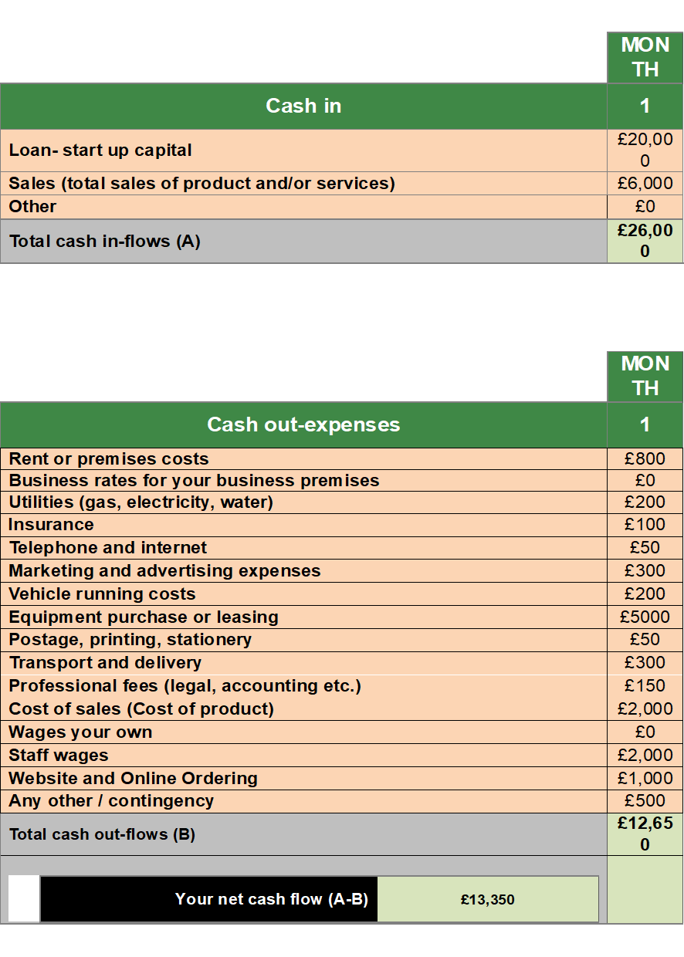

FreshBite will need approximately £20,000 initial funding.

The initial funding could be obtained from the owner's personal savings, a small business loan or potentially support from business start-up schemes or investors.
The largest initial costs are the kitchen equipment and staffing. Ingredients costs will be an ongoing expense. The business will need to compare different suppliers as food prices can fluctuate and review menu prices when necessary.
During the first month, the business will focus on attracting customers to build its customer base, rather than focusing on maximising profits. It will also monitor number of sales, food costs, staff costs, delivery costs and marketing costs.
FreshBite will aim to maximise profits by controlling costs and increasing number of sales.

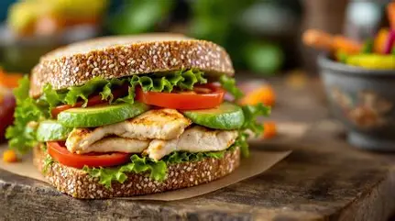

Stock images

Conclusion

FreshBite Lunch Ltd is a food delivery business that will provide affordable, healthy, and convenient lunch options in Birmingham. The business has a clear target market and USP based on affordability, convenience, local sourcing and freshly home-style prepared food.

The business will encounter challenges and competition however, they can manage them through financial management, effective marketing and quality customer service.

Local sourcing, environmentally friendly packaging, food-waste reduction and local job opportunities contribute to sustainability and to the community, making FreshBite a business that can be sustainable and with a strong future.

Reference List 

Department for Business and Trade (2024) Business Population estimates for the UK and regions 2024. Available at: https://www.gov.uk/government/statistics/business-population-estimates-2024 ( Accessed: 10th October 2026).
Environment Agency and Department for Environment, Food & Rural Affairs (2025) Packaging waste and recyclables: how to classify. Available at: https://www.gov.uk/guidance/packaging-waste-and-recyclables-how-to-classify (Accessed: 10th October 2026).
Food Standards Agency (2026) Allergen labelling changes for prepacked for direct sale (PPDS) food. Available at: https://www.gov.uk/government/publications/introduction-to-allergen-labelling-for-ppds-food (Accessed: 10th October 2026).
GOV.UK (2026) National Minimum Wage and National Living Wage rates. Available at: https://www.gov.uk/national-minimum-wage-rates (Accessed: 11th October 2026)
GOV.UK (2026) Plastic Packaging Tax. Available at: https://www.gov.uk/green-taxes-and-reliefs (Accessed: 10th October 2026).
NHS (2026) Eating a balanced diet. Available at: https://www.nhs.uk/live-well/eat-well/how-to-eat-a-balanced-diet/eating-a-balanced-diet/ (Accessed: 12th October 2026).
Office for National Statistics (2025) Consumer price inflation, UK: December 2025. Available at: https://www.ons.gov.uk/releases/consumerpriceinflationukdecember2025 ( Accessed 11th October 2026)
Porter, M.E. (1980) Competitive Strategy: Techniques for Analysing Industries and Competitors. New York: Free Press.

