
Internet Technology and Security (ACCA4018)
Image belongs to UWTSD
Link: https://uwtsd.ac.uk/bsc-web-development/
Change

Contents

Page 1: Introduction

Page 1 - 3: Requirements

Page 4 - 6: Implementation

Page 6- 8: Validation

Page 8 - 10: Evaluation

Page 10 - : References

Introduction
This report will be about a website developed by the author about the game, Sekiro: Shadows Die Twice. The website will be called RetroGib. Before development a requirements document was created which was pasted into the next section. The document includes a wireframe for how each page of the website should look, notes on the information including images and sources for the website, it also includes how it was made as accessible as possible to as many people as possible. The implementation section will be images of the website running. The validation section is when the websites http://validator.w3.org/ [] and http://jigsaw.w3.org/css-validator/ [] were used to ensure the HTML and CSS code work and have as few errors as possible respectively, it will also include how those errors were fixed or a description of them if they couldn’t. In the Evaluation section will be referencing WCAG 2.1 in order to briefly discuss the accessibility of the website with focus on the four principles that provide the foundation of web accessibility.
Requirements
Requirements Document
The websites purpose is to provide information, tips and tricks on the game Sekiro: Shadows Die Twice and its numerous side quests and bosses, the website will include information on the bosses such as a brief description, their move sets and their weaknesses. It will also include information on where to get some of the games hidden upgrade items such as prayer beads and gourd seeds. Finally, it will explain how to do go about the games numerous side quests and the different items and paths they contain. The game follows an immortal ninja (shinobi) named Sekiro as he tries to find his master who was kidnapped by the man who chopped of one of his arms and ultimately free himself and his master from the curse of immortality. Target audience. The website will be a database containing boss information, including their lore, step by step guides on side quests and the locations of upgrade items. It is relevant as the game the website is about is only a few months old and takes a long time to complete, and a lot of the content contains in this website can be missed/overlooked by players that aren’t knowledgeable about where to find the items or how to fight the numerous bosses.

Wireframes
Note: Final designs of the webpages may vary
Home Page
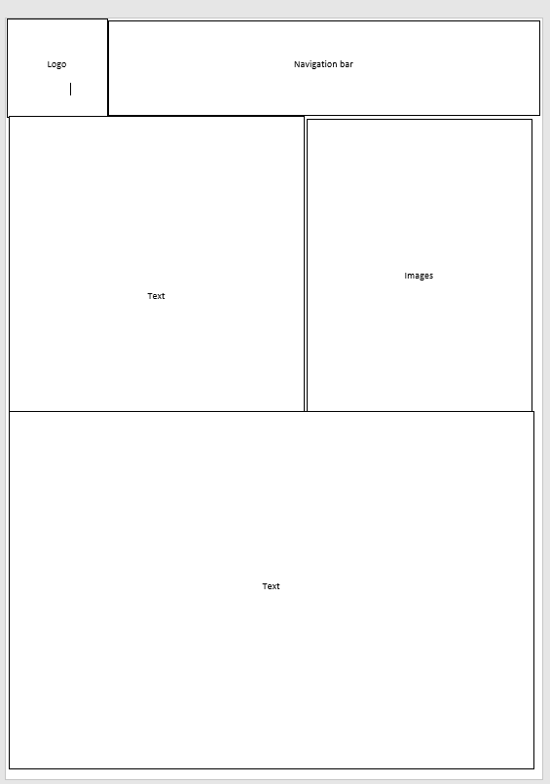

Other pages
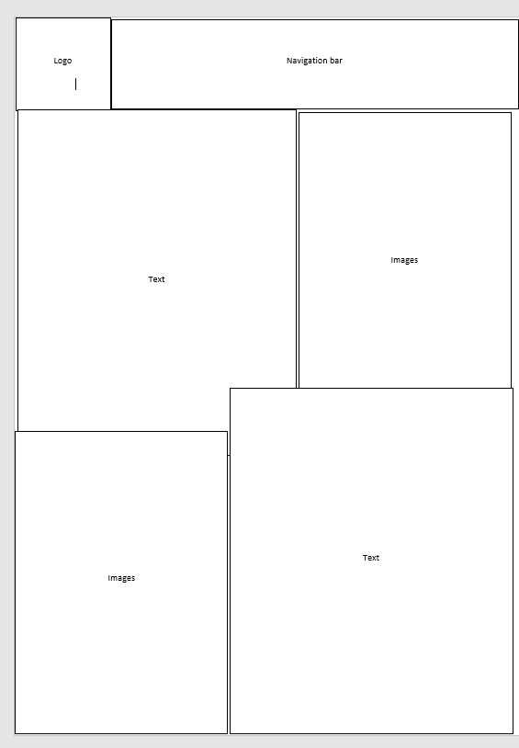

Implementation
Home Page
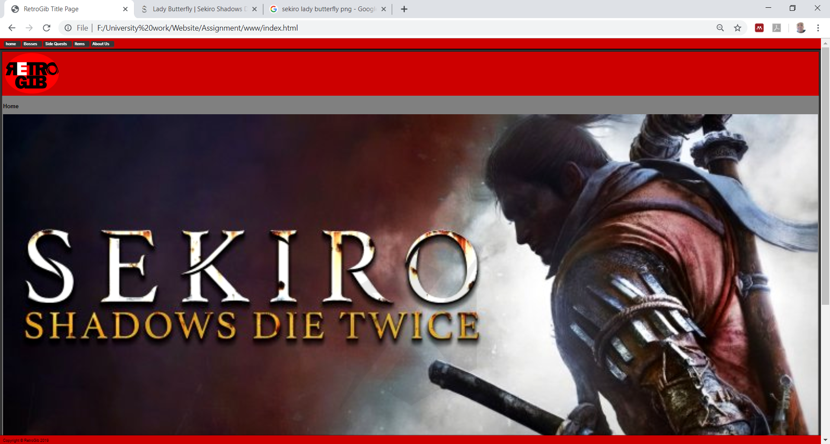
Boss Page
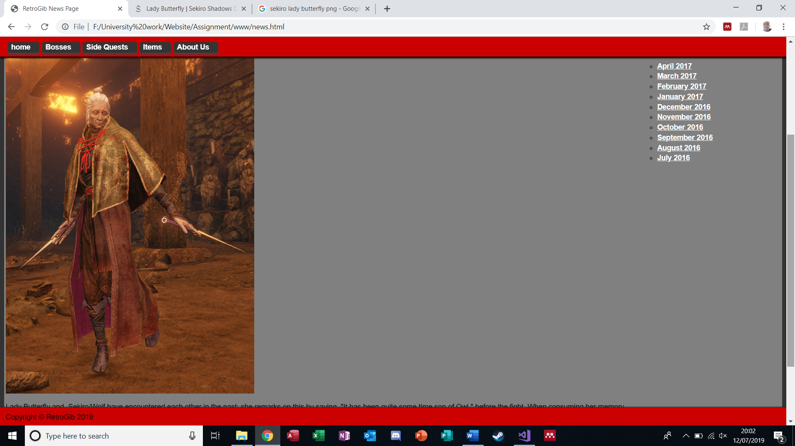

Side Quest Page
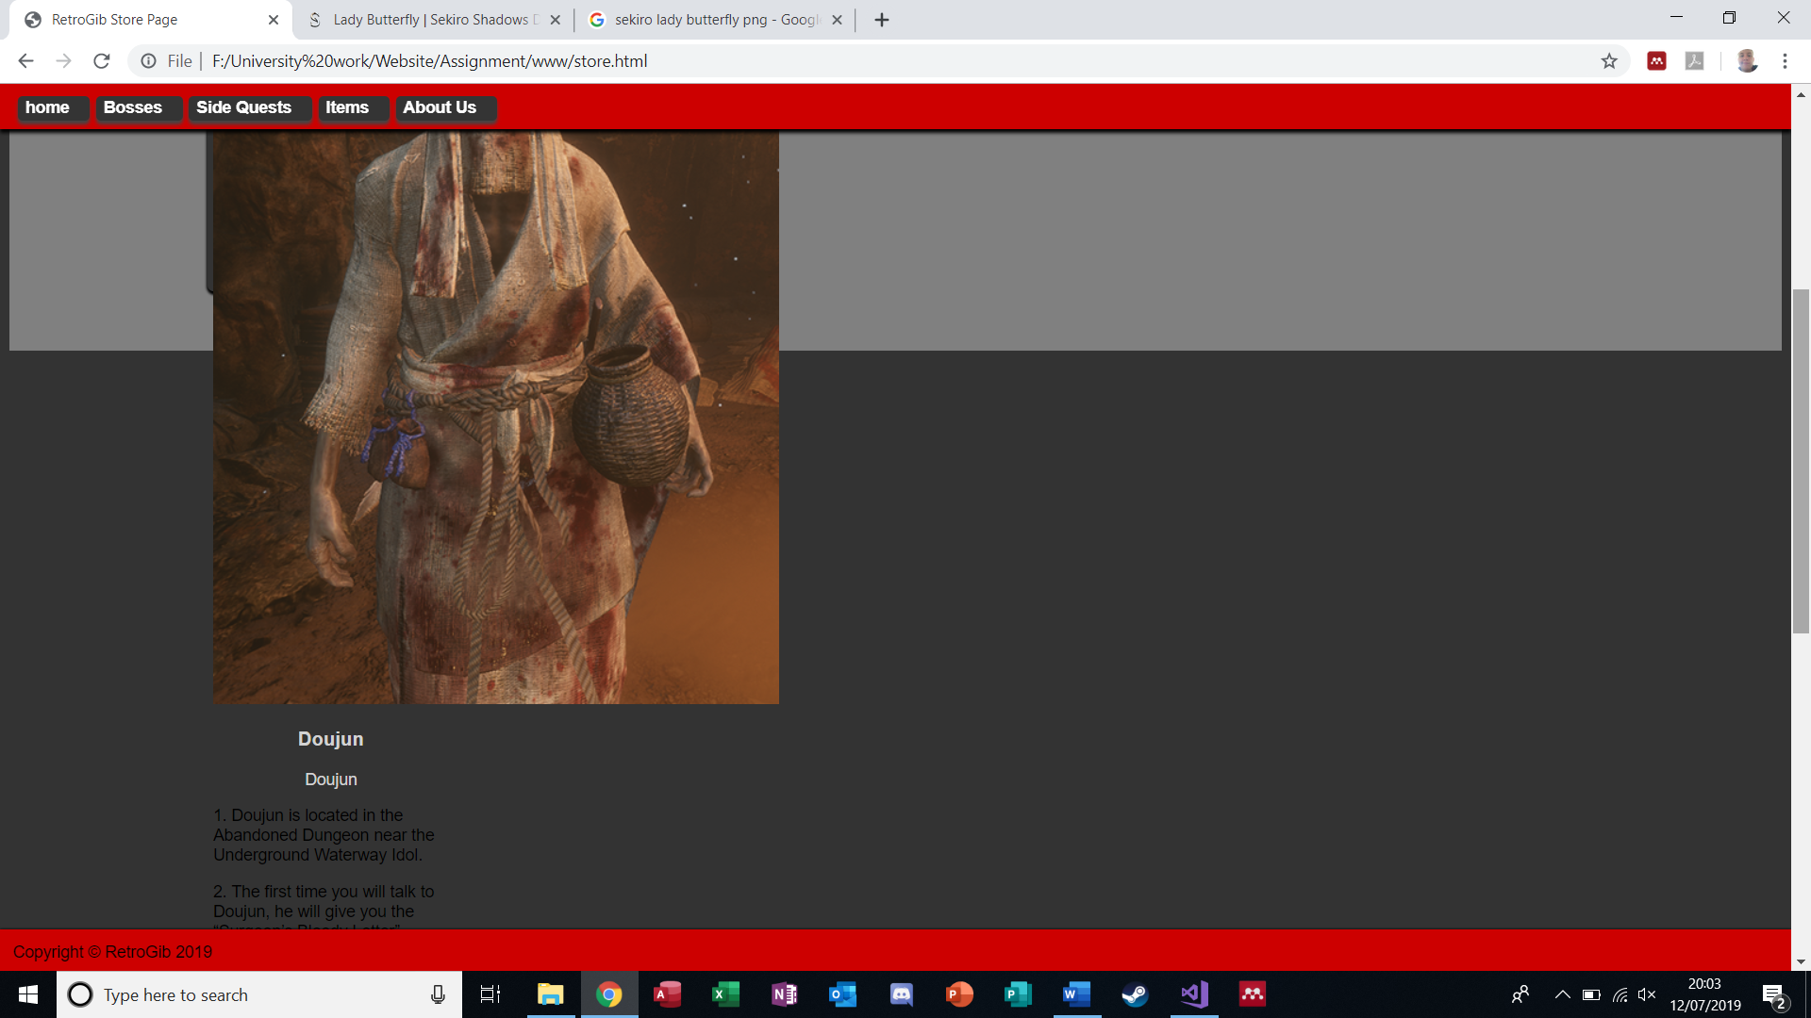
Items Page
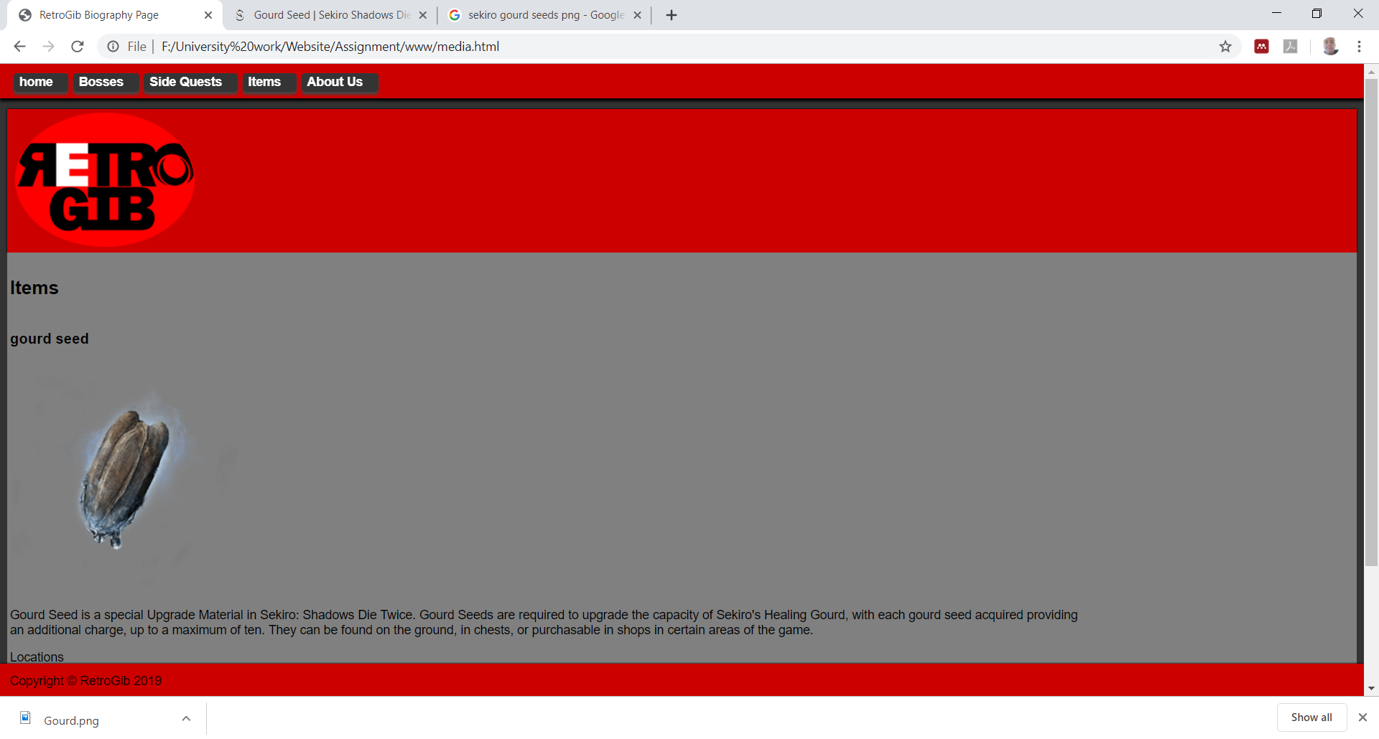

About us page
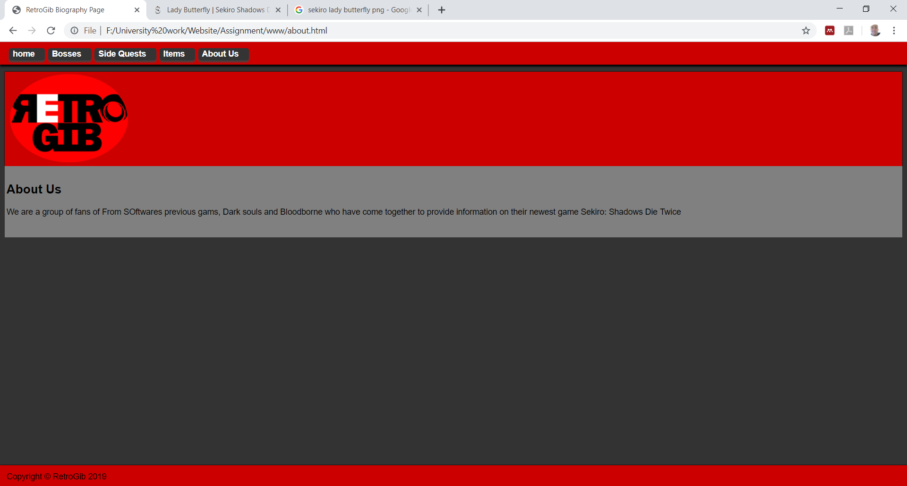
Validation
Index
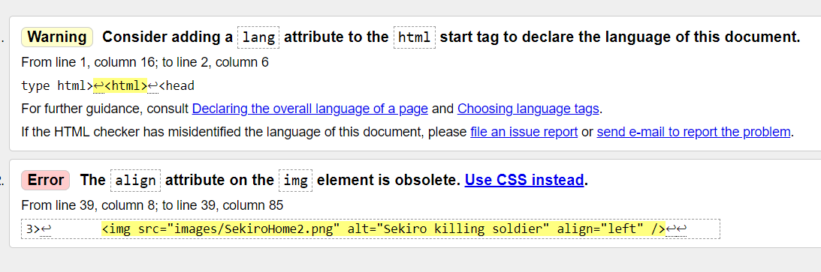
I have fixed the error.

About Us
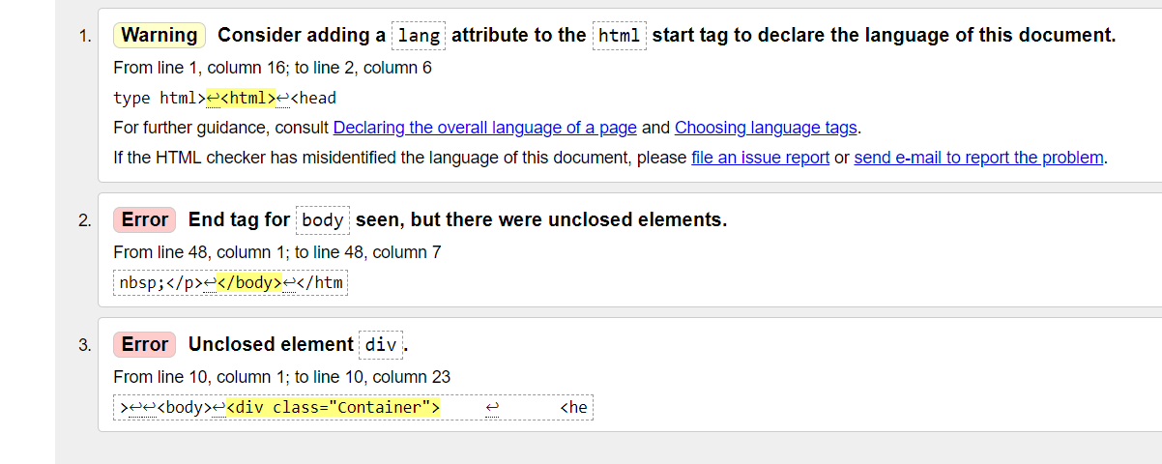
Fixed second error, which fixed the first
Item Page
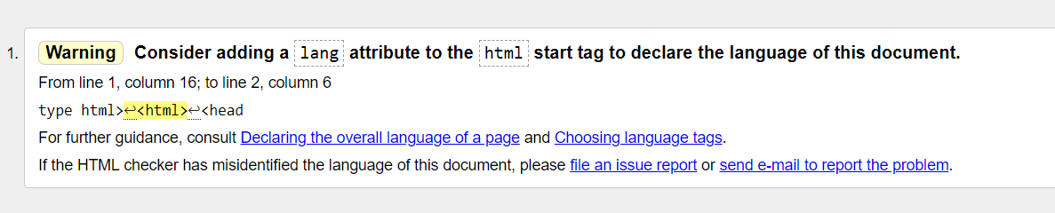
Boss Page
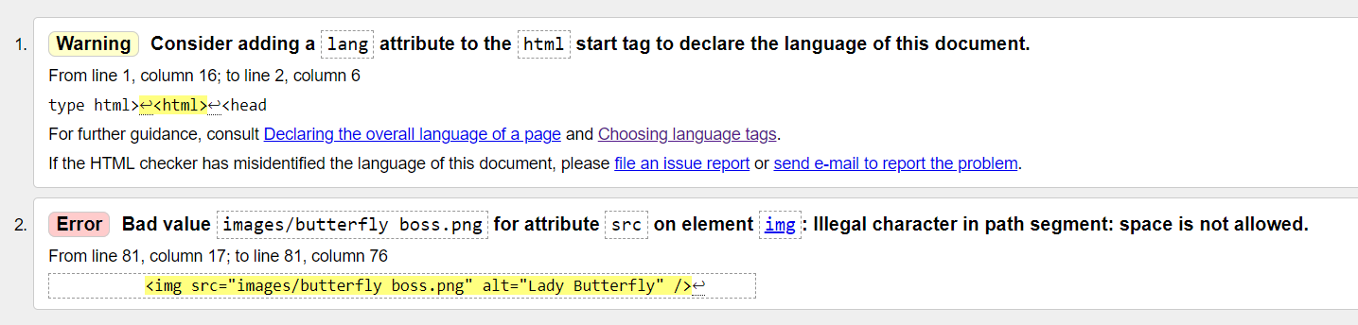

Side Quest
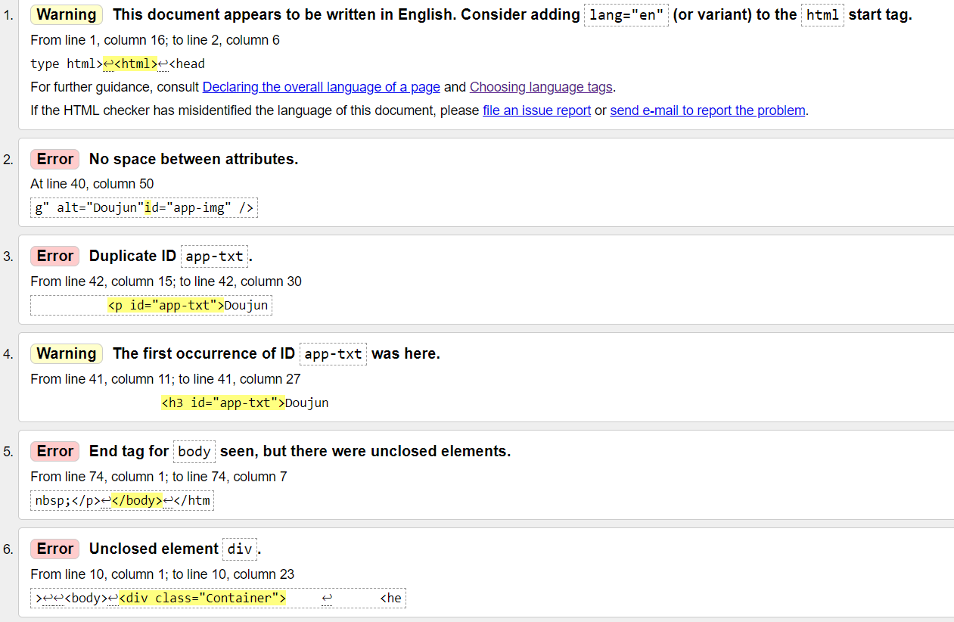
CSS
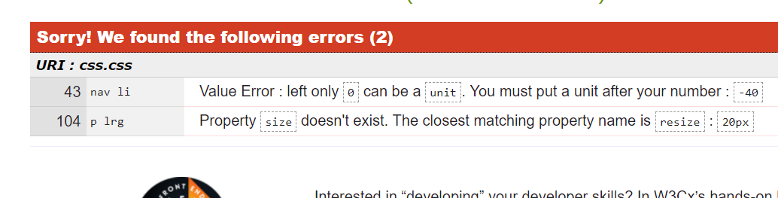
Evaluation
The following section is the criteria the website will be evaluated under.
The UK government [1] has the list of and details on the principles that WCAG have outlined.
Web Content Accessibility Guidelines (WCAG) 2.1 are the guidelines for making Web content more accessible. Following them will make content more accessible to a larger amount of people with disabilities, some of the disabilities that are accommodated are blindness (text to speech), deafness (subtitles for videos), and accommodation for learning disabilities however not all user needs will not be addressed as it would make the website slow or otherwise unusable.
WCAG have 4 design principles/criteria for website accessibility these are:
“WCAG 2.1 is based on 4 design principles:
- perceivable
- operable
- understandable
- robust” [1]
These criteria are relevant to all aspects of the website, which means it must be planned and implemented appropriately.

Principle 1: Perceivable [1]
To meet this requirement the author needs to ensure that users can recognise and use the website with the senses that are available to them.
This means there should be at least 1 of these features present in the website:
- Provide alternative text for images.
- provide subtitles for audio and video
- use appropriate text colours to prevent clashing with the background colour
- Make the website adapt to the user i.e. user’s device, page orientation and font size.
- make sure content is structured logically and can be navigated and read by a screen reader.
- make sure every feature can be used when no matter the text size.
- Don’t use images featuring small text.
- make sure the website works with assistive technologies.

Principle 2: Operable [1]
To meet the requirement of this criteria users have to be able to find and use the content present on the website, regardless of how they interact with it.
This means:
- have play, pause, and rewind functionality for videos
- not using content that can affect epileptic people
- use appropriate titles for pages and other content i.e. images and videos
- make sure everything works for keyboard-only users
- provide a ‘skip to content’ option.
- make sure users can manoeuvre around the website easily.
- use descriptive links so users know where a link will take them, or what downloadable linked content is
- make it easy for users to disable and/or change shortcut keys

Principle 3: Understandable [1]
To meet the requirement of this principle, you have to make sure people can understand your content and how the website works.
This means you need to do things like:
- use normal English
- keep sentences short
- make it clear what language the content is written in, and indicate if this changes
- make sure features look consistent and behave in predictable ways
- use word or phrases that everyone can understand, unless it is necessary to do otherwise.
- Explain all acronyms and abbreviations
- Make sure the website is consistent and behaves predictably

Principle 4: Robust [1]
To meet this principle, you must make sure your content can be interpreted reliably by a wide variety of users.
This means you need to do things like:
- use valid HTML so user agents, including assistive technologies, can accurately interpret and parse content
- allows the user return to what they were doing after they’ve interacted with the status message or modal input
The website meets Principle 1 as it utilizes alternate text for all images, uses a text colour that appropriately contrasts against the background.

References
[1] - https://www.gov.uk/service-manual/helping-people-to-use-your-service/understanding-wcag

