


Cover Page

Dale Monks

Module: Advanced Construction Technology
Module code: ACBA6009
Student ID: 2114358

Word Count - 2680 (Exc Reference Section)

1.0 - Table of Contents
Contents
Cover Page 1
Dale Monks 1
1.0 - Table of Contents 2
2.0 - Index of Tables 3
3.0 - Index of Figures 3
4.0 - Introduction 4
5.0 - Feasibility Report 4
5.1 - Geotechnical Investigations 4
5.2 - Geotechnical Initial Recommendations 6
6.0 - Foundations and Superstructure 7
7.0 - Off-Site Construction Approaches 9
7.1 - Suitable Approach 10
8.0 - Building Envelope 10
9.0 - Building Services and Sustainability Report 11
9.1 - Heating and Cooling Options 11
9.1.1 - Passive Methods 11
9.1.2 - Active Systems 12
10.0 - Recommended Heating and Cooling System 13
11.0 - Intelligent Building Features 14
12.0 - Fire Safety 15
13.0 - Innovative Materials and Methods 16
13.1 - Materials 16
Internals 16
13.2 - Methods 17
14.0 - Sustainability Considerations 17
14.1 - Energy Efficiency 17
15.0 - Additional Options 18
16.0 - References 19

2.0 - Index of Tables

3.0 - Index of Figures
Figure 1 - Geology - (British Geology Survey, 2025) 4
Figure 2 - Borehole Data - (British Geology Survey, 2025) 5
Figure 3 - Borehole Depths - (British Geology Survey, 2025) 5
Figure 4 - Raft Pilled Foundations - (Jerzy Szołomicki, 2021) 7
Figure 5 - Pile Foundations - (Greeno, 1988) 7
Figure 6 - Butress Core 8
Figure 7 - Outrigger Truss - (Jerzy Szołomicki, 2021) 8
Figure 8 - Marriot Swansea - Algae Façade - (Monks) 10
Figure 9 - Marina Swansea - Wood Façade - (Monks) 10
Figure 10 - Quartzite Stone Tiles/Cladding 11
Figure 11 - Average temperatures below ground level - (Jon Busby, 2020) 13

4.0 - Introduction
This report will provide guidance and advice to the development team at the SA1 Project, constructing a luxury block of flats, considering the clients specifications.

5.0 - Feasibility Report
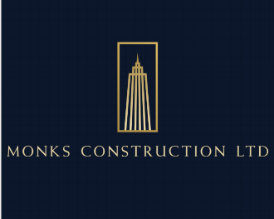
__________________________________________________________________________________
Client: UWTSD
Project: Luxury Flats Development in Maritime Qtr, Swansea
Prepared by: Monks Construction
Date: 13.12.2024

5.1 - Geotechnical Investigations
Swansea is the 5th wettest city in the UK in 2021 with monthly average rainfall of 83.7mm and 12.3 average number of wet days per month (TOUA, 2021).
Using the mapping tools available at British Geology Survey (BSG) website, we can see the strata underneath the area is alluvium, clay, silt, sands, and gravel, as seen if Figure 1.
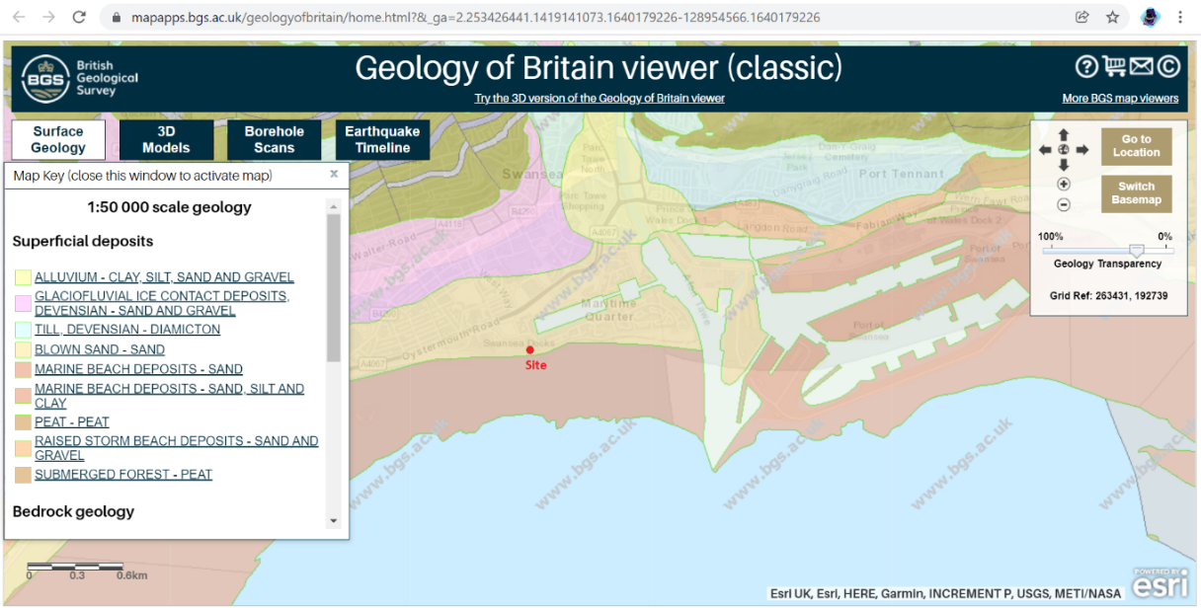
Figure 1 - Geology - (British Geology Survey, 2025)
The data also provides us with a list of boreholes in the vicinity, as seen in Figure 2.
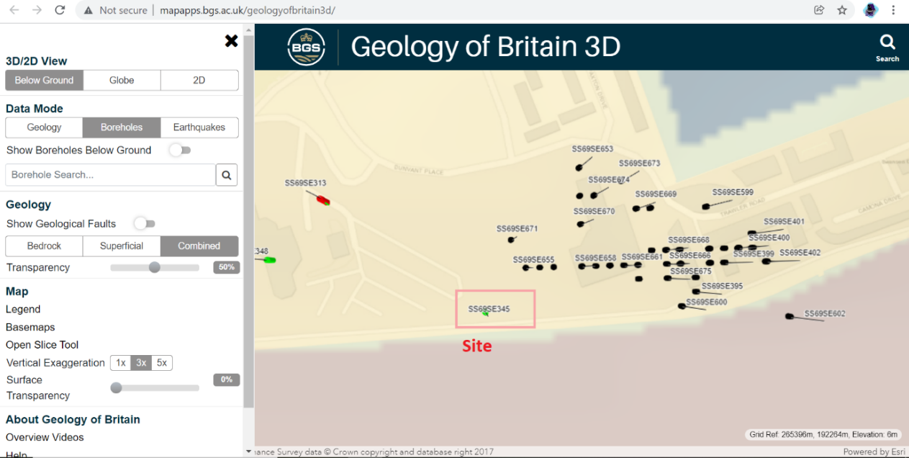
Figure 2 - Borehole Data - (British Geology Survey, 2025)
This borehole ‘ss69se345 - proposed new county hall Paxton street Swansea, displayed as Figure 3, shows a depth drilled to 22m, uncovering grey mudstone at a depth of 18.6m down to 22m.
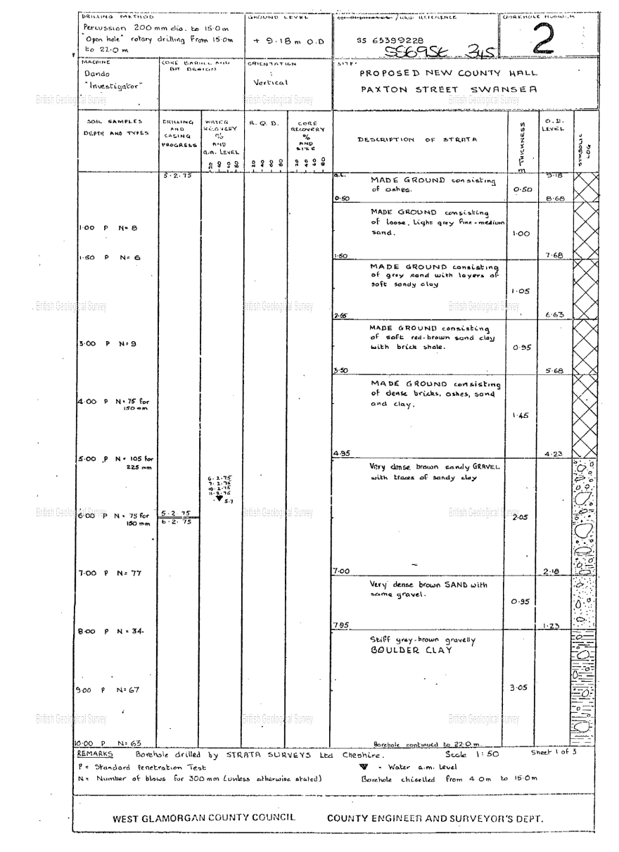
Figure 3 - Borehole Depths - (British Geology Survey, 2025)
The area is part of a designated quiet area as assigned by the NRW’s Noise Action Plan. The site is also classed as National Marine Character Areas. Therefore, these bodies will be contacted to create links as stakeholders and in turn uncover any additional requirements from materials and or construction restrictions (NRW, 2024).

5.2 - Geotechnical Initial Recommendations
- Soil Sampling Investigation/Ground Investigation following BS EN 1997-2, this will provide a specifics to:
- Angle of shearing resistance and drained young modulus. bearing/sheering capacity.
- Determine the settlement for spread foundations
- Stress dependent oedometer modulus from CPT results
- Compressive resistance of a single pile.
- Sampling and ground water measurements following EN ISO 22475-1 and Sampling qualification criteria EN ISO 22475-2.

6.0 - Foundations and Superstructure
Foundations: Due to the maritime location and the depth required of 18-22m as per the borehole data (Figure 3), pile foundations are suggested to ensure stability.
Piled raft foundations evenly distribute weight across the concrete pad, making them ideal for high-rise buildings, unlike general raft foundations, which can't support such weight. Caisson foundations suit water-rich ground conditions. A dual system of raft and piles efficiently handles heavy loads and controls settlement, beneficial for tall buildings on stiff clays or dense sands. This system can be cost-effective by reducing the number of piles needed, thus potentially lowering costs. (Structures Centre - Foundations, 2025)
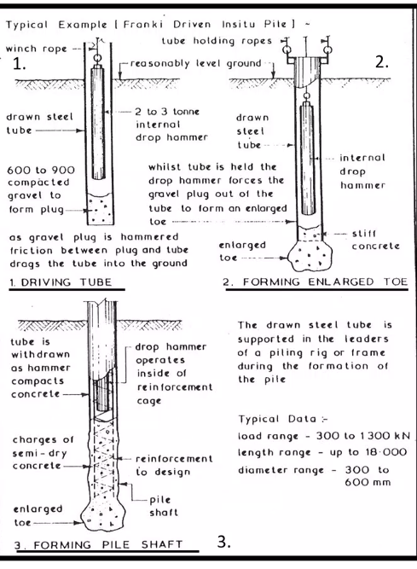
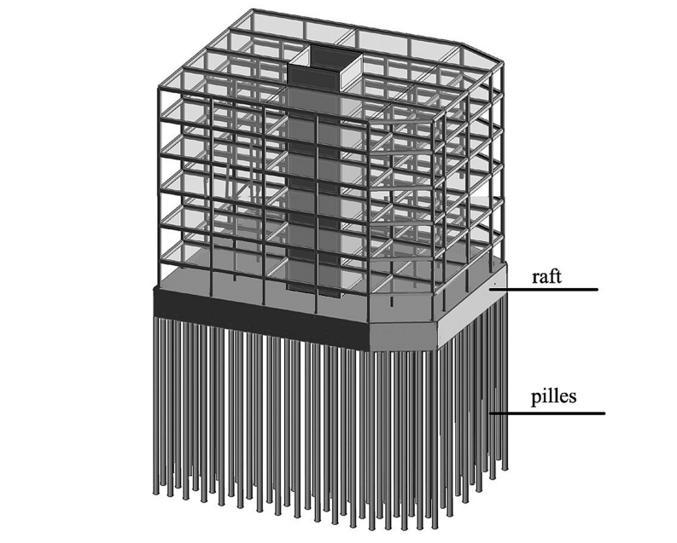
Figure 4 - Raft Pilled Foundations - (Jerzy Szołomicki, 2021)
Figure 5 - Pile Foundations - (Greeno, 1988)
After completing a Poulos-Davis-Randolph (PDR) analysis which simplifies complex soil-pile-raft interactions into manageable calculations. The stiffness values for the raft (K_{r}), piles (K_{p}​), and the combined system (K_{pr}) are critical parameters whilst factoring the weight, height and total area of the build, we recommend pilled raft foundations (Impe, 2021).

Superstructure: A steel frame is ideal for supporting modular construction, offering strength and flexibility for multi-storey designs, coupling this with a buttressed core system, the central reinforced concrete core and three supports provide lateral stability and resistance to wind forces, a critical feature for tall structures. This is a similar system used on the Burj Khalifa Residences, Dubai in Figure 6 - Butress Core.
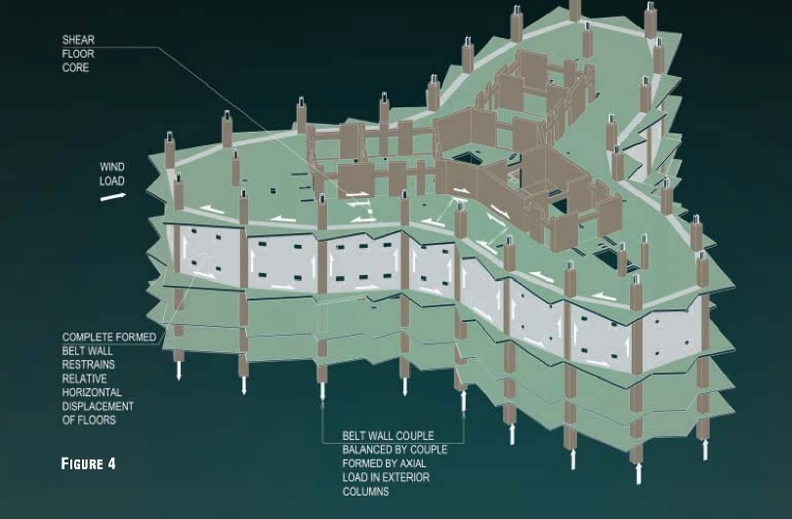
Figure 6 - Butress Core
This system eliminates the need for interior columns offering open and luxurious living spaces, or can be constructed using an outrigger truss system (Figure 6) providing lateral stability, significantly speeding up construction while maintaining precision, allows for open floor plans without columns, maximizing the luxury feel (W. Baker, 2012) as seen in the One57 building in NYC.
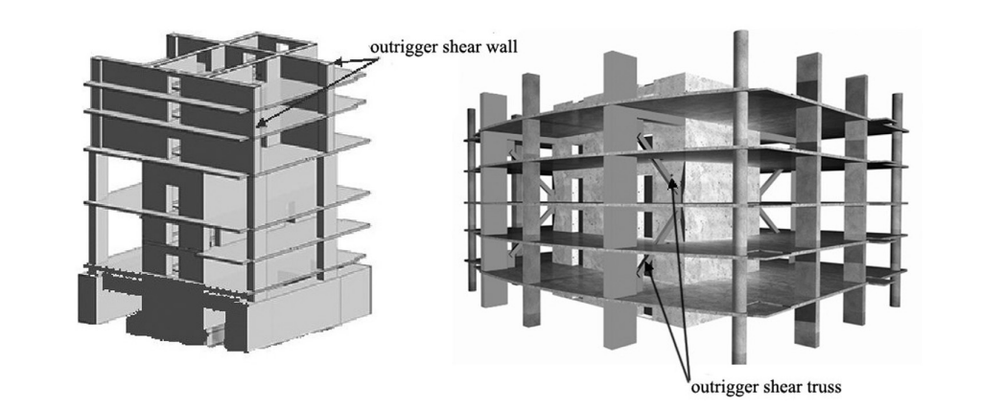
Figure 7 - Outrigger Truss - (Jerzy Szołomicki, 2021)

7.0 - Off-Site Construction Approaches
Primarily, it reduces construction time significantly by allowing building components to be manufactured concurrently with site preparation. This leads to faster project completion and reduced labour costs. It also enhances quality control, as components are produced in a controlled factory environment utilising LEAN methodologies and provides a safer environment for the employees to work reducing workplace accidents (Gov.uk, 2024)
Off-site construction is not hampered by poor weather conditions or low natural light in the winter months, increasing time to construct. This method is environmentally friendly, generating less waste and promoting sustainability through efficient use of materials. Additionally, it minimises disruptions to surrounding communities, as much of the noisy, disruptive work is conducted off-site. The result is safer, cleaner, and more efficient construction processes (Juan Du a, 2023). However, delivery to site of large fully furnished pods needs to be well planned, as not to hinder traffic or cause damage with cranes through small lanes. Working with the local authority to manage delivery times during low traffic flows would further minimise disruption and risk.
To achieve a high spec finish, we recommend using a hybrid system, of volumetric construction such as prefabricated modules manufactured off-site and transported for assembly, with Panelised Systems Flat panels (walls, floors). Thus, allowing for some modifications during the install phase and being customised by the end user.
Whilst some emerging technologies show real progress in 3D concrete printing, research indicates it would not be suitable for a high-rise building in the UK at this time, due to the printing machinery needing specialist supervision, continued security and presents health and safety concerns of being operated whilst other employees are within the site (3D printing in construction, 2024).
7.1 - Suitable Approach
Volumetric Construction is recommended due to:
Efficient use of restricted space leads to minimal on-site activities and faster construction times. Modules can be produced simultaneously with site preparation, ensuring quicker project completion. Factory-controlled conditions enhance quality control, allowing for precise construction. This method also promotes sustainability by minimizing waste and enabling the reuse of modules when necessary. (Gov.uk, 2024)

8.0 - Building Envelope
Selecting the correct building envelope to marry the volumetric pods would require another hybrid system utilising a curtain wall of sleek modern high glass content to maximise solar gains from its coastal location, including well positioned green facade, featuring living walls, which enhance both sustainability and visual appeal, contributing to the building's eco-friendly credentials.
Taking note of how similar buildings in the marina have seen a high algae growth upon render, requiring ongoing maintenance, creating poor aesthetics (Figure 8), some other buildings have utilised wood (Figure 8), but this must be approved under the Building Safety Act approved materials, this cladding could be hazardous akin to the Grenfell disaster (BBC, 2024). In recent months this wood façade was removed as it did not meet the required fire rating standards. (BBC, 2023)
Therefore, we recommend using a cladding system with lightweight stone tiles which can be locked in place, preferable made from quartzite (Figure 10) which is found naturally in Wales making it a local and sustainability sourced material (Quartzite – Formation, Composition, Properties, and Uses, 2024).
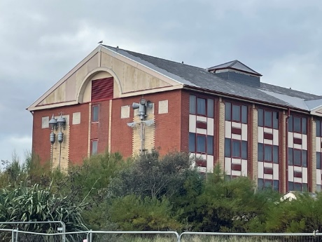
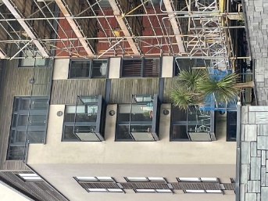

Figure 8 - Marriot Swansea - Algae Façade - (Monks)
Figure 9 - Marina Swansea - Wood Façade - (Monks)

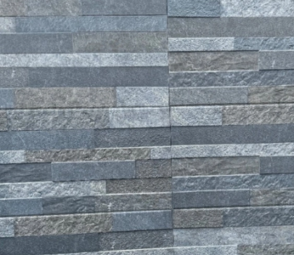
The nearly pure silica content of the rock provides little opportunity for chemical or organic bodies to form. This stone can be further protected at the point of manufacturing with an impregnating sealer which has a high silicone content, to resist any water damage for prolonged spells.

Figure 10 - Quartzite Stone Tiles/Cladding
As for the design element we would recommend using composite materials such as Aluminium, Fibre Cement which are lightweight and highly customizable, making them ideal for a variety of design needs.
A combination of curtain walling and composite panels is recommended for the following reasons:
- Distinctive Appearance - Combination allows for bold and unique designs, incorporating reflective or textured finishes.
- Energy Efficiency - Utilizing triple glazing in curtain walls helps minimize heat transfer, improving energy efficiency.
- Sustainability - Composite panels often incorporate recycled materials, contributing to the project's sustainability goals.

9.0 - Building Services and Sustainability Report

9.1 - Heating and Cooling Options

9.1.1 - Passive Methods
- Thermal Massing: Thermal massing involves using materials that have the capacity to store heat and gradually release it. By optimizing this principle, buildings can maintain a more stable indoor temperature without relying heavily on mechanical heating or cooling
- Solar Shading: Solar shading includes the use of adjustable screens, louvers, or overhangs to control the amount of sunlight entering the building. This technique helps in managing solar gain, reducing heat buildup during peak sunlight hours. By adjusting the shading systems, the building can optimize daylight while minimizing the need for air conditioning. Particularly effective in climates with significant seasonal temperature variations.
- Trombe Wall: A Trombe wall is a passive solar design feature that consists of a thick, heat-absorbing wall positioned directly behind a large south-facing window This wall is typically made of materials with high thermal mass, such as concrete or brick, which can absorb, store, and slowly release heat.

9.1.2 - Active Systems
- Chilled Beam Systems: Chilled beam systems are an advanced form of cooling that circulates chilled water through panels (or beams) placed in the ceiling.
- Heat Pumps (Ground-Source or Air-Source): Heat pumps are highly energy-efficient systems that can provide both heating and cooling by transferring heat between the building and the environment. Ground-source heat pumps (GSHP) use the stable temperatures of the ground as a heat source or sink, making them particularly effective in maritime or temperate climates where the ground remains relatively consistent year-round. Air-source heat pumps, on the other hand, draw heat from the outside air.
- VRF Systems (Variable Refrigerant Flow): VRF systems are highly efficient and flexible air conditioning and heating solutions that allow multiple zones within a building to be controlled independently. These systems use refrigerants to provide heating or cooling and can adjust the flow based on the demand in different areas. VRF systems are ideal for buildings with varying temperature needs across different zones, offering substantial energy savings while maintaining comfort.

10.0 - Recommended Heating and Cooling System
The proposed heating and cooling system for the building is a Ground-Source Heat Pump (GSHP) system, coupled with underfloor heating. This combination is recommended due to the following advantages:
- High Efficiency: The GSHP system operates by extracting heat from the ground, which maintains a stable temperature throughout the year, resulting in a highly efficient method for both heating and cooling. This reduces the overall energy consumption of the building, contributing to lower operational costs. (Jon Busby, 2020)
- Low Operational Costs: The integration of GSHP with underfloor heating minimizes energy usage and reduces long-term operating expenses, offering a sustainable and cost-effective solution.
- Suitability for Maritime Location: The GSHP system is especially suited to the building’s maritime location, where stable subsurface temperatures can be leveraged. This system capitalizes on the consistent temperatures found underground, offering reliability and energy efficiency in this specific geographic context.
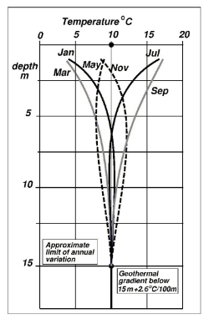
Figure 11 indicates that the average temperature below UK ground level is a 10°c at 15m. At a proposed foundation depth of 18-22m this would see an increase of 2.6°c per 100m, making it an ideal choice for this project.

Figure 11 - Average temperatures below ground level - (Jon Busby, 2020)

11.0 - Intelligent Building Features
Intelligent building features help enhance operational efficiency, comfort, and energy savings by integrating advanced technologies into the building systems.
- Building Management Systems (BMS): A BMS automates the control of various building functions, including lighting, heating, ventilation, air conditioning (HVAC), and energy monitoring. This system ensures optimal performance, energy conservation, and operational efficiency by adjusting settings based on real-time data and occupancy patterns.
- Smart Thermostats: Smart thermostats allow for more precise control of heating and cooling systems, enhancing occupant comfort and energy efficiency. These devices can be programmed or learn from occupant preferences and external weather conditions, ensuring that energy is not wasted on unnecessary heating or cooling.
- IoT Sensors: Internet of Things (IoT) sensors will be used throughout the building to monitor critical parameters such as air quality, temperature, and occupancy. These sensors provide real-time data that helps adjust building systems for comfort and efficiency, contributing to overall energy savings and enhanced indoor air quality.

12.0 - Fire Safety
Ensuring the safety of building occupants in the event of a fire is paramount. The proposed building should feature several fire safety measures:
- Sprinkler Systems: Automatic sprinkler systems are essential for controlling fires, particularly in high-rise buildings where fire spread can be rapid.
- Compartmentalization: We recommend fire-resistant barriers that compartmentalize the building, limiting the spread of fire between units and sections of the building. This increases the time available for evacuation and firefighting interventions.
- Fire-Resistant Materials: Key structural elements and walls will be constructed using fire-resistant materials to ensure the building’s integrity in case of a fire. These materials help prevent the spread of fire and smoke.
- Evacuation Systems: Clearly marked evacuation routes, pressurised stairwells, and dedicated firefighting lifts should be incorporated into the design. These systems ensure safe and efficient evacuation of occupants and allow firefighting personnel to access critical areas of the building quickly as seen in the Petronas Towers, Kuala Lumpur, Malaysia and any other modern high rise buildings, which is far more prevalent since the Grenfell and 9/11 disaster (chakra, 2020).

13.0 - Innovative Materials and Methods
The use of innovative materials and construction methods plays a crucial role in enhancing the building's sustainability, performance, and longevity. We recommend using the below materials where possible.

13.1 - Materials

Internals
- Cross-Laminated Timber (CLT): CLT is a sustainable building material made from layers of wood glued together at right angles. It is strong, lightweight, and has excellent thermal properties. CLT is particularly suited for internal features and partitions, providing a natural aesthetic and contributing to the overall sustainability of the building. (Souza, 2018)
- Graphene-Enhanced Concrete: Graphene is a material known for its exceptional strength and conductivity. When added to concrete, it enhances the material’s durability while reducing the volume of concrete needed. This innovation allows for more sustainable use of concrete while maintaining strength and reducing material waste. (Prof Dusan Losic, 2020)
- Self-Healing Concrete: Self-healing concrete is designed to automatically repair cracks that form over time. This reduces the need for maintenance and extends the lifespan of the building’s structural elements, contributing to both cost savings and sustainability. (Venugopal, 2020)
- Recyclable Materials: Recyclable materials will be prioritized in the building’s cladding (Quartzite) and internal finishes a mix of marble and Quartz which are highly prized for their durability, non-porous nature, and stunning appearance. They are resistant to scratches, stains, and heat. Additionally, quartz offers a wide range of colours and patterns, allowing for a customized look and does not require ongoing maintenance such as marble or granite which are porous. This will help reduce the environmental impact of construction and ensure that materials can be reused or recycled at the end of their lifecycle.

13.2 - Methods
- Digital Twin Technology: Digital twin technology creates a virtual replica of the building that can simulate its performance throughout its lifecycle. This allows for real-time monitoring, predictive maintenance, and optimization of building systems. By integrating digital twin technology, the building’s performance can be continually optimized for energy efficiency, comfort, and safety.
- 3D Printing: 3D printing technology is used for the creation of customized architectural elements, that may be difficult or costly to achieve using traditional methods. However, we do not recommend this approach as detailed in section 7.0.

14.0 - Sustainability Considerations

14.1 - Energy Efficiency
- Solar Panels: should be installed on the building’s roof to offset the dependency on grid electricity. This will contribute to the building's energy needs, reducing its carbon footprint and overall energy costs.
- Rainwater Harvesting: should be implemented to collect and store rainwater for non-potable uses such as irrigation and cleaning. This reduces the demand on the local water supply and promotes sustainability.
- Passive Solar Design: The building will be oriented to maximize natural sunlight, minimizing the need for artificial lighting. Incorporating large windows, skylights, improving light penetration and energy efficiency.

15.0 - Additional Options
To achieve the luxury status required we recommend including a swimming pool, gym, sauna and steam room. The buildings dimensions also allow for several penthouse suites, with private elevator access. In competition with the Meridian tower, it is advised to utilise an upper floor as a restaurant.

16.0 - References

- 3D printing in construction. (2024, 12 07). Retrieved from UCEM: https://www.ucem.ac.uk/whats-happening/articles/3d-printing-construction/
- BBC. (2023, 03 27). Cladding: Swansea flat owner's cautious welcome on safety scheme. Retrieved from BBC News: https://www.bbc.co.uk/news/uk-wales-65036387
- BBC. (2024, 12 5). Grenfell Tower inquiry: 9 things we now know about the cladding. Retrieved from BBC News: https://www.bbc.co.uk/news/uk-56403431
- BBC. (2024, 12 07). Red weather warning issued as Storm Darragh targets UK with 90mph winds and flooding rain. Retrieved from BBC NEWS: https://www.bbc.co.uk/weather/articles/cd60v5d744lo
- British Geology Survey. (2025, 12 07). Geology of Britian Viewer. Retrieved from Geology of Britian Viewer: https://mapapps.bgs.ac.uk/geologyofbritain/home.html?&_ga=2.253426441.1419141073.1640179226-128954566.1640179226
- chakra, M. A. (2020). THE LACK OF FIRE SAFE CK OF FIRE SAFETY KNOWLEDGE AND IMPLEMEN Y KNOWLEDGE AND IMPLEMENTATION. Beirut: Beirut Arab University.
- Gov.uk. (2024, 11 26). Volumetric Modular Construction research. Retrieved from Gov.UK: https://www.gov.uk/government/publications/volumetric-modular-construction-research/volumetric-modular-construction-research#:~:text=The%20effective%20implementation%20of%20volumetric,and%20reduce%20project%20lifecycle%20costs.
- Greeno, R. C. (1988). Building Construction Handbook. Oxford: Butterworth-Heinemann.
- Impe, P. D. (2021, 12 4). METHODS OF ANALYSIS OF PILED FOUNDATIONS. Retrieved from International Society of Soil Mechanics and Geotechnical: http://geo-soft.ru/userfiles/File/files/94_Pile_raft_foundation.pdf
- Jerzy Szołomicki, H. G.-S. (2021). Analysis of technical problems in modern super-slim. Poland: Orginal Article.
- Jon Busby, M. L. (2020). Initial geological considerations before installing ground source heat pump. Nottingham: British Geological Survey.
- Juan Du a, J. Z.-L. (2023, 06 1). Lean manufacturing applications in prefabricated construction projects. Retrieved from sciencedirect: https://www.sciencedirect.com/science/article/abs/pii/S092658052300050X
- Monks, D. (n.d.). Facades. Swansea.
- NRW. (2024, 12 07). LLE. Retrieved from http://lle.gov.wales/map#m=-3.93725,51.61481,15&b=europa&l=95;108h;109h;110h;111h;112;113h;114h;115h;
- Prof Dusan Losic, D. A. (2020). GRAPHENE ENHANCED CONCRETE:. Adelaide: First Graphene Ltd.
- Quartzite – Formation, Composition, Properties, and Uses. (2024, 12 04). Retrieved from Earth Eclipse: https://eartheclipse.com/science/geology/quartzite.html
- Souza, E. (2018, 05 01). Cross Laminated Timber (CLT): What It Is and How To Use It. Retrieved from archdaily.com: https://www.archdaily.com/893442/cross-laminated-timber-clt-what-it-is-and-how-to-use-it?form=MG0AV3
- Structures Centre - Foundations. (2025, 12 07). Retrieved from Structures Centre: https://structurescentre.com/comprehensive-guide-to-piled-raft-foundations/
- TOUA, M. (2021). UK's wettest towns and cities mapped - and it's not Manchester! Lodon: Daily Express.
- Venugopal, A. (2020, 09 30). Self-healing Concrete | How Self Healing Concrete Works. Retrieved from EngineeringCivil.org: https://engineeringcivil.org/articles/concrete/self-healing-concrete-how-self-healing-concrete-works/?form=MG0AV3
- W. Baker, J. P. (2012, 10 1). Higher and Higher: The Evolution of the Buttressed Core. Retrieved from Semantic Scholar: https://www.semanticscholar.org/paper/Higher-and-Higher%3A-The-Evolution-of-the-Buttressed-Baker-Pawlikowski/c2ab91fccaa239004ba1cfb8fa9523f70ed561e6

