University of Wales Trinity Saint David
School of Engineering



Ultrasonic Attenuation Coefficient Determination and Probability of Sizing Analysis
ACEA7013

Jacob Quarry
(2000885)
08/01/2024
Contents
1 Ultrasonic Attenuation Coefficient Determination 1
1.1 Abstract 1
1.2 Apparatus 1
1.3 Methodology 2
1.4 Measurements 3
1.5 Calculations 4
1.6 Results 5
1.7 Conclusion 9
2 Probability of Sizing Analysis 10
2.1 Abstract 10
2.2 Methodology 10
2.3 Measurements 10
2.4 Calculations 10
2.5 Results 11
2.6 Conclusion 13
3 References 14

Ultrasonic Attenuation Coefficient Determination

Abstract
The focus of this study was to measure and calculate the ultrasound attenuation coefficient of steel and aluminium using two sample pieces and a 5MHz ultrasonic probe.

Apparatus
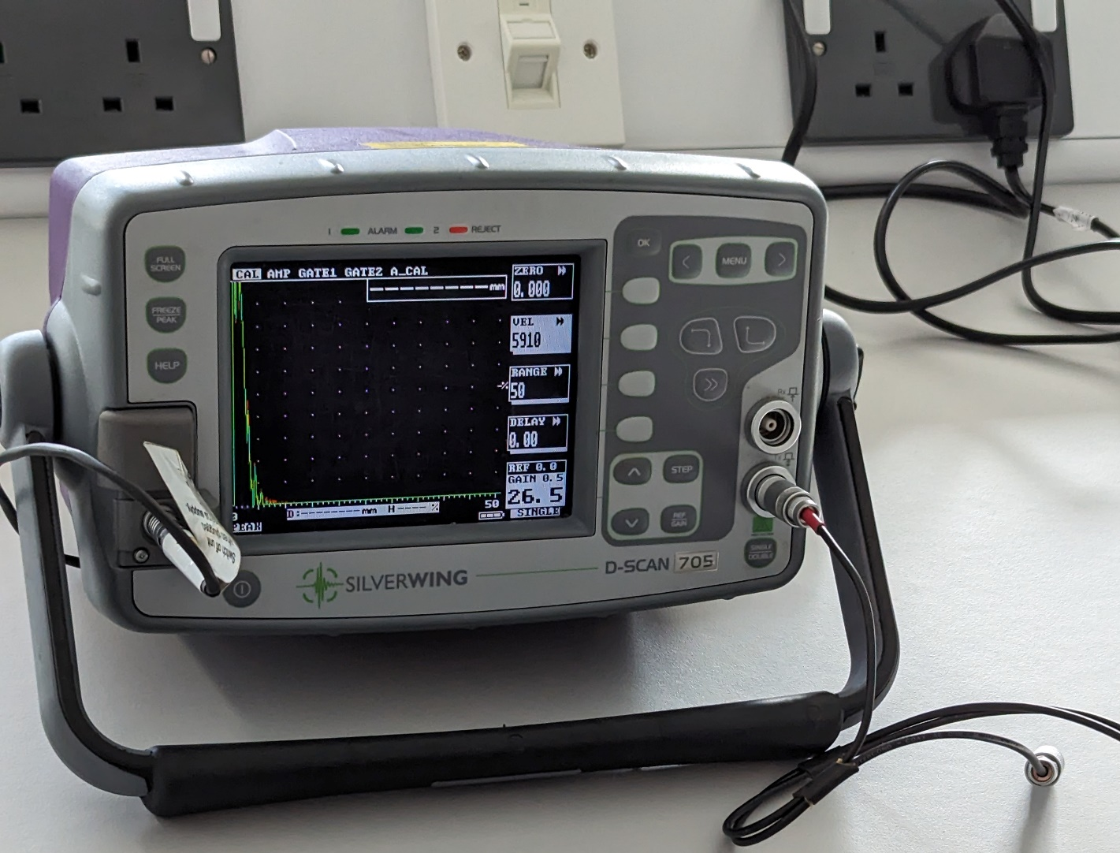
Figure 1 - The Oscilloscope and 5Mhz probe used for recording measurements.

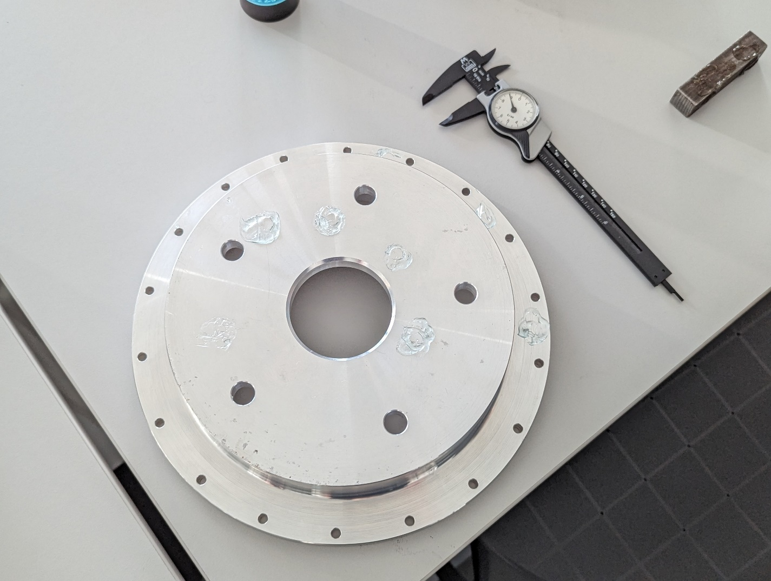
Figure 2 - The two test pieces with the aluminium spacer on the left and steel bar on the right.
For this experiment a 5MHz ultrasonic probe was used, connected to a digital oscilloscope to report the results, as shown in fig. 1. Fig 2 shows the two test pieces of an aluminium spacer and steel bar. It further shows the use of ultrasonic medium, in this case hair gel, to expel any air and maintain good conductivity and also the vernier calipers for thickness measurements.

Methodology
The first step was determination of the component thickness with vernier calipers. A multitude of measurements were taken but unfortunately not recorded. It was however found that the thicknesses were consistent throughout so for our calculations a singular value was used per plane. These being 19.5mm for the first steel axis, 18.5mm for the second and 13mm for the aluminium spacer inner and outer rim.
Following this, the gel was applied and then the probe held onto the spot. The oscilloscope screen was frozen and the height of the first three spikes recorded in excel. Three points were recorded per axis on the steel bar, midpoint and each extreme. This resulted in a total of 18 recorded values across 6 points. The inner and outer surface of the spacer were initially measured separately but values were consistent across the two so combined.
Two issues are of note, first being a lack of consistency in the initial stages of measuring. This was determined to be poor application of the gel leading to air being trapped. To resolve this for the recorded values an excess of gel and firm downward pressure on the probe were utilised. This ensured all the air was expelled, good contact and led to much more consistent results. The second issue was that our aluminium measurements were split over two sessions, these are recorded separately from each other in order to allow comparison in case there was any change in the apparatus. As well as being calculated separately, they were also combined together for the overall aluminium result, alongside the combination of the two separate steel axes.

Measurements
Table 1 - Raw Data recorded by Jacob & Ilias
Table 1 shows the results we gathered from the ultrasonic testing, divided into the four instances. Reported is the height on the oscilloscope with the scale remaining constant for each testing instance. This is key as the relative values across the three spikes are required for the ultrasound attenuation calculations.

Calculations
For the initial measurements mean and standard deviation of the measurements were calculated to see how consistent the measurements were:
Table 2 - Raw Results with average and standard deviation
The average being calculated as the sum of all values, divided by the number of them. The standard deviation is calculated by the standard method in equation 1.
Equation 1 - Equation for standard deviation
$$σ= \sqrt{\frac{\sum{{(Measured Value-Mean)}^{2}}}{Number of values}}$$
The whole point of the data however was to calculate the ultrasonic attenuation coefficient of each material. In this case the ratio between each measured peak was used and the results expressed in dB/mm as shown in equation 2.
Equation 2 - Calculation of Ultrasonic Attenuation Coefficient (UAC) from the results. NOTE: divisor is 4 not 2 when using the ratio of peaks 1:3 due to the extra passes through the material
$$UAC=\frac{(20×\log_{10}{(\frac{Peak 2}{Peak 1}))}}{2×Thickness}$$
This gives a range of values for the ultrasonic attenuation coefficient, using the ratio of peaks 1:2, 2:3 and 1:3 (with 1:3 using the divisor of 4, as mentioned in eqn. 2). This was calculated across each measured point and the average value of the testing instance.
Finally, for the confidence intervals, the standard deviation multiplied by 1.96 is used to cover 95% of the values.

Results
Table 2 shows a range of standard deviations for the measured values, from zero on the 2nd measurement from the first axis of the steel bar to a maximum of 2.49 on the third measurement of the second steel bar axis. It also shows how, with the exception of the first data point, the deviation was substantially lower across the second set of aluminium spacer measurements. This, albeit limited observation, indicates that the second set of measurements were conducted in a more consistent manner.
Table 3 - Complete data with raw, analysis of raw and calculated attenuation coefficient
Through a combination of sections 1.4 and 1.5 a range of ultrasonic attenuation coefficients can be calculated, showing a range for each material. From these values the average and standard deviation were also calculated, alongside a combination of the steel and aluminium tests.
Table 4 - Mean and Standard Deviation of the Ultrasonic Attenuation Coefficient
Table 4 shows a summary of the values, with the mean for each test and a combination of them depending on material. Alongside this is the standard deviation for each.
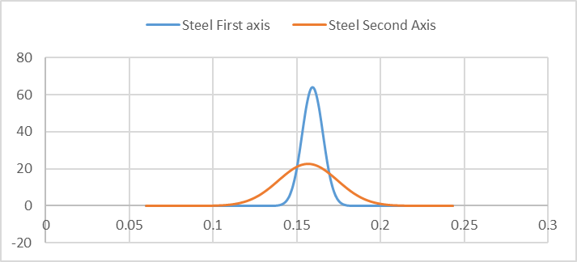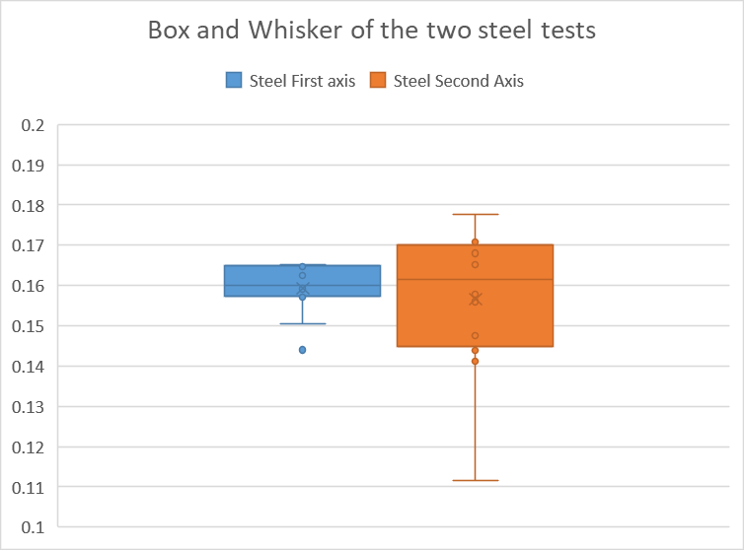
Figure 3 - Guassian and Box and whisker plots of the two steel tests
Fig. 3 shows how the first set of steel measurements were tighter grouped than those from the second axis. This is corroborated by the increased standard deviation shown in the initial raw measurements shown in table 3. As a result, it would indicate that the measuring conditions in the first sample were more consistent and accurate. There is an anomaly in the first data set, the value of 1.44 calculated from the 2:3 ratio on the midpoint of the bar, shown by a dot underneath the lower limit at 1.5 indicating it is greater than 1.5 times the interquartile range from the mean value. It is also noteworthy that said mean value is slightly lower than that recorded in the second set. If this is a system offset error it indicates an issue in the measurement of the thickness in one of the two axes.
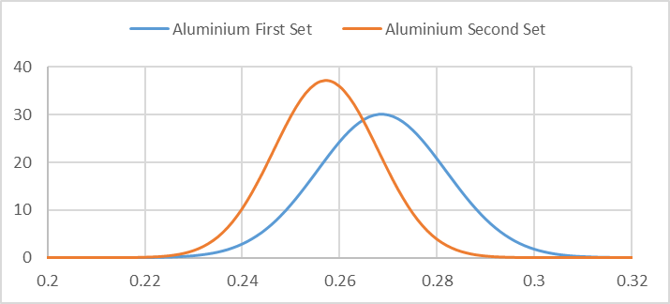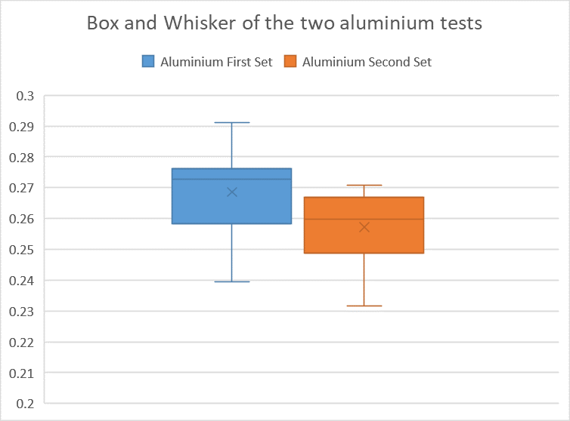
Figure 4 - Guassian and Box and whisker plots of the two aluminium tests
Fig. 4 shows that although there is largely comparable standard deviation (slightly less on the second, as shown by Table 4) there is a marked shift towards a lesser mean value, with tighter clustering shown on the box and whisker plot on the second set of data. No anomalies were found on the aluminium data.
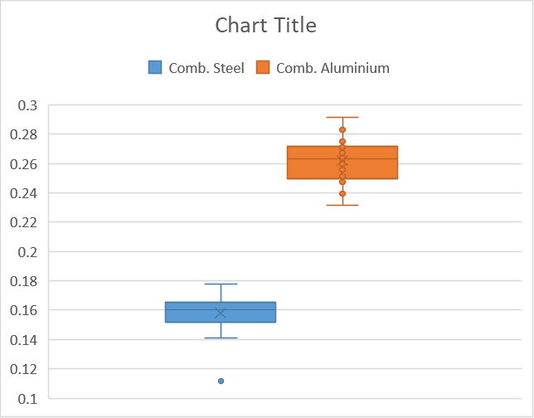
Figure 5 - Gaussian plot and box and whisker plot of the combined steel and aluminium data
When the data is combined streamed by material there are comparable gaussian plots showing that combined the data is comparable. This indicates the variability is human randomness rather than a machine scatter. It also shows the clear separation between the two materials.
Table 5 - This shows the range of values, and sum values, of the attenuation coefficient of each material with the 95% confidence applied
Table 5 shows the resulting measurements in dB/mm of 0.158 ± 0.026 for the steel and 0.262 ± 0.026
For the aluminium. Both materials are within the window of the incredibly variable values (Ono 2020).

Conclusion
The data showed great variability in our measurements due to the human aspect of the data recording. A person had to hold the probe with good contact and then read the results off the frozen oscilloscope. This could’ve been improved upon by recording the results without human interpretation or judgement.
However, we did see remarkably consistent results across the two materials when the data was all collated. This indicates that we had good results for the ultrasonic attenuation coefficient of the two materials at the room temperature with a 5 MHz probe.
For further study, the coefficient will change with frequency, tending to increase (Ono 2020). Given this, it would be worthwhile to measure at a range of frequencies and try to derive a coefficient that accounts for this. Dividing the Db/mm by the MHz can be used but even this won’t provide a constant value as some materials have a linear relationship and others don’t (Ono 2020). As a result, a sufficient range must be tested, plotting coefficient against frequency for each material to attempt to derive a constant coefficient.

Probability of Sizing Analysis

Abstract
The purpose of this analysis was to calculate the error sizing using linear regression and conduct an analysis of the operators likelihood of error detection.

Methodology
The methodology for this analysis is conducting a linear regression analysis on a provided data set of the measured size of a predefined defect in the material.

Measurements
Table 6 - Provided raw data for Probability of Sizing
This analysis is based upon a provided data set as shown in table 6. It shows the measured size from 10 different operators of 21 individual defects.

Calculations
So the key in this analysis is a linear regression analysis of each operator to determine their consistency and if there is any system offset. This will be determined using the standard y=mx+c format with m showing increasing/decreasing error with increasing defect size and c representing any inherent system offset. Alongside this the error will be analysed to determine the mean and standard deviation using the same equations as shown in section 1.5.

Results
Table 7 - Results of the linear regression analysis
Table 7 shows how all of the operators have a proclivity to underestimate the error with increasing defect size with the exception of the minor overestimation of operator one. They all have a positive system offset however which will have an impact on measuring the size of the defect, in this case above the true size. Due to this being a constant offset, it’ll have a greater impact as a proportion on the smaller defects.
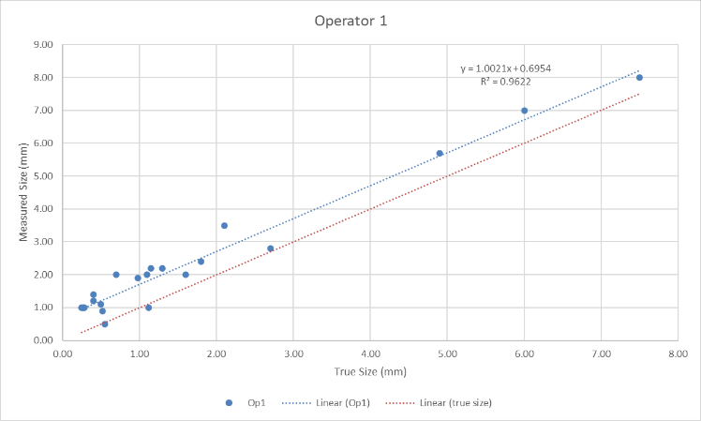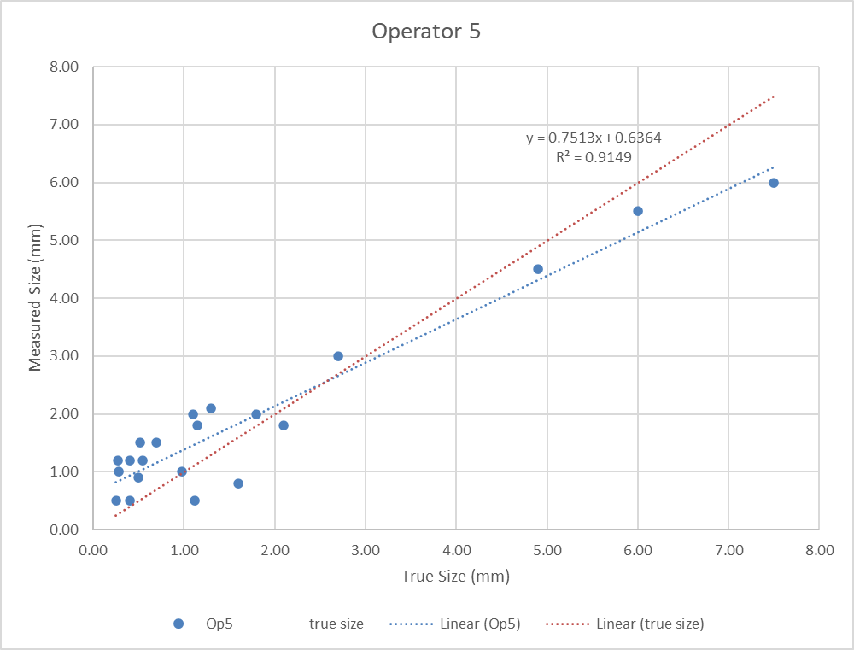
Figure 6 - Comparison of Operator 1 and 5, measured size against true defect size.
This is shown in figure 6, a comparison of operator 1 and 5. Operator 1 tended to consistently overestimate the size of the defect whereas operator 5 tended to overestimate the smaller defects, with the substantial offset, but then underestimate the size of larger defects as shown by the gradient being less than 1. In both cases the line of the true defect size is shown by the dotted orange line.
Table 8 - Table of Operator error. Measured value with true value subtracted
Table 8 shows the error of each operator, with their measured value minus the true size of the defect. It shows in this case how operator 9 has the least error as a mean value but still with substantial deviation of their measured values. It furthermore shows that averaged out all of the operators tended to overestimate the size of the defect. This is advantageous from a safety or quality control perspective as it causes defects to be explored before truly necessary but increases the business expense due to unnecessary maintenance/ part rejection. This is however biased as the majority of the defects were smaller in size and as a result the larger defects are less represented in the averages and standard deviation. Therefore, as shown in Fig. 6, larger defects could be underestimated by these operators due to the gradient being less than 1, shown in table 7. This is a safety concern if large defects go undetected. Given the bias in the data set to smaller defects it is possible that larger defects, even if measured undersize, would still be larger than their acceptable tolerance and rectified.
It is also worth noting the false negatives in the dataset. Operator 9 and 6 both missed a singular defect (resulting in a detection rate of 95.2%), reporting none present where there was one, whilst operator 2 missed three defects (with a detection rate of 85.7%). This poses a significant safety concern.

Conclusion
The analysis has shown that the oeprators tend to overestimate the size of smaller defects but broadly underestimate the size of larger more critical defects. The overestimation of smaller defects could increase the maintenance costs unnecessarily due to false positives for maintenance whilst also causing safety concerns through underestimation of larger more concerning defects. Reliable conclusions about larger defects can’t be drawn however as only 3 of the 21 defects are larger than 3mm, skewing the dataset to the lower values.
It is also noteworthy the safety concern of the 3 operators (2, 6 and 9) who have detection rates of below 100%, where they report false negatives.

References
Ono, K. 2020. A Comprehensive Report on Ultrasonic Attenuation of Engineering Materials, Including Metals, Ceramics, Polymers, Fiber-Reinforced Composites, Wood, and Rocks. Journal of Applied Sciences. Available at: www.mdpi.com/journal/applsci [Accessed: 6 January 2024].

