Report- Research Report
Student Name: Costel-Lucian Isop
Student Number: 2017454
Lecturer Name: Seyed Navid Nasirpour
BMSW4003_BIRM
Digital Skills and Research Methods
Executive Summary
The inclusion of technology increased day by day. This inclusion helps people to increase their efficiency and adds a positive impact on people’s lifestyles. It is very common in modern business as well as education sectors to use technological advancement. Besides the business firms, education sectors use technology to support their students and easily solve their problems. It can also be said that the implementation of technology also helps students to collaborate more efficiently. Technology Students are using collaboration tools to strengthen their teams. The use of collaboration tools in universities ameliorates the performance of students. Technology in education has many benefits. The individuals that benefit from technology include students and teachers. Research has shown that student attitudes and involvement has increased due to technology use. It has also shown that technology helps to enhance curriculum. It also helps with personalizing students’ individual learning experience.Besides that, the students, as well as the teachers, are interested to promote technological advancement in the educational sector. The professional development will give teachers knowledge and confidence in using the technology tools and resources that students prefer. Teachers will be more effective in their technology integration. Effective technology integration will result in students that are more engaged in their learning.The task deliberately focuses on the research design, research approach, research aim and questions. Apart from this the task also includes information taken from the surveys. The result of surveys conducted by the author is also represented in this task. by analysing those graph charts the exact data was collected. This result shows the response of people towards the involvement of technology in the educational sector.

Table of Contents
1. Introduction 4
2. Research design 4
2.1 Research Question 4
2.2 Methodology 4
2.3 Ethical Considerations 6
3. Results 6
4. Discussion 13
5. Conclusion 15
6. Reference List 16
7. Appendix 17

1. Introduction
Our digitally advanced era demands the whole educational process to be virtually sound. The online educational system is changing the overall concept of communicating drastically. The impact of the virtual learning process helped both the teacher and the students to communicate in a far better way. The latest technological advancement collaborated the students with their universities in a hassle-free way which is one of the greatest gifts in our generation to make the learning process easier (Raja and Nagasubramani, 2018). They are now able to connect with their guides as well as the administrative department in their available time. In this research proposal, a detailed explanation of the research design is described along with providing the point research-related questions. Keeping in mind the objectives of the very proposal a subtle research methodology is provided here. This proposal has also included an ethical consideration section where the authenticity of the overall research proposal is highlighted by declaring the fact that all the credentials provided in that proposal are the outcome of the personal experiences of various individuals.

2. Research design

2.1 Research Question
- What is how the students collaborate in the university while collaborating?
- What is how the teachers help the students while collaborating using different technological tools?
- How the technological dependence on collaboration can impact negatively the student’s lives?
- How do the teachers help the students to be more tech-savvy while collaborating with modern technology?
- How do the teachers try to be more tech-savvy so that they can help the students to collaborate?
- What are how various other collaboration tools can be used by the students for collaborating?

2.2 Methodology
Research Philosophy
The researcher has chosen the positivism research philosophy for this entire study. Positivism focuses more on general information (Alharahsheh and Pius, 2020). The researcher has chosen this type of research philosophy as it provides many advantages. It helps the researcher to profile a piece of brief and clear information about the respective topic. This philosophy also allowed the author to understand the pattern and trends. It is important as it helped to show the current technology used by the student (Atmowardoyo, 2018). Another advantage of this design is the observation of the author between the phenomenon and the characteristics.
Research Approach
For this entire study, the author has chosen a deductive research approach. In deductive research process sets out to establish greater certainty, and knowledge claims are stronger (Behfar and Okhuysen, 2018). It helps the author as it is based on the previous existing theories. The author chose this research approach as it is time-consuming and also helped the author to think logically.
Data Collection Method
The author has chosen quantitative data collection for this entire research. In this method, the author used standardised questionaries to collect numeric data (Rutberg and Bouikidis, 2018). The author was able to identify the exact statistics that enrich the information provided by the author. This type of Data Collection method also helped the author as it was cost-effective.
Data Collection Sources
The researcher chose primary data collection sources for this inter-study. It refers to the data that are specifically collected for the given research (Velentgas, 2021). It was selected by the researcher as it provided authentic and up-to-date information regarding the topic. To collect the data the researcher arranged some surveys. The researcher also had the authority of the university to conduct the surveys. It also helped the author to gather the accurate number of students who were using technology in university. it also provided the author to include relevant information in this inter-study.
Sampling method
The author chose simple random sampling for this entire study. There are many estimators of the finite populations that are undergoing simple random sampling (Irfan, Javed and Haider Bhatti, 2022). It helped the author as the author was able to select a particular sample set from a given population. It also helped the author to analyse the overall information about the respective topic. It was also helpful for the author as this sampling technique was free from any bias and prejudice.

2.3 Ethical Considerations
Human rights are the primary right a person should get and the researcher with ethical principles while doing research is protecting the human right in the most precious way (Arifin, 2018). However, in a research paper, the ethical consideration portion is not written in a distinct way (Suri, 2020). Therefore, in the research, the information provided by the people was not misrepresented (Hancock, Naaman and Levy, 2020). The researchers in this research have tried to keep the research to be the most authentic and ethical and relevant as it can be. In the samples that the author has taken, the people that the author interviewed were not given any kind of pressure to voice their opinions aloud. The author has tried to maintain the utmost secrecy while taking the samples and also is not inclined to put out the names of the people who have given opinions on various topics and the questions that the author has asked. The researcher had kept no time constraints for the people participating in the survey and they took their own time while giving answers to the questions that the author had asked.

3. Results
A graph chart is a picture that depicts a relationship with different kinds of information. It also includes the numbers or quantities and puts these into a series of dots, lines, etc, plotted with reference.
a. Do you think that collaboration tools help students to collaborate?
Options | Responses | Percentage
Agree | 18 | 60%
Strongly Agree | 4 | 13.3%
Neutral | 2 | 6.7%
Disagree | 3 | 10.0%
Strongly Disagree | 3 | 10.0%
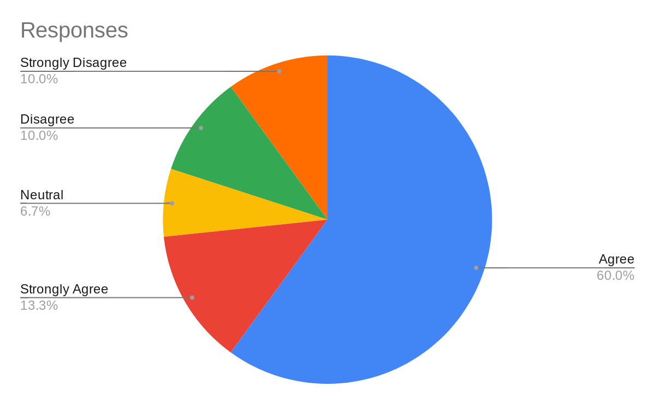
In this portion, the author surveyed 30 people and developed a graph chart. It can be said that almost 10 % of people disagreed and strongly disagreed with the statement. Besides that, 6.7% of people stayed neutral. However, 13.3% of people strongly believed in the conclusion. It can be observed that 60.0% of people agreed with this statement. So, it can be concluded that the majority of the people agreed with the above-mentioned statement.
b. Do you think that the tools are very handy in collaboration?
Options | Responses | Percentage
Agree | 17 | 56.7%
Strongly Agree | 5 | 16.7%
Neutral | 4 | 13.3%
Disagree | 2 | 6.7%
Strongly Disagree | 2 | 6.7%
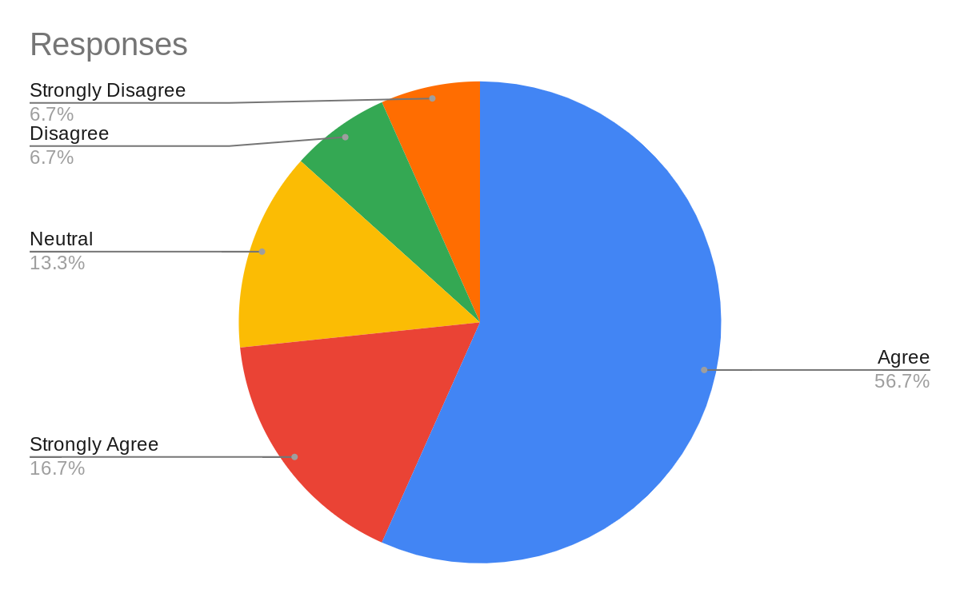
After analysing this graph chart it can be said that 6.7% of people disagreed and strongly disagreed with the statement. However, the number of agreeing persons was more than 56%, the strongly agreeing ones are more than 16% and the participants who remained neutral were 13.3%. So, it can be said that the majority of the people said that the tools are handled in collaboration.
c. Do you think that the technologies that the students use are very ethical in approach?
Options | Responses | Percentage
Agree | 15 | 50.0%
Strongly Agree | 5 | 16.7%
Neutral | 3 | 10.0%
Disagree | 3 | 10.0%
Strongly Disagree | 4 | 13.3%
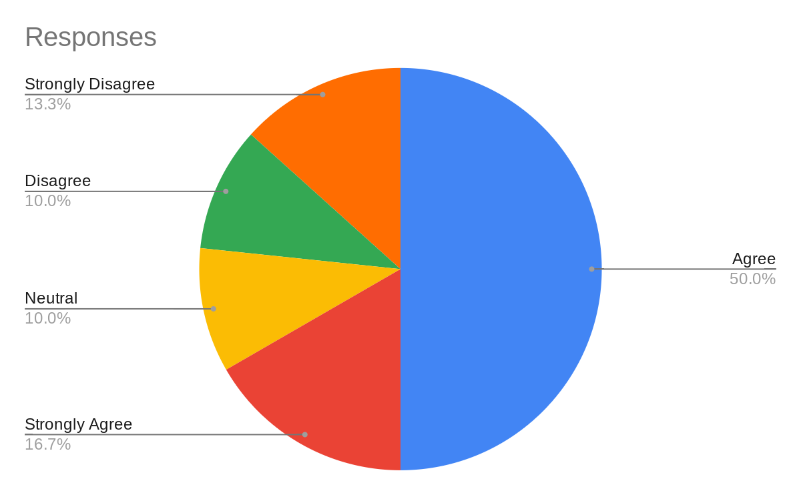
By analysing this chart it can be said that 10.0% of people were neutral and disagreed with the given statement. 16.7% of people strongly agreed and 50.0% of people agreed. Besides that 13.3% of people strongly disagree with the statement. So, this chart said that 50% of people believed in this conclusion.
d. Do you think that the teachers help in using technology?
Options | Responses | Percentage
Agree | 20 | 66.7%
Strongly Agree | 4 | 13.3%
Neutral | 2 | 6.7%
Disagree | 2 | 6.7%
Strongly Disagree | 2 | 6.7%
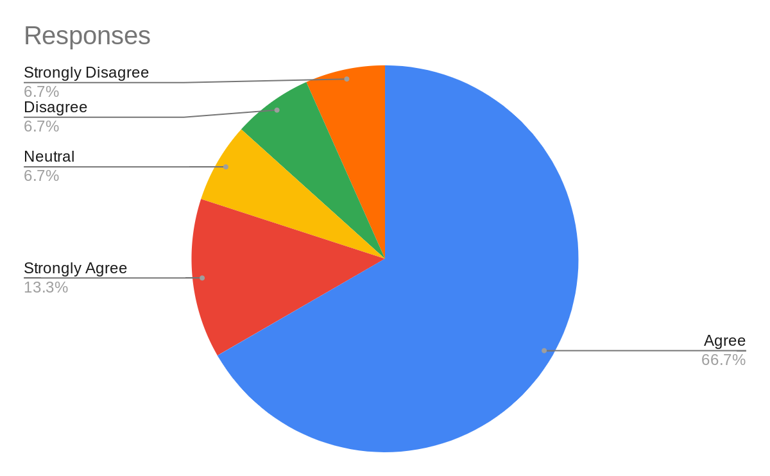
By analysing the table it is seen that 6.7% of people strongly disagreed. Neutral people were 6.7% and 13.3% of people strongly agreed. Besides that 66.7% of people agreed with the statement. So, this chart said that the majority of the people believed in this conclusion.
e. Do you think that the students are very much tech-savvy while using collaboration tools?
Options | Responses | Percentage
Agree | 18 | 60.0%
Strongly Agree | 2 | 6.7%
Neutral | 4 | 13.3%
Disagree | 3 | 10.0%
Strongly Disagree | 3 | 10.0%
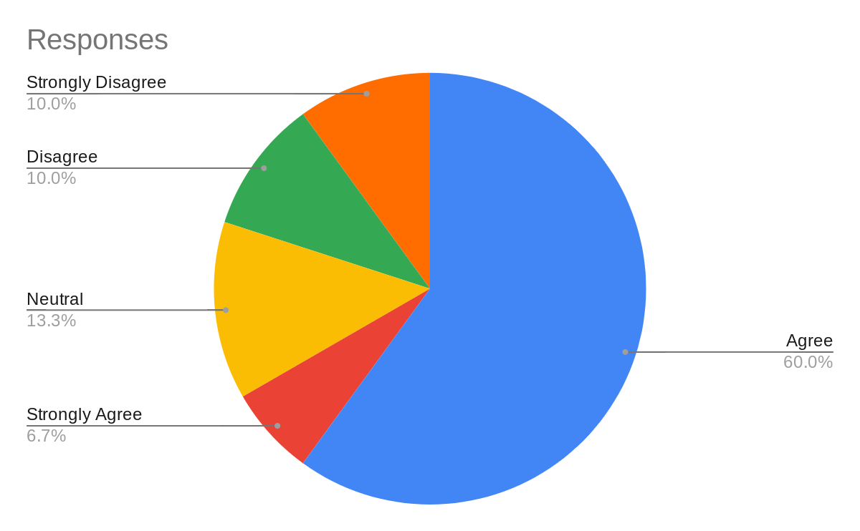
Analysing said that 10.0% of people strongly disagreed and disagreed with the given statement. 13.3% of people were neutral and 6.7% of people strongly agreed. Besides that 60.0% of people agreed with the statement. So, it can be concluded that the majority of the people believed that the students are very tech-savvy while using collaboration tools.
f. Do you think that the students are inclined to use more modern technology?
Options | Responses | Percentage
Agree | 14 | 46.7%
Strongly Agree | 6 | 20.0%
Neutral | 4 | 13.3%
Disagree | 3 | 10.0%
Strongly Disagree | 3 | 10.0%
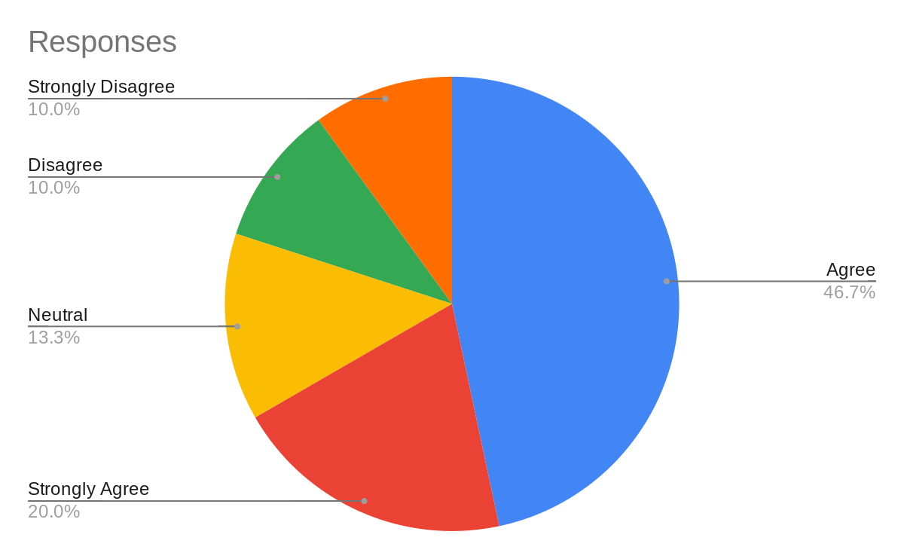
The portion of the analysing said that 10.0% of people strongly disagreed and disagreed with the given statement. 13.3% of people were neutral and 20.0% of people strongly agreed. Besides that 46.7% of people agreed with the statement. So, it can be concluded that the overall majority of the people believed in the given statement.
g. Do you think that the teachers are encouraging more towards becoming technology dependent while collaborating?
Options | Responses | Percentage
Agree | 16 | 53.3%
Strongly Agree | 4 | 13.3%
Neutral | 3 | 10.0%
Disagree | 4 | 13.3%
Strongly Disagree | 3 | 10.0%
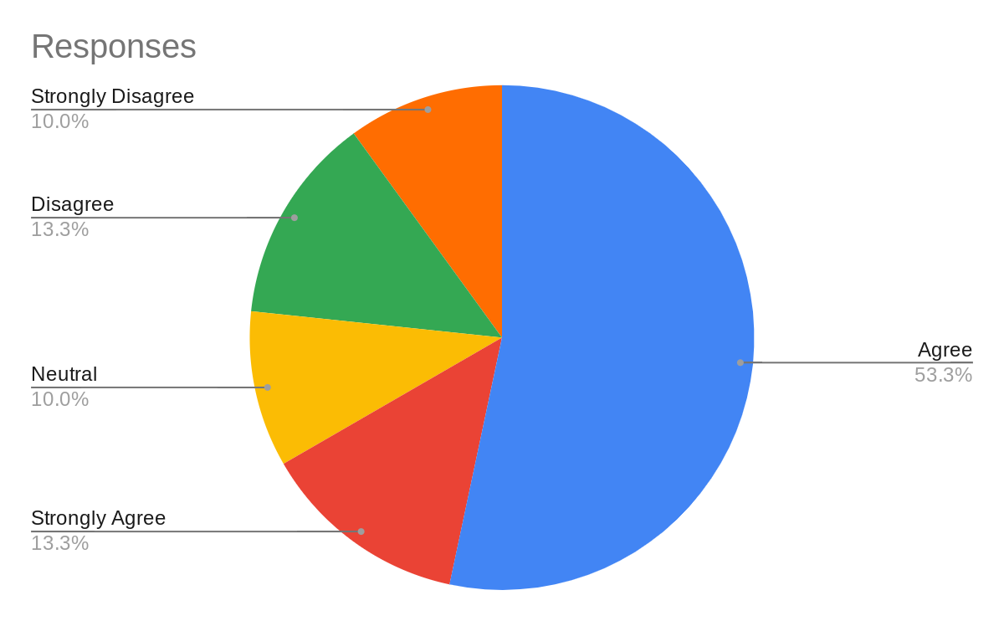
The portion of the analysing said that 10.0% of people strongly disagreed and 13.3% of people disagreed with the given statement. 10.0% of people were neutral and 13.3% of people strongly agreed. Besides that 53.3% of people agreed with the statement. So, it can be concluded that overall more than 50% of the people believed in the given statement.

4. Discussion
To understand the result the discussion portion elaborately describes all the graph charts. The author surveyed 30 people and gathered the information in this graph chart. After analysing the first chart it can be observed that among the 30 people 10% people disagreed and 10% people strongly disagreed with the given statement mentioned in the first chart. It can be said that those people thought that collaboration tools were not helping the students to collaborate in university. Besides that, the chart also said that 6.7% of people were neutral with the given statement. After analysing the chart the data also shows that 13.3% of people strongly agreed and 60.0% of people agreed with the statement. It means those people said that the collaboration tools help the student to collaborate successfully in the university. After analysing the second response it can be observed that 6.7% of people disagreed and strongly disagreed with the statement. It means they did not comply with the given statement. It simply means that a huge number of people believe that the tools were handy in collaboration. The information also said that the majority of the people believe in the given statement. The third question of the result includes the response of the people regarding whether the technologies that the students used are ethical or not. After analysing their response it can be concluded that 10.0% of people were neutral and disagreed with the given statement. 16.7% of people strongly agreed and 50.0% of people agreed. Besides that 13.3% of people strongly disagree with the statement. So, this chart said that 50% of people believe the statement.
The author also asked the participants whether they think that the teachers help in using Technology. Besides that 66.7% of people agreed with the statement. In this context, the author received positive answers from the majority of the participants. After this question, the author talked about the tech-savvy nature of students while using the collaboration tool. The response said that 10.0% of people strongly disagreed and disagreed. Besides that 60.0% of people agreed with the statement. This response also showed the positive sense of the participants.
The next graph chart included the response of people while supporting the statement of using modern technology more by the student. The response said 13.3% of people were neutral and 20.0% of people strongly agreed. Besides that 46.7% of people agreed with the statement. At last, after gathering the response to the last question, the author understood that 53.3% of people agreed that teachers should encourage the students to use technology while collaborating in university. The author overall tried to follow a particular process for this entire study. In this context, it can be stated that the author already confirmed the use of the primary data collection method for this study. Furthermore, the author also used this method in the study. Besides that, the Data Collection method and the sampling method were already confirmed by the author. the author also follow the exact he wanted to complete the study.
Besides that, the author also tries to take all the authentic references in this study. The reference mentioned in the introduction section is authentic and relevant to the study. By collecting the information from this reference the author successfully represented the core matter in this study. The reference was also used by the author in this study only. It effectively represents that technological improvement helps the students to collaborate effectively in the university. It also concluded that the implementation of Technology advancement helps the student to develop a hassle-free environment in the universities. In this regard, it can also be said that the author was effectively implementing the information from this reference to make the study authentic.

5. Conclusion
The author concludes this research proposal, on how students use technology to collaborate at university. These topics are described by the author because any university student needs to collaborate and use technology to do their learning properly. Students use new types of technology and different types of collaboration tools so that teachers and students both communicate easily. When a student is learning collaboratively their learning skills are very improved and for that reason, the author chose this topic in this research proposal. The author has proposed a prescribed methodology in this proposal so that the research can be carried on in an ideal way. The author has proposed the research using positivism philosophy, deductive research approach, qualitative data collection method, primary data collection source and simple random sampling with 30 samples. The author has used a graph chart to show the results of simple random sampling. In the discussion arena the author has proven the results found, the relevance of the literature given and if the research went along with the hypothesis of the author or not. Thus the author of this report provided a detailed analysis of the research that is how students use technology for collaboration.

6. Reference List
Alharahsheh, H.H. and Pius, A., 2020. A review of key paradigms: Positivism VS interpretivism. Global Academic Journal of Humanities and Social Sciences, 2(3), pp.39-43. Available at: https://gajrc.com/media/articles/GAJHSS_23_39-43_VMGJbOK.pdf
Arifin, S.R.M., 2018. Ethical considerations in qualitative study. International Journal of Care Scholars, 1(2), pp.30-33. Available at: https://journals.iium.edu.my/ijcs/index.php/ijcs/article/download/82/27
Atmowardoyo, H., 2018. Research methods in TEFL studies: Descriptive research, case study, error analysis, and R & D. Journal of Language Teaching and Research, 9(1), pp.197-204. Available at: http://academypublication.com/issues2/jltr/vol09/01/25.pdf
Behfar, K. and Okhuysen, G.A., 2018. Perspective—Discovery within validation logic: Deliberately surfacing, complementing, and substituting abductive reasoning in hypothetico-deductive inquiry. Organization Science, 29(2), pp.323-340. Available at: https://pubsonline.informs.org/doi/pdf/10.1287/orsc.2017.1193
Hancock, J.T., Naaman, M. and Levy, K., 2020. AI-mediated communication: Definition, research agenda, and ethical considerations. Journal of Computer-Mediated Communication, 25(1), pp.89-100. Available at: https://academic.oup.com/jcmc/article/25/1/89/5714020?login=true
Irfan, M., Javed, M. and Haider Bhatti, S., 2022. Difference-type-exponential estimators based on dual auxiliary information under simple random sampling. Scientia Iranica, 29(1), pp.343-354. Available at: http://scientiairanica.sharif.edu/article_21789_5a2057f475080573c8aeb23499c98615.pdf
Raja, R. and Nagasubramani, P.C., 2018. Impact of modern technology in education. Journal of Applied and Advanced Research, 3(1), pp.33-35. Available at: https://www.academia.edu/download/63887921/Impact_of_modern_technology_in_education20200710-27957-jsmaeg.pdf
Rutberg, S. and Bouikidis, C.D., 2018. Focusing on the fundamentals: A simplistic differentiation between qualitative and quantitative research. Nephrology Nursing Journal, 45(2), pp.209-213. Available at: https://www.researchgate.net/profile/Shannon-Rutberg/publication/328250766_Focusing_on_the_Fundamentals_A_Simplistic_Differentiation_Between_Qualitative_and_Quantitative_Research/links/5eea3789299bf1faac5e6bfb/Focusing-on-the-Fundamentals-A-Simplistic-Differentiation-Between-Qualitative-and-Quantitative-Research.pdf
Suri, H., 2020. Ethical considerations of conducting systematic reviews in educational research. Systematic Reviews in Educational Research, pp.41-54. Available at: https://library.oapen.org/bitstream/handle/20.500.12657/23142/1007012.pdf?sequen#page=59
Velentgas, P., 2021. Primary Data Collection for Pharmacoepidemiology. Textbook of Pharmacoepidemiology, pp.192-202. Available at: http://ndl.ethernet.edu.et/bitstream/123456789/91341/1/Textbook%20of%20Pharmacoepidemiology-Brian%20L%20Strom_Stephen%20E%20Kimmel_Sean%20Hennessy-John%20Wiley%20%26%20Sons%20Ltd-2022-3.pdf#page=220

7. Appendix
a. Do you think that collaboration tools help students to collaborate?
b. Do you think that the tools are very handy in collaboration?
c. Do you think that the technologies that the students use are very ethical in approach?
d. Do you think that the teachers help in using technology?
e. Do you think that the students are very much tech-savvy while using collaboration tools?
f. Do you think that the students are inclined in using more modern technology?
g. Do you think that the teachers are encouraging more towards becoming technology dependent while collaborating?

