

NAME :- KARAN RAJESHBHAI SONI
STUDENT ID :- 2237322
MODULE :- MARKETING MANAGEMENT (75%)
MODULE CODE :- LCMB7001
LECTURER :- TUSHARA BALENDRAN
GROUP :- 2

“Innovative Marketing at Mindgrub Technologies LLC”

Table of Contents
Introduction 2
Company Background 2
Founders 2
Mission Statement 3
Communication 3
The Crucial Role of Communication in Marketing 3
Crafting a Comprehensive Communication Strategy 3
Listening and Responding: The Essence of Effective Communication 4
Empowering Through Content Marketing 4
The Imperative of Effective Communication in Marketing 4
Communication Model 5
Shannon-Weaver Model 5
Osgood-Schramm Model 5
Definition and Importance of IMC 6
How IMC Enhances Brand Communication 6
Promotional Strategies for Mindgrub Technologies LLC 7
Branding and Brand Equity in Marketing 8
Defining Branding and Brand Equity 8
Importance in Marketing 8
Brand Equity Model: Keller's Brand Equity Model 9
Keller's Brand Equity Model Overview 9
Keller's Brand Equity Model Explained 9
Application to Mindgrub Technologies LLC 10
Advantages of Keller's Model 10
Disadvantages of Keller's Model 10
Customer Journey and Touchpoints for Mindgrub Technologies LLC 11
Understanding the Customer Journey 11
Customer Journey Map for Mindgrub Technologies LLC 11
Customer Journey Map Explanation 11
Importance of Customer Journey and Touchpoints 12
Total Engagement Model 12
conclusion 12
References 13

Introduction

This report aims to review how Mindgrub Technologies LLC can create innovative marketing strategies to raise brand awareness and manage customer experiences across various communication channels. The report will explore Mindgrub's background and its growth into a leader in digital experiences, as well as its commitment to delivering meaningful connections between people and technology.
Mindgrub Technologies LLC, is a cutting-edge digital agency specializing in mobile, web, marketing, and emerging technologies. Its mission is to craft impactful digital experiences that bridge human interactions with technology. This report will investigate how Mindgrub can continue to innovate its marketing strategies to enhance brand awareness and customer journey management.
Starting small, Mindgrub initially focused on web and mobile app development. As time passed, it expanded its services to include augmented reality, virtual reality, artificial intelligence, user experience design, and digital marketing. With creativity and technical expertise, Mindgrub delivers solutions that push technological limits, serving various industries like healthcare, education, entertainment, and government.
Mindgrub's dedication to excellence is evident in its awards and client roster, featuring notable names like Wendy's, Under Armour, and Geico. As technology evolves rapidly, Mindgrub's role in shaping digital innovation is crucial. This report will go into its evolution, noteworthy projects, and impact on the tech industry, aiming to extract insights from its success story.

Company Background

In 2002, Mindgrub Technologies LLC was born as a forward-looking digital agency with a clear goal: to reshape how businesses interacted with technology (Mindgrub Technologies LLC, n.d.). Founded in Baltimore, Maryland, USA, it emerged during a pivotal moment in the digital world's evolution.

Founders

At the helm of the company stood Todd Marks, an entrepreneur and technologist with visionary ambitions. Recognizing technology's potential to shape the future, Marks aimed to establish a platform for innovative solutions. Under his guidance, Mindgrub transformed from its modest origins into a dynamic, influential force within the tech realm (Mindgrub Technologies LLC, n.d.).

Mission Statement

The crux of Mindgrub Technologies LLC's mission centers on delivering impactful digital solutions that enrich experiences, spark engagement, and ignite innovation (Mindgrub Technologies LLC, n.d.). While the phrasing may vary, the essence remains unaltered: blending ingenuity, leading-edge tech, and strategic insight to forge solutions that stretch limits and surpass client expectations.
The company is resolutely committed to leveraging its technical proficiency, creative aptitude, and profound industry insights to create immersive experiences across diverse platforms (Mindgrub Technologies LLC, n.d.). Mindgrub's dedication extends to aiding clients in thriving amid the digital era, equipping them with the means to effectively connect with their audiences, streamline operations, and outpace the technological curve.
Embodied within its mission statement, Mindgrub encapsulates not just the fulfilment of client requisites, but also the pursuit of technological boundary-pushing (Mindgrub Technologies LLC, n.d.). The bedrock values of innovation, collaboration, and excellence radiate through the myriad projects it undertakes, leaving an indelible mark in the tech sphere and beyond.

Communication

In the intricate tapestry of human interaction, communication emerges as the linchpin connecting diverse individuals and groups (Rogers & Steinfatt, 1999). It is the conduit through which information, ideas, and emotions traverse, shaping perceptions and fostering connections. In the realm of marketing, this concept finds profound significance.

The Crucial Role of Communication in Marketing

In the dynamic landscape of commerce, communication assumes a pivotal role (Kotler et al., 2017). It orchestrates the symphony through which a product's or service's value proposition resonates with potential patrons. The resonance of communication in this context is far-reaching, nurturing the germination of brand awareness, the establishment of trust, and the nurturing of credibility. Ultimately, this orchestration culminates in the crescendo of sales.

Crafting a Comprehensive Communication Strategy

In the age characterized by digital omnipresence, companies find themselves endowed with an array of conduits for customer dialogue – social media, emails, websites, and mobile apps. Each conduit, akin to an instrument in an ensemble, possesses its unique timbre (Strauss & Frost, 2020). Navigating this symphony demands a nuanced understanding of which conduits best harmonize with the intended audience. A harmonious symphony emerges when a comprehensive communication strategy harnesses the strengths of each channel, weaving a compelling narrative.

Listening and Responding: The Essence of Effective Communication

The virtuosity of effective communication extends beyond monologue; it flourishes in dialogue (Cornelissen, 2017). Companies that embrace this duality nurture a profound understanding of their clientele's desires and preferences. Such companies have an adeptness in turning feedback into insights, insights into innovation. It's a reciprocal dance where trust is cultivated, and loyalty nurtured through timely, empathetic responses.

Empowering Through Content Marketing

In the modern lexicon of marketing, an artful brushstroke known as content marketing has taken center stage (Kotler et al., 2021). This artistry involves crafting valuable, context-rich content that beckons and engages a bespoke audience. This transcendence from promotion to enrichment establishes a company as a beacon of wisdom within its sphere. In turn, trust unfurls its wings, and patrons are drawn to this lighthouse of insight.

The Imperative of Effective Communication in Marketing

The domain of marketing, a crucible of competition, finds its core imperative in communication (Fill, 2013). From forging crystalline messaging to orchestrating the channels through which it resonates, communication is the crucible of success. The journey is guided by meticulous crafting, selective resonance, open dialogue, and the dissemination of value through content. As each note aligns with precision, the symphony of success resonates, and enduring relationships are forged, leaving an indelible imprint in the tapestry of commerce.

Communication Model

A communication model serves as a roadmap for understanding how information flows between individuals (Miller, 1967). It provides a framework to grasp the journey of communication from one person to another, shedding light on the process of message transmission.

Shannon-Weaver Model

One notable communication model is the Shannon-Weaver model (Shannon & Weaver, 1949). Imagine you wish to communicate with a friend. The process begins with formulating the message and translating it into words, known as encoding. Subsequently, these words traverse a communication channel, such as a phone call or an email. This journey constitutes the message's passage. Your friend, the recipient, decodes the message to extract its intended meaning. Importantly, this model encompasses the concept of noise, encompassing factors that hinder the message's clarity, akin to disturbances in a telephone conversation.

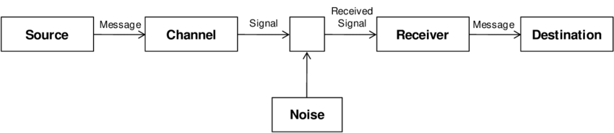
Fig.1 Shannon-Weaver model

Osgood-Schramm Model

An alternative model is the Osgood-Schramm model (Osgood & Schramm, 1954). This model centers on the intricate process of assigning meanings to words. It resembles a cognitive puzzle, with words serving as puzzle pieces. People attach their personal experiences and emotions to words, rendering the same word capable of evoking diverse interpretations. The Osgood-Schramm model delves into the cognitive mechanism of assembling these linguistic components to facilitate mutual comprehension.

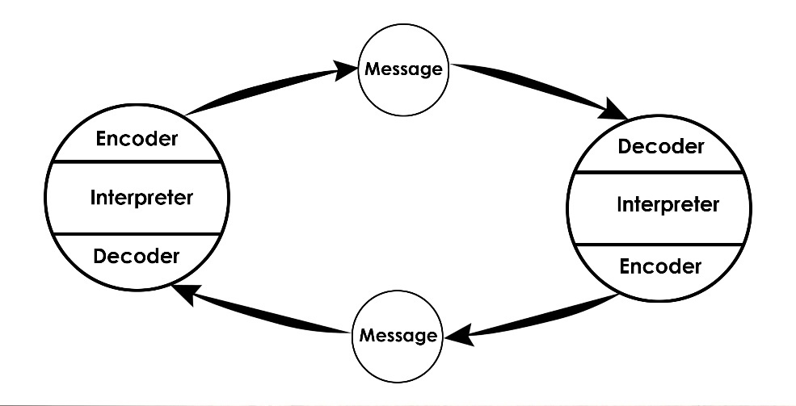
Fig.2 Osgood-Schramm model

Definition and Importance of IMC

Integrated Marketing Communications (IMC) is a strategic approach that synergizes various communication channels and tools to deliver a consistent and unified message about a brand or company. IMC blends traditional marketing methods with contemporary digital platforms, ensuring that all aspects of communication work harmoniously to convey a cohesive brand identity.
For Mindgrub Technologies, IMC is a crucial strategy that aligns its diverse digital offerings, services, and brand messaging across multiple touchpoints. It facilitates the creation of a well-rounded and compelling brand story that resonates with its target audience.

How IMC Enhances Brand Communication

Consistent Messaging: IMC ensures that Mindgrub's brand message remains consistent across all communication avenues, whether it's on their website, social media, or marketing materials. This consistency strengthens brand recognition and reinforces key brand values (Chitty et al., 2012).
Multi-Platform Presence: By leveraging various channels, IMC enables Mindgrub to be present where their audience is most active. This multi-platform approach increases the chances of engaging potential clients at different stages of their decision-making journey (Kitchen & Burgmann, 2015).
Enhanced Visibility: IMC maximizes Mindgrub's visibility through a coordinated effort. As the brand's message appears across multiple channels, it creates a stronger impact, increasing the likelihood of being noticed by a broader audience (Pelsmacker et al., 2019).
Unified Brand Identity: With IMC, Mindgrub can maintain a unified brand identity that transcends various digital solutions they offer. This unified identity helps in conveying a clear understanding of their services and expertise (Gupta & Gupta, 2017).
Customer Engagement: IMC fosters deeper engagement with Mindgrub's audience. Through consistent and integrated messaging, customers have a more immersive experience, leading to increased interaction and potentially, stronger client relationships (Schultz & Schultz, 2018).
Building Trust: Consistency in communication, a hallmark of IMC, builds trust with the audience. When the audience encounters the same messaging across different platforms, it establishes credibility and authenticity for the brand (Kitchen et al., 2004).
Comprehensive Approach: IMC enables Mindgrub to view their marketing efforts holistically. This comprehensive approach allows for better optimization of resources, strategic planning, and the ability to target specific segments effectively (Belch & Belch, 2021).
Adapting to User Behavior: In the digital realm, user behavior can vary widely. IMC empowers Mindgrub to tailor their communication approach based on where and how their audience interacts, ensuring optimal engagement (Dahlen et al., 2019).
We know that, Integrated Marketing Communications is the linchpin that amplifies Mindgrub Technologies' brand communication. By unifying messages, leveraging multiple platforms, and creating a consistent brand experience, IMC ensures that Mindgrub's voice is heard effectively, resonating with their clients and establishing a lasting brand presence.

Promotional Strategies for Mindgrub Technologies LLC

In the ever-evolving landscape of digital marketing, new promotional strategies are vital for companies like Mindgrub Technologies LLC to maintain and elevate their brand awareness. Several innovative approaches can be employed to effectively enhance the company's visibility and engagement with its target audience.

Influencer Marketing: Collaborating with industry influencers who align with Mindgrub's values and expertise can create authentic endorsements. According to a study by Influencer Marketing Hub (2021), influencer marketing generates a return on investment of $5.20 for every dollar spent, making it a powerful strategy to amplify brand visibility.
Interactive Webinars and Workshops: Hosting interactive webinars and workshops can position Mindgrub as an authority in the tech industry. These events offer value to participants while showcasing the company's knowledge. Such engagement can cultivate brand loyalty and attract potential clients (Wicklund, 2021).
User-Generated Content Campaigns: Encouraging customers to share their experiences and solutions using Mindgrub's products or services can lead to authentic user-generated content. This approach not only boosts brand awareness but also builds a community of satisfied users (Martin, 2022).
Virtual Reality (VR) Experiences: Given Mindgrub's prowess in emerging technologies, leveraging VR experiences for promotional campaigns can captivate audiences and provide immersive insights into the company's capabilities. This innovative approach can leave a lasting impression (Duggan, 2019).
Interactive Social Media Content: Crafting interactive content like quizzes, polls, and challenges on social media platforms can drive engagement. This strategy not only encourages audience participation but also increases organic reach (Chen, 2020).
Strategic Partnerships: Collaborating with complementary businesses or non-profits can expand Mindgrub's reach. Co-hosting events, launching joint campaigns, or sharing resources can introduce the brand to new audiences (Bhandari, 2020).

These novel promotional strategies, supported by research and industry trends, offer Mindgrub Technologies LLC avenues to enhance its brand visibility and establish a more profound connection with its audience.

Branding and Brand Equity in Marketing

Defining Branding and Brand Equity

Branding is a strategic process that involves creating a unique identity for a product, service, or company through the use of distinct names, logos, designs, and messaging (Kotler et al., 2022). It goes beyond mere aesthetics; branding encompasses the emotional and psychological associations that customers form with a brand. Brand equity, on the other hand, refers to the intangible value a brand holds in the eyes of consumers beyond its tangible attributes (Keller, 1993). It encapsulates the reputation, recognition, and loyalty a brand has cultivated over time.

Importance in Marketing

Branding and brand equity are pivotal components in the marketing landscape, contributing significantly to a company's success and differentiation (Aaker, 1996).

1. Establishing Identity and Differentiation:
Branding allows businesses to carve out a unique identity that distinguishes them from competitors. A well-crafted brand identity resonates with the target audience, creating a memorable and distinct impression (Kapferer, 2012). This differentiation is crucial in a crowded market, enabling customers to recognize and remember a brand amidst the noise.
2. Building Trust and Loyalty:
Brands with strong equity have garnered trust and loyalty over time, which translates into customer retention and advocacy (Keller, 1998). Consumers are more likely to choose brands they are familiar with and have positive associations. A well-established brand can foster an emotional connection, making customers more forgiving of occasional missteps.
3. Pricing Power:
Strong brands command premium pricing due to their perceived value and quality (Kotler et al., 2022). Customers are often willing to pay more for a brand they trust and perceive as superior. This premium pricing helps increase profitability and margins.
4. Market Expansion and Diversification:
Brands with high equity can more easily extend into new markets or product categories (Keller, 2013). The established reputation and trust give these brands a head start in capturing new audiences, reducing the risk associated with expansion.

5. Resilience in the Face of Challenges:
During crises or economic downturns, brands with solid equity tend to fare better. Consumers stick with brands they trust, even in challenging times (Erdem et al., 2006). Strong brands are better equipped to weather fluctuations in the market.

In essence, branding and brand equity work synergistically to shape how customers perceive and connect with a company or its offerings. The strategic cultivation of a brand's identity and equity can yield substantial long-term benefits, positioning a business as a leader in its industry.

Brand Equity Model: Keller's Brand Equity Model

Keller's Brand Equity Model Overview

Kevin Lane Keller created the Keller's Brand Equity Model, which offers a thorough framework for comprehending and managing brand equity (Keller, 1993). This approach emphasises the viewpoint of the consumer and the idea that brand equity is developed through a succession of related actions, each of which affects how the brand is perceived as a whole.

Keller's Brand Equity Model Explained

The model consists of four key components that contribute to building brand equity:
Brand Identity: This stage focuses on creating a distinct and memorable brand identity through elements like brand name, logo, and packaging. For Mindgrub Technologies LLC, this could involve a unique logo and consistent visual elements that reflect the company's innovative and tech-savvy nature.
Brand Meaning: Here, the brand starts to develop associations and meanings in the minds of consumers. This includes attributes, benefits, and emotions linked to the brand. For Mindgrub, this could involve associating the brand with cutting-edge technology solutions, creativity, and reliability.
Brand Response: At this stage, consumers form judgments and emotional responses to the brand. Positive responses lead to stronger brand preference and loyalty. Mindgrub could evoke positive responses by showcasing successful case studies, client testimonials, and demonstrating its expertise in various technological domains.
Brand Resonance: This is the pinnacle of brand equity, where consumers have a deep emotional connection with the brand. They become loyal advocates who actively engage with the brand and promote it to others. For Mindgrub, this could mean having a community of loyal clients who eagerly recommend the company's services.

Application to Mindgrub Technologies LLC

Mindgrub Technologies LLC, being a technology-driven company, could effectively apply Keller's Brand Equity Model to enhance its brand image. By strategically building a unique identity, crafting meaningful associations with innovation and expertise, eliciting positive customer responses, and fostering a loyal client base, Mindgrub can strengthen its brand equity and achieve a competitive edge.

Advantages of Keller's Model

Consumer-Centric: Keller's model places the consumer at the center, ensuring that brand equity aligns with consumer perceptions (Keller, 1998).
Step-by-Step Framework: The sequential nature of the model provides a structured approach to brand-building, aiding in strategic planning and implementation.
The model considers various dimensions of brand equity, helping companies create a comprehensive brand strategy.

Disadvantages of Keller's Model

Simplicity: The model's simplicity might not capture the intricacies of brand equity in highly complex industries.
Lack of Flexibility: The linear progression might not fit every brand's unique journey, especially in rapidly changing markets.
Below is a table summarizing Keller's Brand Equity Model and its application to Mindgrub Technologies LLC:

Model component | Keller's Brand Equity Model | Application to Mindgrub Technologies LLC
Brand Identity | Create a distinct brand identity | Develop a unique tech-savvy brand identity
Brand Meaning | Establish associations and meaning | Associate the brand with innovation, reliability and creativity
Brand Response | Evoke Positive judgments and emotions | Showcase successful case studies, client testimonials
Brand Resonance | Foster deep emotional connections | Cultivate a loyal client community and advocates

Customer Journey and Touchpoints for Mindgrub Technologies LLC

Understanding the Customer Journey

The customer journey refers to the path that a customer takes as they interact with a company, from their initial awareness of the brand to post-purchase engagement and beyond (Lemon & Verhoef, 2016). This journey is not linear; it involves various touchpoints where customers interact with the brand, forming impressions and making decisions.

Customer Journey Map for Mindgrub Technologies LLC

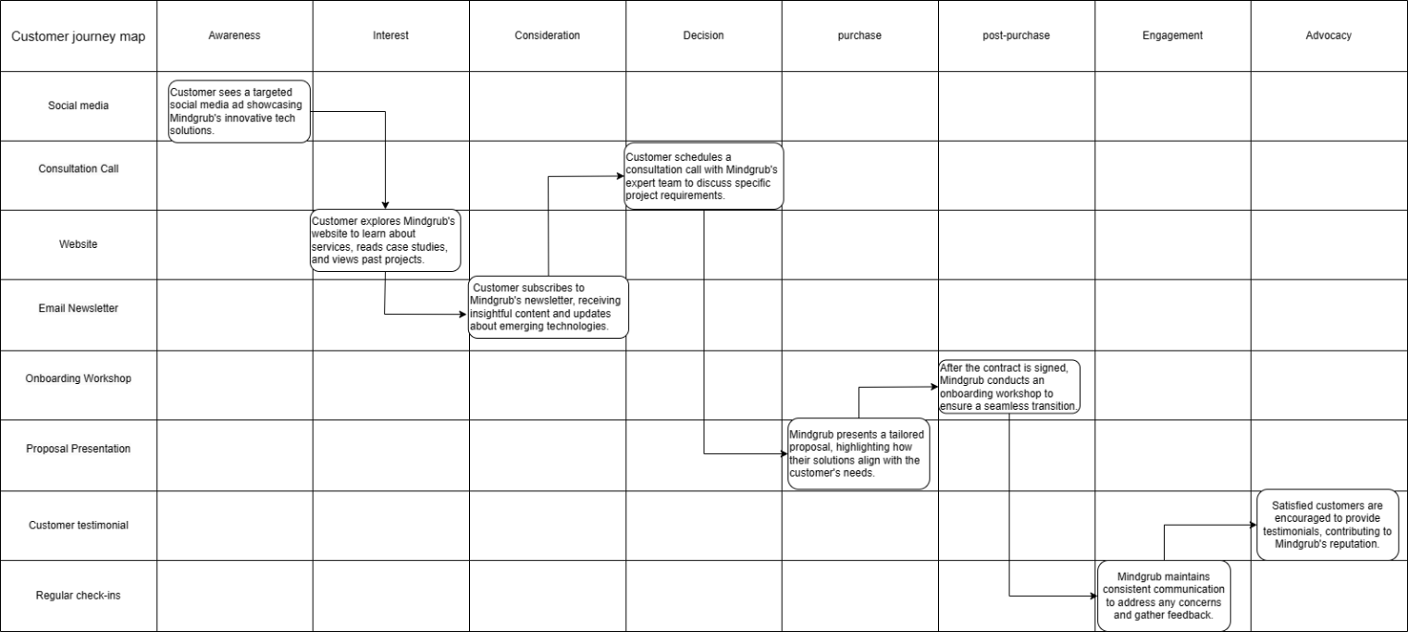
Diagram: Customer Journey Map for Mindgrub Technologies LLC

Customer Journey Map Explanation

The customer journey map illustrates the key touchpoints that customers engage with during their interaction with Mindgrub Technologies LLC. Each touchpoint represents an opportunity to shape the customer's perception and influence their decisions.
At the awareness stage, social media ads grab the customer's attention, while the website at the interest stage provides in-depth information. The email newsletter at the consideration stage nurtures engagement, leading to a consultation call at the decision stage. The proposal presentation at the purchase stage finalizes the decision, followed by an onboarding workshop and regular check-ins to ensure a smooth post-purchase experience. Finally, satisfied customers contribute to Mindgrub's advocacy through testimonials.

Importance of Customer Journey and Touchpoints

Mapping the customer journey and identifying touchpoints helps Mindgrub Technologies LLC optimize interactions, ensuring that each touchpoint aligns with the brand's values and customer expectations. By understanding the customer's path and tailoring experiences at each stage, Mindgrub can foster loyalty, enhance customer satisfaction, and build lasting relationships.

Total Engagement Model

The Total Engagement Model is a comprehensive framework that emphasizes the significance of various levels of customer engagement throughout their journey with a brand. It encompasses three primary stages: cognitive, emotional, and behavioral engagement. In the cognitive stage, customers become aware of a brand's existence. Emotional engagement involves forging a deeper connection based on feelings and values, while behavioral engagement entails taking actions such as making purchases or referring others.
Relating the Total Engagement Model to Mindgrub Technologies LLC, the cognitive phase could involve potential clients encountering the brand through online advertisements. Emotional engagement might stem from the company's ability to deliver innovative tech solutions that align with clients' needs. Finally, behavioral engagement could encompass clients seeking consultations and ultimately partnering with Mindgrub for their technological needs. By understanding and leveraging each engagement level, Mindgrub can enhance customer relationships, improve loyalty, and amplify its brand influence in the digital space.

conclusion
In conclusion, Mindgrub Technologies LLC stands as a dynamic force in the digital realm, driven by innovation and a commitment to impactful solutions. With a strategic communication approach, strong brand equity, and a customer-centric focus, Mindgrub has forged a path of success. By understanding the intricacies of its customer journey and employing the Total Engagement Model, Mindgrub is well-equipped to shape lasting connections, foster loyalty, and elevate its brand influence in the digital landscape. As technology evolves, Mindgrub's role in shaping digital innovation remains pivotal, ensuring its place as a leader in delivering meaningful connections between people and technology.

References

- Miller, G. A. (1967). Psychology and communication. Waveland Press.
- Shannon, C. E., & Weaver, W. (1949). The mathematical theory of communication. University of Illinois Press.
- Osgood, C. E., & Schramm, W. (1954). An approach to the study of communicative acts. Psychological Review, 61(6), 364-378.
- Batra, R., & Keller, K. L. (2016). Integrating Marketing Communications: New Findings, New Lessons, and New Ideas. Journal of Marketing, 80(6), 122-145.
- Belch, G. E., & Belch, M. A. (2021). Advertising and Promotion: An Integrated Marketing Communications Perspective. McGraw-Hill Education.
- Chitty, W., Barker, N., Valos, M., & Shimp, T. A. (2012). Integrated Marketing Communications. Cengage Learning.
- Dahlen, M., Lange, F., & Smith, T. (2019). Marketing Communications: A Brand Narrative Approach. SAGE Publications Limited.
- Gupta, S., & Gupta, R. (2017). An integrated approach to advertising, public relations, and marketing communications. In Handbook of Research on Promotional Strategies and Consumer Influence in the Service Sector (pp. 70-87). IGI Global.
- Kitchen, P. J., & Burgmann, I. (2015). Integrated marketing communication: Making it work at a strategic level. Journal of Marketing Communications, 21(1), 3-17.
- Kitchen, P. J., & Schultz, D. E. (2016). Rethinking Integrated Marketing Communication (IMC) in a Digital Age. In The Routledge Companion to Contemporary Brand Management (pp. 160-180). Routledge.
- Pelsmacker, P. D., Hudders, L., & Rayp, G. (2019). The Impact of Integrated Marketing Communications on Consumer Behavior: Effects on Consumer Decision‐Making Process and Purchase Intention. International Journal of Advertising, 38(2), 228-255.
- Schultz, D. E., & Schultz, H. F. (2018). The Evolution of Integrated Marketing Communications: The Customer-driven Marketplace. Routledge.
- Influencer Marketing Hub. (2021). Influencer Marketing Benchmark Report 2021. Retrieved from https://influencermarketinghub.com/influencer-marketing-benchmark-report-2021/
- Wicklund, M. (2021). How to Generate Leads and Drive Sales With Webinars. HubSpot. Retrieved from https://blog.hubspot.com/marketing/generate-leads-drive-sales-webinars
- Martin, R. (2022). How to Build a User-Generated Content Campaign That Actually Works. HubSpot. Retrieved from https://blog.hubspot.com/marketing/user-generated-content-campaign
- Duggan, J. (2019). How Brands Are Using Virtual Reality to Market Their Products. Entrepreneur. Retrieved from https://www.entrepreneur.com/article/340339
- Chen, Y. (2020). 15 Types of Interactive Content to Help Your Audience Remember You. HubSpot. Retrieved from https://blog.hubspot.com/marketing/interactive-content
- Bhandari, A. (2020). Strategic Partnerships: The Ultimate Guide. HubSpot. Retrieved from https://blog.hubspot.com/marketing/strategic-partnerships
- Cornelissen, J. (2017). Corporate Communication: A Guide to Theory and Practice. SAGE Publications.
- Fill, C. (2013). Marketing Communications: Interactivity, Communities and Content. Pearson.
Kotler, P., Keller, K. L., Brady, M., Goodman, M., & Hansen, T. (2017). Marketing Management. Pearson.
- Kotler, P., Kartajaya, H., & Setiawan, I. (2021). Marketing 4.0: Moving from Traditional to Digital. John Wiley & Sons.
- Rogers, E. M., & Steinfatt, T. M. (1999). Intercultural Communication. In Handbook of Communication Science (pp. 410-428). Routledge.
- Strauss, J., & Frost, R. D. (2020). E-Marketing. Routledge.
- Mindgrub Technologies LLC. (n.d.). About Us. Retrieved from https://www.mindgrub.com/about
- Aaker, D. A. (1996). Building Strong Brands. Free Press.
- Erdem, T., Swait, J., & Louviere, J. (2006). The impact of brand credibility on consumer price sensitivity. International Journal of Research in Marketing, 23(3), 163-176.
- Kapferer, J. N. (2012). The New Strategic Brand Management: Advanced Insights and Strategic Thinking. Kogan Page Publishers.
- Keller, K. L. (1993). Conceptualizing, measuring, and managing customer-based brand equity. Journal of Marketing, 57(1), 1-22.
- Keller, K. L. (1998). Strategic brand management: Building, measuring, and managing brand equity. Prentice Hall.
- Keller, K. L. (2013). Strategic Brand Management: Building, Measuring, and Managing Brand Equity. Pearson.
- Kotler, P., Kartajaya, H., & Setiawan, I. (2022). Marketing 5.0: Technology for Humanity. John Wiley & Sons.
- Lemon, K. N., & Verhoef, P. C. (2016). Understanding Customer Experience Throughout the Customer Journey. Journal of Marketing, 80(6), 69-96.

