University of Wales Trinity Saint David
School of Engineering


Project Planning
Engineering Management (ACHA5012)

Rhys Thomas
(2303931)
07/11/2024

Contents
Introduction 2
Team members roles and responsibilities 3
Group tasks and timings 4
Simulation – Tamzin cooper 4
Aerodynamics and CFD – Harvey Levell and Harvey Hodge 4
Structural Design – Hannah Bathgate and Cameron Andrews 5
Project management – Efa Jones 5
Individual Task and Timings 6
Milestones 8
Gateway objectives 8
Areas of concern 10
Overall project Gantt chart 10
Control Group Gannt Chart 11
References 12

Introduction
In this project, our group is tasked with developing a fully functional active rear wing system for a Morgan Plus Four, aimed at enhancing aerodynamics and vehicle dynamics for optimal handling and braking efficiency. The project is set within the framework of designing, building, and testing an active rear wing, challenging us to apply cross-disciplinary engineering principles spanning aerodynamics, structural integrity, mechatronics, and control systems. This undertaking simulates a real-world automotive design process, requiring us to meet specific technical regulations provided by a hypothetical automotive manufacturer. The goal is to increase the vehicle’s downforce during high-speed manoeuvres and maximize drag for deceleration, embodying a performance-focused design solution. We aim to do measure this success in decreasing a lap time around a selected circuit.

Team members roles and responsibilities
Overall, there is 5 roles and responsibilities included in our team and 8 team members they are as follows:
Project manager – Efa Jones
Simulation – Tamzin cooper
Aerodynamics and CFD – Harvey Levell and Harvey Hodge
Control and Mechatronics – Jac Evans and Rhys Thomas
Structural Design – Hannah Bathgate and Cameron Andrews
As stated above, my role is Control and mechatronics, I’m responsible for setting up the control systems that operate the active rear wing. This involves programming the wing’s movements based on inputs like throttle position and brake pressure to improve downforce and braking. I use tools like MATLAB, Simulink, and an Arduino to build a system that’s reliable and responsive. I also work closely with the aerodynamics and structural teams to make sure everything works together smoothly for the final design.
For my role I believe that certain skills and personality traits are required. Referring to Belbin’s model my strongest skill was Resource Investigator, this is when an individual is good at using their natural skill to find ideas and bring them back to the team to share. This is very useful when working with others in a big team but also like me and Jac working together within our role.
Another skill that’s useful in my role is being a ‘Plant’—someone who’s creative, imaginative, and good at coming up with new ideas and solutions. This means I can look at technical challenges in different ways and often think of solutions that others might not see right away. Being a Plant helps me tackle problems creatively, whether it’s figuring out tricky issues with a circuit or finding new ways to make the system more responsive under certain conditions. (Belbin, 2024)
Here are my scores for Belbin’s models questionnaire:
Belbin’s Category | Implementer | Coordinator | Shaper | Plant | Resource investigator | Monitor Evaluator | Team worker | Complete finisher
My Score | 10 | 4 | 8 | 11 | 13 | 6 | 11 | 6
Average score | 10 | 8.8 | 11.6 | 7.3 | 7.8 | 8.2 | 10.9 | 5.5

Group tasks and timings

Simulation – Tamzin cooper
- Research simulation types and software – 6 hours
Decide on simulation type (driver-in-loop or out-of-loop) and appropriate software (e.g., Optimum Lap, VI Grade), supported by references.
- Create baseline simulations – 10 Hours
Set up baseline simulations of the Morgan Plus Four vehicles in Optimum Lap, providing foundational data for other subgroups.
- Conduct analysis research – 5 Hours
Investigate available analysis tools in the chosen simulation software to assist aerodynamics and other teams.
- Simulate rear wing structure – 20 Hours
Use data from the structural group to analyse the rear wing's integrity through simulations.
- Refine and complete simulations – 26 Hours
Create detailed simulations in VI Grade for advanced aerodynamic analysis and finalize simulations incorporating new aerodynamic designs

Aerodynamics and CFD – Harvey Levell and Harvey Hodge
- Initial CFD setup and baseline simulation – 14/11/24 – 20/11/24
This will be the first task for the two members and start to understand the cars dynamics in its standard form.
- Model designing for wind tunnel testing – 21/11/24 – 11/12/24
This task will require them to start designing models from their CFD testing to be used in the wind tunnel.
- Physical model preparation for wind tunnel testing – 12/12/24 – 18/12/24
Using cad to aid the creation and material selection process to then create testing models for the wind tunnel.
- Wind tunnel testing and data collection – 02/01/25 – 08/01/25
Testing the models in the wind tunnel and correlate data to create a data archive of different models’ data.
- Final analysis and Preparation for next phase – 08/01/25 – 09/01/25
Reviewing the results and data to identify the best model and adjustments that could be made.

Structural Design – Hannah Bathgate and Cameron Andrews
- Research and test materials – 30 Hours
Research suitable materials and test for practicality, including cost estimation.
- Design mounts and components – 15 Hours
Collaborate with the aerodynamics and mechatronics teams to design mounts, endplates, housings, and ensure structural compatibility.
- Analyse loads and refine design – 20 Hours
Determine loads with the simulation group and test the design in FEA software to finalize and validate.
- Collaborate on structural-aerodynamic balance – 25 Hours
Work with aerodynamics to balance structural soundness and aerodynamic flow then perform final FEA testing
- Finalize and attach wing – 15 Hours
Refine the design based on testing, decide attachment methods, and incorporate aerodynamic feedback.

Project management – Efa Jones
- Create and manage task list – 2 Hours
Develop a comprehensive task list, collect responses from team members, and monitor their progress, adjusting tasks as needed to account for incomplete contributions.
- Create and update Gantt chart – 2 Hours
Develop the initial Gantt chart and regularly update it to reflect task progress and delays caused by uneven effort.
- Hold and document weekly meetings - every week, 1 hour per meeting
Organise and lead weekly meetings to ensure team alignment, document decisions, and address gaps in contributions.
- Create and refine draft PowerPoint presentations – 4 Hours
Develop the initial draft PowerPoint and incorporate missing or incomplete sections due to unfulfilled tasks, ensuring the final presentation is cohesive.

Individual Task and Timings
My personal Task and timings are shown in the table below, these are tasks that I have had to undertake and will undertake as part of my role within the team. Each task has an estimated allocated time to them, this is to ensure that each task can be carried out within the time limit, and all get completed. The first 5 tasks are all to develop my skills within control systems and how to use them, this will then enable me to self-progress into developing further for a full-scale project with more complex components and actuation inputs. All tasks are ordered in logical progression moving from basic understanding to final complex system integration.
Task Description | Hours required
Complete MATLAB Onramp for basic understanding of fundamentals | 2
Complete Simulink Onramp for basic understanding of fundamentals | 2
Complete Simscape Onramp for basic understanding of fundamentals | 2
Design a simple circuit to control a servo motor using Arduino Uno | 2
Research open-loop and closed-loop circuits, including their benefits and constraints | 8
Research control devices and feedback controllers, including pros and cons. | 8
Research actuation devices | 8
Research different filter types and test them in a circuit | 8
Build a circuit that gives position output dependent on a sensor input signal | 4
Build and test a circuit that provides position output with position limiters | 6
Build a model system to actuate a prototype wing | 8
Research sensor types for wing actuation control | 6
Adapt the system to accommodate all sensor signals required | 10
Adapt the system to account for loads from a full-size model | 20

The next table will show the materials their cost and the possible lead times on said materials, this will help the project manager finance the whole project and the lead times will help plan when to order items so that they arrive within the schedule for each task.
Materials and Components | Cost (£) | Lead Time (Estimation)
Arduino Uno Mega 2560 Rev3 | £43.80 | 3-5 Days
Motor + Gearbox | £8.24 | 1 Week
Rotary Encoder | £1.80 | 3-5 Days
Battery Holder | £2.66 | 3-5 Days
Gain Block | £6.99 | 1 Week
Rod Ends | £8.00 | 3-5 Days
Threaded Rod | £9.00 | 1 Week
RLC Circuit Components | £29.00 | 3-5 Days
SD Card | £10.63 | 3-5 Days
Diodes | £9.99 | 1 Week
Then the third and final table is of the specialist equipment required to carry out the task to a professional standard. Some tasks could possibly not be carried out unless the equipment was available.
Specialist Equipment | Cost (£) | Lead Time (Estimation)
Oscilloscope for circuit testing | £150-£300 | 1-2 Weeks
Multimeter for electrical testing | £30-£70 | 1 Week
Breadboard and Jumper Wires | £10-£20 | 3-5 Days
MATLAB and Simulink Software | £800 Per Year | Immediate
3D Printer (optional) | £150 -£500 | 1 Week for delivery and setup

Milestones
Initial Research Completion: Completion of research into aerodynamics, structural design, control systems, and mechatronics to define project scope and objectives (17th November 2024).
Interim VIVA Presentation: Delivery of the initial design concept and justification during the interim VIVA, with a focus on the direction and philosophy taken (w/c 9th December 2024).
Prototype Completion: Finalisation of the physical prototype, including structural assembly, control system integration, and aerodynamic testing (10th March 2025).
Simulation and Testing Review: Completion of simulations for vehicle performance and validation of the active rear wing’s effectiveness under operational conditions (24th March 2025).
Group Report Submission: Submission of the detailed group report, documenting the design, testing, and analysis phases, with individual contributions highlighted (30th March 2025, 22:00).
Final VIVA Presentation: Delivery of the final VIVA, presenting the completed design, analysis, and compliance with project requirements (w/c 31st March 2025).

Gateway objectives
A gateway ensures that the control system for the active rear wing is fully operational, meets the project’s technical requirements, and is ready for integration with other subsystems.
Objective: Validate that the control system reliably and accurately operates the active rear wing in response to input signals, ensuring it meets predefined performance and safety criteria.
Criteria for Success:
Sensor Integration: All sensors (e.g., throttle position, brake pressure) are fully functional and provide data with no more than 5% variance from expected readings.
Actuator Responsiveness: The actuator must respond to control commands within 0.5 seconds, achieving precise wing adjustments under simulated conditions.
Error-Free Communication: The MATLAB-to-Arduino interface must transmit signals consistently, with no errors over 100 test cycles.
System Stability: The control system must remain operational and error-free under simulated loads for at least 1 hour of continuous testing.
Testing Procedure:
Initial Functional Testing: Test individual sensors and actuators independently to ensure proper operation and calibration.
System Integration Test: Connect sensors and actuators to the Arduino, with control logic implemented in MATLAB and Simulink. Verify communication and system responsiveness.
Load Simulation: Test the system with simulated aerodynamic loads to validate its performance under real-world conditions.
Endurance Test: Operate the system continuously for 1 hour, monitoring for errors, signal instability, or overheating.
Meeting this gateway ensures that the control system is ready for integration with the aerodynamic and structural subsystems, supporting the project’s overall objectives.

Areas of concern
There are many ways that an issue could arise and cause the project to be delayed or even prevent the total completion of the project. Here are two ways that my half of the project could go wrong:
- PicoScope equipment failing
The picoScope that is used for signal analysis could fail due to a hardware or software issue. This would cause all the timings in the project being delayed until the issue was resolved. A possible mitigation for this issue is to ensure that the picoScope is properly calibrated and setup before it is needed for the project. Another mitigation is to have a backup scope and a backup computer to connect to the picoScope. Finally, familiarising yourself with troubleshooting of a picoScope and laptop so that if an issue that was fixable was to arise it was easily resolved.
- Sensor incompatibility
Sensors that are used to read data from the car to determine the position of the rear wing could possibly not be compatible with an Arduino system. This would limit the complexity of the project using multiple sensors to determine the position would make the system more effective going around a circuit. If for example, the steering wheel position sensor was to not work with the Arduino then deciding where the wing should be during a corner would not be possible leaving it just at one position. A way of mitigating this issue is to ensure that all sensors are tested with the Arduino and don’t assume that they will work, also keeping spare or alternative sensors would be a good idea for a backup plan.

Overall project Gantt chart
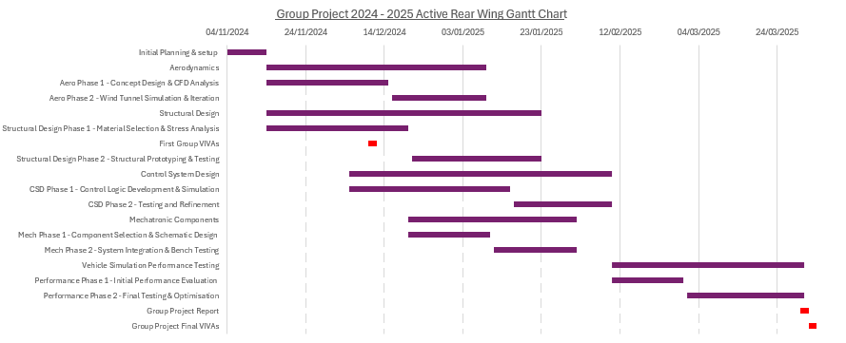

Control Group Gannt Chart
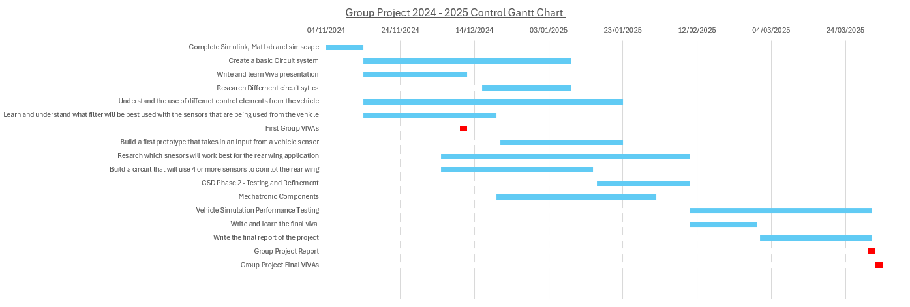

References
Belbin, M., 2024. The Nine Belbin Team Roles. [Online]
Available at: https://www.belbin.com/about/belbin-team-roles
[Accessed 1 11 2024].
ChatGPT, 2024. Chat GPT. [Online]
Available at: https://chat.openai.com/
[Accessed 1 11 2024].

