Hotel Placement - Food & Beverage
Forest of Arden Marriott Hotel & Country Club
Department: CAST IRON RESTAURANT
M4X01920_BIRM
Mubaraca Mombassa - 1905613
Week: 1 & 2
Work Undertaken:
- Introduction to F &B Rooms of Cast Iron Restaurant
- Introduction to storage Areas
- Brand Standard for service: Greeting &serving a table, Presenting bill, and Making personal connections
- Training Bussing a table & Clean as you go
- Breakfast & Room Service Shift (Worked M-F )
- Breakfast & Room service shift (Saturday 7am -11 am)
- Restaurant Host Standard ( Phone, Reservation Book)
- Training: table set up & Sequence, table numbers, Menu Standard (salt, pepper, sugar caddy and Cleanliness
- Training: Restaurant Set up Breakfast & Dinner
- Training Service preparation
- Restaurant Menu training
- Allergy training
- Explanation & Training Lunch shift worked ( Buffet)
- Explanation Tableres System and link to Marriott Website
- Room Service Brand Standard
- Tea Afternoon
- Micros: Enter Room Service
- Demonstrate wine knowledge (Red, White and how to Up sell wine
- Serve a Table – Drinks & Food
- Guest Service Requests
- Hotel Hub & Communication –phone
- Marriott Brand Standards – Appearance/name tag
- Training COSHH/Health & Safety

Self – Appraisal
Strengths:
What astonishing time I am spent inside Cast Iron Restaurant and learn new abilities in the course of the most recent two weeks in that division was sublime and I have increased a great deal of understanding to use later on.
All the Cast Iron Restaurant administration staff must be completely acquainted with all drink things recorded on the menu, how they are arranged and served. Albeit a few things may not be recorded on the menu, all staff will have fundamental yet right information on the most well-known drink things which exist.
Moreover, I learned and increased essential information on wines with respect to the most well-known starting points and nicknames as prepared by the Staff Management Team and as indicated by the Marriott Hotel Standards. Beneath I might want to show a portion of the essential menu information abilities which the lodging F&B administration staff ought to have.
- The food and beverage service staff should be able to describe the dishes on the menu to the guest in a simple and clear way
- Should be able to pronounce all food items in the menu accurate
- To know how the dish should be served
- To know which section of the kitchen to produce the dish.
- To know which are the signature dishes of the restaurant
- To know the selling price of the dish....
- Prepare the facilities for breakfast
- Pre-shift Meeting for skills,
- Room service, preparation the facilities for breakfast
- Preparation the section one, two and three for Lunch
- Specials of the day, Buffet items, and Taste panel
Weaknesses:
I didn't have such a great amount of battled at Cast Iron Restaurant since I discovered a few similitudes with another office, for example, Conference and dinner, in how to deal with certain administrations. For instance, Cleanliness, an association of table administrations, visitor administration, table set up, table numbers on certain occasions, Marriott standard, online reservation, book, and Menu standard. In any case, with the assistance of the staff, I have learned different abilities and furthermore I had the option to do it with more certainty.

Lost opportunities
I might want to rehash a few occupations I have done over the most recent two weeks, to feel increasingly certain, for example, room administration, bar administration, be acquainted with the tables plan of bar and café and how to utilize the espresso machine at Cast Iron Bar.

Plans for next week:
- Start my placement at Zest bar
- Get my rota for the next two weeks
- Booking a meeting with Kitchen Manager about the days I am able to work.

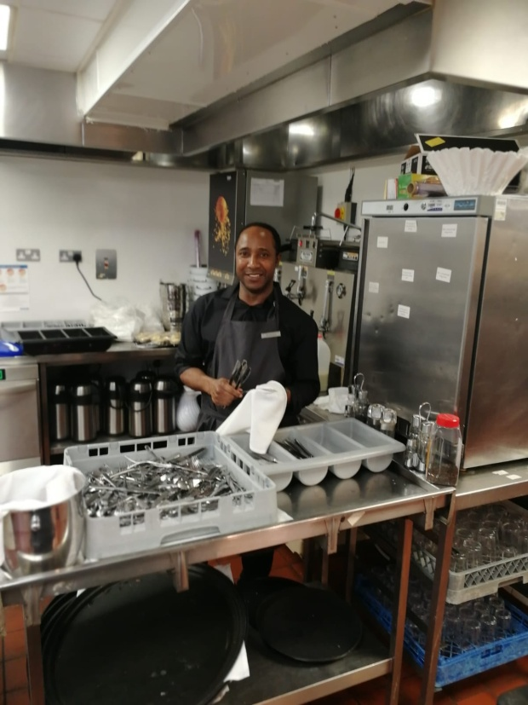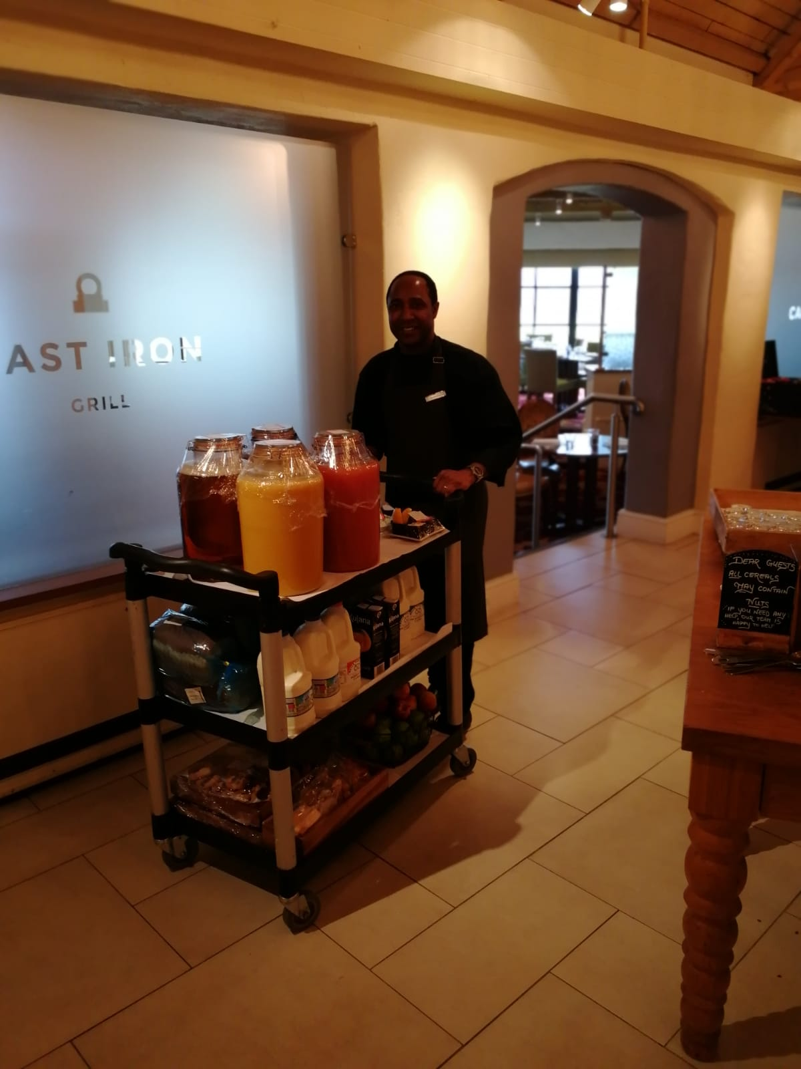
Polishing cutlers preparing Breakfast

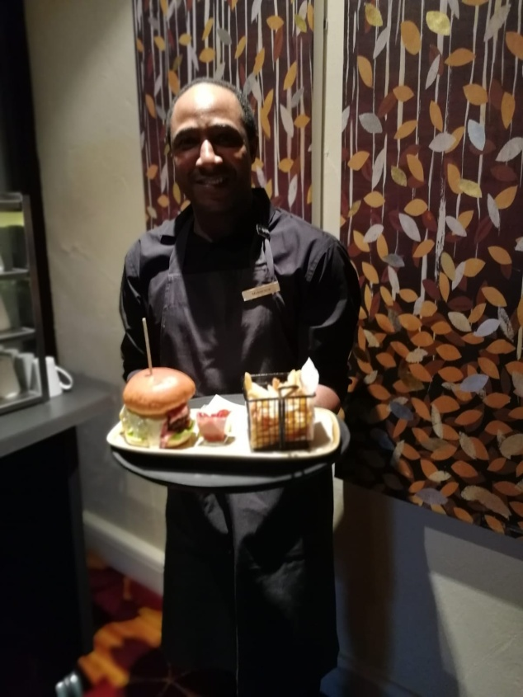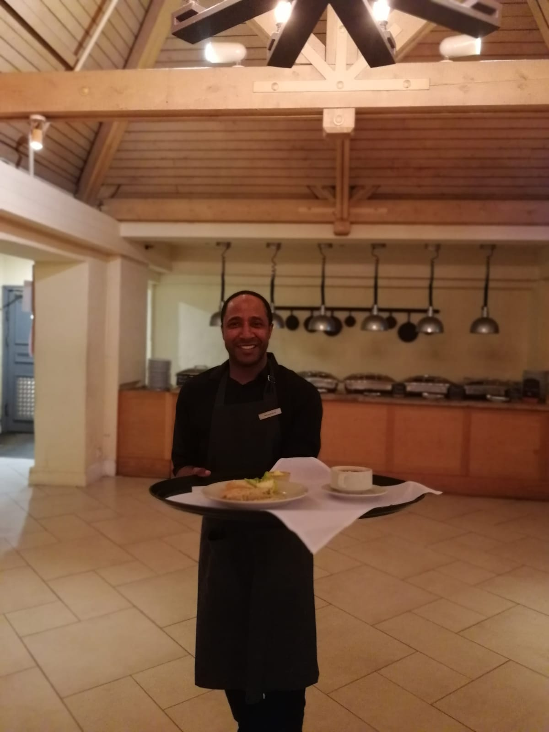
Bar service starter
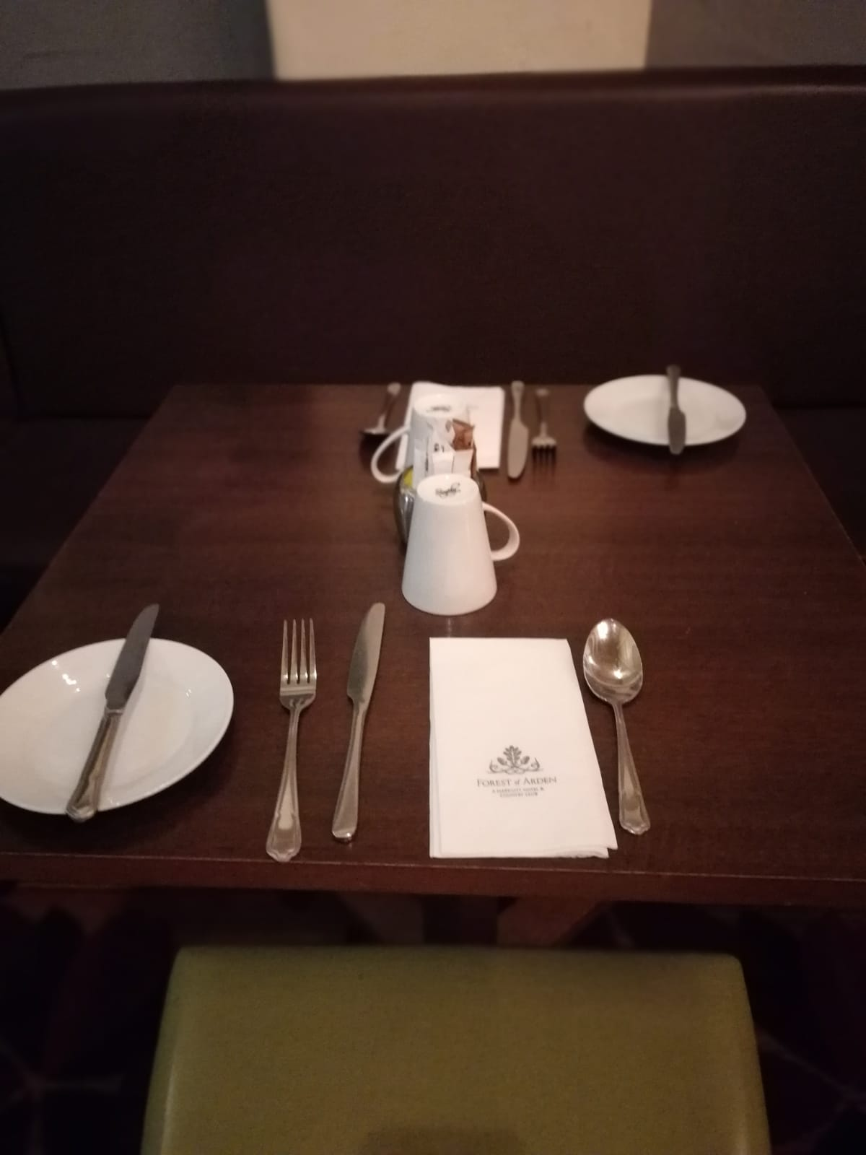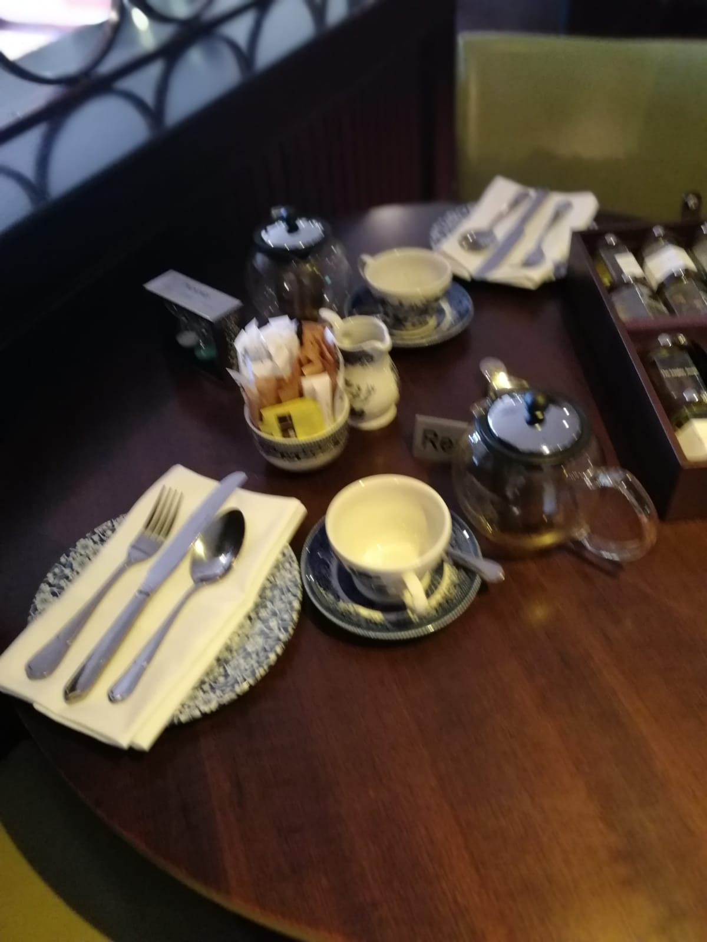
Breakfast table Afternoon Tea

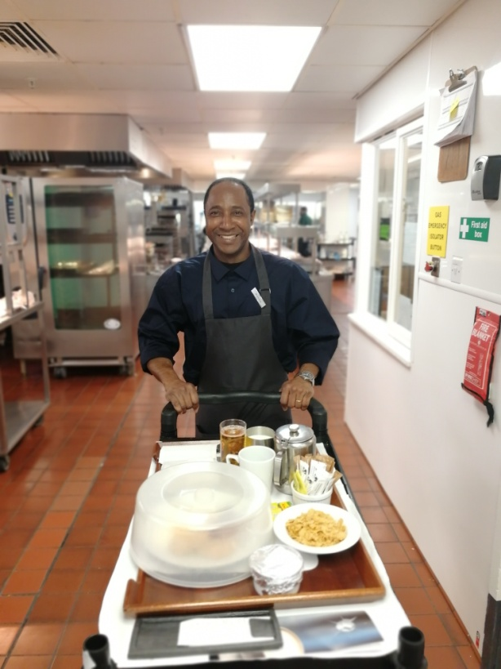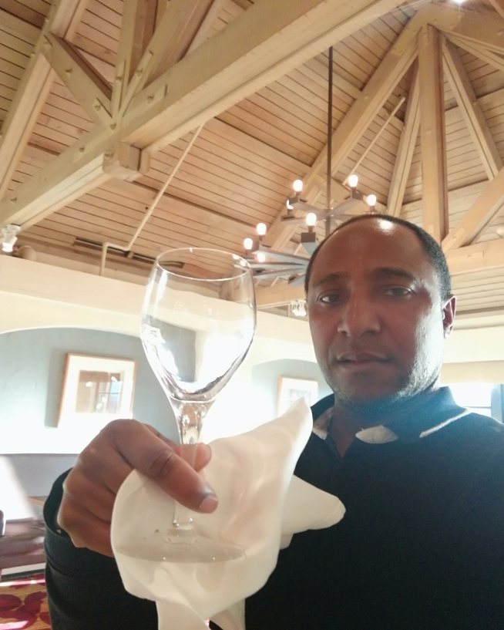
Room service polishing wine Glasses

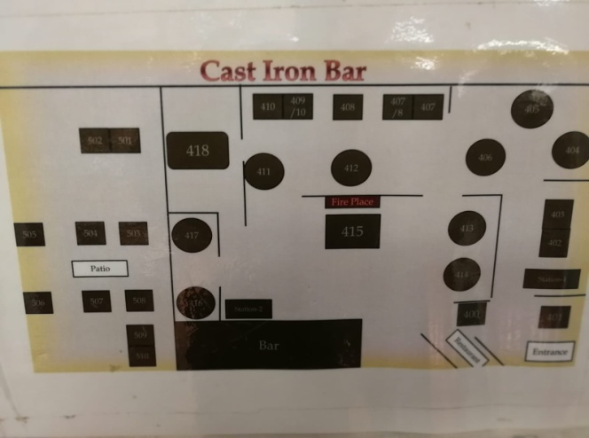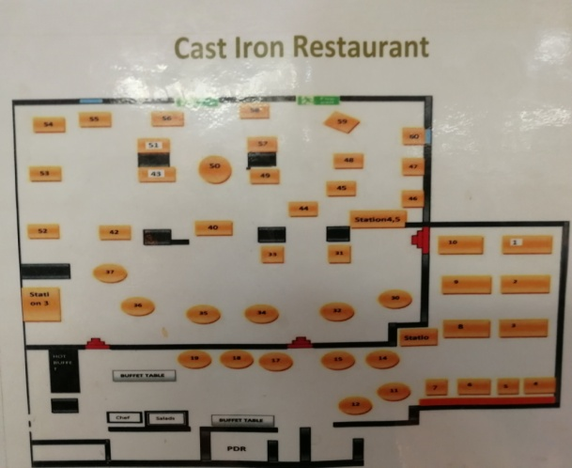
Tables plan of Bar and Restaurant

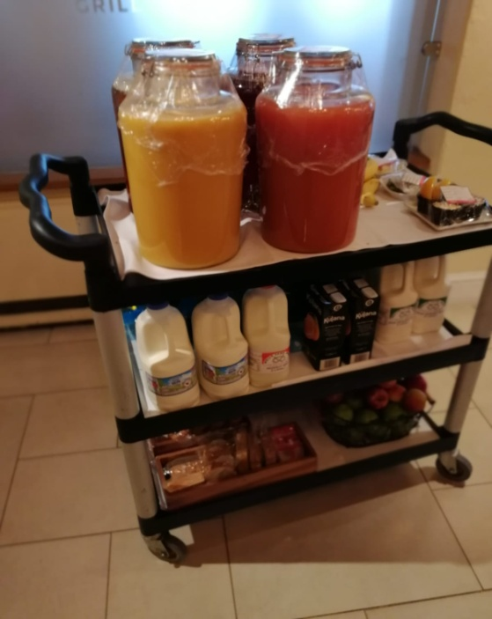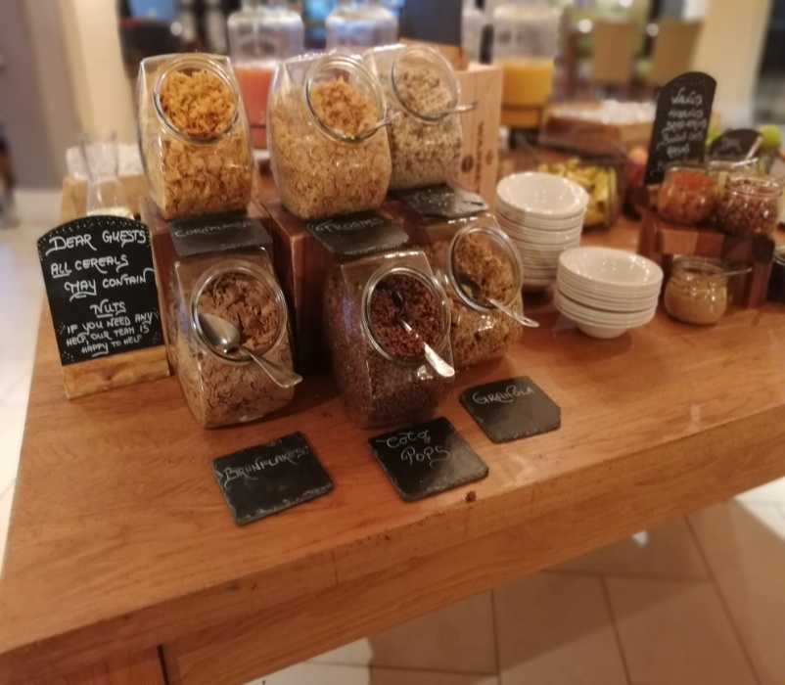
Breakfast....

