Module Name: Protecting and Supporting Families in Health and Care
Module Code: BMHP5021
Programme: BSc (Hons) Health and Social Care
Title of Task – An examination and analysis of how the ‘Early Help’ system is signposted
to UK families by their local authority website.
Student name: Natalia Furtuna
Student number: 2336284

Table of Contents
Introduction 3
Early Help System 4
Explanation of Multi-Agency Working 6
Evaluation of Three Local Authority - Early Help Websites 8
Comparative Analysis of Local authority Early Help Communication 17
Conclusion and Recommendations 19
References 20

Introduction
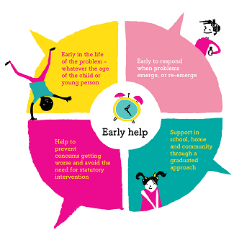
(LEEDS, 2025)
The report provides a critical assessment of the Early Help communication on public websites by three local authorities, including Norfolk, Tower Hamlets, and Leeds. Early Help focuses on a proactive system that aims to support children, young people and families at the earliest stage of need development, thereby preventing such cases from progressing to statutory intervention. The local authority websites play a significant role in signposting the services, acting as the initial point of contact for the families who are seeking guidance. The evaluation of the three websites is based on the criteria of clarity, accessibility, inclusiveness and representation of a multi-agency approach. Moreover, the paper will provide a comparative analysis and recommendations for improving Early Help communication.

Early Help System
Early Help is termed a preventive, multi-level system of support for families and kids, designed to respond to the varying needs before problems lead to agency actions. The Early Help System Guide (Dfe, 2022) states that it is not a standalone service but a cohesive network of partnerships, processes and services working together. This is done to strengthen the resilience among children, families and young people within their communities (Gov.UK, 2025).
1. Purpose of Early Help
- Providing intervention rapidly in order to address the increasing risk
- Reduce the reliance and workload on formal child protection services
- Strengthen the protective factors like harnessing community support and parental skills
- To encourage solution-driven and collaborative planning
2. Early Help (System Levels)
Level | Description | Examples
Targeted | Further assistance for changing needs | Classes for parents, help for teenagers
Universal | All families can get access to support | Health visitor, pupil, doctor
Specialist | Heavy support to avoid reaching the law | Teams for family help, joint agency discussions
3. Key Principles (DfE National Guidance)
- Ease of Access: To ensure that effective support services are easy to navigate and find (Nspcc, 2023).
- Prompt Timeliness: To provide immediate help as soon as problems become apparent
- Family-centered Practice: To empower families to help the process by goal-setting and decisions
- Multi-agency Partnership: To foster a collective working relationship among health, social care, housing and voluntary services

Explanation of Multi-Agency Working
Multi-agency working is a collaborative teamwork between different organsiations and professionals, sharing responsibilities for families, young people and children. This ensures identification of early requirements, effective support across services and better sharing of information. As per the document titled Working Together to Safeguard Children 2023, safeguarding is a shared responsibility among the local government, health partners, police, schools and non-profit organisations (Gov.UK , 2025).
1. Purpose of Multi-Agency Working
- Prevent kids from being unnoticed or "slipping through cracks" between different services.
- Merged knowledge of professional and abilities to deal with the difficult needs that families usually bring (Cheminais, 2008).
- Provide support plans that take into account all parts of a family's life (holistic) and concentrate on their current strengths.
- Increase overall results for families by cutting off redundant efforts and useless hold-ups.
2. Key Components of Effective Multi-Agency Practice
Component | Description | Contribution
Coordinated planning | Shared goals and aligned interventions | Gives consistent support
Information sharing | Relevant data is followed by GDPR and the law protecting shared mannerly | Reduces the escalation of risk
Lead professional role | One practitioner is assigned to coordinate services | Facilitates family communication
Joint assessment | Agencies lead to the formation of Early Help Assessments | Provides understanding for the entire family
3. Why Multi-Agency Working Matters
Complex family challenges like housing instability, parental stress, school truancy or mental health issues are not isolated incidents but connected issues. With the help of the Early Help strategy, this recognises this reality by emphasising shared responsibilities and working across diverse agencies (Mayberry et al., 2014).

Evaluation of Three Local Authority - Early Help Websites
This evaluation provides a comprehensive analysis regarding how the 3 chosen local authorities communicate about early help along with relevant services for family support in their websites.
1. Norfolk Country Council (Early help and family support)
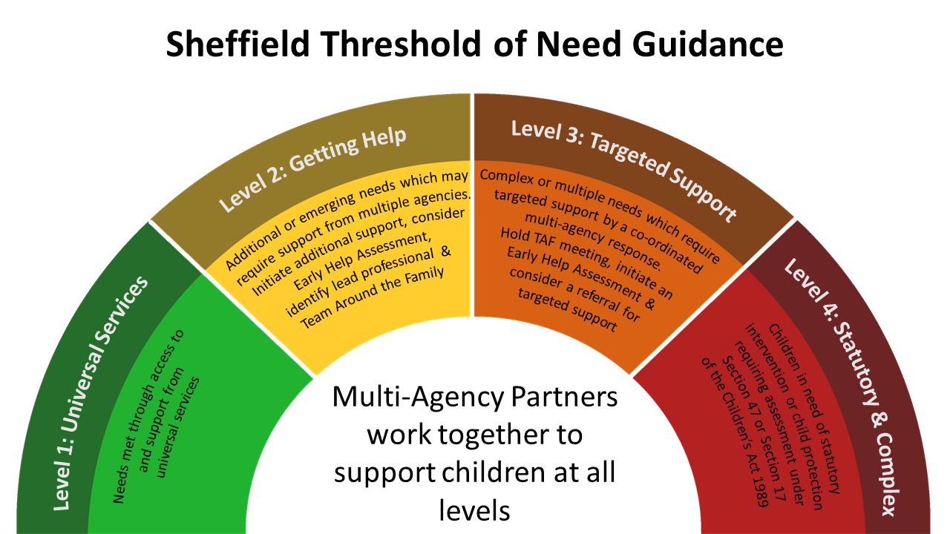
(safeguardingsheffieldchildren, 2024)
1.1 Information Structure and Clarity
Strengths:
- Norfolk describes Early Help as a preventative and needs driven model of support (norfolklscp, 2024).
- The website provides information about this using common categories and headings including family hubs, support for families and what is early help? This makes it easier for users to navigate the site (norfolk, 2025).
- It clearly shows how early help is delivered in different parts of the county through the descriptions of family hubs and how families are informed about where they can access help (MP, 2025).
Limitations:
- These pages heavily depend on complex narrative text that might decrease immediate involvement for potential users that benefit from simplified or visual formats.
- Essential resources involving referral mechanisms are significantly unnoticeable and needs users for navigating via several sections.
- However there are no examples of families receiving Early Help or any illustrations so the information remains theoretical rather than practical.
1.2 Inclusivity and Accessibility
Positive Aspects:
- The main website of Norfolk involves general features of accessibility like contrast modifications and adjustable size of text.
- Pages of Early Help highlights routes for both professional and self referrals providing families diversified entry points (nspcc, 2023)
Areas to Improve:
- There are no multilingual versions or translation tools of the website which could present challenges for families that do not speak English.
- The website lacks many types of resources that would help support users with additional learning requirements including videos, diagrams and visual summaries.
- The website does not provide very much information specifically for certain groups (like SEND families, young carers and families from different cultural backgrounds) (norfolk, 2025).
1.3 Statutory Guidance Alignment
Effective Elements:
- Norfolk effectively acknowledges targeted and universal provision indicating the emphasis of ‘early help system guide’ on the graduated response.
- Mentioned pathway of referral adheres with working together expectations 2023 about timely intervention and early identification (Smith, 2023).
Identified Gaps:
- Core principles of safeguarding are not communicated clearly involving confidentiality, thresholds and consent for escalation may decrease trust.
- This website provides limited insight regarding the interaction, information sharing or cooperative actions of multi agency partners around families.
1.4 Overall Assessment of Norfolk
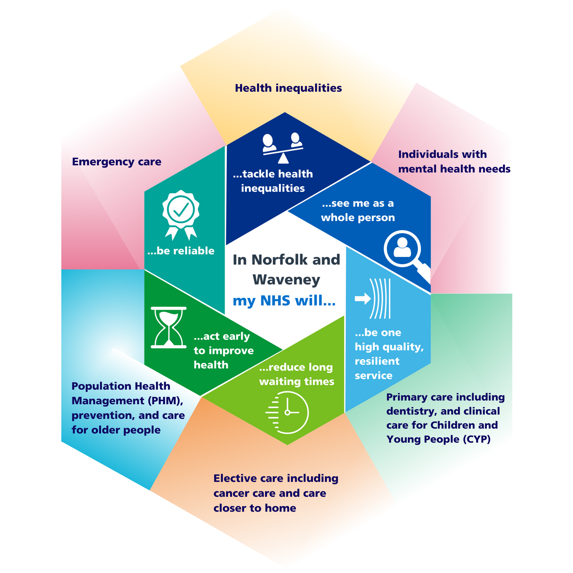
(improvinglivesnw, 2024)
Norfolk provides a basic but traditional Early Help page in its web site for users to understand the concept. However it does not portray a sense of collaboration between multi agency partners as the presentation lacks the element of cooperation that is a large part of the National Guidance (Thomas, 2024). There is a clear focus on informative content but does not encourage user participation or a sense of community.
2. Tower Hamlets Council (Early Help Hub)
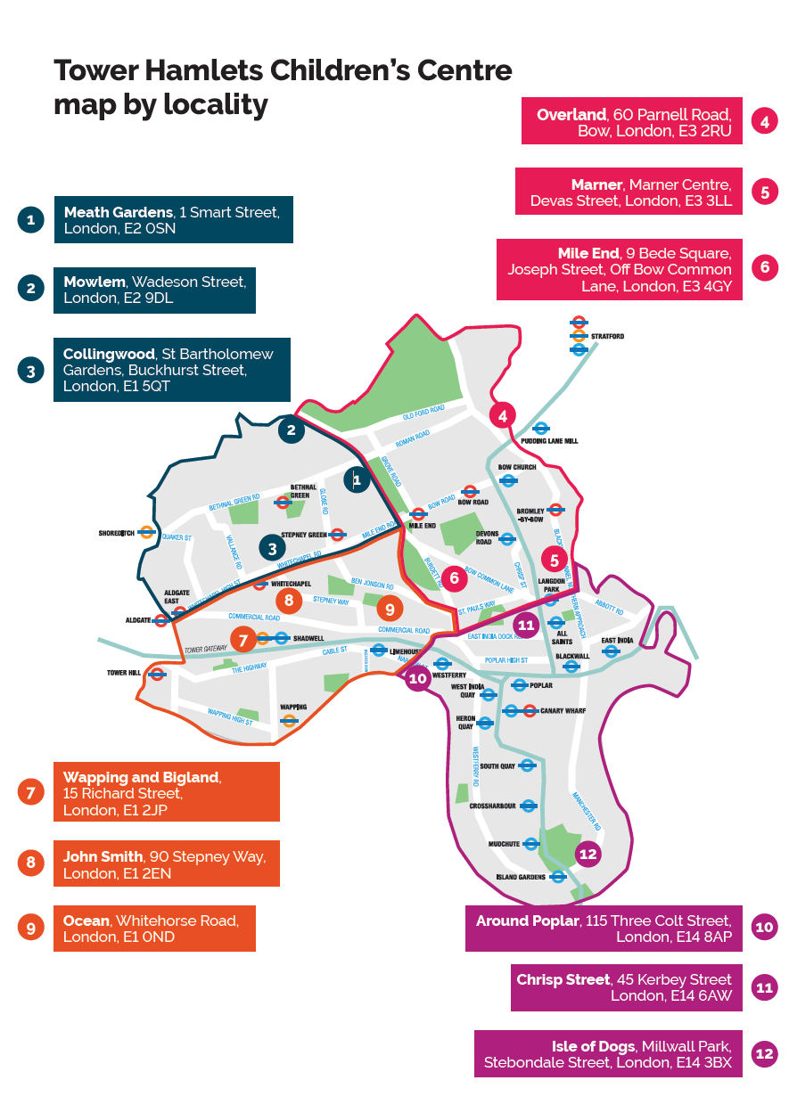
(towerhamlets, 2024)
2.1 Simplicity, User Friendliness and Clarity
Strengths:
- Adopts plain language and highly accessible initiative that makes the site appropriate for families not habituate with the social care procedures (towerhamlets, 2025).
- Early Help Hub offers a centralised gateway decreasing fragmentation that often encountered by families (Elliott, 2024).
- Users are directed to contact the Hub for assistance through email or telephone and therefore removing digital barriers to contact when required.
Limitations:
- The web site contains very little information on the array of interventions makes it difficult for families to understand how Early Help works in practice (towerhamlets, 2024).
- There are no visual representations of the process of assessment and referral available to help families understand how to get help through an early help service.
2.2 Accessibility and Inclusivity
Positive Features:
- Offers multilingual options upholding the multilingual community and culturally diverse borough.
- Besides mobile friendly feature assures seamless access for families utilising tablets and phones.
- Also Hub model indicates a commitment to the provision of "Pathways" as described in the Early Help System Guide.
Drawbacks:
- However the websites have many references to the wide variety of Youth Services available but once a user clicks on those pages it disrupts the flow of the User Journey.
- There are currently no downloadable documents that could assist families with learning difficulties or poor literacy skills in the form of an easy read guide or a visual summary.
2.3 Alignment with Safeguarding and Early Help Principles
Strong Areas:
- This particular website promotes early contact encouraging preventive aim of Early Help.
- The Early Help Hub has been developed with an overarching aim to provide coordinated pathways which is also captured in the Working Together 2023 (WT2023) guidance (gov.uk, 2015).
Weaknesses:
- There is no clear details regarding the escalation procedures and role of lead professional.
- Constrained explanations regarding processes of early help assessment, sharing ethical information and multiagency decision making.
2.4 Evaluation
The Tower Hamlets Early Help website is by far the most accessible and user friendly of all the services reviewed. It uses simple language and the hub is designed to provide a centralised point of access for families. However there are areas where the Tower Hamlets site could provide additional information (towerhamlets, 2024). Practitioners within the Early Help Hub are key to delivering effective services to families and more detailed guidance on their roles and how to work collaboratively is required to enhance service delivery.
3. Leeds City Council (Early Help and Minute Guides)
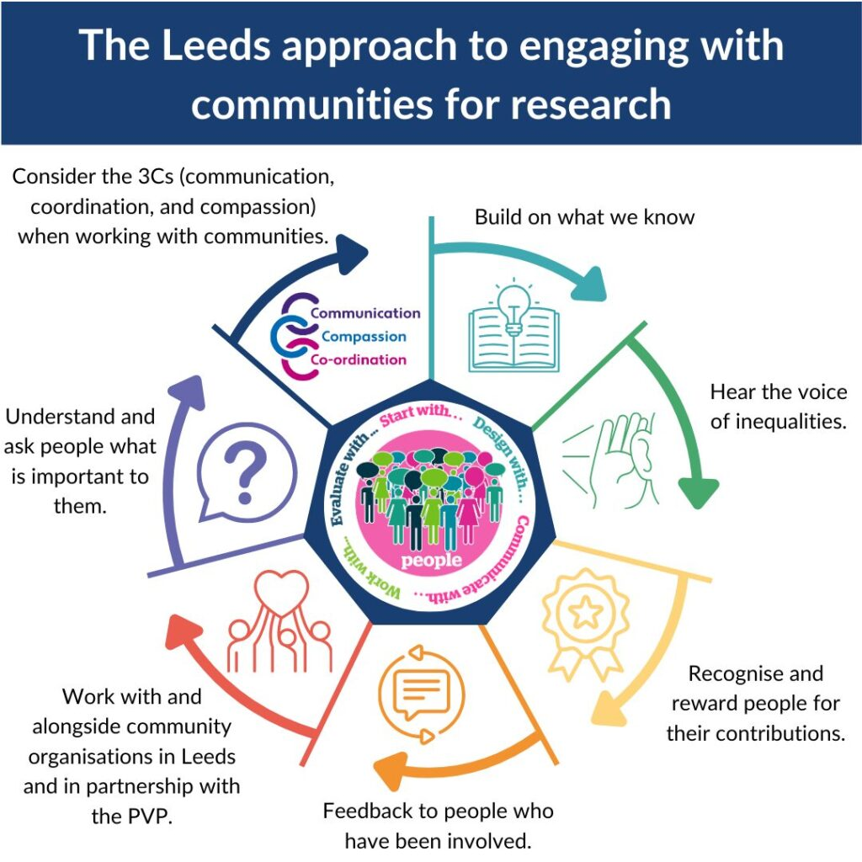
(leedsbrc, 2025)

3.1 Information Quality and Depth
Strengths;
- Offers extensive resources of Early help involving practice guidance and frameworks (leedsscp, 2025).
- Downloadable diagrams and tools reflect a detailed system regarding this.
- 1 minute guides effectively translates complicated processes to brief summaries.
Limitations:
- Families may feel overwhelmed by the volume of practitioner content available on the Tower Hamlets website.
- The use of practitioner language will be complex for the non practitioners.
- Families will not identify with the guidance written for practitioners (Leeds, 2022).
3.2 Accessibility and Inclusion
Positive Elements
- The provision of different formats of resources supports several learning styles.
Areas for Development
- There are no translation resources available for families from bilingual communities.
- Complex navigation bars will hinder quick and easy access to relevant resources.
- Limited amounts of simple visual materials will support families.
3.3 Statutory Guidance Compliance
Effective Components:
- Illustrates clear coordinations among the multi agency members complying with the Working Together 2023 (leeds.gov, 2024).
- Effectively explains responsibilities and roles.
Limitations:
- Heavy tone of practitioners can deter families.
- Less clarity regarding expectations, consent and confidentiality.
3.4 Overall Insights
Multi agency clarity is strong in Leeds however there needs to be a stronger family focused presentation of multi agency clarity to uphold accessibility.
Comparison Table (Summary)
Analysis Criteria | Tower Hamlets | Leeds | Norfolk
Accessibility | Generally user friendly | Needs high effort for navigation | Average
Clarity | Simple, clear | Comprehensive but tech based | Organised however text oriented
Inclusivity | Strong multilingual initiative | Minimal tools for inclusivity | Limited
Explanation of multi agency | Partial | Strongest | Weak
Accurate for Professionals | Moderate | yes | Average
Best for Families | Yes | No | Partly

Comparative Analysis of Local authority Early Help Communication
Comparing how Tower hamlets, Leeds and Norfolk present online information of Early help prioritising accessibility, transparency of multi agency, clarity and inclusivity.
1. Clear, Accessible Information and Presentation
- Norfolks presents its information in a structured way but is text dominant which reduces the speed of comprehension for many users.
- Leeds provides detail on services however the way its services are presented as a 'professional service'. This means families cannot easily navigate to get the straightforward help they are looking for.
- Tower Hamlets provide clear, accessible information through the use of centralised hubs (Early Help Hub).
2.Inclusivity and Accessibility
- The website of Norfolk is accessible moderately however it lacks translation and visual aids.
- Tower Hamlets is significantly strong providing mobile friedly feature along with multilingual options.
- Additionally Leeds offers varied formats of document but no tools for translation and limited visuals for families.
3. Transparency in Multi-Agency
- Leeds presents the clearest example of how multi-agencies can work in alignment with Working Together 2023 (ineqe, 2023).
- Norfolk provides limited information on how agencies work collaboratively or the information sharing routes.
- Tower Hamlets works together to provide coordinated access to support services through their Hub however provides little information on agency specific roles.
Therefore it is evident that tower hamlet website is effectively accessible while Leeds is significantly comprehensive procedurally. In this context Norfolk fits between these providing clarity however there is limitation in multiagency transparency and inclusivity.

Conclusion and Recommendations
This report has indicated that although each of the three local authorities effectively share Early Help information in some respects they all have areas that need further development. Besides Tower Hamlets is comparatively easy way for families to get into Early Help there is structured information from Norfolk and Leeds has strong clarity around multi agency working. Therefore to improve Early Help communication all three local authorities should consider using clearer visual materials including family friendly summaries and multilingual options. This would help to improve the understanding and engagement of families and also increase transparency regarding the roles of agencies, how information is shared and how assessments are made between them. Furthermore the continued refinement might further ensure families get accessible, confident and timely support.

References
Cheminais, C., (2008). The origin, concept and principles of multi agency partnership working. Effective multi-agency partnerships: Putting every child matters into practice, pp.1-22.
Dfe, (2022). Early Help System Guide. [Online] Available at: https://assets.publishing.service.gov.uk/media/628de13be90e071f5f7e1bd2/Early_Help_System_Guide.pdf [Accessed 10 12 2025].
Elliott, D., (2024). Early help: fragmented, uncertain and underfunded. [Online] Available at: https://www.actionforchildren.org.uk/blog/early-help-fragmented-uncertain-and-underfunded/ [Accessed 08 12 2025].
Gov.UK , (2025). Working together to safeguard children. [Online] Available at: https://www.gov.uk/government/publications/working-together-to-safeguard-children--2 [Accessed 10 12 2025].
gov.uk, (2015). Working together to safeguard children. [Online] Available at: https://www.gov.uk/government/publications/working-together-to-safeguard-children--2 [Accessed 09 12 2025].
Gov.UK, (2025). Information sharing advice for safeguarding practitioners. [Online] Available at: https://www.gov.uk/government/publications/safeguarding-practitioners-information-sharing-advice [Accessed 10 12 2025].
improvinglivesnw, (2024). Clinical Strategy – Year 2 – “You said, we did”. [Online] Available at: https://improvinglivesnw.org.uk/clinical-strategy-year-2-you-said-we-did/ [Accessed 09 12 2025].
ineqe, (2023). Working Together to Safeguard Children 2023. [Online] Available at: https://ineqe.com/2023/12/19/working-together-safeguard-children-2023-updates/ [Accessed 07 12 2025].
Leeds, (2022). Leeds City Council. [Online] Available at: https://www.leeds.gov.uk/ [Accessed 08 12 2025].
leeds.gov, (2024). One minute guide: Working Together to safeguard children. [Online] Available at: https://www.leeds.gov.uk/one-minute-guides/working-together [Accessed 06 12 2025].
leedsbrc, (2025). The Leeds Approach to Engaging with Communities for Research. [Online] Available at: https://leedsbrc.nihr.ac.uk/ppie-strategy/engaging-with-communities/ [Accessed 07 12 2025].
leedsscp, (2025). Early Help Approach and Strategy. [Online] Available at: https://www.leedsscp.org.uk/practitioners/approaches/early-help/approach [Accessed 07 12 2025].
Mayberry LS, Shinn M, Benton JG, Wise J. Families experiencing housing instability: the effects of housing programs on family routines and rituals. Am J Orthopsychiatry. 2014;84(1):95-109. doi: 10.1037/h0098946. PMID: 24826832; PMCID: PMC4089513.
MP, O. B., (2025). Access to early SEND support through Best Start Family Hubs. [Online] Available at: https://www.gov.uk/government/news/access-to-early-send-support-through-best-start-family-hubs [Accessed 10 12 2025].
norfolk, (2025). Early help for children and families. [Online] Available at: https://www.norfolk.gov.uk/40407 [Accessed 07 12 2025].
norfolk, (2025). Young carers and families. [Online] Available at: https://www.norfolk.gov.uk/article/42008/Young-carers-and-families [Accessed 08 12 2025].
norfolklscp, (2024). Early Help Assessment & Plan. [Online] Available at: https://norfolklscp.org.uk/about/policies-procedures/policy-framework/14-early-help-assessment-plan [Accessed 08 12 2025].
nspcc, (2023). Early help and early intervention. [Online] Available at: https://learning.nspcc.org.uk/safeguarding-child-protection/early-help-and-early-intervention [Accessed 07 12 2025].
Nspcc, (2023). Early help and early intervention. [Online] Available at: https://learning.nspcc.org.uk/safeguarding-child-protection/early-help-and-early-intervention [Accessed 10 12 2025].
safeguardingsheffieldchildren, (2024). Early Help Assessment and Threshold of Need. [Online] Available at: https://www.safeguardingsheffieldchildren.org/p/processes/early-help-assessment-and-threshold-of-need [Accessed 08 12 2025].
Smith, F., (2023). The Journey to Early Identification and Intervention for Children with Disabilities. [Online] Available at: https://www.mdpi.com/1660-4601/20/18/6732 [Accessed 09 12 2025].
Thomas, F., (2024). Housing and children’s social care in England: learning from embedded research. [Online] Available at: https://www.tandfonline.com/doi/full/10.1080/02673037.2024.2419527#abstract [Accessed 05 12 2025].
towerhamlets, (2024). Children and Family Centres and Family Hubs. [Online] Available at: https://www.towerhamlets.gov.uk/lgnl/health__social_care/children_and_family_care/Early_Help/Children-and-Family-Centres/Children-and-Family-Centre.aspx [Accessed 07 12 2025].
towerhamlets, (2024). Early Help at the front door. [Online] Available at: https://www.towerhamlets.gov.uk/lgnl/health__social_care/children_and_family_care/Early_Help/Early_Help_Hub.aspx [Accessed 07 12 2025].
towerhamlets, (2024). MAST Early Help & Children and Families Service. [Online] Available at: https://www.towerhamlets.gov.uk/lgnl/health__social_care/children_and_family_care/Early_Help/Early-Help-and-Children-and-Family-Service.aspx [Accessed 06 12 2025].
towerhamlets, (2025). Tower Hamlets launches ambitious strategy to support families. [Online] Available at: https://www.towerhamlets.gov.uk/News_events/2025/October/Tower-Hamlets-launches-ambitious-strategy-to-support-families.aspx [Accessed 07 12 2025].

