2023


Assignment 1
Subject Name: International Marketing
Subject Code: LCMB7006
Lecturer: Dr Tushara Balendran
Course: MBA Marketing Management
Semester: 2

Student Name: Varun Joseph Sony
Student Number: 2129151

Table of Contents
Introduction 2
Unilever PLC 2
Macro Environment Analysis 3
PESTLE 3
Similarities and Differences 8
Porters 5 Forces Model 9
Similarities and Differences 11
Strengths and Limitations 12
SWOT Analysis 13
Similarities and Differences 15
STP 16
Perceptual Map 20
Similarities and Differences 22
Marketing Mix Elements 23
Similarities and Differences 28
Directional Development Strategy 29
The BCG Matrix 29
Strengths and Limitations 32
Product Life Cycle Model 32
Recommendations 36
Conclusion 37
References 39

Introduction
International marketing is a complex field in marketing that requires organizations to adapt to diverse global markets and cultures. Hence, companies that want to expand their operations to other global markets has to devise marketing strategies that addresses the unique factors and needs of those specific markets. Unilever is an organization that has implemented such strategies successfully in several countries across the globe. In this report, we will discuss the key international marketing strategies of Unilever in two of the largest global markets; the UK and India. We will commence by applying the PESLTLE model to analyse the macro environmental factors that could affect the company. Then we will look at the environmental factors that could create opportunities as well as threats for the company. Additionally, we will analyse the attractiveness of Unilever’s industry of operation with the help of Porter’s Five Forces framework. The report will also discuss several other key factors and models that helps the company such as STP, SWOT and marketing mix strategies. Finally, the report will also provide recommendations to improve the marketing strategies of the company.

Unilever PLC
Unilever is a British-Dutch multinational conglomerate that was formed in 1929, as a result of the merger between the Dutch margarine producer Margarine Unie and the British soap maker Lever Brothers (Unilever, 2023; Sim et al., 2016). Today, the company operates in more than 190 countries and owns 400+ brands such as Dove, Lipton and Knorr. Unilever employs more than 150, 000 people globally and is valued at 165 billion USD. Till 2020, the company used to follow a dual-listed company (DLC) corporate structure. A dual-listed company is a company that is listed on two or more stock exchanges, but operates as a single business. In the case of Unilever, it is listed on both the London Stock Exchange (LSE) and the Euronext Amsterdam stock exchange. This means that the company has two separate legal entities, one in the UK (Unilever PLC) and one in the Netherlands (Unilever NV), but they operate as a single economic entity. However, in 2020, these organizations merged together to form a unified Unilever PLC (Unilever PLC, 2020). The company has also got into several scandals during its operations. For instance, 2011, Unilever has been accused of price fixing in Europe (Chee, 2011). The company has also faced some backlash in its plastic waste disposal techniques and sustainability practices (Morrison, 2020).
Unilever UK is a subsidiary of the company and is headquartered in Leatherhead, Surrey. The company owns 40+ brands in the UK such as Dove, Persil, PG Tips, Lynx, and Hellmann's and employs more than 7000 people (Unilever, 2023). Similarly, Hindustan Unilever Limited (HUL) is the official name of the Unilever subsidiary in India (Raj & Aithal, 2018). HUL is headquartered in Mumbai and employs more than 20,000 people. Some of HUL’s popular brands in India include Dove, Surf Excel, Lipton, Pepsodent, and Lifebuoy.

Macro Environment Analysis
The macro environmental analysis is the process of evaluating the larger external factors such as politics and economy that affect an organization. Here we apply a wide range of indices such as inflation, demography, technology and so forth to analyse their positive and negative impacts on the company (CFI, 2023). Successful macro environmental analysis not only helps organizations to make key strategic decisions it will also help to identify the opportunities and threats in an industry. For instance, companies can apply macro analysis models to determine whether it is good to expand into a new market. One of the most widely used such model is the PESTLE framework. In the following topic, we will learn more about the model and how it can be applied to Unilever’s operations.

PESTLE
PESTLE is an acronym that stands for Political, Economic, Sociocultural, Technological, Legal, and Environmental factors. It is a macro environmental framework that can be applied to study the external factors that affects an organization. The concept is widely used in strategic planning, risk management and market research (CIPD, 2021). The PESTLE analysis for Unilever in the UK and India can be applied as follows:
Political
These are factors that are caused by political repercussions such as tax and trade policies, war, political climate as well as natural & manmade calamities. For instance, Unilever UK can leverage the commitment of the UK government towards sustainable business operations by highlighting its sustainability and environmentally-friendly practices (GOV.UK, 2021). Similarly, HUL can leverage Indian government's "Make in India" initiative, aimed at promoting domestic manufacturing and attracting foreign investment, by investing more in production facilities in India (Make in India, 2014).
On the other hand, the Russian invasion of Ukraine and Brexit are political factors that could negatively affect Unilever UK. For instance, tariffs and trade embargos on Russia have caused supply chain issues in most British companies (OBR, 2022). Similarly, foreign investment regulations introduced by India caps the investments of foreign corporations in the country (NRF, 2022). This will negatively impact HUL and its vision for expansion in the country.
Economical
Economic factors include growth rates, inflation, and interest rates. Since UK is a developed country, its people enjoy a high level of disposable income. This would encourage people to spend more, which boosts the sales of Unilever UK. Similarly, India is a developing country that records high development in all economic matrices. This could improve the sales and revenues of HUL as well.
However, the Covid 19 has caused inflation in most major economies in the world, including the UK and India. This will affect the operations of Unilever in both the countries as high inflation will reduce the purchasing power of people (Oner, 2019). In other words, it will cause a decline in the sales figures of Unilever in both countries.
Social/Cultural
Sociocultural factors refer to demographic trends, cultural attitudes and values, and social changes that can impact an organization. For instance, the trend towards heathy dietary practices in the UK will help in the sales of wellness products by Unilever such as SlimFast, Simplee Aloe and Lipton Green Tea (BNF, 2021). Similarly, the growing number of middle class and high-income people in India could help to increase the sales of HUL (Farrell & Beinhocker, 2007).
The socio-cultural factors that affect a market can be better analysed with a more informative model; the Hofstede Cultural Dimensions Model.

The Hofstede Cultural Dimensions Model
The Hofstede cultural dimensions model is a framework developed by Dutch social psychologist Geert Hofstede to analyse the cultural factors in a country (Beugelsdijk & Welzel, 2018). The model measures the performance of a country or region across six key factors, which are as follows:
- Power Distance: This factor refers to the extent to which people accepts unequal distributions of power and authority. Countries with high power distance values authority while countries with low power distance values equality and individualism. UK has a low power index as its people value equality, regardless of their social class. India on the other hand, has a high power distance as people respect and accept unequal power distribution and believes in a hierarchical social structure (Bhatnagar, 2017).
- Individualism vs. Collectivism: This factor measures the extent to which people values their own interests over the interests of the society. Individualistic cultures value independence and personal achievements while collectivistic cultures value the needs of the culture or the society. UK is a highly individualistic society that values personal liberty, expressions, and achievements over everything (Bhatnagar, 2017). This is in stark contrast to India where people value social harmony and interdependence.
- Masculinity vs. Femininity: This factor is about the extent to which a society perceives traditionally masculine traits (such as competitiveness, assertiveness, and material success) versus traditionally feminine traits (such as nurturing, collaboration, and quality of life). The UK is relatively masculine society that values assertiveness and competitiveness (Bhatnagar, 2017). Although India too values these masculine factors, the traditional gender roles are strictly defined in its society.
- Uncertainty Avoidance: This factor measures the extent to which people in a society are comfortable with uncertainty and risk. Societies with high uncertainty avoidance score tend to have a strict social structure and prefers clearly defined rules and procedures. However, countries with low uncertainty avoidance tend to be more open minded and agile to change. The UK has a low uncertainty avoidance score as its people are more comfortable to risk taking and changes. India however has a high uncertainty avoidance as its people generally tends to avoid taking risks and prefers a more stable social structure (Bhatnagar, 2017).
- Long-Term Orientation vs. Short-Term Orientation: This factor is about the extent to which a society values long term goals over short term goals. The UK is a relatively short-term oriented society that values immediate results and gratifications. India, on the other hand is a long-term oriented society that values long-term goals with a strong focus on religious and family values (Bhatnagar, 2017).
- Indulgence vs. Restraint: This factor measures the extent to which a culture values pleasures of life over exercising restraint on them. The UK is a highly indulgent society that values the enjoyment of life and pursuing of leisure activities. On the contrary, India is a highly restrained culture that values austerity and self-discipline (Bhatnagar, 2017).
The following graph shows the comparison of the UK and India across the six Hofstede cultural matrices.
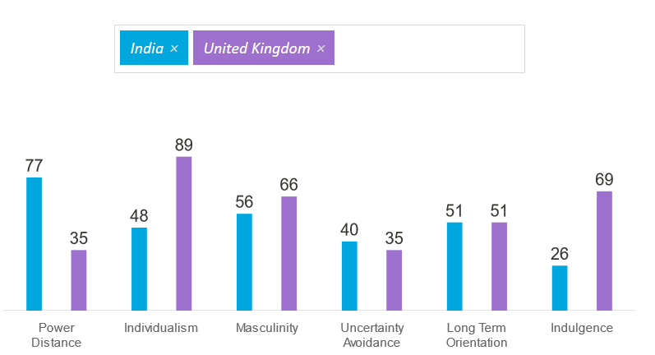
Source: Hofstede Insights

Strengths and Limitations
The Hofstede cultural dimensions model has several benefits (Shaiq et al., 2011) such as;
- Helps to Understand Cultural Differences: The model helps to understand how different cultures operates and the values that shapes them. It can help companies that want to diversify to a new market.
- Provides a Uniform Framework: The model provides a uniform framework to analyse different cultures. This could help in more effective collaborations between organizations that functions in different cultures.
- Helps to Negate Cultural Misunderstandings: The model helps to identify factors that are prone to create cultural misunderstandings. This will help companies to navigate through different cultures more seamlessly.
- Enhances Cultural Tolerance: The model highlights the different values and factors that are important to a culture. By understanding them, organizations can become more respectful towards them. This will help in the smooth functioning of an organisation in a different cultural environment.
The model however also possesses a few limitations (Shaiq et al., 2011), such as:
- Generalization: The model generalises an entire culture and ignores the subcultures and exceptions in them.
- Might not be Universally Applicable: The model was developed with the data from IBM employees based on a small number of countries. Hence, it might not be relevant or acceptable to all countries.
- Stereotypes: The model can also create stereotypes and cultural bias, especially if not analysed with sensitivity and objectivity.
Technology
These are factors that are influence by technology, such as automation and technological changes. The UK being a developed country has access to advanced technological infrastructure which can be leveraged by Unilever especially for moving into digital channels. Similarly, India has a developing technological infrastructure which can help the company to move into digital channels.
On the other hand, the rapid pace of technological change in the UK market will force the company to innovate more, if they want to survive in the market. Similarly, there are places in rural India with limited technological infrastructure which could hamper its operations in the country.
Legal
These refers to factors such as legislations that could affect the operations of a company. UK has a stable legal system that supports businesses, which is favourable for the company. Similarly, India has been improving its laws and regulations pertaining to businesses, which could be favourable for the company.
However, UK also has stringent consumer protection laws and regulations (GOV.UK, 2022). This will negatively affect the company’s marketing strategies based on the efficiency of its products. Likewise, India has a volatile legal environment which constantly changes and updates the laws and regulations. This could hamper the company’s operations in the country.
Environmental
These are factors relating to the environment such as climate change, pollution, and global warming. There is a growing concern towards environment and sustainability in both the UK as well as India. This can be viewed as a positive opportunity for the company to rebrand itself as a sustainable company.
Nevertheless, the UK government is getting more stringent with regards to environment and sustainable business practices, and is continuously devising new policies for the same (ClientEarth, 2022). This could increase the compliance costs for the company and reduce its revenue. Similarly, India has numerous environmental challenges such as water scarcity and pollution, which could affect the supply chain operations of the company (SIWI, 2018).

Similarities and Differences
Similarities
- Political Factors: Both the UK and India has stable political environments that supports businesses. This will help Unilever to invest in long term growth in both countries.
- Economic Factors: Both countries have significant growth prospects. This will help Unilever to expand more, increase the market share and generate more revenue, in both countries.
- Technological Factors: Both companies invest heavily in research and development as well as innovative digital marketing campaigns. This will help them to maintain their competitive advantage as well as in reaching more customers.
- Environmental Factors: Both companies have implemented sustainable business practices in their individual markets. This will help them to increase their brand reputation in the eyes of the emerging environmental conscious customer base.
Differences
- Social Factors: Unilever UK is operating in a multicultural market while HUL is operating in a highly populated and hierarchical market. Hence, Unilever has to devise different strategies to reach the customers in these markets.
- Legal Factors: Unilever UK has to comply with laws and regulations like GDPR whereas HUL has to abide by the FSSAI (Food Safety and Standards Authority of India) standards. Hence, Unilever has to understand and comply with different set of laws and regulations to operate in the two markets.
- Economic Factors: UK being a developed country has a mature consumer market, so the core focus of Unilever UK is to retain its market share. On the other hand, India is a developing market hence the core strategy of HUL is to expand its market share and generate more revenue. In other words, the companies had to adopt different growth strategies owing to the difference in markets.
As we had a detailed analysis of the external factors that affect Unilever, we can now analyse the internal factors and their effects, with the help of Porters Five Forces model.

Porters 5 Forces Model
In layman terms, Porters Five Forces model is a framework developed to analyse the attractiveness of an industry (Porter, 1979). It was developed by Michael Porter, a Harvard Business School professor, in 1979. The model analyses five key factors that are as follows:
- Threat of New Entrants: Refers to the degree of difficulty for new companies to enter the market. If the barriers to enter the market is low, new companies can easily enter the market and increase competition (Porter, 1979). The consumer good industry in the UK is highly competitive with many companies such as Procter & Gamble (P&G), Nestle and Reckitt Benckiser, in the market. Unilever faces the same in India as well, with competitors like Procter & Gamble, Dabur and ITC. However, Unilever has a strong brand image, economies of scale and robust supply chain networks in both countries, which can create strong barriers to entry. Hence, we can say that the threat of new entrants is low for Unilever in both countries.
- Bargaining Power of Suppliers: Refers to the degree of power suppliers have with respect to the price and quality of products. If suppliers have a higher power, they can demand for higher prices which will reduce the profits of a company (Porter, 1979). Both Unilever UK and HUL have access to global supply chain networks and a large number of suppliers, giving it significantly high power over its suppliers (Kissinger, 2017). Hence, we can say that the bargaining power of suppliers is low for both Unilever UK and HUL.
- Bargaining Power of Buyers: Refers to the degree of control buyers have in the market. If they have a high bargaining power, they can demand higher quality products and lower prices, which could reduce the profitability (Porter, 1979). The consumer goods market in both countries are highly competitive and buyers have access to a wide variety of products to choose from. Hence, Unilever has to keep their prices in check and innovate their products continuously to stay in the market (Kissinger, 2017). So, we can say that the bargaining power of buyers is very high for both Unilever UK and HUL.
- Threat of Substitutes: Refers to the degree to which alternative products can satisfy the same needs of the customer (Porter, 1979). Unilever faces significant competition in both countries which could affect its sales and revenue (Kissinger, 2017). Hence, we could say that the threat of substitutes is high for Unilever in both UK and India.
- Competitive Rivalry: Refers to the degree of competition in the industry. Having a large number of competitors can affect the profitability of an industry (Porter, 1979). Unilever competes with companies such as Procter & Gamble, Nestle, and Colgate-Palmolive in both the UK and India. This intense competition can lead to price wars and reduced profits (Kissinger, 2017). Hence, we can say that the competitive rivalry is high for both Unilever UK and HUL.
The following image shows the model alongside the factors that influence each force:
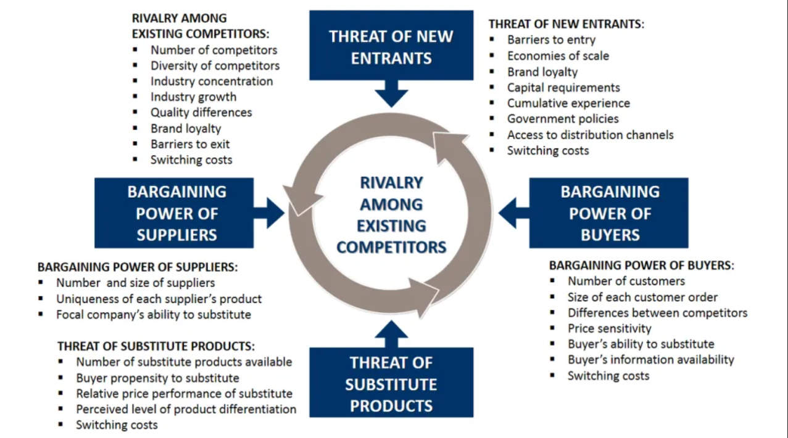
Source: https://www.business-to-you.com/porters-five-forces/

Similarities and Differences
Similarities:
- Threat of New Entrants: Both Unilever UK and HUL faces similar levels of low-level threats of new entrant in the market. This is because the Fast-Moving Consumer Goods (FMCG) industry is highly competitive in both countries and requires high initial investments to enter (Kissinger, 2017).
- Bargaining Power of Suppliers: The suppliers of Unilever in both countries have low power as the company have access to global supply chains, with thousands of suppliers.
- Bargaining Power of Buyers: The buyers in both countries have a high degree of power as they have a large number of products to choose from.
Differences:
- Threat of Substitutes: The company faces a higher level of threat from substitutes in the UK market. This is because the country has a more mature market with a greater number of substitutes.
- Competitive Rivalry: The company faces higher competition in India than in the UK. This is because the Indian FMCG industry has a greater number of local products compared to the UK.
- Regulatory Environment: The company faces stricter regulations and rules in its UK operations as the country has more stringent consumer protection laws and sustainability standards.

Strengths and Limitations
Strengths of Porter's Five Forces (Usmani, 2022) Analysis:
- Structured Framework: Provides a methodical framework for assessing an industry's competitive landscape, which helps in identifying the main factors influencing profitability.
- Understand Power Dynamics: Aids companies in understanding the power dynamics among major participants in an industry, which can help with strategic decision-making.
- Risk Analysis: Can highlight possible opportunities and security threats to a company's market position.
- Competition Analysis: Allows for the comparison of the competitive environment across various markets and regions.
Porter's Five Forces can be applied to analyse both the mature and regulated UK market and the fiercely competitive and fragmented Indian market. The framework can be used by Unilever UK to find potential for differentiation and areas of competitive advantage in a market with well-established consumer preferences and legal constraints. For Unilever India, the framework can be used to better comprehend the power dynamics among major firms in a market, that is changing quickly, and has a lot of local competition.

Limitations of Porter's Five Forces (Usmani, 2022) Analysis:
- Oversimple: Can oversimplify the complex workings of a sector and may fail to take disruptive effects into consideration.
- Subjective Assumptions: Can be subjective, as the analysis is based on the perceptions and assumptions of the analyst.
- Incomplete: Due to its concentration on just five essential characteristics, it might not give a complete picture of the competitive landscape.
- Unsuited for Every Industry: Possibly less significant in fields undergoing fast change, where the hierarchy of power might change suddenly.
For Unilever UK, the model may oversimplify the intricate dynamics of the FMCG sector, which is characterised by rapid innovation and shifting customer needs. It might also understate the influence of new trends, such as the expansion of e-commerce and the emergence of conscious consumerism. For Unilever India, the approach might oversimplify the intricate market dynamics, which are prone to quick shifts in customer preferences and a changing regulatory landscape. Furthermore, it might not accurately reflect the influence of cultural and societal factors, which can be challenging to measure.

SWOT Analysis
SWOT analysis is a strategic planning tool used to evaluate the Strengths, Weaknesses, Opportunities, and Threats of a business. The model identifies the internal and external factors that affects the business and classify it into one of these four factors (CIPD, 2021). A detailed SWOT Analysis of Unilever in both the market is given in the following table.
Unilever UK | Unilever India (HUL)
Strength  Strong Brand Reputation: The company has strong brand reputation in the country (Kissinger, 2017). This is because the company was operating in the market for more than 100 years and provided high quality products and services for its customers.  Diversified Portfolio: The company has a vast range of products from food to personal care products (Kissinger, 2017). This helps the company to not rely on one the sales of one single product. | Strength  Strong Brand Reputation: Unilever has significant brand presence and reputation in India (Kissinger, 2017). Several brands like Dove and Lipton are like household names in the country, which helps in the retention of customers.  Growing Consumer Base: The country is developing in a very fast pace which provides a growing consumer base for the company (Kissinger, 2017). This will provide strong growth opportunities for the company.
Weakness  Dependence on Few Brands: The company relies on the revenues of brands such as Dove and Knorr (Kissinger, 2017). If sales of these products reduce, the company might become vulnerable.  High Operating Costs: The company has to invest a lot of money into advertising and research and development (Kissinger, 2017). These high costs might affect the profit margins of the company. | Weakness  Dependence on a Few Key Brands: The company relies heavily on the revenues from products like Dove (Kissinger, 2017). A reduction in the sales of these products might affect the revenues of the company.  Vulnerability to Raw Material Prices: The company relies on raw materials like palm oil, tea, and coconut oil, which are subject to price volatility (Kissinger, 2017). An increase in the prices of these materials could affect the profit margin of the company.
Opportunity  Demand for Sustainable and Eco-Friendly Products: The company has strong visions for sustainability and eco-friendly practices (Kissinger, 2017). As the consumers in the country are becoming more and more aware about sustainability, Unilever can develop products that provides the same.  Expansion into new markets: The company can also expand to more markets and increase the profit margins (Kissinger, 2017). This will help the company to collect more revenue. | Opportunity  Demand for Natural and Organic Products: India consumers are also becoming more health conscious by the day (Kissinger, 2017). Unilever can develop products that fulfils the need of these customers.  Expansion into New Markets: The company can expand its operations to other developing markets like south Asia and Africa, to increase its revenue (Kissinger, 2017).
Threats  Intense Competition: The company faces intense competitions from companies like Procter & Gamble, Nestle, and Coca-Cola (Kissinger, 2017). This can hamper the market share and revenues of the company.  Economic and Political Uncertainty: The UK is currently experiencing a recession and decreased spending due to Covid 19 and the cost-of-living crisis. This could reduce the sales and revenue of the company. | Threats  Intense Competition: HUL also face strong competition from companies like Procter & Gamble, Nestle, and Colgate-Palmolive (Kissinger, 2017). This could reduce the market share and revenues of the company.  Economic Uncertainty: The pandemic and the invasion of Ukraine by Russia has caused change in consumer behaviour and supply chain constraints. This could reduce the sales figures of the company.

Similarities and Differences
Similarities
- Strong Brand Presence: Unilever has strong brand presence and reputation in both countries. This will help the company in crating brand loyal customers.
- Dependence on a Few Key Brands: The company depends on the revenue from a handful of products in both countries. Any decline in the sales of these products will affect the revenues of the company.
- Intense Competition: The company faces intense competition from similar companies in both markets. This could reduce the market share of the company.
Differences
- Market Size: The Unilever UK is operating in a small and developed market whereas HUL operates in a larger and fast-growing market.
- Product Portfolio: Unilever UK operates in food, beverages, and personal care market while HUL focuses more on consumer goods and personal care products. Hence, the company have different target market in the two countries.
- Supply Chain: Unilever UK has a distribution network that is well established in the UK and the EU. On the other hand, HUL has an established distribution network between India and other south Asian countries.
- Vulnerability to Raw Material Prices: The company depend on different raw materials in the two countries. Unilever UK relies on raw materials like vegetable oils and cocoa while HUL relies on palm oil, tea, and coconut oil. Hence, price changes to these products will affect the operations of the company.
As we had a detailed look at the SWOT factors affecting the company in both countries, we can now proceed to understand the STP practices followed by them.

STP
STP stands for Segmentation, Targeting, and Positioning. It is a marketing framework which help companies to identify, target and reach their target audience (Andaleeb, 2016). The following sections will analyse each of these factors in detail, from the perspective of Unilever UK and HUL.
Segmentation
This is the process of dividing the market into several groups (segments), who share similar characteristics and behaviours (Andaleeb, 2016). It helps to understand the needs and wants of different segments of the market and create opportunities from them.
The Unilever UK applies the following variables to segment its market:
- Geographic Segmentation: The company targets customers in the UK as well as EU, where it has significant brand presence and reputation. The company provides products that cater to the preferences of the consumers in the country such as traditional English tea, and regional food brands like Knorr and Colman's.
- Demographic Segmentation: The company targets consumers from a variety of age groups, genders and income levels by providing them with products that are tailor made to each of them. For instance, Dove, a brand of Unilever, market products that are more focused towards wellbeing and skincare for women while Lynx, another Unilever brand, provides grooming products for men (Unilever PLC, 2023).
- Psychographic Segmentation: The company targets people who values personal wellbeing and quality by providing products that aligns with these values. For instance, Unilever’s Ben & Jerry’s ice cream products are made from sustainable sources and fair-trade ingredients, which might appeal to customers who value sustainability (Unilever PLC, 2023).
- Behavioural Segmentation: The company targets brand loyal as well as price & quality sensitive consumers by providing products that satisfy them. For instance, the Persil brand of Unilever offers laundry products at different prices, to target different customers (Unilever PLC, 2023).
Similarly, Unilever India (HUL) applies segmentation with the help of following sections.
- Geographic Segmentation: HUL applies geographic segmentation to target regions where the company has strong presence and supply chain networks. For instance, HUL offers regional food brands like Annapurna and Brooke Bond Red Label tea products, which aligns with the preferences of its customers in India (Vijayraghavan, 2010).
- Demographic Segmentation: The company uses it to target customers that belong to specific demographic groups, like gender and age. The Fair & Lovely brand of the company focuses on women who wants a fairer complexion while the brand of Lifebuoy provided grooming products suitable for all age groups and gender (Unilever PLC, 2023).
- Psychographic Segmentation: Similar to Unilever UK, HUL targets people who value wellbeing, quality and health. For instance, Knorr, a brand of the company, provides food products made from natural ingredients, to appeal to the health-conscious customers (Unilever PLC, 2023).
- Behavioural Segmentation: The company uses behavioural segmentation to target both brand loyal and price sensitive customers, with the help of analysing consumer behaviour from buying patterns and frequency. For instance, Clinic Plus brand of HUL offers haircare products in different prices to cater to price sensitive customers (Unilever PLC, 2023).
Targeting
Targeting is the process of selecting a group of customers or market segments that a company wants to focus its marketing campaigns on. Targeting helps to create more effective marketing campaigns that could reach the intended audience of a company quickly (Andaleeb, 2016).
Unilever UK employs targeting by creating specific brands that cater to specific groups. Some of them are as follows:
- Knorr: Knorr is a brand of Unilever that produces soups and stocks. The product is targeted at consumers who likes to cook. The company highlights the convenience and versatility of its products to target its customers. For instance, the "What's for Dinner?" campaign created by the company showcases how easy it is to create a dinner with Knorr products (Haynes, 2012).
- Dove: This brand target women across different age groups. The marketing campaign for Dove promotes body positivity and self-confidence. For instance, its "Real Beauty" campaign celebrates the beauty of diversity, by showing women of different age, gender and races (Unilever PLC, 2017).
- Magnum: Magnum is a brand that sells ice creams that are relatively expensive and premium. The marketing of Magnum is focused on the luxurious and premium aspects of its products. For instance, its "Release the Beast" campaign showcases an ice cream in fine black package with intense flavours, to attract consumers who want a premium experience from consuming ice creams (Lowe, 2017).
Unilever India too follows a similar strategy in targeting its customers. Some notable brands of Unilever India apply targeting as follows:
- Lipton: Lipton brand is focused towards people who consumes tea regularly. Its marketing campaigns in India highlights the benefits of consuming tea, such as providing energy. For instance, “Taaza, Ab Chalak Se Chalo" campaign showcases the freshness of Lipton Tea and how it will help people to stay fresh throughout the day (CampaignUK, 2015).
- Surf Excel: This brand produces laundry detergents and other laundry cleaning products. Its marketing campaigns in India focuses on the emotional benefits of wearing clean clothes. For instance, its "Daag Ache Hain" campaign uses the metaphor of severe stains on garments that can be cleaned using Surf Excel's detergent, to emphasise the need of patience and problem-solving skills in everyday life (Sharma, 2021).
- Fair & Lovely: This brand produces cosmetics and skincare products for Indian women consumers. Its marketing campaign highlights the benefits of having lighter skin colour, such as, improved self-confidence and better marriage prospects. However, this led to criticisms and the brand was accused of promoting colourism. Hence, Unilever had to rename the brand as "Glow & Lovely," and change its focus to radiant skin rather than fairer skin (McEvoy, 2020).
Positioning
Positioning is the process of creating a distinct brand image for a product, in the minds of its consumers. This helps companies to differentiate its products from those of its competitors and create a brand image in the market (Andaleeb, 2016).
Some examples of positioning strategies used by Unilever UK are as follows:
- Marmite: Marmite is a savoury spread which has a distinct taste that people either love or hates. The brand's tagline, "Love it or hate it," is focused on this factor and encourage its customers to take a strong stance (position) towards it (Creative Review, 2018).
- Dove: Dove positions itself as a being different from its competitors. Its "Real Beauty" campaign showcases the importance of body positivity and self-confidence (Unilever PLC, 2017). This positions Dove as a brand that cares of the self-confidence and self-esteem of its customers.
- Hellmann's: Hellman’s is a brand of Unilever UK that positions itself as premium producer of mayonnaise. The brand promotes its products with phrases like "real ingredients" and "real mayonnaise", to distinguish itself from cheaper, lower-quality alternatives (Unilever PLC, 2022).
Unilever India too follows a similar strategy in positioning its products. Some notable examples are as follows:
- Lifebuoy: The brand positions itself as a soap manufacturer that promotes good health and hygiene. The brand's "Help a Child Reach 5" campaign emphasises the necessity of handwashing in averting diseases like diarrhoea, which can be fatal in young children (Lifebuoy, 2013). This helps Lifebuoy to position itself as a brand that cares about the wellbeing of its customers.
- Lipton: Lipton positions itself as a brand that promotes energy and freshness. With the help of marketing campaigns such as "Taaza, Ab Chalak Se Chalo" (CampaignUK, 2015), Lipton tries to position itself as a brand that help its customers to stay active.
- Pepsodent: Pepsodent is a toothpaste brand of HUL. The brand positions itself as a promoter of oral health and hygiene. The brand's 'Khushiyon ki Doli' campaign highlights the importance of brushing regularly, to have a good oral health (Bahal & Sahay, 2015). This helps Pepsodent to position itself as a brand that cares about the dental health of its consumers.
As we had a detailed look at the STP factors that affects the Unilever operations in UK and India, we can now shift our attention towards another important concept that could aid STP, the perceptual map.

Perceptual Map
The perceptual map is an STP visual tool that illustrates how a company’s products and services are perceived by its customers, in comparison with the products and services offered by its competitors. Generally, the map is structured as a 2D model which plots key attributes like utility, price and quality of a product against the same qualities of other products (Gigauri, 2019).
The map will help companies to identify the gaps in the market and create opportunities to leverage them. For instance, if there is a gap in market for vegan cosmetics, Unilever can create innovative vegan products to address it and generate more revenue.
Customers perceive HUL brands like Dove and Sunsilk as high-quality high-price brands whereas brands like Fair & Lovely are seen as low-quality low-price brands.
Similarly, customers perceive Unilever UK brands like Dove and Hellman’s as high-quality high-price brands whereas brands like Simple and Radox are seen as low-quality low-price brands.
The perceptual map of HUL and Unilever UK is provided in the following section for a better understanding of this topic. The map analyses the major Unilever brands in both countries and plot them with respect to their price and quality.
Unilever India (HUL)
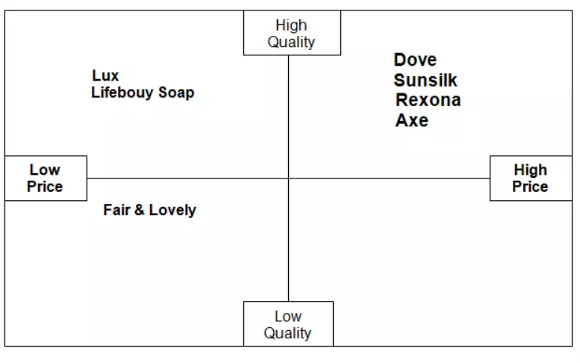
Source: https://ivypanda.com/essays/unilevers-personal-care-products/
Unilever UK
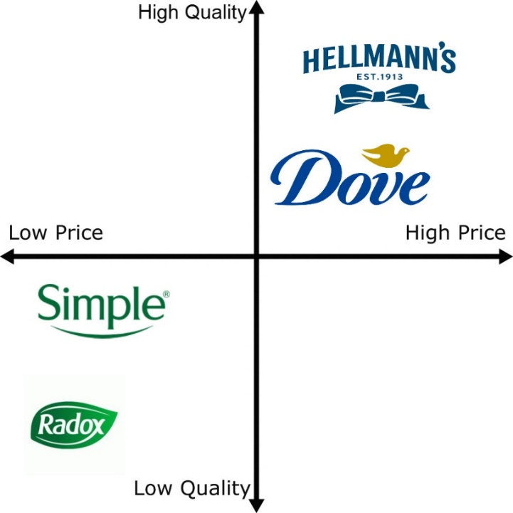
Source: Author’s creation

Similarities and Differences
The plotting of brands across the different attributes might change with the market. For instance, a brand from Unilever might be affordable in the UK but will be expensive in India. The following are such instances of similarities and differences across some notable Unilever brands:
Similarities
- Lux: Lux is a Unilever brand that offers personal care products in both countries. The brand uses high quality ingredients hence is perceived as a premium product in both countries.
- Lipton: The tea brand offers high quality tea powder in mid to expensive price ranges in both countries. Hence the brand is perceived as a high-quality product.
- Axe/Lynx: These brands offer mid-quality low-price men’s grooming products like deodorants. Hence, they are perceived to be low-quality low-price products in both countries.
- Sunsilk: The brand offers high quality yet affordable haircare products. Hence, it is perceived as a high-quality mid-price brand in the two countries.
Differences
- Lifebuoy: In the UK, this brand is perceived as a low-price alternative to premium brands like Dettol and Carex. However, the brand is perceived as a more premium brand in India compared to low priced brands like Himalaya.
- Surf Excel: In the UK the brand is perceived as a low-price alternative to premium brands like Persil whereas it is considered as a high price brand in India, compared to low priced brands like Ujala and Nirma.
- Ben & Jerry’s: The brand is perceived as a premium ice cream brand in the UK market whereas in India, the product is perceived to be a niche product, due to its limited availability.
- Knorr: In the UK, the brand is seen as a mid/low priced option for home cooking while in India, the brand is viewed as a more expensive brand due to its high price and international recipes.
Since we have looked at the perceptual map of Unilever, we can now progress to another major concept in international marketing; the marketing mix elements.

Marketing Mix Elements
The marketing mix elements is a framework that lists the main elements that are required to create an effective marketing strategy. The traditional marketing mix comprises of four elements or four Ps (product, price, promotion, and place) but in the recent times companies are using a more advanced and comprehensive eight Ps (Wickham, 2009). The new 8P marketing mix has four additional elements; people, process, physical evidence and partners). The following sections explains and analyses these factors, in regards to Unilever UK and HUL.
Product
Refers to the products offered by a company. Unilever UK offers a number of products across several categories like skincare, haircare and foods. Similarly, HUL offers products across a wide range of applications. The following table illustrates some of the renowned Unilever brands and their availability in both countries:
Brand | UK | India |  | Brand | UK | India
AdeZ | Yes |  | No | Comfort | Yes | Yes
Annapurna | No |  | Yes | Cornetto | Yes | Yes
Axe | Yes |  | Yes | Degree | Yes | Yes
Bango | No |  | Yes | Domex | No | Yes
Ben & Jerry's | Yes |  | No | Dove | Yes | Yes
Blueair | Yes |  | Yes | Elmlea | Yes | No
Brooke Bond | Yes |  | Yes | Flora | Yes | No
Bru | Yes |  | Yes | Glow & Lovely | No | Yes
Cif | Yes |  | Yes | Hellmann's | Yes | Yes
Clear | No |  | Yes | Horlicks | Yes | Yes
Lakmé | No |  | Yes | Saga | Yes | No
Lipton | Yes |  | Yes | Saint Ives | Yes | No
Lifebuoy | Yes |  | Yes | Simple | Yes | No
Liril | No |  | Yes | St Ives | Yes | No
Lux | Yes |  | Yes | Suave | Yes | No
Magnum | Yes |  | Yes | Sunsilk | Yes | Yes
Marmite | Yes |  | No | Surf | Yes | Yes
Pears | Yes |  | Yes | T2 | Yes | No
Persil | Yes |  | No | TIGI | Yes | No
Pepsodent | No |  | Yes | Toni & Guy | Yes | Yes
Pond's | Yes |  | Yes | Tresemmé | Yes | Yes
Pureit | No |  | Yes | VO5 | Yes | No
Radiant | Yes |  | Yes | Vaseline | Yes | Yes
Red Rose | Yes |  | No | Wall's | Yes | Yes
Rin | No |  | Yes | Wheel | No | Yes
Robertsons | Yes |  | No | Zwan | Yes | No

Price
The factor discusses about the price of products of a company. The price is influenced by several categories like market demand, competition, quality, and availability. Unilever UK applies several pricing strategies to its products. For instance, brands like Radox are priced at lower prices whereas Ben & Jerry’s uses premium pricing for its products. Similarly, HUL employs different pricing strategies to different brands. The company applies a lower price to its affordable detergent brand Wheel, while charging a premium price on brands like Lakme.
Place
In layman terms, place refers to the channels of distribution used by a company. This includes physical stores, e-commerce websites and third-party channels like wholesalers, retailers and distributors. Unilever UK makes its products available across several online and offline channels. Its products are available on e-commerce websites like Amazon and across supermarkets like Sainsbury’s, Tesco, and Waitrose.
HUL too applies similar strategies and have its brands and products available across e-commerce platforms like Amazon and Flipkart as well as through supermarkets like Reliance Fresh and Big Bazaar.
Another major factor that could influence the factor of place is, the market entry methods.
Market Entry Methods
Market entry methods are the different ways by which a company can enter a market. In 1929, the British soap company Lever Brothers joined with the Dutch margarine company Margarine Unie to establish Unilever. Hence, UK is considered as a home country for Unilever. Similarly, the company entered the Indian market in 1933, when it established Hindustan Unilever Limited (HUL) as a joint venture with Lever Brothers India Limited.
Also, there are four main market entry methods; exporting, acquisition, joint ventures, and franchising (Buckley & Casson, 1998). Unilever has implemented them in its operations, as follows:
- Exporting: This is the most common market entry method. Here, companies sell their products in a new market without establishing physical infrastructure (Buckley & Casson, 1998). It could be ideal for companies with strong economies of scale and supply chain networks. Unilever UK employs this strategy to export products to countries like China (Koltrowitz & Cavale, 2019).
- Acquisition: In this method, a company acquire an already established firm in the target market. This helps the company to leverage the market share and distribution networks of the acquired company (Buckley & Casson, 1998). For instance, Unilever India acquired the nutrition brand Horlicks from GlaxoSmithKline (GSK) in 2019, for more than 3.8 billion USD (Unilever PLC, 2020). This helped the company to be a more established player in the health market.
- Joint Ventures: Here a company forms a strategic alliance or partnership with another company in the target market. This helps to share data and resources between the companies (Buckley & Casson, 1998). For instance, in 2020, the Unilever UK partnered with a Japanese beverage company, Asahi, to make its brands like Lipton available in the Japanese market (Asahi, 2019).
- Franchising: Here a company creates a business model and allow other companies to use it for a fee (Buckley & Casson, 1998). This method is commonly used by established fast food chains like McDonalds and KFC. For instance, HUL has a franchise agreement with Kwality Wall's to produce and distribute ice creams (Malviya, 2018).
All these market entry methods have their own set of strengths and limitations. For instance, exporting has the following strengths and limitations (Thuri, 2022):
Strengths:
- Simplest Market Expansion: Exporting is the simplest of all market entry methods that will allow businesses to expand overseas. Exporting will help business to get access to global markets and buyers.
- Greater Economies of Scale: Increase in production for exporting can help businesses to achieve economies of scale faster. This will in turn increase the income and reduce production costs.
- Risk Averseness: Exporting comes with lower risk than other market entry methods. This is because exporting does not require companies to have production or infrastructure facilities in the target country.
- Governmental Support: Exporting will help companies to receive payments in international currencies, in their home accounts. This will help the government to increase its foreign reserves. Hence, exporting companies generally receive overwhelming support from their home governments.
Limitations:
- Supply Chain Constraints: Uncertainties and events like Covid 19 can create global supply chain issues. This may cause the exported products to be delayed while reaching the buyers, which in turn makes unhappy customers and refund requests.
- Loss of Control: Exporting forces companies to rely on middlemen in the target countries. This reduces the power businesses have on their products, such as deciding the price of products.
- Product Adaptation: Consumers in different markets have different preferences and buying behaviours. Hence, exporting companies have to customise their products to fit to them, which will cost more money.
- Exchange Rates: The fluctuations in the exchange rates can also negatively affect exporting businesses. If the currency value of the buyer country decreases, they will reduce the quantity of products they are buying from an exporter. This will cause a reduction in sales for exporting companies.
Promotion
These are activities employed by a company to promote its products to the target audience. Some of the common promotional activities include advertising, public relations and sales promotions. For instance, Unilever UK promotes Magnum ice cream as a luxury product to target customers who are willing to pay a premium price for ice creams (Lowe, 2017). Similarly, HUL promotes Lifebuoy as a healthcare product to make it appealing to health-conscious customers (Lifebuoy, 2013).
People
This factor is about the people responsible for the company operations such as employees, board of member and customer support. Unilever employs a large number of people across all of its operations, in both the UK and India. These people are responsible for providing the company products to the customers and deliver customer support in case of queries.
Process
This factor discusses about the processes and operations used by a company to deliver its products and services to the customers. Unilever UK and HUL has created sustainable manufacturing processes to reduce wastage and energy while producing products of brands like Rin and Surf (Swallow, 2022).
Physical evidence
This factor is about the physical evidences the customers have on the products of a company. Attributes like physical stores and packaging are examples of physical evidence. Unilever has established strong physical presence by making its products available across all major supermarkets, retailers, and wholesalers in both countries. The company has also created creative and colourful packaging for its products to differentiate them from its competitors.
Partners
This factor discusses about the different external partners used by the company such as suppliers, distributors, wholesalers and retailers. Unilever UK has partnership with major supermarket chains like Tesco and Sainsbury’s to make its product available across their stores. Similarly, HUL has partnerships with Indian supermarket chains like Reliance Fresh and Big Bazaar, for the distribution of its products.

Similarities and Differences
Similarities
- Product: Unilever offers a wide range of products from household care to wellness, in both countries. The company also constantly innovate these products to whenever there is a change in consumer behaviour.
- Price: The company applies a variety of pricing strategies in both countries to cater to different sections of buyers. The company have products in affordable as well as premium prices, in both countries.
- Place: In both countries, Unilever employs a variety of distribution channels like websites, supermarkets, and convenience store. This helps the company to have its products widely available in both countries.
- Promotion: The company also uses a wide range of promotional activities in both countries such as social media marketing, video, and print advertising. This helps the company to reach its target customers in both UK and India.
Differences
- People: Unilever has different target customers in the two countries. For instance, Unilever UK has a more diverse and multicultural customer base whereas HUL has a homogenous and cost sensitive customer base.
- Process: The company has different production processes in the two countries. For instance, Unilever UK has brands like the Love, Beauty, and Planet, which promotes products like eco-friendly, vegan, and cruelty-free products (Unilever PLC, 2023) while HUL manufactures products like water purifiers, to tackle the water pollution in India.
- Physical Evidence: The physical evidence attributes of the company also varies in both countries. For instance, Unilever UK focus more on the design of package and premium ingredients for its products, while HUL focus more on affordability and durability of the products.
- Partnerships: The partnerships of Unilever also vary with the countries. For instance, Unilever UK has partnership agreements with supermarket chains like Tesco and Sainsbury’s while HUL has similar agreements with Indian supermarket chains like Reliance Fresh and Big Bazaar.

Directional Development Strategy
Directional development strategies are used by companies to promote business growth into specific directions, such as, expansion, developing a new product or targeting a new customer segment (Bruin, 2017). There are several frameworks used for this and one of the most common of them is the BCG matrix.

The BCG Matrix
The Boston Consulting Group (BCG) matrix is a strategic tool that helps companies to analyse the performance of their products and brands. This will help in the efficient allocation of resources and investments. As the name suggests, the framework was developed by the Boston Consulting Group in 1970 (BCG, 2023).
The framework classifies the products and business groups into one of the four sections (stars, cash cows, question marks, and dogs) with regards to the market share and growth possibilities. Stars are businesses with high growth and market share while cash cows are businesses with low growth and high market share. Similarly, question marks are businesses with high growth but low market share whereas dogs (pets) are businesses with low growth and market share.

The following image illustrates a typical BCG matrix:
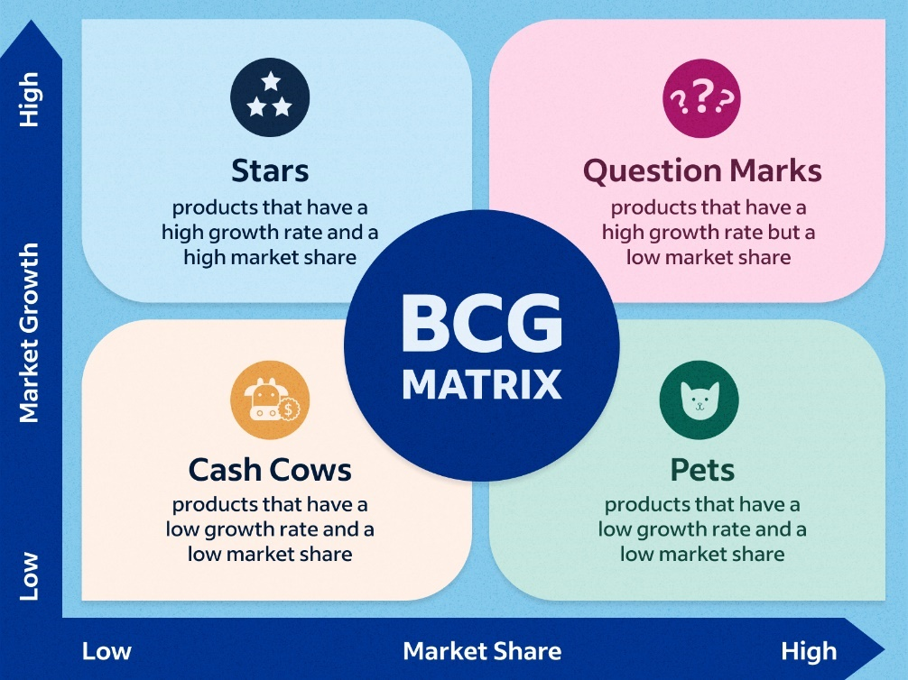
Source: https://www.indeed.com/career-advice/career-development/what-is-bcg-matrix
Similarly, the following image shows the BCG matrix of Unilever UK:
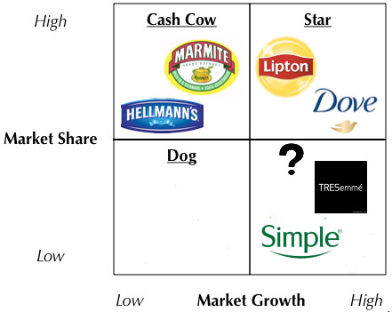
Source: https://themarketingagenda.com/2014/09/20/unilever-bcg-matrix/
As you can see from the above image Unilever UK brands like Lipton and Dove are classified as stars since they have a large market share and revenue (Harfmann, 2020; Cawthray, 2021). Brands like Marmite and Hellman’s are classified into cash cows as their respective markets have limited growth potential (Course hero, 2021). Similarly, brands like Tresemme and Simple are classified as question marks as their market has high growth potential, which can be leveraged by the company (Oakley, 2021).
The HUL on the other hand has its brands classified as follows:
- Stars: Brands like Surf Excel and Axe are considered as stars as their respective industries have high revenue and growth potential.
- Cash Cows: Brands like Sunsilk and Clinic Plus has lower growth potential but they still generate high revenues. Hence, they are considered as cash cows.
- Question Marks: Brands like Pepsodent and Domex has high growth potential but generates low revenue now. Hence, they are classified as question marks.
- Dogs: Brands like Brooke Bond and Bru are classified as dogs as they have low market share and growth.
The following image illustrates the BCG matrix of HUL (Yadav, 2012):
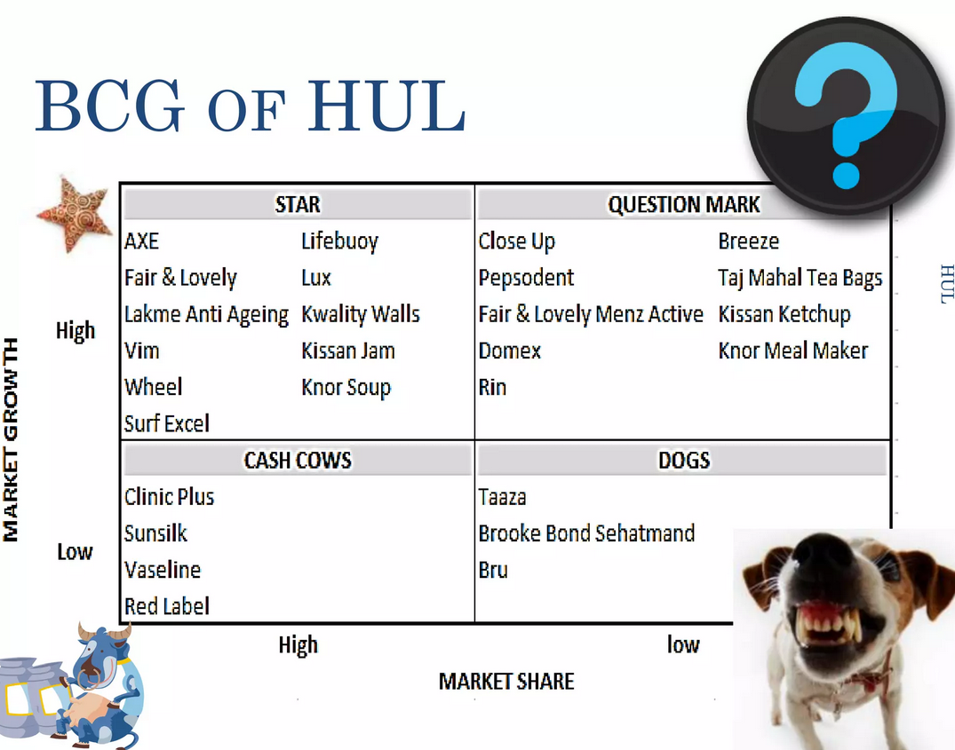
Source: https://www.slideshare.net/gurjantsandhu007/hul-bcg

Strengths and Limitations
Strengths
- Simple Framework: The framework provides a simple method to classify brands. By dividing brands or products with respect to their market shares, we can easily analyse the position of a brand in the market (Excel Dashboards, 2023).
- Identify Growth Potential: The matrix provides an illustration of the growth potential of a brand (Excel Dashboards, 2023).
- Drives Investment Decisions: The matrix helps in making key decisions like when to invest, when to innovate and when to divest from a market (Excel Dashboards, 2023).
Limitations
- Ignores Other Factors: The matrix assumes that the market share is the only factor that affects the growth. However, in reality, several other factors such as quality and competition also play a key role in business growth (Excel Dashboards, 2023).
- Simplistic Approach: As we have already observed, BCG provides a simpler approach to measuring growth. However, it may not always illustrate the actual position of a product in complex markets (Excel Dashboards, 2023).
- Reliance on Market Share: The BCG matrix considers market share as a measurement of the success of a business, which might not be accurate in all situations (Excel Dashboards, 2023). For instance, a business operating in a niche market will have a lower market share yet could generate high revenues.

Product Life Cycle Model
The Product Life Cycle (PLC) Model is a framework that illustrates the stages through which a product passes in a market, from introduction to decline. By analysing these stages, businesses will be able to create bespoke marketing strategies to generate revenue and brand awareness (Harvard Business Review, 2022).
The PLC model comprises of four key stages (Harvard Business Review, 2022), which are as follows:
- Introduction: This is the first stage where a product is launched into a market. Here, companies can use marketing strategies that can create awareness of the product
- Growth: Here the product has garnered awareness from its consumers which will cause a rise in the sales figures. In this stage, companies should implement strategies such as price discounts and sales promotion to attract more customers and create a larger market share.
- Maturity: In this stage there is limited sales growth as the product has saturated the market. This means that companies should devise strategies that will maintain the market share and increase profitability. Strategies like differentiation are suitable at this stage.
- Decline: Here, the product sales will decline steadily. Companies that have products at this stage should either consider leaving the market or differentiate the existing product.
A diagram of the PLC model is given below for reference:
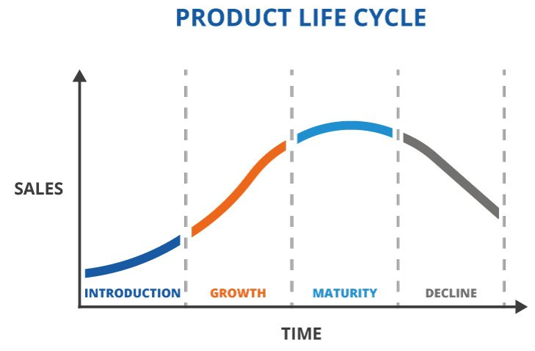
Source: https://www.twi-global.com/technical-knowledge/faqs/what-is-a-product-life-cycle
The following table illustrates various Unilever UK brands with respect to their PLC stages:
Unilever UK Brands | PLC Stage | Description
Dove | Maturity | Dove is a well-known brand in the United Kingdom, with a significant market presence and a dedicated client base. While the company continues to innovate and introduce new products, its basic items, such as the Beauty Bar and Moisturising Cream, have attained market maturity (Nikita, 2014).
Lynx | Growth | Lynx (also known as Axe in other markets) is a popular male grooming product brand in the United Kingdom that is discovering significant growth as a result of its creative product offers and targeted marketing initiatives (Behance, 2010). To maintain its success, the company has moved into other product categories such as hair care and shower gels.
Hellmann's | Introduction | While Hellmann's is a well-known brand in other regions, it is a newcomer to the UK market, having entered in 2019. As a result, the brand is still in the PLC's introduction stage, with a focus on increasing customer awareness and trial.
PG Tips | Maturity | PG Tips is a well-known tea brand in the United Kingdom, and as such, it has reached market maturity. The company continues to innovate and launch new goods, such as its line of fruit and herbal teas, but its core offerings, such as its black tea blends, have established a secure market position.
Persil | Growth | Persil is a well-known brand of laundry detergent in the United Kingdom that is seeing rapid growth as a result of its unique product offers and targeted marketing initiatives (WARC, 2022). To maintain its success, the company has moved into other product categories such as fabric softeners and stain removers.

Similarly, the following table illustrates various HUL brands with respect to their PLC stages:
Brand Name | Stage in PLC Model | Description
Dove | Maturity | Dove has been a well-known brand in India for many years and has a significant market share in the personal care sector. The brand has a devoted consumer base and has gone through multiple product line extensions to preserve its market position (Nikita, 2014).
Surf Excel | Growth | Surf Excel is a well-known laundry detergent brand that has experienced rapid growth in the Indian market as a result of rising demand for laundry goods and aggressive marketing activities (The Economic Times, 2020). The brand has also undergone various product advancements, including as the launch of Surf Excel Easy Wash, which has contributed to its continued success.
Lipton | Maturity | In India, Lipton is a well-known tea brand that has been on the market for several decades. The brand is well-known in both the packaged tea and ready-to-drink tea markets. However, as the Indian tea market developed, Lipton was forced to rely on product improvements and marketing campaigns in order to maintain its market position (Zachariah & Singh, 2018).
Pepsodent | Growth | Pepsodent is a famous toothpaste brand in India that has seen rapid growth in recent years as people become more aware of the importance of oral health and hygiene (Finshots, 2021). The brand has also undergone various product developments, including as the introduction of Pepsodent Germi Check+, which has contributed to its continued success.
Knorr | Introduction | Knorr is a food and beverage brand that has just entered the Indian market. The brand is positioned as a premium brand with a focus on natural ingredients, and it offers a variety of packaged soups, sauces, and spices. Knorr is actively introducing the PLC model and attempting to establish itself in the Indian market (The Times of India, 2015).

Recommendations
The SWOT analysis helped us to identify the main strengths, weaknesses, threats, and opportunities for Unilever operations in the UK and India. This will help us to provide recommendations for the future operations of Unilever. These recommendations can be better provided with the help of the TWOS framework. The following image illustrates an ideal TWOS structure:
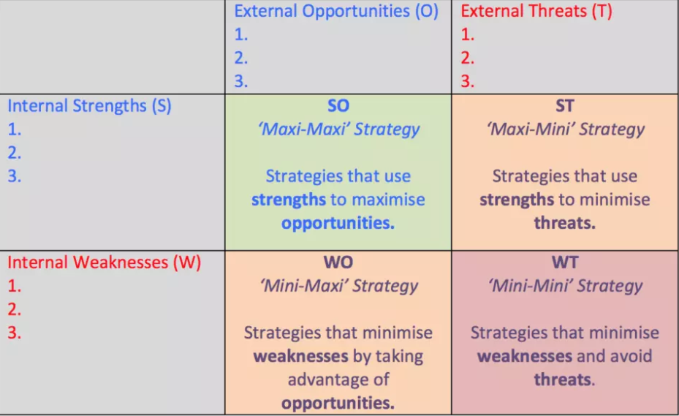
Source: https://marketingadviser.co.uk/financial-marketing/swot-tows-guide/
Unilever could implement the TWOS strategies as follows:
- Maxi-Maxi Strategy: Unilever UK could invest more in its high-profit and high-growth brands like Hellman’s and Dove. Similarly, HUL could replicate its strengths in the personal care brands to its grooming brands such as Brylcreem.
- Maxi-Mini Strategy: The Unilever UK could divest its operations in low growth brands like Marmite and focus more in brands that generates higher revenues like Dove. Likewise, HUL could divest its operations in food products such as the Modern brand of bread to focus on more revenue generating brands like Lifebuoy.
- Mini-Maxi Strategy: Unilever UK could invest more in low performing brands like Flora to increase its appeal among health-conscious customers. Similarly, HUL could invest more in its ayurvedic medicine brand Ayush as there is a growing demand for healthcare products in the Indian market.
- Mini-Mini Strategy: Unilever UK could divest its operations from low performing household care brands like Domestos. It will help the company to focus more on high performing household care brands like Comfort fabric conditioner, Cif cleaning products, and Persil laundry detergent. Likewise, HUL can introduce sustainable and healthier products in its Knorr brand to appeal better to the emerging health-conscious consumers.

Conclusion
Unilever UK and Hindustan Unilever Limited are two key players in the fast-moving consumer goods (FMCG) sector. Both companies operate in highly competitive and fast paced markets and are influenced by several external and internal factors. The PESTLE and Porter’s Five Forces models helped us to identify and analyse these factors and their effects on the companies. The analysis also showed that alongside the similarities the companies also had several differences in its operations, which were caused by several factors like consumer behaviour and cultural variances. Additionally, the report also analysed several other important factors such as STP, Marketing Mix as well as the BCG matrix to examine the different factors that affects the companies in strategic decision making and marketing techniques. The analysis showed that Unilever can maintain its operations and competitive advantage in both countries by monitoring these factors and updating its strategies accordingly.

References
- Andaleeb, S.S. (2016) “Market segmentation, targeting and positioning,” Strategic Marketing Management in Asia, pp. 179–207. Available at: https://doi.org/10.1108/978-1-78635-746-520161006.
- Asahi (2019) Asahi Beverages partners with Lipton Iced Tea , Asahi Beverages. Asahi Beverages. Available at: https://www.asahi.com.au/news-media/media-releases/179-asahi-beverages-partners-with-lipton-iced-tea (Accessed: April 28, 2023).
- Bahal, S. and Sahay, A. (2015) “Promoting oral health in rural India: The case of pepsodent,” Global Business Review, 16(3), pp. 524–536. Available at: https://doi.org/10.1177/0972150915569941.
- BCG (2023) What is the growth share matrix?, BCG Global. Boston Consulting Group. Available at: https://www.bcg.com/about/overview/our-history/growth-share-matrix (Accessed: April 28, 2023).
- BCG (2023) What is the growth share matrix?, BCG Global. Boston Consulting Group. Available at: https://www.bcg.com/about/overview/our-history/growth-share-matrix (Accessed: April 28, 2023).
- Behance (2010) Design for manufacture and Sustainability Analysis Lynx, Behance. Behance. Available at: https://www.behance.net/gallery/14559941/Design-for-Manufacture-and-Sustainability-Analysis-LYNX (Accessed: April 28, 2023).
- Bhatnagar, N. (2017) “The effect of national culture differences on perceived organisational support: Examining the case of India and the United Kingdom,” Review of Social Studies, 4(2), pp. 53–67. Available at: https://doi.org/10.21586/ross0000051.
- BNF (2021) British Nutrition Foundation Survey reveals 62% of Britons have altered their diet to get healthier, British Nutrition Foundation. British Nutrition Foundation. Available at: https://www.nutrition.org.uk/news/2021/british-nutrition-foundation-survey-reveals-62-of-britons-have-altered-their-diet-to-get-healthier-in-the-past-year/ (Accessed: April 27, 2023).
- BNF (2021) British Nutrition Foundation Survey reveals 62% of Britons have altered their diet to get healthier, British Nutrition Foundation. British Nutrition Foundation. Available at: https://www.nutrition.org.uk/news/2021/british-nutrition-foundation-survey-reveals-62-of-britons-have-altered-their-diet-to-get-healthier-in-the-past-year/ (Accessed: April 27, 2023).
- Bruin, L.de (2017) Internal and External Growth Strategies Explained with examples: B2U, Business. B2U. Available at: https://www.business-to-you.com/internal-external-growth-strategies/ (Accessed: April 28, 2023).
- Buckley, P.J. and Casson, M.C. (1998) “Analyzing foreign market entry strategies: Extending the internalization approach,” Journal of International Business Studies, 29(3), pp. 539–561. Available at: https://doi.org/10.1057/palgrave.jibs.8490006.
- CampaignUK (2015) In India, Lipton Ice Tea scripts a heartwarming 'why not?' match, Campaign UK. CampaignUK. Available at: https://www.campaignlive.co.uk/article/india-lipton-ice-tea-scripts-heartwarming-why-not-match/1350545 (Accessed: April 28, 2023).
- CFI (2023) Macro environment, Corporate Finance Institute. Corporate Finance Institute. Available at: https://corporatefinanceinstitute.com/resources/economics/macro-environment/ (Accessed: April 27, 2023).
- Chee, F.Y. (2011) Unilever, P&G fined 315 million euros for price fixing, Reuters. Thomson Reuters. Available at: https://www.reuters.com/article/us-eu-cartel-idUSTRE73C1XV20110413 (Accessed: April 27, 2023).
- CIPD (2021) Pestle analysis, CIPD. The Chartered Institute of Personnel and Development. Available at: https://www.cipd.org/uk/knowledge/factsheets/pestle-analysis-factsheet/ (Accessed: April 27, 2023).
- CIPD (2021) SWOT analysis: Factsheets, CIPD. The Chartered Institute of Personnel and Development. Available at: https://www.cipd.org/uk/knowledge/factsheets/swot-analysis-factsheet/ (Accessed: April 28, 2023).
- ClientEarth (2022) The UK environment act - what's happening now?, ClientEarth. ClientEarth. Available at: https://www.clientearth.org/latest/latest-updates/news/why-the-uk-environment-bill-matters/ (Accessed: April 28, 2023).
- Course hero (2021) The Boston Consulting Group BGC growth share matrix is a planning tool that uses, The Boston Consulting Group BGC growth share matrix is a planning tool that uses | Course Hero. Available at: https://www.coursehero.com/file/p72qcn3p/The-Boston-Consulting-Group-BGC-growth-share-matrix-is-a-planning-tool-that-uses/ (Accessed: April 28, 2023).
- Creative Review (2018) The history of the marmite you either love it or hate it slogan, Creative Review. Creative Review. Available at: https://www.creativereview.co.uk/you-either-love-it-or-hate-it/ (Accessed: April 28, 2023).
- Excel Dashboards (2023) The Pros and cons of the BCG matrix, Excel Dashboards. Excel Dashboards. Available at: https://excel-dashboards.com/blogs/blog/pros-cons-bcg-matrix (Accessed: April 28, 2023).
- Farrell, D. and Beinhocker, E. (2007) Next big spenders: India's middle class, McKinsey & Company. McKinsey & Company. Available at: https://www.mckinsey.com/mgi/overview/in-the-news/next-big-spenders-indian-middle-class (Accessed: April 27, 2023).
- Finshots (2021) The toothpaste wars, Finshots. Finshots. Available at: https://finshots.in/markets/the-toothpaste-wars/ (Accessed: April 28, 2023).
- Gigauri, I. (2019) “Perceptual mapping as a marketing research tool for brand positioning,” International Journal of Economics and Management Studies, 6(4), pp. 73–79. Available at: https://doi.org/10.14445/23939125/ijems-v6i4p110.
- GOV.UK (2021) Implementing the sustainable development goals, GOV.UK. The Government of UK. Available at: https://www.gov.uk/government/publications/implementing-the-sustainable-development-goals/implementing-the-sustainable-development-goals--2 (Accessed: April 27, 2023).
- GOV.UK (2022) New rules to protect consumers' hard-earned cash , GOV.UK. The Government of UK. Available at: https://www.gov.uk/government/news/new-rules-to-protect-consumers-hard-earned-cash (Accessed: April 28, 2023).
- Harfmann, B. (2020) 2020 state of the beverage industry: Tea market sales relatively flat, Beverage Industry RSS. Beverage Industry. Available at: https://www.bevindustry.com/articles/93236-state-of-the-beverage-industry-tea-market-sales-relatively-flat (Accessed: April 28, 2023).
- Harvard Business Review (2022) Exploit the product life cycle, Harvard Business Review. Harvard Business Review. Available at: https://hbr.org/1965/11/exploit-the-product-life-cycle (Accessed: April 28, 2023).
- Haynes, M. (2012) Knorr kicks off "what's for dinner?", Media In Canada - keeping media and marketing execs up to speed on the Canadian media scene. Media In Canada. Available at: https://mediaincanada.com/2012/12/14/knorr-kicks-off-whats-for-dinner/ (Accessed: April 28, 2023).
- Kissinger, D. (2017) Unilever's five forces analysis (Porter's Model) & Recommendations, Panmore Institute. Panmore Institute. Available at: https://panmore.com/unilever-five-forces-analysis-porters-model-recommendations (Accessed: April 28, 2023).
- Kissinger, D. (2017) Unilever's SWOT analysis & recommendations, Panmore Institute. Panmore Institute. Available at: https://panmore.com/unilever-swot-analysis-recommendations (Accessed: April 28, 2023).
- Koltrowitz, S. and Cavale, S. (2019) Emerging markets come off the boil for Nestle and Unilever, Reuters. Thomson Reuters. Available at: https://www.reuters.com/article/us-europe-results-china-idUSKBN1WW1RP (Accessed: April 28, 2023).
- Lifebuoy Help A Child Reach 5 - Gondappa (2013) YouTube. YouTube. Available at: https://www.youtube.com/watch?v=UF7oU_YSbBQ (Accessed: April 28, 2023).
- Lowe, M. (2017) Magnum, Moschino and Cara Delevingne join forces to 'release the beast' in Fierce New Campaign, LBBOnline. Little Black Book. Available at: https://www.lbbonline.com/news/magnum-moschino-and-cara-delevingne-join-forces-to-release-the-beast-in-fierce-new-campaign (Accessed: April 28, 2023).
- Make In India (2014) About us: Make in India, ABOUT US | Make In India. Make In India. Available at: https://www.makeinindia.com/about (Accessed: April 27, 2023).
- Malviya, S. (2018) Hindustan Unilever fights for rights over Kwality walls, The Economic Times. The Economic Times. Available at: https://economictimes.indiatimes.com/industry/services/advertising/hul-fights-for-rights-over-kwality-walls/articleshow/64346118.cms?from=mdr (Accessed: April 28, 2023).
- McEvoy, J. (2020) Critics slam unilever rebrand of 'Fair & Lovely' Skin Lightener as 'glow & lovely', Forbes. Forbes Magazine. Available at: https://www.forbes.com/sites/jemimamcevoy/2020/07/02/critics-slam-unilever-rebrand-of-fair--lovely-skin-lightener-as-glow--lovely/?sh=442c40414b7a (Accessed: April 28, 2023).
- Morrison , R. (2020) Coca-Cola, Nestlé, PepsiCo and Unilever dump half a million tonnes of plastic pollution, Daily Mail Online. Associated Newspapers. Available at: https://www.dailymail.co.uk/sciencetech/article-8168521/Coca-Cola-Nestl-PepsiCo-Unilever-dump-half-MILLION-tonnes-plastic-pollution.html (Accessed: April 27, 2023).
- Nikita (2014) Product life cycle and Industry Life Cycle, PRODUCT LIFE CYCLE AND INDUSTRY LIFE CYCLE. Available at: http://nikitakv1406.blogspot.com/2014/08/product-life-cycle.html (Accessed: April 28, 2023).
- NRF (2022) India, Global rules on foreign direct investment | Publications | Knowledge | Global law firm | Norton Rose Fulbright. Norton Rose Fulbright. Available at: https://www.nortonrosefulbright.com/en/knowledge/publications/24313880/india (Accessed: April 27, 2023).
- Oakley, T. (2021) Unilever: BCG Matrix, The Marketing Agenda. The Marketing Agenda. Available at: https://themarketingagenda.com/2014/09/20/unilever-bcg-matrix/ (Accessed: April 28, 2023).
- OBR (2022) How does the Russian invasion of Ukraine affect the UK economy?, Office for Budget Responsibility. Office for Budget Responsibility. Available at: https://obr.uk/box/how-does-the-russian-invasion-of-ukraine-affect-the-uk-economy/ (Accessed: April 27, 2023).
- Oner, C. (2019) Inflation: Prices on the rise, IMF. International Monetary Fund. Available at: https://www.imf.org/en/Publications/fandd/issues/Series/Back-to-Basics/Inflation (Accessed: April 27, 2023).
- Porter, M.E. (1979) How competitive forces shape strategy, How Competitive Forces Shape Strategy. Harvard Business School. Available at: https://www.hbs.edu/faculty/Pages/item.aspx?num=10692 / (Accessed: April 28, 2023).
- Raj, K. and Aithal, S. (2018) “A ‘desi’ multinational –A case study of hindustan unilever limited,” International Journal of Case Studies in Business, IT, and Education, pp. 1–12. Available at: https://doi.org/10.47992/ijcsbe.2581.6942.0022.
- Shaiq, H.M.A. et al. (2011) “Why not everybody loves Hofstede? What are the alternative approaches to study of culture?,” European Journal of Business and Management, 3(6), pp. 101–112. Available at: http://www.iiste.org/ (Accessed: April 28, 2023).
- Sharma, K. (2021) How surf excel's Daag Acche Hain has evolved over the years, Business Insider. Business Insider. Available at: https://www.businessinsider.in/advertising/brands/article/how-surf-excels-daag-acche-hain-has-evolved-over-the-years/articleshow/81690598.cms (Accessed: April 28, 2023).
- Sim, S., King, H. and Price, E. (2016) “The role of Science in shaping sustainable business: Unilever case study,” Taking Stock of Industrial Ecology, pp. 291–302. Available at: https://doi.org/10.1007/978-3-319-20571-7_15.
- SIWI (2018) The water crisis in India: Everything you need to know: Siwi - leading expert in water governance, SIWI. Stockholm International Water Institute. Available at: https://siwi.org/latest/water-crisis-india-everything-need-know/ (Accessed: April 28, 2023).
- Swallow, T. (2022) Hul is recognised for innovative sustainability technology, Sustainability Magazine. Sustainability Magazine. Available at: https://sustainabilitymag.com/supply-chain-sustainability/hul-is-recognised-for-innovative-sustainability-technology (Accessed: April 28, 2023).
- The Economic Times (2020) Surf excels as Hul's top brand, nets over Rs 5,000 crore in sales, The Economic Times. The Economic Times. Available at: https://economictimes.indiatimes.com/industry/cons-products/fmcg/surf-excels-as-huls-top-brand-nets-over-rs-5000-crore-in-sales/articleshow/74294041.cms?from=mdr (Accessed: April 28, 2023).
- The Times of India (2015) Nestle's 70% Noodle Market Share Faces heat - times of India, The Times of India. The Times of India. Available at: https://timesofindia.indiatimes.com/business/india-business/nestles-70-noodle-market-share-faces-heat/articleshow/47534610.cms (Accessed: April 28, 2023).
- Thuri, V. (2022) Advantages and disadvantages of exporting - 2022 guide, Wise. Wise. Available at: https://wise.com/us/blog/advantages-of-exporting (Accessed: April 29, 2023).
- Unilever PLC (2017) Announcing the dove real beauty pledge, Unilever. Unilever PLC. Available at: https://www.unilever.com/news/news-search/2017/announcing-the-dove-real-beauty-pledge/ (Accessed: April 28, 2023).
- Unilever PLC (2020) Unification of Unilever's legal structure, Unilever. Unilever PLC. Available at: https://www.unilever.com/news/press-and-media/press-releases/2020/unification-of-unilever-legal-structure/ (Accessed: April 27, 2023).
- Unilever PLC (2020) Unilever announces completion of horlicks acquisition from GSK, Unilever. Unilever PLC. Available at: https://www.unilever.com/news/press-and-media/press-releases/2020/unilever-announces-completion-of-horlicks-acquisition-from-gsk/ (Accessed: April 28, 2023).
- Unilever PLC (2022) Behind the brand: What's Hellmann's Secret Sauce for success?, Unilever. Unilever PLC. Available at: https://www.unilever.com/news/news-search/2022/behind-the-brand-whats-hellmanns-secret-sauce-for-success/ (Accessed: April 28, 2023).
- Unilever PLC (2023) Ben & Jerry's, Unilever. Unilever PLC. Available at: https://www.unilever.co.uk/brands/ice-cream/ben-jerrys/ (Accessed: April 29, 2023).
- Unilever PLC (2023) Clinic plus, Unilever. Unilever PLC. Available at: https://www.hul.co.in/brands/beauty-wellbeing/clinic-plus/ (Accessed: April 29, 2023).
- Unilever PLC (2023) Inside our markets: Unilever in India, Unilever. Unilever PLC. Available at: https://www.unilever.com/news/news-search/2023/inside-our-markets-unilever-in-india/ (Accessed: April 29, 2023).
- Unilever PLC (2023) Knorr, Unilever. Unilever PLC. Available at: https://www.hul.co.in/brands/nutrition/knorr/ (Accessed: April 29, 2023).
- Unilever PLC (2023) Love beauty & planet, Unilever. Unilever PLC. Available at: https://www.unilever.com/brands/beauty-wellbeing/love-beauty-planet/ (Accessed: April 29, 2023).
- Unilever PLC (2023) Lynx, Unilever. Unilever PLC. Available at: https://www.unilever.co.uk/brands/personal-care/lynx/ (Accessed: April 29, 2023).
- Unilever PLC (2023) Our history: Unilever global company website - 1900 - 1950, Unilever. Unilever PLC. Available at: https://www.unilever.com/our-company/our-history-and-archives/1900-1950/ (Accessed: April 27, 2023).
- Unilever PLC (2023) Persil, Unilever. Unilever PLC. Available at: https://www.unilever.co.uk/brands/home-care/persil/ (Accessed: April 29, 2023).
- Unilever PLC (2023) Unilever in the UK, Unilever. Unilever PLC. Available at: https://www.unilever.co.uk/unilever-in-the-uk/ (Accessed: April 27, 2023).
- Usmani, F. (2022) Porter's five forces: Examples, Advantages & Disadvatages, Parsadi. Parsadi. Available at: https://parsadi.com/porters-five-forces/ (Accessed: April 28, 2023).
- Vijayraghavan, K. (2010) Hul's appetite- experiments in marketing, The Economic Times. The Economic Times. Available at: https://economictimes.indiatimes.com/industry/cons-products/fmcg/huls-appetite-experiments-in-marketing/articleshow/6790074.cms?from=mdr (Accessed: April 29, 2023).
- WARC (2022) Dirt for good: How Persil evolved its Brand Purpose: WARC, WARC An Ascential Company. WARC. Available at: https://www.warc.com/newsandopinion/opinion/dirt-for-good-how-persil-evolved-its-brand-purpose/en-gb/5595 (Accessed: April 28, 2023).
- Wickham, M. (2009) “Thana-marketing strategy: exploring the 8Ps that dare not speak their name ,” International Journal of Business Strategy, 9(1), pp. 194–201. Available at: https://www.researchgate.net/publication/277825905_Thana-marketing_strategy_exploring_the_8Ps_that_dare_not_speak_their_name (Accessed: April 28, 2023).
- Yadav, H. (2012) “Study of the BCG matrix for Hindustan Unilever Limited,” SSRN Electronic Journal [Preprint]. Available at: https://doi.org/10.2139/ssrn.2124042.
- Zachariah, R. and Singh, N. (2018) After 8 years, Hul Brew beats Tata Tea - Times of India, The Times of India. The Times of India. Available at: https://timesofindia.indiatimes.com/business/india-business/after-8-years-hul-brew-beats-tata-tea/articleshow/63672253.cms (Accessed: April 28, 2023).

