

Assessment 1 – Reading Task Template
PART 1: Upload your photo of your A3 in-class notes here:
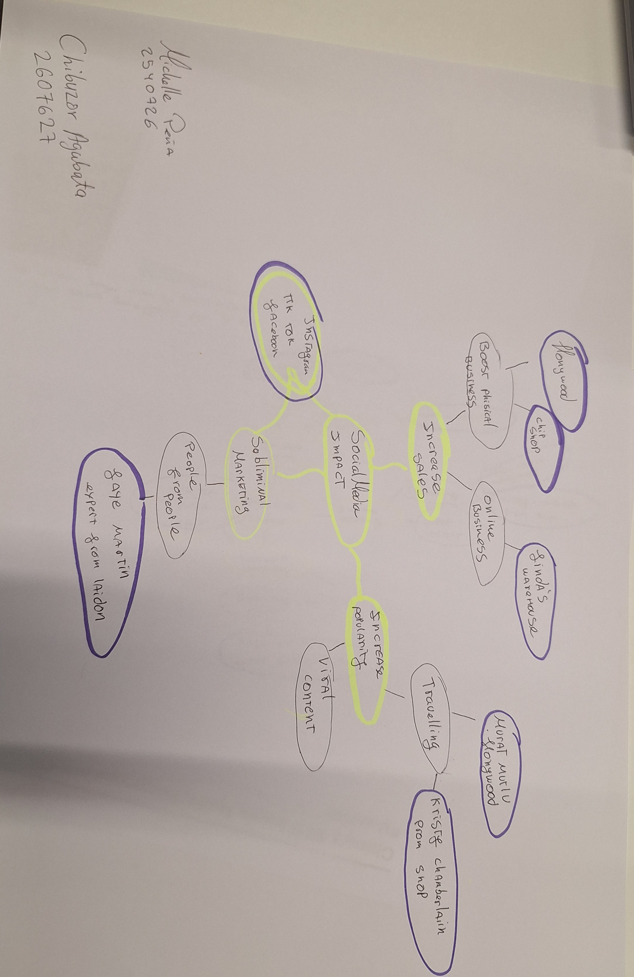

PART 2:
- Answer every question below in 1-3 full sentences.
- Use your own words. Do not use generative AI to answer these questions.
- Include a specific detail from the text when asked.
REMINDER
- The main idea is the overall message of the whole text.
- A key point helps to explain the main idea.
- A specific detail or example from the text shows that the key point is true.

- What is the main idea of the whole text?
The main idea of the text is social media impact on business; social media helps businesses to have more awareness therefore they are more likely to grow.

- What is one key point that supports the main idea, and which specific example from the text shows this?
One key point that supports the main idea is that social media helps businesses to have more awareness, we can see this in the business of ‘Spudman’ where the owner Ben Newman saw that a high number of customers came to his business after his own videos went viral.

- What is a different key point that supports the main idea, and which specific example from the text shows this?
A different key point that supports the main idea is that Linda was able to operate her business fully online, able to reach and sold to more people.

- Which part of the text do you think is most important, and why?
The part of the text that I think is the most important is that social media helped boost popularity for Kristy Chamberlain due to her funny skits which enabled people from other countries e.g. Cyprus and Channel Islands to visit her shop.
Reflection:
- What did you find difficult in this task (including in-class components), and why was it difficult?
I found skimming difficult because I need to pay attention to make decisions on what information to pick out.
I also found the mind map a bit difficult to make.

- What helped you with this difficulty, and how did it help you?
Asking questions, seeking support from the lecturer, colleagues and continuous learning.

